**Building an Analysis and Visualization Interface using Tableau**

Data Intensive Computing - CSE 587

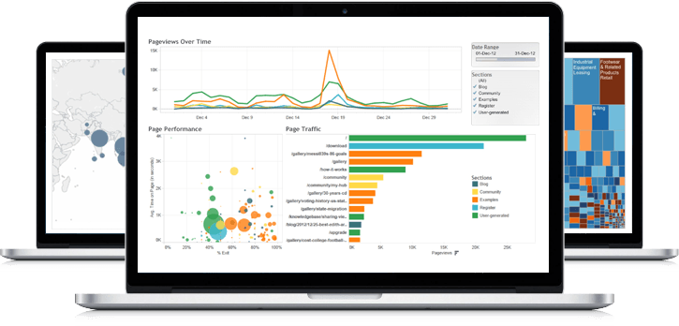



Submitted by

Ramanpreet Singh Khinda (rkhinda | 5016-9622)

Elroy Preetham Alva (elroypre | 5016-8107)

**Question 1: UB Course Demand**

Every semester UB offers great courses to its students and provide the best world class faculty to teach those courses. However, we have observed that some of the courses are always in high demand either due to increasing technology demand of that field or due to extra ordinary teaching faculty.

UB student affairs want to globalize some of its courses which are highly demanding among students but we are not able to shortlist the courses. Can you utilize the “UB Course Scheduling data” to gather an insight on which courses have always been the first choice for the students?

**Solution:**

**Tableau Link:**

<https://public.tableau.com/profile/publish/Q_1_UB_Course_Demand/P2_Q1#!/publish-confirm>

We first analyzed the demand of courses at UB on a general scale i.e. checked what is the overall demand of courses offered by UB and found that there are **743** **courses** which are in **high demand** among students. Based on various factors we calculated a field called **Class Interest Level** which is a %age factor and tells us how much is the class interesting. The below graph also tells us that most of the courses are not in much demand.

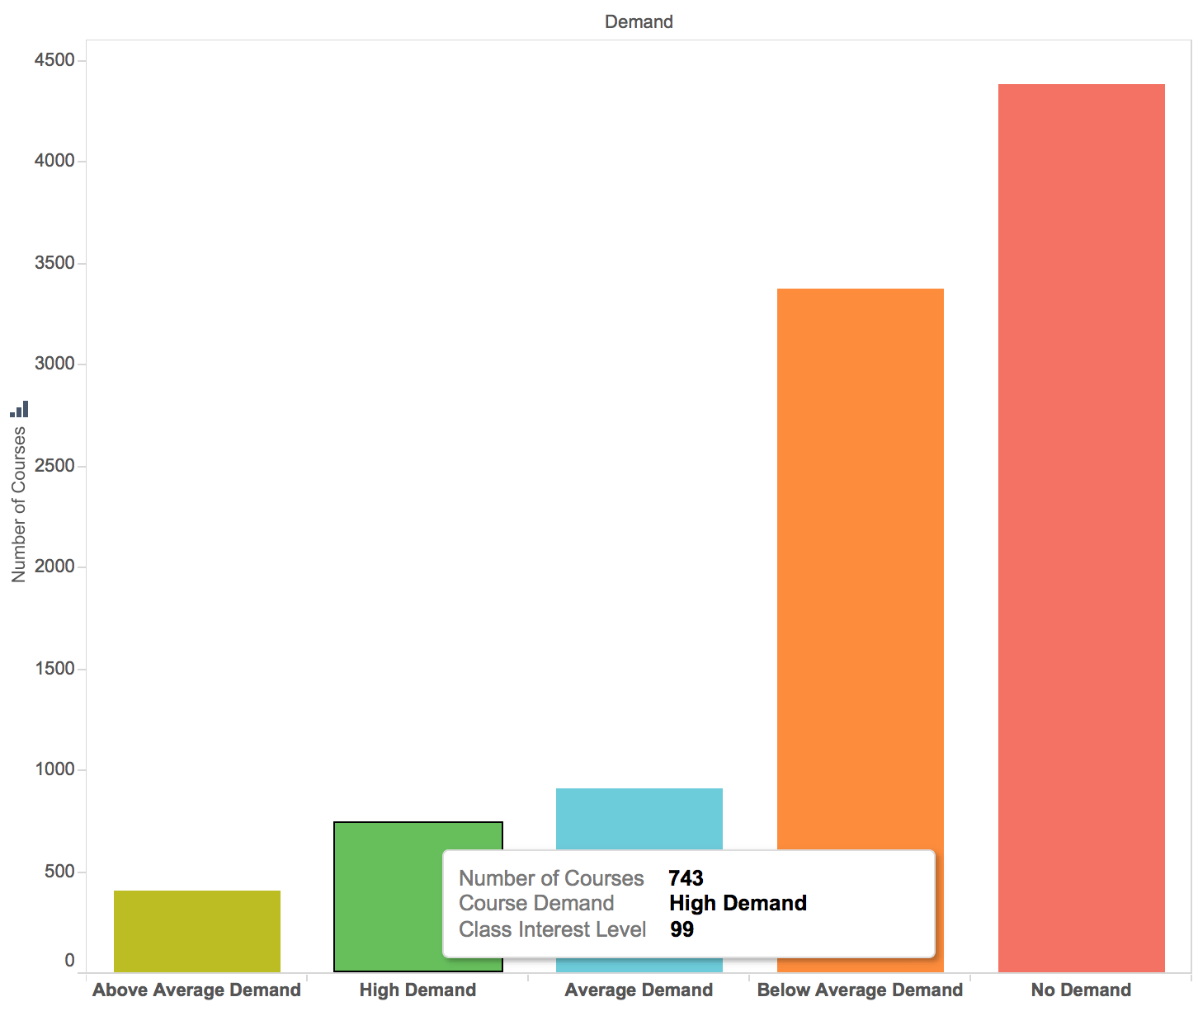

Then we tried to find the most demanding departments in UB based on the courses offered by them. There are filters like *Average Class Capacity, Average Enrolled Students* and *Class Interest Level.* Based on these categories we can filter out and analyze the demanding departments.

As depicted in the graph below the **PSY** department is **below average** in demand with **Class Interest Level of 48**

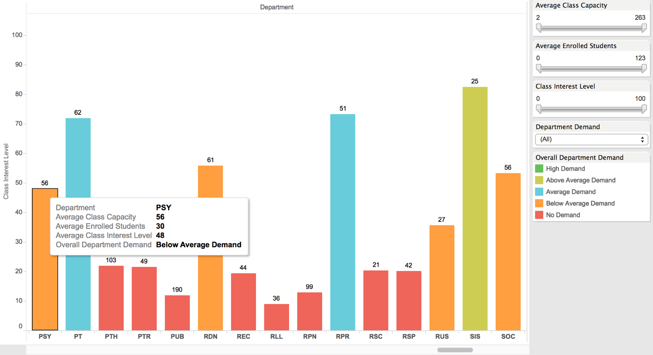

Then we dig our analysis in more deep and analyzed demanding courses. We can select a filter on department and see the demand of various courses.

As depicted on the graph below we can see that the highlighted department **Intro to Machine Learning** is overall **not much demanding** among the students as the **Average Class Interest Level is just 22**

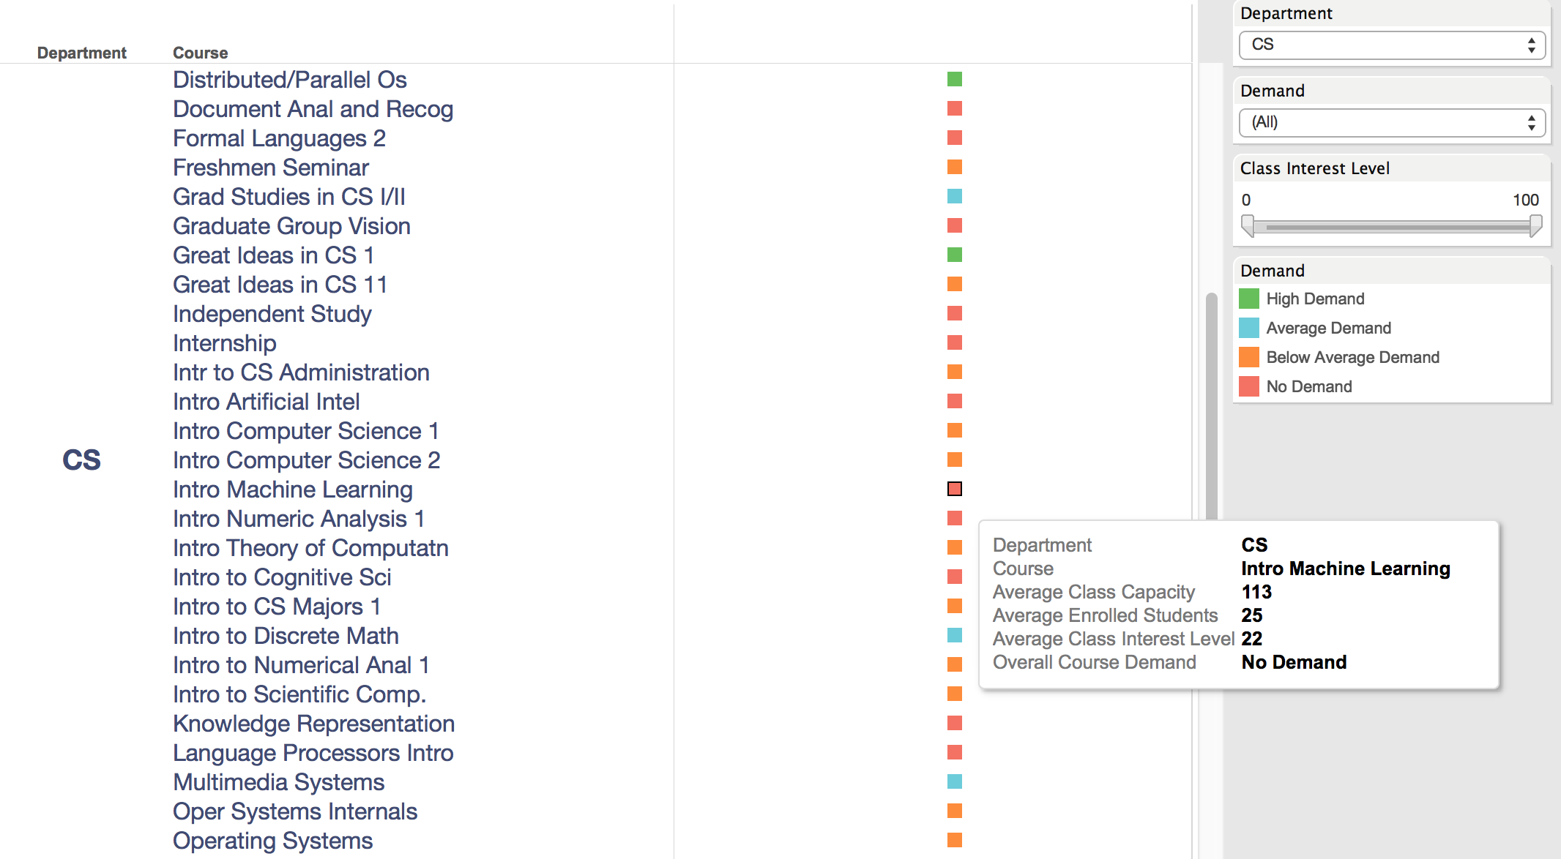

We can also filter out only high demanding courses and shortlist the courses based on that.

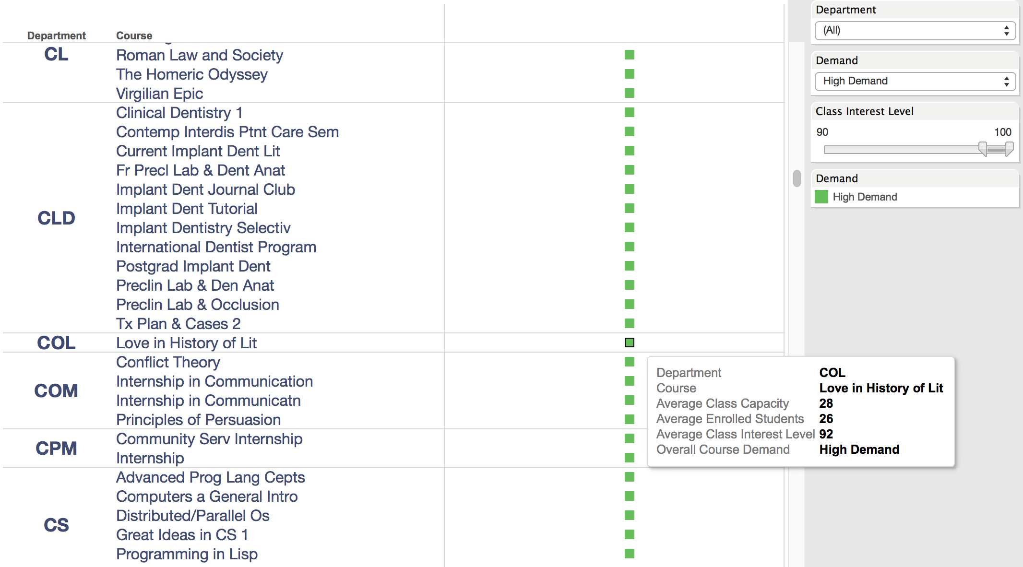

**Question 2: Most Popular Department Every Year**

We see that UB consists of many departments. However, which among these is the most popular?

How do we decide which one is the most popular? Answering this question can give us an idea as to which department needs more classrooms and more time slots.

Since the popularity might change every year we also need to observe trends over the past few years. Therefore, our question would be, find the most popular department by number of enrollments every year.

**Solution:**

**Tableau Link:**

<https://public.tableau.com/profile/publish/Q_2_Popular_Department/AnalysisofPopularDepartments#!/publish-confirm>

We first analyzed the most popular department for each year which have the highest number of enrollments.

As depicted in the below graph we can see that the **Math department** had **highest enrollments in the year 2015**

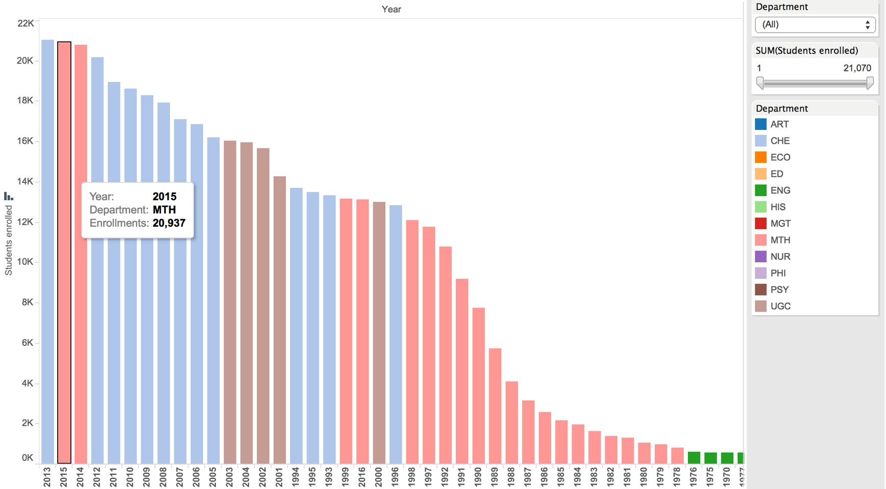

We used Ghant Chart to portray the story line which also provide us the popular department in a range of years.

As depicted in the graph below we can see that the **Chemical department** was **most popular** in the **year** **1996** with **Total Enrollments of 12, 836** students

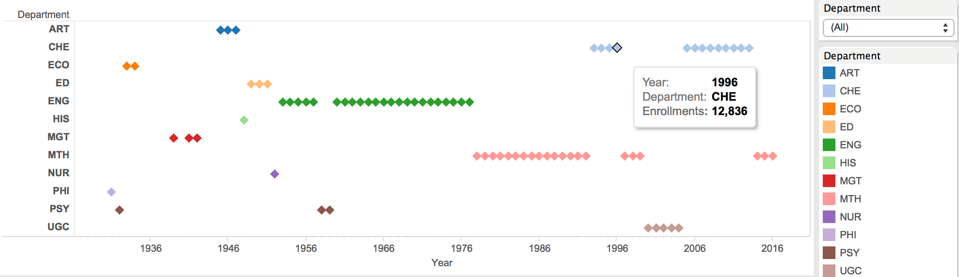

**Question 3: Find wasted space in every building over the years**

UB is broken into buildings and each building has a lab or a lecture hall. A lot of this space is usually wasted. We decided that we wanted to find out the wasted space in every building.

We can find out which buildings have been historically wasting space and which buildings have been efficient. Using this we can allot more classes in the inefficient buildings.

**Solution:**

**Tableau Link:**

<https://public.tableau.com/profile/publish/P2_Q3_0/P2_Q3#!/publish-confirm>

First we tried to find out utilization of Lecture Rooms over the years in UB. The below graph is a simple representation of the same which give us an idea that class scheduling is not efficient in UB. Most of the lecture rooms are either under utilized or over utilized.

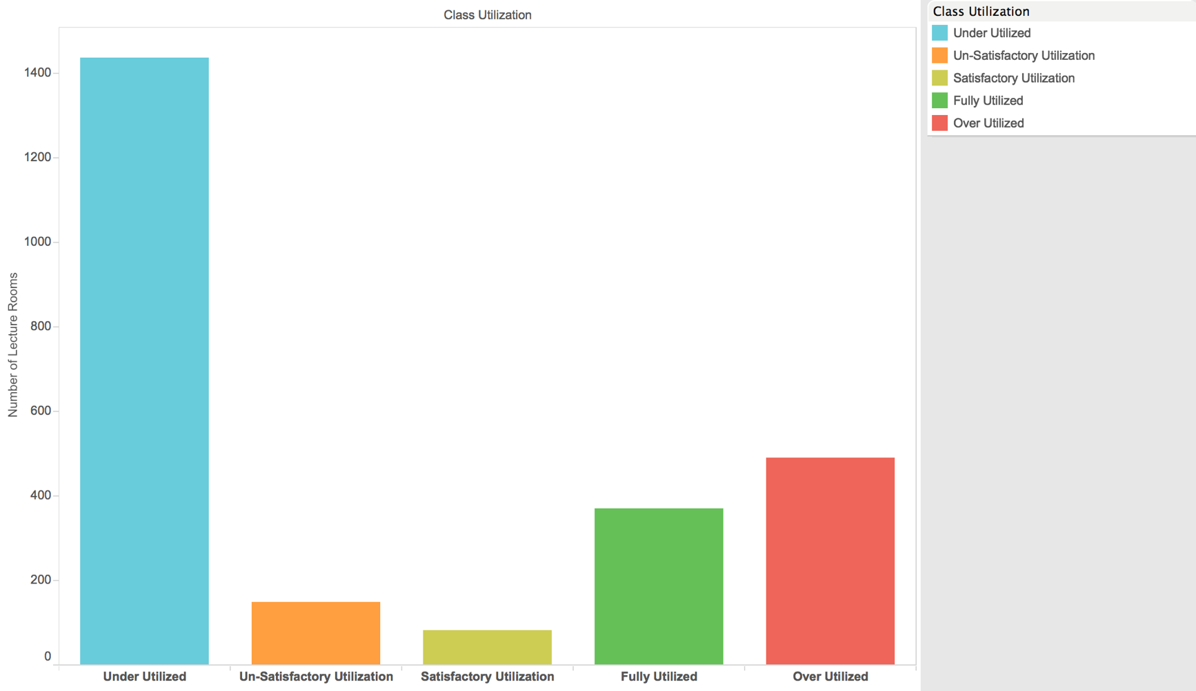

Then we dig our analysis in deep and tried to find out the space utilization of individual lecture rooms.

As we can see in the below graph we have filtered out the results for Bell Hall and can see that the **Bell 340** has remained **under utilized** over the course of years with average **class utilization as 46%**

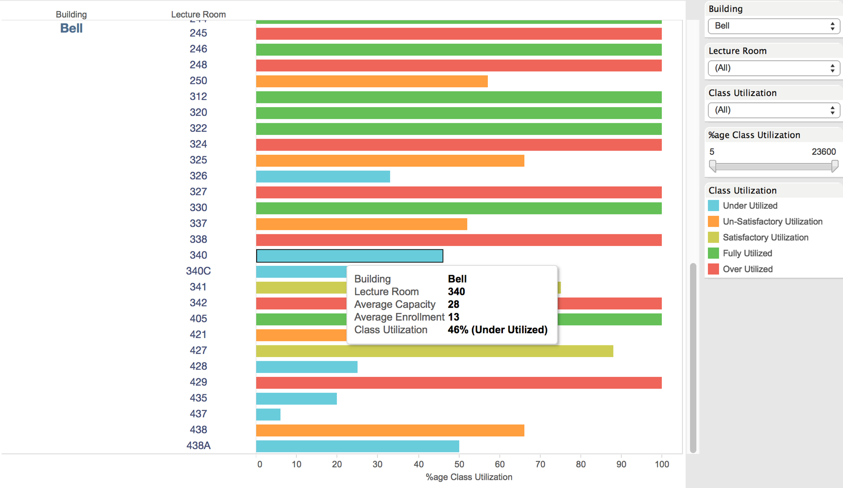

We can also filter out only under utilized lecture rooms and can see all the class rooms which have been remained under utilized over the years.

For example, the **Cooke 121** with **Class capacity of 121** have average **class enrollment as just 89**

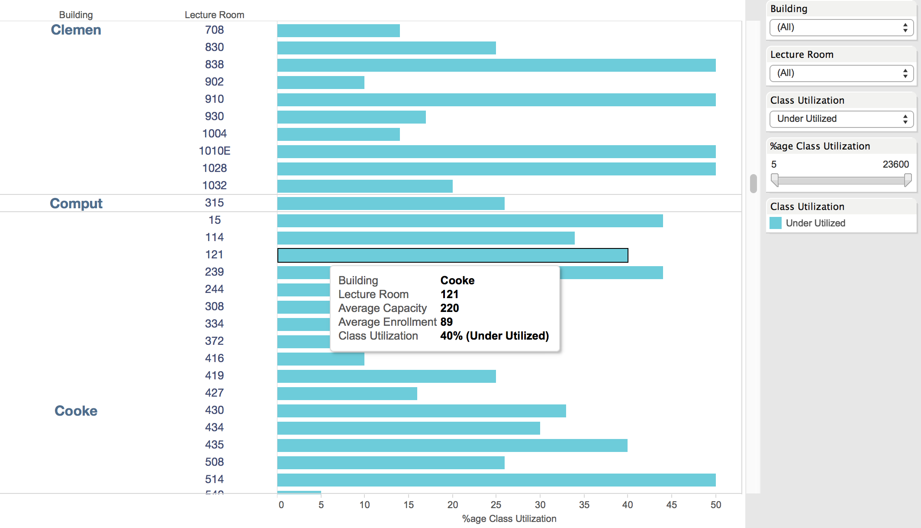

**Question 4: Lecture Time Analysis**

Class scheduling is very complex problem and its all the more difficult in a department where the enrollments are increasing. We have observed that some of the classes are small as compared to the number of students enrolled and vice versa. This not only make it difficult for the professor to deliver his/her lecture efficiently but also creates a bad image of us among international students.

Being a World Class University we do not want our students to fight for a seat during the class. Can you utilize the “UB Course Scheduling data” to provide an insight on what time of the day have remained most occupied with lectures during the years and what is the most suitable time to re-schedule these courses, so that we can allocate them class of proper size?

**Solution:**

**Tableau Link:**

<https://public.tableau.com/profile/publish/Q_4_LectureTime_Analysis/P2_Q4#!/publish-confirm>

Here we were trying to find out which time of the day have most scheduled classes and which time slots remained idle, so that we can solve the class scheduling problem.

The below graph is a simple representation same.

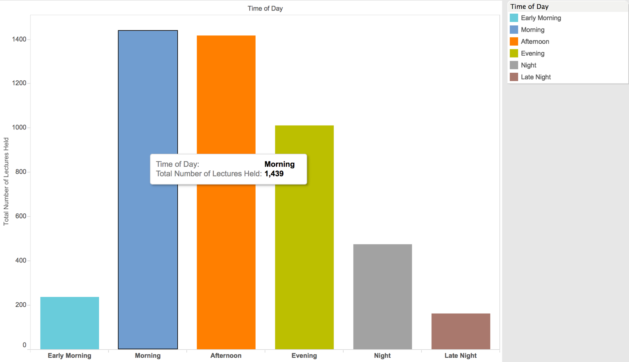

To analyze the idle time slots which took the approach of timeline filtering and analyzed number of classes scheduled for each time slot.

As the below graph depicts the **Time Slot 9:00 AM – 9:59 AM is the busiest time in UB**. This graph also tells the the number of lectures on each week day. The different colors are the different weeks of the day. Thus the colorful representation helps us easily figure out that there are less lectures scheduled on Wednesday.

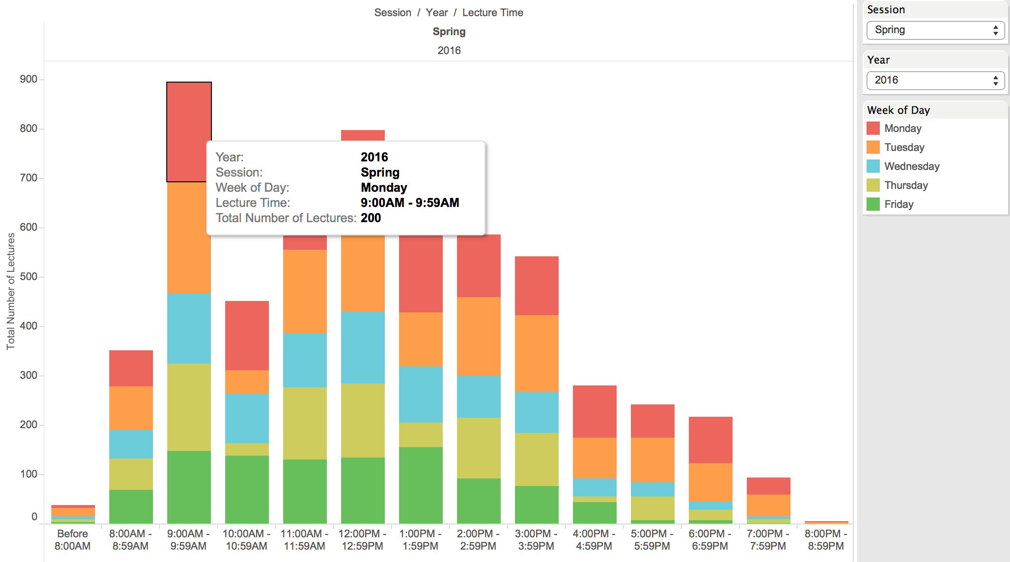

We can also filter out and see the number of lectures in a particular session or in a particular year

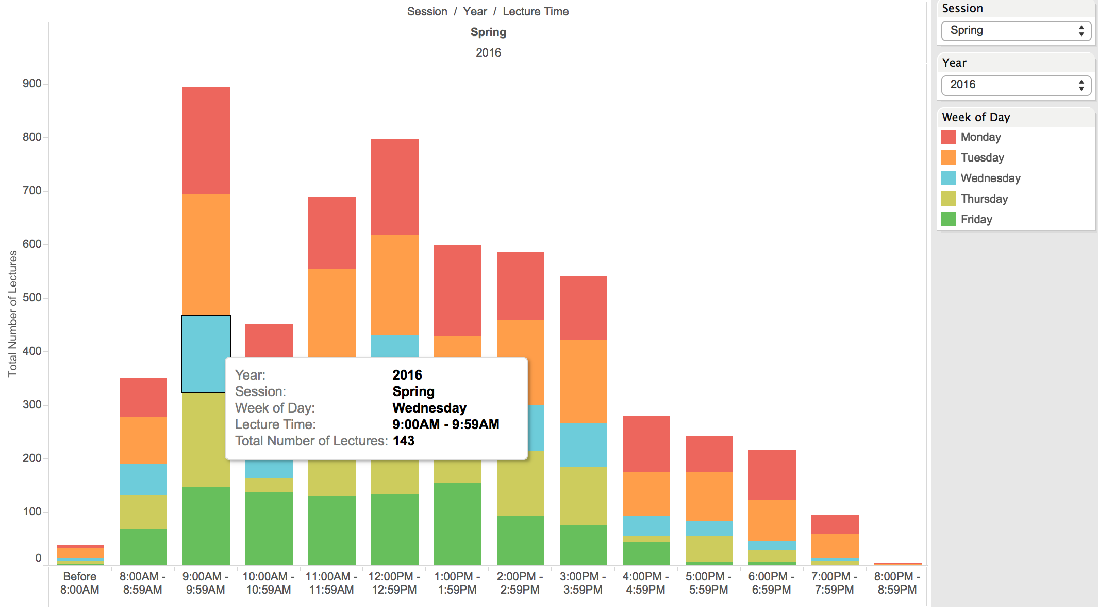

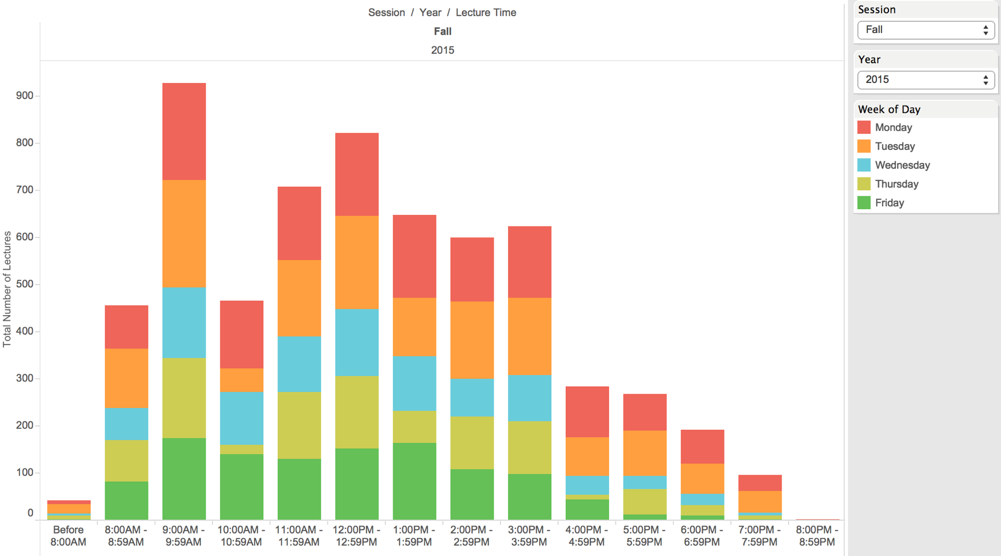

**Question 5: Find the most popular exam slots in every building**

Exam season is stressful for everyone. For the students and especially for the staff. They have to ensure classes are allotted and everyone finds their place. From the 6 years’ exam data that we have we aim to find the most popular exam slots in every building. By this data we can find out what time slot most exams are held. We can further analyze this data and make decisions to move some of the exams at this time slot to another. We can also make decisions to move them to other halls to.

**Solution:**

**Tableau Link:**

<https://public.tableau.com/profile/publish/Q_5_Popular_Exam_Slots/P2_Q5#!/publish-confirm>

We first tried to find out the lecture halls based on the number of exams being held. The below graph tells us that the NSC Department had the most scheduled exams.

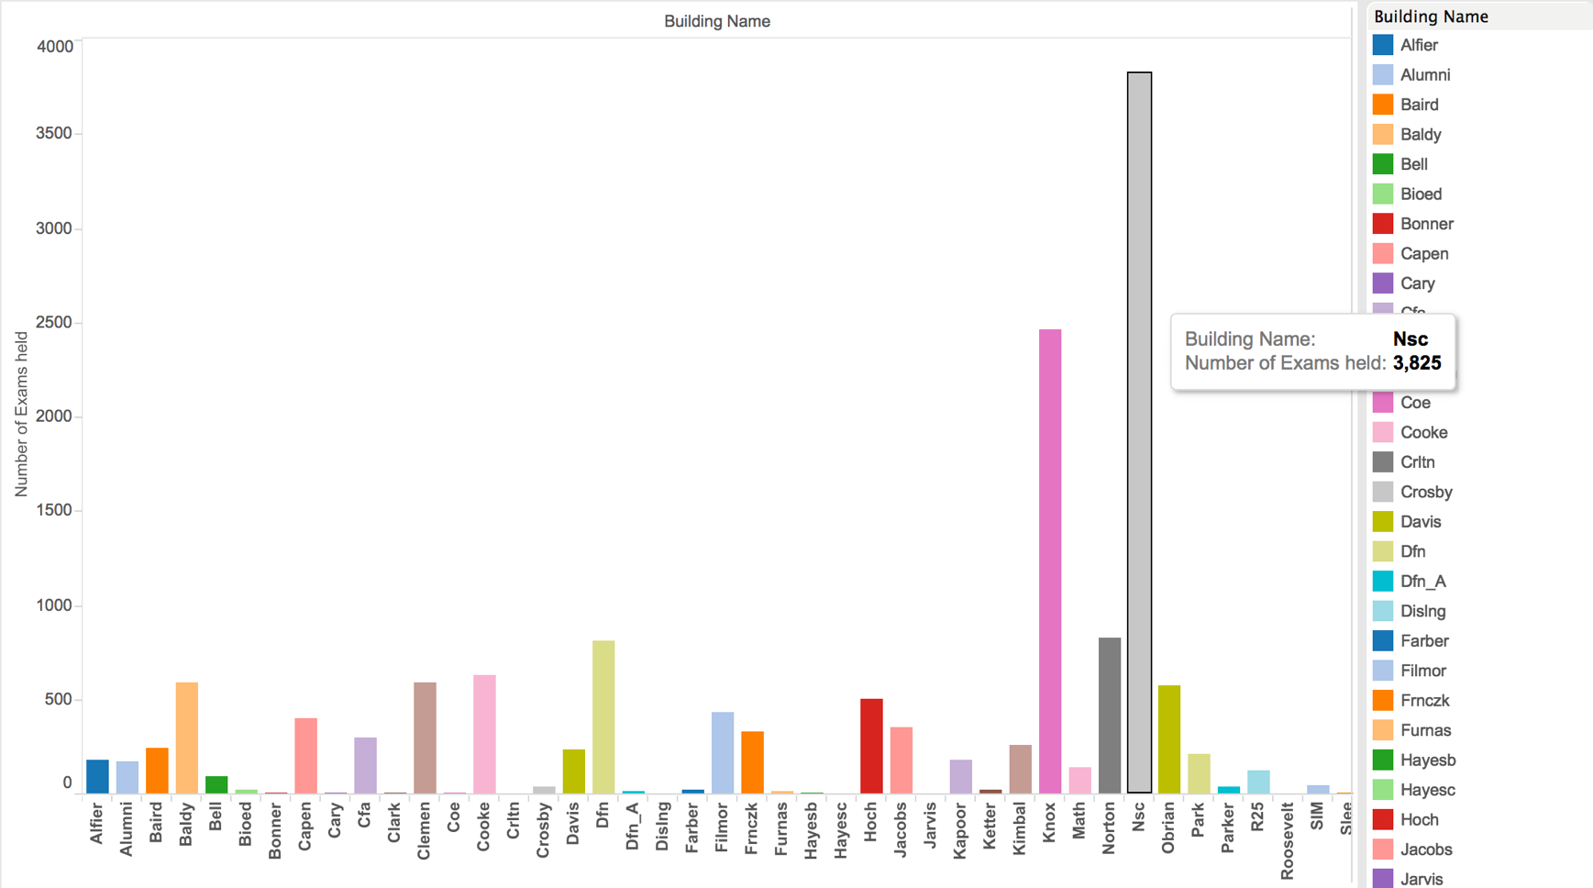

The various charts below give us a deep analysis on the exams slots with various filters.

