**1.8 MC Methods Summary**

[[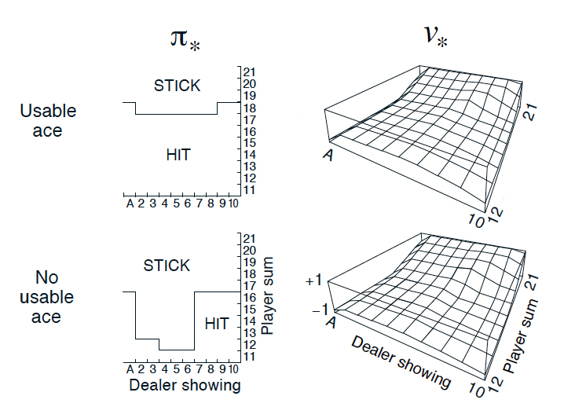](https://classroom.udacity.com/nanodegrees/nd893/parts/8f607726-757e-4ef5-8b64-f2368755b89a/modules/a85374fa-6a60-425b-a480-85b211c5bd5d/lessons/b1d9586f-1b1a-48f4-be1e-4c08a0912082/concepts/374c162d-29e0-413d-8578-d4199b5568c9)](https://classroom.udacity.com/nanodegrees/nd893/parts/8f607726-757e-4ef5-8b64-f2368755b89a/modules/a85374fa-6a60-425b-a480-85b211c5bd5d/lessons/b1d9586f-1b1a-48f4-be1e-4c08a0912082/concepts/374c162d-29e0-413d-8578-d4199b5568c9)

[Optimal Policy and State-Value Function in Blackjack (Sutton and Barto, 2017)](https://classroom.udacity.com/nanodegrees/nd893/parts/8f607726-757e-4ef5-8b64-f2368755b89a/modules/a85374fa-6a60-425b-a480-85b211c5bd5d/lessons/b1d9586f-1b1a-48f4-be1e-4c08a0912082/concepts/374c162d-29e0-413d-8578-d4199b5568c9)

**Monte Carlo Methods**

* Monte Carlo methods - even though the underlying problem involves a great degree of randomness, we can infer useful information that we can trust just by collecting a lot of samples.
* The **equiprobable random policy** is the stochastic policy where - from each state - the agent randomly selects from the set of available actions, and each action is selected with equal probability.

**MC Prediction**

* Algorithms that solve the **prediction problem** determine the value function *vπ*​ (or *qπ*​) corresponding to a policy *π*.
* When working with finite MDPs, we can estimate the action-value function  *qπ*​ corresponding to a policy *π* in a table known as a **Q-table**. This table has one row for each state and one column for each action. The entry in the *s*-th row and *a*-th column contains the agent's estimate for expected return that is likely to follow, if the agent starts in state *s*, selects action *a*, and then henceforth follows the policy *π*.
* Each occurrence of the state-action pair *s*,*a* (*s*∈S,*a*∈A) in an episode is called a **visit to***s*,*a*.
* There are two types of MC prediction methods (for estimating *qπ*​):
  + **First-visit MC** estimates *qπ*​(*s*,*a*) as the average of the returns following *only first* visits to *s*,*a* (that is, it ignores returns that are associated to later visits).
  + **Every-visit MC** estimates *qπ*​(*s*,*a*) as the average of the returns following *all* visits to *s*,*a*.

**Greedy Policies**

* A policy is **greedy** with respect to an action-value function estimate *Q* if for every state *s*∈S, it is guaranteed to select an action *a*∈A(*s*) such that *a*=argmax*a*∈A(*s*)​*Q*(*s*,*a*). (It is common to refer to the selected action as the **greedy action**.)
* In the case of a finite MDP, the action-value function estimate is represented in a Q-table. Then, to get the greedy action(s), for each row in the table, we need only select the action (or actions) corresponding to the column(s) that maximize the row.

**Epsilon-Greedy Policies**

* A policy is *ϵ***-greedy** with respect to an action-value function estimate *Q* if for every state *s*∈S,
  + - with probability 1−*ϵ*, the agent selects the greedy action, and
    - with probability *ϵ*, the agent selects an action *uniformly* at random from the set of available (non-greedy **AND** greedy) actions.

**MC Control**

* Algorithms designed to solve the **control problem** determine the optimal policy *π*∗​ from interaction with the environment.
* The **Monte Carlo control method** uses alternating rounds of policy evaluation and improvement to recover the optimal policy.

**Exploration vs. Exploitation**

* All reinforcement learning agents face the **Exploration-Exploitation Dilemma**, where they must find a way to balance the drive to behave optimally based on their current knowledge (**exploitation**) and the need to acquire knowledge to attain better judgment (**exploration**).
* In order for MC control to converge to the optimal policy, the **Greedy in the Limit with Infinite Exploration (GLIE)** conditions must be met:
  + every state-action pair *s*,*a* (for all *s*∈S and *a*∈A(*s*)) is visited infinitely many times, and
  + the policy converges to a policy that is greedy with respect to the action-value function estimate *Q*.

**Incremental Mean**

* (In this concept, we amended the policy evaluation step to update the Q-table after every episode of interaction.)

**Constant-alpha**

* (In this concept, we derived the algorithm for **constant-***α***MC control**, which uses a constant step-size parameter *α*.)
* The step-size parameter *α* must satisfy 0<*α*≤1. Higher values of *α* will result in faster learning, but values of *α* that are too high can prevent MC control from converging to *π*∗​.