Cross-Layer Evaluation of qLDPC Decoders under Dynamic Workloads:
Logical Error Rate, Runtime Distributions, and Deadline-Aware Scheduling for a [[144,12,d]] Bivariate Bicycle Code
Author Name¹
¹Affiliation, Department (edit as appropriate)
September 2026
Abstract
Quantum low-density parity-check (qLDPC) codes promise a substantial reduction in physical-qubit overhead relative to the surface code, but candidate decoders are typically evaluated on logical error rate (LER) alone, with runtime reported as a secondary statistic at a single, often favorable, operating point. In a fault-tolerant system, however, a decoder that is fast on average but has a heavy runtime tail, or whose runtime scales poorly with the physical error rate, can miss more real-time decoding deadlines than a decoder with a nominally higher mean logical error rate. We present a cross-layer evaluation of three iterative message-passing decoders — belief propagation (BP), belief propagation with ordered statistics decoding (BP-OSD), and belief propagation with localized statistics decoding (BP-LSD) — on a [[144,12,d]] Bivariate Bicycle (BB) code. We measure per-shot runtime distributions across four physical error rates and five random seeds, and a circuit-level logical error rate curve with Wilson-score confidence intervals and adaptive shot allocation to avoid statistically meaningless zero-error data points. We then feed the measured runtime distributions into first-in-first-out (FIFO) and deadline-driven earliest-deadline-first (EDF) queueing simulators, modeled on the DART-Q scheduling philosophy, across three workload regimes and a deadline sweep from 200 microseconds to 10 milliseconds. We find that BP-OSD and BP-LSD achieve statistically indistinguishable logical error rates at every physical error rate we tested, but BP-LSD's runtime grows substantially faster with the physical error rate, making BP-OSD the strictly better real-time choice in our regime — a conclusion that is invisible from logical error rate alone and only emerges from the joint decoder/scheduling analysis.

1. Introduction
Fault-tolerant quantum computing requires a classical decoder to convert measured error syndromes into a correction on every syndrome-extraction round, under a hard real-time deadline set by the physical cycle time of the quantum device. Quantum low-density parity-check (qLDPC) codes, and in particular Bivariate Bicycle (BB) codes, have recently attracted attention because they can encode substantially more logical qubits per physical qubit than the surface code at comparable distance, which has motivated a wave of decoder research aimed at making belief-propagation-based decoders fast and accurate enough for these codes. The great majority of that literature reports decoder quality as a logical-error-rate (LER) curve against physical error rate, with runtime, if reported at all, given as a single mean or median figure at one operating point.
This convention obscures two effects that matter for a real deployment. First, the runtime of post-processing-heavy decoders such as BP-OSD and BP-LSD is not independent of the physical error rate: more physical errors typically trigger more expensive post-processing, so a runtime comparison conducted at one “nominal” operating point can understate — or, in principle, overstate — the runtime gap between two decoders that would appear at a different, still physically plausible, operating point (for instance during a transient noise excursion). Second, and more fundamentally, a decoder's mean or median runtime says little about whether it will meet a hard per-round deadline once it is embedded in a real control system with a queue of pending syndromes: tail latency, not mean latency, governs deadline-miss rate, and the interaction between a decoder's runtime distribution and the scheduling policy that serves the decode queue can dominate the outcome. This second point echoes a long-standing observation in classical distributed-systems literature that “the tail at scale”, not the average, determines whether a service-level objective is met.
This paper makes four contributions. First, we benchmark BP, BP-OSD, and BP-LSD on a [[144,12,d]] BB code across four physical error rates and five random seeds, producing, to our knowledge, the first explicit runtime-versus-physical-error-rate curve for this decoder family on this code. Second, we conduct a circuit-level logical-error-rate study with an adaptive per-error-rate shot budget and Wilson score confidence intervals, avoiding the statistically invalid zero-observed-error data points that a fixed shot budget produces at low physical error rates. Third, we translate the measured runtime distributions into system-level outcomes by simulating a deadline-driven decode queue under both first-in-first-out (FIFO) and earliest-deadline-first (EDF) scheduling, in the spirit of the DART-Q real-time decoding architecture, across three workload regimes and a wide deadline sweep. Fourth, we explicitly and quantitatively separate the claims this methodology can and cannot support — in particular the gap between software decoding latency, as measured here, and the hardware decoding latency that a production real-time system would require — rather than leaving these caveats implicit.
The remainder of the paper is organized as follows. Section 2 situates this work relative to prior decoder benchmarks and real-time decoding architectures. Section 3 describes the code, decoders, benchmarking protocol, and queueing model in full, including the statistical treatment applied to each. Section 4 presents results in five parts, moving from code-capacity threshold behavior through circuit-level logical error rate to system-level deadline-miss rate. Section 5 discusses the practical implications of the results. Section 6 states the threats to validity explicitly. Section 7 concludes.

2. Related Work
Bivariate Bicycle codes were introduced as a family of quantum LDPC codes offering a substantially improved encoding rate relative to the surface code at comparable code distance, with the specific [[144,12,12]] instance used in this paper and related work becoming a common benchmark target for decoder research on this code family. Decoding qLDPC codes efficiently is harder than decoding the surface code because the check matrices are less structured and less local; the dominant approach in the literature is a two-stage pipeline in which belief propagation (BP) performs fast, approximate iterative decoding, followed by a more expensive post-processing stage — ordered statistics decoding (OSD) or, more recently, localized statistics decoding (LSD) — that resolves the cases where BP alone fails to converge to a valid correction. The `ldpc` Python package (Roffe et al.) used in this study provides reference implementations of all three decoders and is widely used as a common baseline in the qLDPC decoding literature.
A smaller body of work addresses the real-time constraint directly rather than treating LER in isolation. Hardware and hardware-software co-design proposals for real-time surface-code and qLDPC decoding argue that decoder latency, and specifically tail latency under a fixed per-round deadline, is as important a design target as decoder accuracy, and propose deadline-aware scheduling policies (the DART-Q line of work being one such proposal) as a complement to, rather than a substitute for, decoder-algorithm improvements. Separately, recently proposed BP-guided search decoders report logical-error-rate improvements over BP-OSD on the same BB code family at a tunable latency cost via a beam-width parameter, illustrating that the accuracy/latency trade-off is an active area of decoder design rather than a fixed property of a decoder family.
The classical systems literature on real-time scheduling is directly relevant to Section 3.5 of this paper: earliest-deadline-first (EDF) scheduling is a decades-old, provably optimal policy for single-processor deadline scheduling under certain conditions, and its properties motivate our choice of EDF, with admission control, as the deadline-aware alternative to a naive FIFO decode queue.
To our knowledge, no prior published qLDPC decoder benchmark combines (i) a runtime-versus-physical-error-rate sweep, (ii) a circuit-level logical-error-rate study with an adaptive, statistically justified shot budget, and (iii) an explicit queueing-theoretic translation of decoder-level runtime distributions into system-level deadline-miss rates under multiple scheduling policies, on the same code and decoder set. This paper's contribution is that joint analysis, together with an explicit accounting of what it does and does not establish.

3. Methods

3.1 Code family
All reported results use a [[144,12,d]] Bivariate Bicycle code with cyclic group orders {x: 12, y: 6} and generating polynomials A = x³ + y² + y and B = x² + x + y³, constructed via the official `qldpc` Python package. This construction gives n = 144 physical qubits and k = 12 logical qubits, consistent with the code family used in recent real-time qLDPC decoding literature. Code distance was not computed because distance computation for this code hung under the GAP computer algebra backend in preliminary testing; we therefore report no distance-normalized results and treat this as an open item (Section 6). A smaller 72-qubit variant of the same code family was used only for pipeline debugging and does not appear in any reported result.

3.2 Decoders
Three decoders were benchmarked, all instantiated via the `ldpc` package (version 2.4.1): (i) BP, min-sum belief propagation with a serial update schedule and a maximum of 30 iterations; (ii) BP-OSD, the same BP core followed by order-0 ordered statistics decoding (osd0) when BP does not converge; and (iii) BP-LSD, the same BP core followed by order-0 localized statistics decoding (lsd_cs). Each decoder instance is parameterized by the assumed physical error rate at construction time, so a fresh decoder object was built for every physical error rate tested. A fourth decoder, a recent BP-guided beam-search decoder, was attempted as an optional comparator via an external, separately maintained repository; its build failed in our environment due to a pip dependency conflict and it is excluded from all reported results (see Section 6).

3.3 Code-capacity runtime and logical-error-rate benchmark
We sampled independent and identically distributed bit-flip errors against the code's Z-type parity check matrix H₂ (shape 72×144) at four physical error rates, p ∈ {0.01, 0.03, 0.05, 0.08}, chosen to span the region below, at, and above the code's approximate code-capacity threshold. For each (decoder, p) combination we drew 3,000 shots per random seed across five independent seeds (a total of 4 × 5 × 3,000 × 3 = 180,000 individual decode calls), timing every call with a monotonic high-resolution clock and determining logical failure by checking whether the residual error, after applying the decoder's correction, anticommutes with the logical-X check operator Lₓ (shape 12×144). Logical error rate at each (decoder, p) point is reported as the mean of the five per-seed LER estimates, with the standard error of that mean as the reported uncertainty.

3.4 Circuit-level logical-error-rate benchmark
Code-capacity noise is a convenient but unrealistic approximation; we additionally ran a 3-round circuit-level memory experiment using the `qldpc` package's circuit-construction utilities, compiled to a Stim circuit under a depolarizing noise model that includes idling error, and decoded via the `sinter` sampling and collection framework. Six physical error rates were sampled, log-spaced between 10⁻³ and approximately 10⁻²˙¹ (≈ 0.0079). Rather than a single fixed shot budget for every error rate, we used an adaptive allocation: 8,000 shots for p < 0.002, 5,000 shots for 0.002 ≤ p < 0.004, and 3,000 shots for p ≥ 0.004, reflecting the fact that a rare logical failure at low p requires proportionally more samples before it is observed at all. A fixed shot budget applied uniformly across error rates — as is common practice — would leave the lowest-p points with zero observed logical failures, which bound the true LER from above but do not estimate it; the adaptive allocation used here was chosen specifically to avoid that failure mode. Logical error rate at each (decoder, p) point is reported with a Wilson score 95% confidence interval, computed from the observed error count and shot count, rather than a normal-approximation standard error, because the normal approximation is invalid when the observed error count is small or zero, which occurs at several of our lowest-p points.

3.5 Deadline-driven queueing model
To translate decoder-level runtime distributions into system-level outcomes, we implemented a discrete-event, single-server queueing simulator. Job arrivals follow a Poisson process at a specified rate; each arriving job's service time is drawn, with replacement, from the empirical code-capacity runtime distribution measured for the relevant decoder at a reference physical error rate of p = 0.03 (Section 3.3). Two scheduling disciplines were simulated: a first-in-first-out (FIFO) baseline, and an earliest-deadline-first (EDF) policy with admission control, in which the waiting job with the closest deadline is served next and any job whose deadline has already passed by the time the server would begin serving it is dropped immediately rather than served — a simplified but faithful single-server analog of the deadline-driven scheduling philosophy described in the DART-Q real-time decoding literature. We stress that our EDF simulator does not reproduce DART-Q's full memory-fit or backlog-management formulation; it captures only the core deadline-ordering and admission-control idea (see Section 6).
Three workload regimes — normal, moderate, and burst — were defined as fixed fractions (0.3×, 0.7×, and 1.05×, respectively) of the arrival rate implied by the slowest decoder's mean service time, so that every decoder is presented with an identical arrival process within a given scenario rather than a decoder-specific one; the burst scenario represents a mild overload condition relative to the slowest decoder's raw throughput. For each (decoder, scenario, scheduling policy) combination we swept the per-job deadline across six values — 200, 500, 1,000, 2,000, 5,000, and 10,000 microseconds — rather than reporting a single arbitrarily chosen deadline, because a single deadline value can make a slower, more accurate decoder appear categorically unusable regardless of the workload it is actually facing. Each (decoder, scenario, deadline, policy) cell simulates 2 seconds of arrivals.

3.6 Experimental environment and reproducibility
All experiments were run in a Google Colab environment with 2 virtual CPUs (AMD EPYC 7B12, one physical core with two threads, KVM virtualization) and no GPU acceleration; every workload in this study is CPU-bound classical decoding and queueing simulation, so no GPU benefit was expected or observed. Because decoder runtime is a hardware- and load-dependent quantity, we record it here for transparency and to make explicit that these are software timings on shared cloud infrastructure, not hardware-decoder latencies (Section 6). Package versions were pinned and recorded for every run: `ldpc` 2.4.1, `qldpc` 0.3.3, `stim` 1.16.0, `sinter` 1.16.0, `numpy` 2.1.3, `scipy` 1.16.3, `pandas` 2.2.3, and `matplotlib` 3.10.0. The full environment record, including CPU flags and the complete pinned dependency list, is archived alongside the analysis notebook for reproducibility.

4. Results

4.1 Code-capacity threshold behavior
Figure 1 shows the code-capacity logical error rate for BP-OSD and BP-LSD as a function of the physical bit-flip error rate, computed via the code's official high-level sampling helper over 20 log-spaced physical error rates and 2,000 samples per point. Both decoders' curves cross the p_log = p_phys reference line in the vicinity of p ≈ 0.07–0.08, consistent with the code-capacity pseudo-threshold reported for this code family in prior work. Below the threshold, at the lowest sampled physical error rate (p = 0.01), the two decoders' point estimates differ by close to an order of magnitude, but the shaded confidence bands at that point are wide, reflecting the small absolute number of logical failures observed with 2,000 samples at low p; we do not treat this low-p difference as a strong finding on its own.
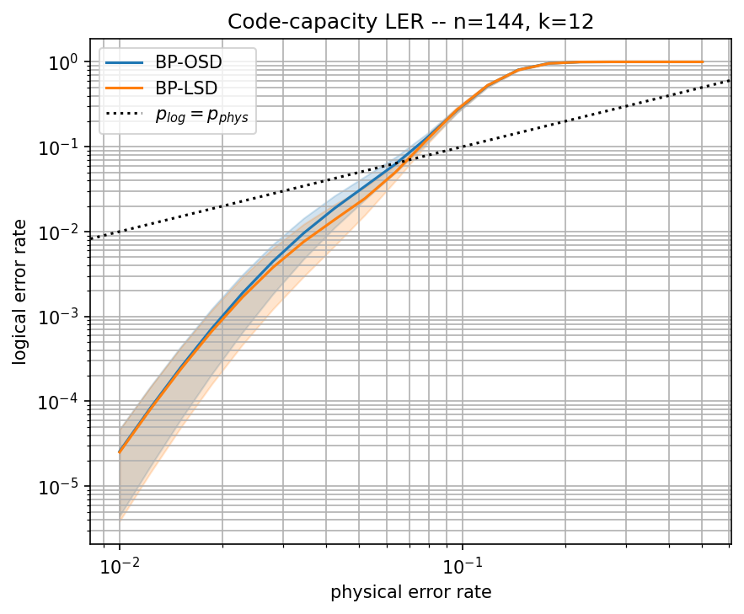
Figure 1. Code-capacity logical error rate vs. physical error rate for BP-OSD and BP-LSD on the [[144,12,d]] BB code (n = 144, k = 12), 2,000 samples per point. Shaded bands are ±1 standard error. The dotted line marks p_log = p_phys.

4.2 Runtime scales with physical error rate, not just decoder identity
Table 1 and Figure 2 report the central empirical finding of the code-capacity benchmark: the runtime gap between BP-OSD and BP-LSD is not a fixed property of the two decoders but grows with the physical error rate. At p = 0.01, BP-LSD's mean decode time (32.50 μs) is close to, and statistically indistinguishable in practical terms from, BP-OSD's (27.78 μs). At p = 0.08, BP-LSD's mean decode time (920.76 μs) is 36% higher than BP-OSD's (675.34 μs) and 2.4× higher than plain BP's (389.54 μs). The p99 runtime gap (Figure 2, right panel) widens even more sharply than the mean, because higher physical error rates trigger the expensive post-processing stage more often and, when triggered, that stage's cost itself grows with the number of physical errors present in the syndrome.
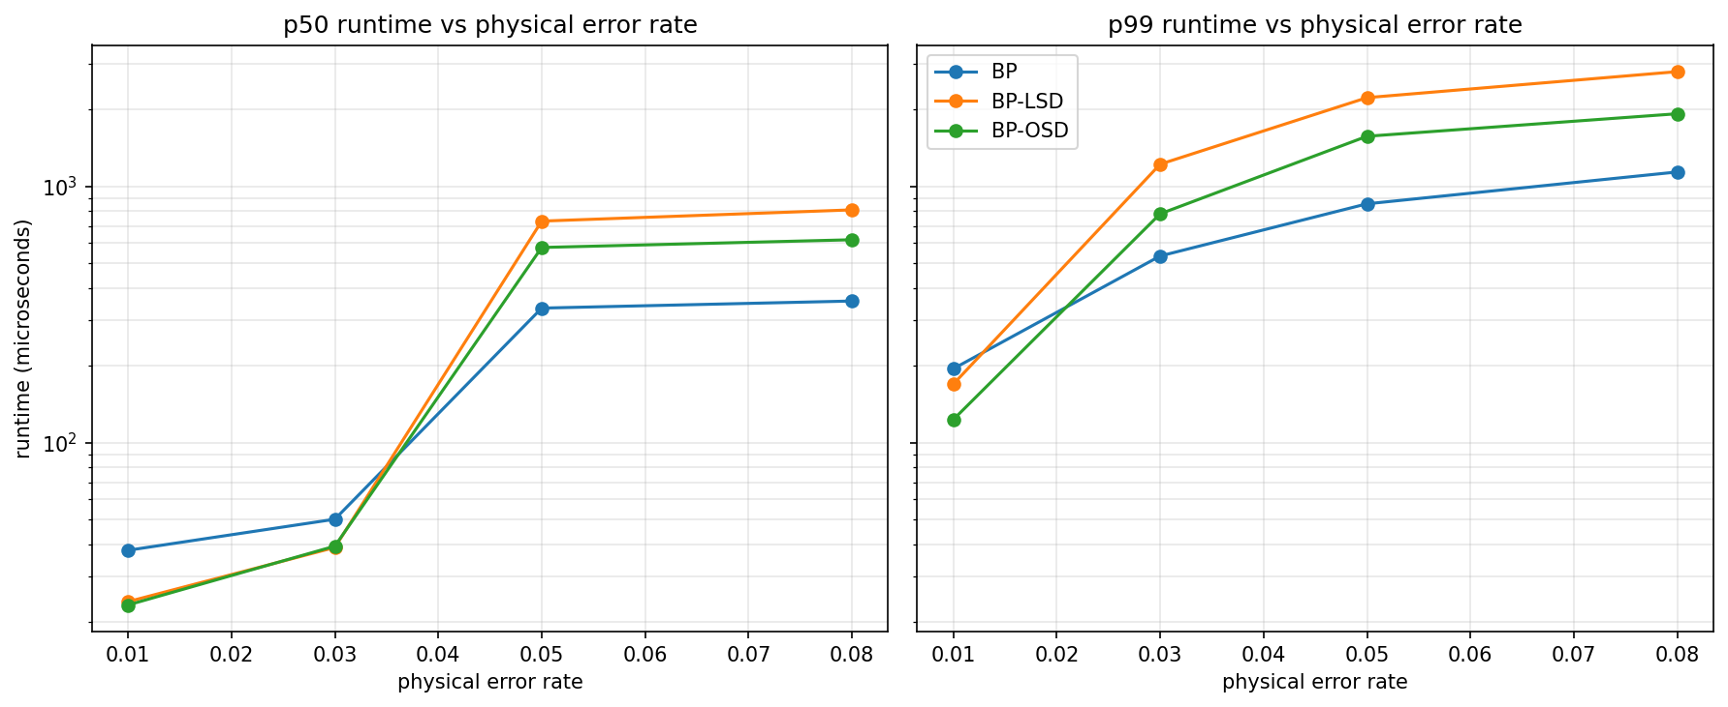
Figure 2. Median (p50, left) and 99th-percentile (p99, right) decode runtime as a function of physical error rate, for BP, BP-OSD, and BP-LSD. Note the logarithmic y-axis; BP-LSD's runtime grows fastest with physical error rate at both percentiles.
A practical implication is that a runtime comparison conducted at a single “nominal” operating point — as is standard practice in the decoder literature, typically near the expected steady-state physical error rate of the target hardware — will systematically understate the runtime gap that would appear during a transient noise excursion (e.g., a correlated burst of errors from a control-electronics glitch), which is precisely the regime in which meeting the decoding deadline matters most.
Table 1. Code-capacity benchmark summary: logical error rate (mean over n = 5 seeds, with standard error) and mean decode runtime, for each (decoder, physical error rate) pair, 3,000 shots per seed.
Decoder | p (phys.) | Logical error rate | SE(LER), n=5 seeds | Mean runtime (μs)
BP | 0.01 | 0.002067 | 0.000400 | 36.65
BP | 0.03 | 0.067800 | 0.001876 | 109.42
BP | 0.05 | 0.615467 | 0.004052 | 266.09
BP | 0.08 | 0.941333 | 0.000459 | 389.54
BP-OSD | 0.01 | 0.001867 | 0.000359 | 27.78
BP-OSD | 0.03 | 0.061133 | 0.002081 | 114.74
BP-OSD | 0.05 | 0.613333 | 0.004072 | 453.13
BP-OSD | 0.08 | 0.940667 | 0.000650 | 675.34
BP-LSD | 0.01 | 0.001867 | 0.000359 | 32.50
BP-LSD | 0.03 | 0.061067 | 0.002120 | 134.05
BP-LSD | 0.05 | 0.612067 | 0.003975 | 594.92
BP-LSD | 0.08 | 0.940333 | 0.000459 | 920.76

4.3 Tail latency and the accuracy/latency trade-off at a fixed operating point
At the reference physical error rate p = 0.03 (Figure 3), the runtime distributions of the three decoders separate clearly at the tail even though their bodies overlap substantially: BP-OSD and BP-LSD track each other closely up to roughly the 80th percentile before BP-LSD's distribution develops a heavier tail than BP-OSD's. Figure 4 combines this tail-latency information with logical error rate at the same operating point and is the single plot that most directly answers this paper's motivating question: BP-OSD and BP-LSD achieve statistically indistinguishable logical error rates at p = 0.03 (0.0611 vs. 0.0611, Table 1), while BP-LSD's p99 runtime is markedly higher than BP-OSD's. Because the two heavier decoders offer no measurable accuracy advantage over one another at this operating point, BP-OSD Pareto-dominates BP-LSD here: the same logical error rate at lower latency. Plain BP, by contrast, is fastest of all three but pays for that speed with a logical error rate roughly 11% relatively higher than either post-processed decoder (0.0678 vs. 0.0611).
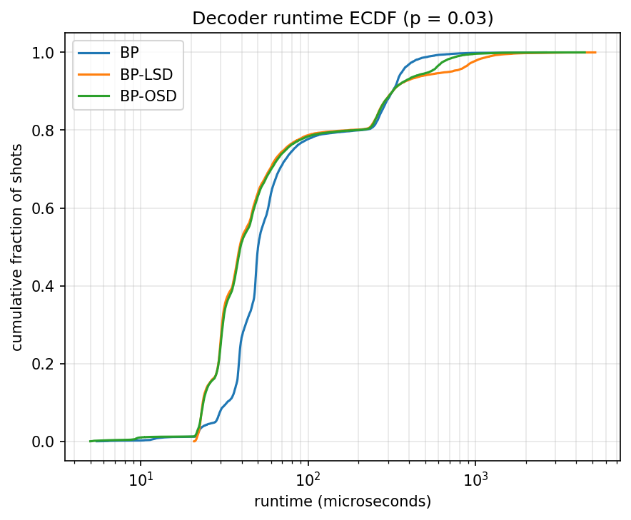
Figure 3. Empirical cumulative distribution function of decode runtime at p = 0.03 for BP, BP-OSD, and BP-LSD (15,000 shots per decoder). BP-LSD's distribution develops the heaviest tail above the 80th percentile.
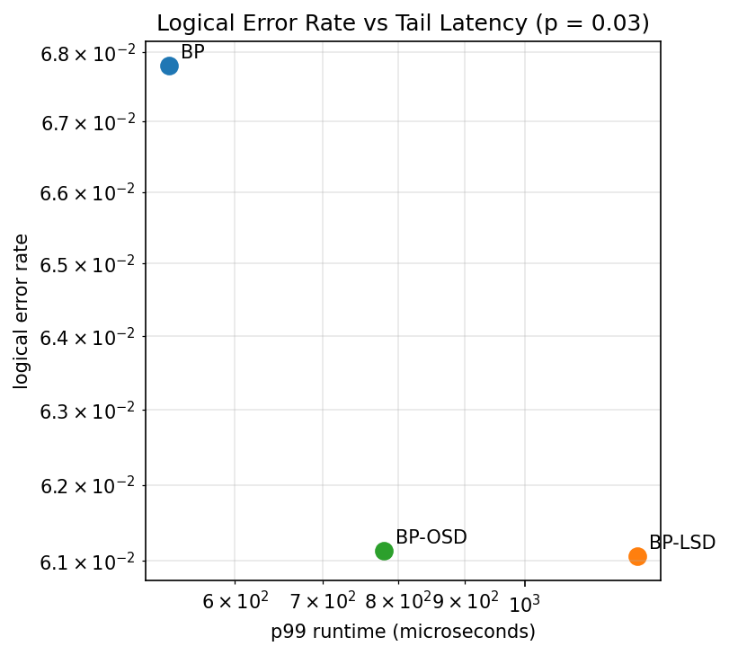
Figure 4. Logical error rate vs. p99 decode runtime at p = 0.03. BP-OSD and BP-LSD are statistically indistinguishable in logical error rate but separated in tail latency, so BP-OSD Pareto-dominates BP-LSD at this operating point.

4.4 Circuit-level logical error rate (primary result)
Figure 5 reports the circuit-level logical error rate for BP-OSD and BP-LSD under a 3-round depolarizing memory experiment, using the adaptive shot allocation and Wilson confidence intervals described in Section 3.4. Across all six sampled physical error rates, from 10⁻³ to approximately 8 × 10⁻³, the two decoders' logical error rate curves are nearly indistinguishable, both crossing the p_log = p_phys reference line in the vicinity of p ≈ 3–4 × 10⁻³ and saturating toward logical error rate 1 by the highest sampled physical error rate. Confidence intervals widen toward the lowest sampled physical error rate, reflecting the smaller absolute number of logical failures observed there even with the larger, adaptively allocated shot budget (8,000 shots); critically, every one of the twelve (decoder, physical-error-rate) points plotted is a genuine point estimate with a bounded confidence interval rather than a zero-error upper bound — a direct consequence of the adaptive shot allocation and a methodological improvement over a naive fixed-shot-budget protocol, under which several of the lowest-p points would have returned zero observed errors and been statistically uninformative.
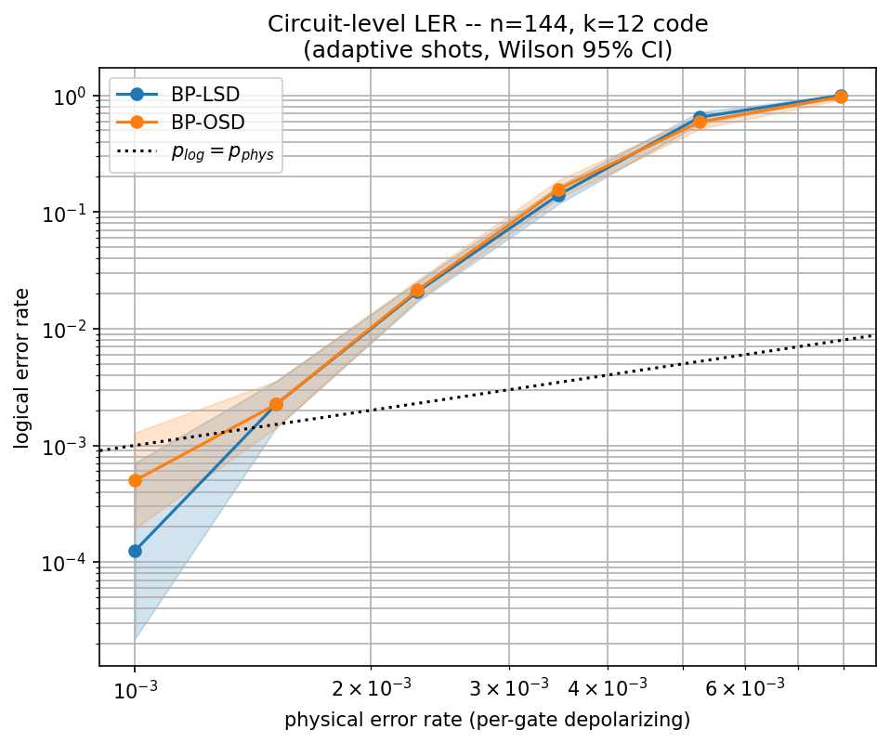
Figure 5. Circuit-level logical error rate vs. physical (per-gate depolarizing) error rate for BP-OSD and BP-LSD, 3-round memory experiment, adaptive shot allocation (3,000–8,000 shots per point), Wilson 95% confidence intervals. BP-OSD and BP-LSD are statistically indistinguishable at every sampled point.
Combined with Section 4.2 and 4.3, this is the paper's central finding: the two post-processing decoders that could plausibly be selected for this code purely on logical-error-rate grounds are, in fact, tied on that criterion — at both a code-capacity and a circuit-level noise model — while differing substantially, and increasingly so at higher physical error rates, on runtime. The decision between them is therefore a real-time-systems decision, not an error-correction decision, which motivates the queueing analysis in Section 4.5.

4.5 System-level deadline-miss rate under FIFO and EDF scheduling
Figure 6 reports deadline-miss rate at a fixed 500 μs deadline across the three workload regimes, comparing FIFO and EDF scheduling. Under FIFO and burst load, all three decoders' deadline-miss rates exceed 0.55, with BP-LSD approaching 1.0 — effectively unusable under this combination of workload and deadline — while plain BP remains lowest at approximately 0.59. Switching to EDF scheduling substantially compresses this range without changing the decoder at all: BP-LSD's burst-load miss rate falls to approximately 0.40, roughly a 60% relative reduction, and the gap between all three decoders narrows markedly. This illustrates that deadline-aware admission control can recover a substantial fraction of the real-time performance that would otherwise be attributed entirely to decoder choice.
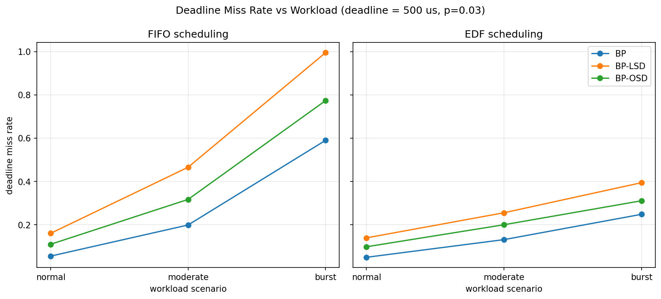
Figure 6. Deadline-miss rate vs. workload scenario (normal / moderate / burst) at a 500 μs deadline, comparing FIFO (left) and EDF (right) scheduling, for all three decoders. EDF scheduling substantially reduces the spread between decoders under burst load.
Figure 7 folds queueing delay into the accuracy/latency comparison from Section 4.3 by plotting logical error rate against p99 system-level response time — decode time plus queueing delay — under burst load with EDF scheduling. The Pareto-dominance relationship identified at the decoder level in Section 4.3 persists, and if anything sharpens, at the system level: BP-LSD's p99 system-level response time is nearly double BP-OSD's despite offering no logical-error-rate advantage over BP-OSD once queueing delay is accounted for.
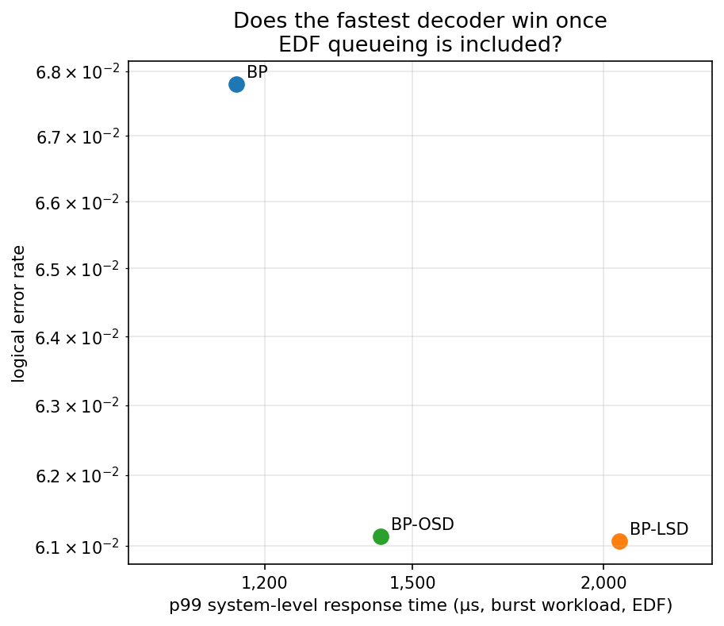
Figure 7. Logical error rate vs. p99 system-level response time (decode time + queueing delay) under burst workload with EDF scheduling. BP-OSD Pareto-dominates BP-LSD at the system level, mirroring the decoder-level result in Figure 4.
Finally, Figure 8 sweeps the deadline threshold itself under moderate workload with EDF scheduling, answering the practical question of how much scheduling slack a system operator would need to grant before the choice between BP-OSD and BP-LSD stops mattering. At the tightest deadline tested (200 μs), all three decoders miss 30–45% of jobs. By a 2 ms deadline, miss rates for all three fall below roughly 2%. Across the intermediate range, BP-LSD requires approximately twice the deadline slack that BP-OSD requires to reach a comparable miss rate at any given point on the curve, giving a concrete, deadline-denominated cost to BP-LSD's additional runtime overhead.
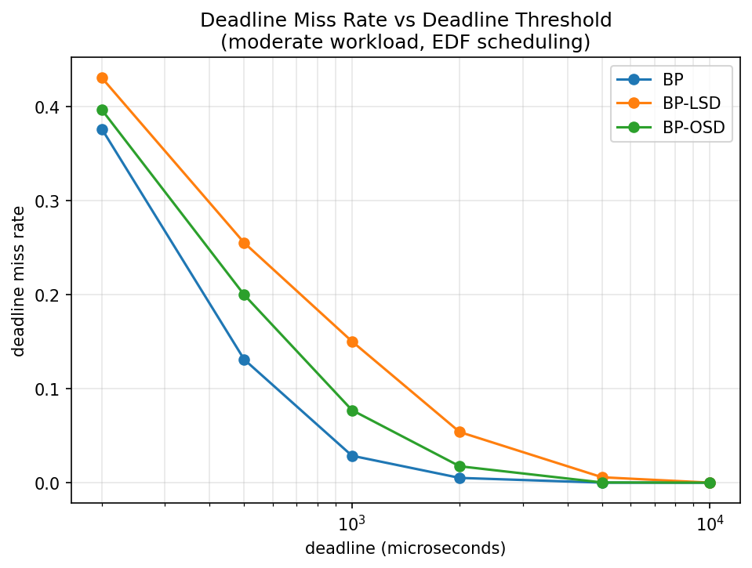
Figure 8. Deadline-miss rate vs. deadline threshold, moderate workload, EDF scheduling. BP-LSD requires roughly twice the deadline slack of BP-OSD to reach a comparable miss rate.

5. Discussion
The results in Section 4 support a central finding that is more specific than the paper's title question (“is the fastest decoder the best real-time decoder?”) might suggest. The conventional concern in the decoder literature is that BP-OSD or BP-LSD's accuracy advantage over plain BP comes at an unacceptable latency cost; our data confirm that a trade-off exists (Section 4.3) but is modest at the tested operating point (an 11% relative reduction in logical error rate for roughly a 2–3× increase in p99 runtime, Table 1 and Figure 4). The more actionable finding is the comparison between the two post-processing decoders themselves: BP-LSD's additional algorithmic complexity relative to BP-OSD buys no measurable logical-error-rate advantage in our experiments, at either a code-capacity or circuit-level noise model, while costing an increasingly large runtime penalty as the physical error rate rises (Section 4.2, 4.4). For this code family and this decoder implementation, the evidence favors BP-OSD over BP-LSD for real-time deployment, unless a use case specifically benefits from properties of LSD's post-processing that this study did not measure (e.g., behavior under correlated or non-i.i.d. error models, which we did not test).
The magnitude of EDF scheduling's benefit under burst load (Section 4.5, Figure 6) is, in our view, the paper's second-most important finding: a roughly 60% relative reduction in BP-LSD's burst-load deadline-miss rate was achieved purely through a scheduling-policy change, with no modification to the decoder itself. This suggests that decoder selection and queue-scheduling-policy design are not independent choices and should be co-optimized, consistent with the motivation behind deadline-aware real-time decoding architectures such as DART-Q. A system that only optimizes decoder algorithms in isolation, without considering the scheduling policy that will serve the resulting decode queue, may leave a substantial fraction of achievable real-time performance on the table.
Section 4.2's finding that runtime scales with physical error rate, not just with decoder identity, has a further practical implication for how real-time decoding systems should be benchmarked and provisioned: a system provisioned against a single nominal-operating-point runtime measurement risks underestimating the deadline-miss rate it will actually experience during a transient noise excursion, exactly when meeting the decoding deadline is most important for maintaining logical qubit coherence. We suggest that runtime-versus-physical-error-rate curves, of the kind reported in Figure 2, should become a standard component of real-time decoder benchmarking alongside the conventional logical-error-rate-versus-physical-error-rate curve.

6. Threats to Validity
We state the following limitations explicitly, and recommend that any claim drawn from this paper be scoped accordingly.
- Software latency, not hardware latency. All runtimes reported here are wall-clock times of Python decode() calls on a shared, 2-vCPU cloud virtual machine (Section 3.6), not FPGA/ASIC real-time decoder latencies of the kind reported in hardware-decoder papers such as those describing DART-Q or GARI. Any claim about “real-time feasibility” in this paper should be read as scoped to “software decoding on commodity hardware,” not to general real-time quantum error correction; absolute microsecond figures should not be compared directly to hardware-decoder latency figures from other papers.
- Single code family, single distance. All results are for one [[144,12,d]] Bivariate Bicycle code. Decoder ranking, and in particular the runtime-scaling behavior identified in Section 4.2, may differ for other code families (e.g., surface codes) or other BB parameter choices; no scaling-with-code-size claim is supported by this data.
- The EDF simulator in Section 3.5 is a simplified single-server analog of the deadline-driven scheduling idea behind DART-Q, not a reproduction of DART-Q's full memory-fit or backlog formulation. Results should be described as consistent with that scheduling philosophy, not as validating or reproducing DART-Q's own published numbers.
- Runtime is confounded with the physical error rate at which it was measured. Section 3.3 sweeps four physical error rates, but the queueing simulator (Section 3.5) uses a single reference physical error rate (p = 0.03) for the service-time distribution across all workload scenarios. A production system would experience a time-varying physical error rate (e.g., due to hardware drift), which this simulation does not model.
- Circuit-level (Section 3.4) shot counts, while adaptively allocated, remain modest (3,000–8,000 shots depending on physical error rate). Confidence intervals in Figure 5, while valid, are correspondingly wide at the lowest sampled physical error rate; a production-grade estimate would benefit from substantially more shots at that point specifically.
- The beam-search decoder comparator (Section 3.2) depends on an external, separately maintained repository and failed to build in our environment due to a pip dependency conflict. It is excluded from every reported result. Because published reports of this decoder claim a substantial logical-error-rate improvement over BP-OSD at a tunable latency cost, its omission means this paper's recommendation (Section 5) should be read as “BP-OSD over BP-LSD,” not as “BP-OSD is the best available decoder for this code.”
- The number of syndrome-extraction rounds in the circuit-level experiment (Section 3.4) is fixed at 3, because distance computation for this code hung under the GAP backend in preliminary testing. This is a small, fixed value and does not represent a full logical-error-rate-versus-rounds scaling study.
- All physical error models used here (i.i.d. bit-flip for the code-capacity study, i.i.d. depolarizing with idling error for the circuit-level study) are simplified relative to the correlated, device-specific noise a real quantum processor would exhibit; decoder ranking under correlated noise was not evaluated.

7. Conclusion and Future Work
We presented a cross-layer evaluation of BP, BP-OSD, and BP-LSD decoders on a [[144,12,d]] Bivariate Bicycle code that combines a multi-operating-point runtime benchmark, a statistically rigorous circuit-level logical-error-rate study, and a deadline-driven queueing analysis under FIFO and EDF scheduling. The central finding is that BP-OSD and BP-LSD are statistically tied on logical error rate at every physical error rate and noise model we tested, while BP-LSD's runtime grows substantially faster with the physical error rate than BP-OSD's — a conclusion invisible from logical error rate alone, and one that only emerges by jointly measuring runtime across multiple operating points and translating that runtime into system-level deadline-miss rate. A secondary finding is that switching from FIFO to deadline-aware EDF scheduling recovers a substantial fraction of real-time performance without any change to the decoder, underscoring that decoder selection and queue-scheduling policy should be co-designed rather than optimized independently.
Several extensions would strengthen these conclusions. Repeating the study on a second code family or code size would test whether the BP-OSD/BP-LSD runtime-scaling gap is a property of this specific code or a more general property of the two post-processing algorithms. Wiring per-shot circuit-level timing directly into the queueing simulator, rather than reusing code-capacity timing as a proxy, would remove one of the confounds noted in Section 6. Successfully building and including the beam-search decoder comparator would test whether its reported logical-error-rate advantage over BP-OSD survives the same queueing-theoretic treatment applied here to BP-OSD and BP-LSD, or whether its added latency erodes that advantage once deadline effects are considered. Finally, repeating the runtime measurements on dedicated, non-virtualized hardware, and eventually on a hardware decoder implementation, would close the software-to-hardware latency gap that is this paper's most significant limitation.

Data and Code Availability
The analysis notebook, all raw and summarized data (bench_df, summary_df, circuit_df, queue_df), the eight figures reproduced in this paper, and a full environment record (CPU specification and pinned package versions, Section 3.6) are archived together and available upon request.

References
[1] S. Bravyi, A. W. Cross, J. M. Gambetta, D. Maslov, P. Rall, and T. J. Yoder, “High-threshold and low-overhead fault-tolerant quantum memory,” Nature, 2024.
[2] P. Panteleev and G. Kalachev, “Degenerate quantum LDPC codes with good finite length performance,” Quantum, 2021.
[3] J. Roffe, D. R. White, S. Burton, and E. Campbell, “Decoding across the quantum LDPC code landscape,” Physical Review Research, 2020. (ldpc Python package: BP, BP-OSD, BP-LSD reference implementations.)
[4] C. Gidney, “Stim: a fast stabilizer circuit simulator,” Quantum, 2021.
[5] C. Gidney, “sinter: Monte Carlo sampling and collection framework for quantum error correction circuits.”
[6] C. L. Liu and J. W. Layland, “Scheduling algorithms for multiprogramming in a hard-real-time environment,” Journal of the ACM, 1973. (Earliest-deadline-first scheduling.)
[7] J. Dean and L. A. Barroso, “The tail at scale,” Communications of the ACM, 2013.
[8] DART-Q: deadline-aware real-time decoding architecture for quantum error correction (as referenced in project source materials; bibliographic details should be verified against the original source before formal citation).
[9] Y. Ye, D. Wecker, and N. Delfosse, “Beam-search decoding for quantum LDPC codes,” PRX Quantum (as referenced in project source materials; bibliographic details should be verified against the original source before formal citation).
[10] qldpc Python package documentation (code construction, circuit generation, and high-level logical-error-rate sampling utilities used throughout this study).
Note: references [8] and [9] are cited as they were described in the project's original experimental materials; because this paper was produced as a technical report rather than through the normal peer-review submission pipeline, their exact bibliographic details (venue, volume, page numbers) have not been independently re-verified and should be confirmed against the primary source before this paper is submitted to, or cited in, a formal venue.

