One time setup (requires about 25 gb of space):

1. Download and install VMWARE Workstation Player 12.5.7 from: <https://my.vmware.com/en/web/vmware/free#desktop_end_user_computing/vmware_workstation_player/12_0|PLAYER-1257|product_downloads>
2. Download the virtual machine from the link: <https://1drv.ms/u/s!AtFFi00i_k5kl8EMOT0TmA5s5jqVLg>
3. Unzip the virtual machine into any folder of your choice
4. Open the vmware player and select player -> file -> open
5. Go to the folder into which the files were extracted. Select the “Ubuntu” file.
6. Double click the “Ubuntu” virtual machine that was just added to the list.
7. In the message that appears select “I copied it”
8. If a message appears asking about a virtual device, select “No”

Step by step search process (note: if asked about upgrading VMWARE tools, dismiss the message):

1. Open vmware player and double click the Ubuntu Virtual Machine
2. When asked for a password, enter HeinzCollege$1
3. Click on the Ubuntu icon (upper left corner).
4. Type “Terminal”
5. Select the terminal icon.
6. Type the following commands:  
   cd vpn  
   sh ./connect.sh
7. When asked for a password in the console, type the same password above.
8. Wait until the last message in the terminal says “Initialization Sequence Completed”
9. If instead of the message above you see something saying “connection timed out” and it repeats several times, type control+c and run the second command in step 6 again, until you get a successful connection. Leave the terminal window open.
10. Open Firefox.
11. Enter the website [www.iplocation.net](http://www.iplocation.net) and find the current state and city shown in the webpage. It should look like this:

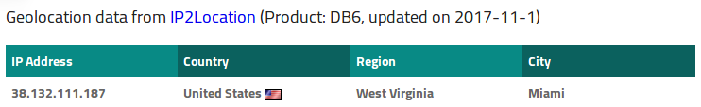

1. In a separate firefox window inside the virtual machine, open the shared google docs spreadsheet <https://docs.google.com/spreadsheets/d/1hJG2cGAIjs53-fjmo-1BmTbfb2POQ9kST-4HI4KrlM8/edit#gid=0> and select the tab with your name.
2. Enter the state and city in the first two columns in the google spreadsheet in a new row.
3. Clear cookies (Menu icon in the top right -> preferences -> privacy and security -> clear your recent history), making sure that the tame range to clear is “Everything and that all the items are selected in the “details” section.
4. Close preferences and go to [www.google.com](http://www.google.com)
5. Search for the product you have assigned.
6. Save the results webpage as html in the default folder with the default name.
7. In the following page you will see sponsored and organic results. Here is a classification of the results you will see:

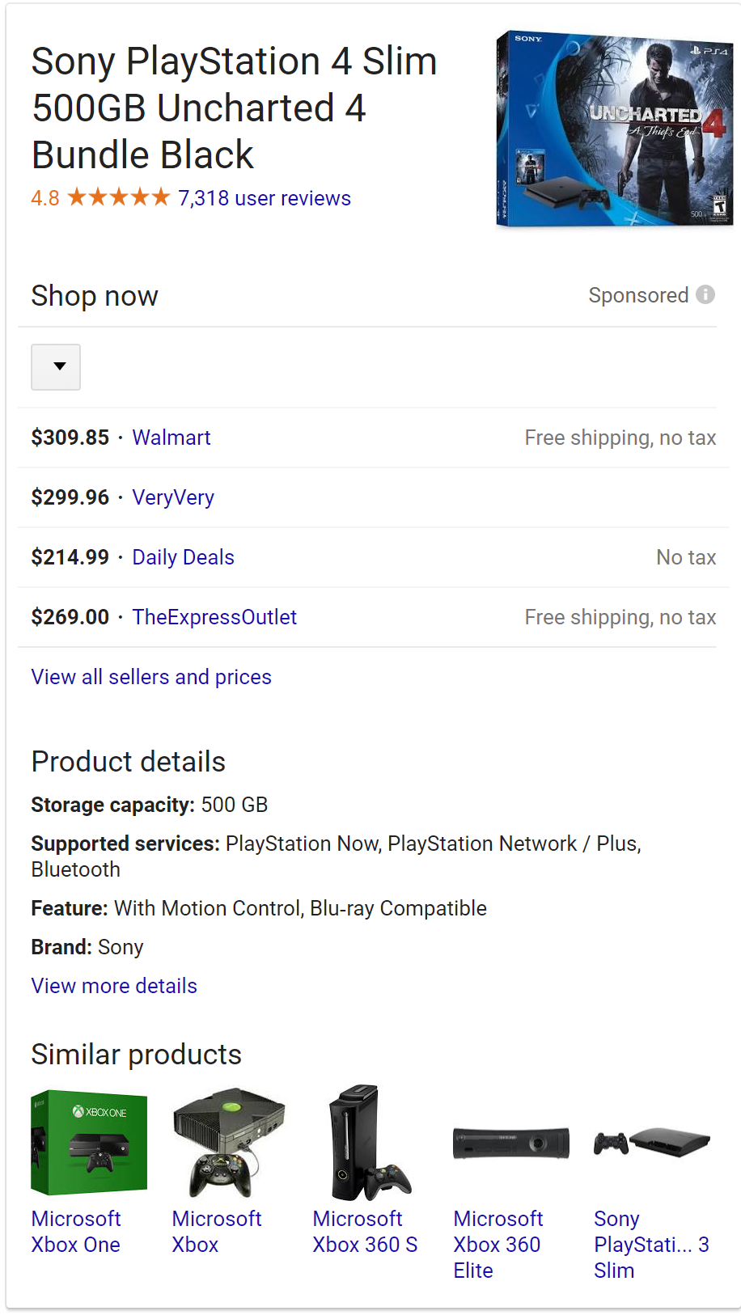

This is called a “sidebar”. It is shown usually on the right side of the screen and shows a vertical list of vendors. For a single product. When you click on it, sometimes it leads to another page. If that is the case, ignore the other page. When clicking on it extends the sidebar to show more vendors without changing the page, then keep it extended.

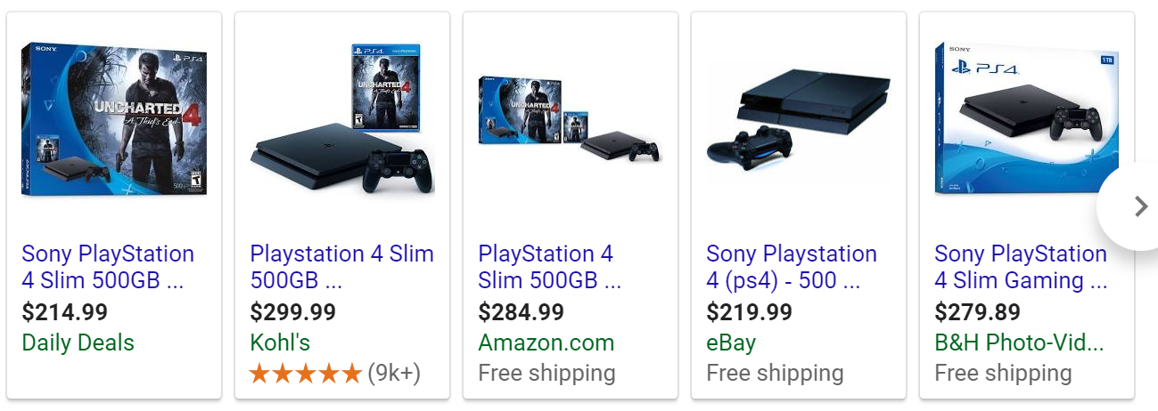

This strip shows tiles of several vendors side by side. It appears on the top or bottom of the page. If it is on the top, we call it a “top tile”. If it is on the right, we call it a “bottom tile”

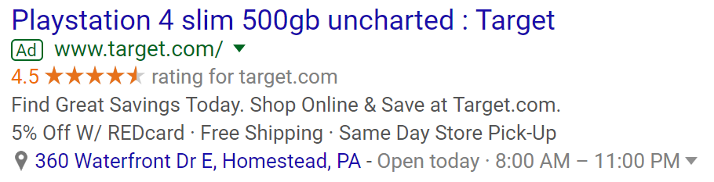

This is a “sponsored result”. It shows along organic results but with an “Ad” indicator. If it appears on the top of the page, it is a “top sponsored result”. If it appears on the bottom of the page, it is a “bottom sponsored result”.

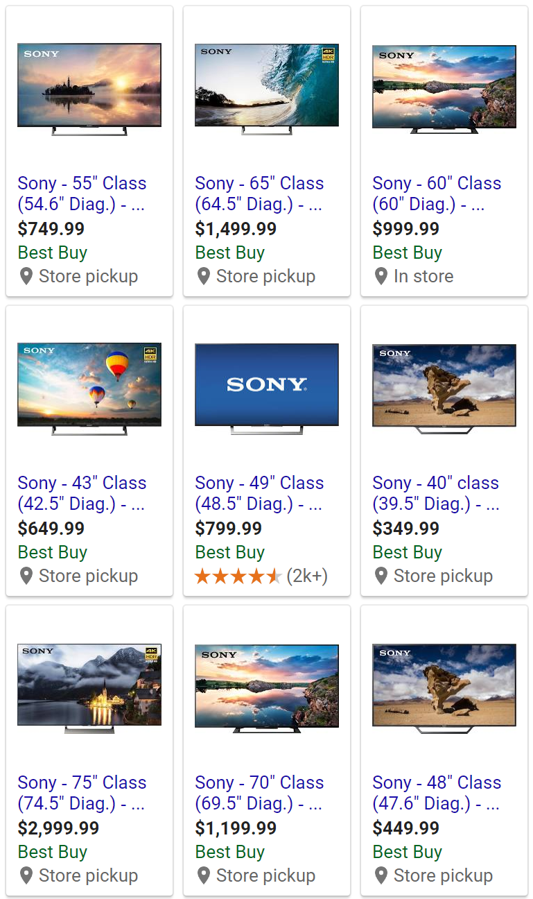

This is a “side tile” it appears on the right side of the page. When this appears, we go through it from left to right first and then from top to bottom. The order would be Top left, top middle, top right, middle left, center, middle right, bottom left, bottom middle, bottom right.

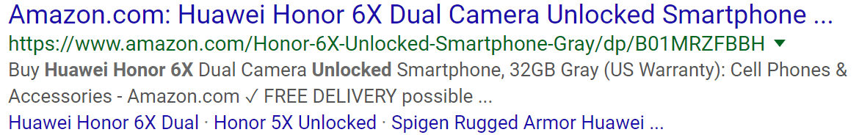

This type of result is called “Organic”. Notice there is no “ad” indicator.

1. Go through the results in the following order (if they are present):
   1. Side bar / Side tile
   2. Top tile
   3. Top sponsored result
   4. Organic search results.
   5. Bottom sponsored result.
   6. Bottom tile.
2. For each result, going in precise order, you need to do the following:
   1. Click on the link.
   2. Obtain the following information and type it in the corresponding column of the spreadsheet, one row for each website, starting from the row where you typed state and city:
      1. Datetime: Date and time. To do this quickly, simply select the appropriate cell in the “datetime column” and press ctrl+atl+shift+;
      2. Search term: what was typed in the google search box.
      3. Website: name of the website. (for example: Amazon)
      4. Vendor: name of the vendor. Some websites have a 3rd party vendor system, and you should note when the vendor is different from the website. If the vendor is the same as the website, write the website name again in this column. Here is an example in which the website would be “Amazon” and the vendor “ANLI(TM)”. 
      5. Price: The list price of the product.
      6. Shipping: any shipping cost available to the product. If it takes more than five clicks to find out (for example, you might need to add it to cart and start the check-out process, which is two or three clicks), type N/A. Do not create accounts on websites to find out this info.
      7. $ to free shipping: If the website requires a minimum amount for free shipping type it here. If you cannot find it out in less than three clicks, type N/A. If it offers free shipping without a minimum, type 0.
      8. Other costs: If the website mentions any costs that are not SHIPPING or TAXES, type the value here. If you cannot find it out in less than five clicks, leave it blank.
      9. Result is consistent. If the result you are looking at has the exact same product (model, specs, amount, color) as most of the results for your search string, type Y. Otherwise type N and add details in the comments column (for example: product is red instead of gray).
      10. Page number. The number of the results page we are looking at. As we are only considering the first two results pages, it should be either 1 or 2.
      11. Type of result: indicate the classification that corresponds to this link according to what was shown above: sidebar, sidetile, top tile, bottom tile, top sponsored result, bottom sponsored result or organic.
      12. Comments: anything that might be of note that is not covered by the other columns.
3. During your search, keep mindful of the following possible things that might occur:
   1. If the website is not an actual seller but links to another website that sells the model we are looking for, note the website in the “website” column,  the actual seller in the “seller” column, and add a comment indicating “referral website” and take the price that appears in the actual
   2. If it has more than one link that sells the model, take the cheapest one (usually the cheapest one is also the most prominent) and add a comment indication “referral website, multiple links”
   3. If the website is a vendor but is a product listing that has the model we are looking for among others, get the information from that model shown on the listing. If it shows it more than once, take the cheapest alternative.
   4. If it is a vendor, it is a product listing but does not have the actual model, add NA to all the price related fields, N in the consistent field, and add a comment mentioning “product listing, does not show the actual model”
   5. If it is the main page of a vendor that does not show the actual product, do the same as above but mention “main page, does not show actual model” in the comment field.
   6. If it is a website that sells something unrelated to the model are searching for or is not even , do the same as above with the comment “unrelated website”.
   7. If it is a review video or review page that does not sell the product, do as above and mention in the comments: “review”
   8. If it is a pinterest or similar site that has some sort of information on the product like photos, but is not a review, comment: “not a vendor”
   9. If there is something that is not contemplated in the list above that you encounter, describe it in the comments. If there is no product being sold, always put NA in all the price related fields. If there is a single product being sold, add the price but if it is not the actual model always put N in the consistency and put “different model”, ”different color”, or any other difference you find in the comments. If there is more than one product shown, only add price information if the actual model we are searching for is there, and if the model appears more than once, take the cheapest one, and note in the comments that there were multiple options available.
4. When going to page 2 of the results, save the HTML page again, using the default name. If it is the same as the name of the page 1 results, add a 2 at the end of the name.
5. After typing the results of the first two pages of results, copy the region and state that were typed in the first row and copy to the rest of the rows.
6. If there are still more products to search for, close firefox, go back to the terminal window and type ctrl+c. Retype the second command in step 6 and repeat steps 7-21. Otherwise, finish.