**Project Documentation**

**Introduction:** My project name is Billing System it is provides a simple way to generating the bill receipt for particular store or small organization where limited items are buying and selling. In this project the java technology used with mysql basically the mysql used for login and register reason because different stores use your different information. In this project we need two select the item which are buying by the customer and fill the quantity of items after that click on the calculate button so automatically this application adding the CGST and SGST taxes and after that if any offers regarding price so it reduced the cost and finally it is generate the bill now this bill we can print after entering the user details like user name and mobile number. In future we are implementing the one feature is that when user enter the user name and mobile name then explicitly what ever the amount are generated this this amount user can pay online the link of payment is send to customer and customer pay the amount these way like internet banking, Debit Card or UPI after that the detail of payment is store on server because in future if customer wants to check their detail so check. For the confirmation of the amount which are automatically generated if oner think that something is wrong here so it is calculate the amount with the help of the calculator that is present in UI.

**Software Requirements:**

* Windows 7 or higher
* My Sql 5.6
* Netbeans 8.2
* WAMP Server

**Hardware Components**

* Processor – i3
* Hard Disk – 5 GB
* Memory – 1GB RAM

**Technology Used**

* Java
* MySql

**UI of billing system**

User interface of the this application is provided the interface to user that make the billing of any customer and some basic information is needed when user going to making the bill like name and mobile number. here not need to customer login only user of the software can be log

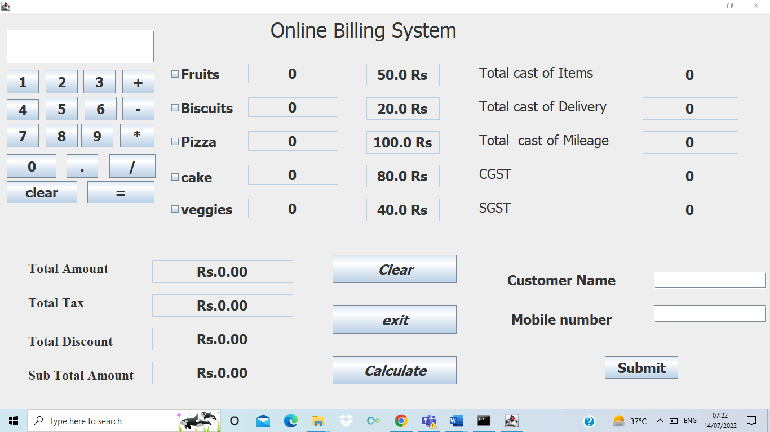

After entering the quantity of items click on calculate for generating the bill receipt.

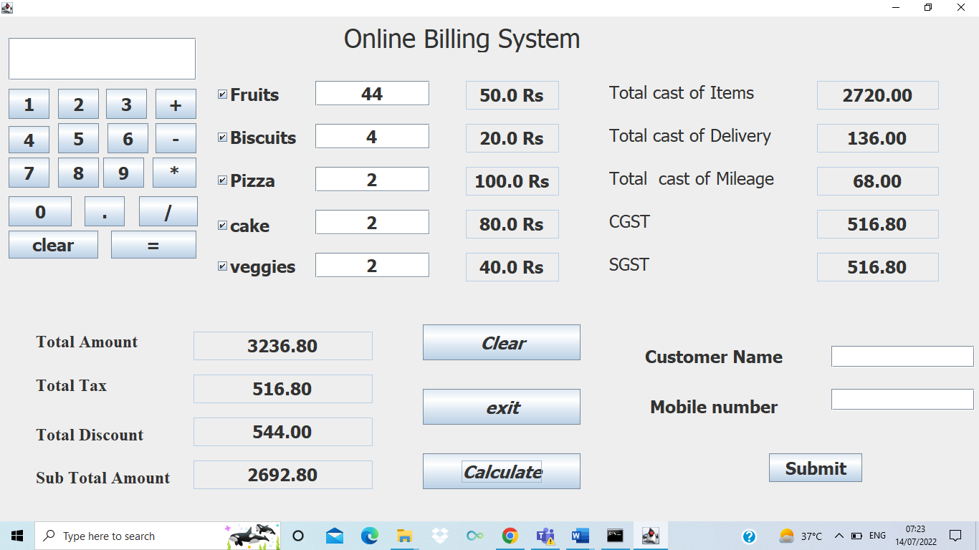

**Register Page**

When anyone want to use this particular application in your organization or store then he is firstly register yourself according to your personal and business detail.

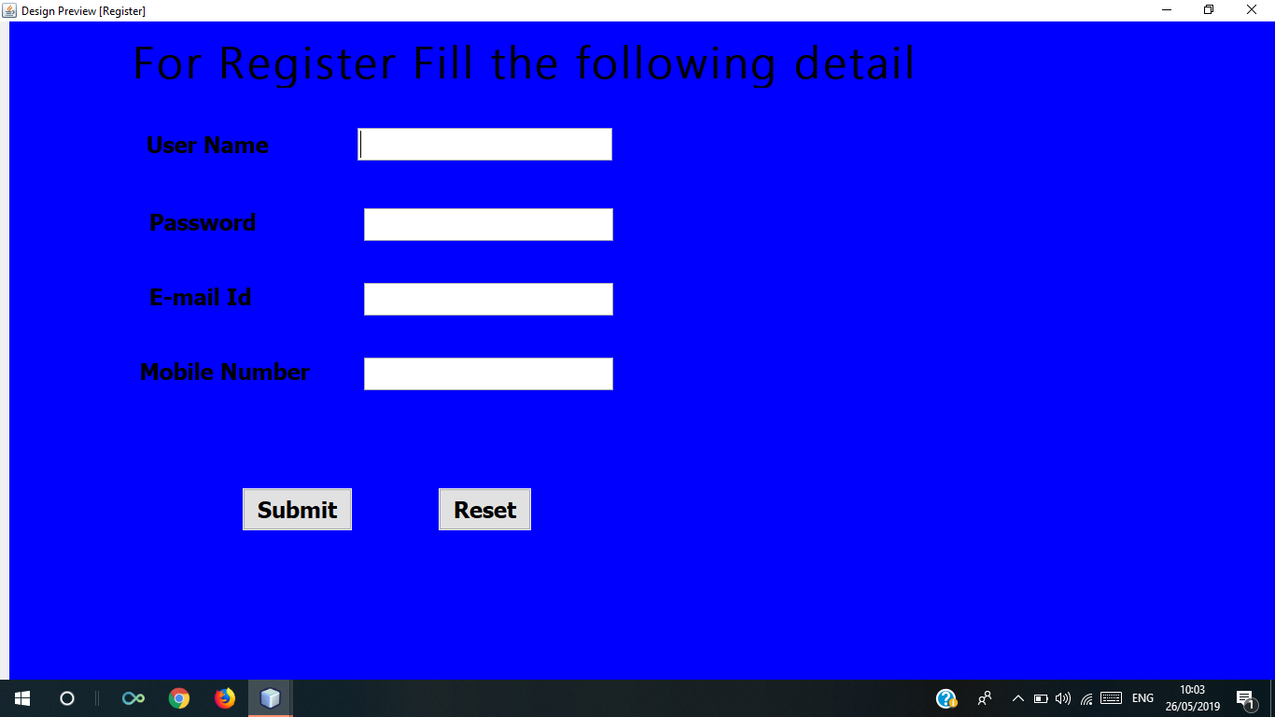

After the entering the user name, Password, Email Id, and Mobile number the store owner are registered and now he can able to use this application.

**Login Page**

Owner need not be register more than one time after registering one time

They can simply login and use the application.

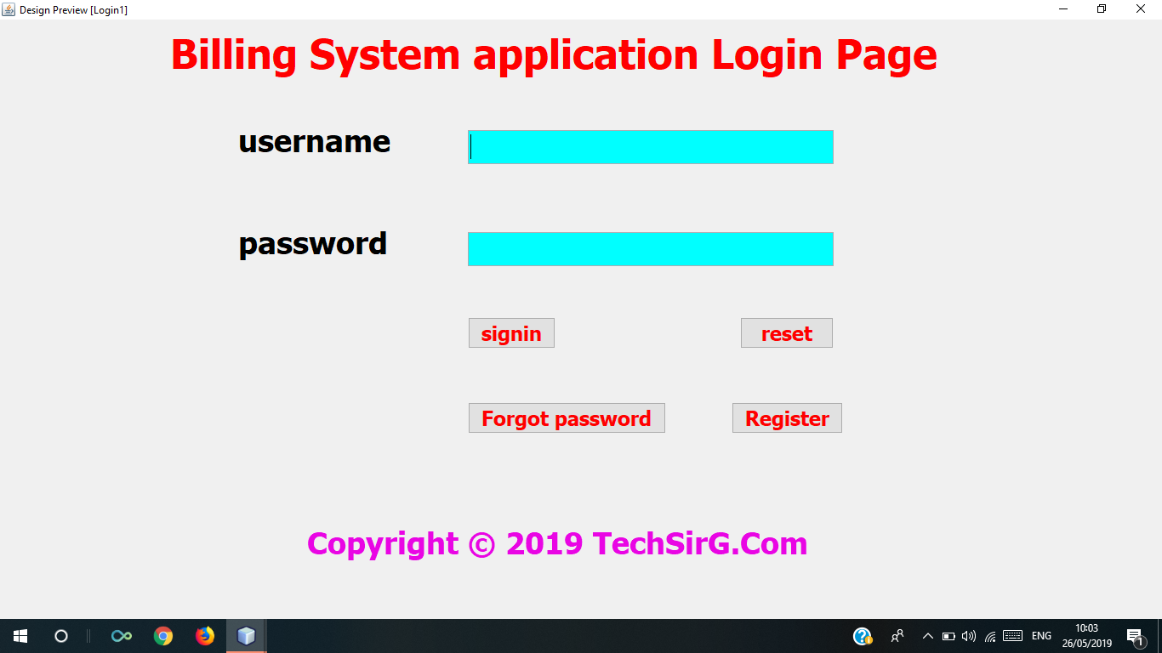

**Password Recovery page**

When user forgot your password so using this page they can recover your password if they know your email id.

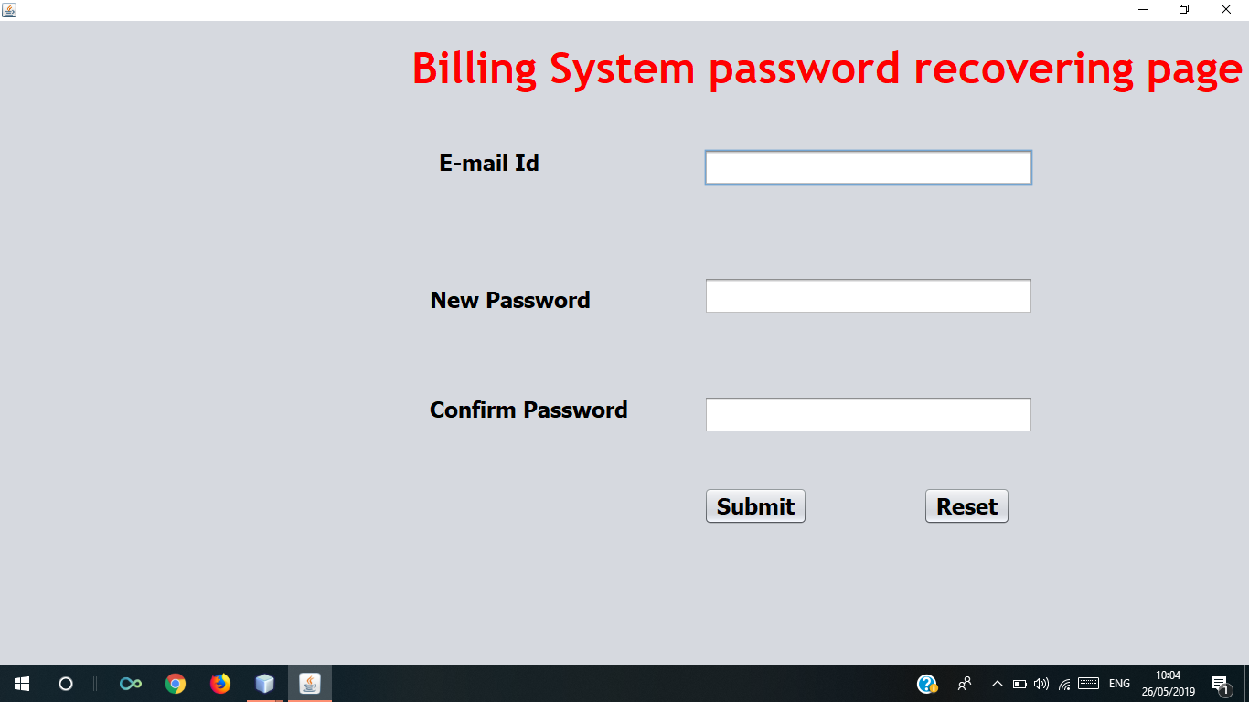

Upload this project on Github through git command

Step.1

First create a repository on github

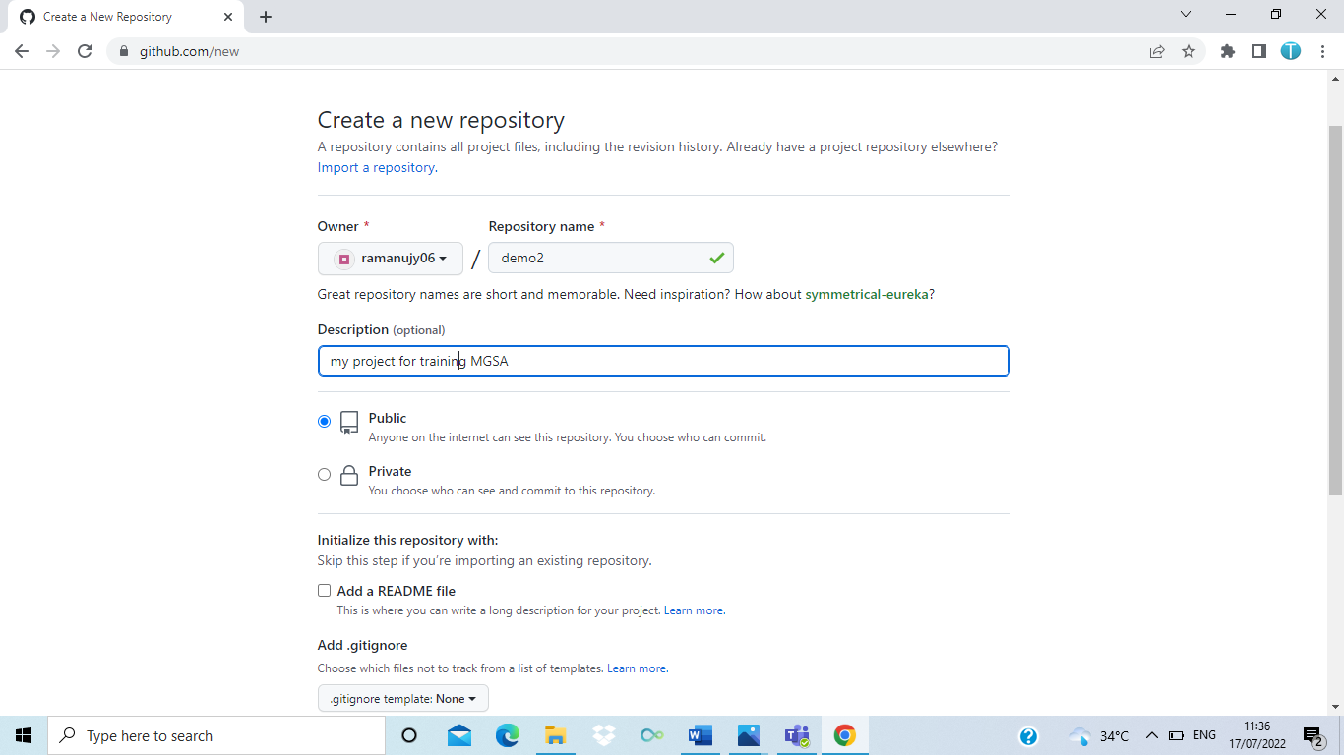

Step.2: store your project files in git directory

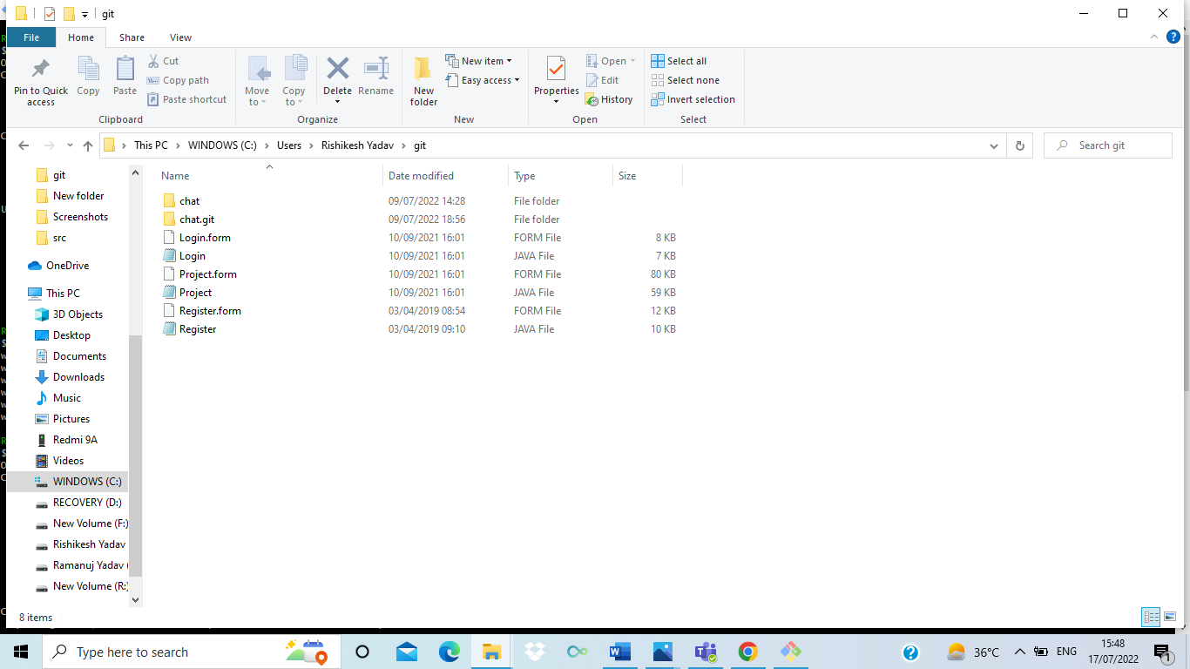

Step.3. Now use the following commands to store the local files on github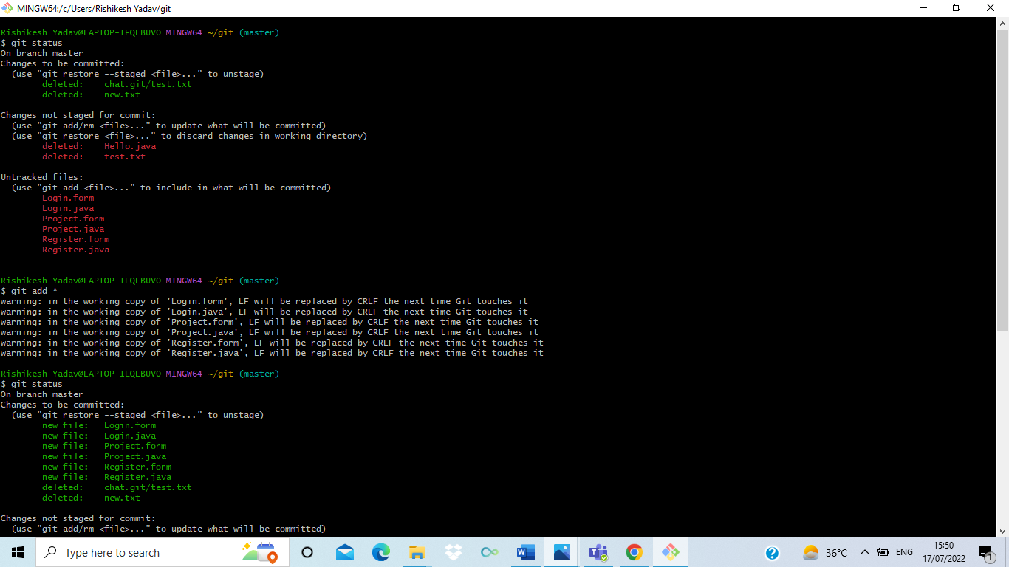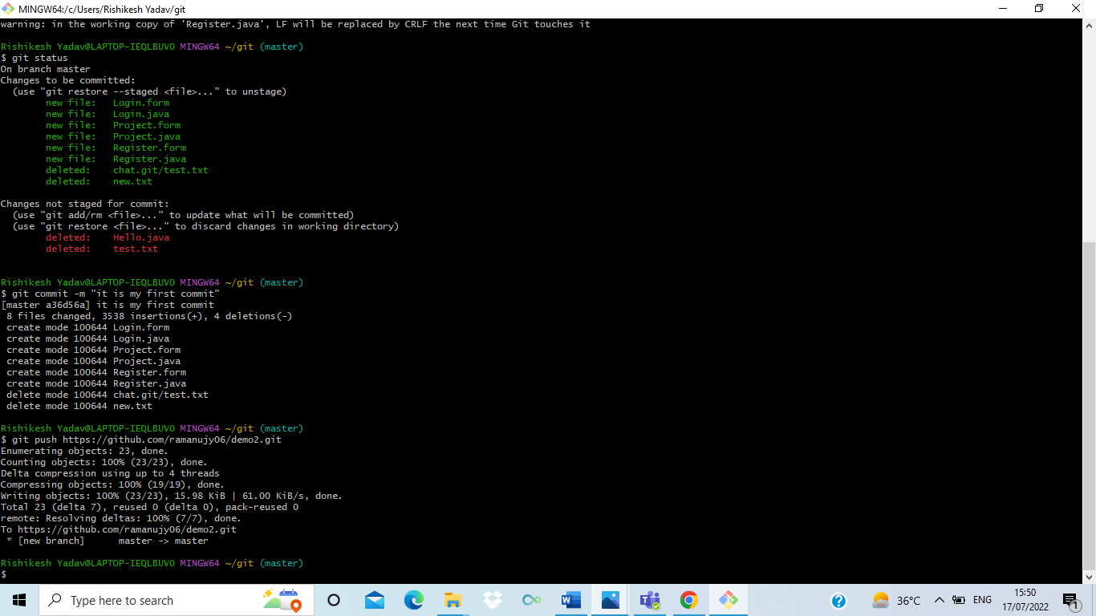

Step.4: now your project files added on your github account

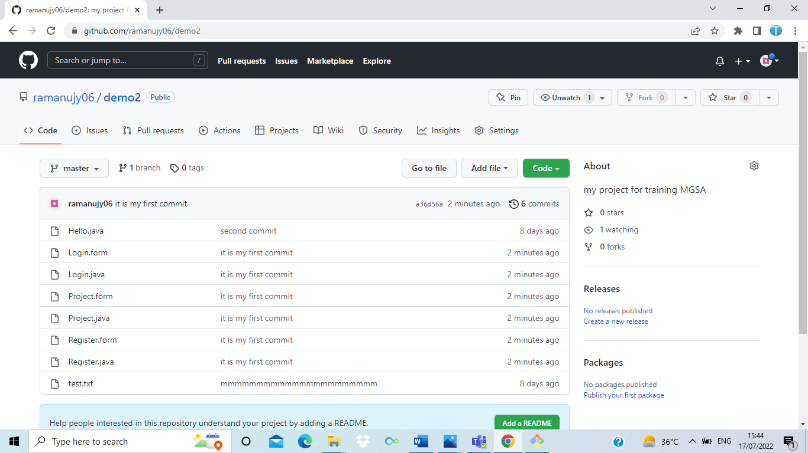

Step.5:

Now finally the documentation/readme file add on git hub.