1. Check Application functionality with API (doing positive and negative testing).
2. Open bugs if any

**Registration**

**URL -** <https://qwallity.herokuapp.com/register/api>

**Method –POST**

**Body –**

{

"first_name": "string",

"email": "string",

"username": "string",

"password": "string"

}

Case1: Empty fields

Case2: Check "first_name" field with <1 or >25 characters long

Case3: Check "email" field with <6 or >25 characters long, and without matching right format

Case4: Check "username" field with <4 or >50 characters long

Case5: Check "password" field with <8 or >14 characters long

Case6: Check registering with existing "username", or existing "email"

Case7:Check registering "first_name" -1-25 characters long,

"email" - 6-50 characters long,

"username" - 4-50 characters long,

"password" - 8-14 characters long

**Bug Name:** Registering user with empty fields  
**Bug ID:** 1

**Description:**Application allows to create user with empty fields

**Expected Result:** We should receive a message “Please fill out this field”. (On UI this message appears near password field when we submit with empty fields)

**Bug Name:**  “first_name” field   
**Bug ID:** 2

**Description:**Application allows to create user when “first_name” field is more than 25 characters long

**Expected Result:** We should receive a message “Field must be between 1 and 25 characters long.”. (On UI this message appears near “first_name” field when we submit)

**Bug Name:** Email format and length of field

**Bug ID:** 3

**Description:**Application allows to create user with wrong email format, and allows to create user with over 50 characters long email

**Expected Result:** We should receive a message “Field must be between 6 and 50 characters long. Email format is not valid.”. (On UI this message appears near email field when we submit)

**Bug Name:** Username field lenght

**Bug ID:** 4

**Description:**Application allows to create user with 3 characters long and with over 50 characters long

**Expected Result:** We should receive a message “Field must be between 4 and 50 characters long.”. (On UI this message appears near username field when we submit)

**Bug Name:** password field lenght

**Bug ID:** 5

**Description:**Application allows to create user with less than 8 characters long and with over 14 characters long password

**Expected Result:** We should receive a message “Field must be between 8 and 14 characters long.”. (On UI this message appears near password field when we submit)

**2.Login**

**URL -**  [https://qwallity.herokuapp.com /login/api](%20https://qwallity.herokuapp.com%20/login/api)

**Methdo –POST**

**Authorization –** Basic Auth

Username

Password

**Response Body**

**Token**

Case1: Username -empty

Password – empty

Response Body

Token

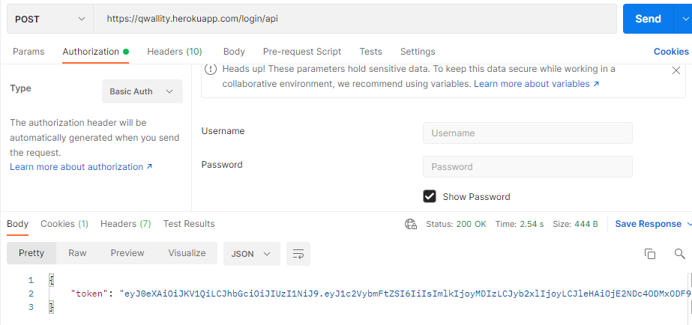

Case2: Username –existing user

Password – empty or wrong pass.

Case3: Username – empty

Password – existing pass

Case4: Username – non-existent user

Password – any pass.

Case5: Username –existing user

Password – right pass.

Response Body

Token

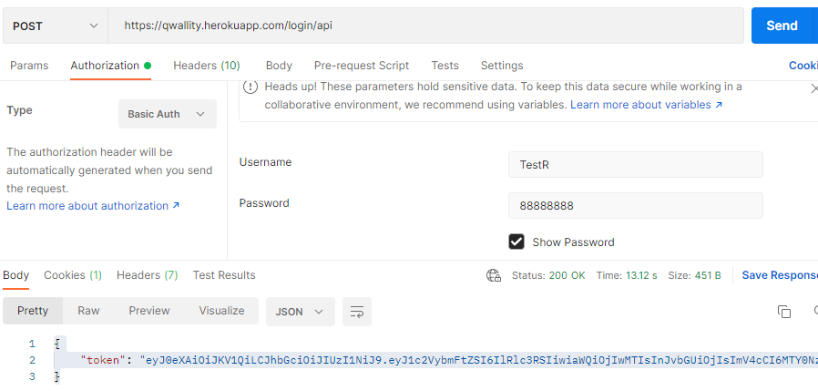

**3.Get Fundamental/Advanced Courses**

**URL –**

**Fundamental -**  [https://qwallity.herokuapp.com /courses/fundamental/api](http://qwallity5.herokuapp.com/courses/fundamental/api)

**Advanced -** <https://qwallity.herokuapp.com/courses/advanced/api>

**Methdo –GET**

**Authorization –**Bearer Token

token

**Response Body**

Fundamental/Advanced courses

**Fundamental courses for user with existing user**

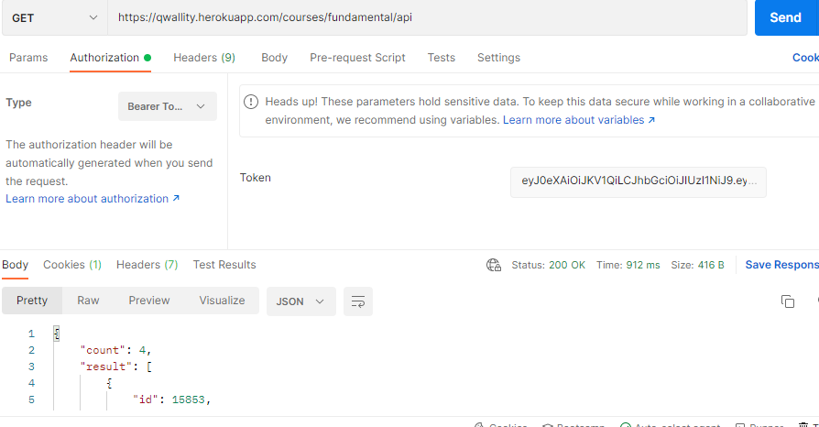

**Advanced courses for user with existing user**

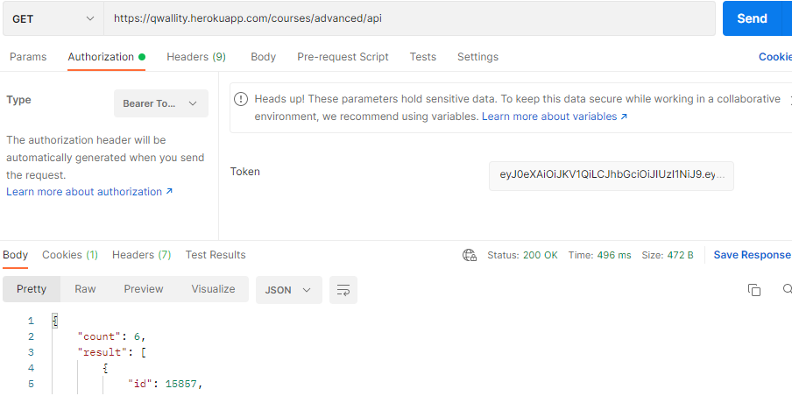

**Very Good Raya jan, thanks for your job. Bugs are correct, Back end has not validation as in Front End.   
I think you write bugs in short way just to show me existing issue, in real case please input all required fields of bug report**