1. 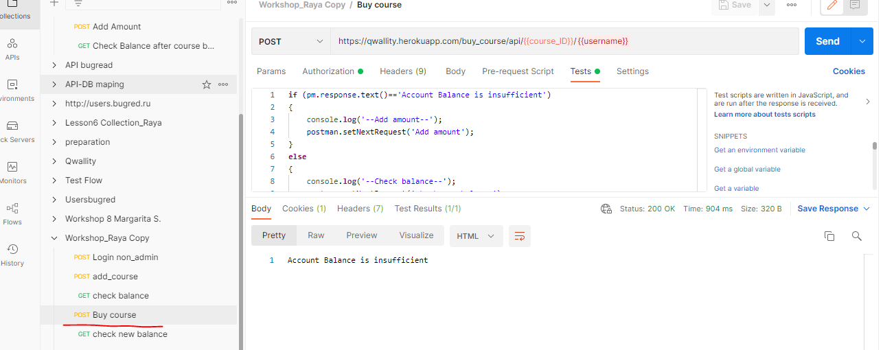In this request would be better to add checking when balance is less than price get Insufficient message and if bigger, Success message
2. 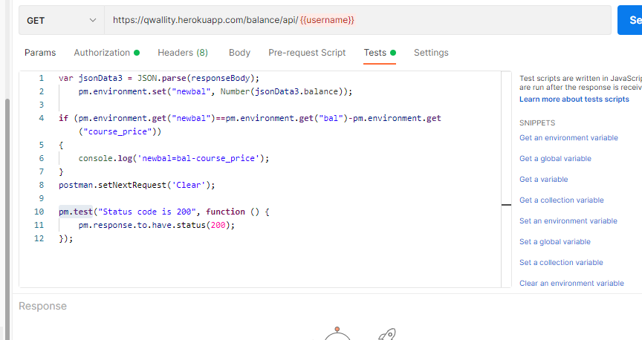

If you want your checking be as a test you need input it in pm.test() function, for example

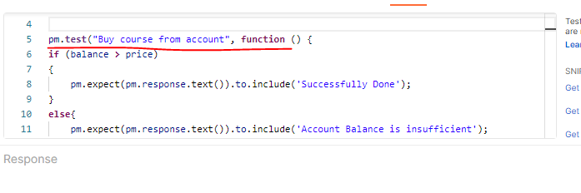

Good job Raya jan