1. Create User from UI https://dev-qwallity.herokuapp.com/. Change user role in DB.
2. Insert Course in database
3. Update Course name
4. Select all advanced courses
5. Delete you added course

**1.**

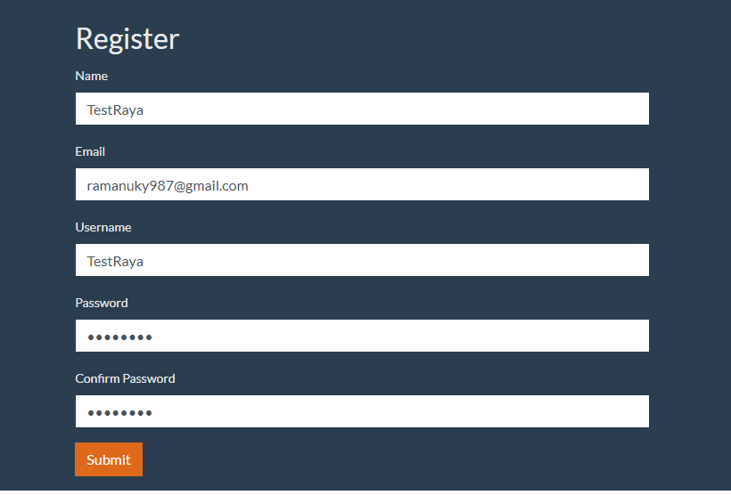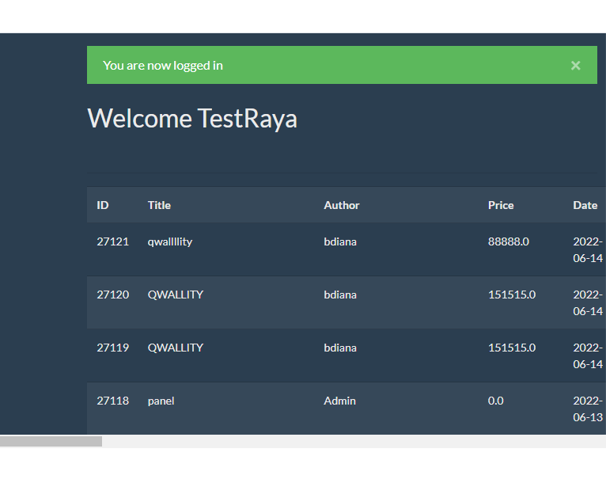

SELECT * FROM qwallity_db.users WHERE username='TestRaya';

UPDATE qwallity_db.users SET role_id=1 WHERE id = 3829;

**2.**

INSERT INTO courses(title, body, author, coursetype, price)

VALUES('Rcourse', 'Rbody', 'Rauthor', 1, 1500);

**3.**

SELECT * FROM qwallity_db.courses WHERE title='Rcourse';

UPDATE qwallity_db.courses SET title='Rcourse_updated' WHERE Id=27122;

**4.**

SELECT * FROM qwallity_db.course_type WHERE type_value='Advanced';

SELECT * FROM qwallity_db.courses WHERE coursetype=2;

**5.**

DELETE FROM qwallity_db.courses WHERE id=27122;

**Good job ☺**