**Hello Team!Consider the below two tables**:

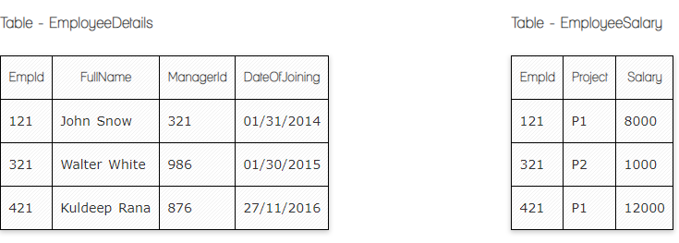

**Ques.1. Write a SQL query to fetch the count of employees working in project 'P1'.**

**Your Answer:**

**SELECT COUNT(EmpId)**

**FROM EmployeeSalary**

**WHERE Project=’P1’**

**Group BY Project;**

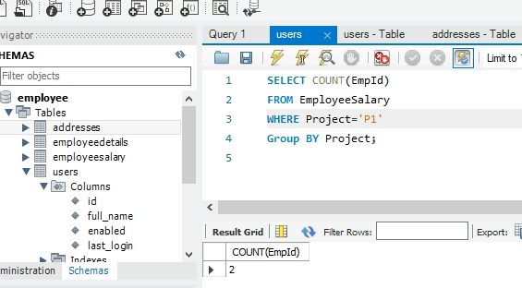

**Ques.2. Write a SQL query to fetch employee names having salary greater than or equal to 5000 and less than or equal 10000.**

**Your Answer:**

**SELECT EmployeeDetails.FullName**

**FROM EmployeeDetails**

**INNER JOIN EmployeeSalary ON EmployeeDetails .EmpId= EmployeeSalary.EmpId**

**Where Salary BETWEEN 5000 AND 10000**

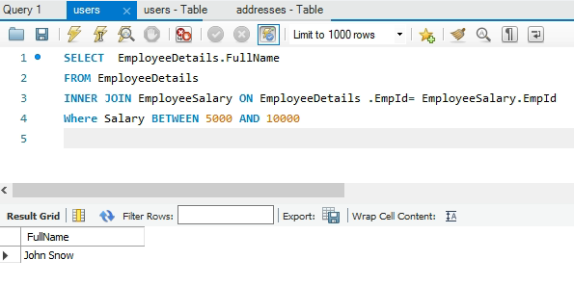

**Ques.3. Write a SQL query to fetch count of employees sorted by project's count in descending order.**

**Your Answer:**

**SELECT COUNT(EmpId), Project**

**FROM EmployeeSalary**

**GROUP BY Project**

**ORDER BY COUNT(EmpId) DESC**

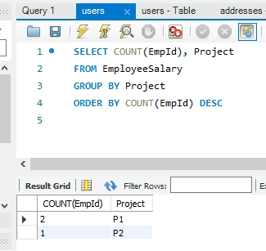

**Ques.4. Write a query to fetch employee names and salary records. Return employee details even if the salary record is not present for the employee.**

**Your Answer:**

**SELECT EmployeeDetails.FullName,EmployeeSalary. Salary**

**FROM EmployeeDetails**

**LEFT JOIN EmployeeSalary ON EmployeeDetails .EmpId= EmployeeSalary.EmpId**

**Image done after ques.8, it is more visible ☺**

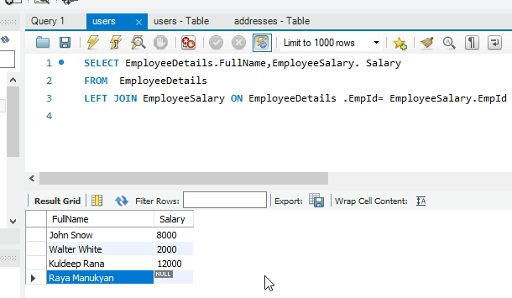

**Ques.5. Write a SQL query to create an empty table with ‘Test’ name.**

**Your Answer:**

**CREATE TABLE** Test (  
 **ID** *int NOT NULL*,  
   **PRIMARY KEY***(ID)*  
);

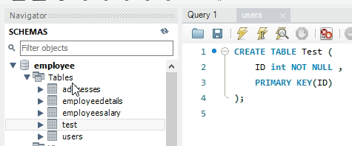

**Ques.6. Write a SQL query to delete an empty table with ‘Test’ name.**

**Your Answer:**

**DROP TABLE  Test**

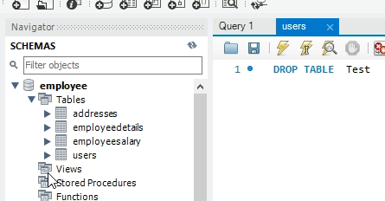

**Ques.7. Write a SQL query to fetch all the Employees details from EmployeeDetails table who joined in Year 2016.**

**Your Answer:**

**SELECT \***

**FROM EmployeeDetails**

**WHERE DateOfJoining BETWEEN '2016/01/01' AND '2016/12/31'**

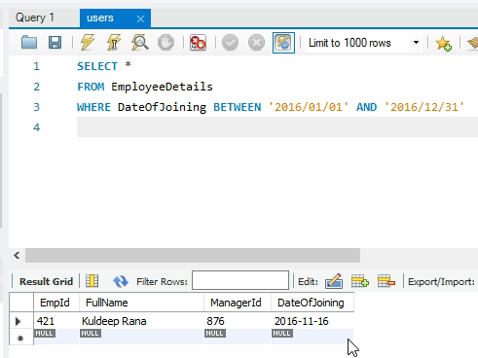

**Ques.8. Write a SQL query to insert new record to the EmployeeDetails table with any data.**

**Your Answer:**

**INSERT INTO EmployeeDetails (EmpId, FullName, ManagerId, DateOfJoining)**

**VALUES(503,'Raya Manukyan', 485, '2022/06/17')**

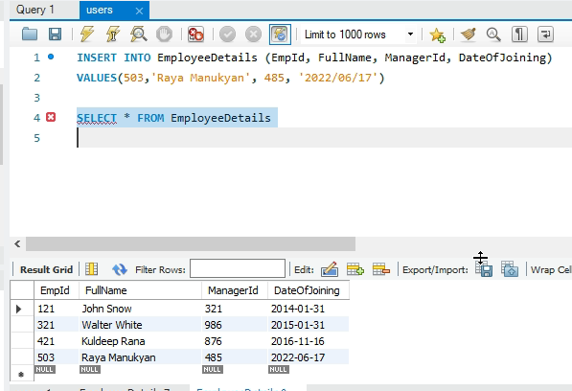

**Ques.9. Write a SQL query to update EmployeeSalary table with setting Salary to 2000 for Project P2.**

**Your Answer:**

**UPDATE EmployeeSalary SET Salary=2000 WHERE Project='P2'**

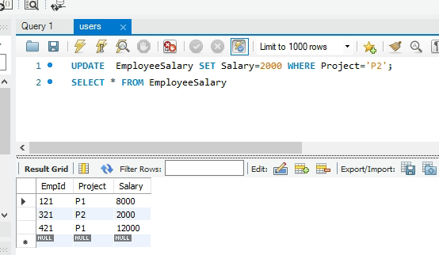

**Ques.10. Write a SQL query to right join both tables and draw the results.**

**Your Answer:**

**SELECT \***

**FROM EmployeeDetails**

**RIGHT JOIN EmployeeSalary ON EmployeeDetails .EmpId= EmployeeSalary.EmpId**

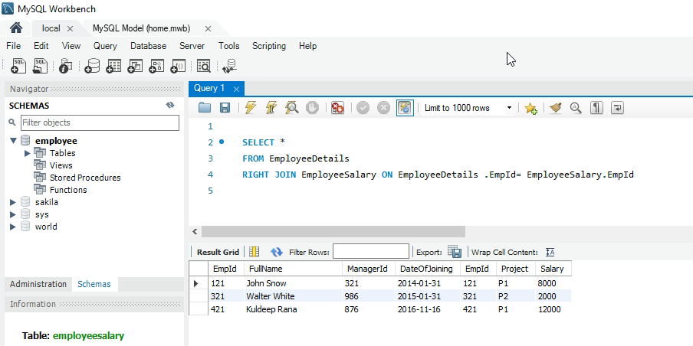

**Now take these two tables:**

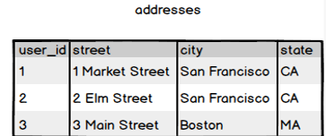

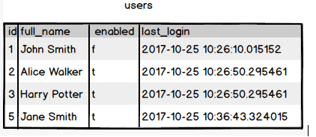

**Ques.11. Write a SQL query to fetch all users full_name from San Francisco.**

**Your Answer:**

**SELECT users.full_name**

**FROM users**

**LEFT JOIN addresses ON users.id=addresses.user_id**

**WHERE addresses.city=’San Francisco’**

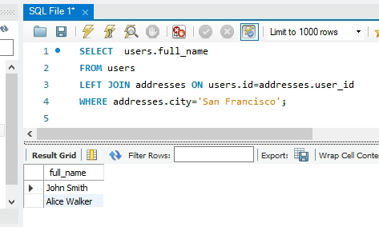

**Ques.12. Write a SQL query to fetch all users full_name, last_login who are enabled**

**Your Answer:**

**SELECT full_name, last_login**

**FROM users**

**WHERE enabled=’t’**

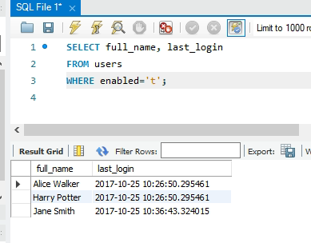

**Ques.13. Write a SQL query to fetch all users full_name who are not from Main street**

**Your Answer:**

**SELECT users.full_name**

**FROM users**

**LEFT JOIN addresses ON users.id=addresses.user_id**

**WHERE NOT COALESCE(addresses.street,'')='Main Street';**

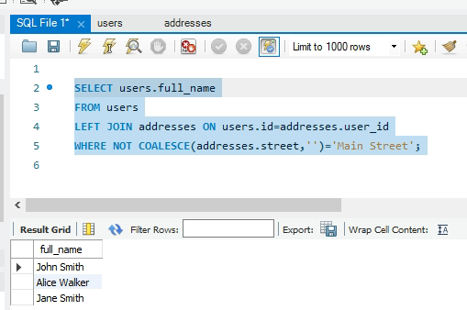

**Ques.14. Write a SQL query to fetch all users full_name who are from Main street or San Francisco**

**Your Answer:**

**SELECT users.full_name**

**FROM users**

**LEFT JOIN addresses ON users.id=addresses.user_id**

**WHERE addresses.street=’Main Street’ OR city=’San Francisco’**

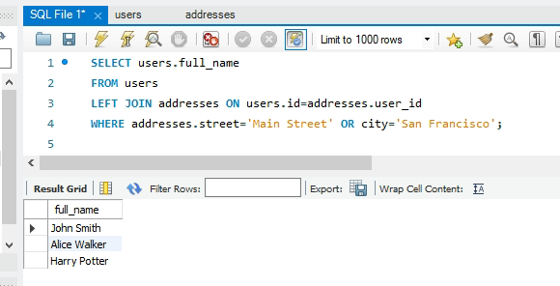

**Ques.15. Write a SQL query to fetch user full_name who is equal to user_id from Boston (find user_id value in sub_query)**

**Your Answer:**

**SELECT full_name**

**FROM users**

**WHERE id=(SELECT user_id FROM addresses WHERE city=’Boston’)**

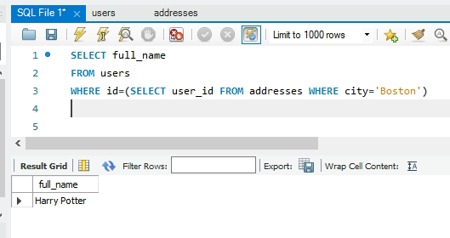

**Good job**