**Case 1: Create Product**

**Scenario 1.a : Success scenario:**

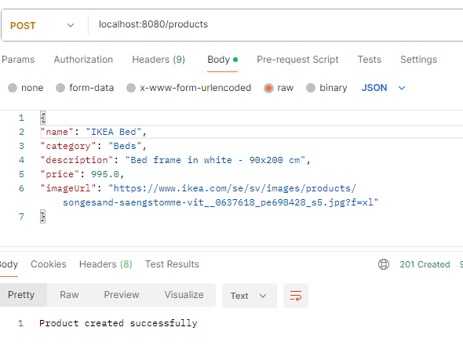

From logs: (level: INFO)



**Case 1.b : Validations for create products:**

**Logs:**



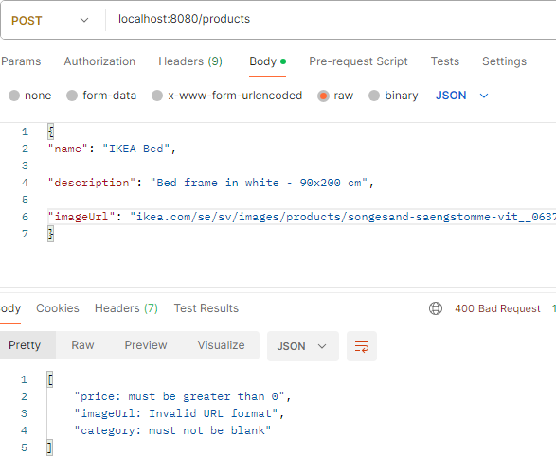

**Case 1c: Validations for all fields**

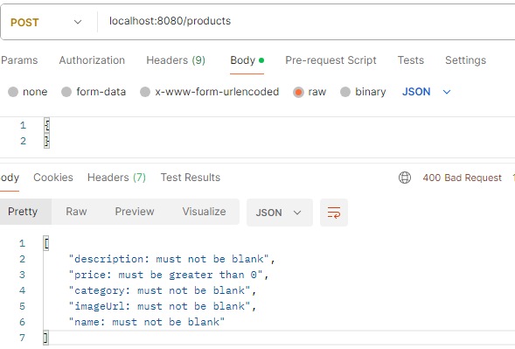

**Case 2: Search Products using fuzzy logic and implementing caching**

**Case 2a**. Success scenario: input query with typo . (First time search query):

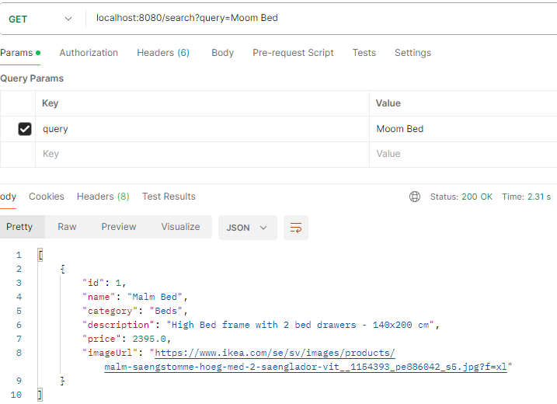



**2b: Caching: Request sent for the same query**

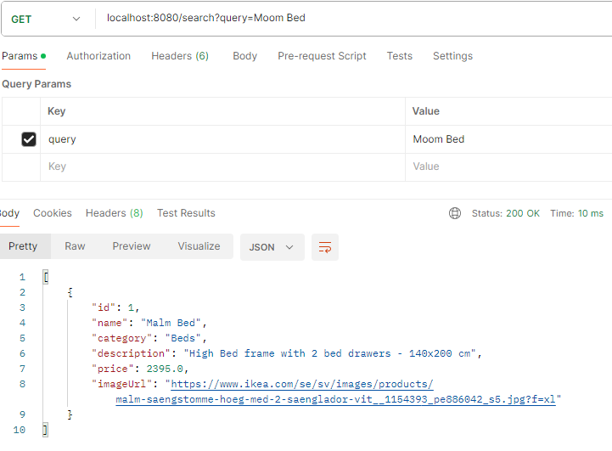

Logs: Fuzzy logic is not calculated. The result is taken from the cache.

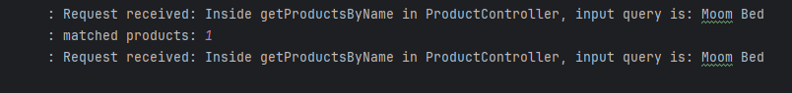

**Case 2c**: Matching input text found anywhere in the product name. (Product name containing the given query, irrespective of the distance)

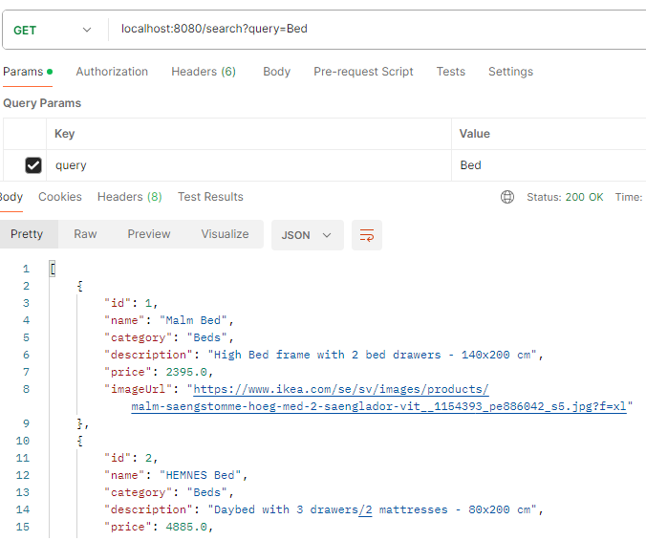

**Case 2d: Error in the input param name(identifier)**

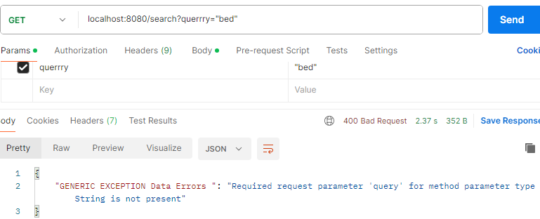

**Case 2e: No Matching products found for the given input search query:**

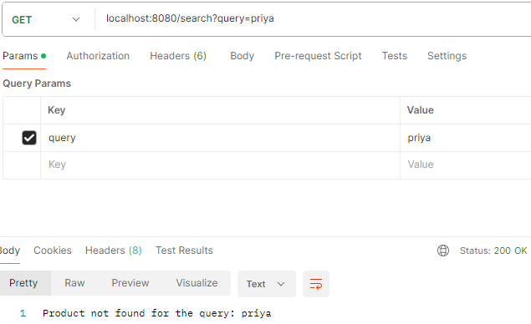

**Case 3: Get Products**: (input params - page no and page size for pagination are optional params. But output is paginated. If no value is provided as input, then default values are : pageNo: 0, pageSize: 10

**3a: Success case (14 products are in system. But the request retrieved 10 products)**

**……………………….**

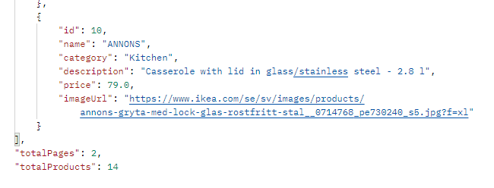

**3b: Success case with pagination details in the request.** (total products available in the system: 14, response retrieved 4 products.)

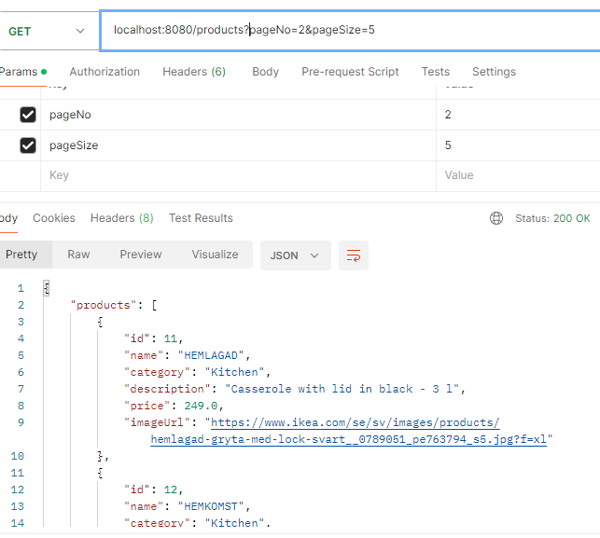

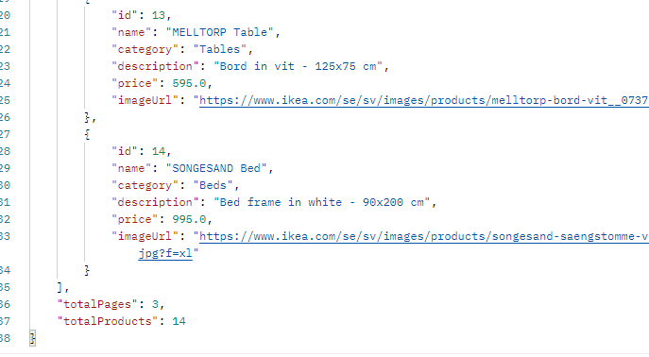

**Case 3c: Issue in input params. (Page Number is not valid or out of range for the available products)**

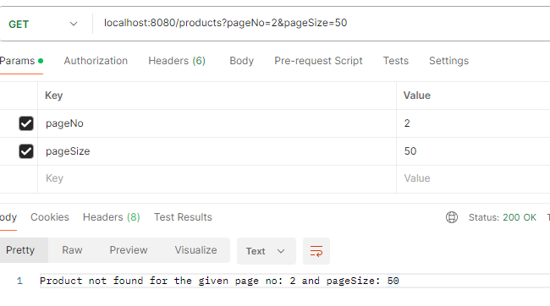

**Logs:**



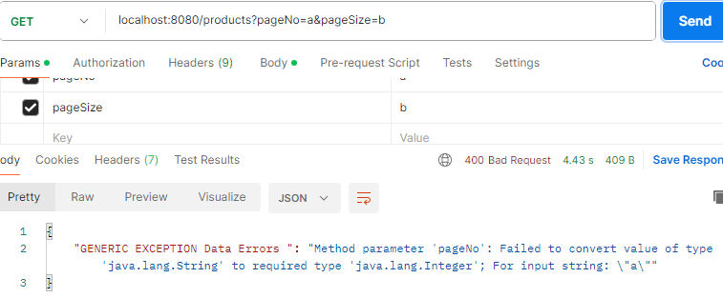

**Case 4: Get product by ID:**

**4a: Success case:**

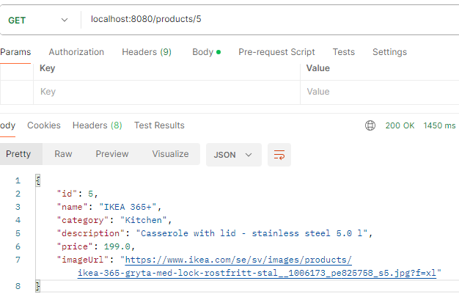

**4b: Product Not found:**

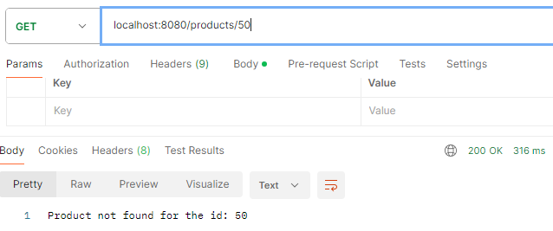

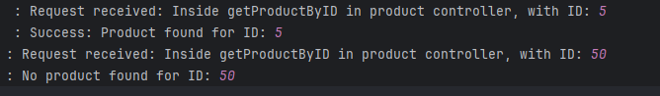

**Case 5: Loading products Data.**

**Data is loaded from products.csv file when the server starts.**

**Case 5.a: If file is not present, ERROR is logged and the server starts up and functions as expected.**

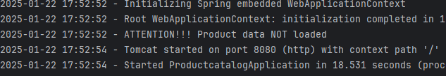

**Case 5.b: If file has no product data in it. ERROR is logged and the server starts up and functions as expected.**

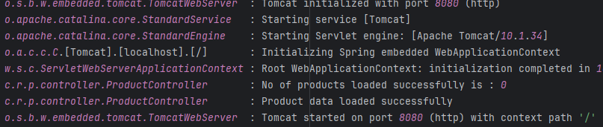

**Case 5c: When there is an error in product data, say error in 4th product data of the total 14 products, then 3 products will be loaded and then error will be logged and server functions as expected**

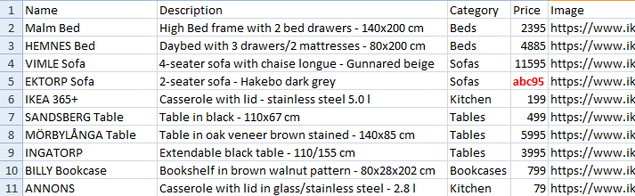

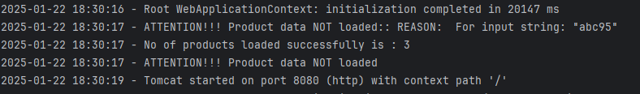**.**

**Case 5d: Data loaded successfully.**

