When the page is loaded, the request to fetch the fetch products is sent (with default options of no of products per page is 10 and first page – these default numbers are configurable in the backend property file)

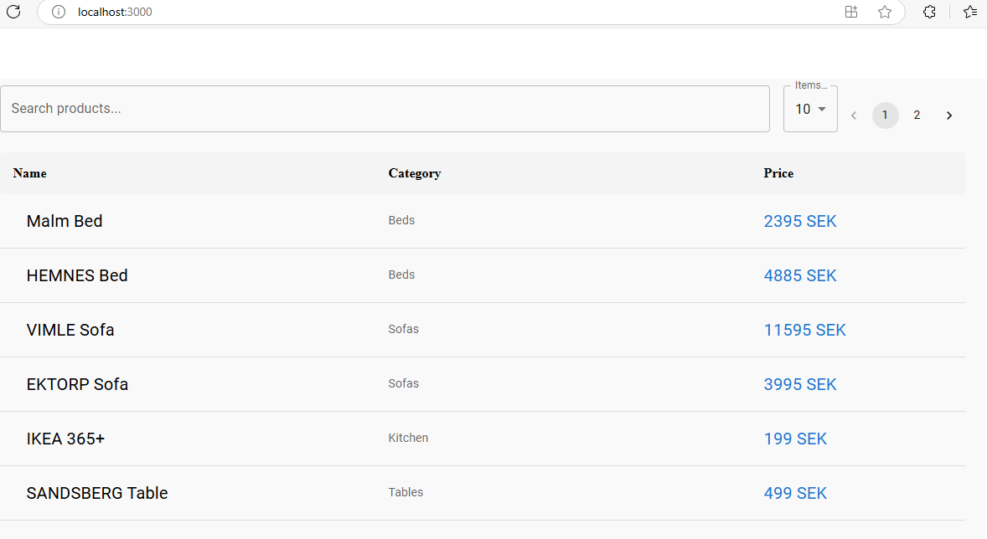

**Detail View:**

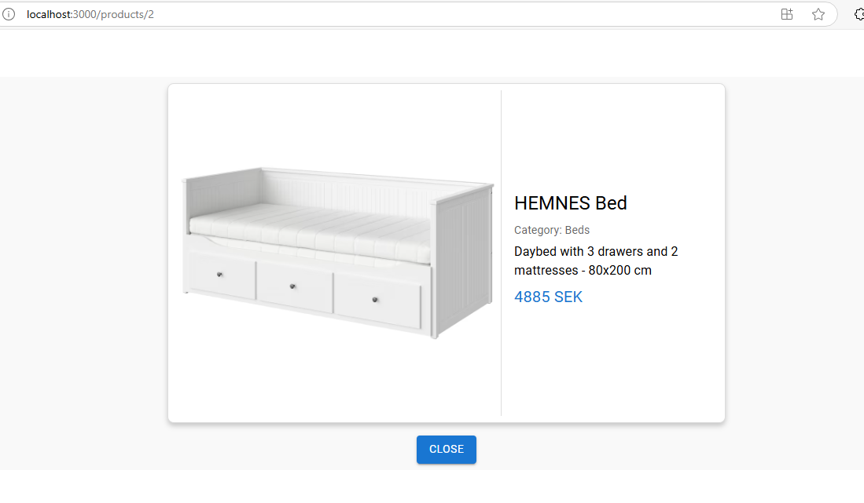

**Search options: (with throttling)**

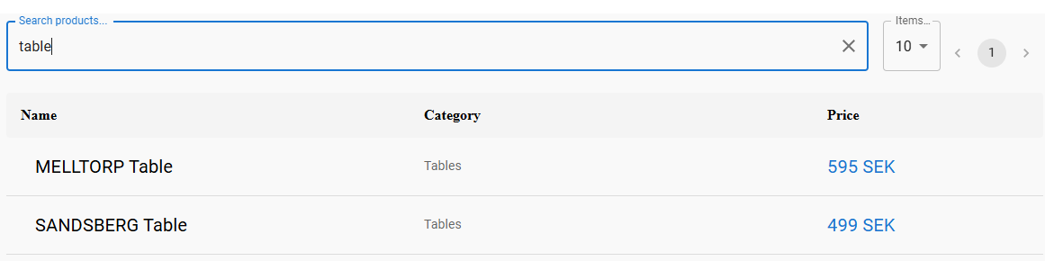

With typo:

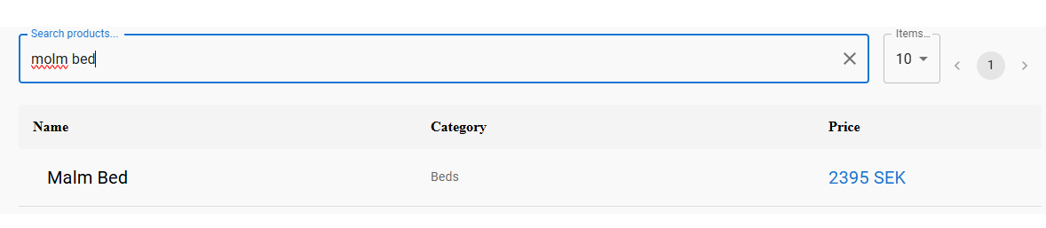

Product not found:

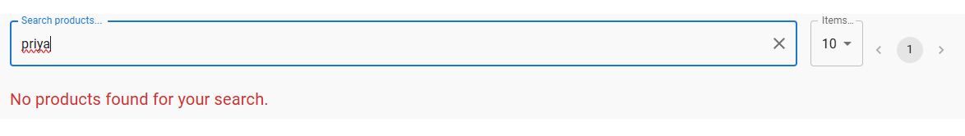

On clearing the input in the search field, the page gets loaded with the initial data