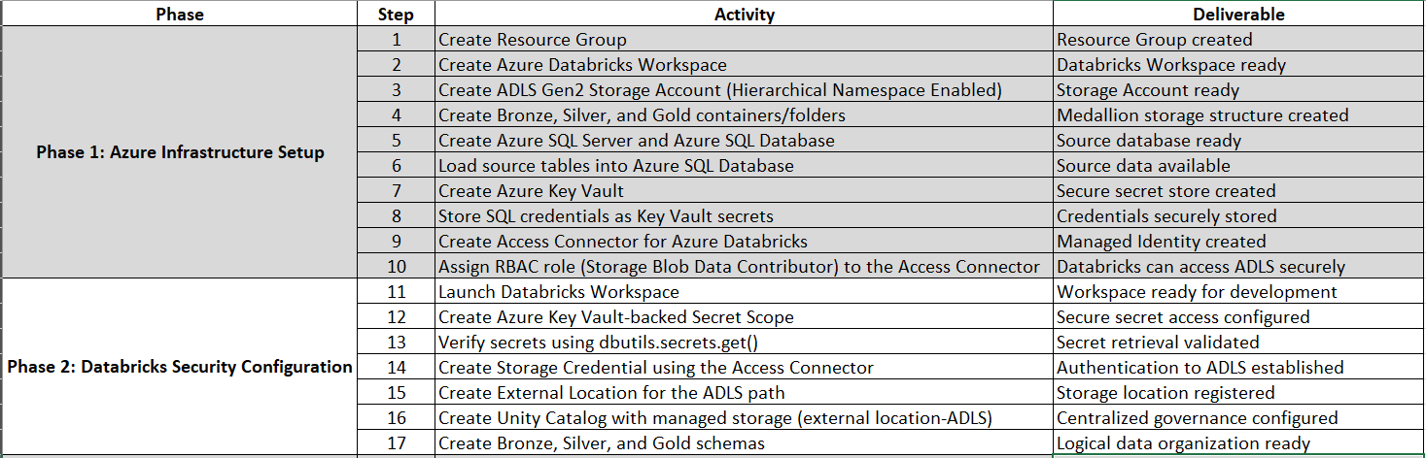
- Phase-1 & 2 are [DONE]. Refer ‘Azure_and_Databricks_Configuration_Document’

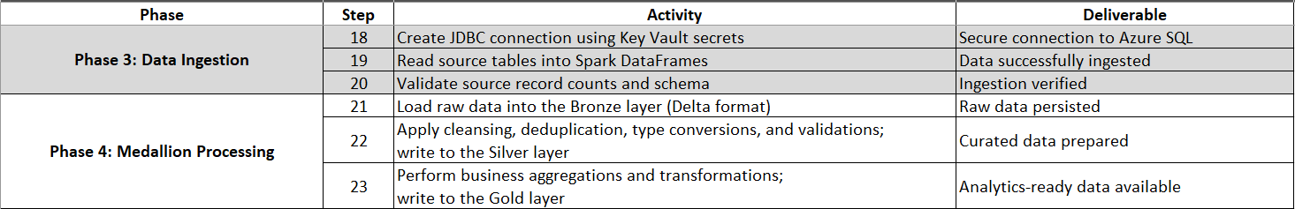
- Phase-3 & 4: Data Ingestion and Medallion Processing

Phase-3 (DATA INGESTION):
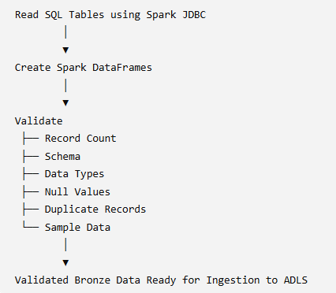
Data Ingestion stage of a Medallion Architecture pipeline is where the data is securely extracted from Azure SQL Database, validated for quality and structure, and prepared for writing to the bronze layer in ADLS Gen2 as Delta tables.

Step-1: Databricks Cluster/Compute details:

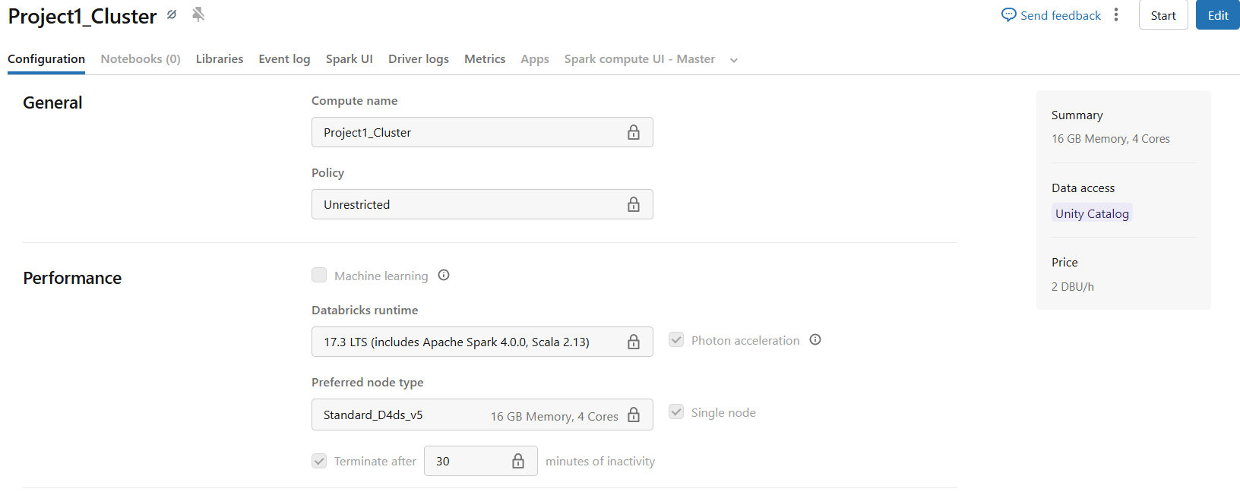

Step-2: Create JDBC Connection: This connects Databricks to Azure SQL DB

JDBC (Java Database Connectivity) is a standard Java API used to connect applications to relational databases. In Azure Databricks, JDBC is commonly used to read data from databases such as Azure SQL Database, SQL Server, Oracle, MySQL, PostgreSQL, and others.

Method: How to get JDBC URL
- Sign in to the Azure portal.
- Go to your Azure SQL Database.
- Select Connection strings from the left menu.
- Under JDBC, you'll see a connection string

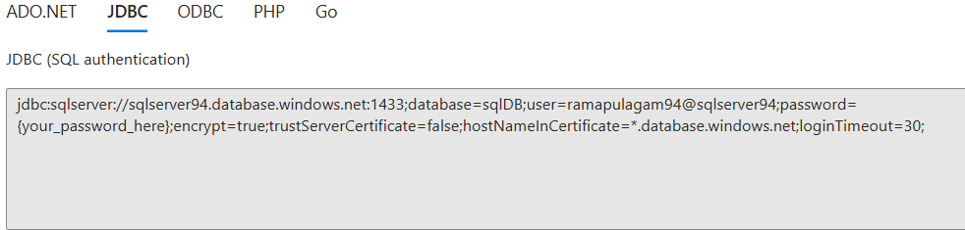

Required fields for JDBC: (Sample)
jdbc:sqlserver://sqlserver94.database.windows.net:1433;
database=sqlDB;
user=<username>;
password=<password>;

Note: Created a Common_functions (Notebook) for JDBC
I have imported these functions in parent notebook and passed the tablename / query / write (dataframe, tablename, writemode) as Parameters.

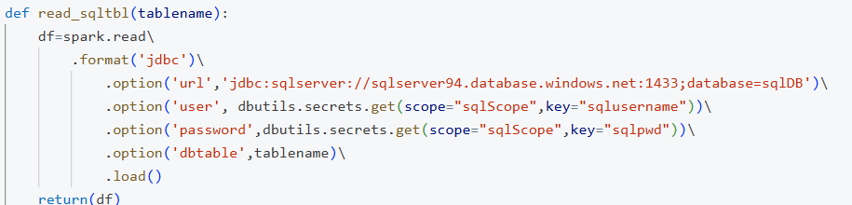
Read from SQL DB via JDBC:

Pass SQL Query via JDBC: Used for Predicate Pushdown (early filtering), Column pruning (select only required columns) before data is read.

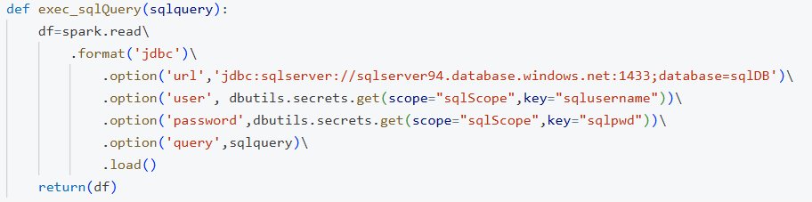

Write to SQL DB: To update SQL database
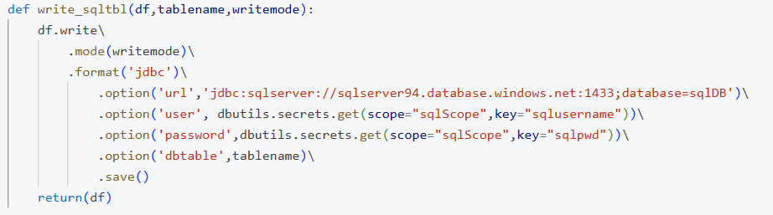

Step-3: Read Source Table into Spark DataFrame and display
Refer Project_Implementation.py

Import the functions from common_functions(notebook)
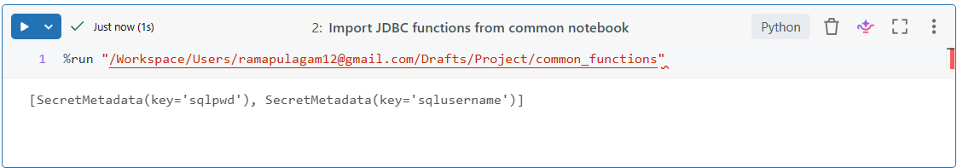

Pass the query to [def exec_sqlQuery] function: COLUMN PRUNING, Reading into a dataframe and display.

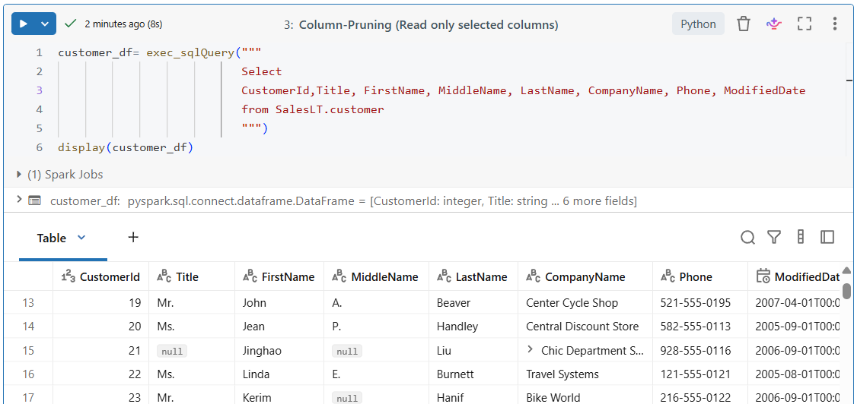

Step-4: DATA VALIDATION

- Validate Source Record Count
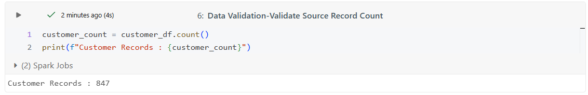

- Validate Source Schema
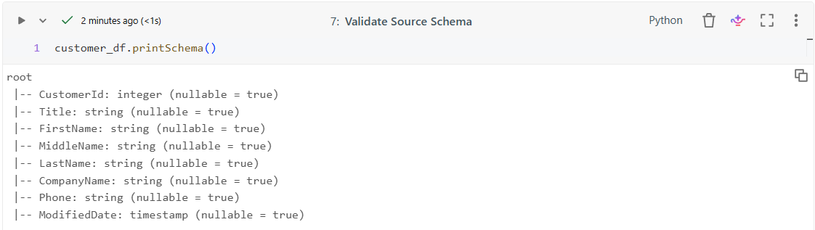

- Validate Data Types
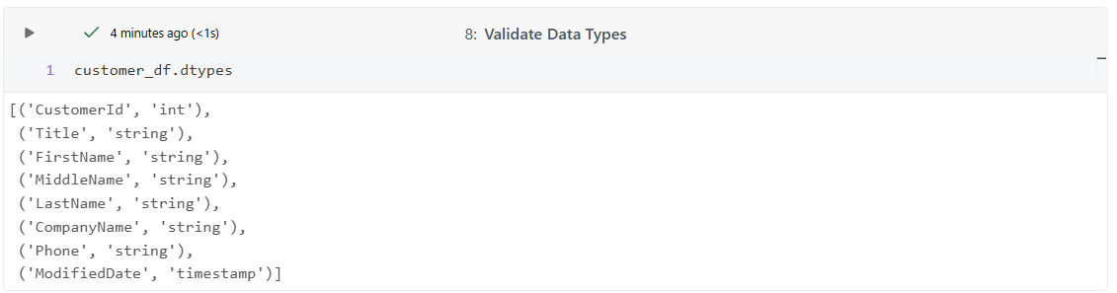

- Check for Null Values
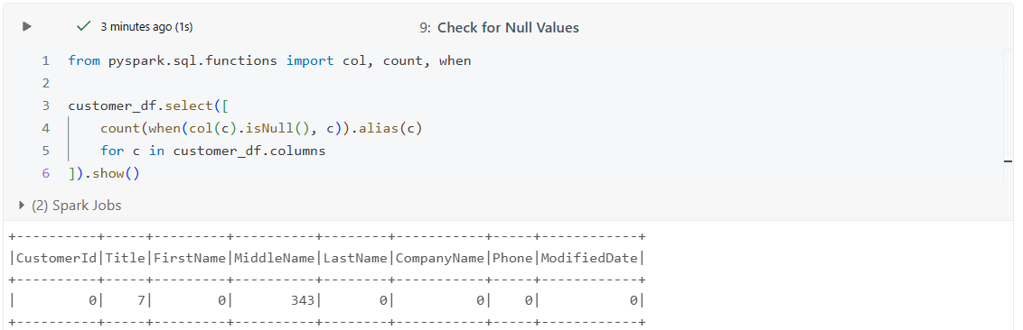

- Check Duplicate Records
- Check duplicates exist in ‘CustomerId’ column
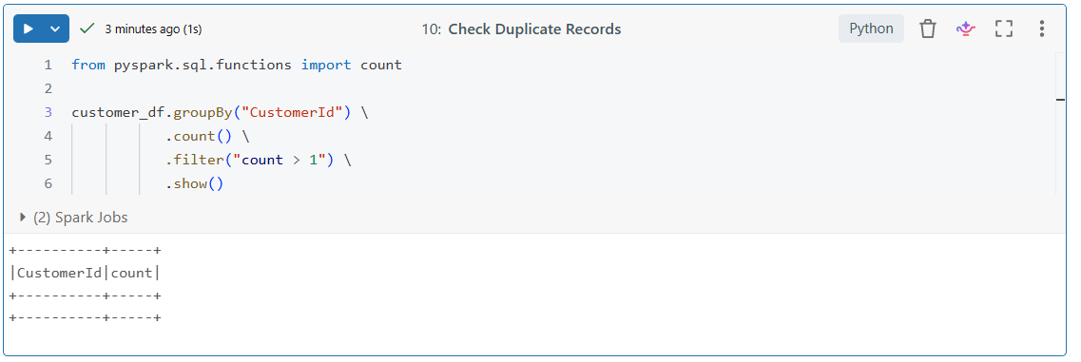

- Find duplicate rows across all columns without explicitly listing column names
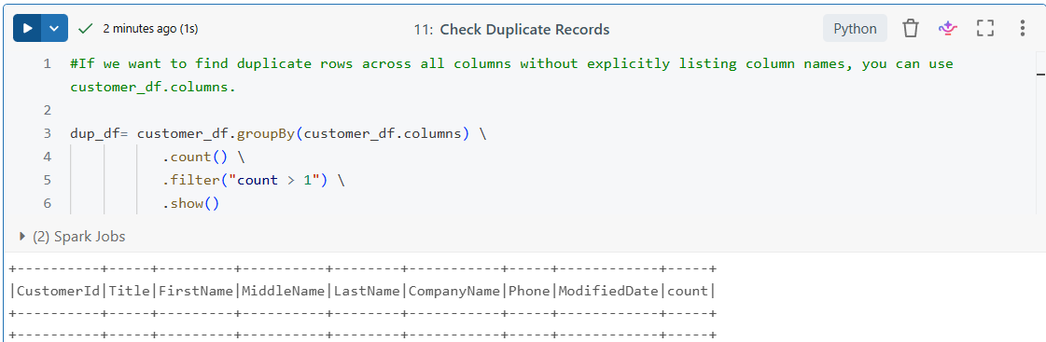

-If we want only unique rows, then use customer_df.distinct()

***************** INGESTION VERIFIED *****************

Phase-4 (MEDALLION PROCESSING):

Step-1: Load Ingestion ready data into Bronze Layer
Objective:
Store raw data exactly as received from Azure SQL with minimal changes.
Steps
- Read only the required columns (early filtering done before reading data).
- Add ingestion metadata.
- Write as a Delta file/table.

Added metadata
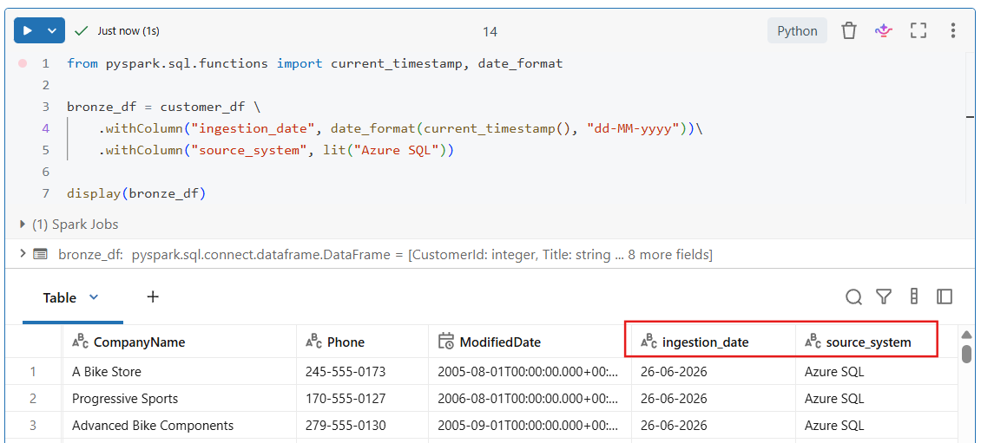

Writing directly to an ADLS path
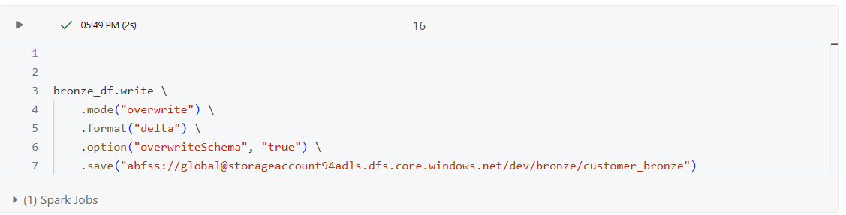

Here you're using:
- .save(path) → writes only Delta files to the specified ADLS location.
- Spark does not create a table in Unity Catalog.
- To query this data later, you'd need to create an external table yourself.
Cross-check in Azure portal storage account
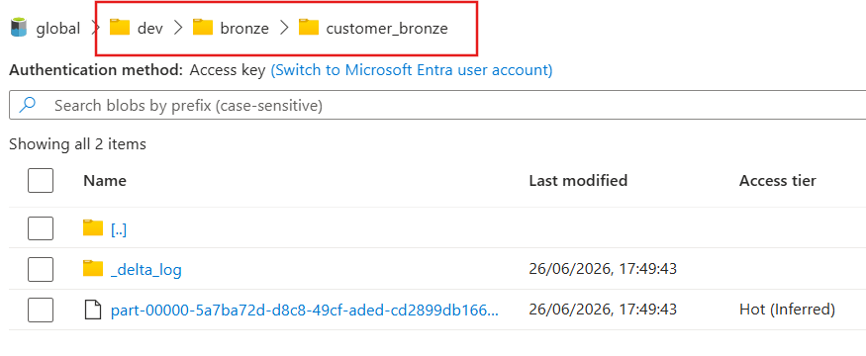
Step-2: Silver Layer (Transformations)
Objective:
Apply cleansing, deduplication, type conversions, and validations and write to the silver layer.

Reading Delta files into Databricks workspace from ADLS Gen2 location
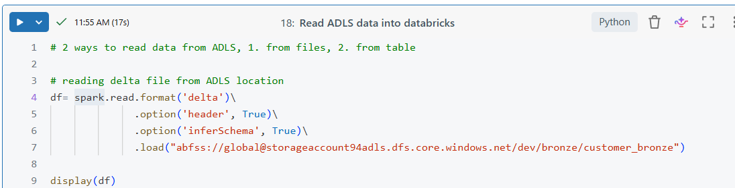

Transformations Performed:

- Remove Duplicate customers
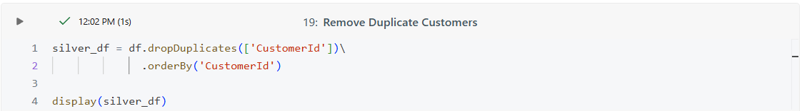
- Trim Leading/Trailing Spaces
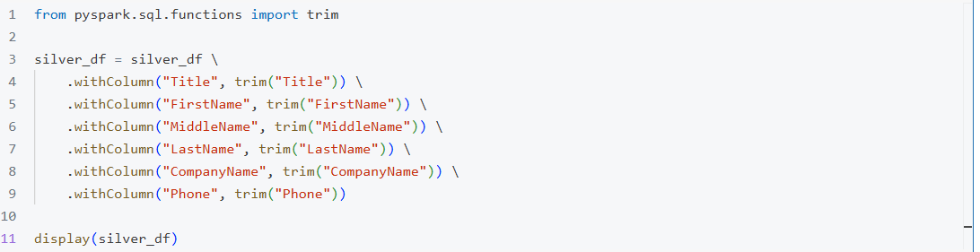
- Standardize Name Case
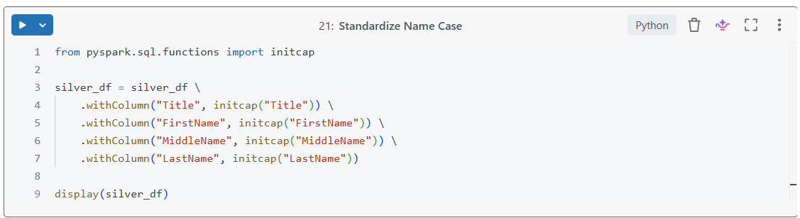
- Create Full Name
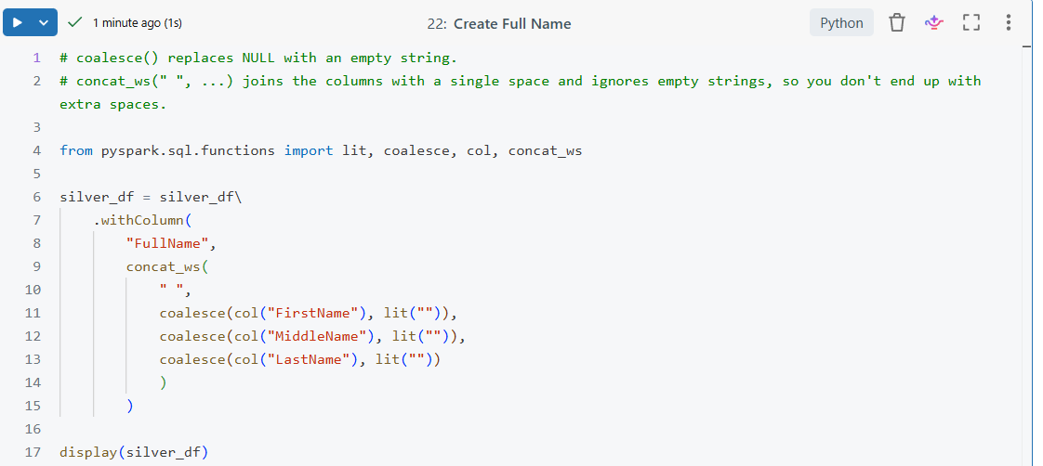
- Standardize Phone number
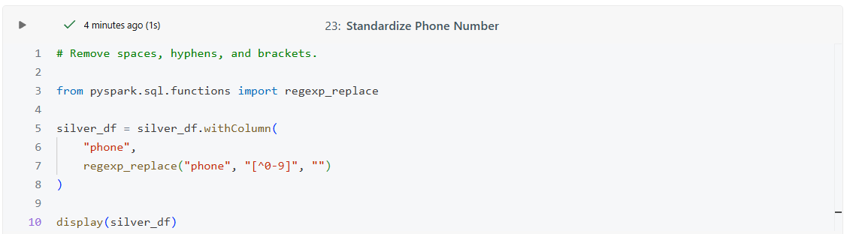
- Add Data processing timestamp
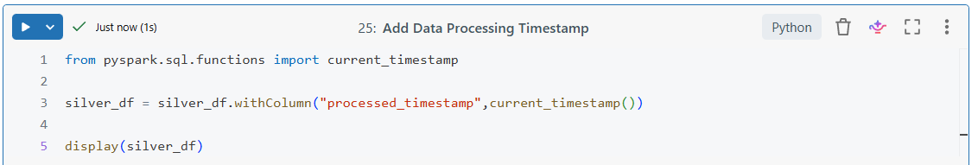

- Reorder Columns
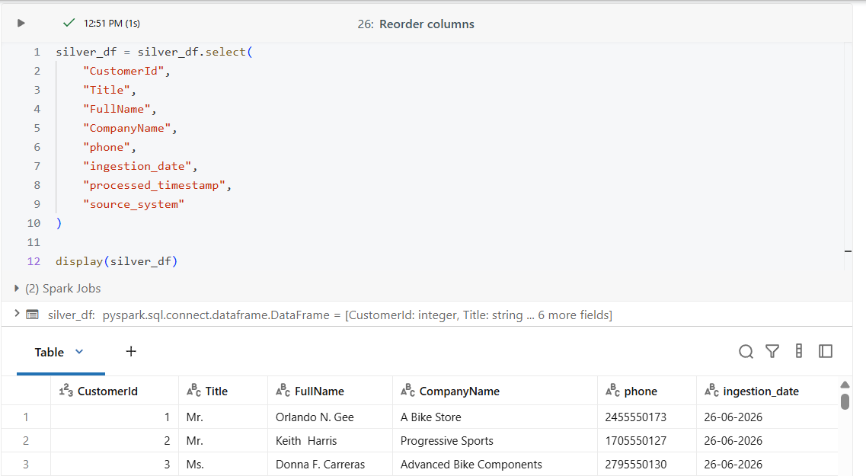

Step-3: Write into Silver Layer in ADLS Gen2
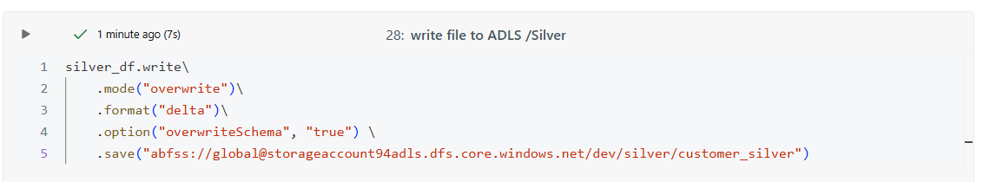

Step-4: Gold Layer (Transformations)
Objective:
Create business-ready datasets for reporting and analytics.

Reading Delta files into Databricks workspace from ADLS Gen2 files location
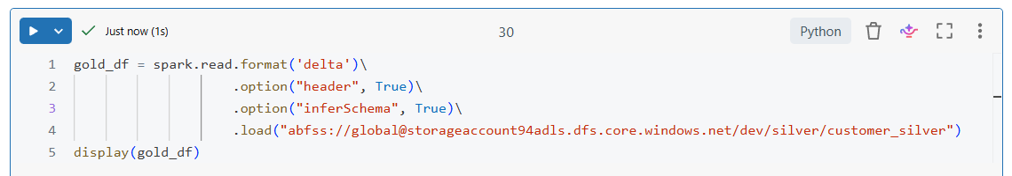

Transformations:
- Create Full name with Mr. /Ms.
- Select required and reorder columns
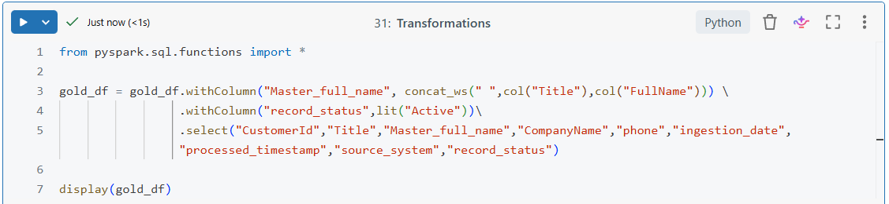
Note: Some other transformations that can be performed on customer related are
- Active Customers by City/State
- Customers by Gender
- Age Group Analysis

Step-5: Write into Gold Layer in ADLS Gen2
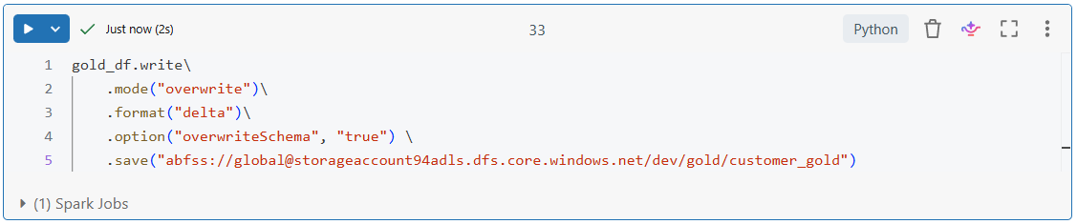

Crosscheck in Azure-> ADLS Gen2
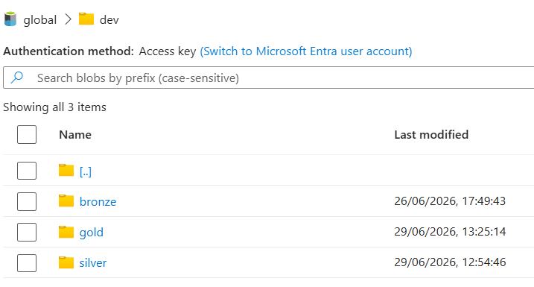
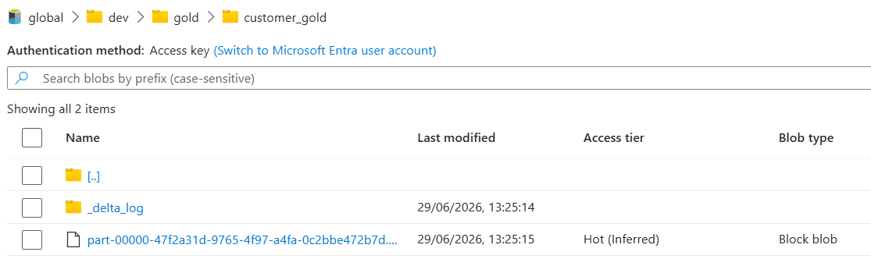

PHASE-5: Unity Catalog & External Tables

Register delta files as external tables:
- The external tables are reflected in catalog, crosscheck its metadata on ‘Success’.
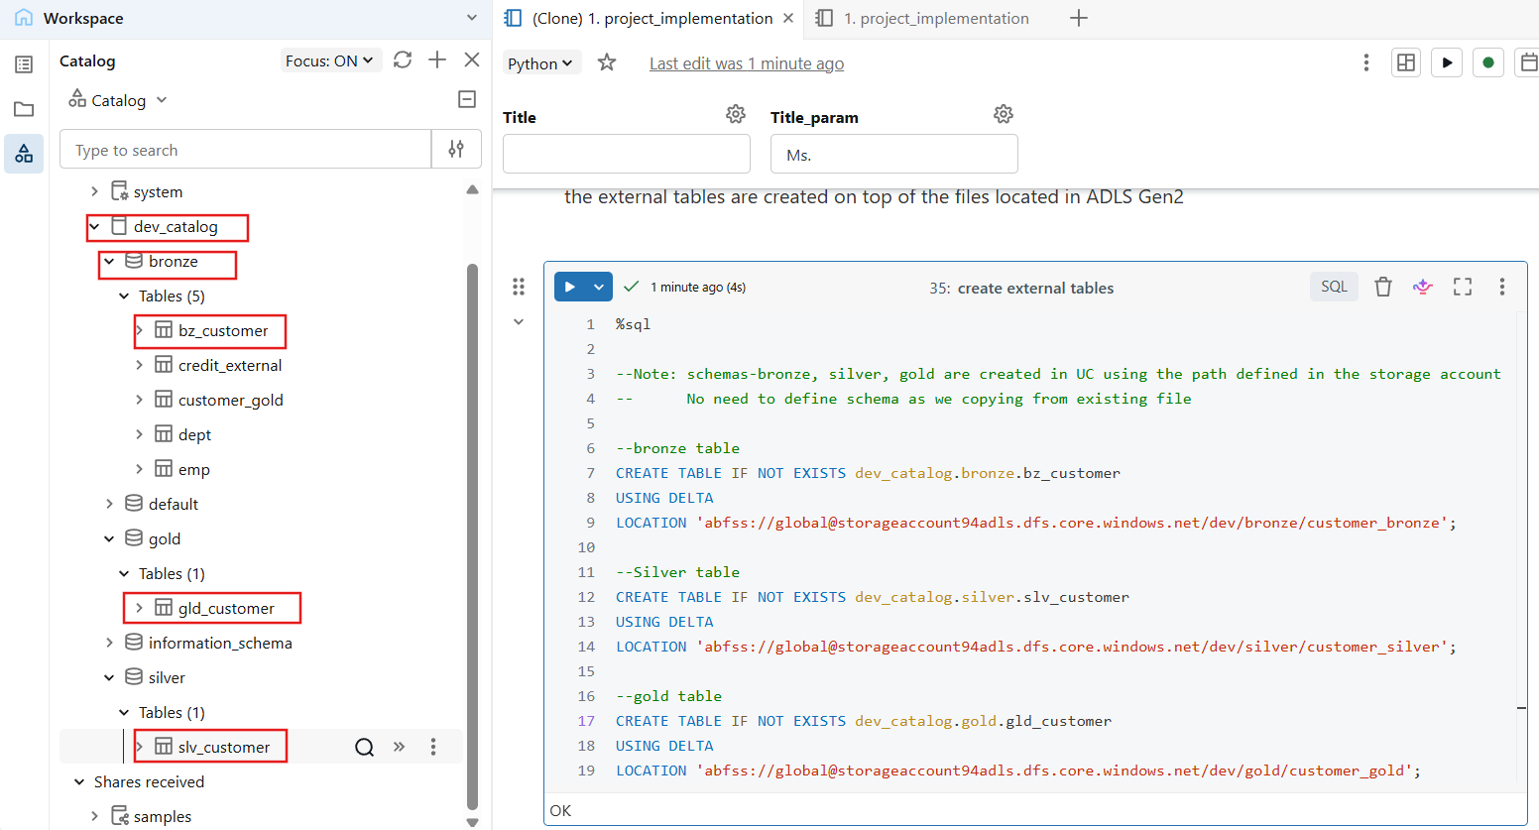

Read the external table from catalog.
