Table of contents:

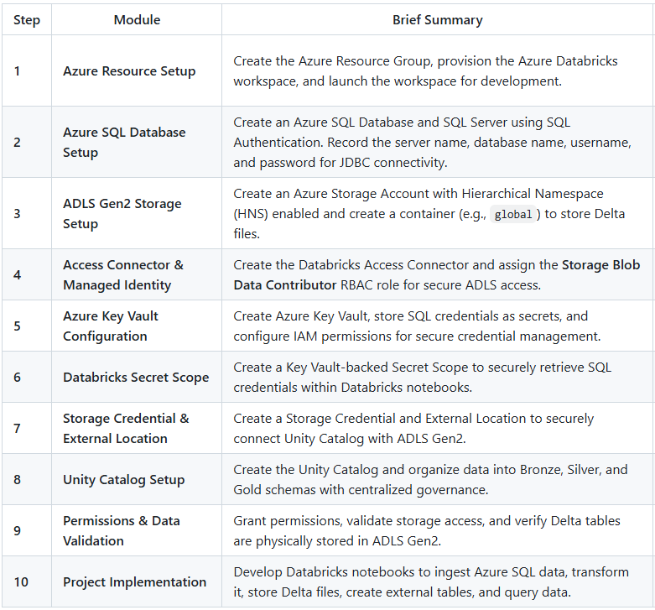

IN AZURE PORTAL:

Step 1:
-Login to portal.azure.com, Create a Resource group
-Create Azure Databricks account
-Launch Azure Databricks

Step 2:
-Create Azure SQL Database & SQL Server.
Note: Authentication->SQL Server Authentication
-Get the connection information: Server name, Database name, Admin User & Password

Step 3:
-Create Storage account with Hierarchical Namespace (HNS) which is required for ADLS Gen2 (Azure Data Lake Storage)
-Create a container ‘global’ for storing the data.

Step 4:
-Create an Access Connector for Azure Databricks
-Go to storage account--> IAM --> Select Storage blob data contributor role and assign Databricks access connector as member.
This securely allow Azure Databricks to access Azure resource (Azure Data Lake Storage Gen2) using a Managed Identity, instead of storing credentials like client IDs & secrets.

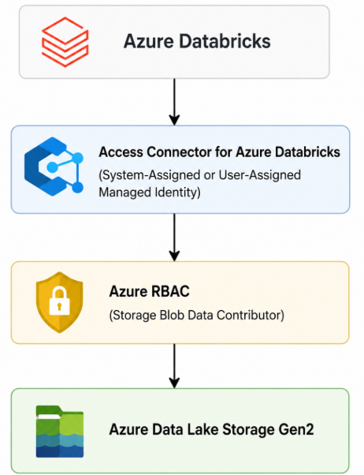

Flow
- Azure Databricks sends a request to access ADLS Gen2.
- The Access Connector uses its Managed Identity to authenticate with Azure.
- Azure verifies that the Managed Identity has the required RBAC permissions.
- If authorized, Databricks can read from or write to the storage account.

Step 5:
-Create Azure Key Vault (secures credentials needed to connect to Azure SQL Database)
-Go to Objects Secrets Create secrets for SQL server admin username & password.

-Go to IAM Add role assignment ‘key Vault Administrator’ Assign access to Managed Identity for the following members.

- AzureDatabricks Application
- Your Username

IN DATABRICKS:

Step 6:
-Create Databricks Secret scope. https://<databricks-workspace-url>#secrets/createScope

Note: The Secrets are stored in Microsoft Azure Key Vault and accessed through the Databricks Secret Scope.

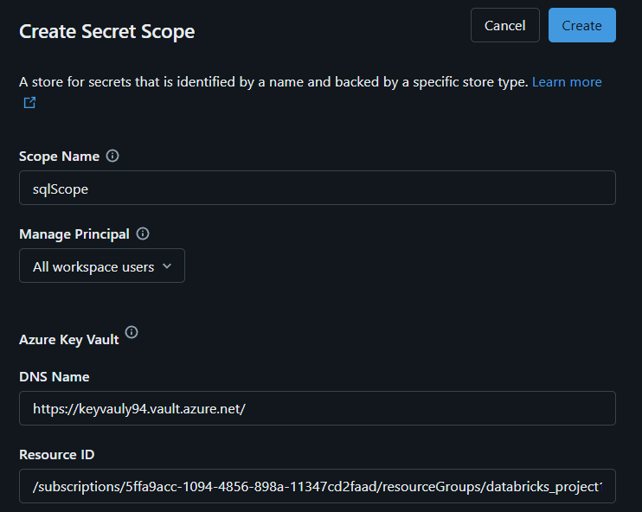

- Verify the list of scopes: dbutils.secrets.listScopes()
- Verify the list of secrets in the scope: dbutils.secrets.list("sqlscope")

Step 7:

Securely access the data stored in ADLS Gen2 into the Databricks workspace.

- Create Storage Credential (using Use-Assigned Managed Identity):
This tells how should Databricks authenticate to ADLS Gen2, it only stores the authentication method (Managed Identity, Service Principle, SAS Token)

Use, Databricks access connector ID
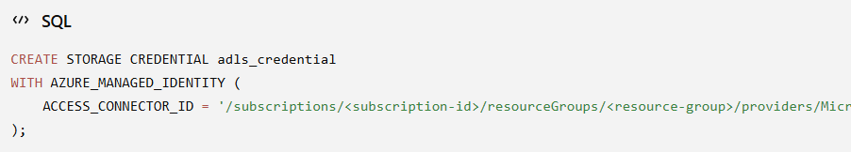

- Create External Location:
mapping the Storage Credential to a specific ADLS Gen2 path.

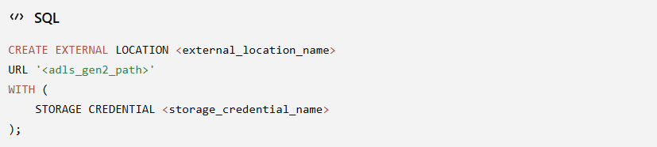

URL: abfss://global@storageaccount94adls.dfs.core.windows.net

Now Unity Catalog knows:
- Which identity to use (Storage Credential)
- Which storage path can be accessed (External Location) using this storage credential

Step 8: Create Unity Catalog
-Unity Catalog is the top-level container for organizing data. It has 3-level namespace,
Catalog Schema Tables/Views
-Create Unity Catalog and organize your data into bronze, silver and gold schemas.
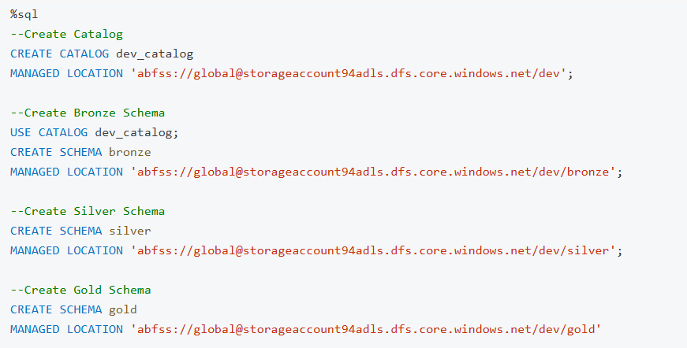

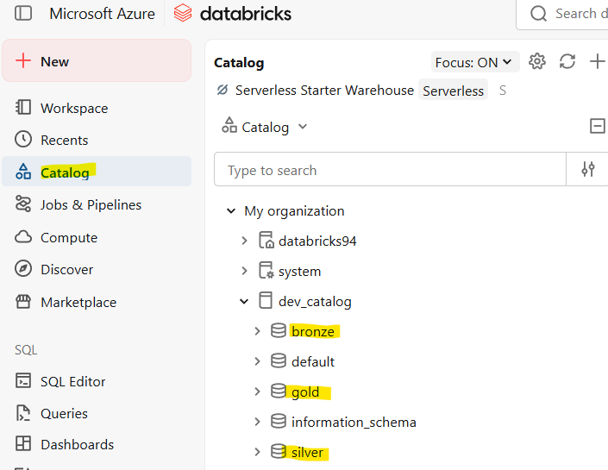

Key points:
- Grant permissions: dev_catalog -> Permissions Grant All privileges to Users.
- Databricks automatically creates the required folders in ADLS when data is written.
- Data files and table directories are physically stored in ADLS.

Step 9:
Create Notebooks for the project (Look in the Project Implementation Notebooks)

