Table of Contents
Use Case: AI-Powered Knowledge Assistant using Databricks 2
How it works 2
Architecture flow 3
Business value 3
Implementation: 4
- Upload data files (unstructured and structured) to Unity Catalog Volume 4
2. Databricks Notebook: “02_Parse_PDF_Docs” 4
3. Create tables on top of csv files in databricks UnityCatalog 5
4. Databricks notebook: “03_Enrich_PDF_Files” 5
5. The Indexed documents are ready for: 6
7. Build own serving model 13
8. Register as an Agent and build a databricks app on it. 14
10. AI Customer service app flow 23
Appendix 25

Use Case: AI-Powered Knowledge Assistant using Databricks
A conversational AI assistant that answers business questions using both PDF documents and structured Delta Tables, with Databricks managing retrieval, data access, and application serving.

How it works
1. Unstructured Knowledge Base: Approximately 500 PDF files are processed into smaller chunks. Embeddings are generated for these chunks and stored in a Vector Search Index to enable semantic search.
2. Structured Knowledge Base: Structured data stored in Delta Tables is made accessible to the agent through Unity Catalog (UC) Functions.
3. Databricks Agent: The agent uses the Vector Search Endpoint to retrieve relevant information from PDF documents and UC Functions to query structured data.
4. Model Serving Endpoint: The agent is exposed through a Model Serving Endpoint, allowing the application to interact with it.
5. Databricks App: Provides a user-friendly interface where users can ask questions in natural language and receive relevant answers.

Compute: serverless compute

AI and application component specifications:
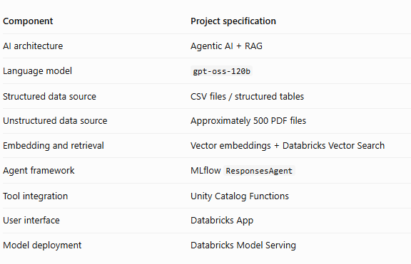

Architecture flow
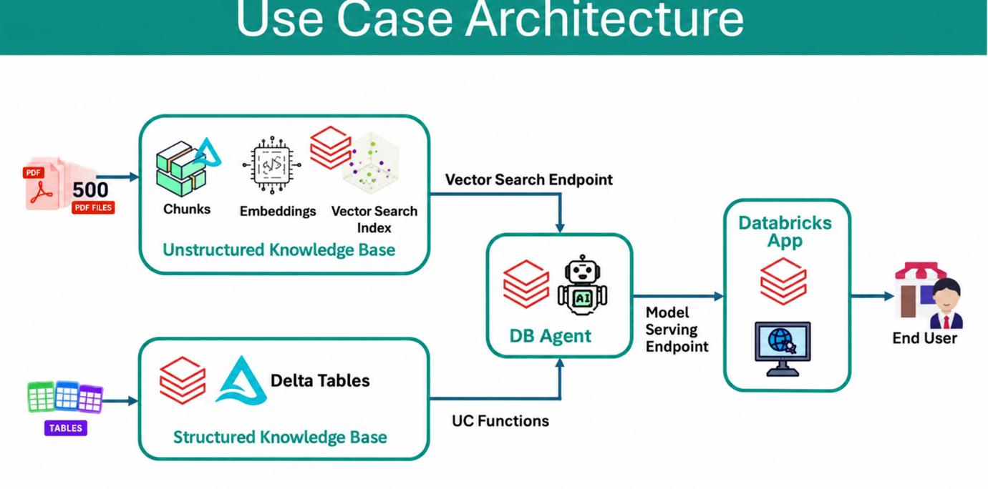
This is based on
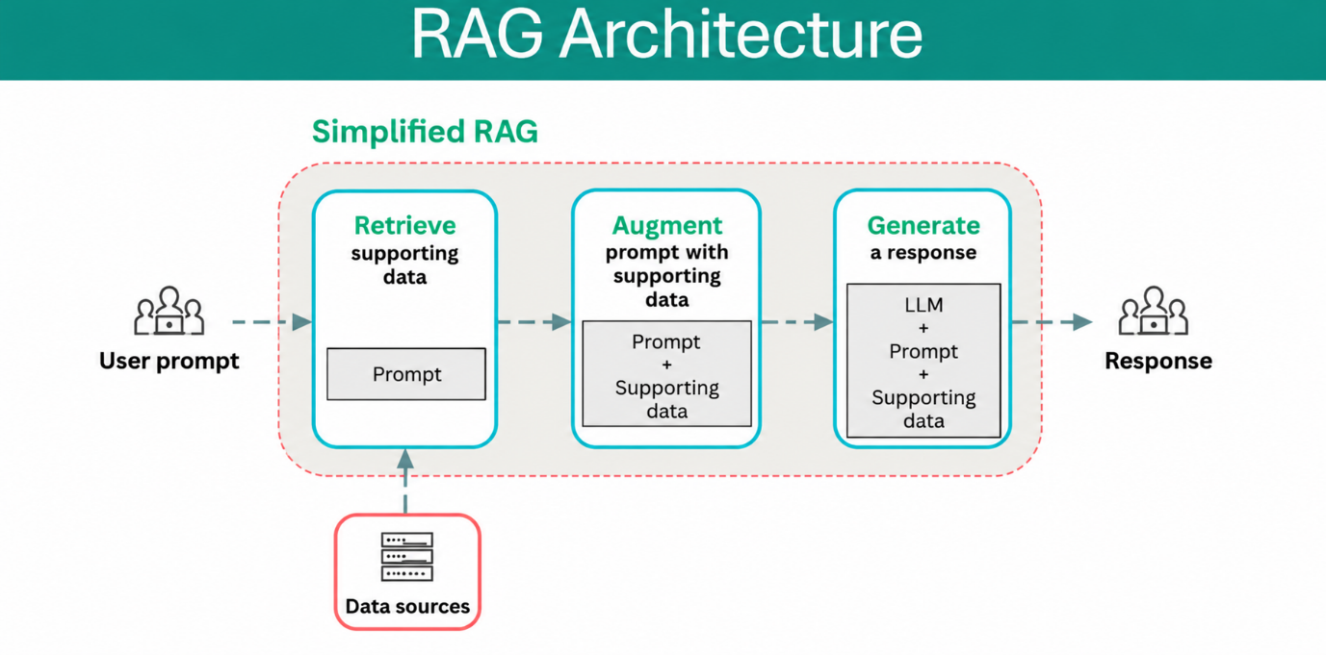

Business value
- Enables users to search hundreds of PDF documents using natural language.
- Provides access to structured business data stored in Delta Tables.
- Reduces manual effort spent searching documents and querying tables.
- Combines information from different data sources through a single conversational interface.
- Uses Databricks capabilities for data access, retrieval, model serving, and application delivery.

Implementation:

Upload data files (unstructured and structured) to Unity Catalog Volume

Catalog Create new Catalog(Agentic_catalog) Create schema(agentic_schema) create a volume(customer_service)-> upload all data files (PDFs and CSV files)

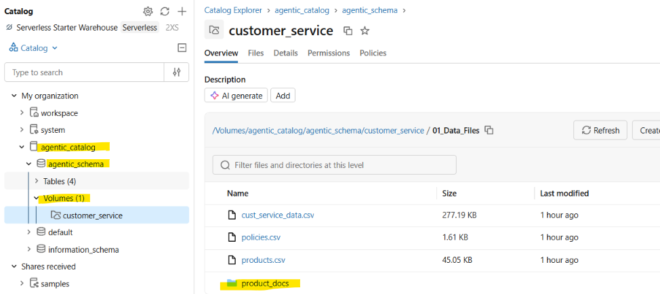

Databricks Notebook: “02_Parse_PDF_Docs”

a PDF Document Processing Pipeline which
- Discover the PDF files
- Develop a Text Extraction Function for PDF
- Extract text from all PDFs Iterate through each PDF file, extract the text, and prepare the data for our table.
- Create Delta tableconvert extracted data to spark data frame and write it to unity catalog table.
- Verify the generated table

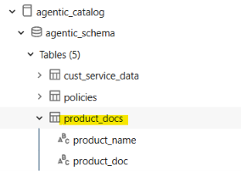

- Create tables on top of csv files in databricks UnityCatalog

agentic_catalogagentic_schemacreate table upload csv files

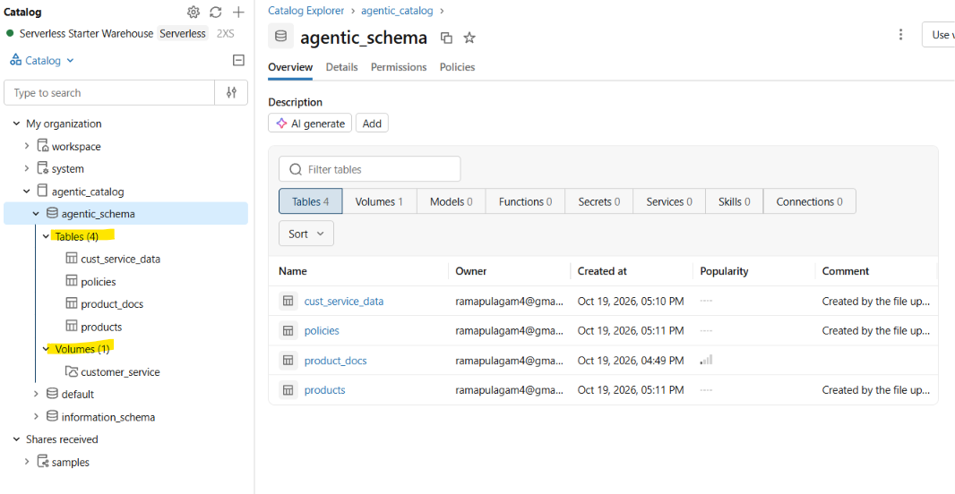

Databricks notebook: “03_Enrich_PDF_Files”

Product Documentation Indexing Pipeline
- Load product and documentation data from Unity Catalog tables
- Join the tables based on product name
- Create an indexed document format for downstream processing
- Save the results to a new table

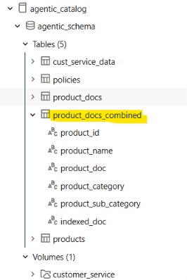
- The Indexed documents are ready for:
- Vector embeddings generation
- LLM-based retrieval
- Semantic search applications
- AI agent workflows

In my project: Databricks generates a vector (embedding) from each text entry in product_docs_combined. The Vector Search index organizes those vectors. When a user asks a question, Databricks converts the question into a vector too, finds similar vectors in the index, and retrieves the corresponding text rows for the LLM.
- Embedding/Vector = numerical representation of text meaning [0.12,0.23….]
- Delta table = stores the source text, embeddings and metadata.
- Vector Search index = enables similarity search over those embeddings.
- Endpoint = the serving infrastructure used to perform the search.
Key distinction: the vector is the numerical representation; the Vector Search index is the system that makes searching those representations efficient.
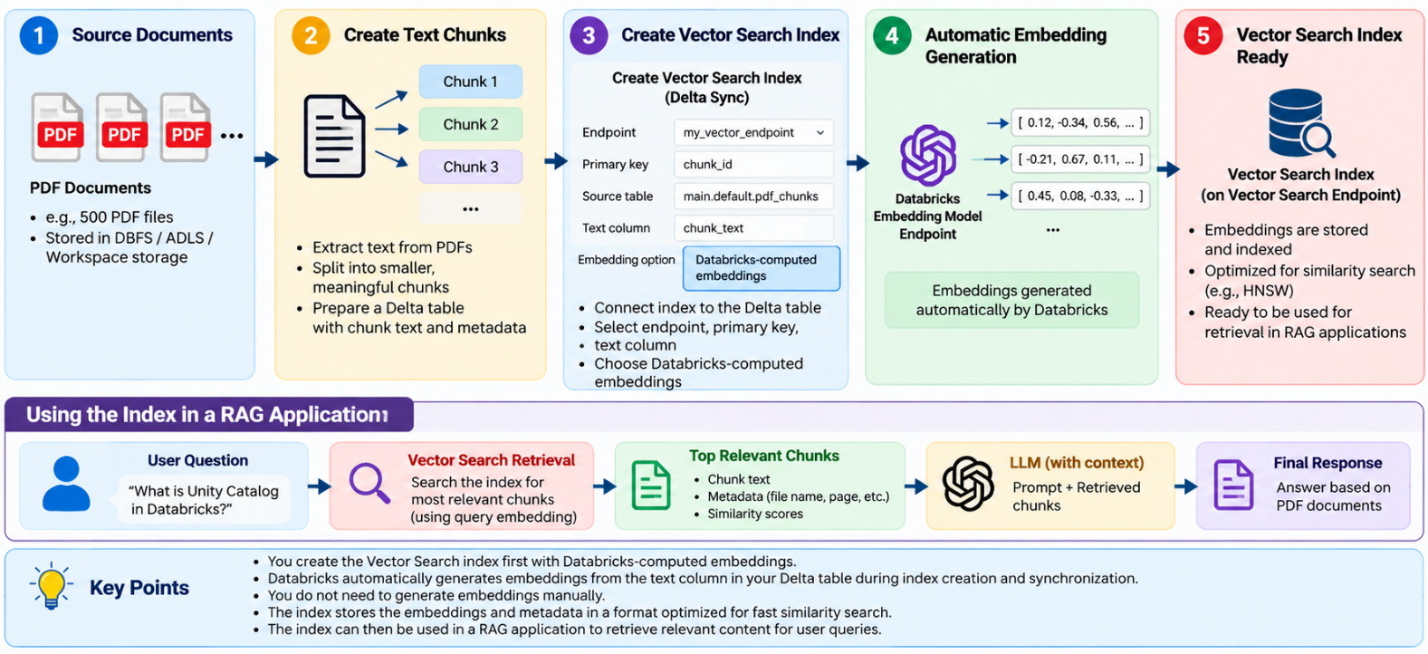

Step-1: To query the enriched table(product_docs_combined), we create Vector Search Index, to do that
set the table properties delta.enableChangeDataFeed = true
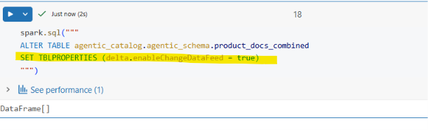

Step-2: Create Vector Search Endpoint
For hosting vector index that we are going to create so that it can queried programmatically. This functionality is provided through Vector Search Endpoint.
ComputeAI SearchCreate End Point
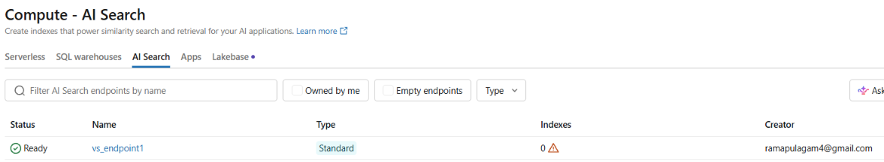
To make index available here, create an index
Agentic_catalog agentic_schema product_docs_combined table Create AI search Index
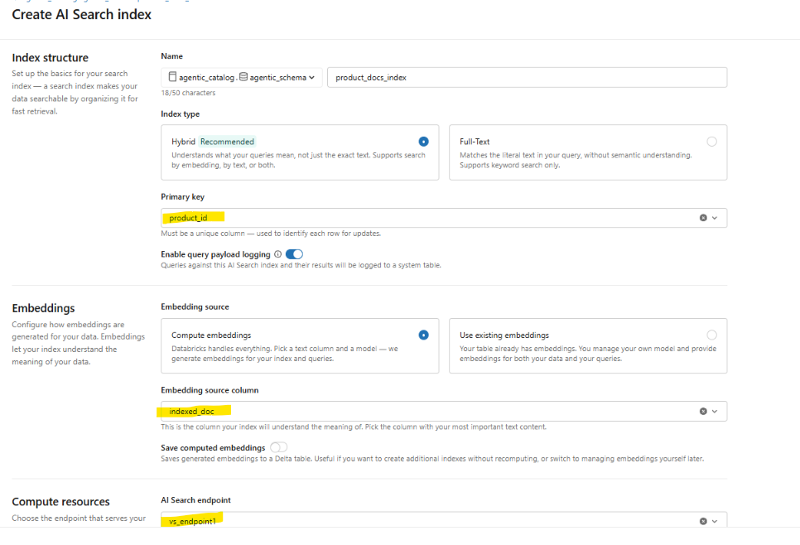
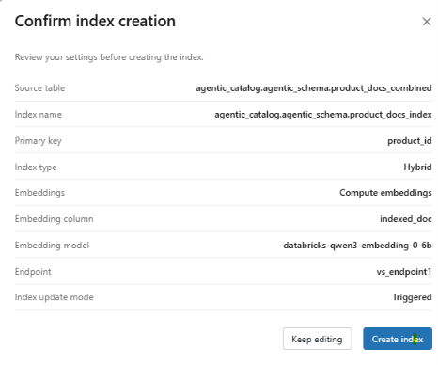
Check the status under:
agentic_catalogagentic_schemaproduct_docs_index Pipeline id (click on the link)
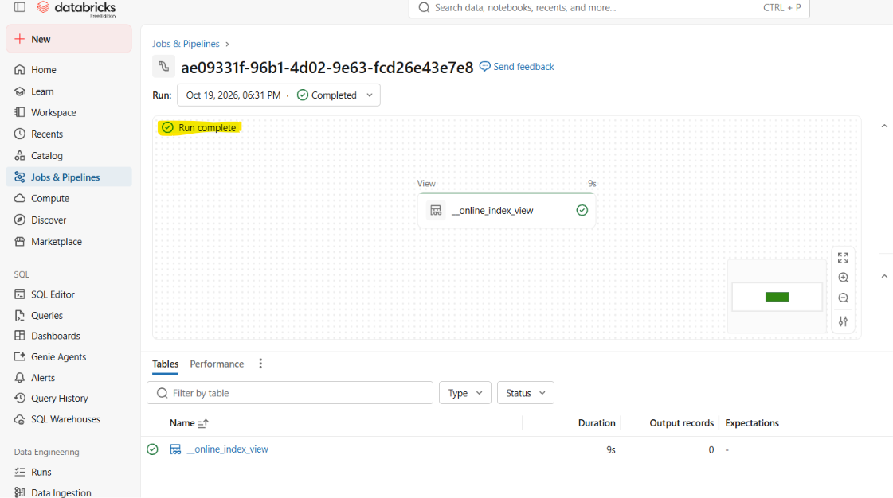
View the sample data:
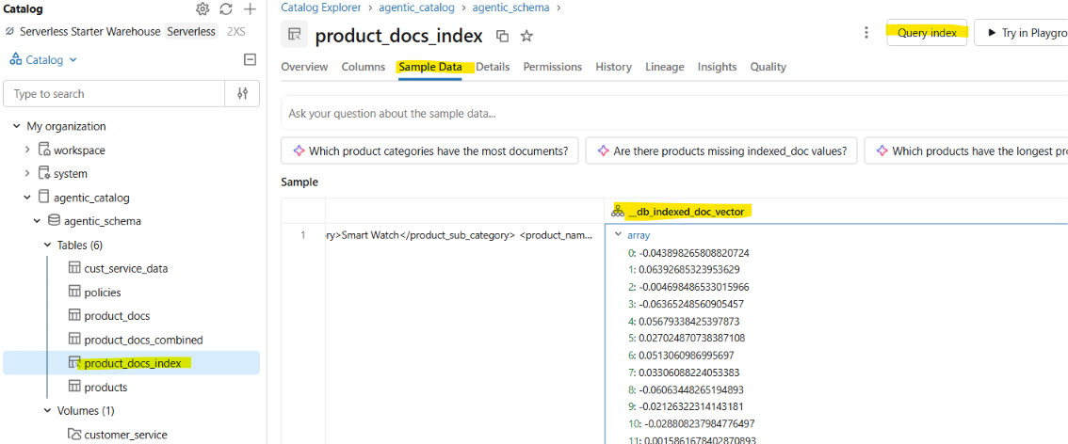

Test query: where can I find Accountease Pro Documentation

Click on query index: type your query, disable “Enable reranker”

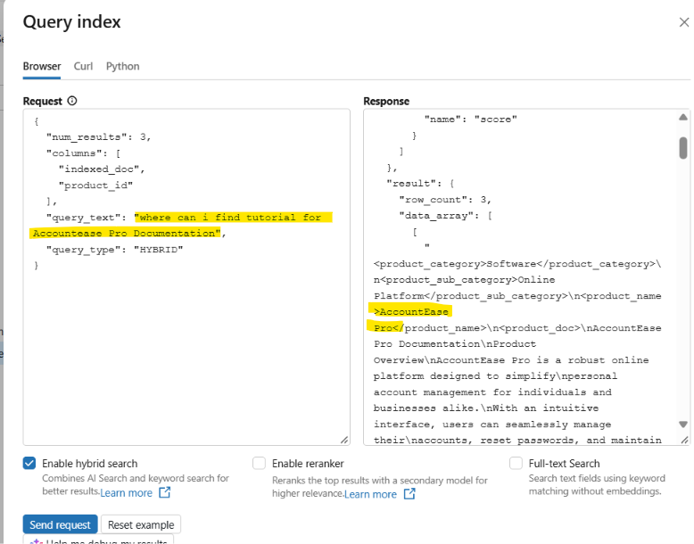

You can also try out in python: copy paste the code in notebook

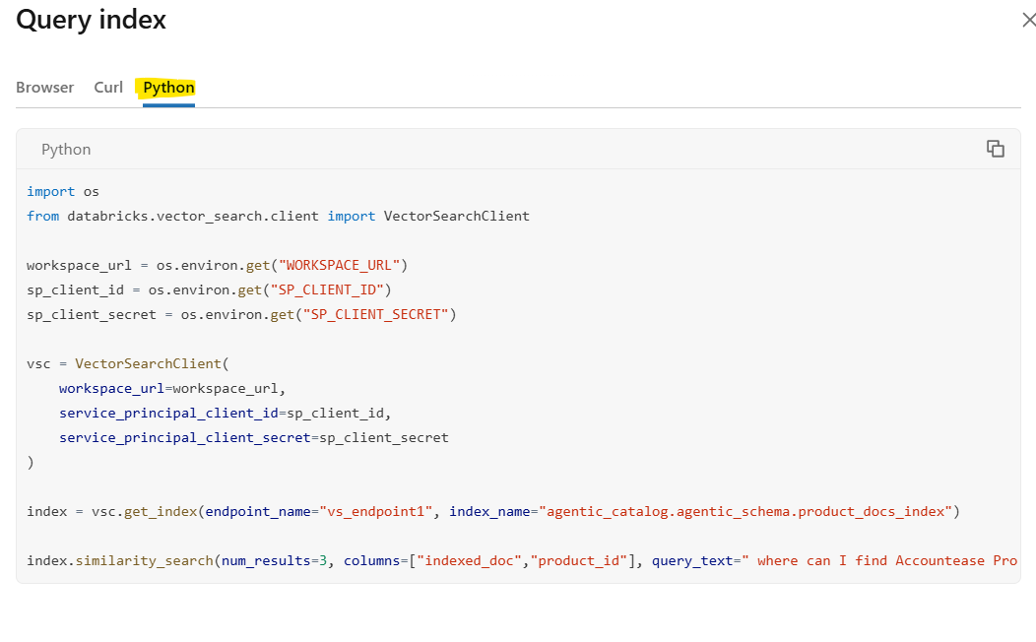

Databricks notebook: 04_VectorSearch_Index

Genie corrected the code to avoid system crash

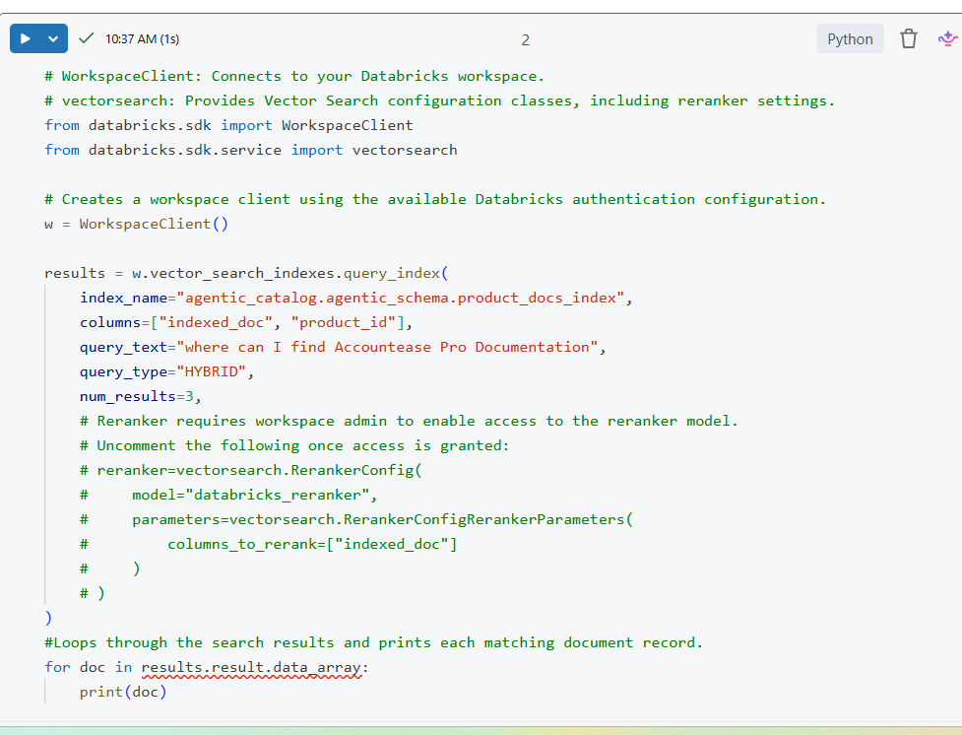

- Create User defined functions for structure data

(csv data as tables) as there is no direct way to include tables in the playground.

1). get_return_policy:
- This function creates a reusable Unity Catalog SQL table-valued function named get_return_policy that accepts a policy name as input.
- RETURNS TABLE defines the output structure: policy, policy_details, and last_updated.
- RETURN (SELECT ...) executes the SQL query, filters the policies table using the input policy name, and returns at most one matching record.
- The function is stored in Unity Catalog and can be called whenever policy details are needed, without rewriting the query.

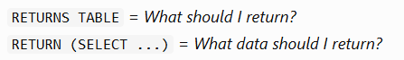

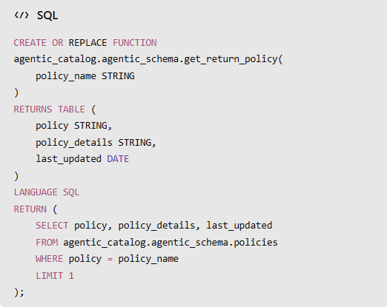

2). Get_service_history:
- Creates a reusable Unity Catalog SQL table-valued function named get_service_history that accepts a customer's email as input.
- RETURNS TABLE defines the output columns: return count, issue category, and today's date.
- The SQL query filters cust_service_data by email, groups records by issue_category, and counts records in each category.
- The function returns the results for customer-service analysis; currently, it does not filter records to the last 12 months despite the column name.

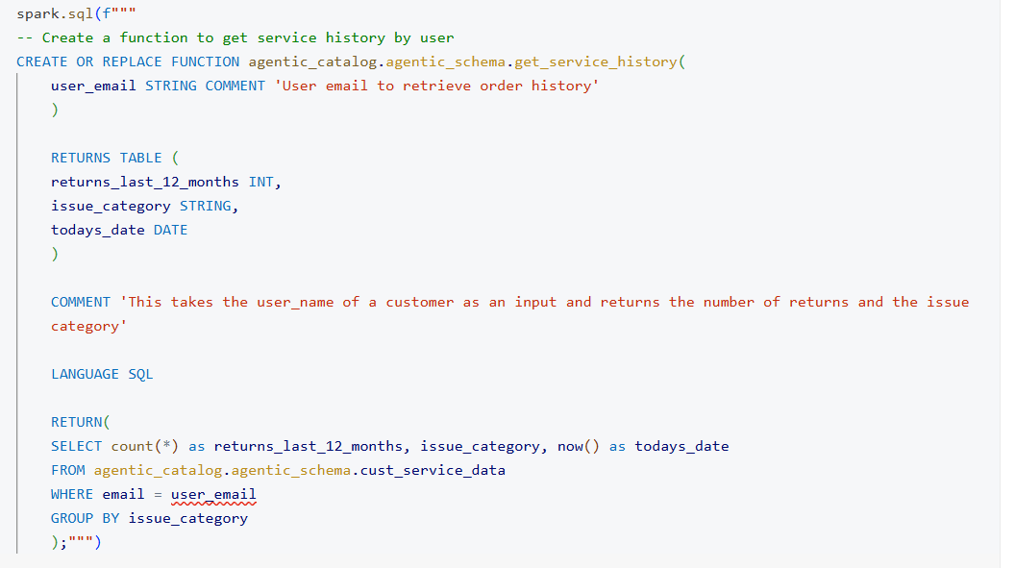

- Build own serving model

LLM model GPT OSS 120B

Tools Add all UC functions and AI search vector index.

Go to Playgroundtoolsadd Toolvector search/UC functionsselectsave

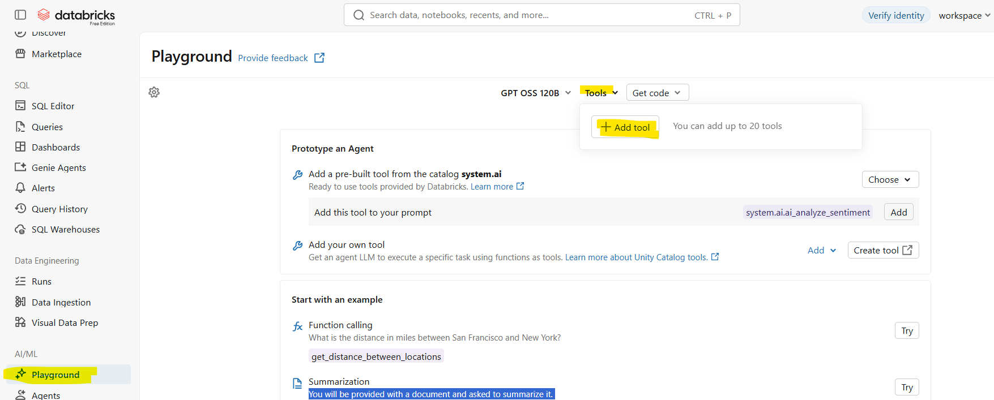

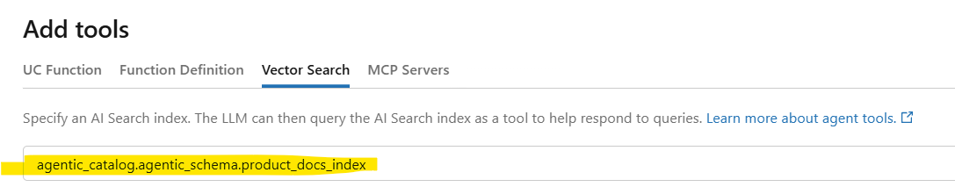

Now ask the question in query window:

Successful RAG flow: User Question Converted to embeddings → Databricks Vector Search across the table → Retrieve Relevant Documents → LLM Generates Answer → Response to User.

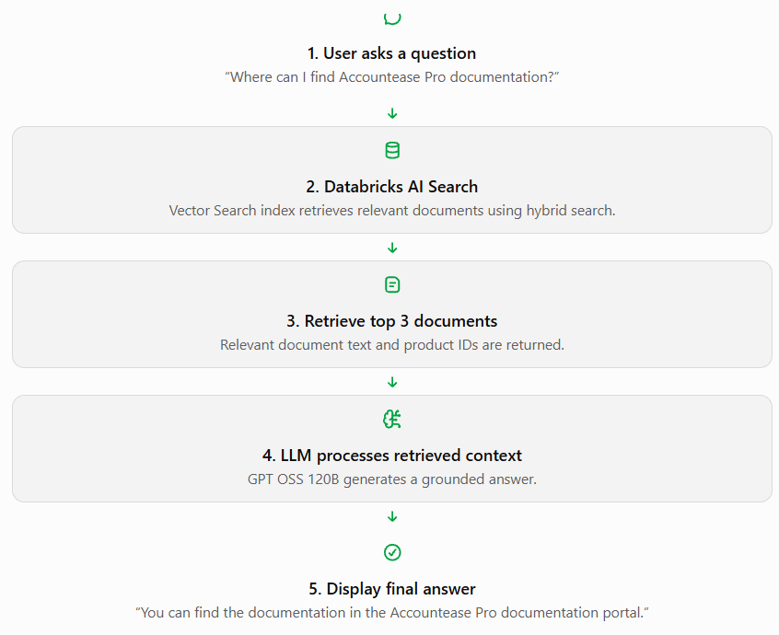
- Register as an Agent and build a databricks app on it.

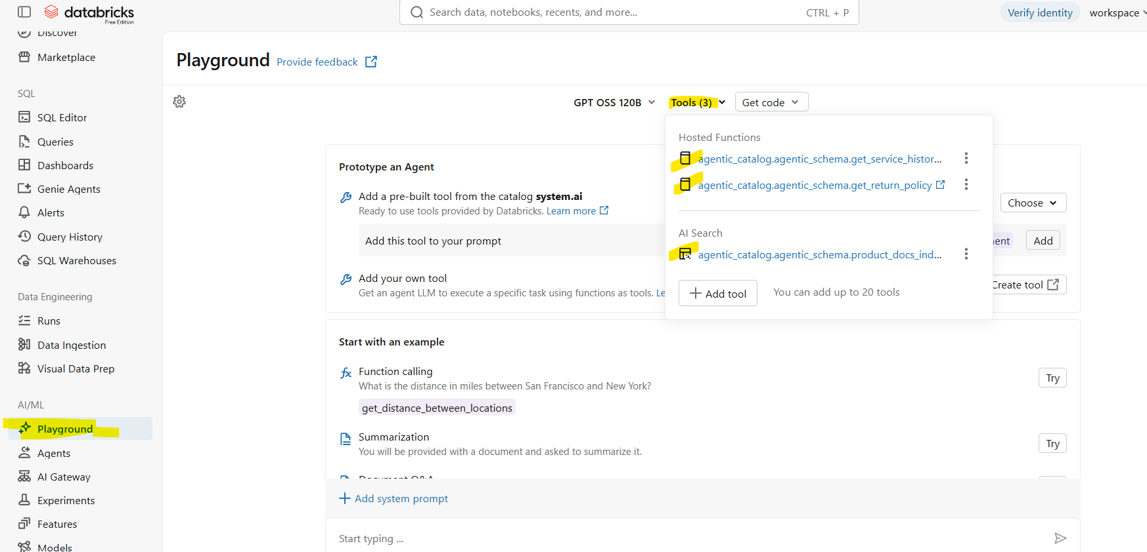

Crosscheck the combination: user querysummarize return policy

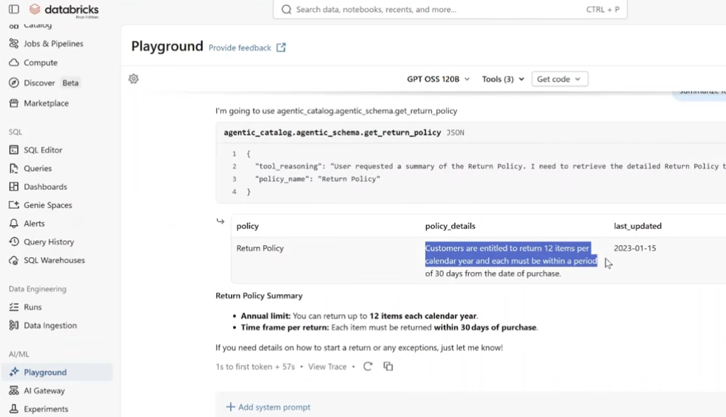
Now, register this combination as a model serving
  - Clear out history first
  - Click on get codecreate agent notebook
  - Opens up a new page and databricks automatically writes code for the model
  - Provide Input for catalog, schema and model name
  - Run
Important check: the endpoint name shall be consistent
DatabricksServingEndpoint may expect a traditional serving endpoint, while system.ai.gpt-oss-120b is a Unity Catalog model service.
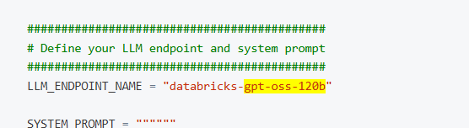

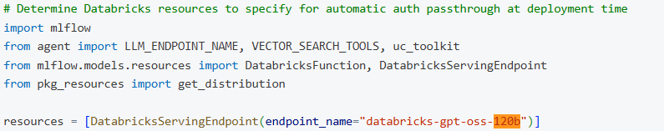

Inputs shall be provided for:
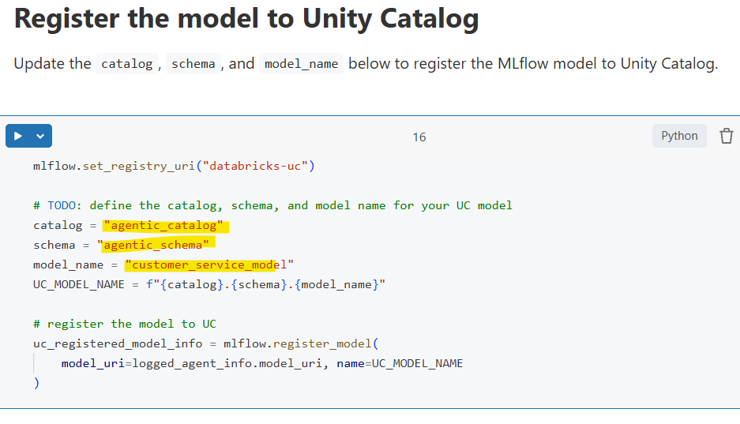
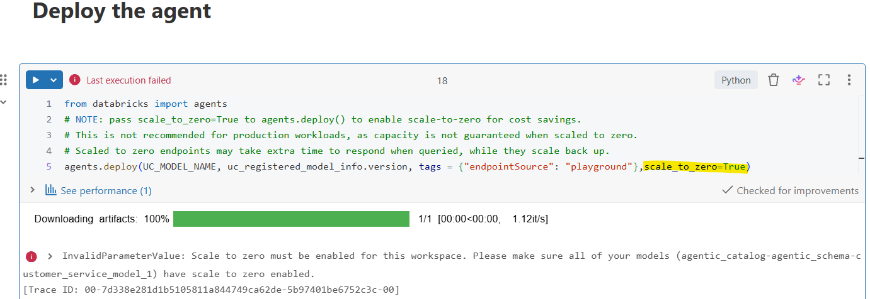
Add this parameter for free edition, it no errors->It has successfully deployed the model
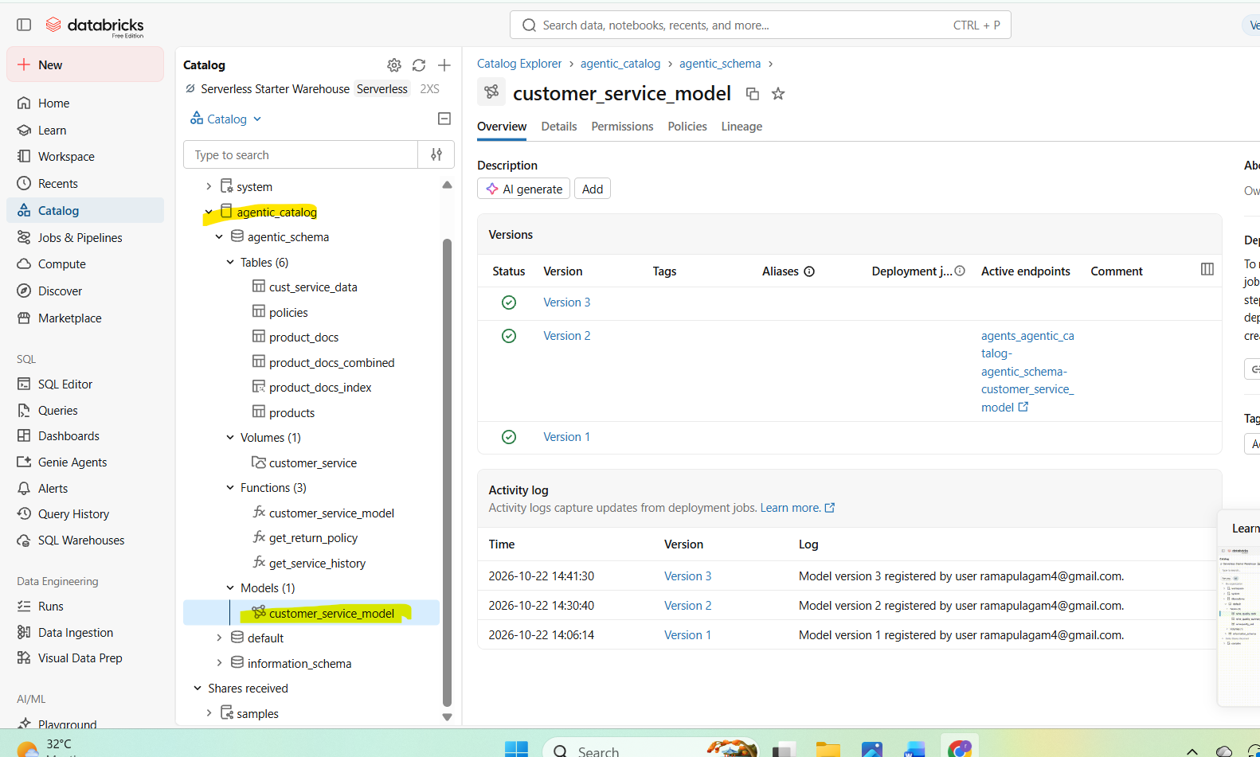

View the deployed agent:
Serving-> your modelclickopen in playground
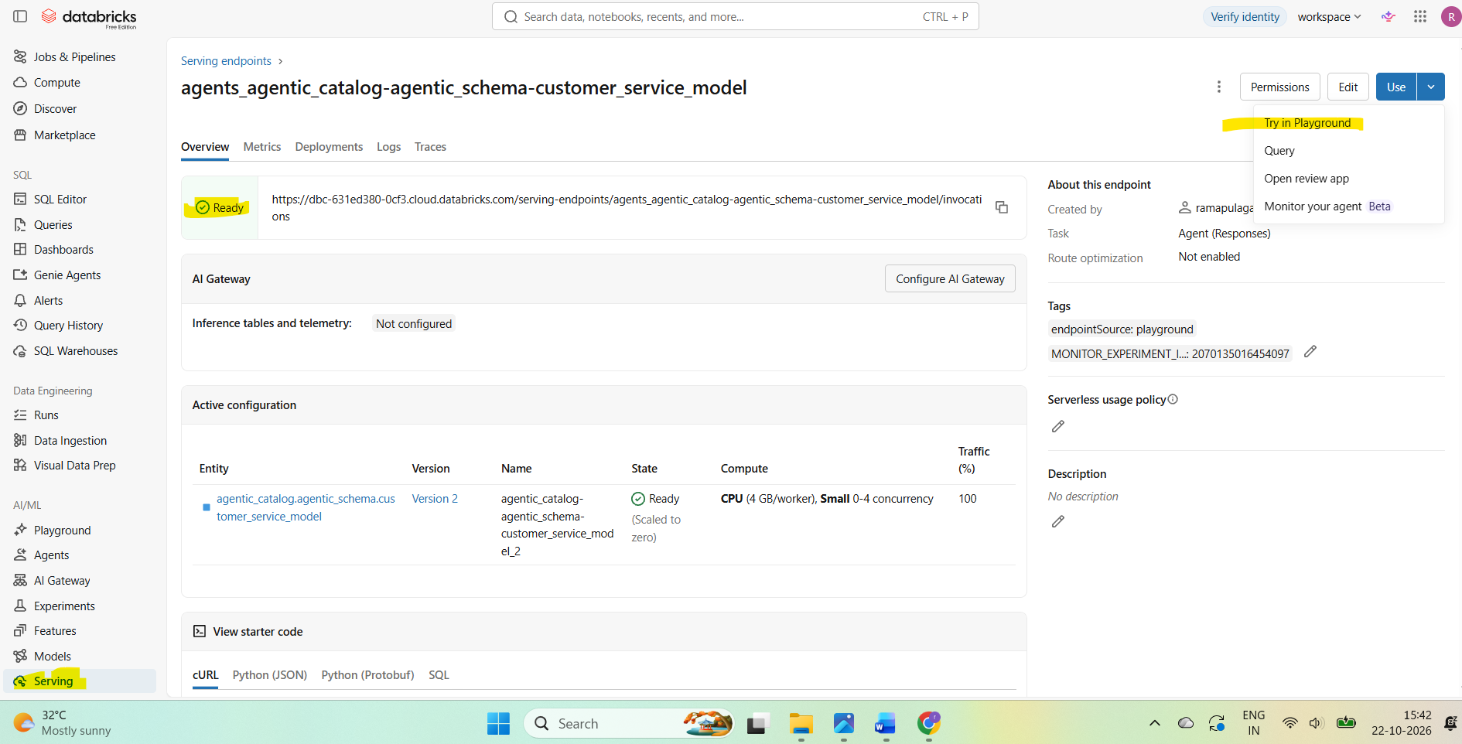
It shows as below,
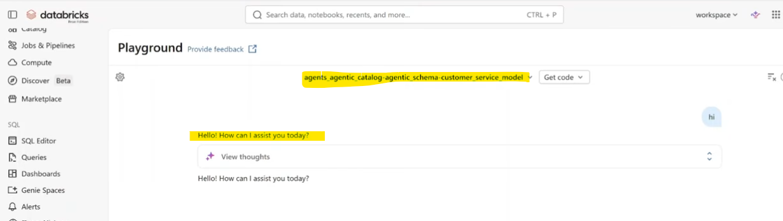

Environment details:
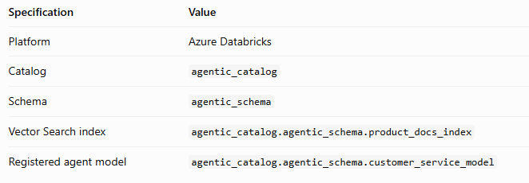

- Create Databricks APP to make this model available for business users

ComputeAppsDatabricks AppCreate NewSelect AgentsChat UI for existing Agent

ConfigureAuthorization(default)Add Metadata

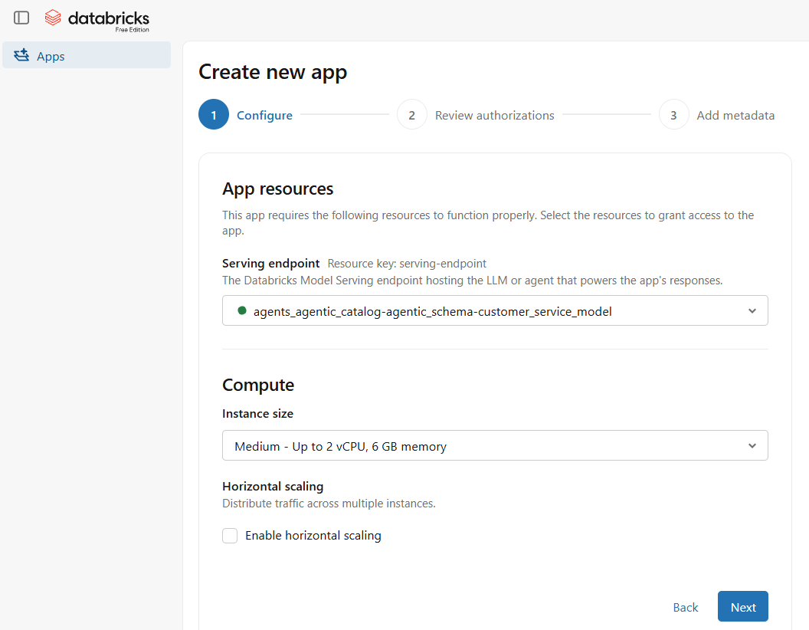

Add Metadata: Give App name and description and click Create.
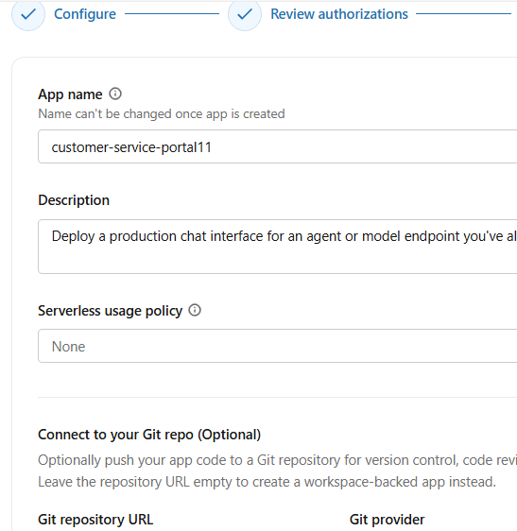

Last setting:
1. user authorizationadd scopeAccess databricks Model serving
2. Overviewdeploy

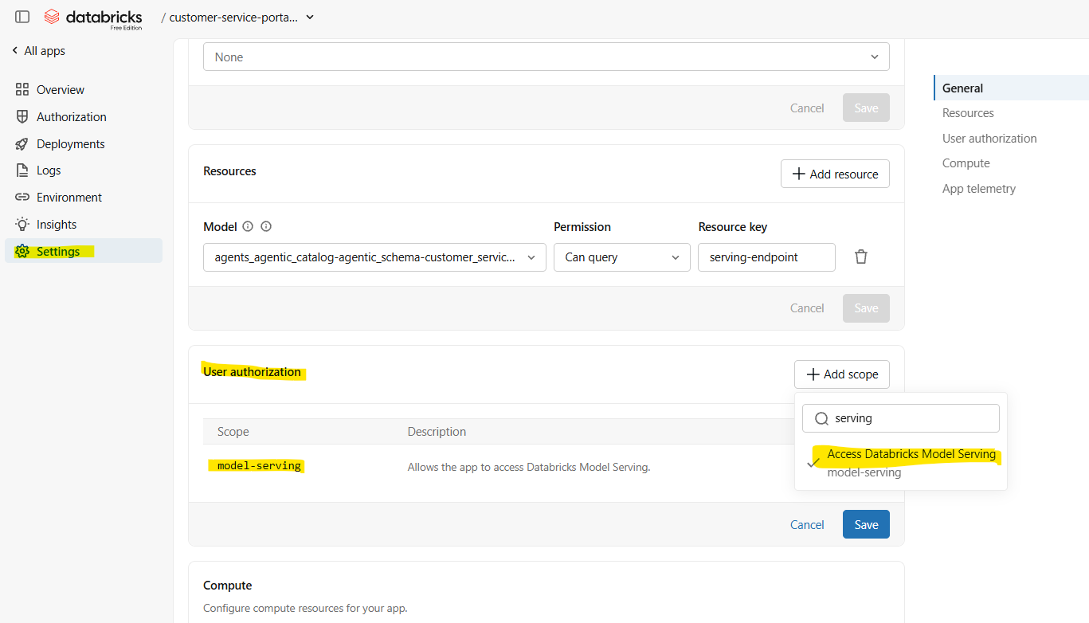

Deployment done, Click on the App URL:

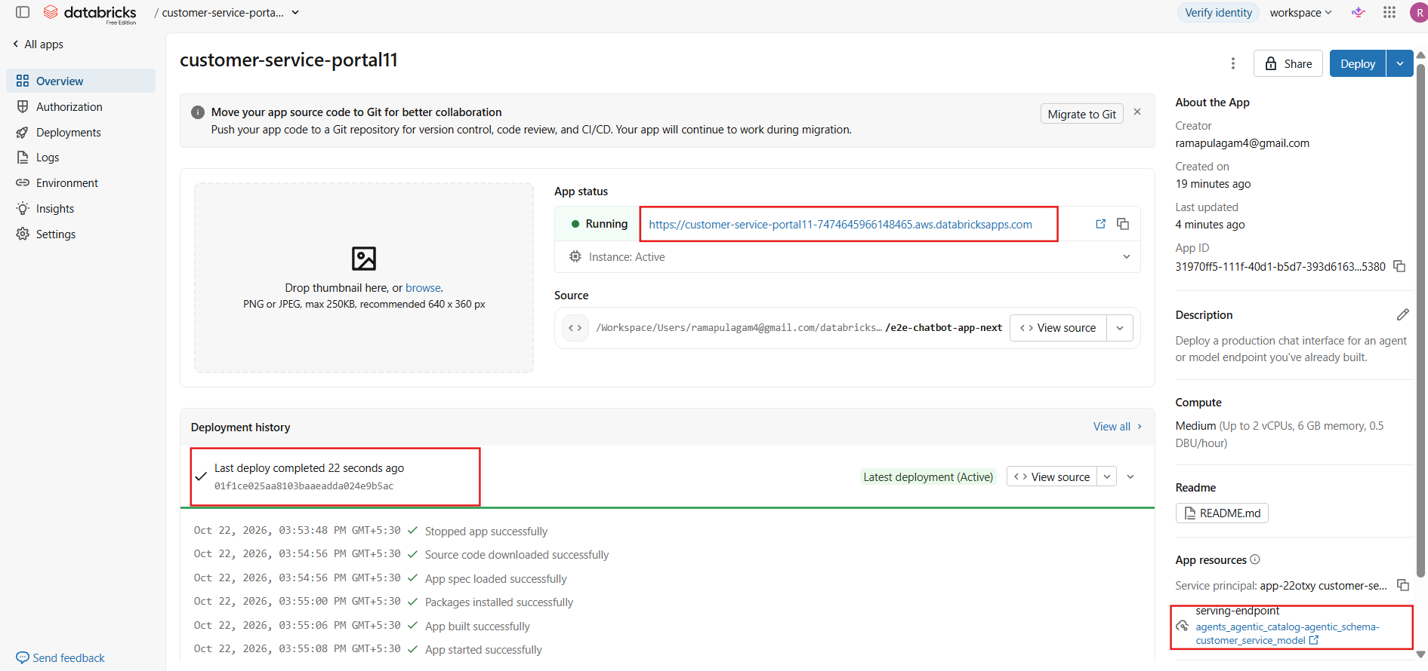

Login, authenticate (scope is helpful now) APP:
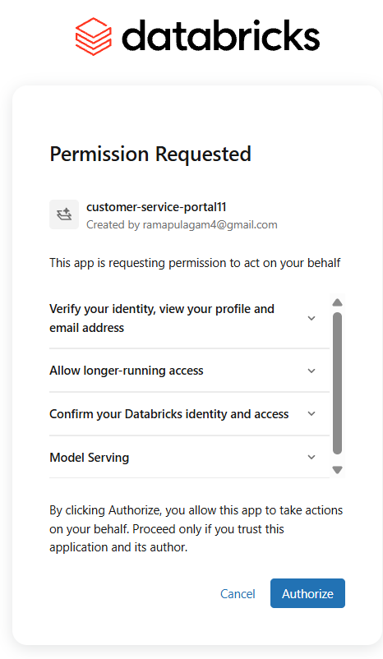

Your App is ready for chat:
App is able to query from structured and unstructured tables
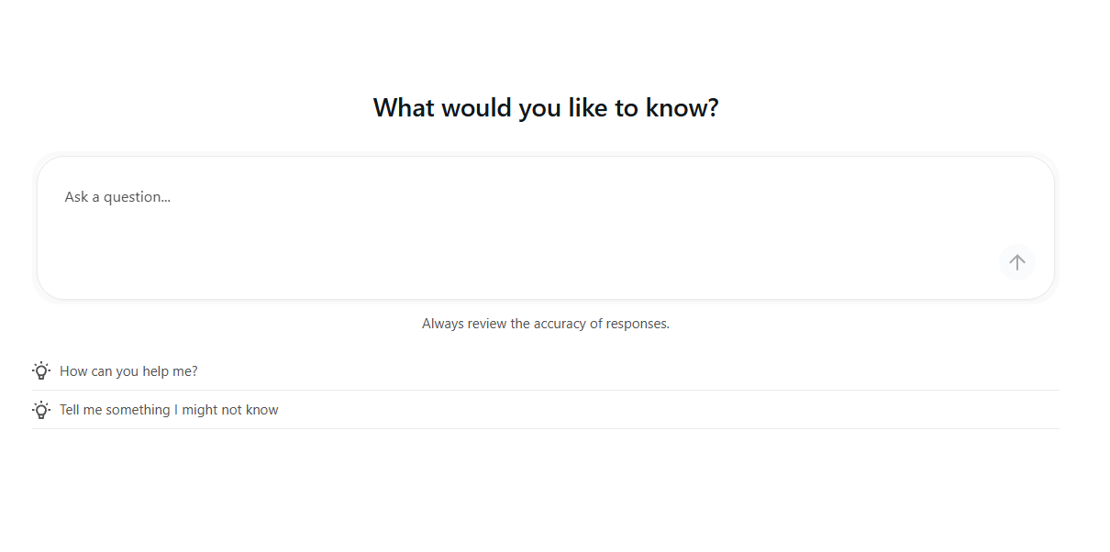
Chatbot is responding:

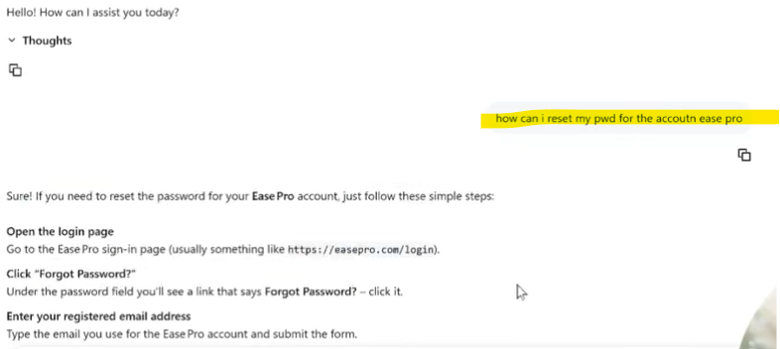

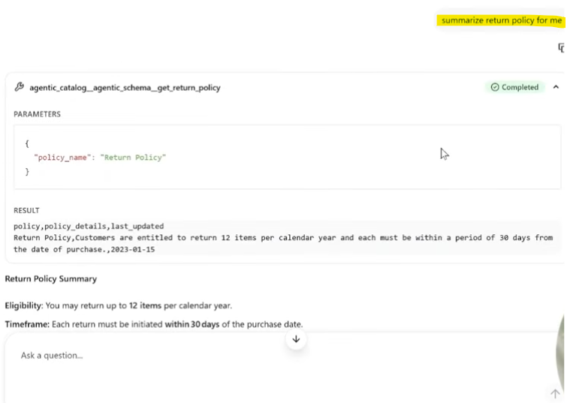

Crosscheck the ML flow:

Servingyour modeltraces

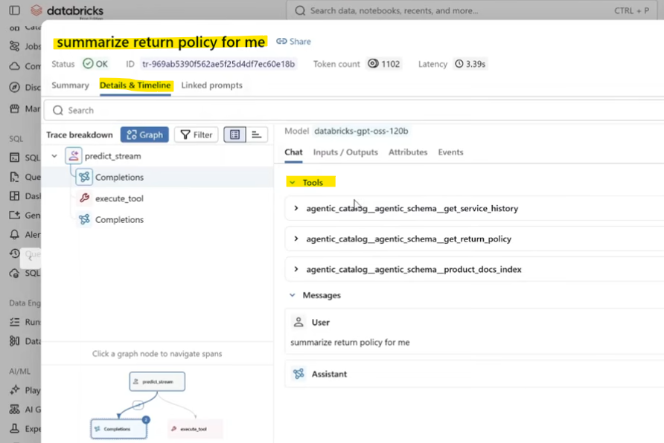

AI Customer service app flow
- Databricks App: authenticates to the deployed agent using its configured backend identity.
- Agent: invokes the approved Unity Catalog functions and Vector Search index.

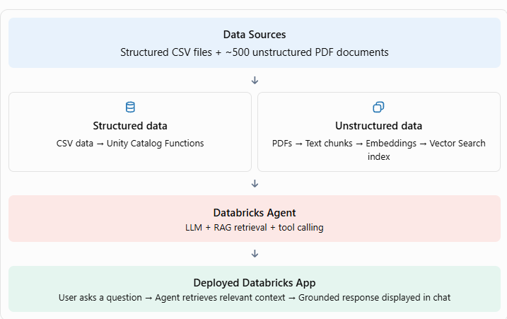

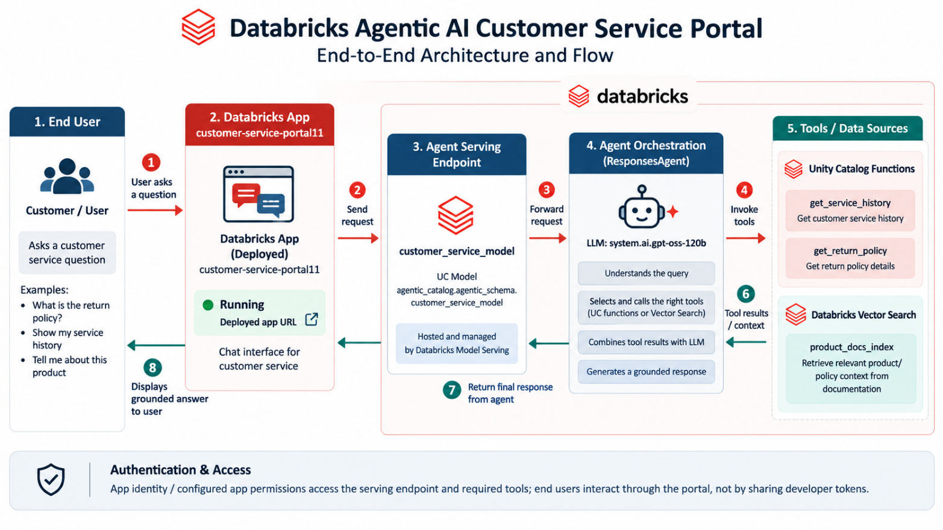
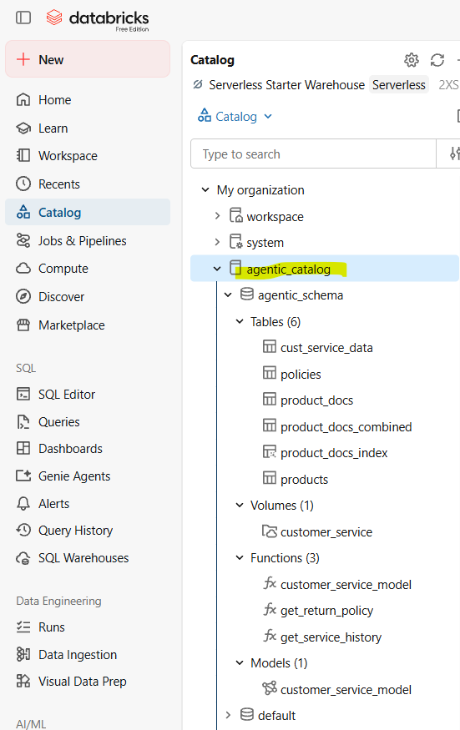

Appendix
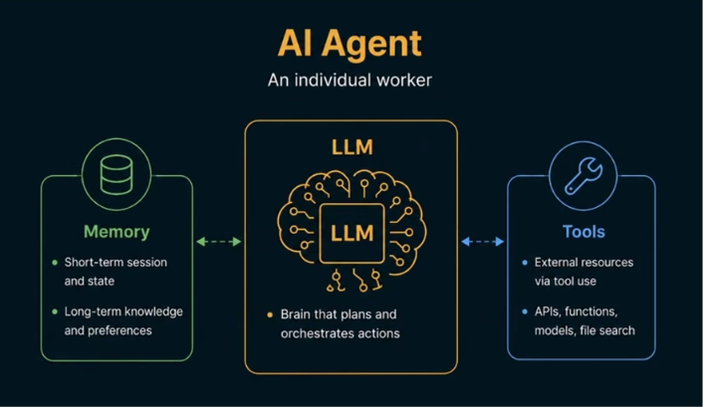

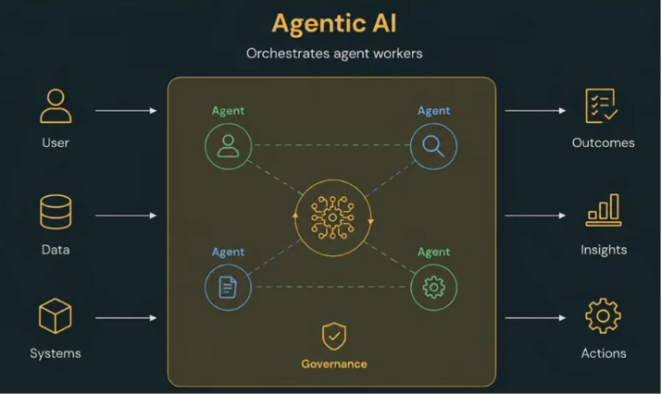

Scenario: A user wants to returns his/her order
Human process thinks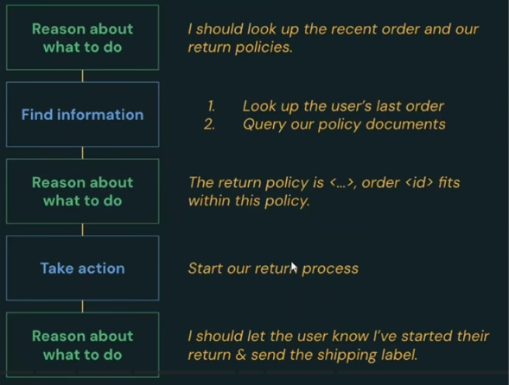

Same does the AI Agent
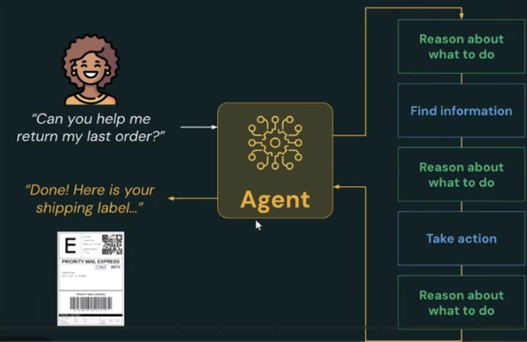

Model used:
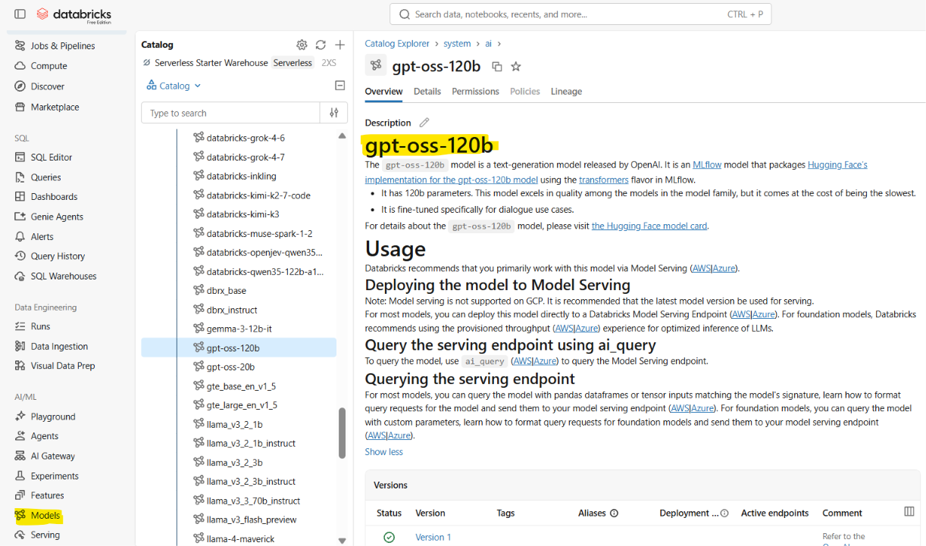

Interacting with AI Model
- Using python program:
Note: you give your query in the content field
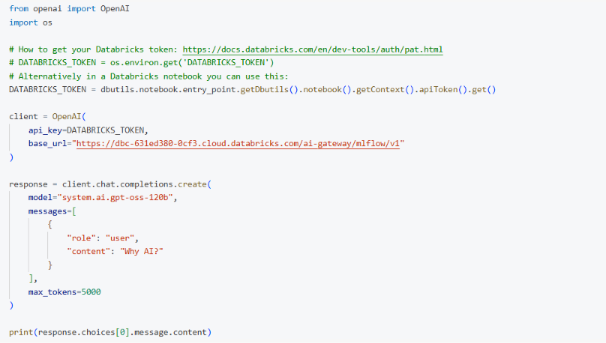
Output as below:
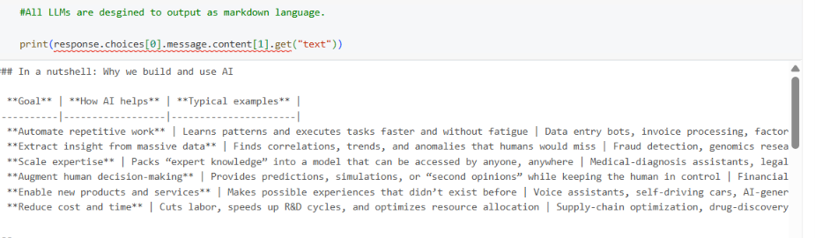
Copy-paste in markdown window:
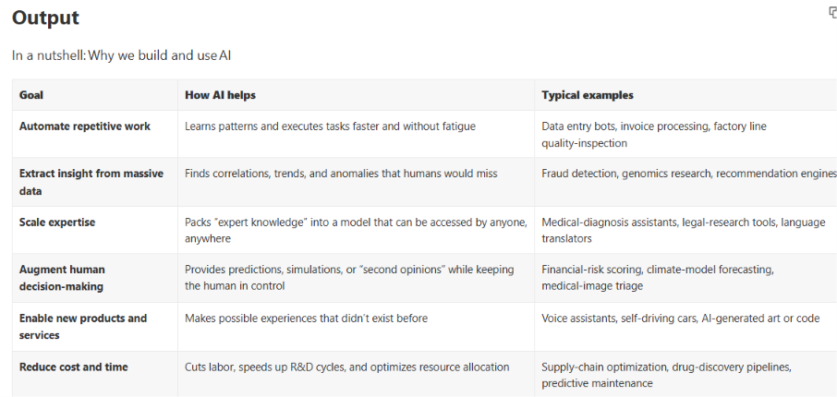

- Using SQL query

