1. Create Database project_movie_data and deploy table data according to ER diagram.

ANS<-create database project_movie_data ;

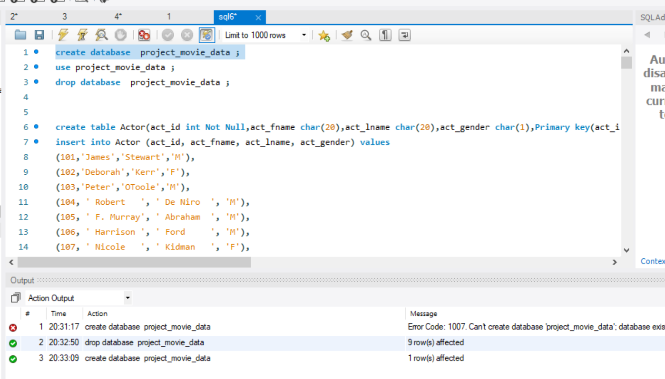2.Create 9 tables which are presented in ER model and load the data with their foreign key and primary key values.

ANS->1. create table Actor(act_id int Not Null,act_fname char(20),act_lname char(20),

act_gender char(1),Primary key(act_id));

1)create table Director(dir_id int Not Null ,dir_fname char(20),dir_lname char(20),

Primary Key (dir_id));

2)create table Genres(gen_id int Not Null,gen_title char(20) Not Null,Primary Key(gen_id));

3)create table Reviewer(rev_id int Not Null,rev_name char(30),primary key(rev_id));

4)create table Movie(mov_id int Not Null ,mov_title char(50),mov_year int,mov_time int,mov_lang char(50) Not Null,mov_dt_rel date,mov_rel_country char(50) ,Primary Key(mov_id));

5)create table Movie_cast(act_id int Not Null ,mov_id int Not Null,role char(30),foreign key(act_id) references actor(act_id),foreign key(mov_id)references movie(mov_id));

6)create table Movie_direction(dir_id int Not Null,mov_id int Not Null,foreign key(dir_id) references director(dir_id),foreign key(mov_id)references movie(mov_id));

7)create table Rating(mov_id int Not Null ,rev_id int Not Null,rev_stars int,num_o_ratings int,foreign key(mov_id) references movie(mov_id),foreign key(rev_id) references reviewer(rev_id));

8)create table Movie_genres(mov_id int Not Null,gen_id int Not Null,foreign key(mov_id)references movie(mov_id), foreign key(gen_id) references genres(gen_id));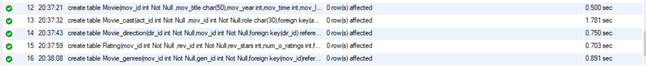

3. Write a query in SQL to list the Horror movies?

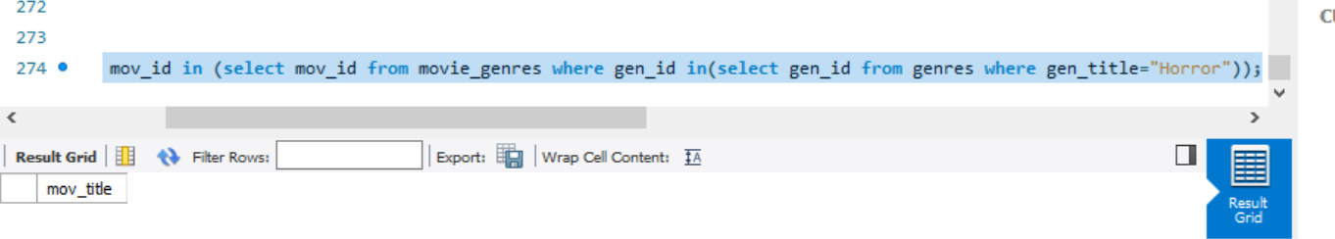

4. Write a query in SQL to find the name of all reviewers who have rated 8 or more stars?

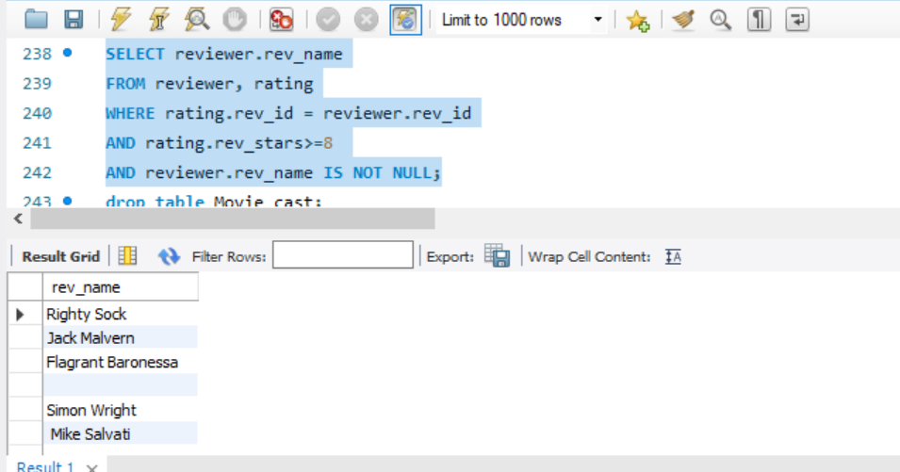

5. Write a query in SQL to list all the information of the actors who played a role in the movie ‘Deliverance’

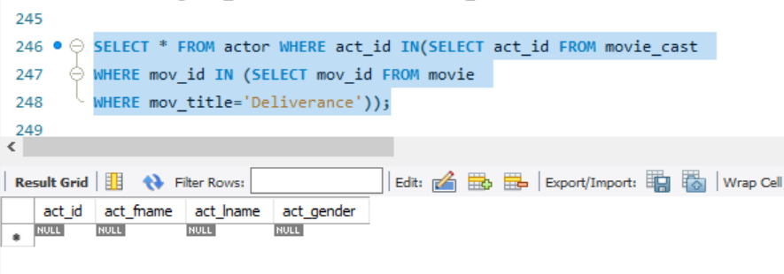

6. Write a query in SQL to find the name of the director (first and last names) who directed a movie that casted a role for ‘Eyes Wide Shut’. (using subquery)

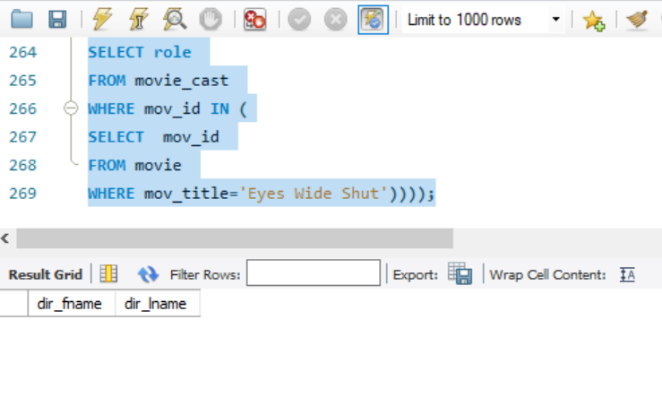

7. Write a query in SQL to find the movie title, year, date of release, director and actor for those movies which reviewer is ‘Neal Wruck’

