1. Write a program that prompts the user to input a positive integer. It should then output a message indicating whether the number is a prime number. 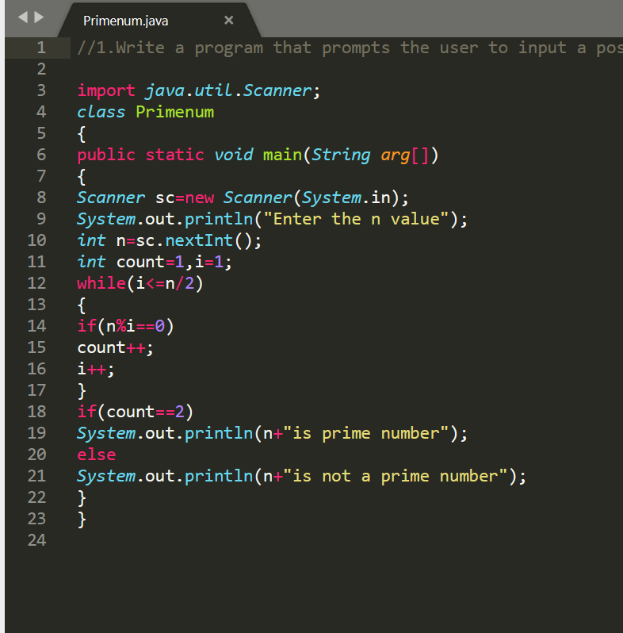

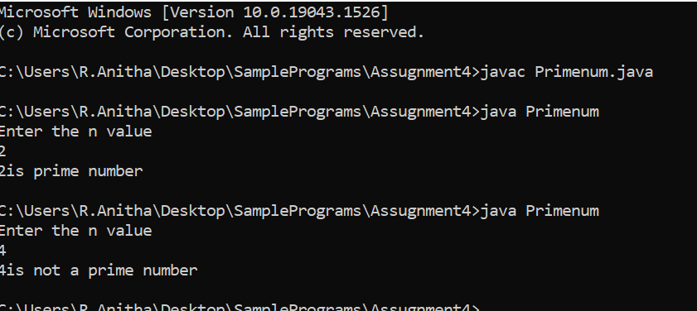

1. Write a program that prompts the user to input a positive integer. It should then print the multiplication table of that number.

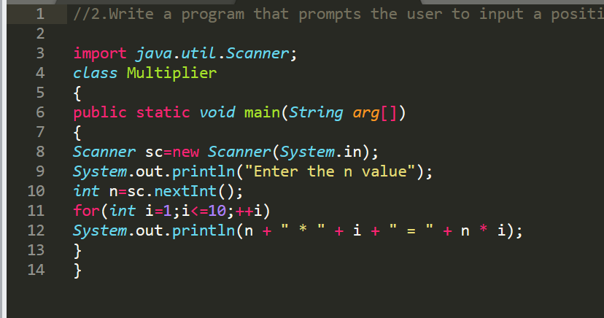

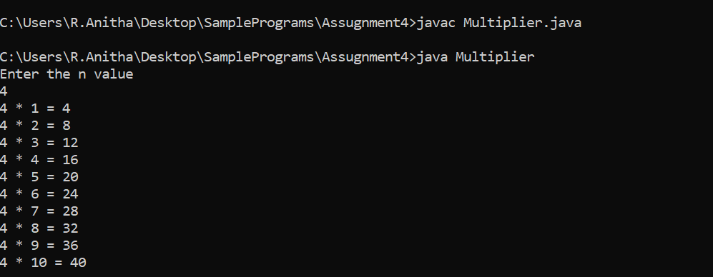

3.A student will not be allowed to sit in exam if his/her attendance is less than 75%.

Take following input from user

Number of classes held

Number of classes attended.

And print

percentage of class attended

Is student is allowed to sit in exam or not.

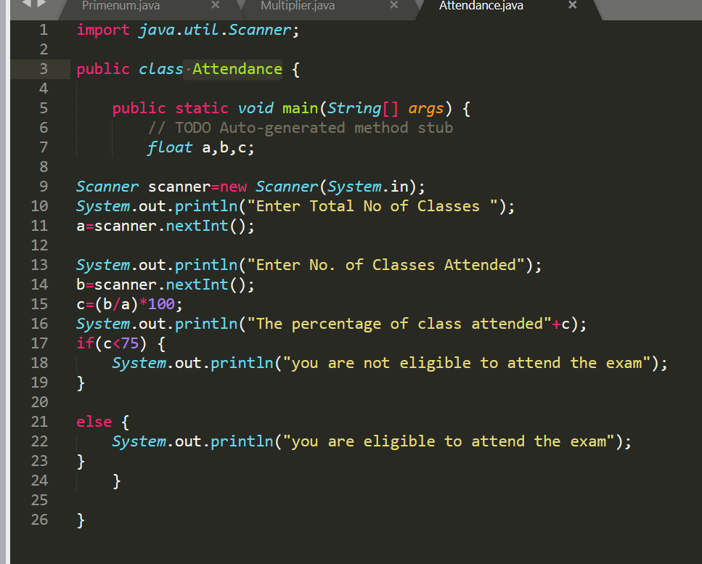

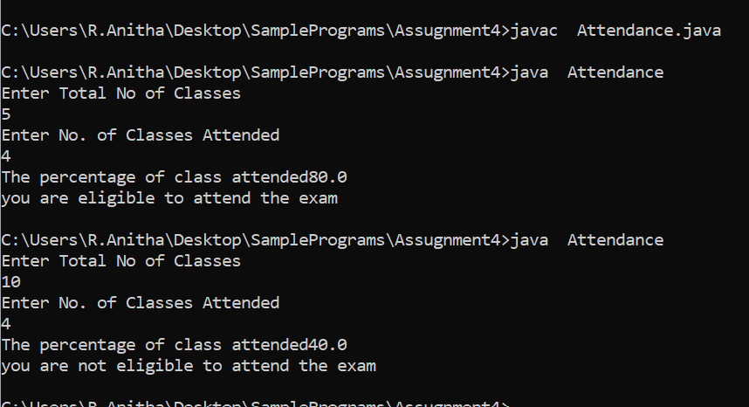

4.A company decided to give bonus of 5% to employee if his/her year of service is more than 5 years.

Ask user for their salary and year of service and print the net bonus amount. Note- create a method Employee Bonus to calculate the bonus and return it.

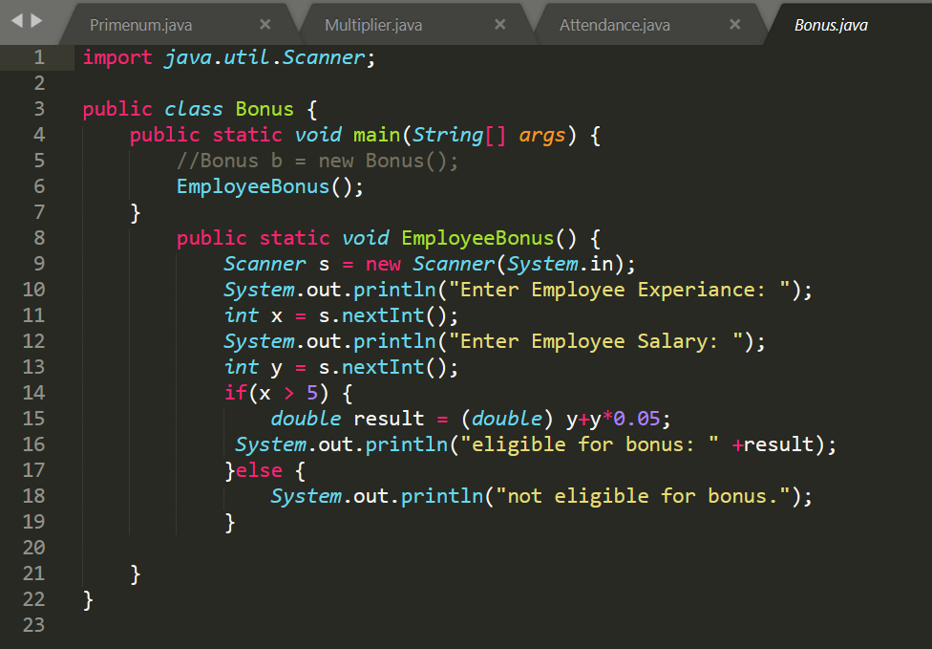

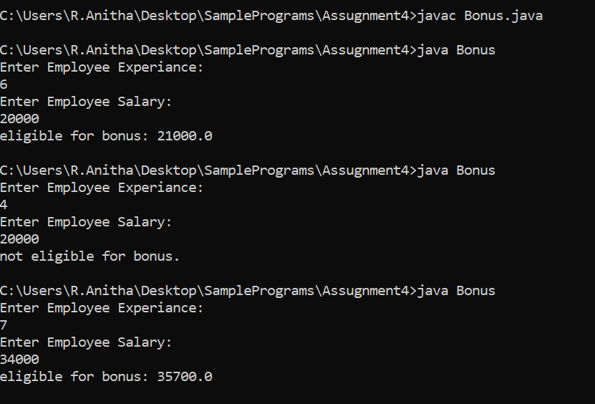

5. Write a program to input the following details:

i)Employee Name

ii)Employee Salary

iii)Employee Year of joining

Calculate the Loyalty bonus of the Employee's by

a)if the year of their joining is on or before than 2017,and their Salary is more than 30000/-,

then the bonus will be 22% of the salary.

b)if the year of their joining is on or before than 2017,and their Salary is less than 30000/-,

then the bonus will be 33% of the salary.

c)if the year of their joining is on or before than 2012,

then the bonus will be 40% of the salary.

d)if the year of their joining is after 2017,and their Salary is less than 30000/-,

then the bonus will be 15% of the salary.

e)if the year of their joining is after 2017,and their Salary is more than 30000/-,

then the bonus will be 10% of the salary.

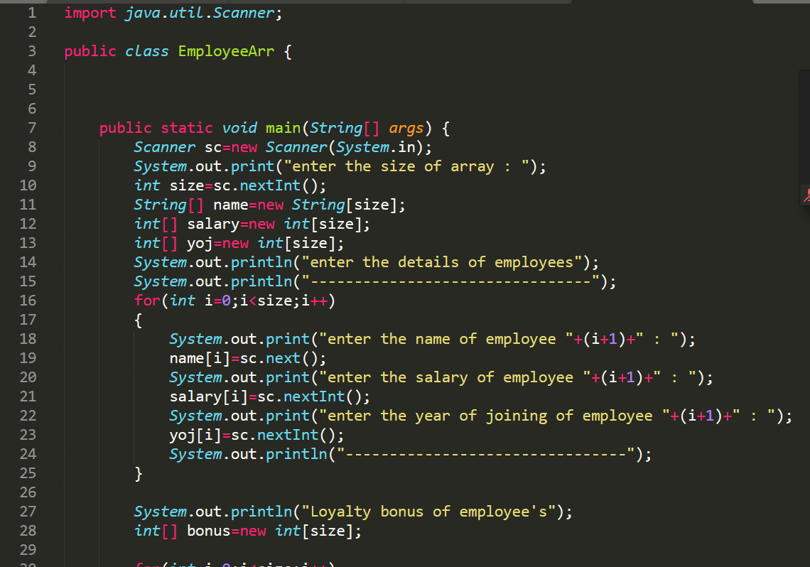

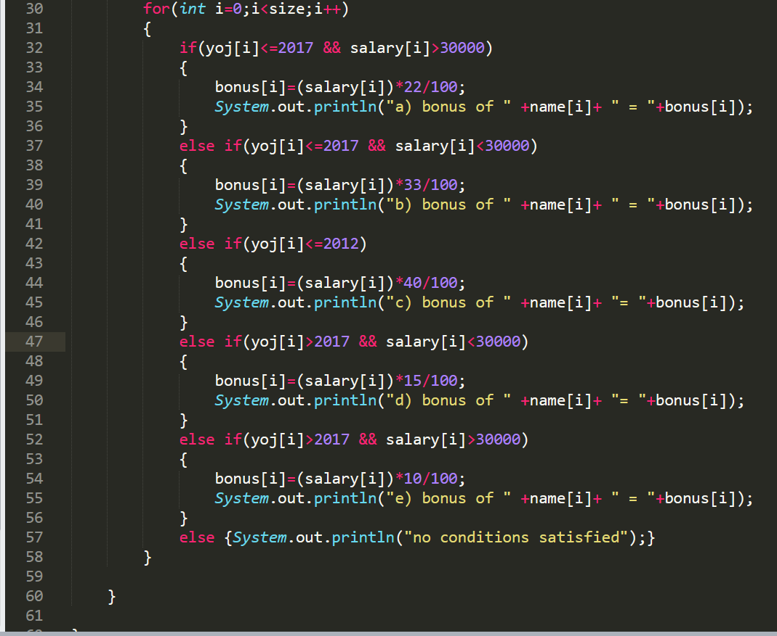

6. Write a program to check for the occurrence of a particular character in a string and display how many times it has occurred.

note: take the String and the character to be checked as a input from the user.

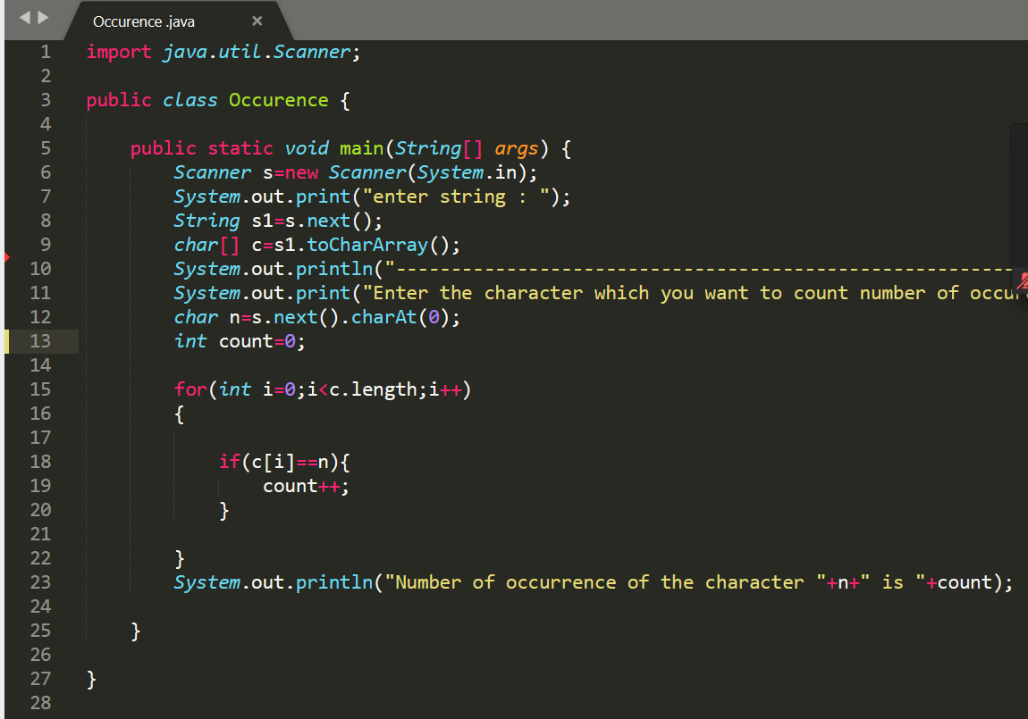

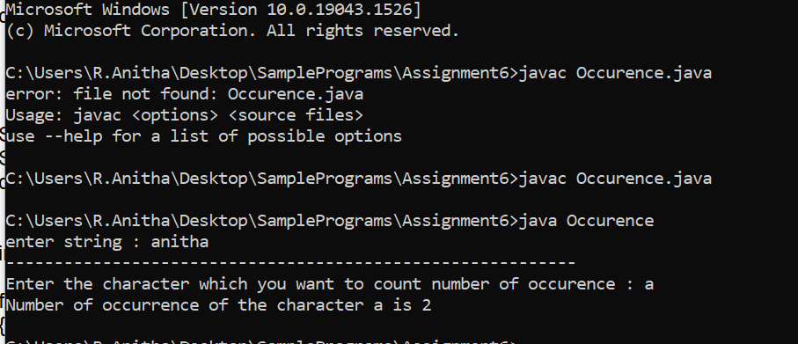

7. Write a program to implement nested try-catch block for NULL Pointer exception

and NumberFormat Exception

