RAMAPURAM VARSHA REDDY
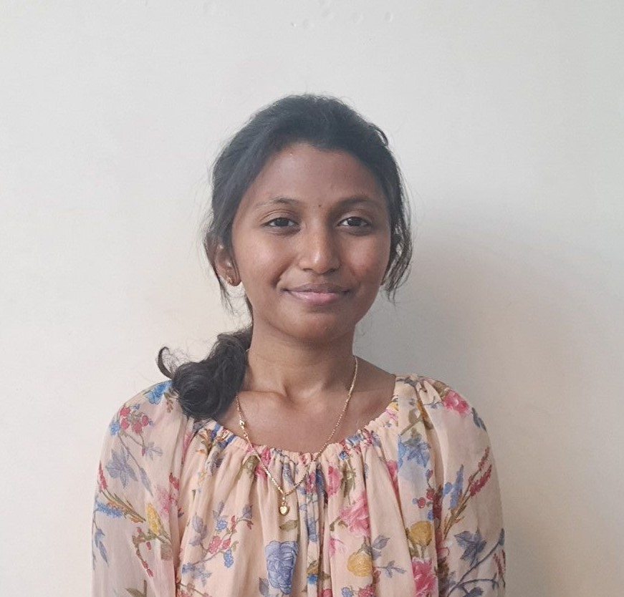

pic.jpeg
- ramapuramvarshareddy@gmail.com
• 9346391583
- LinkedIn: linkedin.com/in/ramapuram-varsha-reddy-ba7816290/
- GitHub: github.com/ramapuramvarshareddy

Objective
Motivated Computer Science (AI) undergraduate with strong foundations in end-to-end application development and AI/ML, seeking opportunities to apply technical skills to real-world problems. Passionate about building secure, intelligent, and user-centric applications using modern technologies. Eager to contribute, learn, and grow in a dynamic and innovation-driven organization.

Education
G Pullaiah College of Engineering and Technology 2022 - 2026
B. Tech in CSE-AI Score: 86%
Narayana Junior College 2020-2022
BIEAP Score: 90%
Sri Lakshmi High School 2020
SSC Score: 97%

Skills and interests
Programming Languages Java, Python, C
Frontend Technologies HTML, CSS, JavaScript, APIs, React, Node.js, JWT
Database SQL, MongoDB
AI / ML Neural Networks, NLP, TensorFlow, Keras, MediaPipe, OpenCV
Tools GitHub, VS Code, Google Colab, Jupyter Notebook, Cursor, OpenAI, Microsoft Office
Soft Skills Critical thinking, Adaptability, Quick Learning, Problem-Solving

Internships
Infosys Springboard Virtual Internship | AI Intern
- Focused on Artificial Intelligence concepts and applications through structured learning modules.
- Gained hands-on experience by developing a project based on AI.
- Enhancing practical knowledge in AI techniques and problem-solving through guided mentorship.

Projects
Placement Pulse
- Developed a full-stack platform where students can share and explore real interview experiences to enhance placement preparation.
- Implemented secure JWT-based authentication, AI-powered content filtering using OpenAI API, and complete post management features (create, edit, delete).
- Built a responsive React + Tailwind UI with personalized dashboards to track user contributions and engagement metrics.
- Tech Stack: MERN Stack
Print Board
- Created an AI-powered virtual keyboard controlled through hand gestures and long-press selection, enabling typing without a physical keyboard.
- Utilized MediaPipe for hand landmark detection and OpenCV for capturing webcam feed and displaying the virtual interface.
- Tech Stack: AI (OpenCV, Media Pipe, pynput)

Certifications
- Google Cloud: Generative AI Leader track
- Oracle Cloud Infrastructure: Certified Generative AI Professional
- Scaler: SQL
- ServiceNow: Certified System Administrator
- Hacker Rank: Python

