# PROJECT-A: Documentation

# **TEAM: PANDAS**

* Venkata Rama Rahul Chintalapati
* Anukta Neela Saraswati
* Amrit Sabat
* Pragyat Singh

1. Import workbook and load_workbook from openpyxl library.

*from openpyxl import Workbook*

*from openpyxl import load_workbook*

1. Import colors and Font from openpyxl.styles.

Colors, Font - These are classes which we are importing from openpyxl.

*from openpyxl.styles import colors*

*from openpyxl.styles import Font*

1. Load the two excel files into workbooks ‘wbn’ and ‘wbo’.

*wbn = load_workbook('excel_file_new.xlsx')*

*wbo = load_workbook('excel_file_old.xlsx')*

1. Load sheet1 from workbooks into the worksheets ‘wsn’ and ‘wso’.

*wsn = wbn['Sheet1']*

*wso=wbo['Sheet1']*

*wbs = Workbook()*

*wss=wbs.active*

1. Create a font object and assign red color to it. We are importing the class color and calling the font and colors functions and assigning red color to the font.

*ft = Font(color=colors.RED)*

1. Iterate over all rows and columns and check for nonzero and string data values to subtract the numeric values and highlight the nonzero values.

*for i in range(1,wsn.max_row+1):*

*for j in range(1,wsn.max_column+1):*

*cell_new=wsn.cell(row=i,column=j)*

*cell_old=wso.cell(row=i,column=j)*

*#print(cell_new,cell_old)*

*if cell_new.data_type=='n':*

*wss.cell(row=i, column=j).value = cell_new.value-cell_old.value*

*else:*

*wss.cell(row=i, column=j).value = cell_new.value*

*if wss.cell(row=i,column=j).data_type=='n' and wss.cell(row=i,column=j).value!=0:*

*wss.cell(row=i,column=j).font=ft*

1. Save the sheet into a new excel file.

Save() – This function will create or overwrite a new excel file.

*wbs.save('subtract_openpyxl_final.xlsx')*

# **Input excel files:**

Table 1-Old

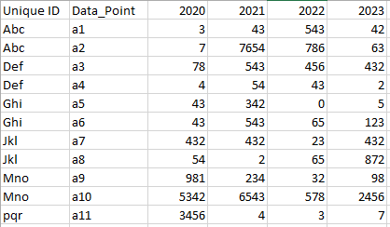

Table 2-New

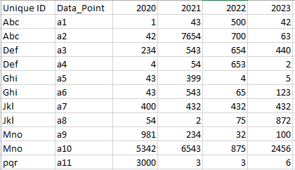

# **Output excel file:**

Table 3-Output

