# PROJECT-A: Documentation

# **TEAM: PANDAS**

1. Import pandas library.

*Import pandas as pd*

1. Insert the new excel file into dataframe (df1).

*df1=pd.read_excel('excel_file_new.xlsx')*

1. Extract the required columns from the new and old excel files and store it into two dataframes df4 and df5.

*cols=[2,3,4,5]*

*df4=pd.read_excel('excel_file_new.xlsx',usecols=cols)*

*df5=pd.read_excel('excel_file_old.xlsx',usecols=cols)*

1. Subtract the data using the dataframes and store into another dataframe df6.

*df6=df4.subtract(df5)*

1. Define a function ‘color_negative_red()’ for highlighting the nonzero data values.

*def color_negative_red(val):*

*color = 'red' if val != 0 and type(val)!=str else 'black'*

*return 'color: %s' % color*

1. Insert the two identifiers column back into the result.

Insert() – This function is used to insert columns at their respective positions depending on the parameter passed.

*df6.insert(0,"Unique ID",df1["Unique ID"].tolist(),True)*

*df6.insert(1,"Data_Point",df1["Data_Point"].tolist(),True)*

1. Call the above function to edit df6 and store it in df9.

*df9=df6.style.applymap(color_negative_red)*

1. The final result is stored in the excel file titled, ‘subtracted_excel_file_final.xlsx’ in the sheet titled, ‘Sheet1’.

*writer = pd.ExcelWriter('subtracted_excel_file_pandas_1.xlsx', engine='xlsxwriter')*

*df9.to_excel(writer, sheet_name='Sheet1', index=False)*

*workbook = writer.book*

*worksheet = writer.sheets['Sheet1']*

1. Close the panda excel writer to output the excel file.

*writer.save()*

# **Input excel files:**

Table 1-Old

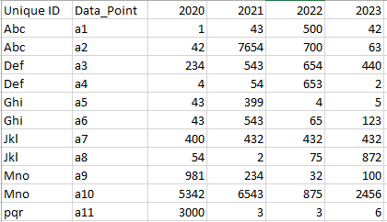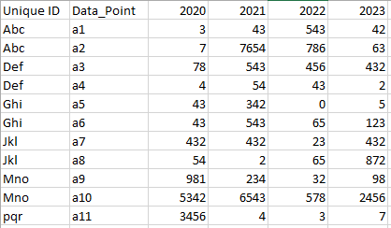

Table 2-New

# **Output excel files:**

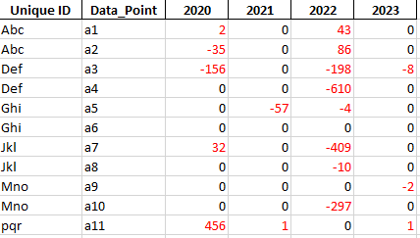

Table 3-Output