ClaimSense AI
Software Design Document and 12-Week MVP Delivery Plan
An intelligent, evidence-based insurance claims review platform for a three-person engineering team.
Safety boundary: ClaimSense AI supports adjusters. It does not autonomously approve, deny, or pay a claim. Every final decision is made and recorded by an authorized human adjuster.

Document field | Value
Version | 1.0 - MVP design baseline
Prepared for | ClaimSense AI project team (3 members)
Planning horizon | 12 weeks / approximately 60 working days
Status | Ready for team review and implementation
Date | 2026-09-06

How to use this document
Use this as the single implementation baseline for the next three months. Create backlog items from the requirement IDs, record architecture changes in the decision log, and update model/evaluation results as the team replaces assumptions with measured evidence.

Contents
- 1. Product definition and scope
- 2. Users and workflows
- 3. Requirements and acceptance criteria
- 4. Architecture and technology
- 5. Data and AI design
- 6. APIs and user interface
- 7. Security, testing, and operations
- 8. Team plan for twelve weeks
- 9. Risks, decisions, and appendices

1. Product Definition and Scope

1.1 Purpose
ClaimSense AI is a demonstrable claims-review platform that accepts a new claim and supporting evidence, applies transparent analytics, retrieves policy provisions, and produces a cited review packet for an adjuster. This SDD translates the use case into a buildable MVP for a three-person team and defines the interfaces, data structures, controls, and acceptance checks needed to complete it over twelve weeks.

1.2 Problem statement
Claims reviewers often switch between intake records, PDFs, photographs, policy documents, and manual checklists. The work is slow and inconsistent, while purely generative automation can introduce unsupported statements. ClaimSense AI centralizes the evidence, separates predictive scores from policy retrieval, cites every policy-grounded conclusion, surfaces data quality problems, and leaves the disposition decision with the adjuster.

1.3 MVP goals
- Create a claim and upload PDF, image, or text evidence through a usable web interface.
- Return an explainable severity band, review priority, and fraud-risk indicator.
- Retrieve the most relevant policy chunks with policy/section/page citations.
- Generate a structured claim summary that clearly distinguishes source facts, model inferences, and unresolved questions.
- Detect missing required fields and a small, testable set of factual conflicts.
- Recommend a next action while requiring a human decision and rationale.
- Run locally with Docker Compose and be deployable to one cloud environment without redesign.

1.4 Scope boundary
In scope for the 12-week MVP | Explicitly out of scope
One claim line: personal auto physical-damage demo | Production adjudication, payment, or reserve authority
Synthetic/de-identified sample claims and policies | Real customer PII or insurer production data
PDF/JPG/PNG/TXT uploads; basic OCR fallback | Handwriting, audio/video, and advanced image damage estimation
Offline-trained baseline models plus explainable rules | Online learning or automated model retraining
Policy RAG with citations and metadata filters | Enterprise-wide legal interpretation
Single adjuster role plus simple admin setup | Full identity federation and complex organization hierarchy
Local deployment; optional managed cloud mapping | Kubernetes or multi-region high availability

1.5 Success criteria
Area | MVP success criterion | How measured
Workflow | At least 25 end-to-end synthetic claims complete without manual database edits | Demo run log
Retrieval | Top-3 contains the labeled supporting policy chunk for >=80% of evaluation questions | Recall@3
Citations | Every policy statement in the summary maps to a retrieved chunk | Citation coverage audit
Factuality | No unsupported claim facts in the approved evaluation set | Human factuality review
Latency | Typical analysis completes in <=20 seconds in the demo environment, excluding unusually slow OCR | P50/P95 timing
Human control | No final decision endpoint succeeds without adjuster action and rationale | API/security test
Quality | Critical path tests pass and no high-severity security finding remains | CI test report

MVP principle: Optimize for a complete, measurable workflow. A transparent baseline that the team can test is more valuable than several disconnected AI demonstrations.

2. Users and Workflows

2.1 Primary personas
Persona | Needs | Permitted actions
Claims adjuster | Fast evidence review, policy support, visible uncertainty | Create/open claim, upload evidence, run analysis, edit notes, decide/refer
Team administrator | Policy corpus and evaluation control | Ingest policies, activate versions, review health and model metadata
Project evaluator | Repeatable demo and measurable quality | Run synthetic cases and compare expected vs. actual outputs

2.2 Golden path
- Adjuster creates a claim with policy number, loss date, loss type, narrative, reported amount, and parties.
- Adjuster uploads supporting documents; the system validates, stores, extracts, and records source locations.
- Adjuster starts analysis. The system derives structured facts, scores severity and fraud risk, and retrieves policy provisions.
- The system generates a structured summary, lists missing/conflicting information, and recommends a next action.
- Adjuster reviews source excerpts and citations, edits the note if needed, and records approve, deny, request-information, or refer-to-investigation with rationale.
- The system writes an immutable audit event containing inputs, model/prompt versions, retrieved chunk IDs, AI output, edits, and final decision.
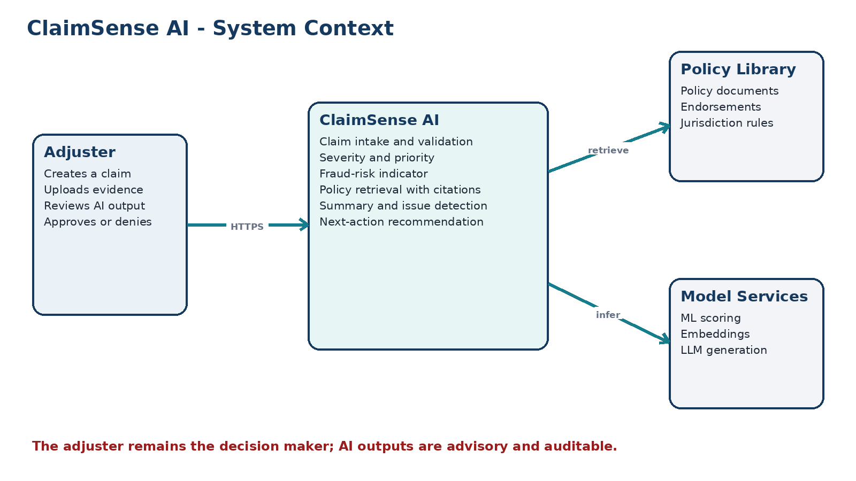

2.3 Alternate and failure paths
- Unsupported or oversized file: reject before storage with a precise user message.
- OCR confidence below threshold: mark extracted text as low confidence and ask for manual confirmation.
- Policy retrieval confidence low: do not present a coverage conclusion; show 'insufficient supporting policy evidence.'
- Model service unavailable: keep the claim usable, show the failed stage, and allow a retry.
- Contradictory evidence: present both values with document/page sources instead of selecting one silently.
- Duplicate analysis request: reuse the completed analysis for the same claim version or return the in-progress job.

3. Requirements and Acceptance Criteria

3.1 Functional requirements
ID | Priority | Capability | Requirement | Acceptance check
FR-01 | P0 | Claim intake | Create and update a draft claim with required validation | Invalid required fields return field-level errors
FR-02 | P0 | Evidence | Upload approved file types and store checksum/metadata | File is retrievable by claim; duplicate hash is flagged
FR-03 | P0 | Extraction | Extract text and source locations from uploaded evidence | Text and page/span provenance are persisted
FR-04 | P0 | Severity | Return low/medium/high severity plus probability/confidence | Response includes model version and top contributing features
FR-05 | P0 | Priority | Calculate review queue priority from severity, missing data, and risk | Priority is deterministic for identical versioned input
FR-06 | P0 | Fraud indicator | Return 0-100 risk indicator and triggered reasons | Indicator is labeled advisory and reasons are inspectable
FR-07 | P0 | Policy search | Retrieve ranked policy chunks using query and metadata | Each result includes policy version, section, page, score
FR-08 | P0 | Summary | Produce structured evidence-based summary | Claim facts have evidence refs; policy assertions have citations
FR-09 | P0 | Data quality | List missing required facts and configured conflicts | Each conflict presents both values and their sources
FR-10 | P0 | Next action | Recommend request-info/review/SIU referral/ready-for-decision | Recommendation includes reasons and unresolved items
FR-11 | P0 | Human decision | Allow authorized adjuster to decide with rationale | No AI process writes final disposition
FR-12 | P0 | Audit | Record append-only workflow and decision events | History includes actor, time, versions, inputs, outputs
FR-13 | P1 | Policy admin | Ingest, version, activate, and deactivate policy files | Search uses only active applicable version
FR-14 | P1 | Dashboard | Show claims by status and priority | Adjuster can filter and open a review workspace
FR-15 | P2 | Export | Export a human-reviewed claim packet | Generated PDF/JSON clearly labels AI vs. human content

3.2 Non-functional requirements
ID | Category | Requirement
NFR-01 | Security | Reject executable content; enforce file allowlist, size limits, safe names, and malware-scan adapter.
NFR-02 | Privacy | Use synthetic/de-identified data in the MVP; never log full document text or secrets.
NFR-03 | Reliability | Each analysis stage is idempotent, retryable, and observable; partial failure does not corrupt the claim.
NFR-04 | Traceability | Persist code/model/prompt/policy versions and evidence IDs for every generated result.
NFR-05 | Accessibility | Core UI is keyboard navigable, labeled, and does not rely on color alone.
NFR-06 | Maintainability | Backend modules have clear boundaries and shared typed schemas; no business logic in route handlers.
NFR-07 | Performance | Claim reads target <1 second locally; complete analysis target <=20 seconds typical in the demo environment.
NFR-08 | Portability | Core services run through Docker Compose with provider adapters selected by configuration.
NFR-09 | Governance | Fraud and severity outputs are advisory, explainable, versioned, and evaluated separately by subgroup where data permits.

3.3 Evidence and decision rules
- A claim fact is displayed as verified only when it is directly supported by an intake field or an extracted source span.
- A policy conclusion is displayed only with one or more policy citations from the active policy version.
- A low-confidence extraction is shown as unverified and cannot silently override a user-entered field.
- Fraud-risk indicators must not use protected attributes or obvious proxies. The MVP uses synthetic data and documented, reviewable signals.
- Denial and approval are separate human actions; the system may recommend 'ready for decision' but never choose the disposition.

4. Architecture and Technology

4.1 Architecture choice
The MVP uses a modular monolith: one FastAPI application with internal modules for claims, documents, scoring, retrieval, synthesis, decisions, and audit. Long-running analysis executes through a background worker. This provides clean boundaries without the operational cost of microservices during a twelve-week build. Provider interfaces make the OCR, embedding, and LLM implementations replaceable.
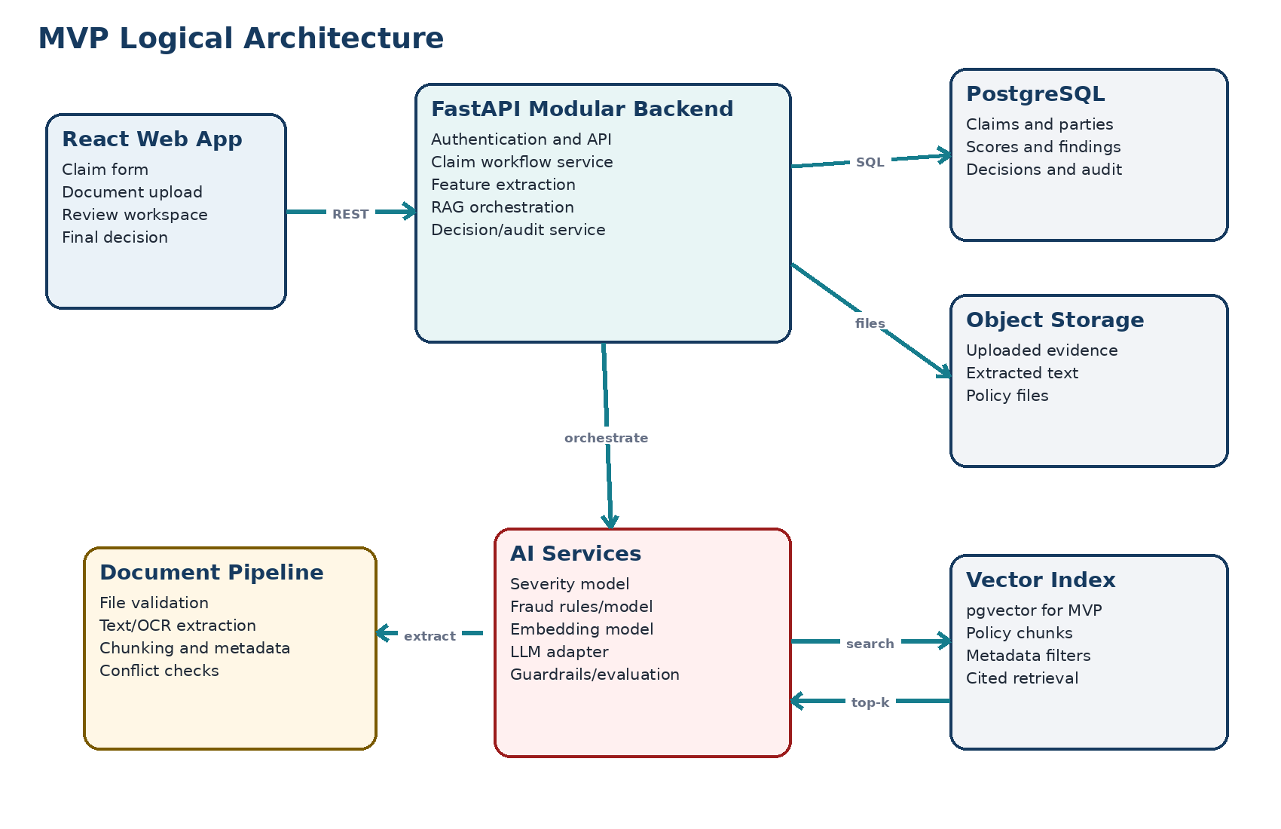

4.2 Recommended MVP stack
Layer | Choice | Reason for MVP choice | Upgrade path
Frontend | React + TypeScript + Vite | Fast form/dashboard development; typed API client | Next.js if server rendering is needed
Backend | Python 3.12 + FastAPI + Pydantic | Typed APIs and natural fit for ML/RAG | Split workers/services only after measured need
Database | PostgreSQL 16 + pgvector | One reliable store for app data and vector search | Managed PostgreSQL or dedicated vector engine
Files | Local MinIO/S3-compatible storage | Keeps binary files out of the relational database | AWS S3/Azure Blob/GCS adapter
Async jobs | Celery + Redis or FastAPI worker adapter | Retryable document and analysis jobs | Managed queue/service bus
Extraction | PyMuPDF + Tesseract fallback | Local PDF text and basic OCR | Azure Document Intelligence/Textract
ML | scikit-learn/XGBoost baseline | Small, explainable structured models | Calibrated champion/challenger models
RAG | sentence-transformers + pgvector | Low-cost local embeddings and metadata filtering | Managed embeddings/vector search
Generation | LLM provider adapter | Supports local/mock or configured enterprise endpoint | Azure OpenAI/Bedrock/Vertex adapter
Packaging | Docker Compose | Repeatable local demo for three developers | Terraform and managed containers

4.3 Component responsibilities
Component | Owns | Does not own
Claims module | Claim lifecycle, version, status transitions | Model inference or file bytes
Document module | Upload validation, storage metadata, extraction jobs | Coverage interpretation
Feature module | Canonical facts and model-ready features | Final business decision
Scoring module | Severity, priority, fraud indicator, explanations | Policy retrieval
Policy module | Ingestion, chunking, embeddings, metadata, search | Claim disposition
Synthesis module | Structured summary, issues, next action, citations | Writing final decision
Decision module | Human action, rationale, authorization, optimistic lock | Changing prior audit events
Audit module | Append-only events and version provenance | Operational log aggregation

4.4 End-to-end control flow
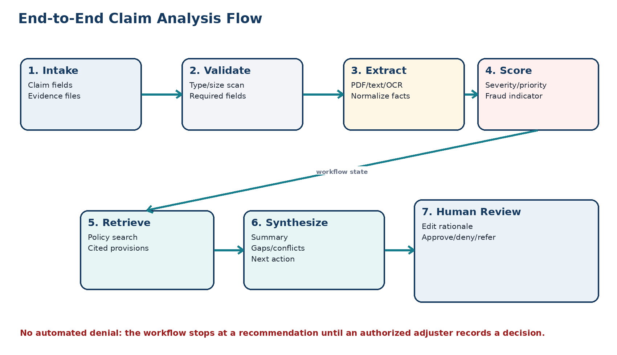
Workflow state: Each stage writes status and output under a single analysis_id. A failed stage can be retried without recreating the claim, and a claim edit creates a new claim_version so stale analyses cannot be used for a final decision.

5. Data and AI Design

5.1 Core data model
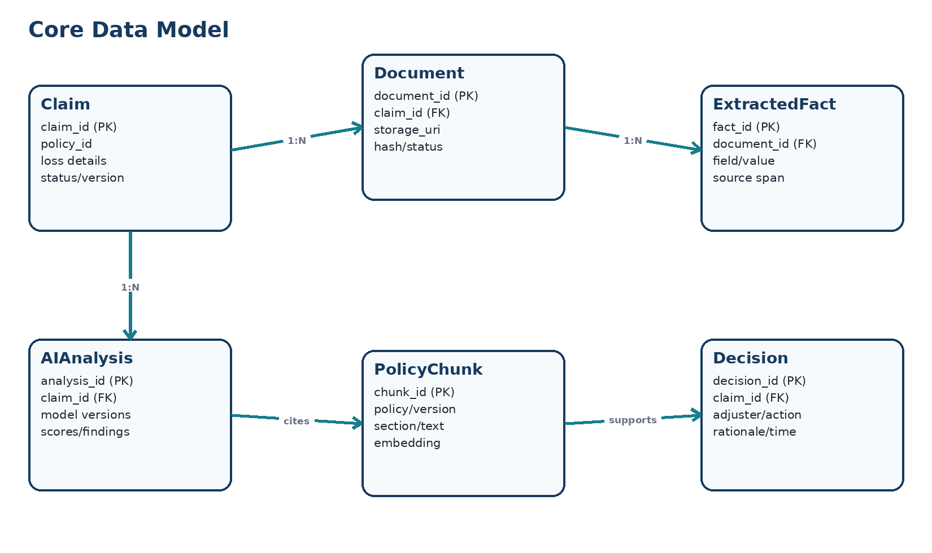
Entity | Important fields | Key integrity rule
claim | id, policy_number, loss_date, loss_type, description, amount, status, version | Decision references the exact claim version
document | id, claim_id, type, filename, mime, size, sha256, storage_uri, extraction_status | Unique hash per claim flags duplicates
extracted_fact | document_id, field_name, normalized_value, confidence, page, char offsets | Every extracted value retains provenance
analysis | claim_id/version, stage status, model/prompt versions, started/completed | Only one active run per claim version
score | analysis_id, score_type, value, band, confidence, reasons | Scores are immutable within an analysis
policy_document | policy_id, jurisdiction, line, effective dates, version, active | Only applicable active versions are searched
policy_chunk | document_id, section, page, text, metadata, embedding | Chunk stores stable citation coordinates
finding | analysis_id, type, severity, description, evidence_refs | Conflict contains at least two source references
decision | claim_id/version, adjuster_id, action, rationale, timestamp | Authorized human actor required
audit_event | actor, action, entity, entity_version, payload_hash, timestamp | Append-only; no update/delete from app API

5.2 Claim state model
DRAFT -> EVIDENCE_PROCESSING -> READY_FOR_ANALYSIS -> ANALYZING -> READY_FOR_REVIEW -> DECIDED. A processing error creates NEEDS_ATTENTION without discarding completed work. Any material edit after analysis increments claim_version and returns the claim to READY_FOR_ANALYSIS.

5.3 Severity and review priority
Severity estimates operational complexity and potential loss magnitude; priority decides review order. They are related but not identical. The first baseline should be simple enough to validate on synthetic data.
Output | Inputs (MVP) | Method | Explanation
Severity band | Reported amount, injury flag, vehicle operability, parties, narrative indicators | Calibrated multiclass baseline or rules when labels are unavailable | Probability, band, top features
Review priority | Severity, fraud risk, missing critical facts, elapsed time | Versioned weighted rules | Triggered priority reasons
Uncertainty | Model probability and data completeness | Thresholds and missingness penalty | Low confidence forces normal/manual review

Do not claim production accuracy from synthetic data. Report only measured validation metrics and label the model as a demonstration baseline.

5.4 Fraud-risk indicator
The indicator is triage support, not a fraud determination. The MVP combines transparent signals such as reporting delay, repeated identifiers in synthetic history, incompatible dates, unusually high amount for the scenario, and document inconsistencies. Each signal has a documented weight and evidence reference. The UI uses 'risk indicator' and 'refer for investigation,' never 'fraudster' or an automatic denial.

5.5 Policy retrieval (RAG)
- Ingestion: validate policy file -> extract text -> preserve heading/page -> semantic chunk -> enrich with policy line, jurisdiction, coverage, effective date, and version -> embed -> index.
- Query: build search text from loss facts and the reviewer question; filter to applicable active policy; retrieve top candidates; optionally rerank; return chunks with stable citations.
- Generation: provide only selected claim evidence and retrieved policy chunks to a structured-output prompt. The LLM must abstain when evidence is insufficient.
- Citation validation: reject or flag a generated policy statement when its citation ID is missing from the retrieved context.
- Evaluation: maintain labeled policy questions and expected chunk IDs; measure Recall@k, MRR, citation coverage, citation correctness, groundedness, latency, and cost.

5.6 Summary, gaps, conflicts, and next action
Section | Required behavior
Verified facts | Summarize only intake fields or extracted facts with evidence references.
Policy relevance | List retrieved provisions with section/page citations; avoid unsupported coverage conclusions.
Missing information | Compare canonical facts with a loss-type checklist and name the required item.
Conflicts | Apply deterministic comparisons first: dates, amounts, names/IDs, location, and loss narrative.
Next action | Select one advisory action from a controlled enum and include reasons, blockers, and required evidence.
Adjuster note | Keep AI draft and human-edited final note separately for audit and evaluation.

5.7 Structured AI output contract
The generation response is validated against a Pydantic/JSON schema. Free-form text is never accepted as the workflow state.
Field | Type | Example/constraint
facts | array | text, evidence_ref, confidence
policy_provisions | array | statement, chunk_id, policy_section, page
missing_items | array | controlled item code plus explanation
conflicts | array | field, value_a/ref_a, value_b/ref_b
recommendation | enum | REQUEST_INFORMATION | STANDARD_REVIEW | REFER_SIU | READY_FOR_DECISION
recommendation_reasons | array | Short reasons grounded in facts/findings
limitations | array | Low-confidence or unavailable evidence

6. API and User Interface Design

6.1 API conventions
- Base path /api/v1; JSON request/response; multipart only for file upload.
- Bearer authentication in deployable environments; local development identity is clearly labeled and disabled outside dev.
- Idempotency-Key required for analysis creation and decision submission.
- Optimistic concurrency uses claim_version; stale decisions return HTTP 409.
- Errors use a shared schema: code, message, field_errors, correlation_id, retryable.
- All timestamps use UTC ISO-8601; monetary values use decimal plus currency.

6.2 MVP endpoints
Method | Endpoint | Purpose | Success
POST | /claims | Create draft claim | 201 + claim/version
GET | /claims | List/filter claims | 200 + paginated items
GET | /claims/{id} | Read claim workspace | 200 + evidence/analysis/decision
PATCH | /claims/{id} | Update claim using version | 200 + incremented version
POST | /claims/{id}/documents | Upload evidence | 202 + document/job
GET | /documents/{id} | Get metadata/extraction status | 200
POST | /claims/{id}/analyses | Start idempotent analysis | 202 + analysis id
GET | /analyses/{id} | Poll stage status and results | 200
GET | /analyses/{id}/citations/{chunk} | Open supporting policy excerpt | 200
POST | /claims/{id}/decisions | Record human disposition and rationale | 201 + immutable decision
POST | /admin/policies | Ingest a policy version | 202 + ingestion job
GET | /health/ready | Dependency readiness | 200 or 503

6.3 Example analysis response
{"analysis_id":"an_123","claim_version":2,"status":"READY_FOR_REVIEW","severity":{"band":"MEDIUM","confidence":0.72},"fraud_risk":{"score":34,"reasons":["amount-document mismatch"]},"missing_items":["police_report_number"],"recommendation":"REQUEST_INFORMATION","citations":[{"chunk_id":"pc_88","section":"Collision Coverage","page":12}]}

6.4 User interface
Screen | Core content | Primary action
Claims queue | Claim number, status, severity, priority, risk, age | Open next claim
New claim | Validated claim fields and evidence upload | Save and process evidence
Review workspace | Evidence viewer, extracted facts, scores, issues, cited policy, summary | Review sources and resolve questions
Decision panel | Recommendation, adjuster action, mandatory rationale, version warning | Submit human decision
Policy admin | Policy versions, metadata, ingestion status | Activate tested version
Evaluation view | Test set results, failures, latency, model/prompt versions | Compare run to acceptance thresholds

UI requirement: Every score and generated conclusion must have an adjacent 'Why?' or 'View source' path. Confidence colors are accompanied by text labels so meaning is not conveyed by color alone.

7. Security, Testing, and Operations

7.1 Security and privacy controls
Threat/control area | MVP control
Untrusted upload | Allowlist MIME/extensions, size/page limits, random storage key, checksum, safe extraction, malware-scan interface.
Prompt injection in documents | Treat document text as data; fixed system rules; tool allowlist; no document-triggered actions; cite and validate output.
Unauthorized access | Role check on claim/document/decision routes; deny by default; object access through backend only.
Sensitive data leakage | Synthetic data; redact operational logs; secrets in environment/secret store; do not send entire corpus to model.
Tampering/repudiation | Append-only audit events, hashes, actor/time, model/prompt/policy versions, immutable decision records.
Model overreach | Advisory labels, abstention, controlled actions, mandatory human decision, low-confidence handling.
Dependency risk | Pinned dependencies, software composition scan, container scan, and documented licenses.

7.2 Testing pyramid
Test layer | Examples | 12-week target
Unit | Validation, state transitions, feature logic, fraud rules, citation validator | >=80% on critical backend modules
Contract | Pydantic schemas, error model, frontend generated client | All public endpoints
Integration | PostgreSQL/pgvector, object storage, worker, extraction, model adapters | Happy path plus dependency failures
AI evaluation | Retrieval labels, groundedness, citations, missing/conflict cases, abstention | Versioned evaluation set in repository
End-to-end | Create -> upload -> analyze -> review -> decide | At least 25 synthetic scenarios
Security | AuthZ, upload abuse, injection strings, secret/log scan | No open high-severity finding
Usability | Three scripted adjuster tasks | No blocking issue; feedback recorded

7.3 AI evaluation gates
Capability | Primary metrics | Release gate
Severity | Macro F1, calibration error, confusion matrix | Report honestly; no minimum production claim on synthetic data
Fraud risk | Precision/recall at referral threshold; reason accuracy | Every high indicator has valid triggered evidence
Retrieval | Recall@3, MRR, nDCG@5 | Recall@3 >=80% on labeled MVP set
Summary | Fact support rate, contradiction count, completeness | No unsupported critical fact in approved cases
Citations | Coverage and correctness | 100% coverage for policy statements; >=90% correct in evaluation
Next action | Agreement with labeled action; unsafe-action count | Zero autonomous decisions; reasons present
System | P50/P95 latency, errors, cost/run | Typical run <=20 sec; no silent stage failure

7.4 Observability
- Structured logs: correlation_id, claim_id hash, analysis_id, stage, duration, status; never raw evidence text.
- Metrics: request rate/errors/latency, queue depth, extraction failures, model latency, retrieval scores, LLM tokens/cost, citation validation failures.
- Traces: intake -> extraction -> scoring -> retrieval -> generation -> validation, with external provider spans.
- Audit events are business records and remain separate from disposable operational logs.

7.5 Deployment
Developer deployment uses Docker Compose for web, API, worker, PostgreSQL/pgvector, Redis, and MinIO. CI runs linting, type checks, unit/integration tests, migration checks, image build, and scans. A demo environment can use managed PostgreSQL and object storage plus two container services (web/API and worker). Kubernetes is intentionally deferred until load, tenancy, or organizational standards justify it.

8. Three-Person Team and Twelve-Week Plan

8.1 Team ownership
Member | Primary ownership | Secondary ownership | Key deliverables
Member 1 - Backend/Platform | FastAPI, schema, database, storage, workflow, security | Deployment and observability | APIs, migrations, job orchestration, audit/decision controls
Member 2 - AI/ML | Data fixtures, extraction, severity/fraud baselines, RAG, evaluation | Backend adapters | Models, policy index, structured synthesis, evaluation report
Member 3 - Frontend/QA | React UI, API integration, UX/accessibility, end-to-end tests | Product coordination | Queue, intake/review/decision screens, demo script, test evidence

All three members review pull requests and rotate one daily integration owner. No feature is complete until its API, UI path, tests, and documentation agree.

8.2 Working agreements
- One repository with /frontend, /backend, /ml, /infra, /docs, and /tests/e2e.
- Short-lived branches; pull request review by one teammate; main must stay demoable.
- Daily 15-minute stand-up and end-of-day integration check; Wednesday and Friday demo checkpoints.
- Architecture changes update the decision log; API changes update OpenAPI and frontend types in the same pull request.
- Use synthetic/de-identified artifacts only. Store no secrets or real policyholder data in Git.

8.3 Twelve-week outcome plan
Phase | Weeks | Outcome | Exit gate
1. Discovery and foundation | 1-2 | Approved scope, synthetic dataset, UX flow, repository, environments, and claim/document vertical slice | Create a claim, upload evidence, and inspect extracted text with provenance
2. Predictive intelligence | 3-4 | Versioned features, severity baseline, priority rules, fraud-risk indicator, and explanations | Scores persist through APIs and pass baseline evaluation checks
3. Policy intelligence | 5-6 | Policy ingestion, chunking, embeddings, metadata filtering, retrieval evaluation, and citations | Labeled policy set meets Recall@3 target and citations open to source
4. Evidence synthesis | 7-8 | Structured summary, missing/conflict detection, next-action logic, and grounding validator | Review packet separates facts, policy evidence, inference, and limitations
5. Human workflow and hardening | 9-10 | Decision controls, audit, authorization, recovery, observability, accessibility, and E2E tests | No disposition without human rationale; golden and failure paths pass
6. Deployment and pilot | 11-12 | Deployed demo, 25+ scenario evaluation, tuning freeze, runbook, model card, and pilot feedback | Release candidate meets gates; limitations and next backlog are published

8.4 Week-by-week execution checklist
Week | Team checkpoint
Week 1 | Kickoff, requirements, safety boundary, personas, wireframes, repository/board, and architecture review
Week 2 | Migrations, claim CRUD, upload/storage validation, extraction pipeline, and first vertical-slice demo
Week 3 | Canonical facts, feature pipeline, synthetic labels, severity baseline, and explanations
Week 4 | Priority engine, fraud-risk signals, evaluation harness, and scoring UI integration
Week 5 | Policy corpus/version model, extraction, semantic chunking, and embedding/index pipeline
Week 6 | Retrieval, metadata filters, labeled queries, Recall@k/MRR evaluation, and citation viewer
Week 7 | Structured summary schema, LLM/mock adapter, evidence references, and groundedness checks
Week 8 | Missing-field checklist, conflict detection, next-action rules, abstention, and integrated review packet
Week 9 | Decision panel, rationale, optimistic locking, roles, immutable audit events, and export draft
Week 10 | Integration/E2E/security/accessibility tests, injection cases, failure/retry UX, and telemetry
Week 11 | Deploy demo, performance tests, tune thresholds/retrieval/prompts, and freeze versions
Week 12 | Run 25+ scenarios, fix release blockers, finalize runbook/model card/README, demo, and retrospective

8.5 Weekly ceremony and milestone cadence
- Monday: select the measurable weekly outcome, confirm story owners, and identify integration risks.
- Daily: 15-minute stand-up plus one rotating integration owner who keeps the main branch runnable.
- Wednesday: internal product demo using a fixed synthetic scenario; log failures immediately.
- Friday: acceptance-gate demo, metrics review, retrospective, and SDD/ADR update.
- End of Weeks 2, 6, 8, 10, and 12: formal milestone review against the exit gates in Section 8.3.

8.6 Definition of done
- Requirement ID and acceptance criterion are satisfied.
- Typed API schema and OpenAPI example are current.
- Unit test plus appropriate integration/E2E test passes in CI.
- Error, empty, loading, retry, and unauthorized paths are handled.
- Logs/metrics contain correlation but no sensitive content.
- AI output includes version provenance, evidence, citations, uncertainty, and limitations where applicable.
- A teammate reviewed the change and the main branch remains demoable.

9. Risks, Decisions, and Next Steps

9.1 Risk register
Risk | Impact | Likelihood | Mitigation / trigger
Scope too broad for three people | High | High | Freeze P0 scope after Week 1; use one claim line; cut nonessential admin/export first
No credible labeled data | High | High | Use synthetic scenarios; present baseline honestly; focus on workflow/evaluation
LLM hallucination | High | Medium | Structured outputs, evidence-only prompt, citations, validator, abstention, human review
OCR variability | Medium | High | Prefer text PDFs; confidence flag; manual correction path; limit file types
Policy version mismatch | High | Medium | Effective-date metadata, active-version filter, citation/version display
Integration delayed | High | Medium | Vertical slice by end of Week 2; API examples/mocks; daily integration owner
Sensitive demo data leaks | High | Low | Synthetic-only policy, secret scan, log redaction, pre-demo data review
Provider outage/cost | Medium | Medium | Mock/local adapter, cached test fixtures, token/time limits, retry policy

9.2 Architecture decision log
Decision | Choice | Reason | Revisit when
ADR-001 | Modular monolith | Fast delivery with enforceable internal boundaries | Independent scaling/team ownership is measured
ADR-002 | PostgreSQL + pgvector | Reduces moving parts for MVP | Corpus/search scale exceeds database target
ADR-003 | Background job state | Extraction and generation are slow/retryable | Managed workflow service is adopted
ADR-004 | Structured output + validator | Workflow cannot safely depend on unconstrained prose | Never; schema evolves but principle stays
ADR-005 | Human-only disposition | Safety, accountability, and intended product scope | Requires governance/legal approval beyond MVP
ADR-006 | Synthetic/de-identified data | Safe team learning and demonstration | Approved governed dataset is available

9.3 Immediate next steps
- Hold a 60-minute team review of scope, selected claim line, and safety language.
- Name Member 1/2/3 owners and create the repository plus issue board.
- Approve five initial synthetic claim scenarios: normal low severity, high severity, missing police report, amount conflict, and investigation referral.
- Collect 3-5 public or fabricated policy documents with explicit versions and page/section structure.
- Turn FR-01 through FR-12 into P0 backlog stories and start the Week 1-2 vertical slice.
First build target: By the end of Week 2, an adjuster should be able to create one synthetic claim, upload one document, and see extracted text and provenance in the web application. Do not begin model tuning until this slice works.

Appendix A - Suggested Repository Structure
/frontend (React UI); /backend/app/api, domain, services, repositories, adapters, workers; /ml/training, features, evaluation, artifacts; /infra/compose and deployment; /data/synthetic and policies; /tests/unit, integration, e2e, eval; /docs/architecture, adr, runbook.

Appendix B - Synthetic Scenario Minimum Set
Scenario | Expected behavior
Straightforward minor collision | Low severity, standard priority, applicable collision provision, ready for review
Injury and disabled vehicle | High severity/high priority; urgent human review; no autonomous decision
Missing critical report | Missing item surfaced; request-information recommendation
Amount mismatch | Conflict shows intake amount and invoice amount with two sources
Coverage ambiguity | Low retrieval confidence or conflicting provisions; abstain and flag manual policy review
Investigation signals | Elevated risk indicator with explicit reasons; refer-for-investigation recommendation
Prompt injection text | Document instruction ignored; source treated as evidence only
Duplicate upload/retry | Duplicate flagged; analysis request remains idempotent

Appendix C - Glossary
Term | Meaning
Adjuster | Authorized human responsible for reviewing evidence and recording the claim decision.
Claim severity | Estimated complexity and potential loss impact; not a disposition.
Fraud-risk indicator | Advisory score/reasons that may support further investigation; not a fraud finding.
RAG | Retrieval-Augmented Generation: the model receives retrieved source passages to ground its response.
Citation coverage | Share of policy-related generated statements that include a supporting retrieved source.
MRR | Mean Reciprocal Rank: rewards the first relevant retrieval result appearing near the top.
Groundedness | Degree to which a generated statement is supported by supplied evidence.
Abstention | System behavior that declines to make a conclusion when evidence or confidence is insufficient.
SIU | Special Investigation Unit; a human investigation path, not an automated fraud decision.
Idempotency | Repeated identical request produces one logical operation instead of duplicates.

Appendix D - References
This SDD follows the major sections in the GitHub SDD template and Atlassian's guidance to cover architecture, data, interfaces, components, assumptions, glossary, decisions, and team review.
GitHub - Software Design Document Template
Atlassian - How to Create a Software Design Document

Change History
Version | Date | Change | Owner
1.0 | 2026-09-06 | Initial implementation-ready MVP design | ClaimSense AI team

