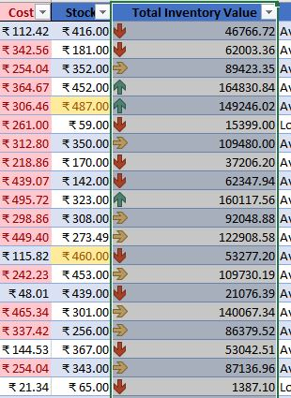

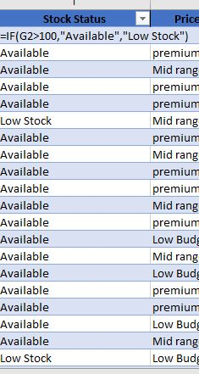
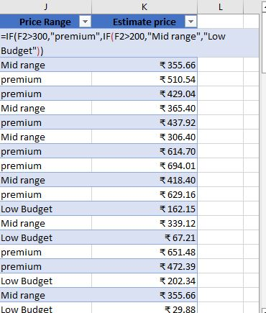
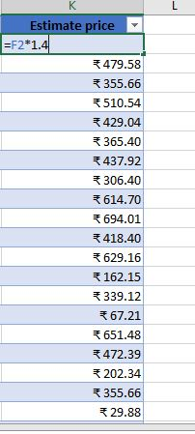
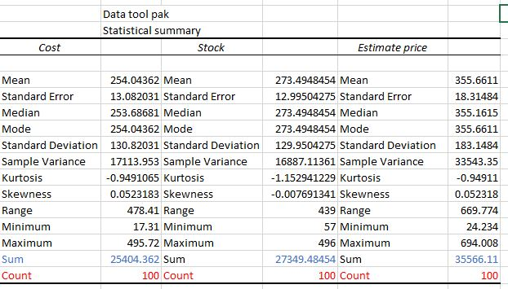
Project Title:E-commerce store Analysis
Project Objective:To find product related information in this dataset

Dataset Description:It has product id,name,its category,sub category,brand,cost,sales etc

Column Description:sales related details regarding its brand,cost,sales

Column Name | Description
Ex: Age | Age of the employee

Data cleaning & transformation:

Visualization and Insights Arrived with screenshot of visualization
Report/Dashboard screenshot:

- Descriptive analysis:
  - summarizes the core characteristics of your e-commerce dataset—such as total revenue, top-selling products, and customer behavior—using statistical summaries and data visualizations
- Diagnostic Analysis:price range value have to be find to bring total inventory value to step in and proceed

- Predictive Analysis:stock status should be analysis prior to fnd real price as well as estimed price

- Prescriptive Analysis:Timeline given for the dataset to analysis inventory vale

Conclusion:
Products driving the highest revenue vs. those languishing in stock.

