

AI-Powered Data Analytics for Predicting Hospital Length of Stay to Enhance Bed Capacity and Staffing Decisions

Meruva Vijaya Rama Seshu
W20115923

Submitted in Partial Fulfillment of the Requirements for the Master of Science in Computing Information System Processes

South East Technological University (SETU) Waterford

Supervisor: Mr.Liam Dyole
Submitted to SETU Waterford, August 2026

Abstract
Purpose: This study aims to explore and apply AI-driven data analytics to forecast hospitalisation Length of Stay and to aid in bed occupancy management and staffing resource allocation within hospitals. The study explores the correlation among patient characteristics, clinical and organisational factors and LOS as well as the feasibility and value of using predictive models to improve healthcare organisational efficiency and decision making.
Procedure: A quantitative and explanatory research design was used which included a publicly available hospital dataset of 100,000 patient records and 28 demographic, clinical and organisational variables. Data have been processed with data preprocessing, exploratory data analysis and supervised machine learning techniques. Linear Regression, Decision Tree, Random Forest, Gradient Boosting and Artificial Neural Network models were created and tested using Mean Squared Error, Root Mean Squared Error, Mean Absolute Error and R² score.
Findings: The results showed that advanced machine learning and deep learning models presented a better performance to traditional statistical approaches. Among the above models, the best model was the ANN model with the highest R² of 0.9645 and the lowest RMSE of 0.4415 days followed by Gradient Boosting and Random Forest model. The results have shown that AI can accurately forecast LOS and offer actionable insights for bed management and personal discharge planning and staffing allocation.
Limitations and Recommendations: A single secondary dataset was used and less interpretable on complex AI models. Future work should highlight external validation, explainable AI methods, and integrate real-time hospital data for better transparency, generalisability and real-world application.
Keywords: Hospital Length of Stay, Artificial Intelligence, Machine Learning, Predictive Analytics, Healthcare Analytics, Random Forest, Gradient Boosting, Artificial Neural Network, Bed Capacity Planning, Staffing Decisions.
Table of Contents
Abstract 2
Chapter 1 - Introduction 6
1.1 Topic Overview 6
1.2 Background 6
1.3 Aim and Objectives 7
1.4 Research Questions 8
1.5 Research rationale 8
1.6 Research Structure 8
Chapter 2- Literature Review 10
2.1 Introduction 10
2.2 Concept of Hospital Length of Stay and Its Operational Importance 11
2.2.1 Conceptualising Hospital Length of Stay as a Healthcare Performance Indicator 11
2.2.2 Clinical, Demographic and Organisational Determinants of LOS 11
2.2.3 Length of Stay as a Measure of Hospital Efficiency and Resource Utilisation 12
2.2.4 LOS Implications on Patient Flow and Capacity of the Healthcare System 12
2.3 Data Analytics and Artificial Intelligence in Healthcare 13
2.3.1 Evolution of Artificial Intelligence and Machine Learning Applications in Healthcare 13
2.3.2 Data Analytics plays a role in healthcare decision-making 13
2.3.3 AI-Based Decision Support Systems in Health Care 14
2.3.4 Healthcare-specific Opportunities and Challenges of AI 14
2.4 Hospital Length of Stay Predictive Modelling 14
2.4.1 LOS Prediction using traditional Statistical methods 15
2.4.2 LOS Prediction Techniques using machine learning 15
2.4.3 Critical Forecasting Unpredictable in LOS Modelling 16
2.4.4 Performance Measurement and Model Evaluation 17
2.5 Operational Applications of LOS Prediction in Hospitals 17
2.5.1 Bed Capacity Planning and Resource Allocation 17
2.5.2 Patients' Surgery and Hospital Productivity 19
2.5.3 Workforce and Staffing Planning 19
2.5.4 Hospital Operations Decision Support Systems 20
2.6 Challenges in Implementing AI-Based Prediction Systems 20
2.6.1 Data Quality and Availability Problems 21
2.6.2 Technical and Infrastructure Limitations 21
2.6.3 Barriers of Organisational and Workforce Adoption 21
2.6.4 Ethical, Privacy, and Bias Considerations in AI Systems 22
2.6.5 Governance and Regulatory Frameworks for AI in Healthcare 22
2.7 Research Gap and Justification of the Research 23
Chapter 3- Research Methodology 24
3.1 Introduction 24
3.2 Development Environment 24
3.3 Research Design 25
3.4. Data Collection 25
3.5. Hardware and Secondary Requirements 26
3.5.1. Hardware Requirements 26
3.5.2. Software Requirements 27
3.6. Research Deployment Experimental Setup 27
3.6.1. Machine Learning Algorithms 27
3.6.2. Deep Learning Algorithms 28
3.7 Performance Evaluation 28
3.7.1 Evaluation Metrics 28
3.7.2 Validation Strategy 29
3.7.3 Operational Interpretation 29
3.7.4 Limitations Handling 29
Chapter 4: Data Analysis and Model Implementation 30
4.1 Introduction 30
4.2 Overview of Dataset 30
4.4 Exploratory Data Analysis 34
4.5 Model Implementation and Evaluation 39
4.6 Discussion of Findings 46
4.7 Implications of the Study 48
4.8 Summary 49
Chapter 5: Conclusion and Recommendations 50
5.1 Introduction 50
5.2 Conclusion 50
5.3 Recommendations 52
References 57

Chapter 1 - Introduction

1.1 Topic Overview
The topic focuses on using machine learning models to estimate how long individual patients will remain admitted from the point of hospital entry. Accurate estimates of length of stay are strategically important because they influence bed occupancy, waiting times, cancellation of elective procedures and staff workload across departments. AI-powered data analytics enables organisations to integrate diverse clinical, demographic and administrative variables and extract predictive patterns that traditional statistical approaches may overlook (Cho et al., 2024). Bed capacity planning involves making predictions of the future bed demand and the probable discharge time to assist the hospital in the management of overcrowding and occupancy (Jones, 2023). It helps with making decisions related to bed allocation, patient flow and schedule of surgeries, particularly during periods of high demand over supply. Staffing decisions can be defined as arranging staffing numbers, roles, and skill mix among shifts in relation to anticipated patient load and care requirements (Griffiths, et al., 2020). More accurate occupancy estimates and patient complexity estimates can be used to make safer rotas, workload balance, and more effective utilisation of finite clinical resources. Governance refers to the roles, responsibilities, rules, and monitoring procedures that govern the way the model is approved, used, and maintained (Scholar, 2019). It also involves documentation, access control, performance checks, audit trail, and update decisions, hence the system remains safe and trustworthy over time.

1.2 Background
Ageing populations, the burden of chronic illnesses and growing demands of timely access to specialist care are placing sustained pressure on health care systems around the globe. Hospitals often have high occupancy, resulting in bottlenecks in the emergency department, delayed elective surgery and staff stress and patient dissatisfaction. AI-based data analytics refers to applying AI or machine learning algorithms to discover trends in hospital data, including admission information, diagnoses, and previous results (Majeed and Hwang, 2021). The idea is to justify the decisions in evidence, quantifiable precision and the clear assessment of outcomes and boundaries. However, the implementation of AI-based tools in the sphere of hospital management also poses some problems concerning the quality of data, the skills of the workforce, change management and the ethical accountability of automated decisions. Ethical issues are threats associated with privacy, data security, bias, transparency and responsibility in utilising patient information and predictive results (Kothinti, 2024). The use of predictions in decision-making is also an ethical matter since they do not discriminate against any population in accessing care.
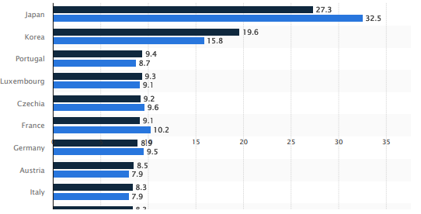
Figure 1: Average length of stay in hospitals for curative (acute) care in select countries worldwide in 2010 and 2022 (in days)
(Source: Statista, 2025)

1.3 Aim and Objectives
The aim of the study is to explore the application of data analytics using AI to predict the length of stay in hospitals correctly, and how such predictions can be used to optimise bed capacity planning and staffing decisions. The research is aimed at establishing the relationship between technical model development and practical strategies of operations, which improve efficiency, quality of services and resources utilisation in hospital contexts.
Objectives
- To explain the concept of AI-powered data analytics and its relevance for predicting hospital length of stay and supporting managerial decision-making.
- To examine the relationship between patient, clinical and organisational factors and hospital length of stay using appropriate AI-based predictive models.
- To identify key technical, organisational and ethical challenges associated with implementing AI-powered length of stay prediction in routine hospital operations.
- To propose practical strategies and governance measures that can help hospitals overcome these challenges and integrate predictive insights into bed and staffing planning.

1.4 Research Questions
- How can AI-powered data analytics be applied to conceptualise and model the relationships between patient, clinical and organisational variables and hospital length of stay, and how can such predictions be applied in helping hospitals make bed capacity and staffing decisions?
- Which technical, organisational and ethical issues affect the implementation of AI-based length of stay prediction tools in routine hospital operations, and which practical strategies and governance can be used to overcome the issues and enable them to be integrated into bed and staffing planning?

1.5 Research rationale
This study addresses these gaps by examining how AI-powered predictive analytics can be integrated with hospital operational decision-making, particularly in relation to bed capacity planning and staffing management. The study intends to add to an applied comprehension of the ways of AI aiding efficient and sustainable management of hospitals, by connecting the notion of predictive modelling with the considerations of operational planning.

1.6 Research Structure
Chapter | Description
Chapter 1: Introduction | Introduces the research topic, background, aims, objectives, research questions and rationale. It explains the importance of AI-powered LOS prediction for hospital bed capacity and staffing decisions.
Chapter 2: Literature Review | Critically reviews previous studies related to hospital LOS, artificial intelligence, predictive analytics and operational healthcare management. It also identifies the research gap addressed in this study.
Chapter 3: Research Methodology | Explains the quantitative research design, dataset selection, data preprocessing methods, machine learning algorithms and evaluation techniques used in the study.
Chapter 4: Data Analysis and Model Implementation | Presents exploratory data analysis, model development, implementation and comparative evaluation of predictive models for LOS prediction.
Chapter 5: Conclusion and Recommendations | Summarises the overall findings, conclusions, recommendations, study limitations and future research directions related to AI-based hospital management systems.

Chapter 2- Literature Review

2.1 Introduction
The rising demand of patients, scarcity of resources and the mounting pressure to optimise the healthcare provision have turned the operational efficiency of hospitals into a critical system concern of healthcare systems. Length of stay (LOS) is one of the major indicators of hospital performance, where it is used to measure the duration of stay of a patient in hospital between hospitalisation and discharge (Emicke et al., 2025). LOS is mainly a factor determining the availability of hospital beds, patient flow, treatment schedule, and staff workload, as well as a significant component of managing the hospital resources (Jones, 2023).
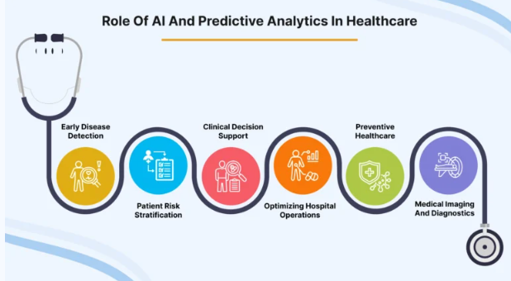
Figure 2: Role of AI and Predictive Analytics in Healthcare
(Source: Shah, 2024)
The recent advancements in the field of artificial intelligence (AI) and data analytics have allowed healthcare organisations to process a significant amount of electronic health records to detect patterns that impact the utilisation of hospitals (Varnosfaderani and Forouzanfar, 2024). Machine learning models can combine demographic, clinical, and administrative factors to enhance the prediction of LOS and operational decision-making (Almeida et al., 2024).
The literature review critically analyses the available studies regarding the AI-driven LOS prediction and its potential impact on hospital work. Using databases, including Google Scholar, Scopus, PubMed, and IEEE Xplore, the relevant studies were located by such keywords as hospital length of stay prediction, machine learning in healthcare, and AI-based hospital resource planning. Peer-reviewed articles that were related to healthcare analytics and hospital management were only selected.

2.2 Concept of Hospital Length of Stay and Its Operational Importance

2.2.1 Conceptualising Hospital Length of Stay as a Healthcare Performance Indicator
The length of stay (LOS) at hospitals has been well known as an important metric of health systems performance and the effectiveness of hospitals in their work. LOS is the interval between patient admission and discharge, and it is commonly employed to measure the quality of healthcare services, their efficiency, and the use of resources. With rising demand and scarce resources in healthcare systems, LOS has become a key measure of hospital productivity and a way of determining the inefficiencies in the processes of patient care.
In a systematic review of LOS prediction studies, Stone, et al., (2022) claim that LOS is the product of interaction between clinical decision-making and hospital resources and patient management practices. According to their results, extended hospitalisation is frequently an indicator of inefficiency in care coordination, delays in treatment or ineffective discharge planning. In the same way, Han, et al., (2022) also show that LOS has a strong relationship with patient outcomes, meaning that both too long and too short hospitalisation can adversely affect recovery and the quality of healthcare. These studies thus make LOS not only an operational measure but a measure of effectiveness in healthcare.
Santana, et al., (2019), argue that medical performance indicators should not only include patient-centred results but also should not prioritise operational efficiency solely. Their analysis indicates that the implementation of policies that only focus on the reduction of LOS can have unintended effects, such as the rise of readmission rates or reduced care delivery to patients.

2.2.2 Clinical, Demographic and Organisational Determinants of LOS
The length of stay is determined by a mixture of clinical, demographic and organisational factors in hospitals. These determinants are important to understand to enhance the efficiency of hospitals and predict patient resource needs. According to research, patient characteristics, the severity of disease, and the processes of healthcare organisations have always been cited as major contributors to LOS variation.
The issue of clinical determinants still plays a central role in the explanation of extended hospital stays. According to Lin, et al., (2022), the disease severity, age, and comorbidity of patients are significantly related to LOS in patients with acute ischemic stroke. Similarly, Tefera, et al., (2020), reported clinical complications and complexity of treatment to be the prominent predictors of prolonged hospitalisation in surgical patients. These results demonstrate a substantial impact on patient health status on the duration of stay in hospitals.
However, organisational and administrative factors are also important. Aung, et al., (2020) show that hospital infrastructure, intensive care utilisation and treatment costs determine LOS in the clinical environment. Similarly, Lim (2020), relied on massive healthcare datasets in demonstrating that the duration of hospital stay can be greatly influenced by the workflow processes and administrative practices in hospitals. Through these studies, it is argued that LOS can be considered as the outcome of interactions between clinical conditions and hospital organisational structures.

2.2.3 Length of Stay as a Measure of Hospital Efficiency and Resource Utilisation
In terms of operation, LOS is very important in hospital efficiency and resource management. Proper management of the duration of stay in hospital can lead to better patient throughput, lower health care expenses and streamline the use of scarce hospital resources.
Bahalkeh, et al., (2022) prove that LOS is an efficient tool that decreases the bed turnover of an intensive care unit and limits the capacity of a hospital. Likewise, Bertsimas, et al., (2022) demonstrate that LOS patterns can be used to enhance the management of hospital operations and patient flows by analysing them. However, LOS is difficult to predict correctly. According to Chrusciel, et al., (2021), the complexity and heterogeneity of healthcare data can be a nuisance for traditional statistical models, which is why more advanced analytical tools can be implemented.

2.2.4 LOS Implications on Patient Flow and Capacity of the Healthcare System
Another important implication of LOS on healthcare systems is the capacity of the healthcare system and patient flow management. The management of LOS is necessary to control the availability of bed space in hospitals and access to healthcare facilities.
Ravaghi, et al., (2020), point out that hospital bed capacity planning is based on proper knowledge about LOS patterns because ineffective LOS management may result in overcrowding and capacity limitation of the system. Equally, Hu, et al., (2021) show that patient-flow models used to optimise LOS have the capacity to enhance hospital throughput. Gualandi, et al., (2020), also suggest that the patient flow processes are not effective enough and cause patients to spend more time in the hospital, causing the rise of operation costs and burdening the health care resources. In more recent studies, Kim and Oh, (2024) emphasise the use of analytical models in enhancing the hospital capacity planning process with the assistance of LOS-based resource allocation plans.

2.3 Data Analytics and Artificial Intelligence in Healthcare

2.3.1 Evolution of Artificial Intelligence and Machine Learning Applications in Healthcare
Artificial intelligence (AI) has developed from rule-based expert systems to complex machine learning (ML) applications that can analyse massive amounts of healthcare data. The initial applications focused more on diagnostic assistance, but recently the scope of the AI has been extended to predictive analytics as well as healthcare management. Davenport and Kalakota (2019) state that AI technologies are used more to increase healthcare delivery in terms of better diagnostic accuracy, treatment planning and administrative efficiency. On the same note, Rong, et al., (2020) emphasise that machine learning approaches, such as classification and regression models, help healthcare systems to find meaningful patterns in the complex data.
The increasing rate of digital health data, especially electronic health records, has also increased the adoption of AI. Secinaro, et al., (2021) highlight that AI is currently becoming more commonly used to perform predictive tasks in a healthcare system. More recent studies are not only limited to clinical applications but also operational applications, where predictive models are applied to predict outcomes, including hospital length of stay (LOS), to aid hospital resource planning and decision-making. However, even with these developments, the use of AI in the daily operations of hospitals has not been widely adopted.

2.3.2 Data Analytics plays a role in healthcare decision-making
Data analytics is the central process of changing healthcare information into meaningful lessons to inform decisions. Data mining and statistical modelling, predictive analytics, and similar methods allow healthcare organisations to process patient data, identify patterns and optimise the use of resources. According to Dash, et al., (2019), big data analytics lead to evidence-based decision-making based on the combination of various clinical and operational data.
Operationally, analytics are being utilised more to assist in management decisions in hospitals. Cozzoli, et al., (2022) reveal that data analytics enhances monitoring of performance and strategic planning in healthcare organisations. In a similar manner, Batko and Slezak (2022) highlight that analytics have the potential to uncover health care delivery issues and improve resource allocation. To be more precise, Xie, et al., (2021) suggest that the analytical models can be used to support hospital resource planning by examining the patient flow and demand trends, whereas Djaya (2025) highlights the importance of analytics in optimising resource allocation decisions. However, existing research is mostly generalised, suggesting limited attention to the application of analytics to indicators of operations, including LOS, which means that the gap in the practice of its implementation to make decisions in hospitals remains.

2.3.3 AI-Based Decision Support Systems in Health Care
AI-based decision support systems (DSS) comprise a primary healthcare application of AI, which allows the use of the data in making decisions that are both clinical and operational. Magrabi, et al., (2019) believe that AI-based DSS has the potential to improve accuracy in diagnosing and minimise medical errors because it offers evidence-based recommendations based on patient data.
Studies suggest the increasing adoption of machine learning models in the prediction of length of stay and hospital as a key operational indicator. Almeida, et al., (2024) confirm that predictive methods, such as regression and ensemble learning models, can be used to predict LOS using healthcare data. Similarly, Jain, et al., (2024) indicate that machine learning models used on health datasets of large volumes enhance the accuracy of predictions and assist in making decisions related to hospital planning. Hospital management can especially find these capabilities significant since accurate LOS prediction allows planning bed capacity better and allocating staffing. Alves, et al., (2024) also emphasise the assistance of AI tools in hospital decision-making.

2.3.4 Healthcare-specific Opportunities and Challenges of AI
Although AI has great potential to enhance healthcare decision-making, its use is associated with several challenges. According to Petersson, et al., (2022), the main barriers include organisational resistance, the absence of technical expertise and data governance issues. Furthermore, Karimian, et al., (2022) mention some ethical issues, such as algorithmic bias and data privacy. These issues indicate that the successful implementation of AI in decision-making in hospitals involves not only complex analytical tools but also powerful governance systems.

2.4 Hospital Length of Stay Predictive Modelling
As per the views of Almeida, et al., (2024), hospital length of stay prediction has been a valuable field of healthcare analytics studies since LOS directly affects the hospital management of capacity, cost, and patient flow. Doknić, et al., (2025), illustrate that the scientists have, over time, devised a massive variety of predictive methods, such as classical statistical models to modern machine learning methods.

2.4.1 LOS Prediction using traditional Statistical methods
According to Abdurrab, et al., (2024), prediction of LOS in the early studies mostly depended on the statistical methods like linear regression, logistic regression and survival analysis. These are the models that were popular due to their transparency, simplicity in reading, and the fact that they do not need a large dataset. As an illustration, Elrazek, et al., (2021), employed regression-based models to examine data concerning the aspects of admission and clinical variables in intensive care, which revealed that the age of patients, the severity of their condition, and comorbidities constituted excellent predictors of LOS.
On the same note, Stone, et al., (2022) observe that the traditional statistical models have always dominated the research on LOS prediction in the past because the traditional statistical model can give out the interpretable predictor-outcome correlation. Also, Slavu, et al., (2025) said that the models allow clinicians and hospital administrators to learn how certain variables affect LOS, and this aids in clinical decision-making and responsibility.

2.4.2 LOS Prediction Techniques using machine learning
Dehouche, et al., (2021), observe that to overcome the drawbacks of the traditional statistical methods, researchers tend to use machine learning (ML) techniques in LOS prediction more. According to Dhillon, et al., (2022), machine-learning algorithms could make predictions on large and complex data sets and recognise nonlinear relationships between predictors, which is not readily obtainable using conventional statistical models. A systematic review of machine learning models applied in the LOS prediction by Almeida, et al., (2024) revealed that in most cases, the ensemble learning models have higher predictive power than the traditional regression models.
Indicatively, Yildirim and Canayaz, (2024) used ensemble learning methods in predicting LOS in neonatal intensive care units. Their findings showed that using a combination of algorithms enhanced the predictive ability since it reflected the complicated interactions between clinical variables and patient features. Similarly, Cho, et al., (2024) have created a machine learning model to anticipate the postoperative LOS based on preoperative and perioperative factors.
Although such developments have been made, machine learning approaches cannot be said to be limitless. Peek, et al., (2024) state that predictive accuracy should not be equated with clinical usefulness because high predictive accuracy does not necessarily imply clinical usefulness. Most machine learning models operate as black boxes, and therefore, it is not easy to know how the predictions are made by clinicians and administrators. Such a lack of transparency may decrease the trust in AI systems and their use in healthcare organisations.

2.4.3 Critical Forecasting Unpredictable in LOS Modelling
Hirani, et al., (2025), observe that one of the key issues in the research on the LOS prediction is the identification of the most important variables that impact the duration of hospital stay. The current state of literature identically singles out three substantial groups of predictors, namely, patient demographic factors, clinical factors, and organisational ones. Mou, et al., (2022), revealed that age, gender, and socio-economic status are other demographic variables that are usually indicated in LOS models due to their impact on patient vulnerability and recovery patterns.
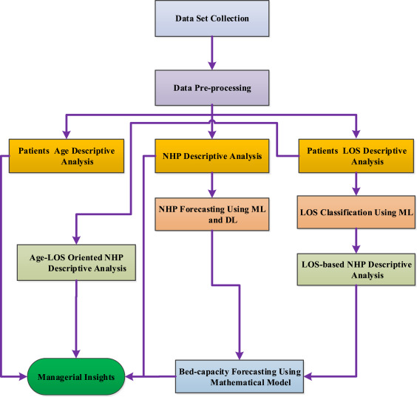
Figure 3: Data-driven HBC forecasting
(Source: Mahmoudian, et al., 2023)
Clinical variables are a significant factor as well. It has been found that the type of diagnosis, illness severity, medical conditions, and surgical complexity had a strong impact on the LOS (Cho, et al., 2024). Electronic health record data may include useful clinical indicators like laboratory findings, vital signs, and treatment processes that would enhance the accuracy of prediction. Besides the patient-related factors, patient LOS could also be influenced by the organisational variables, including hospital bed availability, staffing, and the entry pathways. Lee, et al., (2024) showed that the use of multi-hospital datasets based on common data models enhanced the strength of the LOS predictions by including the factors of the system level that affect the utilisation of the hospital.

2.4.4 Performance Measurement and Model Evaluation
As per the view of Grebovic, et al., (2023), most of the literature evaluates the performance of models based on such statistical measures as mean squared error, root mean squared error, and coefficient of determination. These measures indicate the deviations of the predicted values of LOS and real LOS and are used to evaluate the model in quantitative terms. Other common methods of assessing the model's generalisability between datasets include cross-validation systems. Majlatow, et al., (2025), note that researchers are able to minimise the chances of overfitting by testing models with unknown data and guarantee that models of prediction are stable in other hospital settings.
However, one major criticism in the literature is that a number of studies are based more on predictive accuracy as opposed to operational usefulness. Stone, et al., (2022), note that predictive models must be tested based not only on their statistical performance but also on the fact that they are applicable to the real hospital planning processes. This view raises the issue of research that relates the predictive modelling to the feasible operations of a hospital, which is the core subject of the current study.

2.5 Operational Applications of LOS Prediction in Hospitals
Hospital length of stay (LOS) prediction has received considerable attention in terms of its implications on hospital operational management, especially on bed capacity planning, patient flow, and workforce scheduling.

2.5.1 Bed Capacity Planning and Resource Allocation
According to Cusidó, et al., (2022), LOS prediction has found one of the most important use applications in the prediction of hospital bed capacity. The hospitals fall under limited infrastructure and must manage the changing demand of patients and the limited number of beds. Savioli, et al., (2022), state that failure to manage the bed effectively usually leads to the overpopulation of the emergency department, the inability to admit patients into beds, and the postponement of the elective process. Jones, (2023), hypothesises that most healthcare systems still use past averages and managerial opinion to make projections on the demand for beds, which might not reflect real-time changes in patient complexity and admission trends.
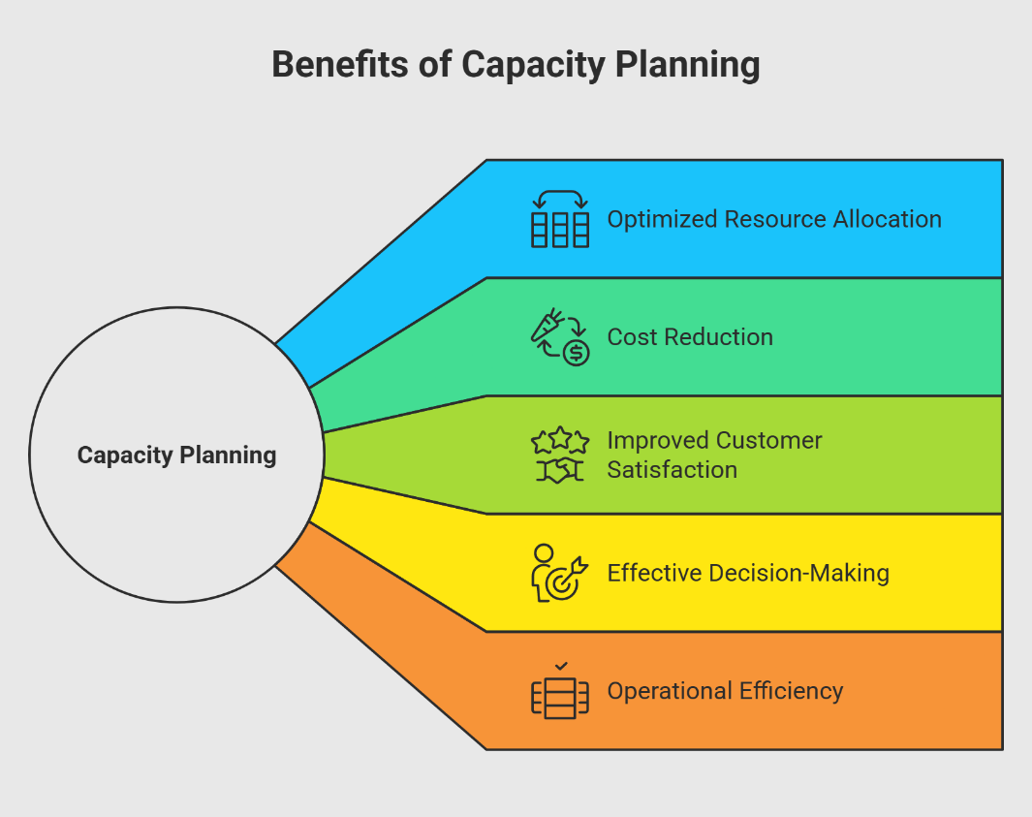
Figure 4: Benefits of Capacity Planning
(Source: Shivakumar, 2025)
Predictive analytics can help to enhance this process by making predictions on the time of expected discharge early in hospital admission. A model based on AI can be used to examine the characteristics of the patient, the state of the case and the trend associated with the past cases to create more accurate projections of the LOS. Alves, et al., (2024), note that the predictions will help hospital administrators to match the number of people who come to the hospital with the number of people who are expected to leave the hospital, which will enhance the use of beds and the elimination of operational bottlenecks.
Unexpected clinical progress such as complications or delays in treatments, may not be fully reflected in predictive models, and this could dramatically increase the duration of stay of a patient. Therefore, the use of algorithmic predictions in the absence of proper clinical supervision can give impractical hopes about the time of discharge.

2.5.2 Patients' Surgery and Hospital Productivity
Another essential part where the LOS prediction can be used to make the operations more effective is the effective management of patient flow. According to Hirani, et al., (2025), the blockages that arise when patients spend longer than expected in hospitals may impact various departments such as emergency care, diagnostic services and the surgical schedule. Inefficient patient flow is not only inefficient in a hospital, but it can also lead to poor patient outcomes and patient satisfaction. Nafjan, et al., (2025), state that predictive analytics based on AI has been suggested as a method to enhance patient flow by analysing the patients most likely to spend a longer time in the hospital. Early detection of such cases helps the clinical teams to start discharge planning sooner, organise multidisciplinary care and better allocation of resources.
According to Varnosfaderani and Forouzanfar, (2024), predictive analytics will help to convert regular electronic health record data into operational insights that may be used to proactively manage hospitals. In spite of these benefits, there are still major challenges encountered in implementation. Peek, et al., (2024), highlight that most AI-based clinical decision support systems do not succeed at the implementation phase since predictive outputs are poorly incorporated in clinical processes.

2.5.3 Workforce and Staffing Planning
Moriwaki, et al., (2025), said that the decision on staffing of hospitals is highly dependent on patient demand and the intensity of workload. The nursing personnel, doctors, and other related healthcare workers should be scheduled based on the anticipated number of patients and the complexity of care provided. Demand forecasting made inaccurately will lead to either understaffing, which will negatively affect the safety of patients, or overstaffing, which will be costly to the operation. According to a study conducted by Griffiths, et al., (2020), staffing tools usually use retrospective workload forecasts instead of a forward-looking one.
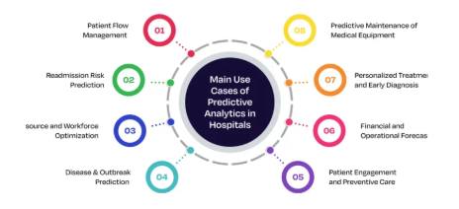
Figure 5: Predictive Analytics
(Source: Kumar, 2025)
The LOS prediction models would, therefore, be useful in workforce planning as it estimates the number of patients that will stay in the hospital on days. With these kinds of forecasts, the hospital managers can optimise the number of staff, provide specialisation, and create more reasonable shifts. However, it has been reported in the literature that the combination of LOS prediction and workforce planning is not very extensive.

2.5.4 Hospital Operations Decision Support Systems
The adoption of LOS prediction models into AI-based systems of decision support is one of the promising paths of healthcare management. These systems are a combination of predictive analytics and hospital information systems to assist in real-time bed occupancy, discharge, and resource utilisation data. Elhaddad and Hamam, (2024), say that decision support systems made with AI can enhance clinical and managerial decisions in healthcare organisations. But the adoption of these systems by organisations is still skewed. According to Preti, et al., (2024), some of the obstacles include data quality concerns, the bias of algorithms, and the absence of transparency in the predictive models. Medical practitioners can also be opposed to automated decision-support systems when they feel that the system is depriving them of professional autonomy.

2.6 Challenges in Implementing AI-Based Prediction Systems
Although the topic of artificial intelligence (AI) and predictive analytics in healthcare management has gained increased popularity, the process of implementing artificial intelligence-based prediction systems in hospital operations is complicated. Although predictive models of hospital length of stay (LOS) prove to be promising with regard to their accuracy in research settings, their implementation in the interruptions of a healthcare organisation is subject to numerous technical, organisational, and ethical problems.

2.6.1 Data Quality and Availability Problems
The success of predictive models is heavily determined by the healthcare data that is available and of good quality. Electronic health records (EHRs) give a wide range of patient information but these data are usually disjointed, incomplete, or interdepartmental across hospitals. Rajkomar, (2020) state that machine learning models can be characterised by high performance and generalisability only when the data in healthcare systems are heterogeneous. Lack of clinical variables, poor coding habits, and poor documentation standards may inject biases in predictive models, which eventually impacts the credibility of the LOS prediction in the end. Besides, the healthcare information is often stored in several information systems that do not interact. According to Petri, et al., (2025), the unification of clinical, administrative, and operational datasets is a significant technical challenge in establishing the whole predictive analytics system.

2.6.2 Technical and Infrastructure Limitations
A large number of medical organisations continue to use old information systems that are not tailored to large data analytics and real-time predictive modelling. Varnosfaderani and Forouzanfar, (2024), believe that implementing AI systems in current hospital information systems is usually resource-consuming and technical to do so. Also, predictive models that are created under controlled circumstances may fail to work in the actual situation of clinical practise. External validity of predictive models can be minimised due to differences in patient populations, hospital processes and clinical procedures.

2.6.3 Barriers of Organisational and Workforce Adoption
Technical systems are only one barrier to organisational adoption, even in the event of their availability. Medical workers might not want to make decisions based on the algorithmic forecasting, especially when it is hard to interpret the results of the prediction. Varnosfaderani and Forouzanfar, (2024), note that the transparency of complex machine learning models, commonly also known as the black box problem, may decrease clinician trust and adoption. Stoumpos, et al., (2023), highlight that to achieve successful digital innovation in healthcare, organisational culture, which facilitates learning, collaboration, and change management are necessary in addition to technological preparedness.

2.6.4 Ethical, Privacy, and Bias Considerations in AI Systems
Ethics and governance are also issues of concern in terms of AI usage in healthcare. The predictive models developed based on the past healthcare data can replicate the pre-existing inequalities or biases already present in clinical data. Ferrara, (2023), showed that unfair treatment suggestions to various groups of patients can occur because of the algorithmic prejudice in the healthcare prediction models.
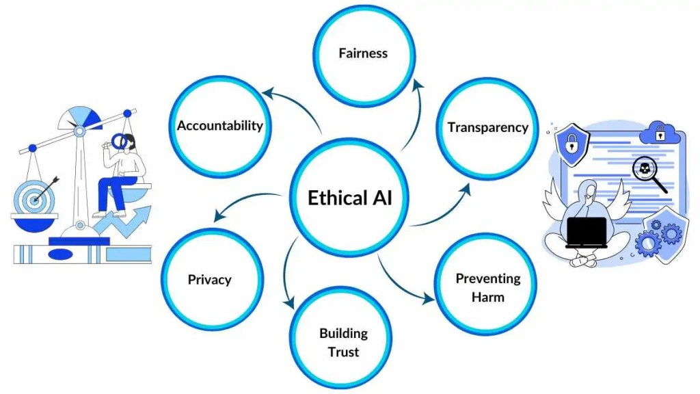
Figure 6: Ethical AI
(Source: Otten and Otten, 2024)
The other significant issue is the privacy of patients, especially where high amounts of sensitive health information are used in predictive modelling. The strict regulatory laws like the General Data Protection Regulation (GDPR) in Europe have seriously stringent demands about data security, transparency and the consent of the patients.

2.6.5 Governance and Regulatory Frameworks for AI in Healthcare
Finally, AI technologies in healthcare are a developing field in terms of governance. The regulatory frameworks of AI-driven clinical decision support systems remain in an early state and cause confusion on accountability and control. According to Jenko, et al., (2025), to implement AI in the healthcare sector responsibly, there should be well-developed governance rules that will cover model validation, monitoring, and risk management. It emphasises the necessity of multi-disciplinary cooperation between clinicians, data scientists, policymakers, and hospital administrators to secure the responsible implementation of AI technologies in healthcare processes.

2.7 Research Gap and Justification of the Research
Even though a considerable number of studies have been carried out to examine predictive modelling capability in hospital length of stay (LOS), several significant gaps still exist regarding its application in the operations of a hospital. A substantial part of the current literature is dedicated to the purpose of enhancing predictive quality of machine learning models, where the algorithms such as random forests, gradient boosting, and neural networks are usually assessed through measures of performance such as accuracy, AUC, and RMSE.
Although such studies are relevant to the improvement of the methodology, they often fail to address the possibility of converting the outputs of the predictor into a practical operational decision in healthcare organisations. Moreover, the existing literature is likely to focus on clinical prediction instead of hospital workforce and staffing issues. Patient demand and care complexity, as well as projected hospital occupancy, are strongly correlated with staffing decisions, but few studies have investigated whether LOS prediction models may be used to guide staffing allocation or workforce scheduling.
The other weakness of the literature is associated with the piecemeal approach to the discussion of ethical, governance and regulation issues. Numerous studies consider algorithmic bias, transparency and patient data privacy independently of predictive modelling frameworks, as opposed to considering them as a part of the operational decision-support systems. Also, not many of the studies take a holistic approach, which would relate technical predictive modelling and the operational planning applied to the hospital, which would involve the bed capacity planning, patient flow planning and the staffing planning. Therefore, the possible strategic importance of AI-based LOS prediction as a means of hospital resource optimisation is not completely researched.

Chapter 3- Research Methodology

3.1 Introduction
This chapter explains how a methodology is to be followed to explore the use of AI-powered data analytics to predict hospital length of stay (LOS), and its consequences on bed capacity and staffing decisions. The research design is quantitative, which is a research design that entails analysis of numerical data and statistical modelling to come up with measurable and objective results. This would be the right method since LOS is a non-discrete numerical variable that would have to be predicted by means of mathematical and computational tools.
Moreover, an explanatory research design will be utilised to define and assess cause-and-effect relationships between patient, clinical, and organisational variables and LOS outcomes. This design will allow the study to go beyond description and give analytical information on the effects of various factors on hospital stay duration. The predictive modelling and evaluation are aided by machine learning methods, especially the supervised regression models. The methodological decisions that are taken to develop, assess, and operationalise AI-based LOS prediction models are justified in this chapter.

3.2 Development Environment
Python is used as the main programming language to implement the research because it is widely used in healthcare analytics and has a rich machine learning library ecosystem. It is used to efficiently process data, develop models, and reproducibly experiment, and is therefore highly suitable for predictive modelling (Raschka, et al., 2020). Python enables scalable and reproducible analytics workflows, which is essential to guarantee transparency and consistency in the results of the research (Davenport and Kalakota, 2019).
Visual Studio Code (VS Code) is selected as the integrated development environment due to its lightweight architecture, flexibility, and seamless integration with Jupyter notebooks, which are essential for iterative data exploration and modelling. It provides built-in support for Git-based version control, facilitating reproducibility and structured experimentation (Microsoft, 2021). The research employs such important Python packages as Pandas to manipulate data, NumPy to perform arithmetic operations, Scikit-learn to implement machine learning, and Matplotlib and Seaborn to visualise data. These tools are also well known as standard elements of the healthcare analytics pipeline, which guarantees methodological consistency with the current literature.
Even though PyCharm is an excellent Integrated Development Environment that provides highly developed facilities for comprehensive software development, it does not become part of this study because of its relatively high level of resource usage and complicated configuration. Since the current research is related to data analysis and experimentation with algorithms in the sphere of Machine Learning, it does not require a full software development process but implies several simple actions instead. This is why PyCharm seems excessive in such a situation, unlike Visual Studio Code.

3.3 Research Design
The research methodology in this study is quantitative because the dependent variable, length of stay (LOS), is continuous and needs to be numerically predicted. Quantitative design also provides the opportunity to apply statistical and machine learning methods and measure them using measurable indicators (mean squared error (MSE), root mean squared error (RMSE), and R²) (Hosamo and Mazzetto, 2024).
It uses an explanatory research design to determine and evaluate the relationship among patient, clinical, and organisational variables that affect LOS, with the current literature that has identified LOS as a complex outcome. The models of machine learning and healthcare analytics are applied to create and test predictive models, according to the hypothesis that patient and clinical factors play a significant role in LOS.
The design is consistent with the research questions. The research questions are concerned with predictive modelling and focus on the implementation problems and governance to guarantee that the methodological aspect of the study is aligned with the research objectives.

3.4. Data Collection
Dataset link: https://www.kaggle.com/datasets/aayushchou/hospital-length-of-stay-dataset-microsoft/data
The dataset used in the study is a publicly available hospital length of stay dataset that is obtained from Kaggle (Choudhury, 2022). The application of a considerable amount of data increases the statistical reliability and allows for conducting a strong training of the model, whereas its open access provides the research with transparency and reproducibility (Knar, 2025). Healthcare analytics studies have a wide application of such datasets, which justify their comparability to existing literature.
The study is founded on secondary data, which is suitable due to the sensitivity of healthcare data. This approach removes the necessity of having direct contact with the patients by utilising secondary data, and thus, ethical issues regarding consent and privacy are minimised.
The data has numerous independent variables that include the patient's sex, comorbidity indicators, laboratory results, vital signs, the number of previous readmissions and the admitting facility, which are generally known to be some of the determinants of length of stay in a hospital. The dependent variable is LOS, which is the number of days between admission and discharge. The current literature indicates that LOS is determined by a set of clinical, demographic, and organisational variables, which supports the applicability of these variables in predictive modelling.
An extensive data pre-processing plan is adopted to maintain data quality and model accuracy (Mu, et al., 2026). Any missing values are addressed with suitable imputation methods, whereas outliers are detected and addressed to avoid the effect of distorting model performance. Categorical variables are coded into the numerical format, and feature scaling is done when needed to facilitate the efficiency of the algorithm. These are necessary steps because the data provided in healthcare is usually incomplete, inconsistent, and heterogeneous, and should be carefully prepared before analysis.

3.5. Hardware and Secondary Requirements

3.5.1. Hardware Requirements
The experimental design used in this study is applied on a conventional personal computing platform with at least 8GB RAM and a multi-core processor, and sufficient storage space to process large healthcare data (Guo, et al., 2022). These specifications are chosen with consideration of the computational needs of machine learning workflows, including data preprocessing, feature engineering, model training, and evaluation. The capacity of memory is a major consideration because datasets of thousands of patient records must be processed efficiently in memory when transforming and analysing data. Equally, a multi-core processor will be more helpful in running algorithms faster, especially when the process of training a model and cross-validation is carried out, and several iterations are done (Ghimire and Amsaad, 2024).
These hardware requirements show that the research has a realistic, practical implementation, as the analysis can be performed without using specialised or expensive infrastructure. This is important with respect to healthcare organisations, where accessibility to advanced computing systems can be restricted due to resource constraints. Although the existing installation can be used experimentally, scalability is also a significant aspect to keep in mind. This scalability is important in the sense that the suggested methodology can be used outside of the research context.

3.5.2. Software Requirements
The research paper is carried out in a Python-based analytic setup, where its vast ecosystem of open-source machine learning and data analytics libraries is exploited. Core libraries include Pandas for data manipulation, NumPy for numerical computation, and Scikit-learn for implementing machine learning models. They are well-known in both academic and industrial studies, which makes them consistent and comparable in terms of methodology to the current research in healthcare analytics (Raschka, et al., 2020). Open-source software proves highly economical in terms of implementation costs, rendering the given approach affordable and possible even in the case of healthcare institutions with insufficient technical capacity (Farré, et al., 2022). Moreover, the Jupyter notebooks are used in exploratory data analysis, model development, and documentation. Combining code, outputs and explanations in one environment makes the research more understandable and facilitates research reproduction.

3.6. Research Deployment Experimental Setup

3.6.1. Machine Learning Algorithms
This research uses a sequence of basic and sophisticated machine learning models to forecast hospital length of stay. The baseline model employed is the linear regression because it is simple, easy to interpret, and can develop a basic relationship between independent variables and LOS. It is a popular statistical technique that is used as a reference point against which the performance of more complicated models can be compared (Mathotaarachchi, et al., 2024).
Overall, to increase the predictive accuracy, sophisticated algorithms like Decision Trees, Random Forest, and Gradient Boosting are introduced. Such models can represent non-linear relationships and other interactions between clinical, demographic and organisational variables that can appear in the healthcare information. The machine learning algorithms, especially the ensemble model, are better in LOS prediction than the conventional statistical models because of their capacity to deal with data complexity and variability.
The training is systematic, where the data is categorised into a training and testing population with an 80/20 ratio (Sivakumar, et al., 2024). The strategy eliminates chances of overfitting and ensures that the models can repeat themselves on unseen data. The fact that it features both baseline comparison and advanced modelling, and the fact that it is heavily validated, make the predictive framework reliable.

3.6.2. Deep Learning Algorithms
Deep Learning algorithms, such as Artificial Neural Networks (ANNs), in addition to the conventional machine learning approaches, are considered a part of the deep learning approach to the prediction of LOS. Neural networks can be especially useful to describe complex, high-dimensional patterns in large amounts of data, and are commonly applied in healthcare settings where there are multiple interacting variables that affect outcomes (Mienye, et al., 2025).
The main strength of deep learning models is that they provide high predictive accuracy because they automatically learn the feature representations based on the available data (Taherdoost, 2023). This renders them useful in detecting fine-grained patterns that may otherwise be missed under basic models. However, one of the weaknesses of neural networks is that they cannot be interpreted and are sometimes known as the black-box problem. This is a problem in the healthcare setting, where explainability and transparency will be critical factors in establishing trust between clinicians and decision-makers.
The literature emphasises that although deep learning models can enhance their prediction efficiency, their implementation in clinical settings tends to be limited by the threats of a lack of confidence, responsibility, and explicability. Thus, their application in this research is critically evaluated with more interpretable models.

3.7 Performance Evaluation

3.7.1 Evaluation Metrics
The predictive models are evaluated against conventional regression assessment indicators, such as Mean Squared Error (MSE), Root Mean Squared Error (RMSE) and the coefficient of determination (R²) (Choi, et al., 2025). MSE and RMSE quantify the size of errors in predictions, and RMSE can be used as an interpretable error that is in the same unit as that of the dependent variable (days of stay). R² tests the amount of variance in LOS that is predicted by the model. These measures are commonly utilised in healthcare predictive modelling and could be fairly compared across the algorithms, making them consistent with the existing literature.

3.7.2 Validation Strategy
A mix of k-fold cross-validation with test set evaluation is used to ensure model reliability and generalisability. Cross-validation evaluates whether the model is consistent across different data splits, whereas the hold-out test set gives an objective measure of model performance on new data (Abedin, et al., 2026). This reduces overfitting and increases robustness.

3.7.3 Operational Interpretation
The findings of the evaluation are interpreted operationally to facilitate the decision-making of the hospital. An increase in the predicted LOS values means that there will be more occupancy in the beds and a possibility of a higher staffing requirement, whereas a lower LOS will imply higher turnover of the patients and better utilisation of the capacity (Hirani, et al., 2025). This knowledge can be used to plan the bed and pre-empt the workforce scheduling.

3.7.4 Limitations Handling
Potential limitations, including overfitting, data bias, and limited generalisability, are addressed through cross-validation, careful feature selection, and acknowledgement of dataset constraints, ensuring responsible interpretation of results. Moreover, grid search hyperparameter tuning methods are used to maximise the performance of the model and minimise the chances of overfitting. The bias of data is given serious consideration, especially because secondary healthcare data sets might represent past inequalities or discrepancies in practices of data recording. To reduce this, feature importance analysis and exploratory data analysis are done to reduce the effect of biased or redundant variables.
Moreover, generalisability is resolved by acknowledging that models which have been trained on one dataset might not be completely representative of different hospital environments. Thus, the research underlines the importance of external validation and contextual adjustment of the application before practice. These enhance the consistency, openness, and moral soundness of the forecasting modelling strategy.

Chapter 4: Data Analysis and Model Implementation

4.1 Introduction
The chapter describes the practical implementation, analysis and evaluation of the use of AI-enabled data analytics for the prediction of hospital length of stay. This aims to apply data cleaning and pre-processing techniques to the hospital LOS dataset before performing an exploratory data analysis, machine learning and deep learning models on the dataset and estimating and analysing the accuracy of the models in predicting the LOS dataset. The objective of the study is to investigate the potential of using AI-driven data analytics in predicting the hospital LOS and with this support in managing hospital bed occupancy and staffing. Therefore, this chapter is directly connected to applying the technical modelling process to the practical operational planning of hospitals.
Length of stay is used as the dependent variable as it provides information on the length of time that the patient spent in the hospital. Independent factors are Demographic, clinical and organisational variables such as genders, ID of facilities, indicators of comorbidities, laboratory measurements, and number of re-admissions. The models used are Linear Regression, Decision Tree, Random Forest, Gradient Boosting and Artificial Neural Network. The Mean Squared Error, Root Mean Squared Error, Mean Absolute Error and R² score were used to evaluate these models (Hodson, 2022). Results are then interpreted with respect to the accuracy of prediction, bed capacity planning and staffing implications.

4.2 Overview of Dataset
This research makes use of the Hospital Length of Stay dataset which is imported into Python using Pandas. The data set was validated by implementing it and it was found to have 100000 patients and 28 variables. This is an appropriate size for machine learning as it contains enough observations to be used for training, testing and comparing various predictive models. The data include a combination of administrative, demographic, clinical and organisational variables that support the dissertation aim of investigating the different patient and hospital-related factors that impact LOS.
The response variable is the length of stay the length of hospital stays in days from admission to discharge. Other administrative variables such as eid, vdate, discharged and facid are also included in the dataset. Demographic data is depicted by gender, and clinical and health features by dialysisrenalendstage, asthma, irondef, pneum, substancedependence, psychologicaldisordermajor, depression, psychother, fibrosisandother, malnutrition and hemo. Laboratory measurements that are used are haematocrit, neutrophils, sodium, glucose, bloodureanitro, creatinine, BMI, pulse and respiration.
The dataset is appropriate for the research as it considers both patient condition and clinical complexity and organisational context to influence LOS. This validates the literature review, which highlighted that LOS does not just measure clinical performance but it is also an operational indicator that is associated with the availability of beds, flow of patients, treatment schedules and staffing workload. The data set may thus serve as a good basis for creating predictive models based on artificial intelligence to aid hospitals in their decision-making process. The dataset structure was confirmed in the practical notebook as 100000 and the length of stay was determined to be the last prediction target in the data.
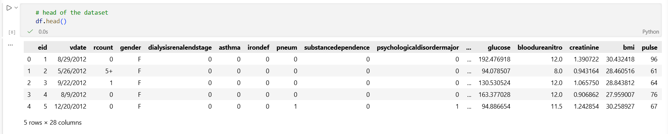
Figure 7: Overview of the dataset
4.3 Data Cleaning and Preprocessing
Before model implementation, the data was cleaned and pre-processed to make sure that the data was suitable for machine learning (Sai, 2020). This was significant because the predictive models needed structured, numerical and reliable data, as the data quality was structured. While the data in its raw form was quite structured, there were several preparation steps to avoid leakage and ensure variables were treated in a consistent manner and could be utilised by the machine learning algorithms (Park, et al., 2024).
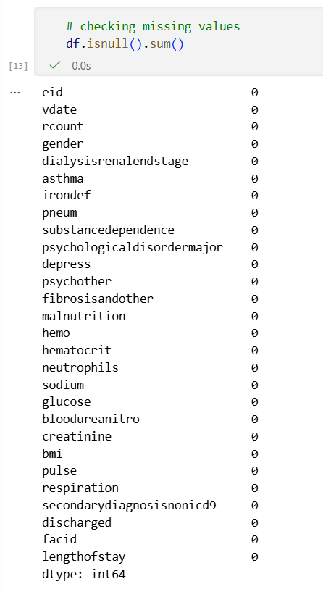
Figure 8: Missing values
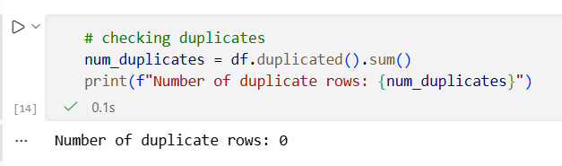
Figure 9: Checking Duplicates
The initial task was to check the data in the dataset for any missing values and duplicate records. All the variables had 100000 values indicating that the raw data did not contain any missing values for each variable. It also verified if there are no duplicate rows, which resulted in no removal of records because of duplications and there were no significant corrections of missing values in the initial data inspection phase. But imputers were still a part of the modelling pipeline as a precaution. This is sound practice as it allows stability of the model pipeline in the event of new hospital datasets with missing data.
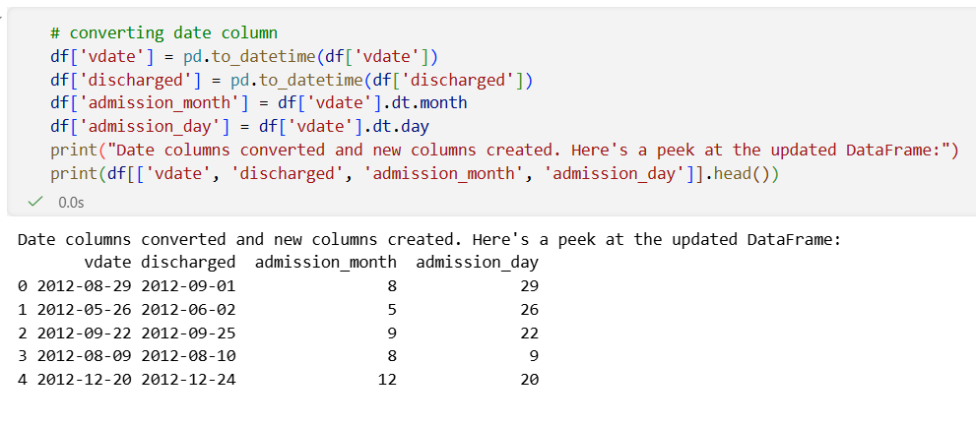
Figure 10: Converting date column
The next step was to convert the date variables. vdate and discharged are variables that are defined as object data types. pd.to_datetime () was used to change these into a date format. Two new features were added from the variable vdate which indicates the date of admission that is admission_month and admission_day. The model gets benefits from these features that it to incorporate admission timing information without using the date strings. This can be helpful because there can be differences between months or days regarding the number of admissions that can have an indirect impact on hospital capacity and patients' flow.
A crucial pre-processing decision that was made was the elimination of the discharged variable. This column was eliminated as it provides information used to calculate LOS which would be seen directly on the discharge date. A study would leak this variable if it were kept, as it would be used in the learning process but not present at the time of admission. This would result in unrealistic performance and a lack of validity in the research. Thus, the exclusion of the discharged helped to ensure that model predictions utilised only information that could be reasonably used for early prediction of the LOS.
The variable rcount also needed to be cleaned since it had the category 5+. This was changed to a numeric variable, rcount_clean, with "5+" replaced by "5". Hence, it was possible to use the count of readmission as a numeric predictor. It was then followed by separating the target class.
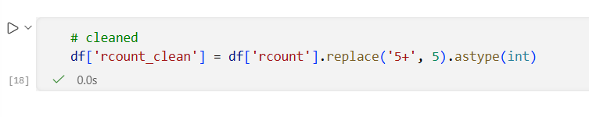
Figure 11: Cleaned data
It was later categorised and numerical variables were divided. Gender and facid were considered categorical variables and the other variables were numerical variables that included the indicators for comorbidities, the various laboratory parameters, the various physiological parameters and rcount_clean. Numerical data were pre-processed using median imputation and a standard scaling method, while most frequent imputation and one-hot encoding methods were used for categorical data (Koukaras and Tjortjis, 2025). This pipeline was used to transform all features meaning that they were transformed in the same way before training the model. In practice, only gender and facid were categorical; all clinical, comorbidity, laboratory and readmission predictors were numerical.
Table 4.3: Preprocessing Actions and Justification below
Preprocessing Step | Action Taken | Justification
Missing value check | Checked all variables | Ensured completeness of data
Duplicate check | Checked duplicate rows | Prevented repeated records
Date conversion | Converted vdate and discharged | Enabled date-based feature creation
Feature engineering | Created admission_month and admission_day | Added admission timing features
Leakage prevention | Removed discharged | Prevented unrealistic prediction
Readmission cleaning | Converted 5+ to 5 | Made rcount_clean numerical
Encoding | One-hot encoded categorical variables | Prepared text categories for ML
Scaling | Standardised numerical variables | Improved model training consistency

4.4 Exploratory Data Analysis
Exploratory data analysis has been performed before predictive models have been created to gain insight into the structure, distribution and relationships of the data (Ogryzek and Jaskulski, 2025). This stage is essential to gain an understanding of the behaviour of LOS, characteristics of patients and the potential effect of demographic, clinical and organisational variables. EDA also facilitates the selection of models since the distribution and complexity of the data can be a sign of a simple linear model or require more advanced machine learning models (Langer and Meisen, 2021).
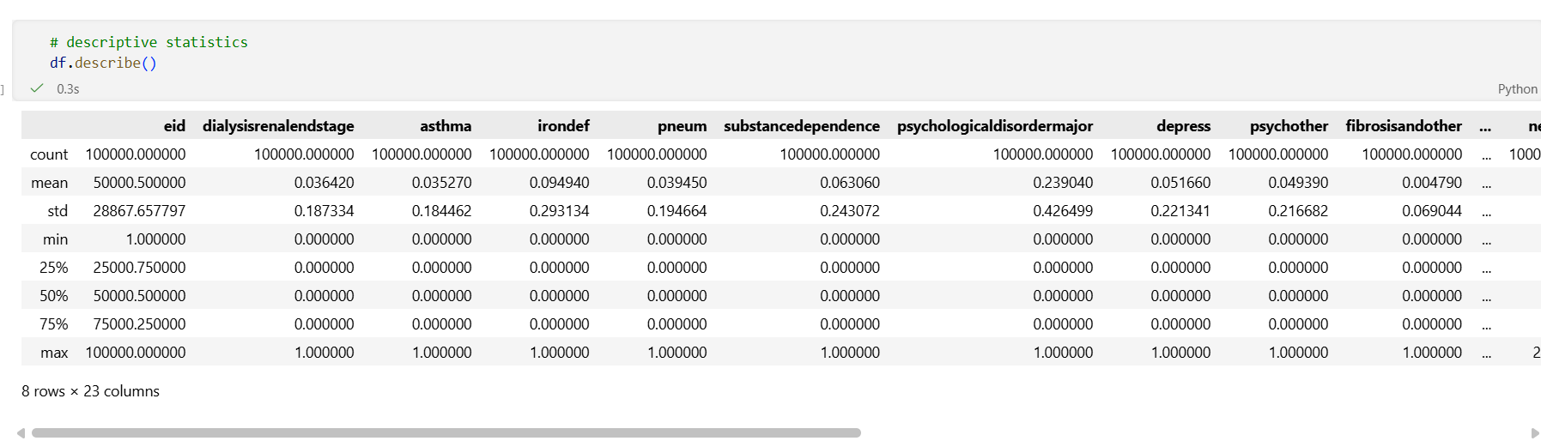
Figure 12: Descriptive Statistics
The descriptive statistics of the target variable indicated that the data had 100000 observations each containing the information on LOS. The mean LOS was about 4.00 days with a standard deviation of 2.36 days. The shortest period of observation (LOS) was 1 day, and the longest was 17 days. 2 days = 25th percentile, 4 days = median and 6 days = 75th percentile. These statistics indicate that patients' stays were short to moderate, with some patients staying for much longer. This variation is significant as it increases the number of people on the bed and the staff turnover. These were confirmed by the practical output for length of stay.
This was then visualised as a LOS distribution using a histogram. This graph represents the distribution of the patient length of stay for this data set. Most patients seem to be concentrated in an area of low and middle LOS with the rest having longer stays. It is helpful in hospital planning as it is possible that a smaller number of the longer stay patients can be accommodated in beds for a longer duration thus minimising the turnover of beds. Thus, it is operationally important to accurately identify patients likely to stay longer. The histogram also supports a modelling point of view that the task of predicting the LOS is indeed a numerical prediction problem and hence the use of a regression-based machine learning model is appropriate (Zippo, et al., 2025).
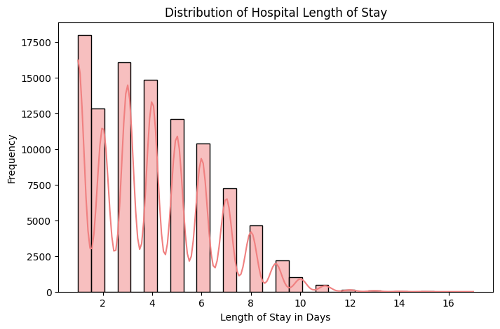
Figure 13: Distribution of hospital length of stay
The figure must be used to substantiate that LOS is variable within patients. It depends on a patient’s profile and the hospital setting. This aligns with the need for the use of AI-driven predictive models as traditional average-based planning approaches might not account for patient-level variations. For instance, if only the average LOS (4 days) is considered a simple approach in bed planning is used as this approach may be too basic because some patients stay for one or two days while others stay more than one week. A predictive model can thus give more personalised estimates to hospital managers.
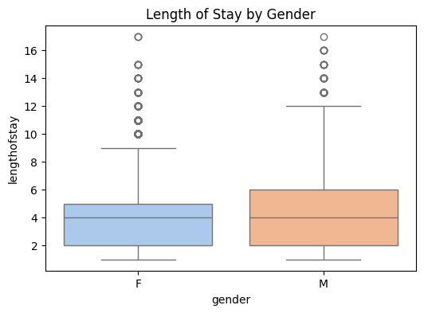
Figure 14: Length of stay by gender
The second EDA output was a boxplot of the data for LOS by gender. Gender is not generally a biological construct but was added in expectation of having some demographic factors that have a relation with patient outcome differences or patterns of hospitalisation. The gender boxplot can be used to compare the median LOS and spread of LOS of male vs. female patients. This chart is not meant to indicate that gender leads to differences in LOS. On the contrary it directs whether the LOS distributions vary among gender groups or not, and whether gender is important for the model. Gender is helpful for this dataset as part of a comprehensive feature set particularly in combination with clinical and organisational features.
A similar median and spread for both gender groups indicates that gender may not be the only predictor of the item. Gender interactions with other clinical or organisational variables can be identified with machine learning models. For instance, gender might not be a strong predictor of LOS alone but provide additional predictive value when factors such as indicators of comorbidity and laboratory tests or facility-level differences are considered. This assists in the replacement of judgment with the use of multivariable models.
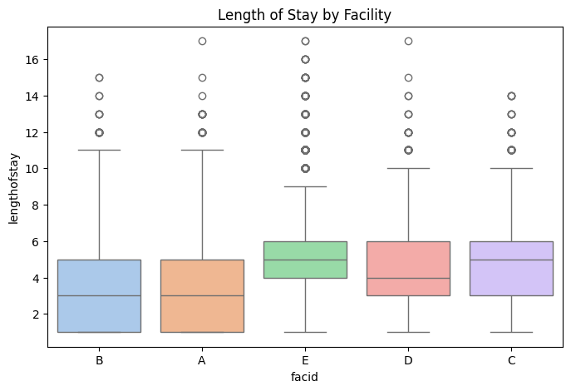
Figure 15: Length of stay by facility
LOS by facility ID was shown using a boxplot in the third EDA output. This is important because facid is an organisational level of grouping. The care processes, the characteristics of the patient population, the discharge procedures, the pressure on bed capacity and staffing structure may vary between facilities. This box plot can be used to visually compare the LOS that occurred at different facilities. A larger variation or larger central LOS in one facility when compared to another may reflect differences in the flow of patients or management of hospitals (Khedr, et al., 2025).
This is significant in relation to the dissertation subject since the capacity of the beds and the number of staff members who are required are operational questions. If there are differences in the LOS at facilities then it is not possible for a hospital manager to use just an overall average. From the perspective of bed allocation and planning of staff, facility-specific prediction might be required to enable more accurate predictions. For instance if the LOS is very diverse more flexibility in staffing and greater attention to discharge planning requirements may be necessary. Also, an institution that has an average LOS that is much shorter could have a higher number of patient turnovers and other resource needs. This enables otherwise uninformative features such as facid to be added to the model as categorical features.
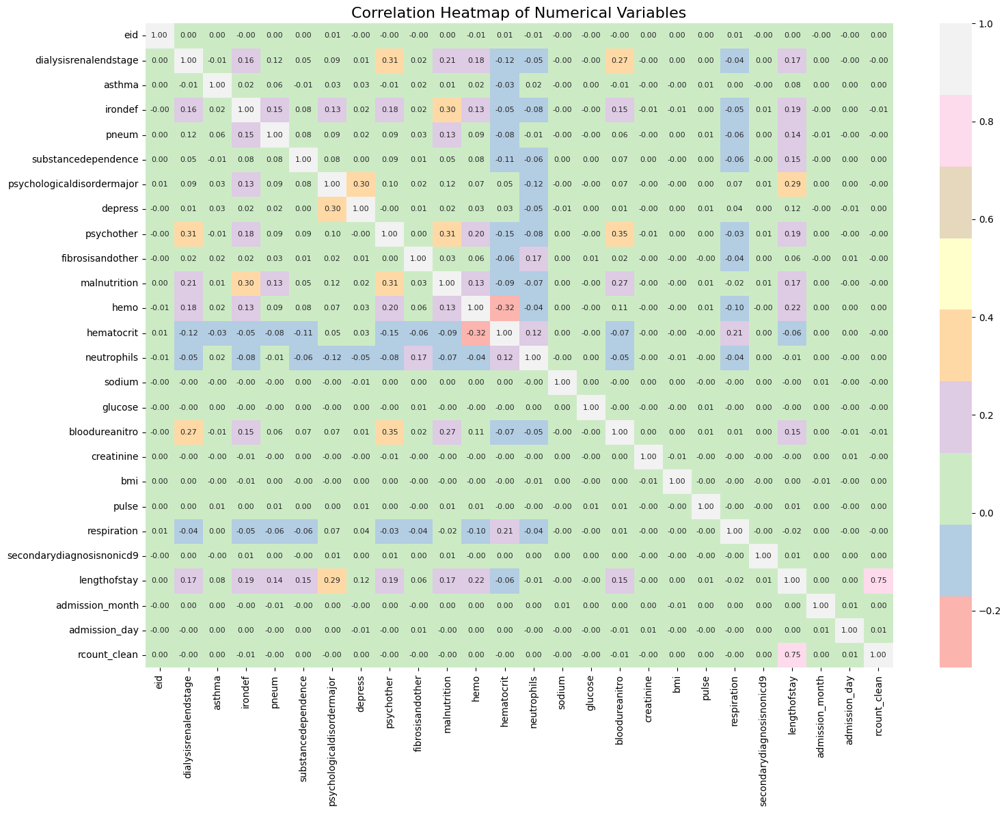
Figure 16: Correlation Heatmap
A pairwise correlation heatmap was also created to explore the relationship between the numerical variables (Sova, et al., 2024). The clinical measurements, the comorbidity indicators and LOS were added to the heatmap. One good use of correlation analysis is to give an early warning of linear relationships among features. The use of clinical variables that may reflect patient condition and clinical complexity such as glucose, creatinine, blood urea nitrogen, BMI, pulse and respiration was included. Comorbidity indicators were also added as these patients could have more severe or multiple issues necessitating a longer hospital stay.
It should be taken with a pinch of salt and the heatmap's interpretation should be done carefully. The linear relationships are mainly the ones that are captured in correlation potentially there are non-linear and interaction effects in LOS. For instance one clinical measurement might have a small direct effect on LOS yet the individual effect of any other measurement might be significant along with it. That is why the machine learning models are applicable for this research. Decision Trees, Random Forest, Gradient Boosting and ANN can model more complicated relationships than the correlation or simple linear models.
The EDA confirmed that overall there is a measurable variation in LOS from patient to patient and from facility to facility. The descriptive statistics revealed that the mean LOS was about four days but there were patients who were in the hospital for up to 17 days. The distribution plot showed that the data on the LOS were suitable for regression modelling. The boxplots by gender and by facility indicated that there may be a relationship between the LOS and the demographic or organisational factors. This heat map demonstrated that there are several clinical and numerical characteristics that are present in the data that could be used for prediction (Rahman, et al., 2025). These results provide grounds for the approach to move from the descriptive analysis to the use of predictive modelling.

4.5 Model Implementation and Evaluation
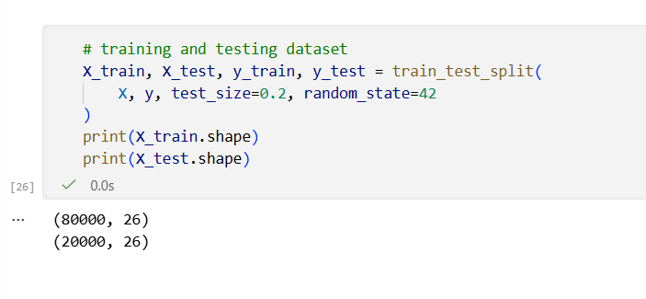
Figure 17: Train-Test Split
The dependent variable (lengthofstay) is numerical in nature so the model implementation was done by a supervised regression approach. The research methodology was applied in the practical part, with an 80/20 split between training and testing (Rácz et al., 2021). This is because 80000 records were employed to train the model and 20000 records were reserved to test the model. These training data enabled the models to learn and identify patterns within the patient, clinical and organisational data. To test their models, the testing data was used to evaluate the models' performance on unseen records (Bhattarai, 2024). This way, it can be determined if the models can generalise outside their training data.
Four regression metrics (MSE, RMSE, MAE and R² score) were used to assess the models. The average squared prediction error is used as the measure of MSE. RMSE equals the square root of the MSE and RMSE is particularly useful since it measures the same units as LOS which is in days (Plevris, et al., 2022). The average absolute error between the actual and predicted LOS is the measure of the MAE. The value of R² indicates the amount of variation in LOS accounted for by the model. A lower MSE, RMSE and MAE value indicates good prediction accuracy and a higher R² value signifies good explanatory performance.
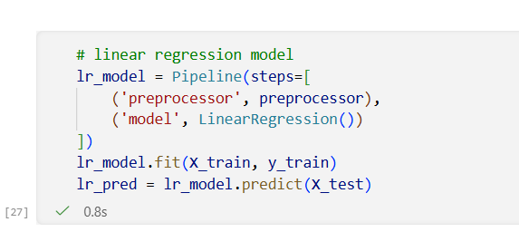
Figure 18: Linear Regression model
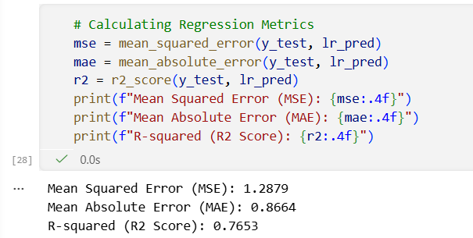
Figure 19: Performance metrics
The first model that was implemented was Linear Regression. This model was chosen as a baseline model as it is simple, transparent and easy to interpret (Mathotaarachchi, et al., 2024). Linear Regression assumes a linear relationship between independent variable(s) and the LOS. The model achieved an MSE of 1.2879, RMSE of 1.1348, MAE of 0.8664 and R² score of 0.7653. The results in this study illustrate that the baseline model accounted for approximately 76.5% of the variance for LOS. This is a logical point from which to start and indicates that there is predictive information in the selected variables. The model performance is limited due to the high RMSE (>1 day) which shows that the model does not necessarily reflect the complex LOS pattern.
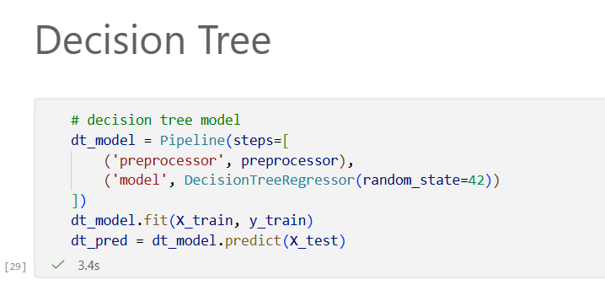
Figure 20: Decision Tree Model
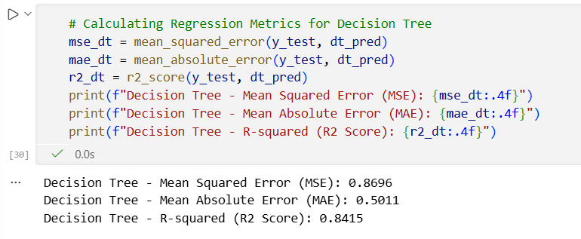
Figure 21: Performance metrics
The other model was the Decision Tree Regressor. This model was chosen as it was able to model non-linearity and could partition patients into various groups according to the feature values (Rad, et al., 2025). The Decision Tree achieved an MSE of 0.8696, RMSE of 0.9325, MAE of 0.5011 and R² score of 0.8415. This result was better than Linear Regression particularly with respect to RMSE and R². The improvement indicates that there are additional non-linear relationships at play with LOS. Rather thresholds, interactions and non-linear patterns, may determine the length of patient stay. Decision Trees can be too complex and prone to over-fitting so the results should be used with care.
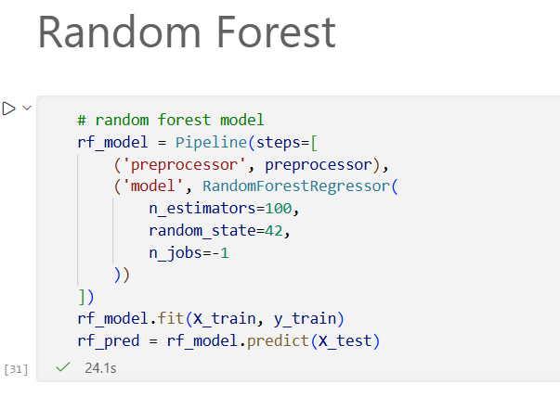
Figure 22: Random Forest model
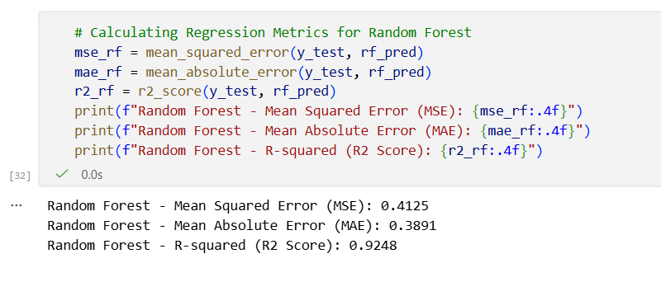
Figure 23: Performance metrics
Random forest regressor was the third one. Random Forest is an ensemble technique that uses many decision trees to gain in predictive stability and to counter the individual tree's weaknesses (Sasi, et al., 2025). This model achieved an MSE of 0.4125, RMSE of 0.6423, MAE of 0.3891 and R² score of 0.9248. The results in these are very promising compared with Linear Regression as well as the Decision Tree. The RMSE was decreased to less than one day which indicates that the model had a better accuracy prediction of LOS. The R² value shows that the Random Forest had an approximate 92.5% of explanation of the variation of LOS. This makes it an excellent model for hospital planning since it offers an accurate prediction yet is much more interpretable than deep learning.
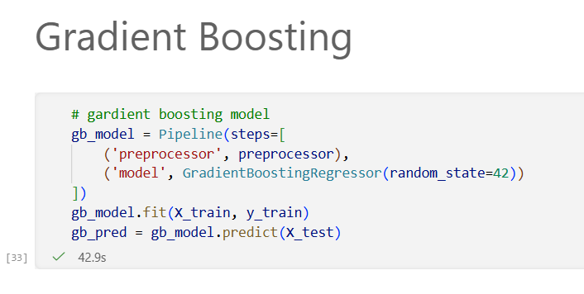
Figure 24: Gradient Boosting Model
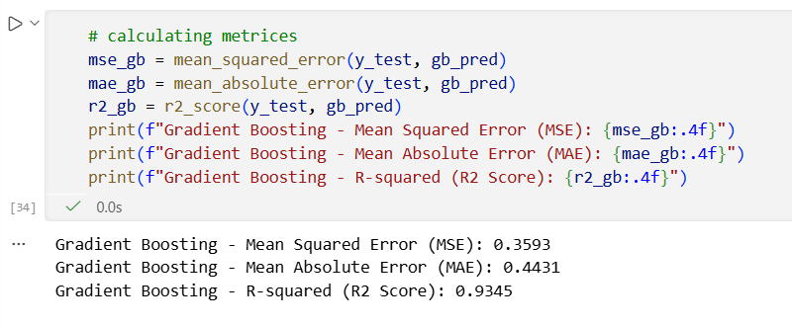
Figure 25: Performance metrics
The fourth one was Gradient Boosting Regressor. Gradient Boosting models are created sequentially where each new model tries to fix errors made by the previous model (Airlangga and Liu, 2025). This model achieved an MSE of 0.3593, RMSE of 0.5994, MAE of 0.4431 and R² score of 0.9345. Random Forest was not as good as Gradient Boosting with regard to RMSE and R². This means it was able to identify complex patterns within the data well. But its MAE was marginally more than that of Random Forest. This indicates that Gradient Boosting was very good at predicting overall but Random Forest was still good at predicting average absolute error.
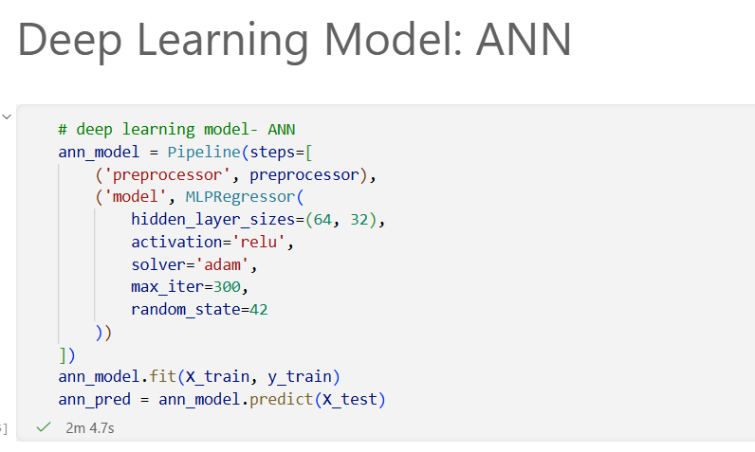
Figure 26: Deep Learning Model (ANN)
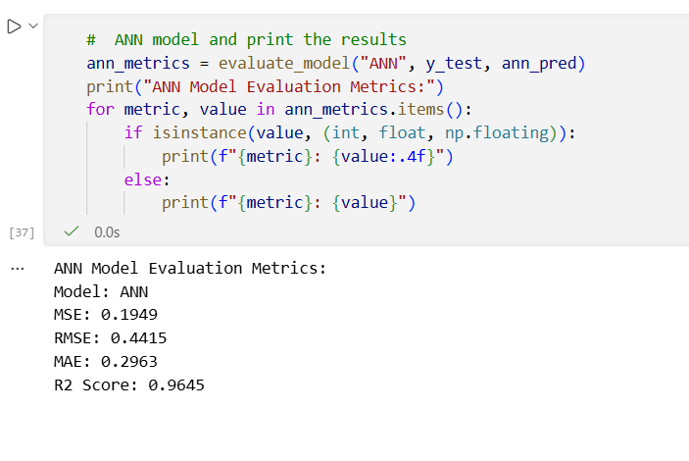
Figure 27: Performance Metrics
The fifth model was the Artificial Neural Network (ANN), which was performed using an MLPRegressor. The ANN architecture has two hidden layers, one of 64 neurons and another of 32 neurons, RelU activation and an Adam optimiser (Abdolrasol, et al., 2021). This model achieved the best overall results, with an MSE of 0.1949, RMSE of 0.4415, MAE of 0.2963 and R² score of 0.9645. Based on the R² score, the ANN model explained approximately 96.5% of the variation in LOS and the average difference between the actual and predicted LOS was less than 0.5 days. This implies that deep learning can learn more complicated relationships in the dataset than conventional regression and ensemble models. The results of evaluation on the ANN from the notebooks agree with the strongest evaluation result than all the models.
The model was also a warning for convergence that is the maximum number of iterations was reached before full convergence though the ANN model also gave a convergence warning. This does not exclude the possibility of using the model result but it should be pointed out as a limitation. Recommends further tuning or more iterations and different learning parameters for model stability. This is important in a healthcare environment where high accuracy is not sufficient. Additionally, a model needs to be reliable, explainable and validated before being put into practice.
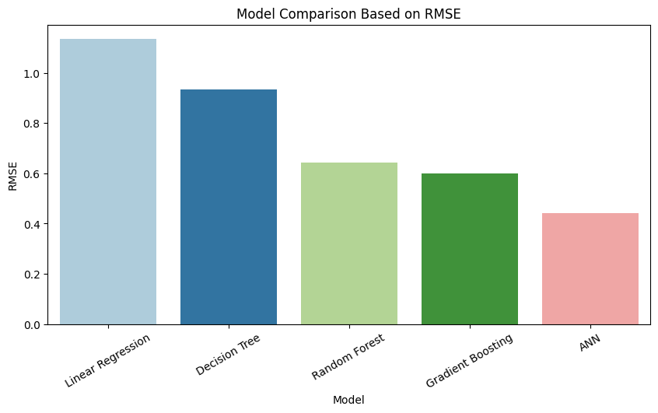
Figure 28: Model Comparison based on RMSE
The model comparison figure in terms of RMSE is clear that the prediction error is reduced with the advancement of the models. The highest RMSE was achieved with the help of Linear Regression and the lowest RMSE was achieved by using ANN (Gyparakis, et al., 2025). This indicates that the data has complex relationships that can be better represented by non-linear and deep learning approaches. Operationally it is significant that the RMSE is lower as this error of one day in LOS prediction can impact bed allocation and staffing decisions. Thus, a model with minimum prediction errors can be more useful to the hospital managers.
There was also another validation with the Random Forest model by considering the cross-validation. The five cross-validation RMSE scores were approximately 0.6456, 0.6614, 0.6581, 0.6479 and 0.6555, with an average RMSE of 0.6537. This indicates that Random Forest was stable over various data partitions. To optimise hyperparameters, GridSearchCV was used with Random Forest. max_depth=None, min_samples_split=5 and n_estimators=100 were the most optimal parameters. The tuned Random Forest model gave a RMSE performance of around 0.6415, R² score of around 0.9250. The results of this showed that tuning slightly improved the Random Forest model and it helped to support the stability of the model. These are reported in the practical notebook, as results of cross-validation and tuning.
Overall, the model implementation showed that predictive analytics can estimate the LOS in hospitals with good accuracy, using AI. A linear Regression model was provided as a baseline, but more advanced models had better results. Random Forest and Gradient Boosting models worked well and may be considered if the interpretability remains crucial. ANN performed well in the prediction task, but has a less interpretable set and convergence warning, so this model should be used with caution in healthcare decision-making (Abdullah, et al., 2021). Thus, accuracy must not be the only criterion for selecting a model. Other considerations are explainability, governance, staff trust and operational integration which all hospitals must consider.

4.6 Discussion of Findings
The purpose of this research was to explore the potential of using AI tools for data analysis to predict hospital LOS and make decisions regarding the hospital bed capacity and staffing. The results show that Machine Learning or Deep Learning methods are effective in predicting LOS based on a set of demographic, clinical and organisational variables. The findings align with the literature review and the argument presented that AI-powered predictive analytics can enhance the operational efficiency of healthcare organisations allowing them to plan proactively and allocate resources effectively.
The first research question focused on the ability of AI-based data analytics to simulate the interaction between patient, clinical and organisational factors and hospital length of stay and its potential role in hospital operational decision-making. The results demonstrate that AI-powered predictive analytics can effectively detect patterns related to LOS and yield meaningful operational insights. This result is in line with the findings of Almeida et al. (2024), Cho, et al., (2024) and Yildirim and Canayaz, (2024), who found that machine learning models can outperform traditional statistical models because they can capture complex interactions among demographic, clinical and organisational variables. The literature also indicated that patient condition, comorbidities, admission characteristics and organisational context play an important role in LOS, which explained that the study is based on the theory. These observations were confirmed in the practical. The models implemented had good predictive ability but there were significant discrepancies in their predictive powers. The R² for Linear Regression was 0.7653, which means that 76.53% of the variation in LOS was explained by a traditional statistical model. But the more sophisticated machine learning models yielded significantly better results. Random Forest gave an R² value of 0.9248, Gradient Boosting 0.9345 and the Artificial Neural Network (ANN) the highest R² value of 0.9645. These results suggest that LOS is a complex phenomenon, associated with a non-linear relationship that is not necessarily expressible by simple linear modelling.
The improvement observed from Linear Regression to ensemble and deep learning models supports previous research which emphasised the superior predictive capability of advanced AI techniques in healthcare analytics. Random Forest and Gradient Boosting models were able to capture the hidden interactions between variables while the ANN model had the lowest RMSE (0.4415 days) which indicated that the model has excellent prediction accuracy for LOS. Operationally, the findings indicate that AI-driven predictive models can offer hospitals more early warning about the number of beds they might need to prepare for, as well as pinpoint the patients with a high risk of extended hospital stays and facilitate more proactive staffing and discharge planning. Therefore, the results directly address Research Question 1 by showing that AI-powered predictive analysis can accurately capture the factors influencing LOS and provide useful insights for hospitals in resource management.
The second research question addressed the challenges that can be technical, organisational, and ethical when implementing AI-based LOS prediction systems. The results show that the models are effective in predicting hospital LOS, but some issues need to be addressed during its implementation. The ANN model gives the best accuracy, but it is not very interpretable. Healthcare practitioners may need to understand the reasons behind the predictions made by models before they can use them to inform clinical and operational decisions (Siam, et al., 2025). The black box of the deep learning model might therefore diminish the acceptance and trust level of the Hospital staff. Random Forest and Gradient Boosting offer a more even combination of accuracy and explainability compared to the other methods.
Data quality and data leakage are also key technical challenges (Byabazaire, et al., 2020). The variable Discharge Date was dropped during the pre-processing phase since it has a direct effect on calculating the LOS. If this variable had been retained it would have resulted in artificial high performance and unrealistic results. The point to be emphasised is that proper feature selection and data governance are crucial when implementing AI systems in healthcare settings. In addition, the data set was large (100,000 records) and provided excellent predictive results but the model was only trained on a single data set. Further external validation in other hospitals and healthcare settings will be required before use in practice.
The results also give support to the study hypothesis that the patient, clinical and organisational factors can have significant predictive value regarding hospital LOS with AI predictive models. Random Forest, Gradient Boosting and ANN gained a very good R² showing that these variables were able to explain a significant amount of the variation in LOS. All the variables associated with patient condition, comorbidities, laboratory measurements and facility characteristics contributed to the predictive performance. It is important to note however that there is no causal relationship between the two predictive relationships. The models can recognise patterns in historical data but they do not point to any causal mechanisms. AI predictions should be used in combination with clinical skills and experience not as a substitute for them.
The results are also in line with the literature discussed in Chapter 2. Previous studies have shown that most of the machine learning models outperform traditional statistical models in predicting LOS because they can capture the interdependence between variables and the non-linearities in the data. The findings of this study have large and strong support for this proposition. Furthermore, the literature highlights that there is a close association between the literature operational factors and LOS prediction which include bed management, staffing allocation and discharge planning. The results show how predictive data analytics can provide valuable insights that can then be acted upon for these operational goals. However, there were also issues about transparency, fairness, bias and governance highlighted in the literature, issues that are also relevant for real-world implementation. So proper predictive models are not enough to make adoption successful there is a need for appropriate governance frameworks, validation procedures and organisation readiness as well.
In conclusion, this discussion confirms that AI-driven predictive analytics can provide significant benefits in enhancing the operational efficiency of hospitals. The results show that the advanced machine learning and deep learning models can predict the LOS accurately and offer great decision-supporting potential for healthcare organisations. But to be successful these benefits must be balanced against the need for predictive accuracy, governance, ethical aspects and integration with the organisation.

4.7 Implications of the Study
This study's results highlight the potential operational advantages of utilising AI-powered predictive analytics in healthcare settings. Predicting hospital LOS accurately helps to plan for bed availability which helps in managing the hospital capacity in a better way. LOS prediction also helps hospitals in workforce management by forecasting staff requirements and allocating workloads for better utilisation. The study also adds to the body of evidence that suggests machine learning and deep learning can be helpful in making decisions in healthcare. But good governance, ongoing validation, transparency and human oversight are key to successful implementation to ensure responsible effective deployment.

4.8 Summary
The implementation and evaluation of an AI-powered data analytics system for predicting hospital length of stay is explored in this chapter. Data exploration, data preprocessing, exploratory data analysis, model development and model performance evaluation were a part of the analysis. The models used to predict were Linear Regression, Decision Tree, Random Forest, Gradient Boosting and Artificial Neural Network. The ANN model gave the most accurate predictions, followed by Gradient Boosting and Random Forest. The results showed that AI models can effectively forecast LOS and offer helpful assistance to bed capacity planning and staffing.

Chapter 5: Conclusion and Recommendations

5.1 Introduction
The overall conclusions and recommendations from the research for leveraging AI-driven data analytics to predict hospital length of stay for bed capacity planning and staffing decisions are presented in this chapter. The chapter brings together the results of the literature search, the research methods and the evaluation of the practical model to answer the research questions and objectives. The effectiveness of machine learning and deep learning methods to predict LOS, the operational value of predictive analysis to hospital management and implementation challenges are discussed. The chapter concludes with suggestions for healthcare organisations on how to implement predictive systems based on AI.

5.2 Conclusion
This study explored the use of AI-powered data analytics in predicting the hospital length of stay as well as how predictive analytics could aid in hospital bed capacity planning and staffing decisions. Operational pressures in healthcare systems such as the growing demand for patients, limited resources, bed shortages and workforce issues were the driving forces behind the study. The importance of LOS as one of the most critical measures of hospital efficiency was underlined throughout the literature review as it affects the flow of patients, bed occupancy, treatment scheduling and the utilisation of the workforce. This means that there is a significant opportunity to improve the accuracy of LOS prediction which could have an intense impact on the decisions made in the operation of healthcare organisations. The research aimed to bridge the gap between predictive modelling research and real-world hospital management by exploring the use of AI to aid proactive planning and resource allocation.
Based on the literature reviewed, it was found that the traditional statistical approach has been widely used in the LOS prediction research for its transparency and easier interpretation. However, with the arrival of modern research the techniques of machine learning have been increasingly confirmed to give better predictive performance as they are able to model non-linear and complex relationships between patient, clinical and organisational variables. This research also underscored the focus on predictive analytics to aid hospitals in their operations including bed management, discharge planning and staff scheduling. Meanwhile, key concerns were noted on data quality, transparency, ethics and governance, algorithmic bias and organisational uptake. The results laid the groundwork for exploring the potential of using advanced AI methods to create accurate and practical LOS predictions.
In the research, a hospital LOS data set was used that consisted of 100,000 patient records and 28 variables of demographic, clinical and organisational characteristics. Data preparation procedures included data validation, feature engineering, prevention of data leakage, encoding of categorical variables and scaling of numerical variables. These pre-processing activities made sure that predictive models were trained with more realistic information, as it can be found at the time of hospital admission and not information created after the completion of treatment. The deletion of the discharge variable was especially problematic as it would have led to an artificial high level of accuracy in predictions and thus a decrease in the validity of the study.
The results of exploratory data analysis supported the hypothesis that there is significant variability of LOS across patients and facilities. The average LOS was around four days, but some patients stayed for much longer highlighting the drawbacks of planning based on averages, which are often employed in healthcare operations. Differences also existed between facilities indicating that the organisational factors play a role in addition to clinical factors in determining LOS. The results confirmed the hypothesis cited in the literature which advances that LOS is a function of various demographic, clinical and operational factors.
Five predictive models were created and tested namely Linear Regression, Decision Tree, Random Forest, Gradient Boosting and Artificial Neural Network. All the models showed the ability to predict LOS but significant variations in their predictive ability were detected. The traditional Linear Regression showed good prediction accuracy showing that there are known relationships between predictor variables that influence LOS. However, the ensemble learning techniques and deep learning methods were found to be always superior to traditional methods. Random Forest and Gradient Boosting stood out with superior predictive accuracy as these models were able to model complex interactions among the variables whereas the ANN model performed best overall. The ANN demonstrated the best R² and the lowest prediction errors, suggesting that deep learning could be used to effectively model very complex patterns in health-related data.
The results align with the study objectives and the research hypotheses that patient, clinical and organisational variables can be effectively utilised to predict hospital LOS with the help of AI-powered predictive analytics. Significantly, the research shows how valuable an accurate LOS prediction can be to the operations. Predictive insights can help hospitals to predict bed occupancy, better discharge planning, predict the need for extended stays and more accurate staffing planning. Predictive models are not just about historical averages and managerial estimates and they can be used to guide evidence-based decision-making and more proactive use of resources in healthcare organisations.
The results also highlight key constraints and challenges for implementation. While the ANN performed best in terms of prediction accuracy, its lack of interpretability could delay its use in the healthcare domain where transparency and accountability are crucial. Healthcare practitioners need to be informed in a comprehensible manner before using algorithmic recommendations in practice. Additionally, it is not a sign of effectiveness to simply have high predictive accuracy. The performance of the model can be different in hospitals, patient types, and health care systems and external validation is still required before the broader use of the model. Furthermore, issues of data governance, privacy and algorithmic bias and workforce acceptance remain as major challenges for implementation.
In conclusion, the study shows that AI-based predictive analytics is a highly promising strategy to enhance the operational management of hospitals. The advanced machine learning and deep learning models have proven to be very capable of accurate prediction of LOS and derivation of actionable values for bed capacity and staffing. However, getting to a successful implementation is not enough with predictive accuracy. A solid governance system, clear model construction, regular performance assessment and meaningful linkage with clinical and management decision-making are essential to sustainable uptake. In healthcare settings, therefore, AI should be seen as a tool to assist rather than replace the skills, experience, and critical thinking of healthcare professionals.

5.3 Recommendations
5.3.1 Implement Explainable and Transparent AI Models
While the ANN was the most accurate predictor, healthcare organisations need to consider predictive accuracy in relation to the interpretability of the model. Prediction models that are black boxes can generate resistance by clinicians and hospital administration where the logic behind the predictions isn't easy to comprehend (Žlahtič, et al., 2024). Predictive models should be used in tandem with explainable AI techniques at the hospital. Hospitals should incorporate feature importance analysis, frameworks for model interpretation and decision-support dashboards to increase transparency and user trust in predictive systems (Ucar, et al., 2024). In practice a slightly reduced predictive accuracy may be acceptable given the increased interpretability and the ability of the model to enable confident decision-making by healthcare professionals.
5.3.2 Develop Effective Data Governance Structures
The results showed that the quality of the data and suitable data preprocessing techniques are crucial to the effectiveness of the model. The elimination of the discharge variable highlighted the importance of avoiding data leakage as well as realistic prediction conditions. Healthcare organisations should develop a comprehensive data governance framework that establishes data collection, data validation, integration, storage and data monitoring standards (Oliveira, et al., 2023). Standardised and consistent coding practices, the use of standardised electronic health records and regular quality audits should be adopted to enhance data reliability. Governance should also establish roles and responsibilities to support the long-term maintenance of datasets and the monitoring of the performance of a predictive model (Guillen-Aguinaga, et al., 2025). Even the most advanced AI systems can make inaccurate predictions and make suboptimal decisions without reliable data.
5.3.3 Incorporate LOS predictions into Bed Capacity Management Systems
Predictive analytics should be embedded in the bed management system and not be viewed as a one-off analytical tool in hospitals. Real-time LOS forecasts can be used for daily operational planning, to gain insight into the number of admissions, expected discharges and future occupancy (Vural, et al., 2025). Managers should use predictive dashboards that help them to identify patients at risk for long stays and potential blockages before they happen. This involves the hospital being able to fill beds more effectively, decrease overcrowding and enhance patient flow. However, predictions need to be continually updated as clinical information is gathered as patients may change their condition while in hospital.
5.3.4 Apply Predictive Analytics to Managing Workforce Planning
The literature review identified that historical patterns of staffing are often the basis for individuals' decisions on staffing instead of predictive workload trends. Estimating future patient demand and care requirements is a chance to enhance workforce planning, and predictive LOS models offer it. Incorporating LOS forecasts into staffing management systems should enable optimisation of nurse scheduling, physician scheduling and the planning of specialities. Predictive workforce planning is a solution that can help minimise risks of both under- and overstaffing, enhance service quality and optimise operational effectiveness (Căvescu and Popescu, 2025). However, algorithm-based staffing should not be the individual basis for staffing decisions as unplanned clinical events can impact patient demand.
5.3.5 Conduct External Validation before Deployment
An important weakness of this study is that the predictive models were created employing a single data set. With 100,000 observations, the results were good, but it would not be assumed that the model would perform well in all settings in a healthcare organisation. Other implementations should include external validation with data from other hospitals, departments and patient cohorts. Cross-organisational validation can detect performance differences and enhance the robustness of models before going into operation (Allgaier and Pryss, 2024). Another type of pilot testing program should be considered by hospitals before the actual implementation of predictive performance in the real world.
5.3.6 Enhance Ethical Supervision and Bias Monitoring
AI in healthcare raises ethical and moral issues of fairness, transparency, privacy and accountability (Bailo, et al., 2026). Predictive models can be used to incorrectly under-serve certain groups of patients if the training data have underlying biases. Healthcare organisations should therefore have a dedicated governance committee to ensure fairness and ethical compliance are monitored (Nacu, et al., 2025). Valuations of regular bias should be conducted to assess whether there are differences in prediction accuracy across demographic groups or healthcare facilities. Additionally, patients and health care professionals should be educated on the use of predictive analytics in the decision-making process. Ethical oversight should not be a one-off compliance check but also be viewed as an ongoing responsibility of the organisation.
5.3.7 Invest in Workforce Training and Change Management
Organisational reluctance to the implementation of AI is one of the specific issues highlighted in the literature. Implementation will require and demand workforce readiness and acceptance in addition to technological capability. Hospitals need to have a structured learning program where healthcare professionals can be taught about predictive analytics, model interpretation, and applications within the operational environment (Mohamed, et al., 2025). Emphasis should be placed on the fact that AI is a tool to support decision-making not a substitute for clinical knowledge. Also, in terms of implementation, the change process must be an integral part of the entire process and clinicians, managers and operational staff should be engaged with to ensure ownership and decrease resistance. Predictive systems even when they are very accurate may not deliver practical benefits if they don't involve workforce engagement.
5.3.8 Develop Real-Time Adaptive Prediction Systems
The models created in this research were mostly based on information and historical records related to admission. But many factors affecting the patient's condition may change during hospitalisation. Current healthcare systems should be shifted towards adaptive prediction frameworks, which would continually adapt LOS predictions based on current clinical data. Linking predictive models with the EHR systems would enable integration of new clinical observations and treatment advances and laboratory outcomes as they are generated (Lee, et al., 2020). Dynamic prediction systems would beat static admission-based systems in terms of accuracy and timeliness of insights to the operations.
5.3.9 Encourage Future Research into Operational Impact
This study follows this trend of most literature in which statistical measures such as RMSE and R² are used to assess the predictive accuracy. These indicators are valuable, but more detailed indicators of future outcomes should be explored. The feasibility of using AI technology to predict the number of patients in hospital beds is worth further study to see if this would improve the reduction of bed shortages in a real hospital setting as well as assists in discharge planning, minimise wait times and improve the efficiency of hospital staff. Assessing the impact of operations would give more concrete evidence of the usefulness of predictive analytics and enable greater access to healthcare systems.
5.3.10 Adopt a Human-Centred Decision Support Approach
Finally, healthcare organisations will need to make sure that predictive analytics is not seen as an independent decision-making process. The best implementation method is using algorithmic intelligence along with professional expertise. Predictive outputs should be used as an aid to, rather than a substitute for, managerial and clinical judgment. Hospital leaders, doctors and workers must remain in control of the final decision but leverage predictive insights to increase the planning accuracy (Nguyen, et al., 2026). The approach is human-centred and ensures that AI is used to support healthcare provision in an accountable manner that respects professionals' autonomy and principles of care that are trained in the patient's perspective.

References
Abd-Elrazek, M.A., Eltahawi, A.A., Abd Elaziz, M.H. and Abd-Elwhab, M.N. (2021) Predicting length of stay in hospitals' intensive care unit using general admission features. Ain Shams Engineering Journal, 12(4), pp.3691-3702.
Abdolrasol, M.G.M., Hussain, S.M.S., Ustun, T.S., Sarker, M.R., Hannan, M.A., Mohamed, R., Ali, J.A., Mekhilef, S. and Milad, A. (2021) Artificial Neural Networks Based Optimization Techniques: A Review. Electronics, 10(21), p. 2689.
Abdullah, T.A.A., Zahid, M.S.M. and Ali, W. (2021) A Review of Interpretable ML in Healthcare: Taxonomy, Applications, Challenges, and Future Directions. Symmetry, 13(12), p. 2439.
‌Abdurrab, I., Mahmood, T., Sheikh, S., Aijaz, S., Kashif, M., Memon, A., Ali, I., Peerwani, G., Pathan, A., Alkhodre, A.B. and Siddiqui, M.S. (2024) Predicting the Length of Stay of Cardiac Patients Based on Pre-Operative Variables—Bayesian Models vs. Machine Learning Models. Healthcare, 12(2), pp. 249.
‌Abedin, T., Xu, H. and Uddin, S. (2026) The impact of K selection in K-fold cross-validation on bias and variance in supervised learning models. Scientific Reports, 16(1).
Airlangga, G. and Liu, A. (2025) A Hybrid Gradient Boosting and Neural Network Model for Predicting Urban Happiness: Integrating Ensemble Learning with Deep Representation for Enhanced Accuracy. Machine Learning and Knowledge Extraction, 7(1), p. 4.
‌Allgaier, J. and Pryss, R. (2024) Cross-Validation Visualized: A Narrative Guide to Advanced Methods. Machine Learning and Knowledge Extraction, 6(2), pp. 1378–1388.
Almeida, G., Brito Correia, F., Borges, A.R. and Bernardino, J. (2024) Hospital Length-of-Stay Prediction Using Machine Learning Algorithms—A Literature Review. Applied Sciences, 14(22), pp. 10523.
‌Alves, M., Seringa, J., Silvestre, T. and Magalhães, T. (2024) Use of Artificial Intelligence tools in supporting decision-making in hospital management. BMC Health Services Research, 24(1), pp. 1282–1282.
Aung, Y.N., Nur, A.M., Ismail, A. and Aljunid, S.M. (2020) Determining the cost and length of stay at intensive care units and the factors influencing them in a teaching hospital in Malaysia. Value in Health Regional Issues, 21, pp. 149-156.
Aung, Y.Y., Wong, D.C. and Ting, D.S. (2021) The promise of artificial intelligence: a review of the opportunities and challenges of artificial intelligence in healthcare. British medical bulletin, 139(1), pp. 4-15.
Bahalkeh, E., Hasan, I. and Yih, Y. (2022) The relationship between intensive care unit length of stay information and its operational performance. Healthcare Analytics, 2, pp. 100036.
‌Bailo, P., Nittari, G., Pesel, G., Basello, E., Spasari, T. and Ricci, G. (2026) Governing Healthcare AI in the Real World: How Fairness, Transparency, and Human Oversight Can Coexist: A Narrative Review. Sci, 8(2), p. 36.
Batko, K. and Ślęzak, A. (2022) The use of Big Data Analytics in healthcare. Journal of Big Data, 9(1), pp. 3.
Bertsimas, D., Pauphilet, J., Stevens, J. and Tandon, M. (2022) Predicting inpatient flow at a major hospital using interpretable analytics. Manufacturing & Service Operations Management, 24(6), pp. 2809-2824.
Bhattarai, K. (2024) Improving Clinical Information Extraction from Electronic Health Records: Leveraging Large Language Models... ResearchGate.
‌Byabazaire, J., O’Hare, G. and Delaney, D. (2020) Data Quality and Trust: Review of Challenges and Opportunities for Data Sharing in IoT. Electronics, 9(12), p. 2083.
‌Căvescu, A.M. and Popescu, N. (2025) Predictive Analytics in Human Resources Management: Evaluating AIHR’s Role in Talent Retention. AppliedMath, 5(3), p. 99.
‌Cho, H.N., Ahn, I., Gwon, H., Kang, H.J., Kim, Y., Seo, H., Choi, H., Kim, M., Han, J., Kee, G., Park, S., Jun, T.J. and Kim, Y.-H. (2024). Explainable predictions of a machine learning model to forecast the postoperative length of stay for severe patients: machine learning model development and evaluation. BMC Medical Informatics and Decision Making, [online] 24(1), pp.350–350.
‌Choi, S.-W., Kang, T.-H. and Chang, S.-H. (2025) Model Performance Improvement by Accumulated Application of Machine Data in Machine Learning Model for TBM Advance Rate Prediction. Applied Sciences, 16(1), pp. 295.
‌Choudhury, A. (2022) Hospital Length of Stay Dataset Microsoft. [Online] Kaggle.com. Available at: https://www.kaggle.com/datasets/aayushchou/hospital-length-of-stay-dataset-microsoft/data [Accessed on: 3rd April, 2026].
Chrusciel, J., Girardon, F., Roquette, L., Laplanche, D., Duclos, A. and Sanchez, S. (2021) The prediction of hospital length of stay using unstructured data. BMC Medical Informatics and Decision Making, 21(1), pp. 351.
Cozzoli, N., Salvatore, F.P., Faccilongo, N. and Milone, M. (2022) How can big data analytics be used for healthcare organisation management? Literary framework and future research from a systematic review. BMC Health Services Research, 22(1), pp. 809.
Cusidó, J., Comalrena, J., Alavi, H. and Llunas, L. (2022) Predicting Hospital Admissions to Reduce Crowding in the Emergency Departments. Applied Sciences, 12(21), pp. 10764.
Dash, S., Shakyawar, S.K., Sharma, M. and Kaushik, S. (2019) Big data in healthcare: management, analysis and prospects. Journal of Big Data, 6(1), pp. 54.
Davenport, T. and Kalakota, R. (2019) The potential for artificial intelligence in healthcare. Future healthcare journal, 6(2), pp. 94-98.
‌Dehouche, N., Viravan, S., Santawat, U., Torsuwan, N., Taijan, S., Intharakosum, A. and Sirivatanauksorn, Y. (2021) Hospital Length of Stay: A cross-Speciality Analysis and Beta-Geometric Model.
‌Dhillon, S.K., Ganggayah, M.D., Sinnadurai, S., Lio, P. and Taib, N.A. (2022) Theory and Practice of Integrating Machine Learning and Conventional Statistics in Medical Data Analysis. Diagnostics, 12(10), pp. 2526.
Djaya, N., 2025. The Role of Data Analytics in Optimising Hospital Resource Allocation and Decision-making. Journal of Tropical Pharmacy and Chemistry, 9(2), pp.160-171.
‌Doknić, I., Mitrović, M., Bukumirić, Z., Virijević, M., Pantić, N., Sabljić, N., Antić, D. and Bojović, Ž. (2025) The Comparison of Classical Statistical and Machine Learning Methods in Prediction of Thrombosis in Patients with Acute Myeloid Leukaemia. Bioengineering, 12(1), pp. 63.
‌Elhaddad M and Hamam, S. (2024) AI-Driven Clinical Decision Support Systems: An Ongoing Pursuit of Potential. Cureus, 16(4), pp. e57728–e57728.
Elrazek, M.A.A., Eltahawi, A.A., Abd Elaziz, M.H. and Abd-Elwhab, M.N. (2021) Predicting length of stay in hospital intensive care unit using general admission features. Ain Shams Engineering Journal, 12(4), pp. 3691-3702.
Emicke, R., Shepherd, A. and Powell, D. (2025) Exploring the Opportunities and Challenges of Healthcare Innovation in UK Higher Education: A Narrative Review. Nursing Reports, 15(5), pp. 171.
‌Farré, R., Gozal, D., Nguyen, V.-N., Pearce, J.M. and Dinh-Xuan, A.T. (2022) Open-Source Hardware May Address the Shortage in Medical Devices for Patients with Low-Income and Chronic Respiratory Diseases in Low-Resource Countries. Journal of Personalized Medicine, 12(9), pp. 1498.
‌Ferrara, E. (2023) Fairness and Bias in Artificial Intelligence: A Brief Survey of Sources, Impacts, and Mitigation Strategies. Sci, 6(1), pp. 3.
‌Ghimire, A. and Amsaad, F. (2024) A Parallel Approach to Enhance the Performance of Supervised Machine Learning Realised in a Multicore Environment. Machine Learning and Knowledge Extraction, 6(3), pp. 1840–1856.
Giordano, C., Brennan, M., Mohamed, B., Rashidi, P., Modave, F., and Tighe, P. (2021) Accessing artificial intelligence for clinical decision-making. Frontiers in digital health, 3, pp. 645232.
Grebovic, M., Filipovic, L., Katnic, I., Vukotic, M. and Popovic, T. (2023) Machine learning models for statistical analysis. Int. Arab J. Inf. Technol., 20(3A), pp.505-514.
Griffiths, P., Saville, C., Ball, J.E., Ball, J., Chable, R., Dimech, A., Jones, J., Jeffrey, Y., Pattison, N., Saucedo, A.R. and Saucedo, A. (2020) The Safer Nursing Care Tool as a guide to nurse staffing requirements on hospital wards: observational and modelling study. Health and Social Care Delivery Research, 8(16), pp. 1-162.
Gualandi, R., Masella, C. and Tartaglini, D. (2020) Improving hospital patient flow: a systematic review. Business process management journal, 26(6), pp. 1541-1575.
‌Guillen-Aguinaga, M., Aguinaga-Ontoso, E., Guillen-Aguinaga, L., Guillen-Grima, F. and Aguinaga-Ontoso, I. (2025) Data Quality in the Age of AI: A Review of Governance, Ethics, and the FAIR Principles. Data, 10(12), p. 201.
‌Guo, J., Huang, C. and Hou, J. (2022) A Scalable Computing Resources System for Remote Sensing Big Data Processing Using GeoPySpark Based on Spark on K8s. Remote Sensing, 14(3), pp. 521.
Gyparakis, S., Trichakis, I., Daras, T. and Diamadopoulos, E. (2025) Artificial Neural Networks (ANNs) and Multiple Linear Regression (MLR) Analysis Modelling for Predicting Chemical Dosages of a Water Treatment Plant (WTP) of Drinking Water. Water, 17(2), p. 227.
Han, T.S., Murray, P., Robin, J., Wilkinson, P., Fluck, D. and Fry, C.H. (2022) Evaluation of the association of length of stay in hospital and outcomes. International Journal for Quality in Health Care, 34(2), pp. mzab160.
‌Hirani, R., Podder, D., Stala, O., Mohebpour, R., Tiwari, R.K. and Etienne, M. (2025) Strategies to Reduce Hospital Length of Stay: Evidence and Challenges. Medicina, 61(5), pp. 922.
Hodson, T.O. (2022) Root-mean-square error (RMSE) or mean absolute error (MAE): when to use them or not. Geoscientific Model Development, 15(14), pp. 5481-5487. ‌
‌Hosamo, H. and Mazzetto, S. (2024) Performance Evaluation of Machine Learning Models for Predicting Energy Consumption and Occupant Dissatisfaction in Buildings. Buildings, 15(1), pp. 39.
Hu, Y., Dong, J., Perry, O., Cyrus, R.M., Gravenor, S. and Schmidt, M.J. (2021) Use of a novel patient-flow model to optimise hospital bed capacity for medical patients. The Joint Commission Journal on Quality and Patient Safety, 47(6), pp. 354-363.
Jain, R., Singh, M., Rao, A.R. and Garg, R., 2024. Predicting hospital length of stay using machine learning on a large open health dataset. BMC Health Services Research, 24(1), p.860.
‌Jenko, S., Papadopoulou, E., Kumar, V., Overman, S., Krepelkova, K., Wilson, J., Dunbar, E., Spice, C. and Exarchos, T. (2025) Artificial Intelligence in Healthcare: How to Develop and Implement Safe, Ethical and Trustworthy AI Systems. AI, 6(6), pp. 116.
Jones, R.P. (2023) Addressing the knowledge deficit in hospital bed planning and defining an optimum region for the number of different types of hospital beds in an effective health care system. International Journal of Environmental Research and Public Health, 20(24), pp. 7171.
Karimian, G., Petelos, E. and Evers, S.M. (2022) The ethical issues of the application of artificial intelligence in healthcare: a systematic scoping review. AI and Ethics, 2(4), pp. 539-551.
Khedr, A., Hassan, E., Asim, R., Khan, M.K., Duseja, N., Attallah, N., Mueller, J., Newman, J., Loomis, E., Bartelt, J., Khan, S.A. and Bartlett, B. (2025) The Impact of a Novel Transfer Process on Patient Bed Days and Length of Stay: A Five-Year Comparative Study at the Mayo Clinic in Rochester and Mankato Quaternary and Tertiary Care Centers. International Journal of Environmental Research and Public Health, 22(6), p. 871.
Kim, J.N. and Oh, I.H. (2024) Optimizing hospital bed capacity and resource allocation using inflow and outflow indices for effective healthcare management. INQUIRY: The Journal of Health Care Organisation, Provision, and Financing, 61, pp. 00469580241304244.
‌Knar, E. (2025) Integrating Scientific Readiness and Added Scientific Value: A Multiplicative Conceptual Model for Research Assessment. Publications, 13(4), pp. 57.
Kothinti, R.R. (2024) Artificial intelligence in healthcare: Revolutionising precision medicine, predictive analytics, and ethical considerations in autonomous diagnostics. World Journal of Advanced Research and Reviews, 19(3), pp.3395-3406.
Koukaras, P. and Tjortjis, C. (2025) Data Preprocessing and Feature Engineering for Data Mining: Techniques, Tools, and Best Practices. AI, 6(10), p. 257.
‌Kumar, S. (2025) A Complete guide to Predictive analytics in Hospital Management. [Online] Ailoitte. Available at: https://www.ailoitte.com/blog/predictive-analytics-in-hospital-management / [Accessed on: 5th March, 2026].
Langer, T. and Meisen, T. (2021) System Design to Utilize Domain Expertise for Visual Exploratory Data Analysis. Information, 12(4), p. 140.
‌Lee, H., Kim, S., Moon, H.-W., Lee, H.-Y., Kim, K., Jung, S.Y. and Yoo, S. (2024) Hospital Length of Stay Prediction for Planned Admissions Using Observational Medical Outcomes Partnership Common Data Model: Retrospective Study. Journal of Medical Internet Research, 26, pp. e59260.
‌Lee, T.C., Shah, N.U., Haack, A. and Baxter, S.L. (2020) Clinical Implementation of Predictive Models Embedded within Electronic Health Record Systems: A Systematic Review. Informatics, 7(3), p. 25.
Lim, J. (2020) Big data-driven determinants of length of stay for patients with hip fracture. International Journal of Environmental Research and Public Health, 17(14), pp. 4949.
Lin, K.H., Lin, H.J. and Yeh, P.S. (2022) Determinants of prolonged length of hospital stay in patients with severe acute ischemic stroke. Journal of Clinical Medicine, 11(12), pp. 3457.
Magrabi, F., Ammenwerth, E., McNair, J.B., De Keizer, N.F., Hyppönen, H., Nykänen, P., Rigby, M., Scott, P.J., Vehko, T., Wong, Z.S.Y. and Georgiou, A. (2019) Artificial intelligence in clinical decision support: challenges for evaluating AI and practical implications. Yearbook of medical informatics, 28(01), pp. 128-134.
Mahmoudian, Y., Nemati, A. and Safaei, A.S. (2023) A forecasting approach for hospital bed capacity planning using machine learning and deep learning with application to public hospitals. Healthcare Analytics, 4, pp. 100245.
Majeed, A. and Hwang, S.O. (2021) Data-driven analytics leveraging artificial intelligence in the era of COVID-19: an insightful review of recent developments. Symmetry, 14(1), p.16.
‌Majlatow, M., Shakil, F.A., Emrich, A. and Mehdiyev, N. (2025) Uncertainty-Aware Predictive Process Monitoring in Healthcare: Explainable Insights into Probability Calibration for Conformal Prediction. Applied Sciences, 15(14), pp. 7925.
‌Maleki Varnosfaderani, S. and Forouzanfar, M. (2024) The Role of AI in Hospitals and Clinics: Transforming Healthcare in the 21st Century. Bioengineering, 11(4), pp. 337.
Mathotaarachchi, K.V., Hasan, R. and Mahmood, S. (2024) Advanced Machine Learning Techniques for Predictive Modeling of Property Prices. Information, 15(6), p. 295.
Microsoft (2021) Visual Studio Code. [Online] Visual Studio. Available at: https://code.visualstudio.com/docs/sourcecontrol/overview#:~:text=Visual%20Studio%20Code%20has%20integrated,line%20rather%20than%20replacing%20it.&text=Your%20browser%20can't%20play%20this%20video.&text=An%20error%20occurred.,is%20disabled%20in%20your%20browser. [Accessed on: 3rd April, 2026].
‌Mienye, I.D., Swart, T.G., Obaido, G., Jordan, M. and Ilono, P. (2025) Deep Convolutional Neural Networks in Medical Image Analysis: A Review. Information, 16(3), pp. 195.
‌Mohamed, A., AlAleeli, R. and Shaalan, K. (2025) Advancing Predictive Healthcare: A Systematic Review of Transformer Models in Electronic Health Records. Computers, 14(4), p. 148.
Moriwaki, M., Kakehashi, M., Hayashida, K., Koizumi, M. and Horiguchi, H. (2025) Impact of Nurse Staffing Levels on Patient Fall Rates: A Retrospective Cross-Sectional Study in General Wards in Japan. Healthcare, 13(1), pp. 88.
‌Mou, T.J., Afroz, K.A., Haq, Md.A., Jahan, D., Ahmad, R., Islam, T., Chowdhury, K., Kumar, S., Irfan, M., Islam, Md.S., Islam, Md.F., Adnan, N. and Haque, M. (2022) The Effect of Socio-Demographic Factors in Health-Seeking Behaviours among Bangladeshi Residents during the First Wave of COVID-19. Healthcare, 10(3), pp. 483.
‌Mu, W., Cardelli, R. and Ferrari, S. (2026) Data Preprocessing Techniques for Machine Learning Towards Improving Building Energy Performance: A Systematic Review. Energies, 19(6), pp. 1561.
‌Nacu, A.-G., Constantin, D.-A. and Rogozea, L.M. (2025) Ethical Dilemmas and Legal Responsibilities in Patient Care: An Analysis of Hospital Safety. Healthcare, 13(21), p. 2800.
‌Nafjan, A.A., Aljuhani, A., Alshebel, A., Alharbi, A. and Alshehri, A. (2025) Artificial Intelligence in Predictive Healthcare: A Systematic Review. Journal of Clinical Medicine, 14(19), pp. 6752.
‌Nguyen, H.B., Krishtopaytis, E., Lopez, E., Farnoudi, N., Van, T., Kharalampova, V. and Coz Yataco, A. (2026) Artificial Intelligence to Facilitate SEP-1 Measure Compliance and Fluid Management in Sepsis. Journal of Clinical Medicine, 15(9), p. 3477.
Ogryzek, M. and Jaskulski, M. (2025) Applying Methods of Exploratory Data Analysis and Methods of Modelling the Unemployment Rate in Spatial Terms in Poland. Applied Sciences, 15(8), p. 4136.
‌Oliveira, N.R. de, Santos, Y. de R. dos, Mendes, A.C.R., Barbosa, G.N.N., Oliveira, M.T. de, Valle, R., Medeiros, D.S.V. and Mattos, D.M.F. (2023) Storage Standards and Solutions, Data Storage, Sharing, and Structuring in Digital Health: A Brazilian Case Study. Information, 15(1), p. 20.
‌Otten, N.V. and Otten, N.V. (2024) Ethical AI Explained: Key Issues & Practical How-To Implement Guide. [Online] Spot Intelligence. Available at: https://spotintelligence.com/2024/07/30/ethical-ai-explained-key-issues-practical-how-to-implement-guide/ [Accessed on: 5th March, 2026].
Park, H.-J., Koo, Y.-S., Yang, H.-Y., Han, Y.-S. and Nam, C.-S. (2024) Study on Data Preprocessing for Machine Learning Based on Semiconductor Manufacturing Processes. Sensors, 24(17), p. 5461.
Peek, N., Capurro, D., Vlada Rozova and Sabine (2024) Bridging the Gap: Challenges and Strategies for the Implementation of Artificial Intelligence-based Clinical Decision Support Systems in Clinical Practice. Yearbook of Medical Informatics, 33(01), pp. 103–114.
Petersson, L., Larsson, I., Nygren, J.M., Nilsen, P., Neher, M., Reed, J.E., Tyskbo, D. and Svedberg, P. (2022) Challenges to implementing artificial intelligence in healthcare: a qualitative interview study with healthcare leaders in Sweden. BMC Health Services Research, 22(1), pp. 850.
‌Petri, V., Antoine, T., Emma, B., Hervé, H., Emma, F. and Hana, V. (2025) Clinical data integration and processing challenges in healthcare caused by contemporary software design. DIGITAL HEALTH, 11.
Phyo, P.-P. and Jeenanunta, C. (2022) Advanced ML-Based Ensemble and Deep Learning Models for Short-Term Load Forecasting: Comparative Analysis Using Feature Engineering. Applied Sciences, 12(10), p. 4882.
Plevris, V., Solorzano, G., Bakas, N. and Ben Seghier, M. (2022) Investigation of performance metrics in regression analysis and machine learning-based prediction models. 8th European Congress on Computational Methods in Applied Sciences and Engineering.
‌Preti, L.M., Ardito, V., Compagni, A., Petracca, F. and Giulia Cappellaro (2024) Implementation of Machine Learning Applications in Health Care Organisations: Systematic Review of Empirical Studies. Journal of Medical Internet Research, 26, pp. e55897–e55897.
Rácz, A., Bajusz, D. and Héberger, K. (2021) Effect of Dataset Size and Train/Test Split Ratios in QSAR/QSPR Multiclass Classification. Molecules, 26(4), p. 1111.
Rad, D., Cuc, L.D., Croitoru, G., Gomoi, B.C., Mazuru, L., Bilți, R.S., Rusu, S., Sinaci, M. and Barbu, F.S. (2025) Modeling Investment Decisions Through Decision Tree Regression—A Behavioral Finance Theory Approach. Electronics, 14(8), p. 1505.
Rahman, F., Hossain, S., Tiang, J.-J. and Nahid, A.-A. (2025) Diabetes Prediction Using Feature Selection Algorithms and Boosting-Based Machine Learning Classifiers. Diagnostics, 15(20), p. 2622.
Rajkomar, A. (2020) Using Machine Learning to Forecast and Improve Clinical Outcomes and Healthy Ageing Using Sensor Data. [Online]. Available at: https://www.ncbi.nlm.nih.gov/books/NBK563114/#:~:text=Overview%20of%20Machine%20Learning,2019)%20and%20show%20promising%20results. [Accessed on: 5th March, 2026].
Raschka, S., Patterson, J. and Nolet, C. (2020) Machine Learning in Python: Main Developments and Technology Trends in Data Science, Machine Learning, and Artificial Intelligence. Information, 11(4), pp. 193.
Ravaghi, H., Alidoost, S., Mannion, R. and Bélorgeot, V.D. (2020) Models and methods for determining the optimal number of beds in hospitals and regions: a systematic scoping review. BMC Health Services Research, 20(1), pp. 186.
Rong, G., Mendez, A., Assi, E.B., Zhao, B. and Sawan, M. (2020) Artificial intelligence in healthcare: review and prediction case studies. Engineering, 6(3), pp. 291-301.
Saabith, S., Vinothraj, T. and Fareez, M. (2021) A review on Python libraries and IDEs for Data Science. Int. J. Res. Eng. Sci, 9(11), pp.36-53.
Sai (2020) The Importance of Data Cleaning in Machine Learning: Best Practices and Techniques. ResearchGate. [Online]. Available at: https://www.researchgate.net/publication/385173406_The_Importance_of_Data_Cleaning_in_Machine_Learning_Best_Practices_and_Techniques [Accessed on: 21st May 2026].
Santana, M.J., Ahmed, S., Lorenzetti, D., Jolley, R.J., Manalili, K., Zelinsky, S., Quan, H. and Lu, M. (2019) Measuring patient-centred system performance: a scoping review of patient-centred care quality indicators. BMJ open, 9(1), pp. e023596.
Sasi, M., Adegboye, O.R. and Alzubi, A. (2025) Explainable and Optimized Random Forest for Anomaly Detection in IoT Networks Using the RIME Metaheuristic. Electronics, 14(22), p. 4465.
‌Savioli, G., Ceresa, I.F., Gri, N., Bavestrello Piccini, G., Longhitano, Y., Zanza, C., Piccioni, A., Esposito, C., Ricevuti, G. and Bressan, M.A. (2022) Emergency Department Overcrowding: Understanding the Factors to Find Corresponding Solutions. Journal of Personalised Medicine, 12(2), pp. 279.
Scholar, A.R. (2019) Governance and good governance: A conceptual perspective. Journal of Public Administration and Governance, 9(3), pp.133-142.
Secinaro, S., Calandra, D., Secinaro, A., Muthurangu, V. and Biancone, P. (2021) The role of artificial intelligence in healthcare: a structured literature review. BMC Medical Informatics and Decision Making, 21(1), pp. 125.
Shah, H. (2024) Anticipating Tomorrow’s Health: AI Predictive Analytics in Healthcare. [Online]. Available at: https://getondata.com/ai-predictive-analysis-in-healthcare/ [Accessed on: 5th March, 2026].
‌Shivakumar, K. (2025) What is Capacity Planning? Definition, Methods, Types, Goals, Benefits. [Online]. Available at: https://www.upgrad.com/blog/what-is-capacity-planning/ [Accessed on: 5th March, 2026].
‌Siam, M.K., Hossain, He, B., Cheng, J.Q. and Gu, H. (2025) Multimodal Models in Healthcare: Methods, Challenges, and Future Directions for Enhanced Clinical Decision Support. Information, 16(11), p. 971.
‌Sivakumar, M., Parthasarathy, S. and Padmapriya, T. (2024) Trade-off between training and testing ratio in machine learning for medical image processing. PeerJ Computer Science, 10, pp. e2245.
‌Slavu, I., Tulin, R., Dogaru, A., Dima, I., Slavu, C.O., Mutu, D.-E.G. and Tulin, A. (2025) Machine Learning Modelling of Hospital Length of Stay After Breast Cancer Surgery: Comparison of Random Forest and Linear Regression Approaches. Medicina, 62(1), pp. 88.
Sova, R., Tudor, C., Tartavulea, C.V. and Dieaconescu, R.I. (2024) Artificial Intelligence Tool Adoption in Higher Education: A Structural Equation Modelling Approach to Understanding Impact Factors among Economics Students. Electronics, 13(18), p. 3632.
Statista. (2025). Hospital average length of stay by OECD country worldwide| Statista. [online] Available at: https://www.statista.com/statistics/1116826/oecd-length-of-hospital-stays-select-countries-worldwide/?srsltid=AfmBOopn3q5FLdGEt2fKHIUq67PXG-C30iPo0gUzuVhyJNX2vxvkc0ru [Accessed 14 Nov. 2025].
Stone, K., Zwiggelaar, R., Jones, P. and Mac Parthaláin, N. (2022) A systematic review of the prediction of hospital length of stay: Towards a unified framework. PLOS digital health, 1(4), pp. e0000017.
‌Stoumpos, A.I., Kitsios, F. and Talias, M.A. (2023) Digital Transformation in Healthcare: Technology Acceptance and Its Applications. International Journal of Environmental Research and Public Health, 20(4), pp. 3407.
‌Taherdoost, H. (2023) Deep Learning and Neural Networks: Decision-Making Implications. Symmetry, 15(9), pp. 1723.
Tefera, G.M., Feyisa, B.B., Umeta, G.T. and Kebede, T.M. (2020) Predictors of prolonged length of hospital stay and in-hospital mortality among adult patients admitted at the surgical ward of Jimma University medical centre, Ethiopia: prospective observational study. Journal of Pharmaceutical Policy and Practice, 13(1), pp. 24.
‌Ucar, A., Karakose, M. and Kırımça, N. (2024) Artificial Intelligence for Predictive Maintenance Applications: Key Components, Trustworthiness, and Future Trends. Applied Sciences, 14(2), p. 898.
Varnosfaderani, S. and Forouzanfar, M. (2024) The Role of AI in Hospitals and Clinics: Transforming Healthcare in the 21st Century. Bioengineering, 11(4), pp. 337.
‌Vural, O., Ozaydin, B., Booth, J., Lindsey, B.F. and Ahmed, A. (2025) Deep Learning-Based Forecasting of Boarding Patient Counts to Address Emergency Department Overcrowding. Informatics, 12(3), p. 95.
Xie, J., Zhuang, W., Ang, M., Chou, M.C., Luo, L. and Yao, D.D., 2021. Analytics for hospital resource planning—two case studies. Production and Operations Management, 30(6), pp.1863-1885.
Yildirim, A.E. and Canayaz, M. (2024) Machine learning-based prediction of length of stay (LOS) in the neonatal intensive care unit using ensemble methods. Neural Computing and Applications, 36(23), pp. 14433–14448.
Zippo, V., Robotti, E., Maestri, D., Fossati, P., Valenza, D., Maggi, S., Papallo, G., Belay, M.H., Cerruti, S., Porcu, G. and Marengo, E. (2025) Development of a Self-Updating System for the Prediction of Steel Mechanical Properties in a Steel Company by Machine Learning Procedures. Technologies, 13(2), p. 75.
‌Žlahtič, B., Završnik, J., Blažun Vošner, H. and Kokol, P. (2024) Transferring Black-Box Decision Making to a White-Box Model. Electronics, 13(10), p.1895.
‌

