AI Powered Data Analytics for Predicting Hospital Length of Stay to Enhance Bed Capacity and Staffing Decisions

Meruva Vijaya Rama Seshu
W20115923
Table of Contents
Chapter 1 - Introduction 4
1.1 Topic Overview 4
1.2 Background 4
1.3 Aim and Objectives 5
Chapter 2- LITERATURE REVIEW 7
2.1 Introduction 7
2.2 Concept of Hospital Length of Stay and Its Operational Importance 8
2.2.1 Conceptualising Hospital Length of Stay as a Healthcare Performance Indicator 8
2.2.2 Clinical, Demographic and Organisational Determinants of LOS 8
2.2.3 Length of Stay as a Measure of Hospital Efficiency and Resource Utilisation 9
2.2.4 LOS Implications on Patient Flow and Capacity of the Healthcare System 9
2.3 Data Analytics and Artificial Intelligence in Healthcare 10
2.3.1 Evolution of Artificial Intelligence and Machine Learning Applications in Healthcare 10
2.3.2 Data Analytics plays a role in healthcare decision-making 10
2.3.3 AI-Based Decision Support Systems in Health Care 11
2.3.4 Healthcare-specific Opportunities and Challenges of AI 11
2.4 Hospital Length of Stay Predictive Modelling 12
2.4.1 LOS Prediction using traditional Statistical methods 12
2.4.2 LOS Prediction Techniques using machine learning 12
2.4.3 Critical Forecasting Unpredictable in LOS Modelling 13
2.4.4 Performance Measurement and Model Evaluation 14
2.5 Operational Applications of LOS Prediction in Hospitals 15
2.5.1 Bed Capacity Planning and Resource Allocation 15
2.5.2 Patients' Surgery and Hospital Productivity 16
2.5.3 Workforce and Staffing Planning 17
2.5.4 Hospital Operations Decision Support Systems 18
2.6 Challenges in Implementing AI-Based Prediction Systems 18
2.6.1 Data Quality and Availability Problems 18
2.6.2 Technical and Infrastructure Limitations 19
2.6.3 Barriers of Organisational and Workforce Adoption 19
2.6.4 Ethical, Privacy, and Bias Considerations in AI Systems 19
2.6.5 Governance and Regulatory Frameworks for AI in Healthcare 20
2.7 Research Gap and Justification of the Research 20
3. Research Questions 22
4. Methodology 23
References 27

Chapter 1 - Introduction

1.1 Topic Overview
The topic focuses on using machine learning models to estimate how long individual patients will remain admitted from the point of hospital entry. Accurate estimates of length of stay are strategically important because they influence bed occupancy, waiting times, cancellation of elective procedures and staff workload across departments. AI powered data analytics enables organisations to integrate diverse clinical, demographic and administrative variables and extract predictive patterns that traditional statistical approaches may overlook (Cho et al., 2024). Bed capacity planning involves making predictions of the future bed demand and the probable discharge time in order to assist the hospital in the management of overcrowding and occupancy (Jones, 2023). It helps with making decisions related to bed allocation, patient flow and schedule of surgeries particularly during periods of high demand than supply. Staffing decisions can be defined as arranging staffing numbers, roles, and skill mix among shifts in relation to anticipated patient load and care requirements (Griffiths, et al., 2020). More accurate occupancy estimates and patient complexity estimates can be used to make safer rotas, workload balance, and more effective utilisation of finite clinical resources. Governance refers to the roles, responsibilities, rules, and monitoring procedures that govern the manner in which the model is approved, used, and maintained (Scholar, 2019). It also involves documentation, access control, performance checks, audit trail, and update decisions, hence the system remains safe and trustworthy over time.

1.2 Background
Ageing populations, the burden of chronic illnesses and growing demands of timely access to specialist care, are placing sustained pressure on health care systems around the globe. Hospitals often have high occupancy, resulting in bottlenecks in the emergency department, delayed elective surgery and staff stress and patient dissatisfaction. AI-based data analytics refers to applying AI or machine learning algorithms to discover trends in hospital data, including admission information, diagnoses, and previous results (Majeed and Hwang, 2021). The idea is to justify the decisions in evidence, quantifiable precision and the clear assessment of outcomes and boundaries. However, the implementation of AI-based tools in the sphere of hospital management also poses some problems concerning the quality of data, the skills of the workforce, change management and the ethical accountability of automated decisions. Ethical issues are threats associated with privacy, data security, biasness, transparency and responsibility in utilising patient information and predictive results (Kothinti, 2024). The use of predictions in decision-making is also an ethical matter since they do not discriminate against any population in accessing care.
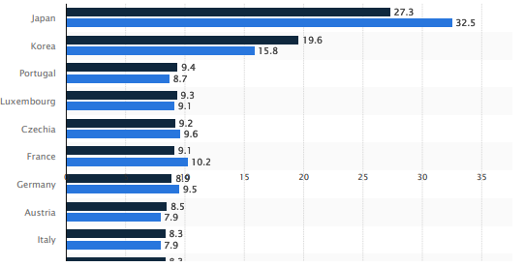
Figure 1: Average length of stay in hospitals for curative (acute) care in select countries worldwide in 2010 and 2022 (in days)
(Source: Statista, 2025)

1.3 Aim and Objectives
The aim of this study is to explore the application of data analytics using AI to predict the length of stay in hospitals correctly and how such predictions can be used to optimise bed capacity planning and staffing decisions. The research is aimed at establishing the relationship between technical model development and practical strategies of operations, which improve efficiency, quality of services and resources utilisation in hospital contexts.
Objectives
- To explain the concept of AI powered data analytics and its relevance for predicting hospital length of stay and supporting managerial decision making.
- To examine the relationship between patient, clinical and organisational factors and hospital length of stay using appropriate AI based predictive models.
- To identify key technical, organisational and ethical challenges associated with implementing AI powered length of stay prediction in routine hospital operations.
- To propose practical strategies and governance measures that can help hospitals overcome these challenges and integrate predictive insights into bed and staffing planning.

Chapter 2- LITERATURE REVIEW

2.1 Introduction
The rising demand of patients, scarcity of resources and the mounting pressure to optimise the healthcare provision have turned the operational efficiency of hospitals into a critical system concern of healthcare systems. Length of stay (LOS) is one of the major indicators of hospital performance where it is used to measure the duration of stay of a patient in hospital between hospitalisation and discharge (Emicke, et al., 2025),. LOS is mainly a factor determining the availability of hospital beds, patient flow, treatment schedule, and staff workload, as well as a significant component of managing the hospital resources (Jones, 2023).
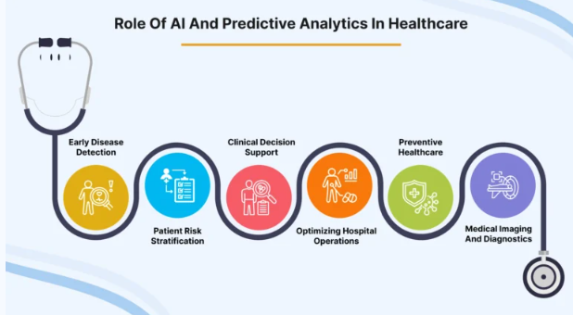
Figure 1: Role of AI and Predictive Analytics in Healthcare
(Source: Shah, 2024)
The recent advancements in the field of artificial intelligence (AI) and data analytics allowed healthcare organisations to process a significant amount of electronic health records to detect patterns that impact the utilisation of hospitals (Varnosfaderani and Forouzanfar, 2024) . Machine learning models are capable of combining demographic, clinical, and administrative factors to enhance the prediction of LOS and operational decision-making (Almeida et al., 2024).
The literature review critically analyses the available studies regarding the AI-driven LOS prediction and its potential impact on hospital work. Using databases, including Google Scholar, Scopus, PubMed, and IEEE Xplore, the relevant studies were located by such keywords as hospital length of stay prediction, machine learning in healthcare, and AI-based hospital resource planning. Peer-reviewed articles that were related to healthcare analytics and hospital management were only selected.

2.2 Concept of Hospital Length of Stay and Its Operational Importance

2.2.1 Conceptualising Hospital Length of Stay as a Healthcare Performance Indicator
The length of stay (LOS) at hospitals has been well known as an important metric of health systems performance and the effectiveness of hospitals in their work. LOS is the interval between patient admission and discharge, and it is commonly employed to measure the quality of healthcare services, their efficiency, and the use of resources. With rising demand and scarce resources in healthcare systems, LOS has become a key measure of hospital productivity and a way of determining the inefficiencies in the processes of patient care.
In a systematic review of LOS prediction studies, Stone, et al., (2022) claim that LOS is the product of interaction between clinical decision-making and hospital resources and patient management practices. According to their results, extended hospitalisation is frequently an indicator of inefficiency in care coordination, delays in treatment or ineffective discharge planning. In the same way, Han, et al., (2022) also show that LOS has a strong relationship with patient outcomes, meaning that both too long and too short hospitalisation can adversely affect recovery and the quality of healthcare. These studies thus make LOS not only an operational measure but a measure of effectiveness in healthcare.
Santana, et al., (2019), argue that medical performance indicators should not only include patient-centred results but also should not prioritise operational efficiency solely. Their analysis indicates that the implementation of policies that only focus on the reduction of LOS can have unintended effects, such as the rise of readmission rates or reduced care delivery to patients.

2.2.2 Clinical, Demographic and Organisational Determinants of LOS
The length of stay is determined by a mixture of clinical, demographic and organisational factors in hospitals. These determinants are important to understand to enhance the efficiency of hospitals and predict patient resource needs. According to research, patient characteristics, the severity of disease and the processes of healthcare organisations have always been cited as major contributors to LOS variation.
The issue of clinical determinants still plays a central role in the explanation of extended hospital stays. According to Lin, et al., (2022), the disease severity, age, and comorbidity of patients are significantly related to LOS in patients with acute ischemic stroke. Similarly, Tefera, et al., (2020), reported clinical complications and complexity of treatment to be the prominent predictors of prolonged hospitalisation in surgical patients. These results demonstrate a substantial impact on patient health status on the duration of stay in hospitals.
However, organisational and administrative factors are also important. Aung, et al., (2020) show that hospital infrastructure, intensive care utilisation and treatment costs determine LOS in the clinical environment. Similarly, Lim (2020), relied on massive healthcare datasets in demonstrating that the duration of hospital stay can be greatly influenced by the workflow processes and administrative practices in hospitals. Through these studies, it is argued that LOS can be considered as the outcome of interactions between clinical conditions and hospital organisational structures.

2.2.3 Length of Stay as a Measure of Hospital Efficiency and Resource Utilisation
In terms of operation, LOS is very important in hospital efficiency and resource management. Proper management of the duration of stay in hospital can lead to better patient throughput, lower health care expenses and streamline the use of scarce hospital resources.
Bahalkeh, et al., (2022) prove that LOS is an efficient tool that decreases the bed turnover of an intensive care unit and limits the capacity of a hospital. Likewise, Bertsimas, et al., (2022) demonstrate that LOS patterns can be used to enhance the management of hospital operations and patient flows by analysing them. However, LOS is difficult to predict correctly. According to Chrusciel, et al., (2021), the complexity and heterogeneity of healthcare data can be a nuisance for traditional statistical models, which is why more advanced analytical tools can be implemented.

2.2.4 LOS Implications on Patient Flow and Capacity of the Healthcare System
Another important implication of LOS on healthcare systems is the capacity of the healthcare system and patient flow management. The management of LOS is necessary to control the availability of bed space in hospitals and access to healthcare facilities.
Ravaghi, et al., (2020), point out that hospital bed capacity planning is based on proper knowledge about LOS patterns because ineffective LOS management may result in overcrowding and capacity limitation of the system. Equally, Hu, et al., (2021) show that patient-flow models used to optimise LOS have the capacity to enhance hospital throughput. Gualandi, et al., (2020), also suggest that the patient flow processes are not effective enough and cause patients to spend more time in the hospital, causing the rise of operation costs and burdening the health care resources. In more recent studies, Kim and Oh, (2024) emphasise the use of analytical models in enhancing the hospital capacity planning process with the assistance of LOS-based resource allocation plans.

2.3 Data Analytics and Artificial Intelligence in Healthcare

2.3.1 Evolution of Artificial Intelligence and Machine Learning Applications in Healthcare
Artificial intelligence (AI) has developed from rule-based expert systems to complex machine learning (ML) applications that can analyse massive amounts of healthcare data. The initial applications focused more on diagnostic assistance, but recently the scope of the AI has been extended to predictive analytics as well as healthcare management. Davenport and Kalakota (2019) state that AI technologies are used more to increase healthcare delivery in terms of better diagnostic accuracy, treatment planning and administrative efficiency. On the same note, Rong, et al., (2020) emphasise that machine learning approaches, such as classification and regression models, help healthcare systems to find meaningful patterns in the complex data.
The increasing rate of digital health data, especially electronic health records, has also increased the adoption of AI. Secinaro, et al., (2021) highlight that AI is currently becoming more commonly used to perform predictive tasks in a healthcare system. More recent studies are not only limited to clinical applications but also operational applications, where predictive models are applied to predict outcomes, including hospital length of stay (LOS), to aid hospital resource planning and decision-making. However, even with these developments, the use of AI in the daily operations of hospitals has not been widely adopted.

2.3.2 Data Analytics plays a role in healthcare decision-making
Data analytics is the central process of changing healthcare information into meaningful lessons to inform decisions. Data mining and statistical modelling, predictive analytics, and similar methods allow healthcare organisations to process patient data, identify patterns and optimise the use of resources. According to Dash, et al., (2019), big data analytics lead to evidence-based decision-making based on the combination of various clinical and operational data.
Operationally, analytics are being utilised more to assist in management decisions in hospitals. Cozzoli, et al., (2022) reveal that data analytics enhances monitoring of performance and strategic planning in healthcare organisations. In a similar manner, Batko and Slezak (2022) highlight that analytics have the potential to uncover health care delivery issues and improve resource allocation. To be more precise, Xie, et al., (2021) suggests that the analytical models can be used to support hospital resource planning by examining the patient flow and demand trends, whereas Djaya (2025) highlights the importance of analytics in optimising resource allocation decisions. However, existing research is mostly generalised, suggesting limited attention to the application of analytics to indicators of operations, including LOS, which means that the gap in the practice of its implementation to make decisions in hospitals remains.

2.3.3 AI-Based Decision Support Systems in Health Care
AI-based decision support systems (DSS) comprise a primary healthcare application of AI, which allows the use of the data in making decisions that are both clinical and operational. Magrabi, et al., (2019) believe that AI-based DSS has the potential to improve accuracy in diagnosing and minimise medical errors because it offers evidence-based recommendations based on patient data.
Studies suggest the increasing adoption of machine learning models in the prediction of length of stay and hospital as a key operational indicator. Almeida, et al., (2024) confirm that predictive methods, such as regression and ensemble learning models, can be used to predict LOS using healthcare data. Similarly, Jain, et al., (2024) indicate that machine learning models used on health datasets of large volumes enhance the accuracy of predictions and assist in making decisions related to hospital planning. Hospital management can especially find these capabilities significant since accurate LOS prediction allows planning bed capacity better and allocating staffing. Alves, et al., (2024) also emphasise the assistance of AI tools in hospital decision-making.

2.3.4 Healthcare-specific Opportunities and Challenges of AI
Although AI has great potential to enhance healthcare decision-making, its use is associated with several challenges. According to Petersson, et al., (2022), the main barriers include organisational resistance, the absence of technical expertise and data governance issues. Furthermore, Karimian, et al., (2022) mention some ethical issues such as algorithmic bias and data privacy. These issues indicate that the successful implementation of AI in decision-making in hospitals involves not only complex analytical tools but also powerful governance systems.

2.4 Hospital Length of Stay Predictive Modelling
As per the views of Almeida, et al., (2024), hospital length of stay prediction has been a valuable field of healthcare analytics studies since LOS directly affects the hospital management of capacity, cost, and patient flow. Doknić, et al., (2025), illustrate that the scientists have, over time, devised a massive variety of predictive methods, such as classical statistical models to modern machine learning methods.

2.4.1 LOS Prediction using traditional Statistical methods
According to Abdurrab, et al., (2024), prediction of LOS in the early studies mostly depended on the statistical methods like linear regression, logistic regression and survival analysis. These are the models that were popular due to their transparency, simplicity in reading, and the fact that they do not need a large dataset. As an illustration, Abd-Elrazek, et al., (2021), employed regression-based models to examine data concerning the aspects of admission and clinical variables in intensive care, which revealed that the age of patients, the severity of their condition, and comorbidities constituted excellent predictors of LOS.
On the same note, Stone, et al., (2022) observe that the traditional statistical models have always dominated the research on LOS prediction in the past because the traditional statistical model can give out the interpretable predictor-outcome correlation. Also, Slavu, et al., (2025) said that the models allow clinicians and hospital administrators to learn how certain variables affect LOS, and this aids in clinical decision-making and responsibility.

2.4.2 LOS Prediction Techniques using machine learning
Dehouche, et al., (2021), observe that in order to overcome the drawbacks of the traditional statistical methods, researchers tend to use machine learning (ML) techniques in LOS prediction more and more. According to Dhillon, et al., (2022), machine-learning algorithms have the ability to make predictions on large and complex data sets and recognise nonlinear relationships between predictors, which is not readily obtainable using conventional statistical models. A systematic review of machine learning models applied in the LOS prediction by Almeida, et al., (2024) revealed that in most cases, the ensemble learning models have higher predictive power than the traditional regression models.
Indicatively, Yildirim and Canayaz, (2024) used ensemble learning methods in predicting LOS in neonatal intensive care units. Their findings showed that using a combination of algorithms enhanced the predictive ability since it reflected the complicated interactions between clinical variables and patient features. Similarly, Cho, et al., (2024) have created a machine learning model to anticipate the postoperative LOS based on preoperative and perioperative factors.
Although such developments have been made, machine learning approaches cannot be said to be limitless. Peek, et al., (2024) state that predictive accuracy should not be equated with clinical usefulness because high predictive accuracy does not necessarily imply clinical usefulness. Most machine learning models operate as black boxes, and therefore, it is not easy to know how the predictions are made by clinicians and administrators. Such a lack of transparency may decrease the trust in AI systems and their use in healthcare organisations.

2.4.3 Critical Forecasting Unpredictable in LOS Modelling
Hirani, et al., (2025), observe that one of the key issues in the research on the LOS prediction is the identification of the most important variables that impact the duration of hospital stay. The current state of literature identically singles out three substantial groups of predictors, namely, patient demographic factors, clinical factors, and organisational ones. Mou, et al., (2022), revealed that age, gender, and socio-economic status are other demographic variables that are usually indicated in LOS models due to their impact on patient vulnerability and recovery patterns.
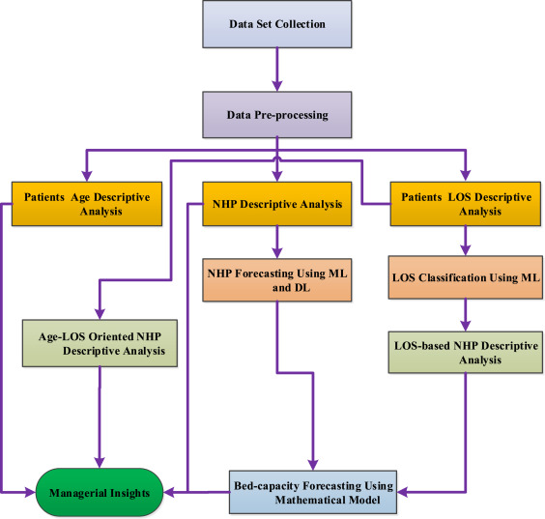
Figure 2: Data-driven HBC forecasting
(Source: Mahmoudian, et al., 2023)
Clinical variables are a significant factor as well. It has been found that the type of diagnosis, illness severity, medical conditions, and surgical complexity had a strong impact on the LOS (Cho, et al., 2024). Electronic health record data may include useful clinical indicators like laboratory findings, vital signs, and treatment processes that would enhance the accuracy of prediction. Besides the patient-related factors, patient LOS could also be influenced by the organisational variables, including hospital bed availability, staffing, and the entry pathways. Lee, et al., (2024) showed that the use of multi-hospital datasets based on common data models enhanced the strength of the LOS predictions by including the factors of the system level that affect the utilisation of the hospital.

2.4.4 Performance Measurement and Model Evaluation
As per the view of Grebovic, et al., (2023), the majority of the literature evaluates the performance of models based on such statistical measures as mean squared error, root mean squared error, and coefficient of determination. These measures indicate the deviations of the predicted values of LOS and real LOS and are used to evaluate the model in quantitative terms. Other common methods of assessing the model's generalisability between datasets include cross-validation systems. Majlatow, et al., (2025), note that researchers are able to minimise the chances of overfitting by testing models with unknown data and guarantee that models of prediction are stable in other hospital settings.
However, one major criticism in the literature is that a number of studies are based more on predictive accuracy as opposed to operational usefulness. Stone, et al., (2022), note that predictive models must be tested based not only on their statistical performance but also on the fact that they are applicable to the real hospital planning processes. This view raises the issue of research that relates the predictive modelling to the feasible operations of a hospital, which is the core subject of the current study.

2.5 Operational Applications of LOS Prediction in Hospitals
Hospital length of stay (LOS) prediction has received considerable attention in terms of its implications on hospital operational management, especially on bed capacity planning, patient flow, and workforce scheduling.

2.5.1 Bed Capacity Planning and Resource Allocation
According to Cusidó, et al., (2022), LOS prediction has found one of the most important use applications in the prediction of hospital bed capacity. The hospitals fall under limited infrastructure and have to juggle the changing demand of patients and the limited number of beds. Savioli, et al., (2022), state that failure to manage the bed effectively usually leads to the overpopulation of the emergency department, the inability to admit patients into beds, and the postponement of the elective process. Jones, (2023), hypothesises that most healthcare systems still use past averages and managerial opinion to make projections on the demand for beds, which might not reflect real-time changes in patient complexity and admission trends.
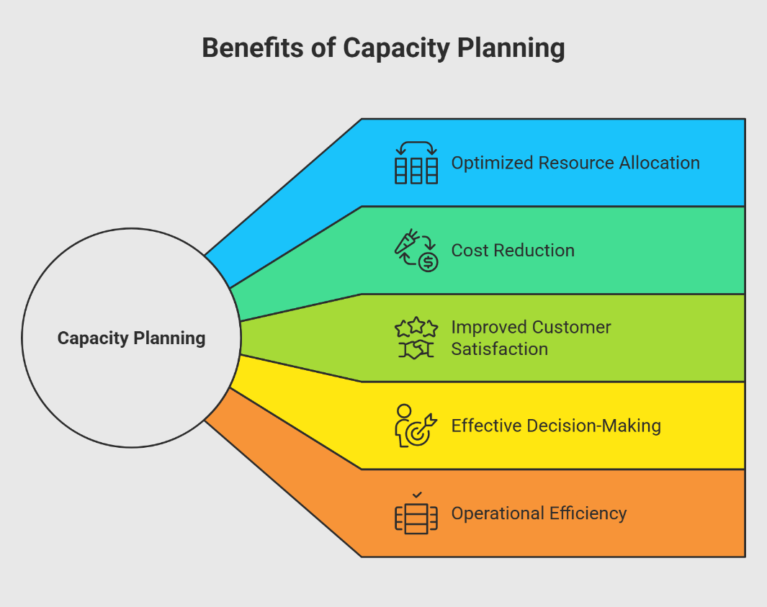
Figure 3: Benefits of Capacity Planning
(Source: Shivakumar, 2025)
Predictive analytics can help to enhance this process by making predictions on the time of expected discharge early in hospital admission. A model based on AI can be used to examine the characteristics of the patient, the state of the case and the trend associated with the past cases to create more accurate projections of the LOS. Alves, et al., (2024), note that the predictions will help hospital administrators to match the number of people who come to the hospital with the number of people who are expected to leave the hospital, which will enhance the use of beds and the elimination of operational bottlenecks.
Unexpected clinical progress, like complications or delays in treatments, may not be fully reflected in predictive models, and this could dramatically increase the duration of stay of a patient. Therefore, the use of algorithmic predictions in the absence of proper clinical supervision can give impractical hopes about the time of discharge.

2.5.2 Patients' Surgery and Hospital Productivity
Another essential part where the LOS prediction can be used to make the operations more effective is the effective management of patient flow. According to Hirani, et al., (2025), the blockages that arise when patients spend longer than expected in hospitals may impact various departments such as emergency care, diagnostic services and the surgical schedule. Inefficient patient flow is not only inefficient in a hospital, but it can also lead to poor patient outcomes and patient satisfaction. Nafjan, et al., (2025), state that predictive analytics based on AI has been suggested as a method to enhance patient flow by analysing the patients most likely to spend a longer time in the hospital. Early detection of such cases helps the clinical teams to start discharge planning sooner, organise multidisciplinary care and better allocation of resources.
According to Varnosfaderani and Forouzanfar, (2024), predictive analytics will help to convert regular electronic health record data into operational insights that may be used to proactively manage hospitals. In spite of these benefits, there are still major challenges encountered in implementation. Peek, et al., (2024), highlight that most AI-based clinical decision support systems do not succeed at the implementation phase since predictive outputs are poorly incorporated in clinical processes.

2.5.3 Workforce and Staffing Planning
Moriwaki, et al., (2025), said that the decision on staffing of hospitals is highly dependent on patient demand and the intensity of workload. The nursing personnel, doctors, and other related healthcare workers should be scheduled based on the anticipated number of patients and the complexity of care provided. Demand forecasting made inaccurately will lead to either understaffing, which will negatively affect the safety of patients, or overstaffing, which will be costly to the operation. According to a study conducted by Griffiths, et al., (2020), staffing tools usually use retrospective workload forecasts instead of a forward-looking one.
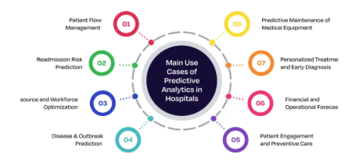
Figure 4: Predictive Analytics
(Source: Kumar, 2025)
The LOS prediction models would, therefore, be useful in workforce planning as it estimates the number of patients that will stay in the hospital on particular days. With these kinds of forecasts, the hospital managers are able to optimise the number of staff, provide specialisation, as well as create more reasonable shifts. However, it has been reported in the literature that the combination of LOS prediction and workforce planning is not very extensive.

2.5.4 Hospital Operations Decision Support Systems
The adoption of LOS prediction models into AI-based systems of decision support is one of the promising paths of healthcare management. These systems are a combination of predictive analytics and hospital information systems to assist in real-time bed occupancy, discharge, and resource utilisation data. Elhaddad and Hamam, (2024), say that decision support systems made with AI can enhance clinical and managerial decisions in healthcare organisations. But the adoption of these systems by organisations is still skewed. According to Preti, et al., (2024), some of the obstacles include data quality concerns, the bias of algorithms, and the absence of transparency in the predictive models. Medical practitioners can also be opposed to automated decision-support systems when they feel that the system is depriving them of professional autonomy.

2.6 Challenges in Implementing AI-Based Prediction Systems
Although the topic of artificial intelligence (AI) and predictive analytics in healthcare management has gained increased popularity, the process of implementing artificial intelligence-based prediction systems in hospital operations is complicated. Although predictive models of hospital length of stay (LOS) prove to be promising with regard to their accuracy in research settings, their implementation in the interruptions of a healthcare organisation is subject to numerous technical, organisational, and ethical problems.

2.6.1 Data Quality and Availability Problems
The success of predictive models is heavily determined by the healthcare data that is available and of good quality. Electronic health records (EHRs) give a wide range of patient information but these data are usually disjointed, incomplete, or interdepartmental across hospitals. Rajkomar, (2020) state that machine learning models can be characterised by high performance and generalisability only when the data in healthcare systems are heterogeneous. Lack of clinical variables, poor coding habits, and poor documentation standards may inject biases in predictive models, which eventually impacts the credibility of the LOS prediction in the end. Besides, the healthcare information is often stored in several information systems that do not interact. According to Petri, et al., (2025), the unification of clinical, administrative, and operational datasets is a significant technical challenge in establishing the whole predictive analytics system.

2.6.2 Technical and Infrastructure Limitations
A large number of medical organisations continue to use old information systems that are not tailored to large data analytics and real-time predictive modelling. Varnosfaderani and Forouzanfar, (2024), believe that implementing AI systems in current hospital information systems is usually resource-consuming and technical to do so. Also, predictive models that are created under controlled circumstances may fail to work in the actual situation of clinical practise. External validity of predictive models can be minimised due to differences in patient populations, hospital processes and clinical procedures.

2.6.3 Barriers of Organisational and Workforce Adoption
Technical systems are only one barrier to organisational adoption, even in the event of their availability. Medical workers might not want to make decisions based on the algorithmic forecasting, especially when it is hard to interpret the results of the prediction. Varnosfaderani and Forouzanfar, (2024), note that the transparency of complex machine learning models, commonly also known as the black box problem, may decrease clinician trust and adoption. Stoumpos, et al., (2023), highlight that to achieve successful digital innovation in healthcare, organisational culture, which facilitates learning, collaboration, and change management are necessary in addition to technological preparedness.

2.6.4 Ethical, Privacy, and Bias Considerations in AI Systems
Ethics and governance are also issues of concern in terms of AI usage in healthcare. The predictive models developed based on the past healthcare data can replicate the pre-existing inequalities or biases already present in clinical data. Ferrara, (2023), showed that unfair treatment suggestions to various groups of patients can occur because of the algorithmic prejudice in the healthcare prediction models.
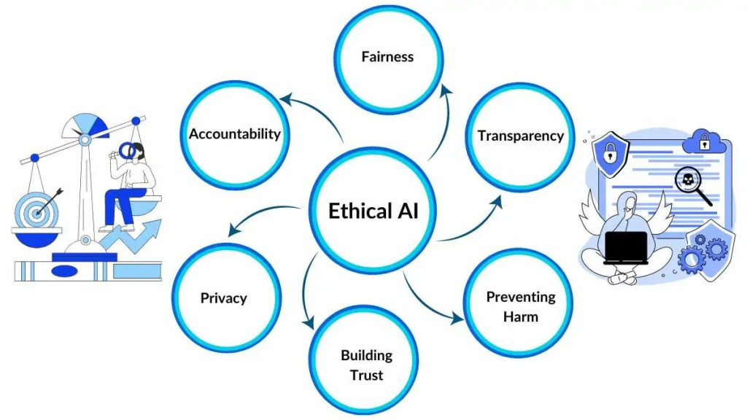
Figure 5: Ethical AI
(Source: Otten and Otten, 2024)
The other significant issue is the privacy of patients, especially where high amounts of sensitive health information are used in predictive modelling. The strict regulatory laws like the General Data Protection Regulation (GDPR) in Europe have seriously stringent demands about data security, transparency and the consent of the patients.

2.6.5 Governance and Regulatory Frameworks for AI in Healthcare
Finally, AI technologies in healthcare are a developing field in terms of governance. The regulatory frameworks of AI-driven clinical decision support systems remain in an early state and cause confusion on accountability and control. According to Jenko, et al., (2025), to implement AI in the healthcare sector responsibly, there should be well-developed governance rules that will cover model validation, monitoring, and risk management. It emphasises the necessity of multi-disciplinary cooperation between clinicians, data scientists, policymakers, and hospital administrators to secure the responsible implementation of the AI technologies in healthcare processes.

2.7 Research Gap and Justification of the Research
Despite the fact that a considerable number of studies have been carried out to examine predictive modelling capability in hospital length of stay (LOS), a number of significant gaps still exist regarding its application in the operations of a hospital. A substantial part of the current literature is dedicated to the purpose of enhancing predictive quality of machine learning models where the algorithms such as random forests, gradient boosting, and neural networks are usually assessed through measures of performance like accuracy, AUC, and RMSE.
Although such studies are relevant to the improvement of the methodology, they often fail to address the possibility to convert the outputs of the predictor to be a practical operational decision in healthcare organisations. Moreover, the existing literature is likely to focus on clinical prediction instead of hospital workforce and staffing issues. Patient demand and care complexity as well as projected hospital occupancy are strongly correlated with staffing decisions, but few studies have investigated that LOS prediction models may be used to guide staffing allocation or workforce scheduling.
The other weakness of the literature is associated with the piecemeal approach to the discussion of ethical, governance and regulation issues. Numerous studies consider algorithmic bias, transparency and patient data privacy independently of predictive modelling frameworks, as opposed to considering them as a part of the operational decision-support systems. Also, not many of the studies take a holistic approach, which would relate technical predictive modelling and the operational planning applied to the hospital, which would involve the bed capacity planning, patient flow planning and the staffing planning. Therefore, the possible strategic importance of AI-based LOS prediction as a means of hospital resource optimisation is not completely researched.
This study addresses these gaps by examining how AI-powered predictive analytics can be integrated with hospital operational decision-making, particularly in relation to bed capacity planning and staffing management. The study intends to add to an applied comprehension of the ways of AI aiding efficient and sustainable management of hospitals, by connecting the notion of predictive modelling with the considerations of operational planning.

3. Research Questions
- What are ways in which AI powered data analytics can be applied to conceptualise and model the relationships between patient, clinical and organisational variables and hospital length of stay and how can such predictions be applied in helping hospitals make bed capacity and staffing decisions?
- Which technical, organisational and ethical issues affect the implementation of AI based length of stay prediction tools in routine hospital operations, and which practical strategies and governance can be used to overcome the issue and enable it to be integrated into bed and staffing planning?

4. Methodology
This study adopts an exploratory and explanatory quantitative design that applies data mining and supervised learning algorithms to Length of Stay dataset. Publicly available health care datasets from sources such as the UCI Machine Learning Repository and Kaggle provide detailed records. These rich attributes support reproducibility and enable the construction of models that capture both behavioural and contractual drives of length of stay.
In this research, the supervised machine learning regression is applied to a publicly available sample of Microsoft hospital length of stay the data on Kaggle having approximately 100000 patient records. The dataset is available at:
https://www.kaggle.com/datasets/aayushchou/hospital-length-of-stay-dataset-microsoft/data. The research question deals with ability of AI powered analytics to predict numeric length of stay values and aid in decision-making regarding bed capacity and staffing. Regression models thus suit well as they provide an estimation of a continuous outcome as opposed to a one-dimensional category. The approach enables the model to acquire trends between clinical, demographic as well as organisational variables against the recorded number of inpatient days. The workflow will involve data preparation, feature engineering, training the model and evaluating the model. The performance will be measured by the mean squared error, root mean squared error and R square on a test set that is held out, which will give direct indication of predictive accuracy of operational planning.
The selected strategy has a number of strengths in this project. Supervised regression can use numerous predictors and can determine complex relationships that are not easily noticeable using simple averages. This massive open data enhances the statistical power and allows reproducibility, since other scientists can get the same information and do the same analysis. The quantitative analysis using mean squared error, root mean squared error and R square generate unambiguous and similar performance measures among the various algorithms. The technique also makes it possible to do scenario analysis, such as estimating the effects of a change in case mix or severity on future bed demand and staffing requirements, which is of great interest to managers.
All analytical procedures will be performed in Python, with the primary programming environment being Visual Studio Code (VS Code). VS Code is selected as it is easier on the processor of the machine, fast to boot, and easy to install to work with Python with extensions and virtual environments. It also allows using Jupyter notebooks within a similar workspace, which is appropriate in this context of the study, consisting of exploration, feature engineering, and model testing. It is also built-in with a terminal and Git support, allowing easy keeping of clear records on code versions, packages and results among runs. PyCharm is also a potent Python environment, and it is very suitable for large software-style projects requiring sophisticated code structuring tools (Saabith, et al., 2021). However, the given study is concerned with a well-defined set of analysis pipeline and replicable modelling, which is why VS Code offers the necessary functionality with fewer set-up costs. Visual Studio Code is also easy to configure to work with Python, widely used and can be connected with Jupyter notebooks and version control, and has all the functionality needed in this project without the added complexity.
The workflow begins with data cleaning to address missing values, inconsistent entries and obvious outliers. Categorical variables will be encoded using appropriate techniques and numerical variables will be scaled where required to support algorithms that are sensitive to feature magnitude. The dataset will then be partitioned into training and testing subsets in order to assess generalisation performance on unseen observations. Python libraries such as Pandas, NumPy and Scikit learn will be employed for data handling, model implementation and diagnostic analysis, while Matplotlib and Seaborn will support visual exploration of feature distributions and relationships.
Several supervised learning models will be developed and compared, including at least one relatively simple and interpretable baseline model and one or more ensemble models with higher predictive capacity. Hyperparameter tuning will be carried out using grid search combined with k fold cross validation to reduce overfitting and improve stability. Feature selection will be used where appropriate to remove redundant predictors and enhance model interpretability for business users.
Predictive models are statistical or machine learning models, which are used to predict an unknown outcome value using known input variables (Grebovic, et al., 2023). The models in this proposal predict LOS using patient and admission factors, including age, diagnosis and type of admission. The predictive models will be evaluated in terms of mean squared error (MSE), root mean squared error (RMSE), and coefficient of determination (R2), with length-of-stay (LOS) being treated as a continuous number. Length of Stay (LOS) is the number of days in which an inpatient is admitted until he or she is released out of the hospital (Abd-Elrazek et al., 2021). The primary outcome variable in this study that will be estimated with the help of the predictive models is LOS. A smaller MSE and RMSE values indicate improvements in predictive fidelity while a higher R2 value means a better explanatory power of a regression framework. The interrelations between salient clinical and demographic covariates such as patient age, complexity of comorbidities, mode of admission (emergency vs. elective), vital physiologic, laboratory indices, and complexity of procedures, will be interrogated using illustrative methods such as correlation matrices and feature-importance visualisations. All experimental runs will be made on a conventional personal computer equipped with 8 GB of RAM and a multi-sec components processor, thus enabling both the reproducibility and the scalability of the analyses.
The analytical design in general is a direct response to the two research questions and all four objectives. Predicting the continuous length of stay values based on the clinical and demographic variables is done by supervised machine learning regression, which addresses Research Question 1 and Objective 1 and 2. Based on the same modelling framework, along with the review of the literature on implementation, the formulation of the technical, organisational and ethical challenges and the creation of the practical strategies and governance recommendations is provided, responding to Research Question 2, and Objectives 3 and 4. The proposed analysis will be able to demonstrate both the performance of the models as well as the way that the outputs of the models can be used in real decisions regarding bed capacity and staffing by doing careful data preparation, k fold cross validation and evaluation based on mean squared error, root mean squared error and R square using a separate test set.
These limitations will be handled through a number of measures. Data cleaning and exploratory analysis will also be used to identify implausible values and understand the meaning of a given variable prior to modelling. The use of K fold cross validation and a separate test set will give more accurate estimates of out of sample performance and minimise overfitting. The importance of features analysis and their comparison with simpler baseline models will ensure that central predictors are operationally and clinically feasible. Lastly, considering the implications to bed capacity and staffing, the dissertation will clearly acknowledge the contextuality of the data used and suggest local validation and adaptation before a particular organisation can use the model to support routine decision-making.
The study will be conducted within a period of about 6 months. The first two months (month 1 and month 2) will be spent on perfecting the literature review, developing the research design and preparing the data, including cleaning, exploratory analysis and selection of variables. Months 3 and 4 will involve the development of the supervised machine learning models, which are to be tuned based on k fold cross validation and tested based on mean squared error, root mean squared error and R square on the test set. Month 5 will see the results analysed with respect to bed capacity and staffing decisions and implication of challenges and governance strategies will be formulated. Month 6 will involve writing the dissertation, revising and submitting it, and scheduling some time to get feedback on it and do final edits.

References
Abd-Abd-Elrazek, M.A., Eltahawi, A.A., Abd Elaziz, M.H. and Abd-Elwhab, M.N. (2021) Predicting length of stay in hospitals intensive care unit using general admission features. Ain Shams Engineering Journal, 12(4), pp.3691-3702.
‌Abdurrab, I., Mahmood, T., Sheikh, S., Aijaz, S., Kashif, M., Memon, A., Ali, I., Peerwani, G., Pathan, A., Alkhodre, A.B. and Siddiqui, M.S. (2024) Predicting the Length of Stay of Cardiac Patients Based on Pre-Operative Variables—Bayesian Models vs. Machine Learning Models. Healthcare, 12(2), pp. 249.
Almeida, G., Brito Correia, F., Borges, A.R. and Bernardino, J. (2024) Hospital Length-of-Stay Prediction Using Machine Learning Algorithms—A Literature Review. Applied Sciences, 14(22), pp. 10523.
‌Alves, M., Seringa, J., Silvestre, T. and Magalhães, T. (2024) Use of Artificial Intelligence tools in supporting decision-making in hospital management. BMC Health Services Research, 24(1), pp. 1282–1282.
Aung, Y.N., Nur, A.M., Ismail, A. and Aljunid, S.M. (2020) Determining the cost and length of stay at intensive care units and the factors influencing them in a teaching hospital in Malaysia. Value in Health Regional Issues, 21, pp. 149-156.
Aung, Y.Y., Wong, D.C. and Ting, D.S. (2021) The promise of artificial intelligence: a review of the opportunities and challenges of artificial intelligence in healthcare. British medical bulletin, 139(1), pp. 4-15.
Bahalkeh, E., Hasan, I. and Yih, Y. (2022) The relationship between intensive care unit length of stay information and its operational performance. Healthcare Analytics, 2, pp. 100036.
Batko, K. and Ślęzak, A. (2022) The use of Big Data Analytics in healthcare. Journal of big Data, 9(1), pp. 3.
Bertsimas, D., Pauphilet, J., Stevens, J. and Tandon, M. (2022) Predicting inpatient flow at a major hospital using interpretable analytics. Manufacturing & Service Operations Management, 24(6), pp. 2809-2824.
‌Cho, H.N., Ahn, I., Gwon, H., Kang, H.J., Kim, Y., Seo, H., Choi, H., Kim, M., Han, J., Kee, G., Park, S., Jun, T.J. and Kim, Y.-H. (2024). Explainable predictions of a machine learning model to forecast the postoperative length of stay for severe patients: machine learning model development and evaluation. BMC Medical Informatics and Decision Making, [online] 24(1), pp.350–350.
Chrusciel, J., Girardon, F., Roquette, L., Laplanche, D., Duclos, A. and Sanchez, S. (2021) The prediction of hospital length of stay using unstructured data. BMC medical informatics and decision making, 21(1), pp. 351.
Cozzoli, N., Salvatore, F.P., Faccilongo, N. and Milone, M. (2022) How can big data analytics be used for healthcare organization management? Literary framework and future research from a systematic review. BMC health services research, 22(1), pp. 809.
Cusidó, J., Comalrena, J., Alavi, H. and Llunas, L. (2022) Predicting Hospital Admissions to Reduce Crowding in the Emergency Departments. Applied Sciences, 12(21), pp. 10764.
Dash, S., Shakyawar, S.K., Sharma, M. and Kaushik, S. (2019) Big data in healthcare: management, analysis and future prospects. Journal of big data, 6(1), pp. 54.
Davenport, T. and Kalakota, R. (2019) The potential for artificial intelligence in healthcare. Future healthcare journal, 6(2), pp. 94-98.
‌Dehouche, N., Viravan, S., Santawat, U., Torsuwan, N., Taijan, S., Intharakosum, A. and Sirivatanauksorn, Y. (2021) Hospital Length of Stay: A cross-Speciality Analysis and Beta-Geometric Model.
‌Dhillon, S.K., Ganggayah, M.D., Sinnadurai, S., Lio, P. and Taib, N.A. (2022) Theory and Practice of Integrating Machine Learning and Conventional Statistics in Medical Data Analysis. Diagnostics, 12(10), pp. 2526.
Djaya, N., 2025. The Role of Data Analytics in Optimizing Hospital Resource Allocation and Decision-making. Journal of Tropical Pharmacy and Chemistry, 9(2), pp.160-171.
‌Doknić, I., Mitrović, M., Bukumirić, Z., Virijević, M., Pantić, N., Sabljić, N., Antić, D. and Bojović, Ž. (2025) The Comparison of Classical Statistical and Machine Learning Methods in Prediction of Thrombosis in Patients with Acute Myeloid Leukaemia. Bioengineering, 12(1), pp. 63.
‌Elhaddad M and Hamam, S. (2024) AI-Driven Clinical Decision Support Systems: An Ongoing Pursuit of Potential. Cureus, 16(4), pp. e57728–e57728.
Abd-Elrazek, M.A.A., Eltahawi, A.A., Abd Elaziz, M.H. and Abd-Elwhab, M.N. (2021) Predicting length of stay in hospital intensive care unit using general admission features. Ain Shams Engineering Journal, 12(4), pp. 3691-3702.
Emicke, R., Shepherd, A. and Powell, D. (2025) Exploring the Opportunities and Challenges of Healthcare Innovation in UK Higher Education: A Narrative Review. Nursing Reports, 15(5), pp. 171.
‌Ferrara, E. (2023) Fairness and Bias in Artificial Intelligence: A Brief Survey of Sources, Impacts, and Mitigation Strategies. Sci, 6(1), pp. 3.
Giordano, C., Brennan, M., Mohamed, B., Rashidi, P., Modave, F. and Tighe, P. (2021) Accessing artificial intelligence for clinical decision-making. Frontiers in digital health, 3, pp. 645232.
Grebovic, M., Filipovic, L., Katnic, I., Vukotic, M. and Popovic, T. (2023) Machine learning models for statistical analysis. Int. Arab J. Inf. Technol., 20(3A), pp.505-514.
Griffiths, P., Saville, C., Ball, J.E., Ball, J., Chable, R., Dimech, A., Jones, J., Jeffrey, Y., Pattison, N., Saucedo, A.R. and Saucedo, A. (2020) The Safer Nursing Care Tool as a guide to nurse staffing requirements on hospital wards: observational and modelling study. Health and Social Care Delivery Research, 8(16), pp. 1-162.
Gualandi, R., Masella, C. and Tartaglini, D. (2020) Improving hospital patient flow: a systematic review. Business process management journal, 26(6), pp. 1541-1575.
Han, T.S., Murray, P., Robin, J., Wilkinson, P., Fluck, D. and Fry, C.H. (2022) Evaluation of the association of length of stay in hospital and outcomes. International Journal for Quality in Health Care, 34(2), pp. mzab160.
‌Hirani, R., Podder, D., Stala, O., Mohebpour, R., Tiwari, R.K. and Etienne, M. (2025) Strategies to Reduce Hospital Length of Stay: Evidence and Challenges. Medicina, 61(5), pp. 922.
Hu, Y., Dong, J., Perry, O., Cyrus, R.M., Gravenor, S. and Schmidt, M.J. (2021) Use of a novel patient-flow model to optimize hospital bed capacity for medical patients. The Joint Commission Journal on Quality and Patient Safety, 47(6), pp. 354-363.
Jain, R., Singh, M., Rao, A.R. and Garg, R., 2024. Predicting hospital length of stay using machine learning on a large open health dataset. BMC Health Services Research, 24(1), p.860.
‌Jenko, S., Papadopoulou, E., Kumar, V., Overman, S., Krepelkova, K., Wilson, J., Dunbar, E., Spice, C. and Exarchos, T. (2025) Artificial Intelligence in Healthcare: How to Develop and Implement Safe, Ethical and Trustworthy AI Systems. AI, 6(6), pp. 116.
Jones, R.P. (2023) Addressing the knowledge deficit in hospital bed planning and defining an optimum region for the number of different types of hospital beds in an effective health care system. International Journal of environmental research and Public Health, 20(24), pp. 7171.
Karimian, G., Petelos, E. and Evers, S.M. (2022) The ethical issues of the application of artificial intelligence in healthcare: a systematic scoping review. AI and Ethics, 2(4), pp. 539-551.
Kim, J.N. and Oh, I.H. (2024) Optimizing hospital bed capacity and resource allocation using inflow and outflow indices for effective healthcare management. INQUIRY: The Journal of Health Care Organization, Provision, and Financing, 61, pp. 00469580241304244.
Kothinti, R.R. (2024) Artificial intelligence in healthcare: Revolutionizing precision medicine, predictive analytics, and ethical considerations in autonomous diagnostics. World Journal of Advanced Research and Reviews, 19(3), pp.3395-3406.
‌Kumar, S. (2025) A Complete guide to Predictive analytics in Hospital Management. [Online] Ailoitte. Available at: https://www.ailoitte.com/blog/predictive-analytics-in-hospital-management / [Accessed on: 5th March, 2026].
‌Lee, H., Kim, S., Moon, H.-W., Lee, H.-Y., Kim, K., Jung, S.Y. and Yoo, S. (2024) Hospital Length of Stay Prediction for Planned Admissions Using Observational Medical Outcomes Partnership Common Data Model: Retrospective Study. Journal of Medical Internet Research, 26, pp. e59260.
Lim, J. (2020) Big data-driven determinants of length of stay for patients with hip fracture. International Journal of Environmental Research and Public Health, 17(14), pp. 4949.
Lin, K.H., Lin, H.J. and Yeh, P.S. (2022) Determinants of prolonged length of hospital stay in patients with severe acute ischemic stroke. Journal of clinical medicine, 11(12), pp. 3457.
Magrabi, F., Ammenwerth, E., McNair, J.B., De Keizer, N.F., Hyppönen, H., Nykänen, P., Rigby, M., Scott, P.J., Vehko, T., Wong, Z.S.Y. and Georgiou, A. (2019) Artificial intelligence in clinical decision support: challenges for evaluating AI and practical implications. Yearbook of medical informatics, 28(01), pp. 128-134.
Mahmoudian, Y., Nemati, A. and Safaei, A.S. (2023) A forecasting approach for hospital bed capacity planning using machine learning and deep learning with application to public hospitals. Healthcare Analytics, 4, pp. 100245.
Majeed, A. and Hwang, S.O. (2021) Data-driven analytics leveraging artificial intelligence in the era of COVID-19: an insightful review of recent developments. Symmetry, 14(1), p.16.
‌Majlatow, M., Shakil, F.A., Emrich, A. and Mehdiyev, N. (2025) Uncertainty-Aware Predictive Process Monitoring in Healthcare: Explainable Insights into Probability Calibration for Conformal Prediction. Applied Sciences, 15(14), pp. 7925.
‌Maleki Varnosfaderani, S. and Forouzanfar, M. (2024) The Role of AI in Hospitals and Clinics: Transforming Healthcare in the 21st Century. Bioengineering, 11(4), pp. 337.
Moriwaki, M., Kakehashi, M., Hayashida, K., Koizumi, M. and Horiguchi, H. (2025) Impact of Nurse Staffing Levels on Patient Fall Rates: A Retrospective Cross-Sectional Study in General Wards in Japan. Healthcare, 13(1), pp. 88.
‌Mou, T.J., Afroz, K.A., Haq, Md.A., Jahan, D., Ahmad, R., Islam, T., Chowdhury, K., Kumar, S., Irfan, M., Islam, Md.S., Islam, Md.F., Adnan, N. and Haque, M. (2022) The Effect of Socio-Demographic Factors in Health-Seeking Behaviors among Bangladeshi Residents during the First Wave of COVID-19. Healthcare, 10(3), pp. 483.
‌Nafjan, A.A., Aljuhani, A., Alshebel, A., Alharbi, A. and Alshehri, A. (2025) Artificial Intelligence in Predictive Healthcare: A Systematic Review. Journal of Clinical Medicine, 14(19), pp. 6752.
‌Otten, N.V. and Otten, N.V. (2024) Ethical AI Explained: Key Issues & Practical How To Implement Guide. [Online] Spot Intelligence. Available at: https://spotintelligence.com/2024/07/30/ethical-ai-explained-key-issues-practical-how-to-implement-guide/ [Accessed on: 5th March, 2026].
Peek, N., Capurro, D., Vlada Rozova and Sabine (2024) Bridging the Gap: Challenges and Strategies for the Implementation of Artificial Intelligence-based Clinical Decision Support Systems in Clinical Practice. Yearbook of Medical Informatics, 33(01), pp. 103–114.
Petersson, L., Larsson, I., Nygren, J.M., Nilsen, P., Neher, M., Reed, J.E., Tyskbo, D. and Svedberg, P. (2022) Challenges to implementing artificial intelligence in healthcare: a qualitative interview study with healthcare leaders in Sweden. BMC health services research, 22(1), pp. 850.
‌Petri, V., Antoine, T., Emma, B., Hervé, H., Emma, F. and Hana, V. (2025) Clinical data integration and processing challenges in healthcare caused by contemporary software design. DIGITAL HEALTH, 11.
‌Preti, L.M., Ardito, V., Compagni, A., Petracca, F. and Giulia Cappellaro (2024) Implementation of Machine Learning Applications in Health Care Organizations: Systematic Review of Empirical Studies. Journal of Medical Internet Research, 26, pp. e55897–e55897.
Rajkomar, A. (2020) Using Machine Learning to Forecast and Improve Clinical Outcomes and Healthy Aging Using Sensor Data. [Online]. Available at: https://www.ncbi.nlm.nih.gov/books/NBK563114/#:~:text=Overview%20of%20Machine%20Learning,2019)%20and%20show%20promising%20results. [Accessed on: 5th March, 2026].
Ravaghi, H., Alidoost, S., Mannion, R. and Bélorgeot, V.D. (2020) Models and methods for determining the optimal number of beds in hospitals and regions: a systematic scoping review. BMC health services research, 20(1), pp. 186.
Rong, G., Mendez, A., Assi, E.B., Zhao, B. and Sawan, M. (2020) Artificial intelligence in healthcare: review and prediction case studies. Engineering, 6(3), pp. 291-301.
Saabith, S., Vinothraj, T. and Fareez, M. (2021) A review on Python libraries and Ides for Data Science. Int. J. Res. Eng. Sci, 9(11), pp.36-53.
Santana, M.J., Ahmed, S., Lorenzetti, D., Jolley, R.J., Manalili, K., Zelinsky, S., Quan, H. and Lu, M. (2019) Measuring patient-centred system performance: a scoping review of patient-centred care quality indicators. BMJ open, 9(1), pp. e023596.
‌Savioli, G., Ceresa, I.F., Gri, N., Bavestrello Piccini, G., Longhitano, Y., Zanza, C., Piccioni, A., Esposito, C., Ricevuti, G. and Bressan, M.A. (2022) Emergency Department Overcrowding: Understanding the Factors to Find Corresponding Solutions. Journal of Personalised Medicine, 12(2), pp. 279.
Scholar, A.R. (2019) Governance and good governance-a conceptual perspective. Journal of Public Administration and Governance, 9(3), pp.133-142.
Secinaro, S., Calandra, D., Secinaro, A., Muthurangu, V. and Biancone, P. (2021) The role of artificial intelligence in healthcare: a structured literature review. BMC medical informatics and decision making, 21(1), pp. 125.
Shah, H. (2024) Anticipating Tomorrow’s Health: AI Predictive Analytics in Healthcare. [Online]. Available at: https://getondata.com/ai-predictive-analysis-in-healthcare/ [Accessed on: 5th March, 2026].
‌Shivakumar, K. (2025) What is Capacity Planning? Definition, Methods, Types, Goals, Benefits. [Online]. Available at: https://www.upgrad.com/blog/what-is-capacity-planning/ [Accessed on: 5th March, 2026].
‌Slavu, I., Tulin, R., Dogaru, A., Dima, I., Slavu, C.O., Mutu, D.-E.G. and Tulin, A. (2025) Machine Learning Modelling of Hospital Length of Stay After Breast Cancer Surgery: Comparison of Random Forest and Linear Regression Approaches. Medicina, 62(1), pp. 88.
Statista. (2025). Hospital average length of stay by OECD country worldwide| Statista. [online] Available at: https://www.statista.com/statistics/1116826/oecd-length-of-hospital-stays-select-countries-worldwide/?srsltid=AfmBOopn3q5FLdGEt2fKHIUq67PXG-C30iPo0gUzuVhyJNX2vxvkc0ru [Accessed 14 Nov. 2025].
Stone, K., Zwiggelaar, R., Jones, P. and Mac Parthaláin, N. (2022) A systematic review of the prediction of hospital length of stay: Towards a unified framework. PLOS digital health, 1(4), pp. e0000017.
‌Stoumpos, A.I., Kitsios, F. and Talias, M.A. (2023) Digital Transformation in Healthcare: Technology Acceptance and Its Applications. International Journal of Environmental Research and Public Health, 20(4), pp. 3407.
Tefera, G.M., Feyisa, B.B., Umeta, G.T. and Kebede, T.M. (2020) Predictors of prolonged length of hospital stay and in-hospital mortality among adult patients admitted at the surgical ward of Jimma University medical center, Ethiopia: prospective observational study. Journal of pharmaceutical policy and practice, 13(1), pp. 24.
Varnosfaderani, S. and Forouzanfar, M. (2024) The Role of AI in Hospitals and Clinics: Transforming Healthcare in the 21st Century. Bioengineering, 11(4), pp. 337.
Xie, J., Zhuang, W., Ang, M., Chou, M.C., Luo, L. and Yao, D.D., 2021. Analytics for hospital resource planning—two case studies. Production and Operations Management, 30(6), pp.1863-1885.
Yildirim, A.E. and Canayaz, M. (2024) Machine learning-based prediction of length of stay (LOS) in the neonatal intensive care unit using ensemble methods. Neural Computing and Applications, 36(23), pp. 14433–14448.

