Online Food Delivery System Ontology
Student Number: W20115923
15 April 2026

Table of Contents
1. Introduction 4
2. Class Hierarchy 4
3. Object Properties 4
4. Data Properties 6
5. Individuals 7
Customers 7
Delivery Agents 7
Restaurants 7
Orders 7
Remaining Individuals 7
6. Extension Tasks 9
Disjointness 9
Cardinality Restriction 9
Realistic Class Added Address 10
7. Reasoning 11
8. SPARQL Queries & Results 12
Results Summary 13
9. Linked Data – GitHub Hosting 15

List of Figures
Figure 1 shows Class Hierarchy 4
Figure 2 Object Properties of food delivery 5
Figure 3 Data Properties of food delivery 6
Figure 4 Individuals by Class of food delivery 8
Figure 5 Disjointness Rules 9
Figure 6 Cardinality Restriction on Order 9
Figure 7 Reasoner Consistency Check of the food delivery 11
Figure 8 Results of Query 1:: List All Customers 12
Figure 9 Results of Query:Customers & Orders 12
Figure 10 Results of Query Orders & Items 12
Figure 11 Results of Query Delivery Agents & Orders 13
Figure 12 Results of Cardinality Check 13
Figure 13 : Results of Customers & Addresses 13

1. Introduction
This paper contains the ontology for an online food delivery system created in Protégé as part of the CA2 coursework. The ontology represents a food delivery service that includes customers, delivery agents, restaurants, orders, items on the menu, payments, and addresses through OWL 2. It has complete property assertions, disjointness axioms, a cardinality restriction, HermiT reasoning, and six SPARQL queries.

2. Class Hierarchy
Eight classes were defined. Person is the shared superclass for Customer and DeliveryAgent:
- Person → Customer (subclass), DeliveryAgent (subclass)
- Restaurant – a food-preparation establishment
- Order – links a customer, restaurant, and menu items
- MenuItem – an individual food item available for ordering
- Payment – a financial transaction associated with an order
- Address – a physical delivery location linked to a customer
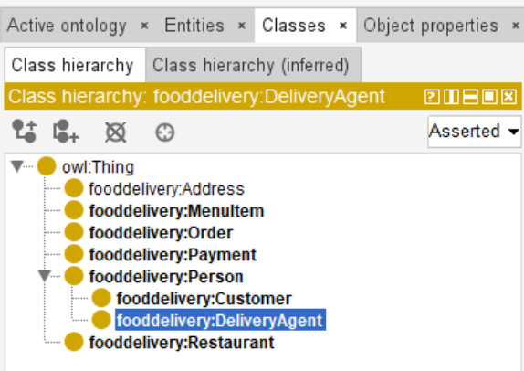
Figure 1 shows Class Hierarchy

3. Object Properties
Six object properties define inter-class relationships, each with domain and range entered as plain class names:
- placesOrder (Customer → Order)
- hasAddress (Customer → Address)
- containsItem (Order → MenuItem)
- hasPayment (Order → Payment)
- preparedBy (Order → Restaurant)
- deliversOrder (DeliveryAgent → Order)
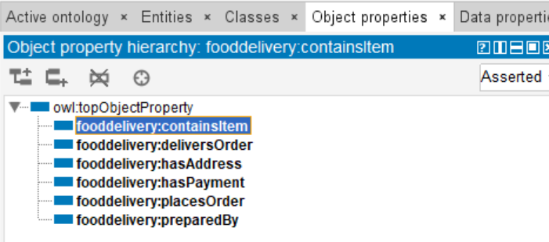
Figure 2 Object Properties of food delivery

4. Data Properties
Six data properties store literal values on individuals with appropriate XSD datatypes:
- personName (Person → xsd:string)
- restaurantName (Restaurant → xsd:string)
- itemName (MenuItem → xsd:string)
- orderDate (Order → xsd:dateTime)
- paymentAmount (Payment → xsd:decimal)
- addressLine (Address → xsd:string)
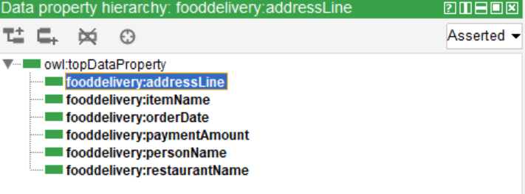
Figure 3 Data Properties of food delivery

5. Individuals
Fourteen individuals were created across all classes with values sourced directly from the RDF file.

Customers
- Customer_Asha – personName: Asha Reddy | placesOrder: Order_001 | hasAddress: Address_001
- Customer_Rohan – personName: Rohan Kumar | placesOrder: Order_002 | hasAddress: Address_002

Delivery Agents
- Agent_Vikram – personName: Vikram Singh | deliversOrder: Order_001
- Agent_Neha – personName: Neha Sharma | deliversOrder: Order_002

Restaurants
- Restaurant_SpiceHub – restaurantName: Spice Hub
- Restaurant_PizzaPoint – restaurantName: Pizza Point

Orders
- Order_001 – orderDate: 2026-04-15T18:30:00 | containsItem: Item_Biryani | preparedBy: Restaurant_SpiceHub | hasPayment: Payment_001
- Order_002 – orderDate: 2026-04-15T19:00:00 | containsItem: Item_Pizza | preparedBy: Restaurant_PizzaPoint | hasPayment: Payment_002

Remaining Individuals
- Item_Biryani – itemName: Chicken Biryani | Item_Pizza – itemName: Veg Pizza
- Payment_001 – paymentAmount: 450.00 | Payment_002 – paymentAmount: 300.00
- Address_001 – addressLine: 12 Lake View Road, Hyderabad
- Address_002 – addressLine: 45 Green Park Street, Hyderabad
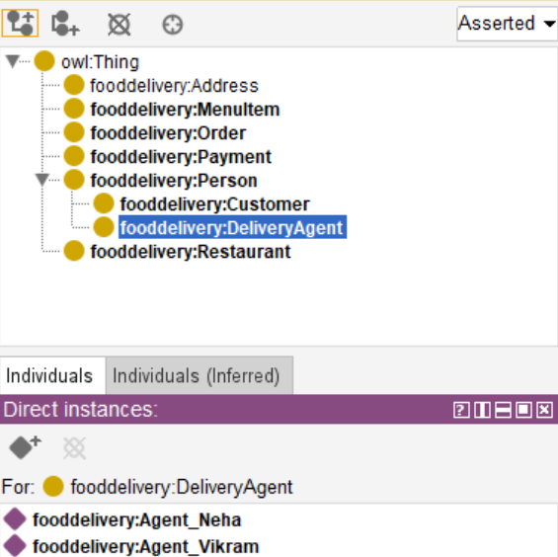
Figure 4 Individuals by Class of food delivery

6. Extension Tasks

Disjointness
Disjoint axioms ensure the exclusivity of membership:
- Customer disjoint with DeliveryAgent
- MenuItem disjoint with Order
- MenuItem disjoint with Restaurant
- Order disjoint with Payment
- Person disjoint with Restaurant
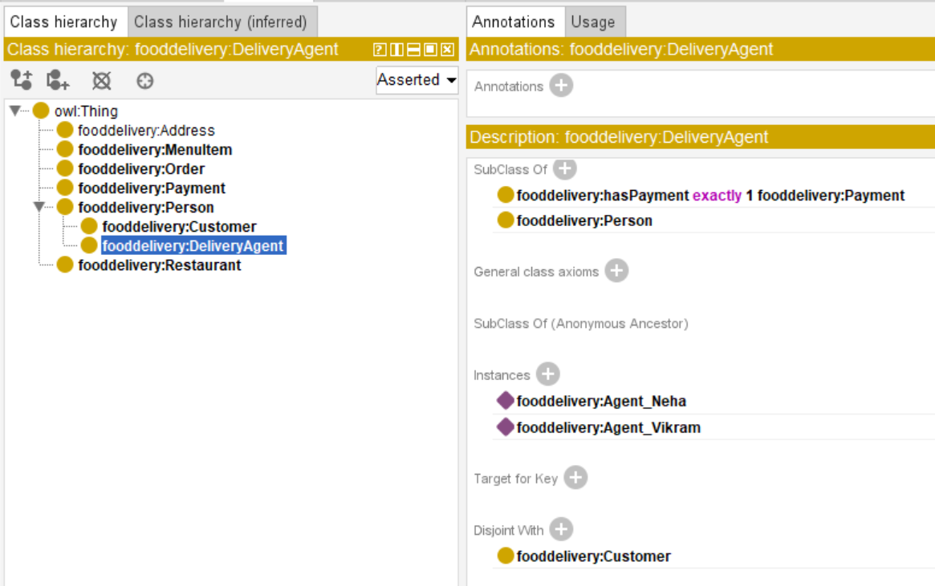
Figure 5 Disjointness Rules

Cardinality Restriction
A proper cardinality constraint was established for the Order entity, meaning that each order corresponds to only one payment:
hasPayment exactly 1 Payment

It ensures a practical requirement: Each order must be paid once only; there should not be an order without payment or more than one payment per order.
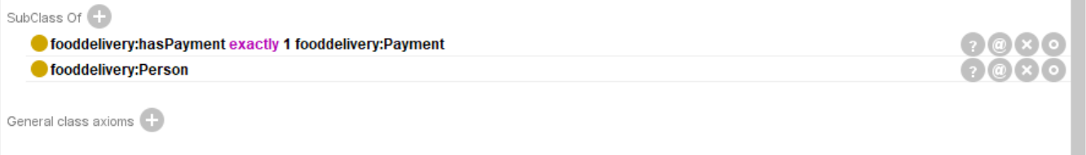
Figure 6 Cardinality Restriction on Order

Realistic Class Added Address
An Address class was introduced to make the ontology as realistic as possible. In practice, a delivery address is an individual that should be considered separate from the Customer individual because it has its own structure and can be modified without any changes made to the Customer individual. By introducing the Address class and using it in our ontology model instead of a simple data property of type xsd:string, we get the ability to operate with Address individuals as entities. This means creating an object property hasAddress from Customer to Address, a data property addressLine from Address to xsd:string and two individuals named Address_001 and Address_002, located at the following addresses:

7. Reasoning
The HermiT reasoner was run via Reasoner → HermiT → Start Reasoner. The following results confirmed ontology consistency:
- No class names turned red in the hierarchy panel
- No individuals appeared under owl:Nothing
- All disjointness axioms were satisfied
- The cardinality restriction (hasPayment exactly 1 Payment) was verified for both Order individuals
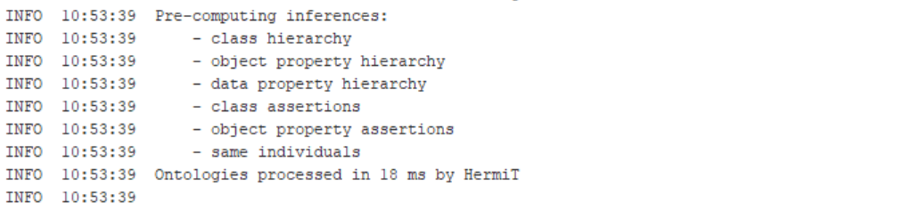
Figure 7 Reasoner Consistency Check of the food delivery

8. SPARQL Queries & Results
All queries use the prefix: PREFIX food: <http://www.semanticweb.org/ontologies/fooddelivery#>
Query 1 : List All Customers
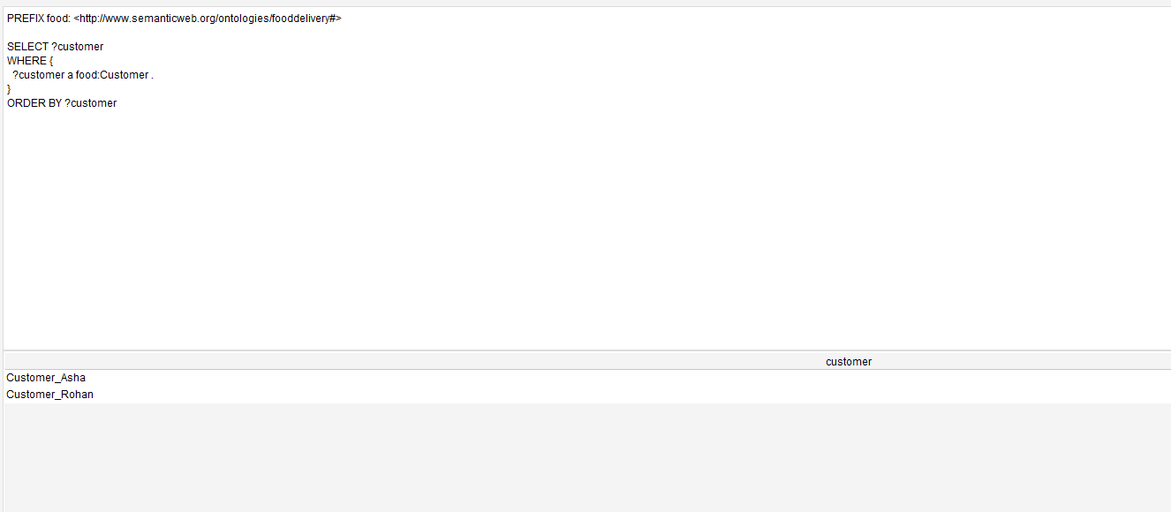
Figure 8 Results of Query 1:: List All Customers
Query 2 : Customer Names & Their Orders
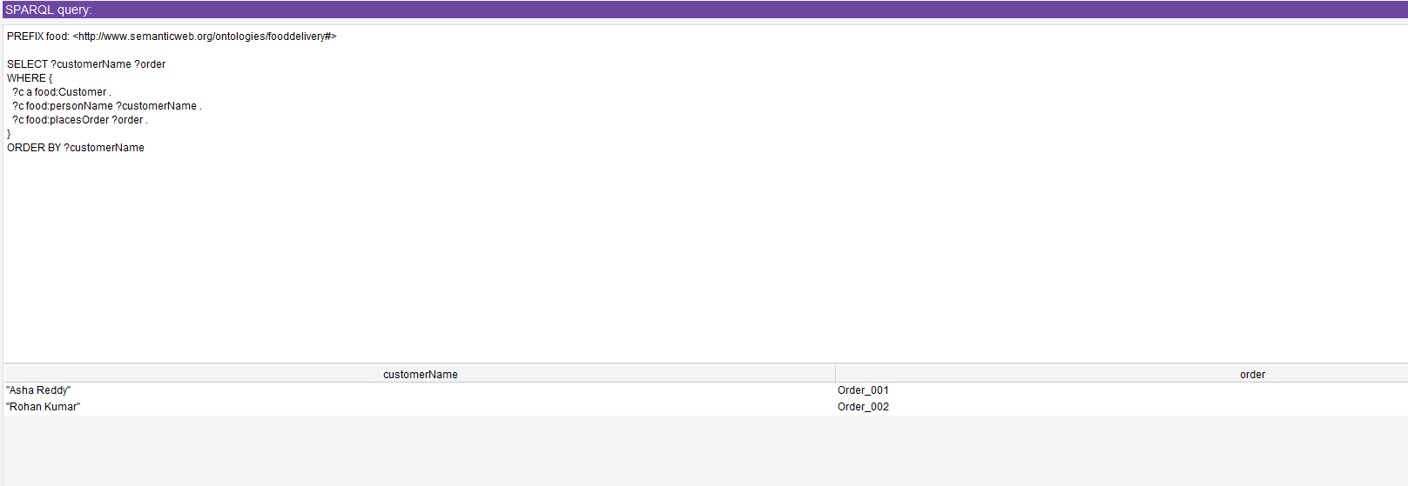
Figure 9 Results of Query:Customers & Orders
Query 3 : Orders & Items They Contain
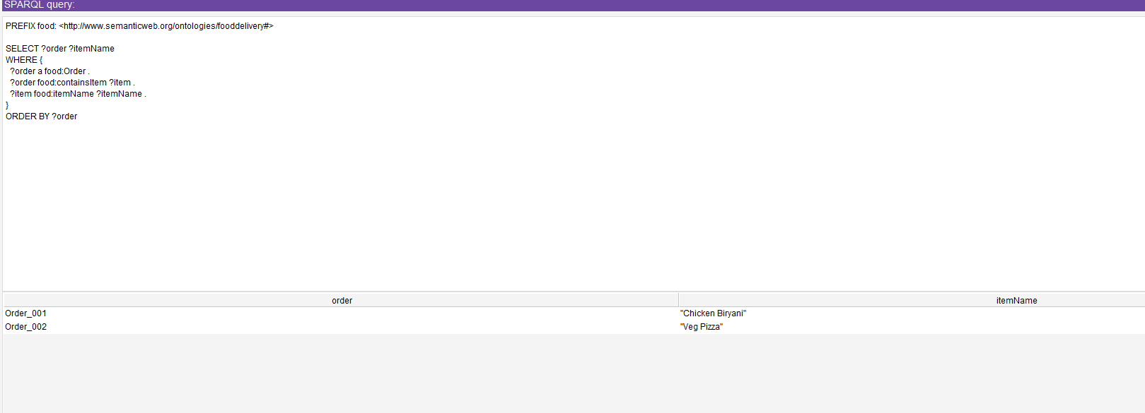
Figure 10 Results of Query Orders & Items
Query 4 Delivery Agents & Orders Delivered
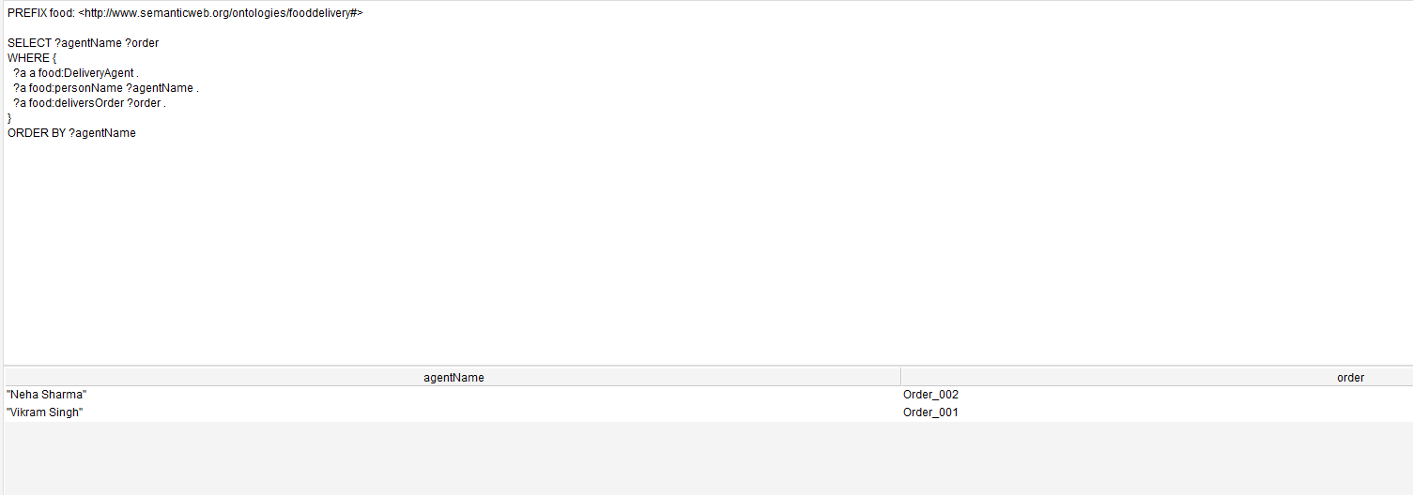
Figure 11 Results of Query Delivery Agents & Orders
Query 5 Cardinality Restriction Check
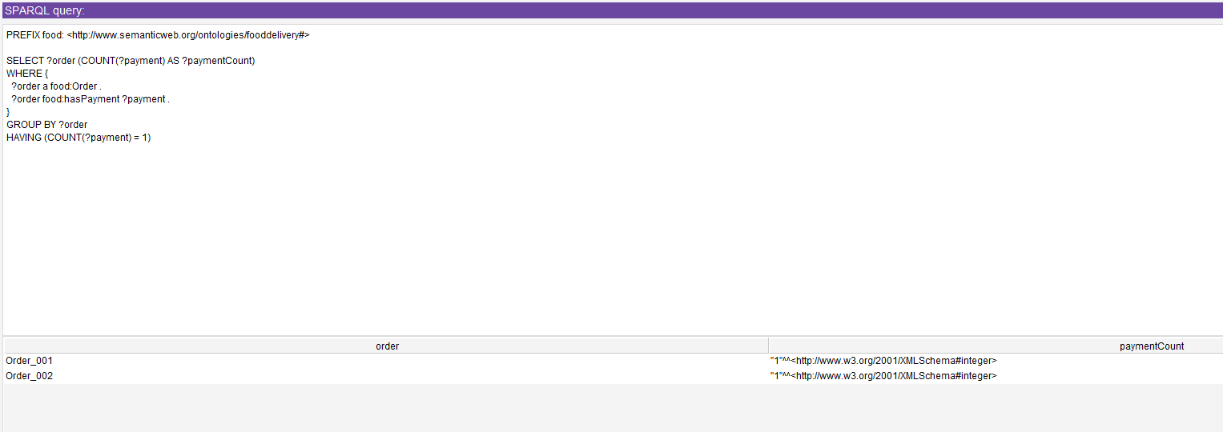
Figure 12 Results of Cardinality Check
Query 6 – Customers & Delivery Addresses
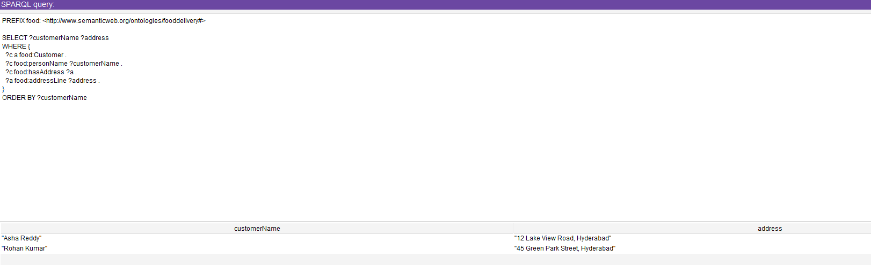
Figure 13 : Results of Customers & Addresses

Results Summary
Table 1:Results summary of the Queries
Q No. | Description | SPARQL Focus | Output
1 | List all Customers | Class membership | food:Customer_Asha, food:Customer_Rohan
2 | Customer names & their orders | Object property traversal | Asha Reddy – Order_001; Rohan Kumar – Order_002
3 | Orders & items they contain | Object property join | Order_001 – Chicken Biryani; Order_002 – Veg Pizza
4 | Delivery agents & orders delivered | Object property traversal | Vikram Singh – Order_001; Neha Sharma – Order_002
5 | Each order has exactly one payment | Cardinality restriction check | Order_001 – 1; Order_002 – 1
6 | Customers & delivery addresses | Data property retrieval | Asha Reddy – 12 Lake View Road, Hyderabad; Rohan Kumar – 45 Green Park Street, Hyderabad

9. Linked Data – GitHub Hosting
The ontology file (online_food_delivery.owl) was saved in RDF/XML format and uploaded to a public GitHub repository. GitHub Pages was enabled to provide a stable, dereferenceable URL:https://github.com/ramaseshu-Data/online_food_delivery

