# **CPD-2154-Oracle Database with SQL**

# **Term Project**

Submitted by,

RAMASUBBAIA ADAIKALAM

C0652863

# Table of Contents

## Conceptual Model

* Requirements Analysis ---------------------------------------------------------------------- 3
* Entities and Attributes------------------------------------------------------------------------4
* ER Diagram ------------------------------------------------------------------------------------ 7
* ERDish ------------------------------------------------------------------------------------------ 8
* Supertype /Subtypes/Arc ------------------------------------------------------------------ 10

## **Physical**

* Relational Physical Model----------------------------------------------------------------- 12
* Relationships using ERD Language-------------------------------------------------------16

## Database Implementation

* Create Physical Tables (DDL) ------------------------------------------------------------- 17

## Queries

* SQL Queries ------------------------------------------------------------------------------------22
* SQL INSERT Statements--------------------------------------------------------------------- 26
* Table Output -----------------------------------------------------------------------------------34
* Business Rules & Constraints ------------------------------------------------------------ 40
* Constraint Testing ----------------------------------------------------------------------------42

## Appearance

# rEQUIREMENT ANALYSIS

## Ashley’s Lawn and Garden Equipment Sales & Service

Mention the name Ashley and the words quality and service immediately come to mind. Ashley's Lawn & Garden Equipment was founded in 2000 by Ashley and, under her ownership, has evolved into the most respected and longest established lawn and garden equipment dealer in the area. Currently, the company sells and services all brands of lawn and garden equipment with a focus on lawn mowers, snow blowers, generators, and chain saws. The company is an authorized service dealer for all the manufactures they deal with, including all engines used in the equipment they sell.

The company employs three full-time office employees and four service employees. Service employees perform the work when equipment is brought in for service. In addition, they hire part-time employees on a seasonal basis. Office employees receive a salary. Service employees are paid an hourly-rate and a bonus based on performance. Part-time employees are paid an hourly rate. Because of the different seasons, part-time employees are hired when needed. As a result, the company stores historical records on part-time employees maintaining their starting and ending dates, job title, and hourly rate during each employment.

Every customer owns at least one equipment. However, some customers may own several equipment. Some customers are in business and can own several equipment of the same model. Each customer is identified by a customer id and their first name, last name, email, and mobile number is retained in the system

As mentioned, the company services several types of equipment. Each equipment is identified by its unique serial number. In addition, the system stores the brand and model of each equipment. For lawnmowers, the system stores the propulsion type, starter type, drive control, speed control, cutting width, wheel size, discharge, and bag capacity. For snow blowers, the system stores amprange, driveway size, clearing width range, chute control, intake height range, electric start, usage. For generators, the system stores remote starter, wattage range, and fuel type. For each chain saws, the system stores the power type, chain saw length, chain oiling, and if the case is included.

When equipment is purchased, it is recorded in the database. As a result, some equipment may not have been serviced yet. When equipment is brought in for service, a service request is generated with a unique service id and assigned to one service employee. For each service, the service date, service description, and hourly labor rate are recorded. Once a service is completed, the actual number of hours spend on the job are recorded. Over time, each equipment may generate several service requests. However, each service request is for only one equipment. An employee can be working on several service requests at any one time. However, an employee may be off and not be working on any service requests.

An equipment service may require a part with some services requiring several parts. For example, the yearly check-up of a lawn mower may include the installation of a new oil filter, a new air filter, and blade. But cleaning the fuel line does not require a part.

Each part is identified by part id. The part description, cost, and quantity on hand are recorded for reorder purposes.

# ER Diagram based on Requirements Analysis

## Entities and Attributes List

## EMPLOYEE:



## FULL_TIME:



## PART_TIME:



## SERVICE:



## JOB_HISTORY:



## PART:



## SERVICE_PART:



## SERVICE_REQUEST:



## CUSTOMER:



## COMPANY:



## PURCHASE:



## EQUIPMENT:



## GENERATOR:



## LAWN_MOVER:



## CHAIN_SAW:

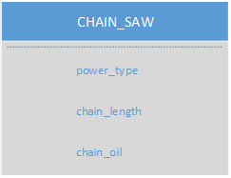

## SNOW_BLOWER:



# ER Diagram

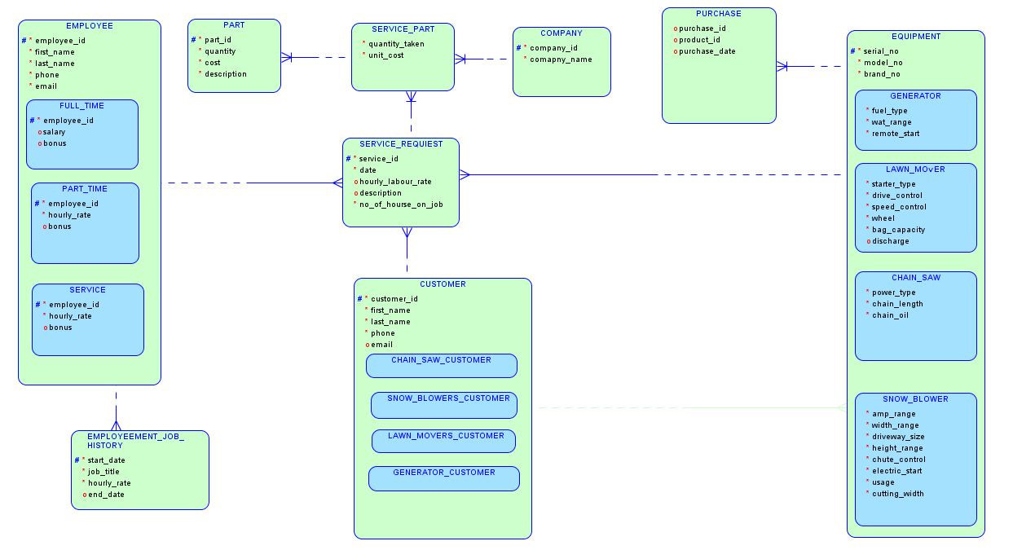

# SUPERTYPE/SUPTYPES:

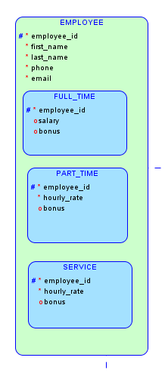 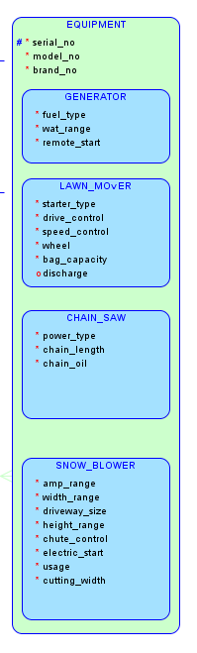

# RELATIONAL PHYSICAL MODEL

## CUSTOMER:

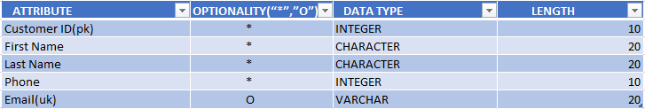

## EMPLOYEE:

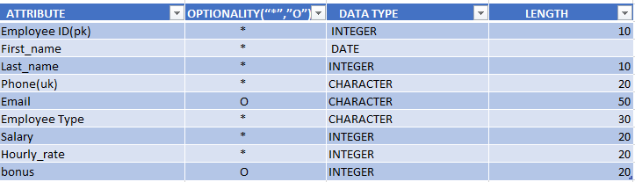

## JOB_HISTORY:

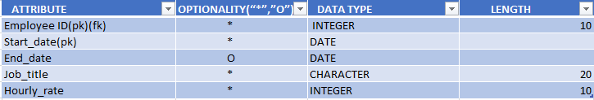

## SERVICE_REQUEST:

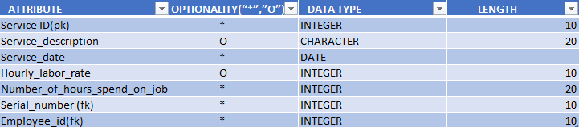

## SERVICE_PART:

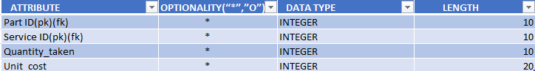

## PART:

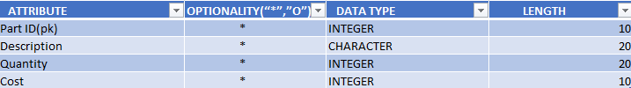

## EQUIPMENT:

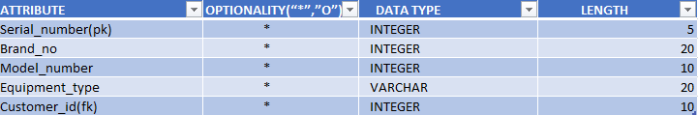

## LAWN_MOWER:

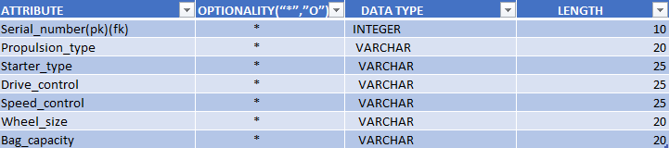

## SNOW_BLOWER:

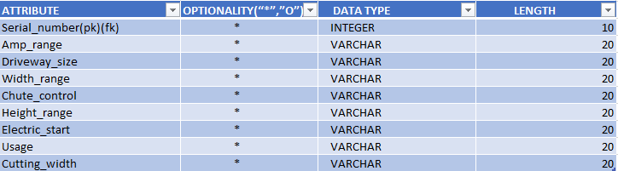

## GENERATOR:

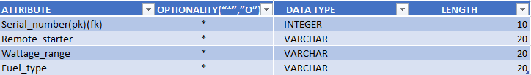

## FULL_TIME:

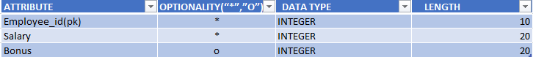

## SERVICE:

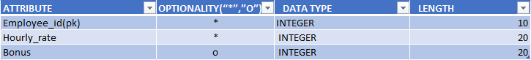

## COMPANY:

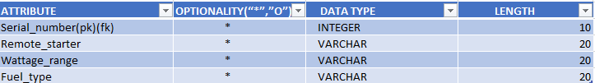

## CHAIN_SAW:

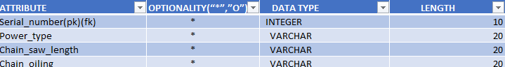

# Relationships using ERD Language

## CUSTOMER_CTR-EQUIPMENT_EQP

* Each CUSTOMER_CTR must buy one or more EQUIPMENT_EQP
* Each EQUIPMENT_EQP must belong to one and only one CUSTOMER_CTR

## CUSTOMER_CTR - SERVICE_REQUEST_SREQ

* Each CUSTOMER_CTR may request for one or more SERVICE_REQUEST_SREQ
* Each SERVICE_REQUEST_SREQ must be requested by one and only one CUSTOMER_CTR

## EQUIPMENT_EQP - SERVICE_REQUEST_SREQ

* Each EQUIPMENT_EQP may come one or more time for SERVICE_REQUEST_SREQ
* Each SERVICE_REQUEST_SREQ must done on one and only EQUIPMENT_EQP

## SERVICE_PART_SP - SERVICE_REQUEST_SREQ

* Each SERVICE_PART_SP must done on one and only SERVICE_REQUEST_SREQ
* Each SERVICE_REQUEST_SREQ may require zero, one or more SERVICE_PART_SP

## SERVICE_SER - SERVICE_REQUEST_SREQ

* Each SERVICE_SER may work on zero, one or more SERVICE_REQUEST_SREQ
* Each SERVICE_REQUEST_SREQ must be performed by one and only one SERVICE_SER

## PART_PR - SERVICE_PART_SP

* Each PART_PR may require by one or more SERVICE_PART_SP
* Each SERVICE_PART_SP must belong to one and only one PART_PR

## PART_TIME_PT - JOB_HISTORY_HSY

* Each PART_TIME_PT must have one or more JOB_HISTORY_HSY
* Each JOB_HISTORY_HSY must belong to one and only one PART_TIME_PT

# Create Physical Tables (DDL)

## SQL Create Statements

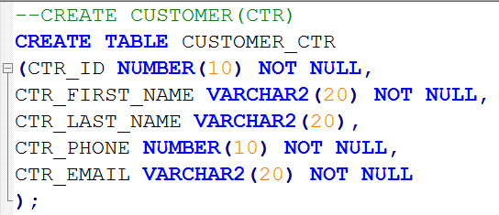

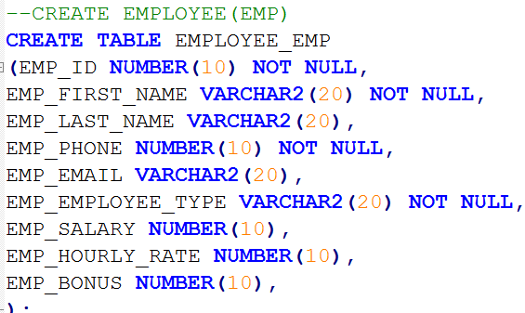

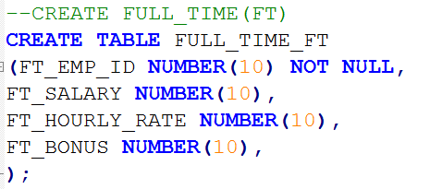

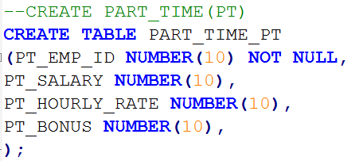

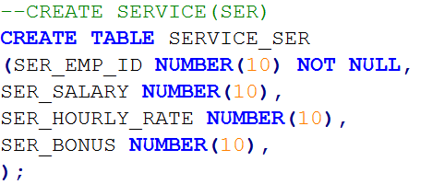

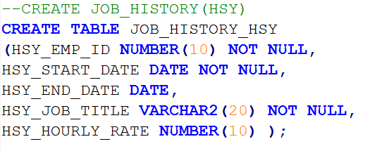

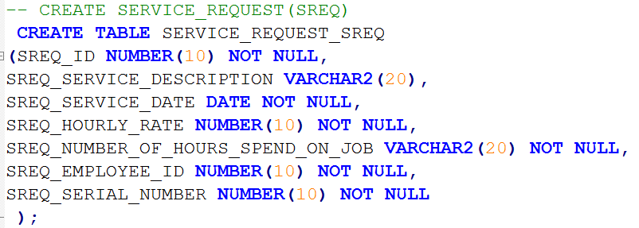

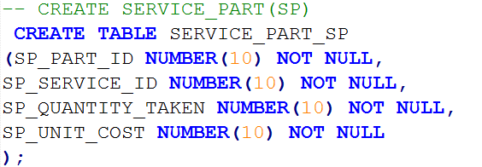

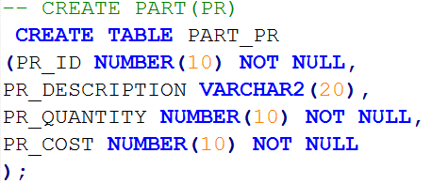

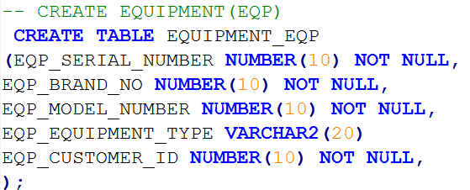

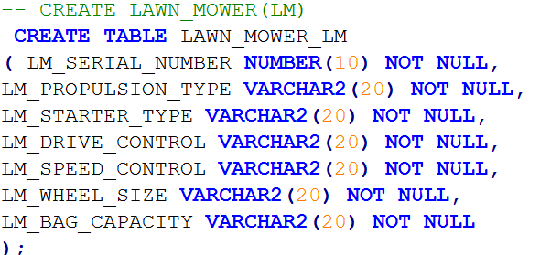

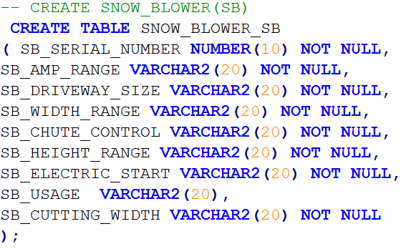

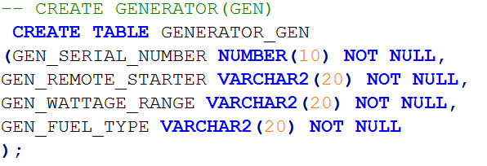

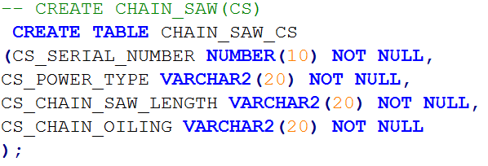

# SQL Constraint Statements

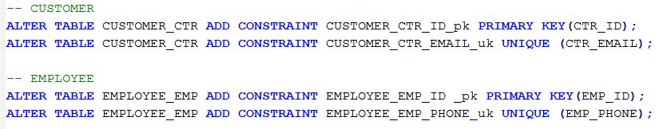

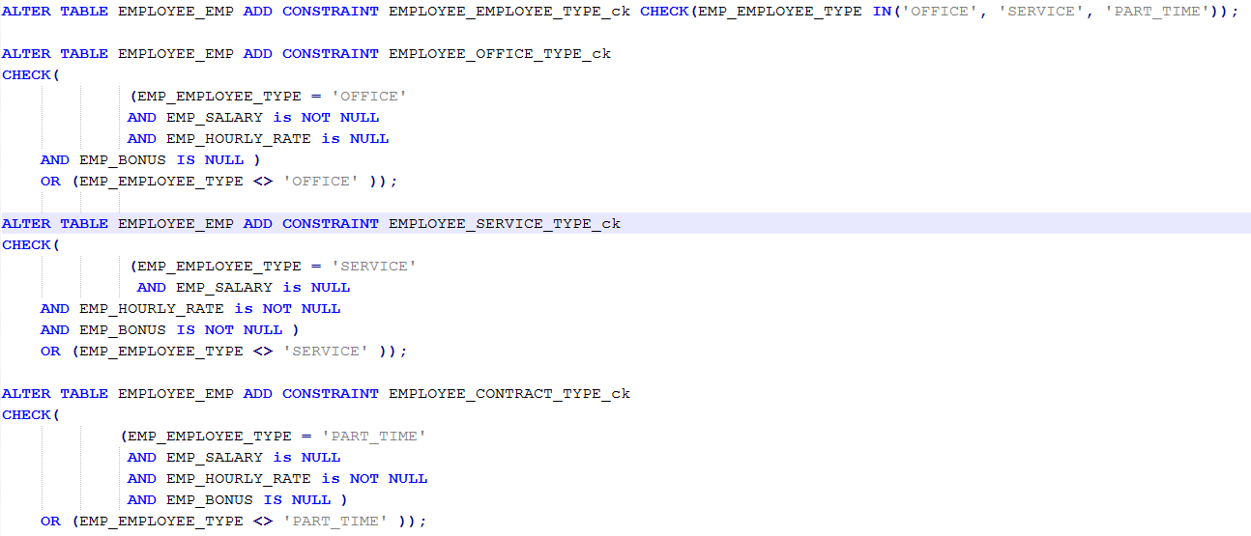

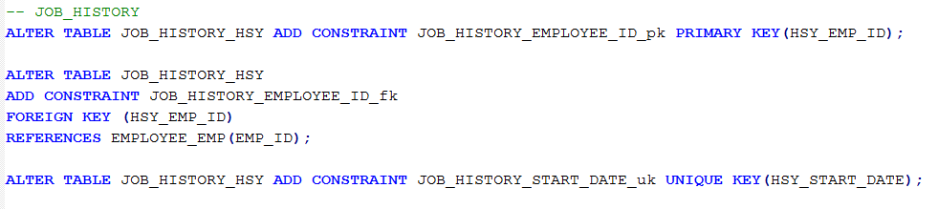

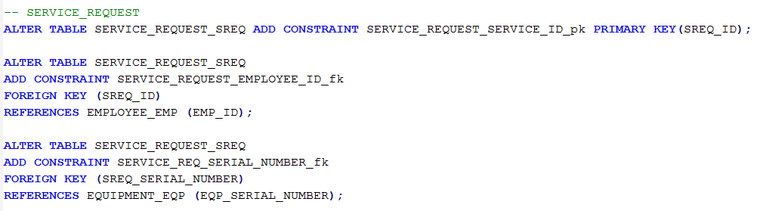

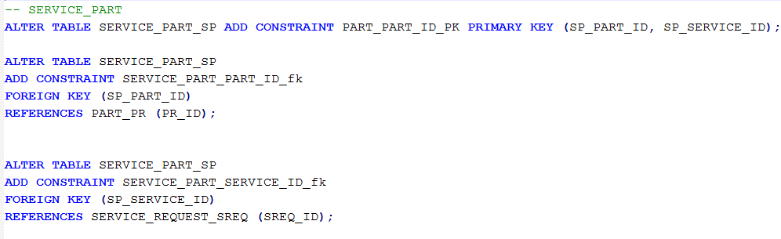

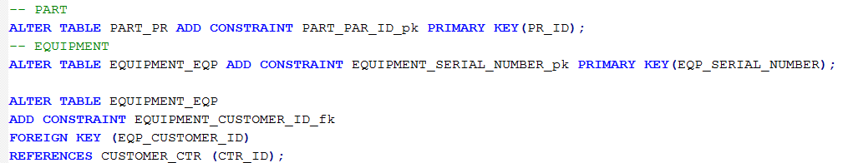

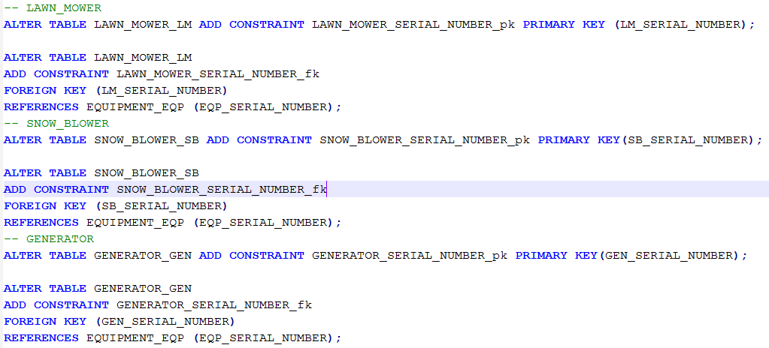

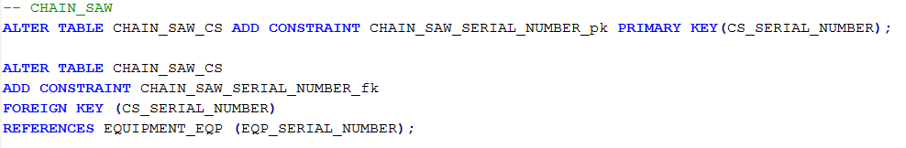

# SQL Insert Statements

## -- CUSTOMER_CTR

INSERT INTO CUSTOMER_CTR(CTR_ID, CTR_FIRST_NAME, CTR_LAST_NAME, CTR_PHONE, CTR_EMAIL)

VALUES(1,'RAMASUBBAIYA','ADAIKKALAM',123245,'A34FG@GMAIL.COM');

INSERT INTO CUSTOMER_CTR(CTR_ID, CTR_FIRST_NAME, CTR_LAST_NAME, CTR_PHONE, CTR_EMAIL)

VALUES(2,'SAM','SONY',234567,'SJF34G@GMAIL.COM');

INSERT INTO CUSTOMER_CTR(CTR_ID, CTR_FIRST_NAME, CTR_LAST_NAME, CTR_PHONE, CTR_EMAIL)

VALUES(3,'ARUN','ADAIKKALAM',345678,'JH343KFG@GMAIL.COM');

INSERT INTO CUSTOMER_CTR(CTR_ID, CTR_FIRST_NAME, CTR_LAST_NAME, CTR_ PHONE, CTR_EMAIL)

VALUES(4,'ANTONY','DEVA',456789,'CVN343HM@GMAIL.COM');

INSERT INTO CUSTOMER_CTR(CTR_ID, CTR_FIRST_NAME, CTR_LAST_NAME, CTR_PHONE, CTR_EMAIL)

VALUES(5,'MUTHU','AAIYA',567890,'343QWGFDH@GMAIL.COM');

## -- EMPLOYEE

INSERT INTO EMPLOYEE_EMP(EMP_ID, EMP_FIRST_NAME, EMP_LAST_NAME, EMP_PHONE, EMP_EMAIL, EMP_EMPLOYEE_TYPE, EMP_SALARY, EMP_HOURLY_RATE, EMP_BONUS) VALUES(01,'RAMASUBBAIYA','ADAIKKALAM',123245,'ASDFG@GMAIL.COM','OFFICE',13,NULL,NULL);

INSERT INTO EMPLOYEE_EMP(EMP_ID, EMP_FIRST_NAME, EMP_LAST_NAME, EMP_PHONE, EMP_EMAIL, EMP_EMPLOYEE_TYPE, EMP_SALARY, EMP_HOURLY_RATE, EMP_BONUS) VALUES(02,'SAM','SONY',234567,'SJFG@GMAIL.COM','SERVICE',NULL,12,10);

INSERT INTO EMPLOYEE_EMP(EMP_ID, EMP_FIRST_NAME, EMP_LAST_NAME, EMP_PHONE, EMP_EMAIL, EMP_EMPLOYEE_TYPE, EMP_SALARY, EMP_HOURLY_RATE, EMP_BONUS) VALUES(03,'RAM','ADAIKKALAM',345678,'JHKFG@GMAIL.COM','PART_TIME',13,12,10);

INSERT INTO EMPLOYEE_EMP(EMP_ID, EMP_FIRST_NAME, EMP_LAST_NAME, EMP_PHONE, EMP_EMAIL, EMP_EMPLOYEE_TYPE, EMP_SALARY, EMP_HOURLY_RATE, EMP_BONUS) VALUES(04,’RAM’,'DEVA',456789,'CVNHM@GMAIL.COM','SERVICE',NULL,12,NULL);

INSERT INTO EMPLOYEE_EMP(EMP_ID, EMP_FIRST_NAME, EMP_LAST_NAME, EMP_PHONE, EMP_EMAIL, EMP_EMPLOYEE_TYPE, EMP_SALARY, EMP_HOURLY_RATE, EMP_BONUS) VALUES(05,’RAM’,'AAIYA',567890,'QWGFDH@GMAIL.COM','OFFICE',13,NULL,NULL);

## -- JOB_HISTORY

INSERT INTO JOB_HISTORY_HSY (HSY_EMP_ID, HSY_START_DATE, HSY_END_DATE, HSY_JOB_TITLE, HSY_HOURLY_RATE)

VALUES('01-JUN-2015','05-MAR-2015','MA',12);

INSERT INTO JOB_HISTORY_HSY (HSY_EMP_ID, HSY_START_DATE, HSY_END_DATE, HSY_JOB_TITLE, HSY_HOURLY_RATE)

VALUES('01-JUN-2015','05-AUG-2015','MA',12);

INSERT INTO JOB_HISTORY_HSY (HSY_EMP_ID, HSY_START_DATE, HSY_END_DATE, HSY_JOB_TITLE, HSY_HOURLY_RATE)

VALUES('01-JUL-2015','05-DEC-2015','CA',11);

INSERT INTO JOB_HISTORY_HSY (HSY_EMP_ID, HSY_START_DATE, HSY_END_DATE, HSY_JOB_TITLE, HSY_HOURLY_RATE)

VALUES('01-AUG-2015','05-JAN-2015','CA',11);

INSERT INTO JOB_HISTORY_HSY (HSY_EMP_ID, HSY_START_DATE, HSY_END_DATE, HSY_JOB_TITLE, HSY_HOURLY_RATE)

VALUES('01-SEP-2015','05-DEC-2015','MA',12);

## -- SERVICE_REQUEST

INSERT INTO SERVICE_REQUEST_SREQ(SREQ_ID, SREQ_SERVICE_DESCRIPTION, SREQ_SERVICE_DATE, SREQ_HOURLY_RATE, SREQ_ HOURS_SPEND_ON_JOB, SREQ_EMPLOYEE_ID, SREQ_SERIAL_NUMBER)

VALUES(01,'LM','05-DEC-2015',12,'6', 01, 01);

INSERT INTO SERVICE_REQUEST_SREQ(SREQ_ID, SREQ_SERVICE_DESCRIPTION, SREQ_SERVICE_DATE, SREQ_HOURLY_RATE, SREQ_ HOURS_SPEND_ON_JOB, SREQ_EMPLOYEE_ID, SREQ_SERIAL_NUMBER)

VALUES(02,'SB','05-JAN-2015',12,'6', 02, 02);

INSERT INTO SERVICE_REQUEST_SREQ(SREQ_ID, SREQ_SERVICE_DESCRIPTION, SREQ_SERVICE_DATE, SREQ_HOURLY_RATE, SREQ_ HOURS_SPEND_ON_JOB, SREQ_EMPLOYEE_ID, SREQ_SERIAL_NUMBER)

VALUES(03,'GEN','05-AUG-2015',12,'6', 03, 03);

INSERT INTO SERVICE_REQUEST_SREQ(SREQ_ID, SREQ_SERVICE_DESCRIPTION, SREQ_SERVICE_DATE, SREQ_HOURLY_RATE, SREQ_ HOURS_SPEND_ON_JOB, SREQ_EMPLOYEE_ID, SREQ_SERIAL_NUMBER)

VALUES(04,'LM','05-MAR-2015',12,'6', 04, 04);

INSERT INTO SERVICE_REQUEST_SREQ(SREQ_ID, SREQ_SERVICE_DESCRIPTION, SREQ_SERVICE_DATE, SREQ_HOURLY_RATE, SREQ_ HOURS_SPEND_ON_JOB, SREQ_EMPLOYEE_ID, SREQ_SERIAL_NUMBER)

VALUES(05,'SB','05-DEC-2015',12,'6', 05, 05);

## -- SERVICE_PART

INSERT INTO SERVICE_PART_SP(SP_PART_ID, SP_SERVICE_ID, SP_QUANTITY_TAKEN, SP_UNIT_COST)

VALUES(1, 4, 92, 6);

INSERT INTO SERVICE_PART_SP(SP_PART_ID, SP_SERVICE_ID, SP_QUANTITY_TAKEN, SP_UNIT_COST)

VALUES(2, 1, 90, 14);

INSERT INTO SERVICE_PART_SP(SP_PART_ID, SP_SERVICE_ID, SP_QUANTITY_TAKEN, SP_UNIT_COST)

VALUES(3, 2, 91, 15);

INSERT INTO SERVICE_PART_SP(SP_PART_ID, SP_SERVICE_ID, SP_QUANTITY_TAKEN, SP_UNIT_COST)

VALUES(4, 3, 93, 8);

INSERT INTO SERVICE_PART_SP(SP_PART_ID, SP_SERVICE_ID, SP_QUANTITY_TAKEN, SP_UNIT_COST)

VALUES(5, 5, 99, 10);

## -- PART

INSERT INTO PART_PR(PR_ID, PR_DESCRIPTION, PR_QUANTITY, PR_COST)

VALUES(01, 'AD', 10, 5);

INSERT INTO PART_PR(PR_ID, PR_DESCRIPTION, PR_QUANTITY, PR_COST)

VALUES(02, 'TMD', 7, 10);

INSERT INTO PART_PR(PR_ID, PR_DESCRIPTION, PR_QUANTITY, PR_COST)

VALUES(03, 'TBD', 8, 24);

INSERT INTO PART_PR(PR_ID, PR_DESCRIPTION, PR_QUANTITY, PR_COST)

VALUES(04, 'TCD', 11, 56);

INSERT INTO PART_PR(PR_ID, PR_DESCRIPTION, PR_QUANTITY, PR_COST)

VALUES(05, 'TTD', 12, 23);

## -- EQUIPMENT

INSERT INTO EQUIPMENT_EQP(EQP_SERIAL_NUMBER, EQP_BRAND_NO, EQP_MODEL_NUMBER, EQP_EQUIPMENT_TYPE, EQP_CUSTOMER_ID)

VALUES(01, '44', 55, 'LAWN_MOWER_LM', 01);

INSERT INTO EQUIPMENT_EQP(EQP_SERIAL_NUMBER, EQP_BRAND_NO, EQP_MODEL_NUMBER, EQP_EQUIPMENT_TYPE, EQP_CUSTOMER_ID)

VALUES(02, '45', 56, 'SNOW_BLOWER_SB', 02);

INSERT INTO EQUIPMENT_EQP(EQP_SERIAL_NUMBER, EQP_BRAND_NO, EQP_MODEL_NUMBER, EQP_EQUIPMENT_TYPE, EQP_CUSTOMER_ID)

VALUES(03, '46', 57, 'GENERATOR_GEN', 03);

INSERT INTO EQUIPMENT_EQP(EQP_SERIAL_NUMBER, EQP_BRAND_NO, EQP_MODEL_NUMBER, EQP_EQUIPMENT_TYPE, EQP_CUSTOMER_ID)

VALUES(04, '48', 59, 'LAWN_MOWER_LM', 04);

INSERT INTO EQUIPMENT_EQP(EQP_SERIAL_NUMBER, EQP_BRAND_NO, EQP_MODEL_NUMBER, EQP_EQUIPMENT_TYPE, EQP_CUSTOMER_ID)

VALUES(05, '47', 58, 'CHAIN_SAW_CS', 05);

## -- LAWN_MOWER

INSERT INTO LAWN_MOWER_LM(LM_SERIAL_NUMBER, LM_PROPULSION_TYPE, LM_STARTER_TYPE, LM_DRIVE_CONTROL, LM_SPEED_CONTROL, LM_WHEEL_SIZE, LM_BAG_CAPACITY)

VALUES(01, '34', '585', '45', '80', '45', '4');

INSERT INTO LAWN_MOWER_LM(LM_SERIAL_NUMBER, LM_PROPULSION_TYPE, LM_STARTER_TYPE, LM_DRIVE_CONTROL, LM_SPEED_CONTROL, LM_WHEEL_SIZE, LM_BAG_CAPACITY)

VALUES(02, '544', '685', '55', '81', '46', '5');

INSERT INTO LAWN_MOWER_LM(LM_SERIAL_NUMBER, LM_PROPULSION_TYPE, LM_STARTER_TYPE, LM_DRIVE_CONTROL, LM_SPEED_CONTROL, LM_WHEEL_SIZE, LM_BAG_CAPACITY)

VALUES(03, '64', '785', '65', '82', '47', '6');

INSERT INTO LAWN_MOWER_LM(LM_SERIAL_NUMBER, LM_PROPULSION_TYPE, LM_STARTER_TYPE, LM_DRIVE_CONTROL, LM_SPEED_CONTROL, LM_WHEEL_SIZE, LM_BAG_CAPACITY)

VALUES(04, '723', '885', '75', '83', '48', '7');

INSERT INTO LAWN_MOWER_LM(LM_SERIAL_NUMBER, LM_PROPULSION_TYPE, LM_STARTER_TYPE, LM_DRIVE_CONTROL, LM_SPEED_CONTROL, LM_WHEEL_SIZE, LM_BAG_CAPACITY)

VALUES(05, '233', '985', '85', '84', '49', '8');

## -- SNOW_BLOWER

INSERT INTO SNOW_BLOWER_SB(SB_SERIAL_NUMBER, SB_AMP_RANGE, SB_DRIVEWAY_SIZE, SB_WIDTH_RANGE, SB_CHUTE_CONTROL, SB_HEIGHT_RANGE, SB_ELECTRIC_START, SB_USAGE, SB_CUTTING_WIDTH)

VALUES(01, '832', '98', '85', '84', '49', '8', '45', '76');

INSERT INTO SNOW_BLOWER_SB(SB_SERIAL_NUMBER, SB_AMP_RANGE, SB_DRIVEWAY_SIZE, SB_WIDTH_RANGE, SB_CHUTE_CONTROL, SB_HEIGHT_RANGE, SB_ELECTRIC_START, SB_USAGE, SB_CUTTING_WIDTH)

VALUES(02, '235', '385', '95', '94', '79', '9', '456', '766');

INSERT INTO SNOW_BLOWER_SB(SB_SERIAL_NUMBER, SB_AMP_RANGE, SB_DRIVEWAY_SIZE, SB_WIDTH_RANGE, SB_CHUTE_CONTROL, SB_HEIGHT_RANGE, SB_ELECTRIC_START, SB_USAGE, SB_CUTTING_WIDTH)

VALUES(03, '345', '485', '35', '74', '89', '10', '457', '767');

INSERT INTO SNOW_BLOWER_SB(SB_SERIAL_NUMBER, SB_AMP_RANGE, SB_DRIVEWAY_SIZE, SB_WIDTH_RANGE, SB_CHUTE_CONTROL, SB_HEIGHT_RANGE, SB_ELECTRIC_START, SB_USAGE, SB_CUTTING_WIDTH)

VALUES(04, '455', '585', '55', '64', '99', '11', '458', '768');

INSERT INTO SNOW_BLOWER_SB(SB_SERIAL_NUMBER, SB_AMP_RANGE, SB_DRIVEWAY_SIZE, SB_WIDTH_RANGE, SB_CHUTE_CONTROL, SB_HEIGHT_RANGE, SB_ELECTRIC_START, SB_USAGE, SB_CUTTING_WIDTH)

VALUES(05, '975', '685', '65', '54', '100', '12', '459', '769');

## -- GENERATOR

INSERT INTO GENERATOR_GEN(GEN_SERIAL_NUMBER, GEN_REMOTE_STARTER, GEN_WATTAGE_RANGE, GEN_FUEL_TYPE)

VALUES(01, '675', '685', '65');

INSERT INTO GENERATOR(SERIAL_NUMBER, REMOTE_STARTER, WATTAGE_RANGE, FUEL_TYPE)

VALUES(02, '645', '785', '75');

INSERT INTO GENERATOR(SERIAL_NUMBER, REMOTE_STARTER, WATTAGE_RANGE, FUEL_TYPE)

VALUES(03, '725', '885', '85');

INSERT INTO GENERATOR(SERIAL_NUMBER, REMOTE_STARTER, WATTAGE_RANGE, FUEL_TYPE)

VALUES(04, '345', '985', '95');

INSERT INTO GENERATOR(SERIAL_NUMBER, REMOTE_STARTER, WATTAGE_RANGE, FUEL_TYPE)

VALUES(05, '345', '585', '45');

## -- CHAIN_SAW

INSERT INTO CHAIN_SAW_CS(CS_SERIAL_NUMBER, CS_POWER_TYPE, CS_CHAIN_SAW_LENGTH, CS_CHAIN_OILING)

VALUES(04, '237', '885', '85');

INSERT INTO CHAIN_SAW(SERIAL_NUMBER, POWER_TYPE, CHAIN_SAW_LENGTH, CHAIN_OILING)

VALUES(05, ‘347', '985', '75');

INSERT INTO CHAIN_SAW(SERIAL_NUMBER, POWER_TYPE, CHAIN_SAW_LENGTH, CHAIN_OILING)

VALUES(03, '237', '385', '65');

INSERT INTO CHAIN_SAW(SERIAL_NUMBER, POWER_TYPE, CHAIN_SAW_LENGTH, CHAIN_OILING)

VALUES(02, '327', '485', '55');

INSERT INTO CHAIN_SAW(SERIAL_NUMBER, POWER_TYPE, CHAIN_SAW_LENGTH, CHAIN_OILING)

VALUES(01, '237', '585', '45');

# Output of Tables:

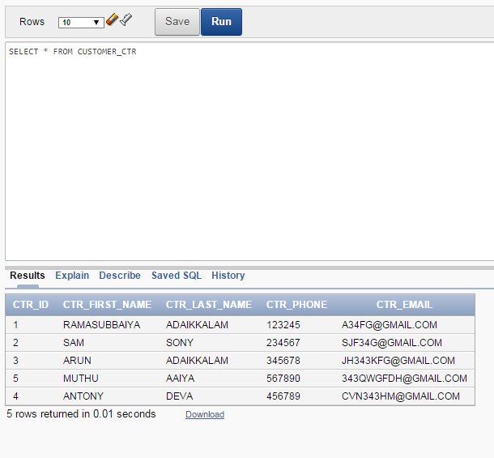

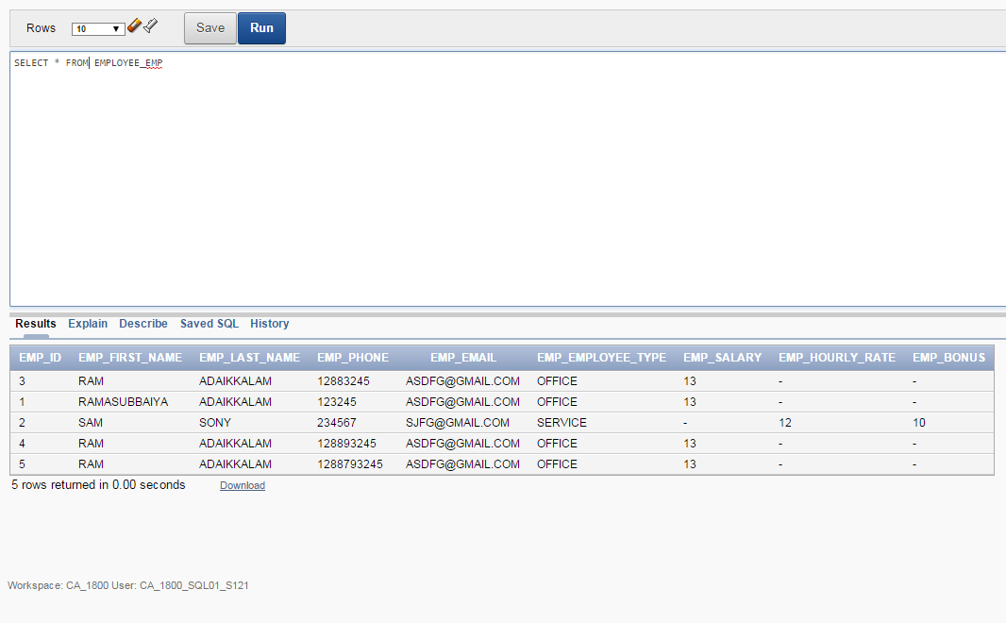

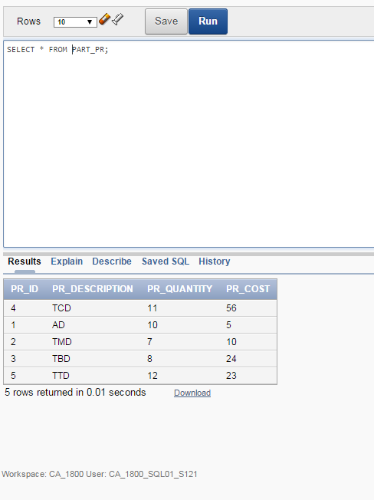

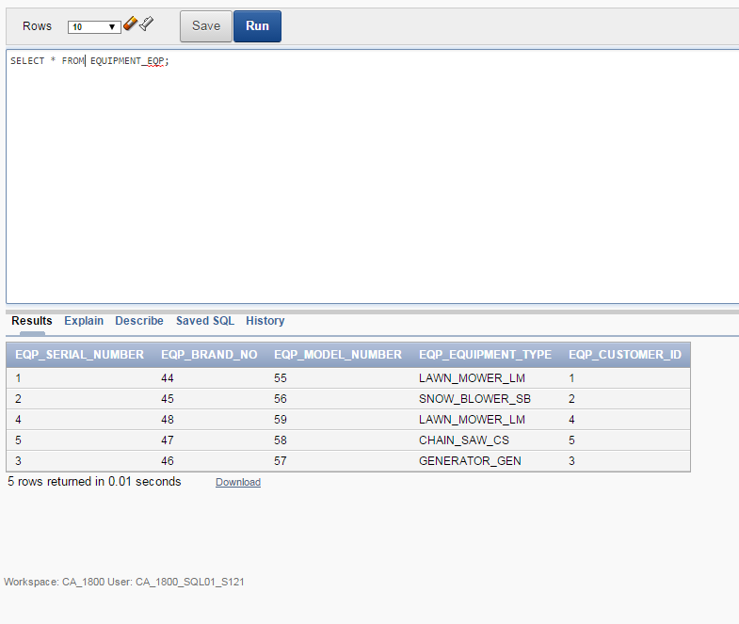

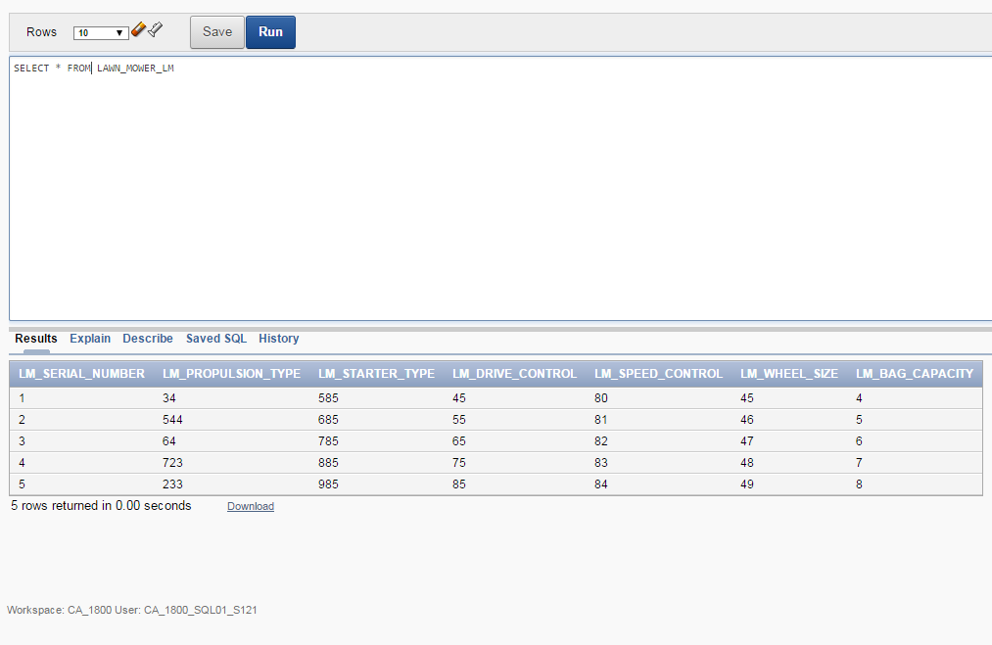

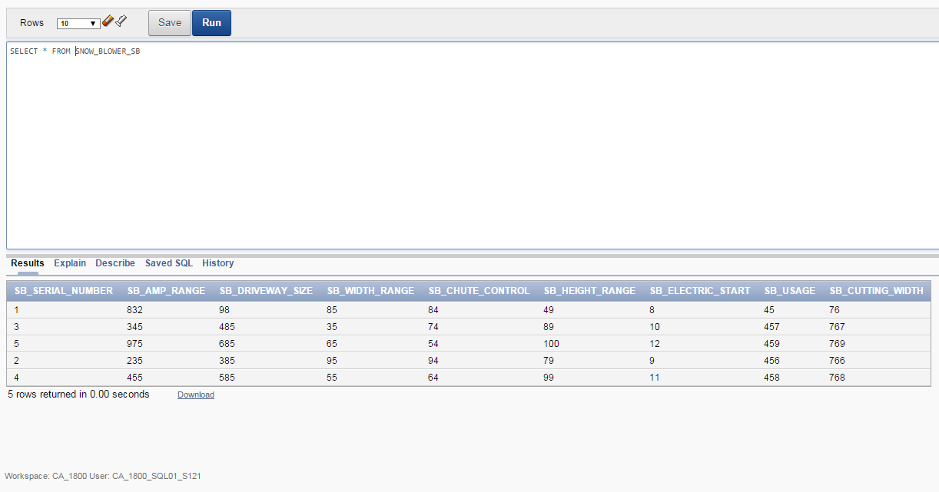

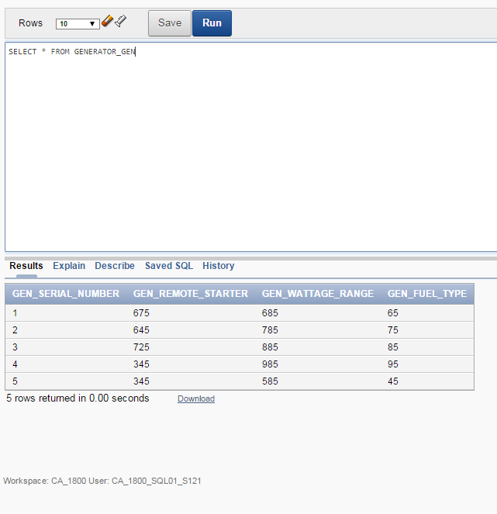

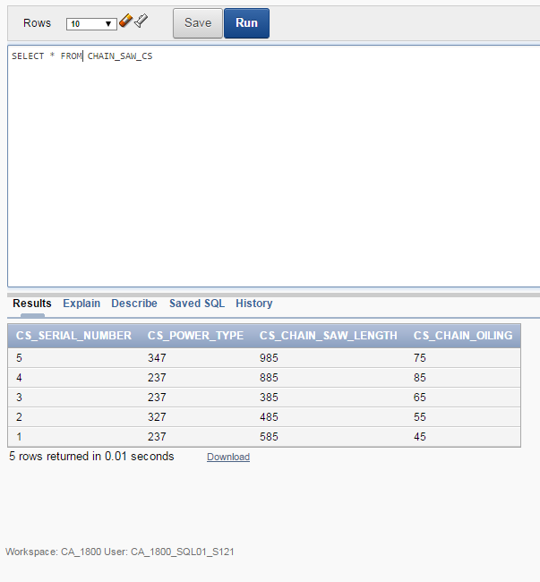

# Business Rules & Constraints

## CUSTOMER_ctr

* Each customer is identified by a unique customer ID.
* Each customer has a customer Name
* Each customer has a Phone Number
* Each customer has  an email which is unique

## EMPLOYEE_emp

* Each employee is identified by a unique EmployeeID
* Each employee has a Employee Name
* Each employee has a unique Phone Number

## JOB HISTORY hsy

* Each employee history has a job title
* Each employee history has a start date
* Each employee history has an end date
* Each employee history has an hourly rate
* Each employee history is identified by start_date and a unique employee ID that references a single part time employee which is identified by a part time employee’s employee ID

## SERVICE_REQUEST_sreq

* Each service is identified by a unique service ID
* Each service has a service description
* Each service has a service date
* Each service has a hourly labour rate
* Each service has number of hours associated with it
* Each service has an employee’s ID that references a single employee which is identified by a service employee’s employee ID
* Each service has a serial number that references a each equipment which is identified by an equipment’s serial number

## SERVICE_PART_sp

* Each service part has an service’s ID that references a single service which is identified by a service’s service ID
* Each service part has part’s ID that references a single part which is identified by a part’s part ID
* Each service part has a quantity taken
* Each service part  has a unit cost

## PART_pr

* Each part is identified by a unique part ID
* Each part has a description
* Each part has a part and quantity
* Cost must be greater than 0
* Each part has a service’s ID that references a single service which is identified by a service’s service ID

## EQUIPMENT_eqp

* Each equipment is identified by a unique serial number
* Each equipment has a brand and a model
* Each equipment has a customer’s ID that references a single customer identified by customer’s customer ID

# --TESTING CONSTRAINT

