**NAME: RAMASUBBAIYA ADAIKKALAM**

**STUDENT #: C0652863**

**A05 - Bluewater Events**

**A04A - Bluewater Events Requirements Analysis Meeting 1**

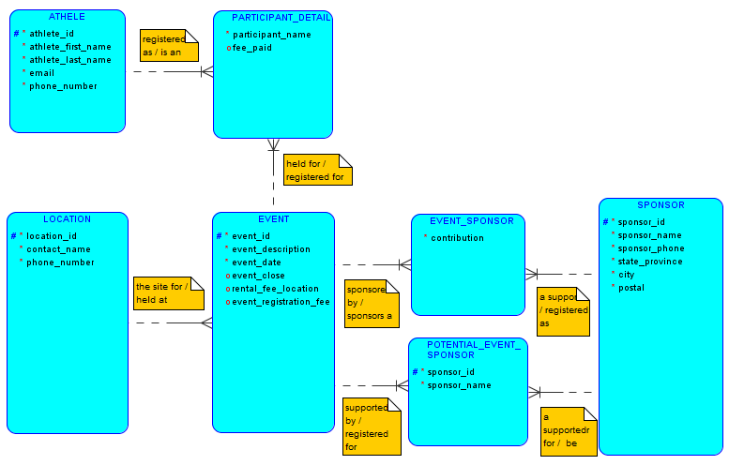

**A04B - Bluewater Events Requirements Analysis Meeting 2**

