**Ramasubbaiya Adaikkalam**

**C0652863**

**ASSIGNMENT 15**

**Question 01)**

**SQL>**

SELECT last_name,   
       first_name,   
       **CONCAT**(last_name, first_name) AS "User Name"   
FROM   employees   
WHERE  department_id = 90;

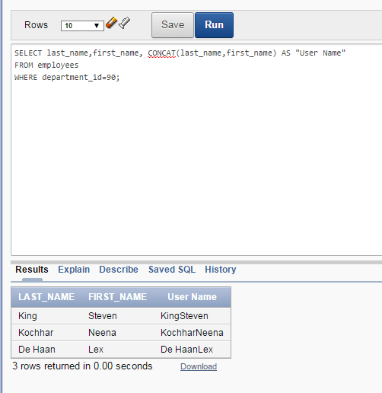

**Question 02)**

**SQL>**

SELECT first_name,   
       last_name,   
       **TO_CHAR**(hire_date, 'Month ddth YYYY') AS "Hired Date"   
FROM   employees;

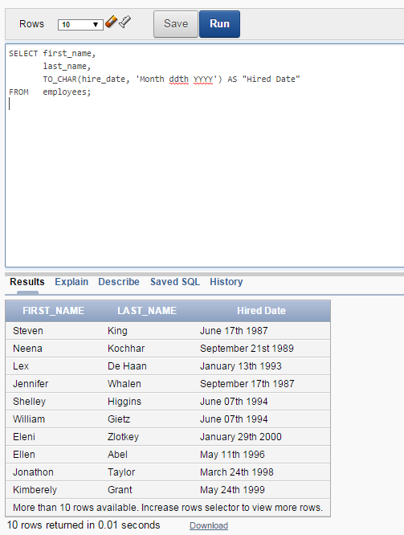

**Question 03)**

**SQL>**

SELECT first_name   
       || ' '   
       || last_name,   
       **ADD_MONTHS**(hire_date, 8) AS "First Review"   
FROM   employees   
WHERE  job_id = 'SA_REP';

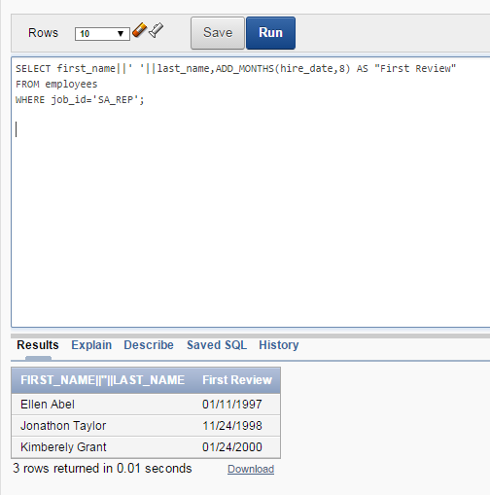

**Question 04)**

**SQL>**

SELECT **TO_CHAR**(salary, '$999999.99') AS "SALARY"   
FROM   employees   
WHERE  department_id = 80;

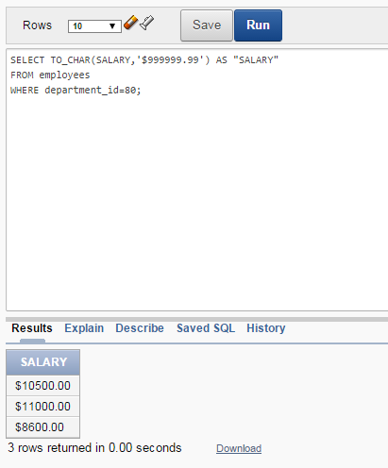

**Question 05)**

**SQL>**

SELECT last_name                                  AS "EMPLOYEE",**NVL**(**TO_CHAR**(manager_id), 'No Manager Assigned')  AS "MANAGER"   
FROM   employees   
WHERE  department_id = 90;

