**Ramasubbaiya Adaikkalam**

**C0652863**

**Assignment 19**

**Insert values in companies table**

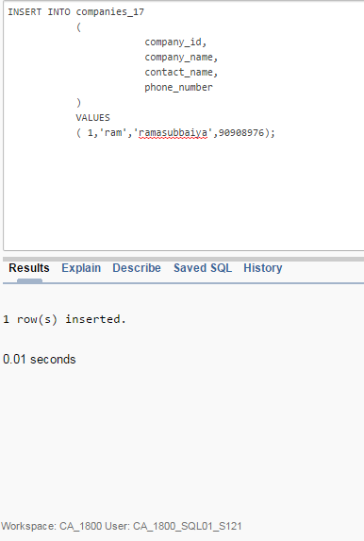

**Checking constraints in table**

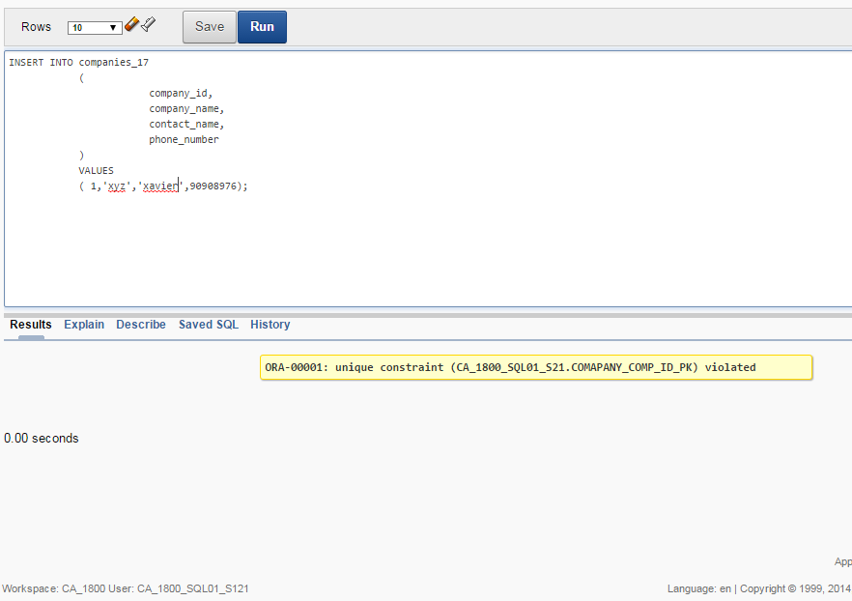

**Inserting values in contract_17**

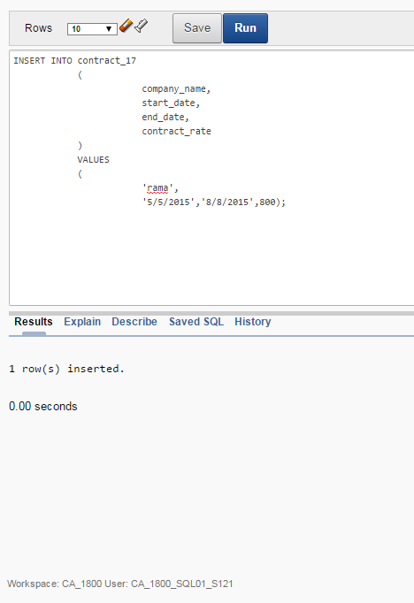

**Checking table – value too large**

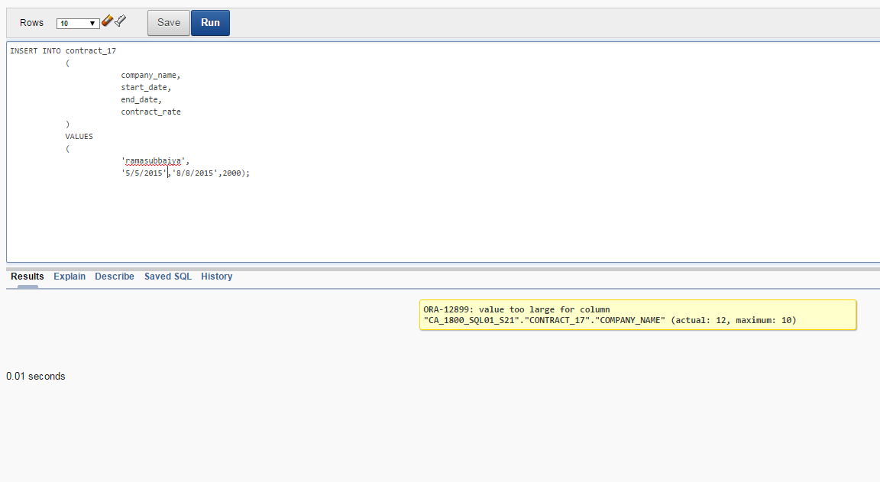

**Checking contract_value less than 1000**

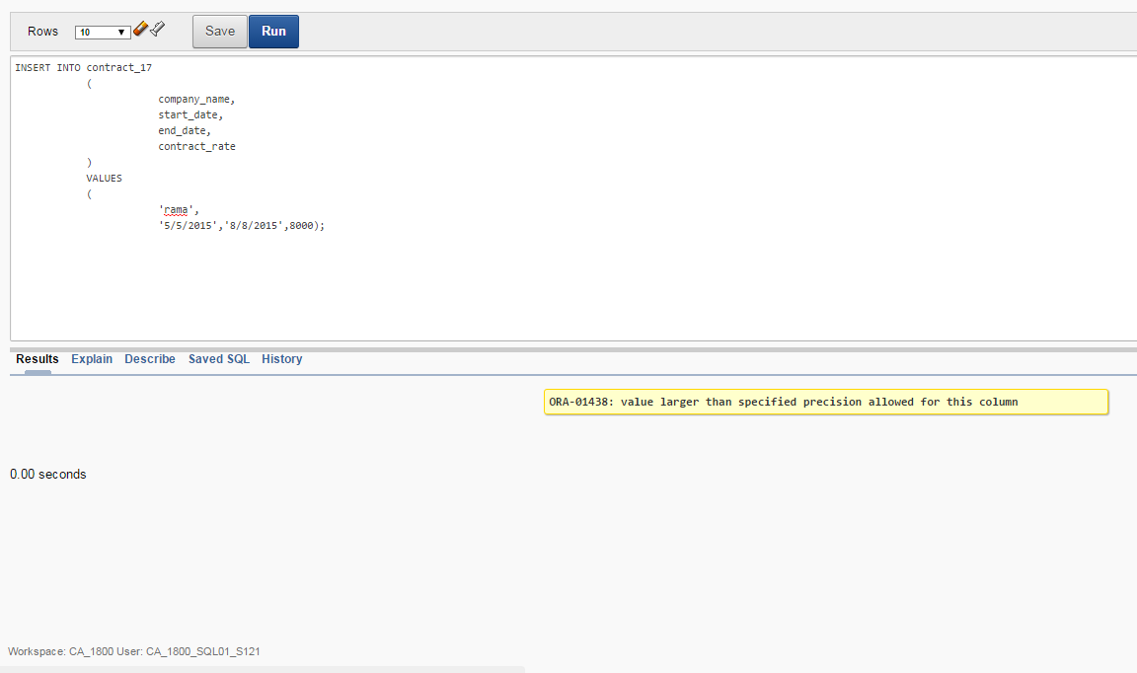

**Insert values in trucks table**

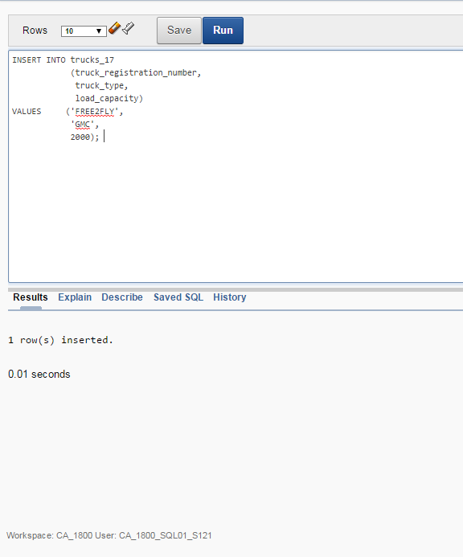

**Inserting another row in trucks table**

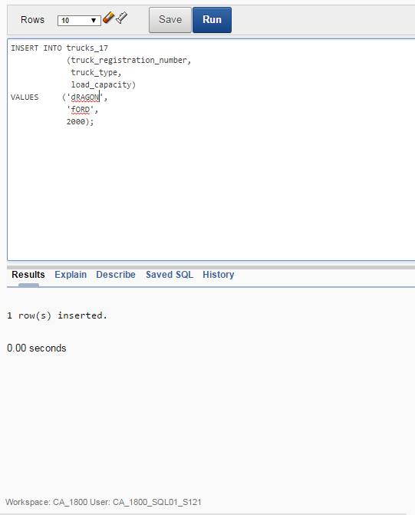

**Insert values in trucks_safety table**

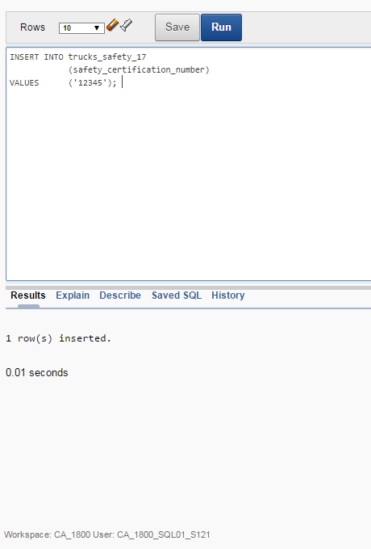

**Checking primary key – can allow only once the value ‘12345’**

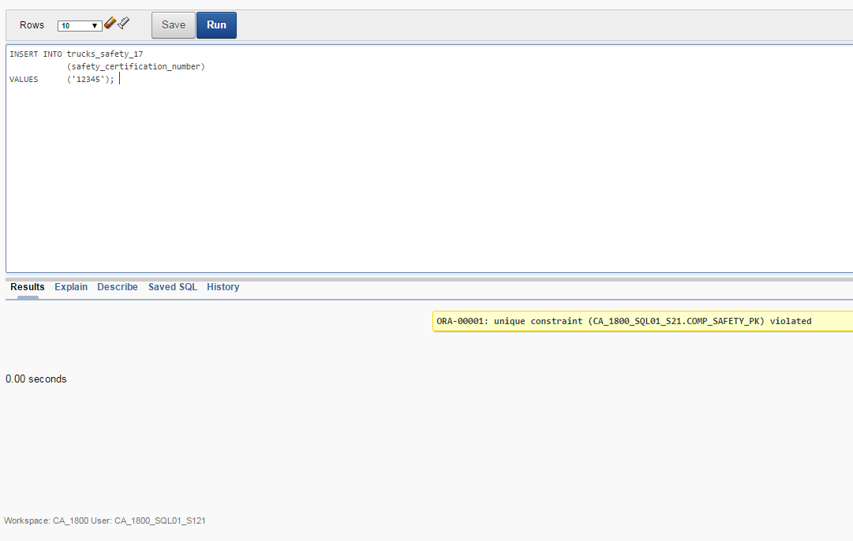

**Inserting values in staffs table**

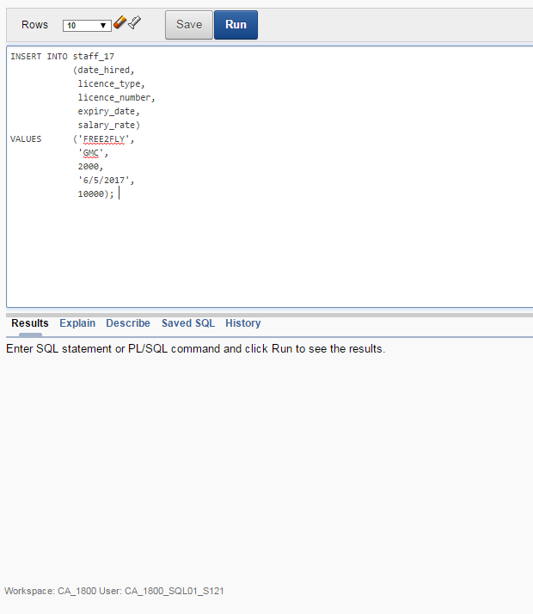

Inserting another row in staffs table

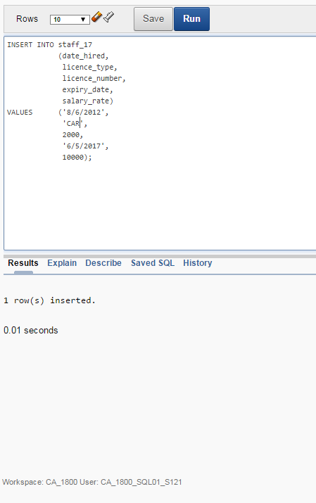

**Invalid identifier – columns are different**

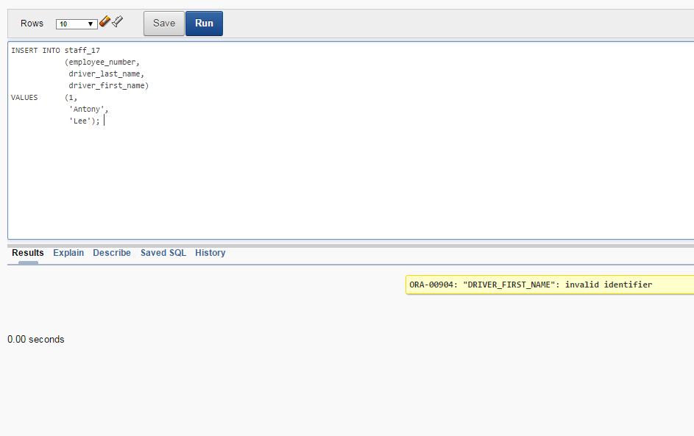

**Inserting values in drivers table**

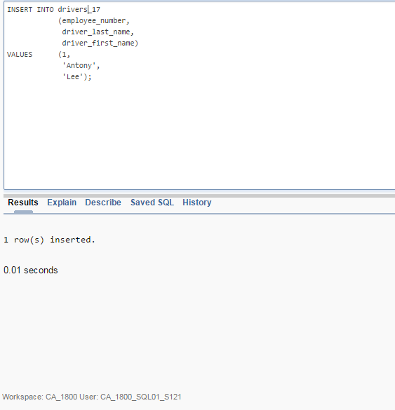

**Checking constraints in drivers table**

