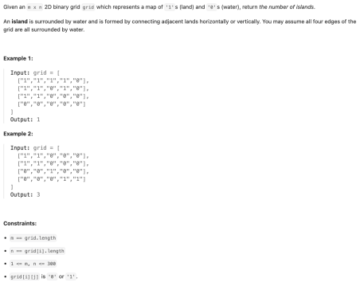

Answer  
  
public int IslandCount(char [] [] grid){

int ans=0;

for(int i=0;i<grid.length;i++)

{

for(int j=0;j<grid[1].length;j++)

{

if(grid[i][j]=='1')

{

ans+=1;

BFS(grid,i,j);

}

}

}

}

public void BFS (char [] [] grid,int i , int j)

{

if(i<0 || i>=A.length|| j<0 || jj>=grid[i].length||A[i][j]==0) return;

grid[i][j]='0';

// for up

BFS(grid,i+1,j);

BFS(grid,i-1,j);doe=wn

BFS(grid,i,j+1); //left

BFS(grid,i,j-1); //right

}

}