CAPTER – 3

Read Data

From Different Data Files

*Learning Topics*

* Read CSV data
* Read excel data
* Read pickle data
* Read JSON data
* Read XML data

**GitHub link:** [*Read_Data_From_Different_Data_Files*](https://github.com/ramasureshvijjana/Data_Science/tree/master/01_data_loading_from_different_files)

In this chapter we will learn how to read different types of data files by using Pandas**.** The first step is reading the data from data files in every data science projects. But data is always available different types of file formats. Here the *pandas* library is help us to read all types of data files.

**1. Read CSV Data:**

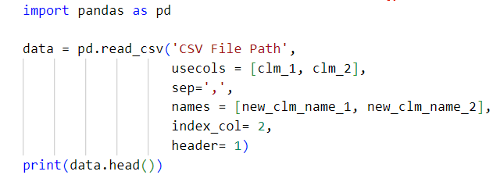

|  |  |
| --- | --- |
| sep | We can mention our field separation based on the input CSV file structure. |
| header | This parameter is used to specify a particular row as header. |
| names | It is used to rename the columns. |
| index_col | To use a particular column as index. |
| usecols | Used to load some specific columns from data. |

**2. Read Pickle Data:**

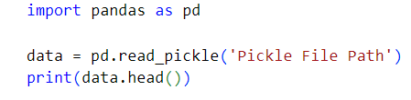

**3. Read Excel Data:**

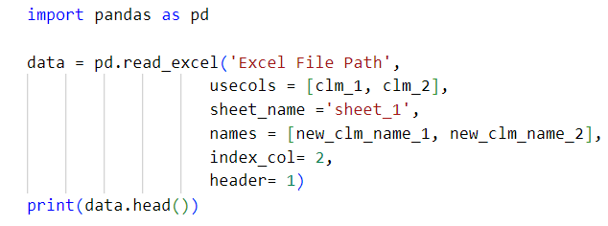

**4. Read JSON Data:**

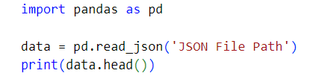

**5. Read XML Data:**

