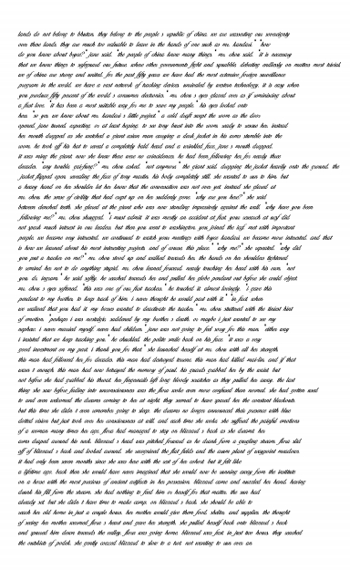

6/7/2021 DATAFILE1.jpg (1190×1941)

file:///C:/Users/jss/Dropbox/My PC (DESKTOP-6GTSF14)/Desktop/DATAFILE1.jpg 1/1