**Request for Proposal**

WEB SCRAPING SOLUTION OVER ePROCUREMENT GOVERNMENT WEBSITE & DATA EXPLORATION VIA WEBSITE AND MOBILE APPS FOR BIDDERS

PROPOSALS DUE BY: [*Date to enter*]

|  |  |  |  |  |  |
| --- | --- | --- | --- | --- | --- |
| **REVISION HISTORY** | | | | | |
| **Version:** | 1 | **Date Started:** | 8 July 2021 | **Initiated By:** | Shashank Jain |
| **Description:** | RFP for Web Scraping Solution over eProcurement Government website and Data Exploration via Website and Mobile apps for bidders | | | | |

**TABLE OF CONTENTS**

1 Organizational Background 4

2 User Profiles and Terminologies 4

3 Project Overview and Goals 4

3.1 Phase 1 4

3.2 Phase 2 5

4 Current Pain Points 5

5 Scope of Work 5

5.1 Web Scrapping 5

5.2 Storing the Data 13

5.3 Website and Mobile Apps Development 13

5.3.1 Home Page 14

5.3.2 Sign In 14

5.3.3 Sign Up 15

5.3.4 Plans 16

5.3.5 Searching Tenders 16

6 Target Deliverable Schedule 18

7 Budget 18

8 Evaluation Metrics 18

9 Submission Requirements 18

10 Contact Information 18

# Organizational Background

Our organization caters the bidders from various industries and domains to have access of Government Tenders Schedule and all specific details related to the tenders. This information eventually helps bidders to take informed decision to bid on tenders.

The Government website which contains all the tenders’ information across India has massive quantity of information available in terms of tenders. Our organization captures the tender’s information in quite manual way by applying required filters and make the information available to the bidders.

# User Profiles and Terminologies

This RFP mentions various users’ profiles and terminologies that are explained as:

1. **Government Tenders Portal:** The master website which contains all the Tenders request from various departments all over India. It holds all the details about the Tenders as Tender description, Cost, Location, related document, date of bidding etc.
2. **Tender:** The tender is an offer to perform some tasks or to supply goods at a fixed price. The bidders are be invited to submit sealed bids for performing those tasks or supply goods.
3. **Bidder:** Also called as Contractors. These are the individual or organizations that put their proposal for the available tenders along with the prices and terms like date and quality of delivery
4. **Website Scraping:** Web scraping is when a bot downloads the content on a website by crawling to the pages of the website
5. **Captcha:** CAPTCHA stands for the Completely Automated Public Turing test to tell Computers and Humans Apart.
6. **Vendor:** An individual or organization proposing our organization with the solution for web scraping and development of Website and Mobile Apps.

# Project Overview and Goals

We are looking for technology specialist company to address our technology needs in terms of web scrapping and showing the relevant content on the to-be developed website and mobile apps.

## Phase 1

1. Data collection from the Government website in automated way on recurring basis using Website Scraping abilities over the Government website

2. Store the collected data in a structured way in database that includes:

1. Textual and numeric data
2. Documents as Excel, Word and PDF Files

3. Building Website and native Mobile apps that features:

1. Searching Tenders with multiple filters like Category, Cost, Location, Dates and more.
2. Viewing entire details of Tenders under various headings
3. Ability to download the documents related to the Tender
4. Subscription Plans for bidders to purchase and access the information per their need
5. Account Management for the Bidders

4. Deployment of Websites and Publishing of Mobile Apps to the respective App Stores

5. Maintenance and Support for the Website and Mobile Apps

## Phase 2

Phase 2 of this project will include further data exploration and analytics and providing bidders with targeted information that helps them further with taking informed decision and understanding key information available in the Tender documents.

To reach the goals, our organization is now accepting bids for **Phase 1** needs in response to this Request for Proposal.

# Current Pain Points

Our organization’s current way of collecting data from Government Tender Portal is quite manual and we have number of executives who follow the steps as:

1. Browse the Government Tender Portal
2. Go to the Search page
3. Enter the required fields in Search page fields to get required results. It also requires entering the Captcha (one time activity per session/ day)
4. Copy the results from Detail’s page and save them in an Excel one by one as per our format with specific fields
5. Go to the details page to download the Tender documents which are available in zip format. It also requires entering the Captcha to go to detailed page (one time activity per session/ day)
6. Store the Tender documents in a folder
7. Upload these excel and documents to the internal Data Storage method

Above process requires number of executives and number of hours on daily basis to capture the details from the Government Tender Portal, in short it is time consuming process and delays the data exploration. And it has possibility of errors while data entry as well.

# Scope of Work

## Web Scrapping

* To scrap the Government Tender Portal and download the content to our Database and Server
* Vendor should provide support in terms of maintain the Web Scrapper in terms of URLs to scrap, page(s) to scrap, filters to be applied on website while scrapping, download all the content from desired pages, and store the content on recommended database and server
* In case, URLs or any specific fields are updated at the Government Tender Portal, the vendor should provide support in updating the web scrapper to scrap details properly without any break in scrapping and download content capability
* Required to have the web scrapping happening on daily basis once to download and store content at our database and server
* Web scrapper should also overcome the Captcha which are asked on the Government Tender Portal and smoothly download the required content

Below are the steps that web crawler should follow and it also mentions which content to be scrapped over the web:

URL: <https://eprocure.gov.in/eprocure/app?page=FrontEndAdvancedSearch&service=page>

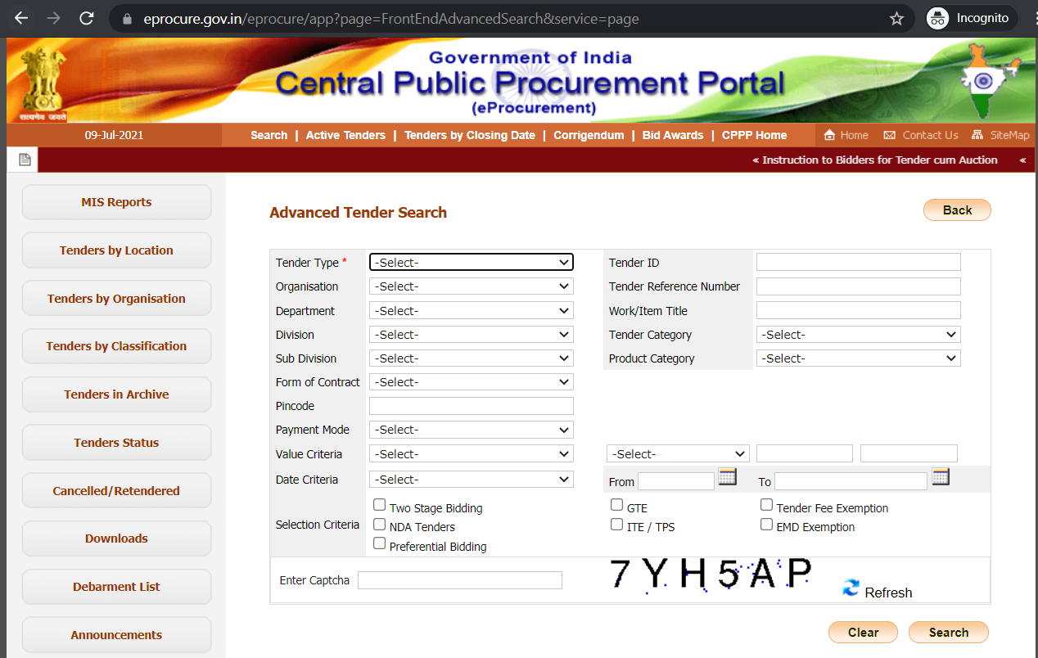

From the above page, the web scrapper should perform the search with following 4 combinations:

1. Tender Type: Open Tender and Value Criteria: EMD

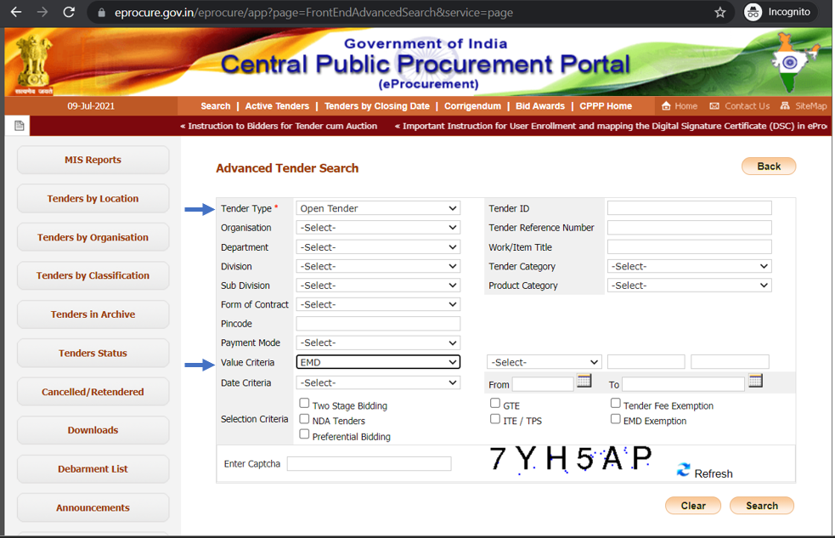

2. Tender Type: Open Tender and Value Criteria: ECV

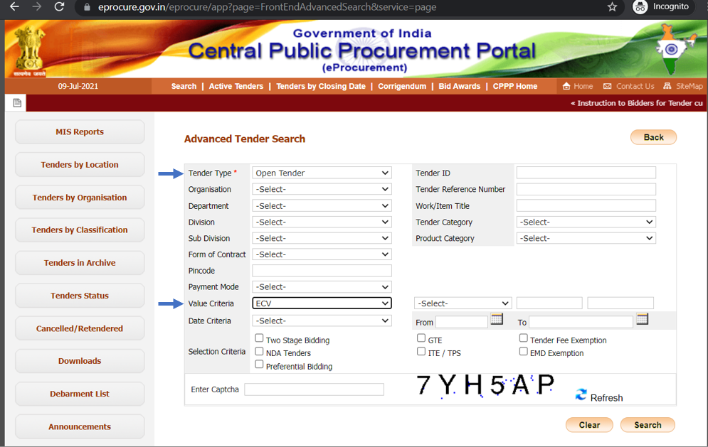

3. Tender Type: Limited Tender and Value Criteria: EMD

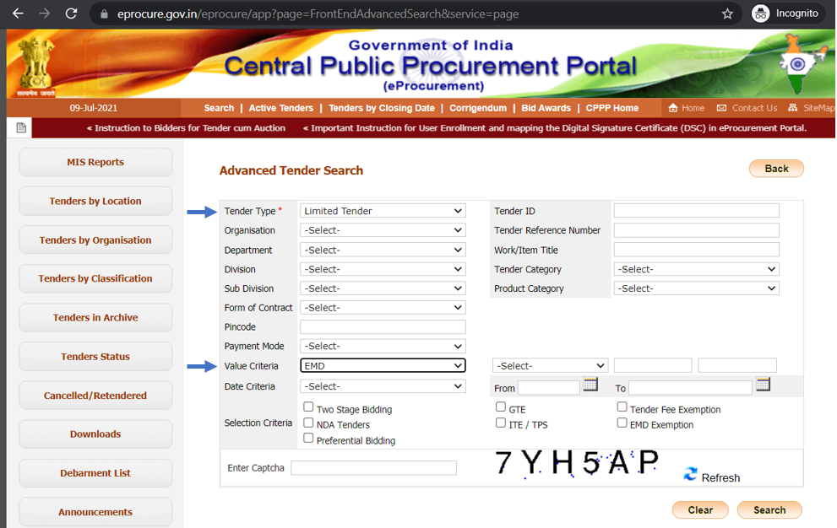

4. Tender Type: Limited Tender and Value Criteria: ECV

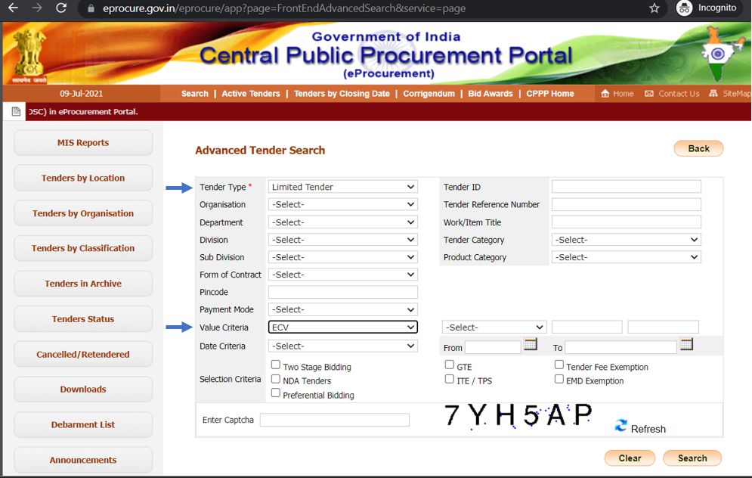

After performing search from above 4 criterions, store the entire content from result page that includes e-Published date, Closing Date, Opening Date, Title and Ref. No/ Tender ID and Organization chain from URL: <https://eprocure.gov.in/eprocure/app>

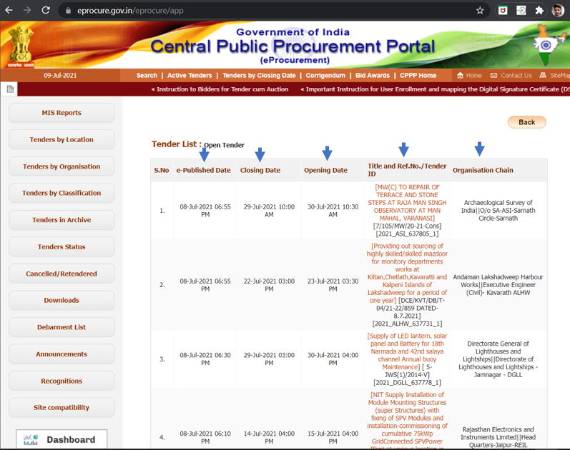

The results that appear on this page should be stored along with the query parameters combinations to understand the results that belong to Open Tender/ ECV, Open Tender/ EMD, Limited Tender/ECV and Limited Tender/EMD.

And then to capture all the details of Tender which can be accessed by the link of Tender title, each detail page of tender can be accessed. Like: <https://eprocure.gov.in/eprocure/app?component=%24DirectLink_0&page=FrontEndAdvancedSearchResult&service=direct&session=T&sp=SnJqIbp7riyodw%2BSUXqxuCg%3D%3D>

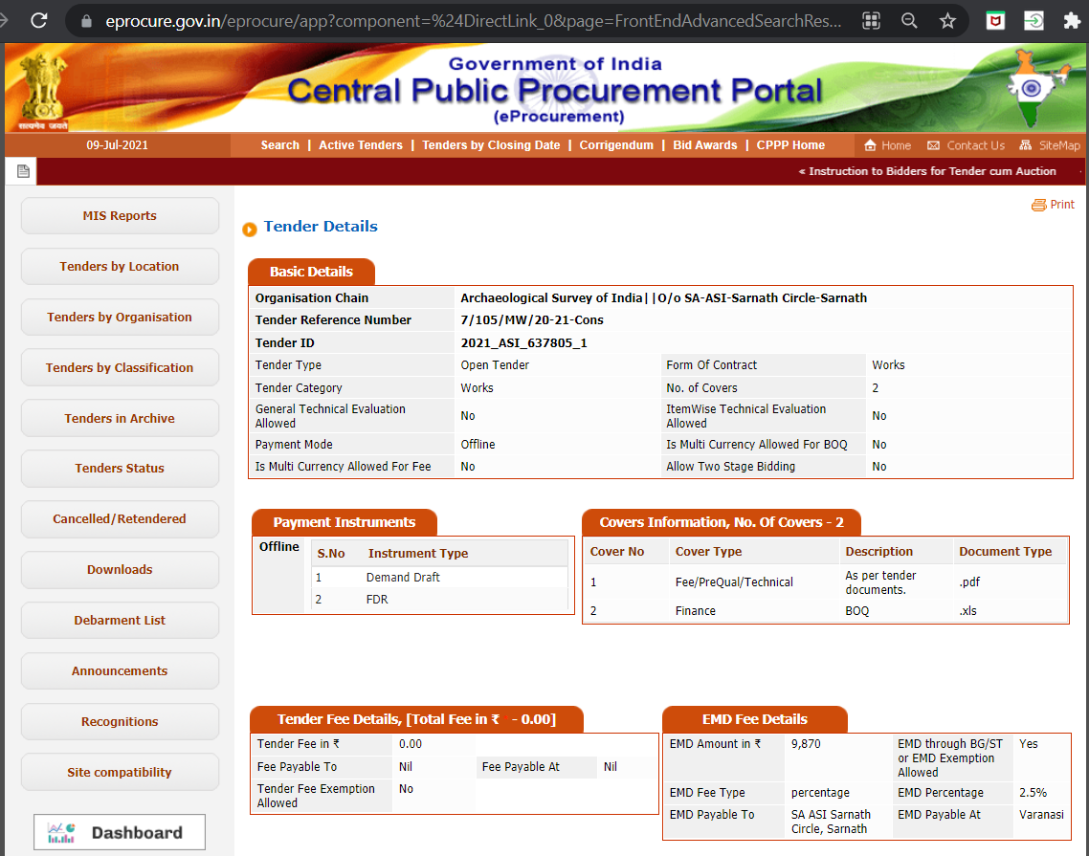

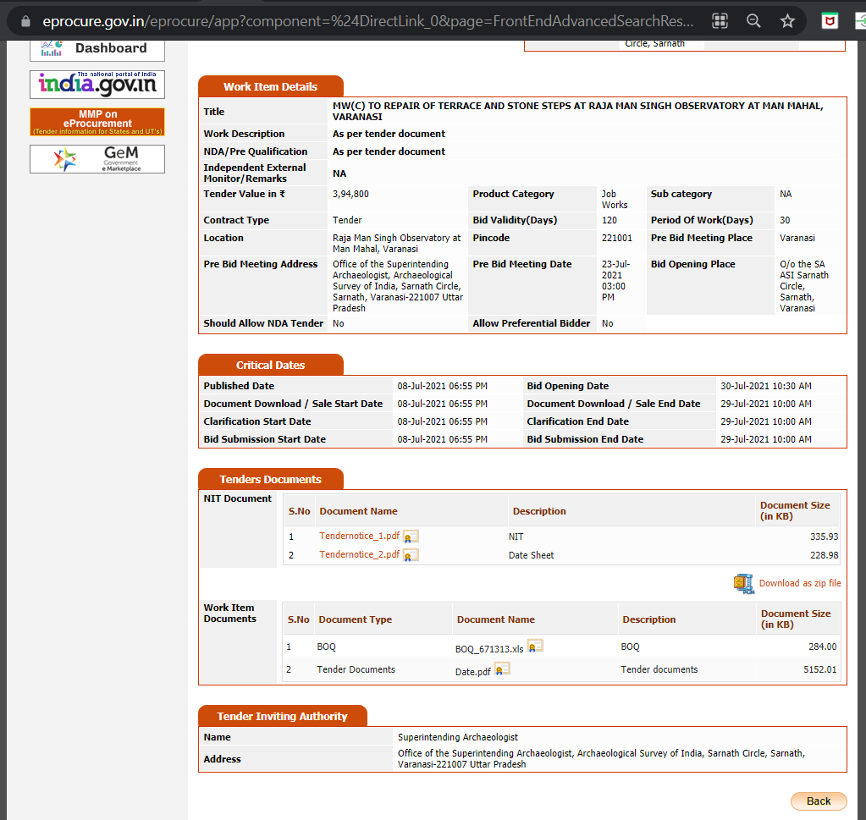

A. All the details on the Tenders details page with various sections should be stored in database:

1. Basic Details

i. Organization Chain

ii. Tender Reference Number

iii. Tender ID

iv. Tender Type

v. Tender Category

vi. General Technical Evaluation Allowed

vii. Payment Mode

viii. Is Multi Currency Allowed for Fee

ix. Form Of Contract

x. No. of Covers

xi. Item Wise Technical Evaluation Allowed

xii. Is Multi Currency Allowed for BOQ

xiii. Allow Two Stage Bidding

2. Payment Instructions

3. Covers Information and No. Of Covers

4. Tender Fee Details

i. Tender Fee in ₹

ii. Fee Payable To

iii. Tender Fee Exemption Allowed

iv. Fee Payable At

5. EMD Fee Details

i. EMD Amount in ₹

ii. EMD Fee Type

iii. EMD Payable To

iv. EMD through BG/ST or EMD Exemption Allowed

v. EMD Percentage

vi. EMD Payable At

6. Work Item Details

i. Title

ii. Work Description

iii. NDA/Pre-Qualification

iv. Independent External Monitor/Remarks

v. Tender Value in ₹

vi. Contract Type

vii. Location

viii. Pre-Bid Meeting Address

ix. Should Allow NDA Tender

x. Product Category

xi. Bid Validity (Days)

xii. Pin code

xiii. Pre-Bid Meeting Date

xiv. Allow Preferential Bidder

xv. Sub category

xvi. Period Of Work (Days)

xvii. Pre-Bid Meeting Place

xviii. Bid Opening Place

7. Critical Dates

i. Published Date

ii. Document Download / Sale Start Date

iii. Clarification Start Date

iv. Bid Submission Start Date

v. Bid Opening Date

vi. Document Download / Sale End Date

vii. Clarification End Date

viii. Bid Submission End Date

8. Tender Documents

i. NIT Documents

ii. Work Item Documents

9. Tender Inviting Authorities

i. Name

ii. Address

B. The web scrapper should also scrap the ‘Download as zip file’ link. This also asks for the Captcha validation for the first time.

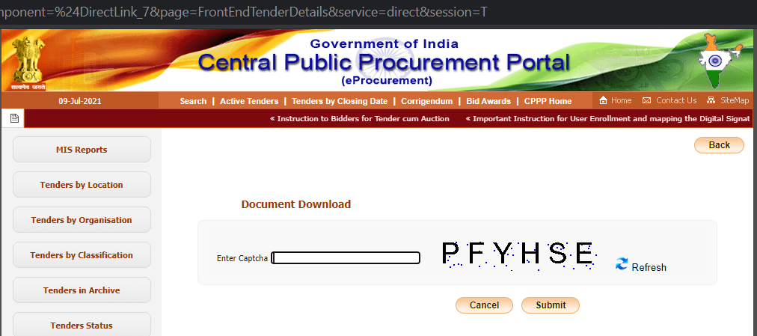

Once the zip file is downloaded, all the content of the zip folder should be stored on server.

Frequency of Web Scrapping: the automation web scrapping should happen once every day in the morning hours.

## Storing the Data

The collected data should be stored in a structured way in database that includes:

i. Textual and numeric data available on the Tender details page

ii. Documents as Excel, Word and PDF Files available on the Tender details page as well as ‘Download as zip file’ mentioned in previous section

## Website and Mobile Apps Development

The website should be accessible on all the modern browsers as Chrome, Edge, Firefox and Safari. The website should be responsive on the mobile devices as well.

Apart from website, it is also required to have the Native mobile apps on iOS and Android platform which can be downloaded from the respective App stores.

The features that are required on the Website and Mobile apps are:

i. Login and Registration, Forgot Password

ii. Website Static Pages: Home Page, Feature’s listing, Pricing Plans, Contact us Page, FAQ

iii. Searching Tenders with multiple filters like Category, Cost, Location, Dates and more.

iv. Viewing entire details of Tenders under various headings

v. Ability to download the documents related to the Tender

vi. Subscription Plans for bidders to purchase and access the information per their need

### Home Page

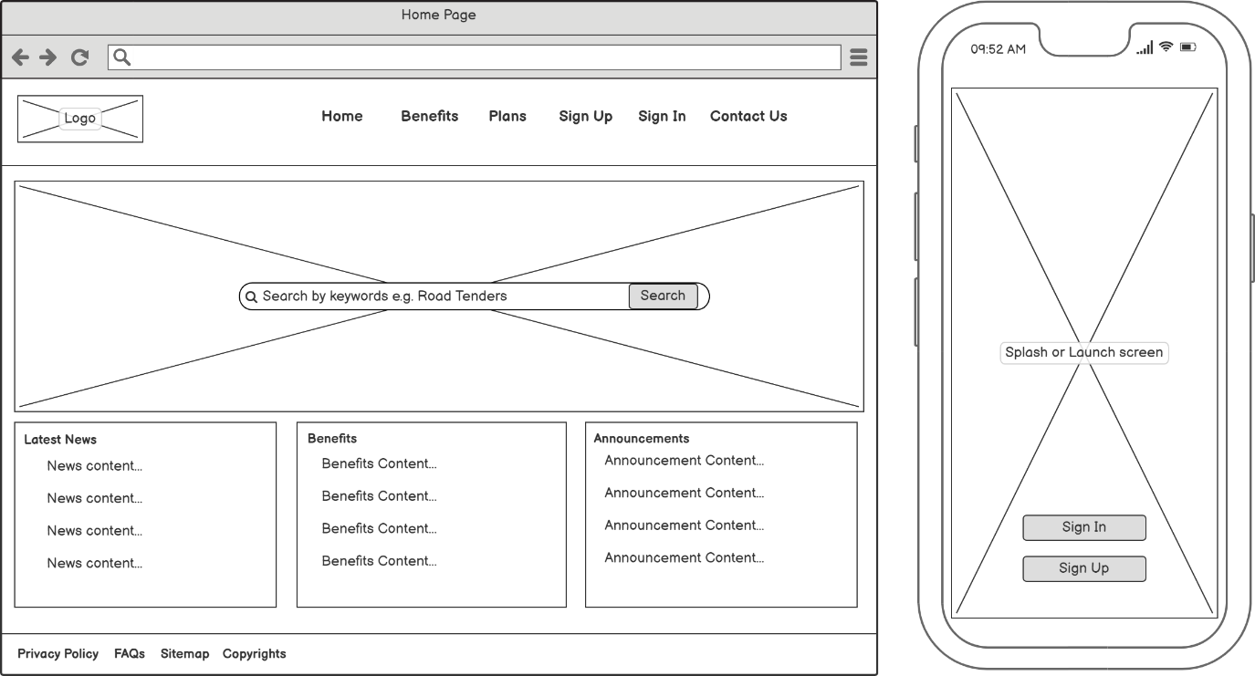

Website: Home page will be landing page on the website and will aid end users to perform search, go to various sections on the website like Benefits, Plans, can do Sign up, can do Sign In, See the latest news, benefits, announcements and static pages like Privacy Policy, FAQs, Sitemap and copyright content.

Mobile App (iOS and Android): The app will be launched with the splash screen and user can Sign in or sign up.

### Sign In

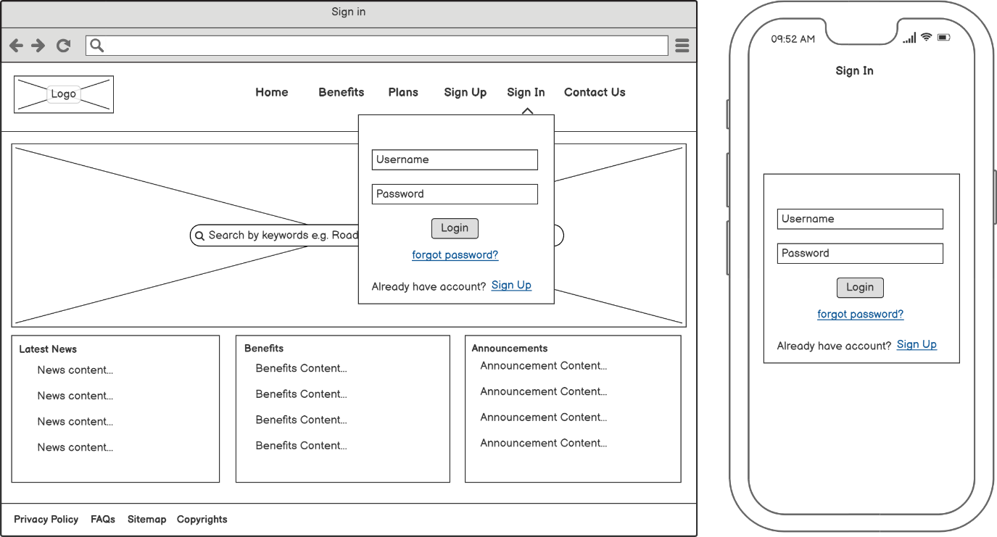

Website: The user should be able to sign in by providing their username and password created while the registration/ sign up process

Mobile App (iOS and Android): The mobile users can log into the mobile app using username and password.

### Sign Up

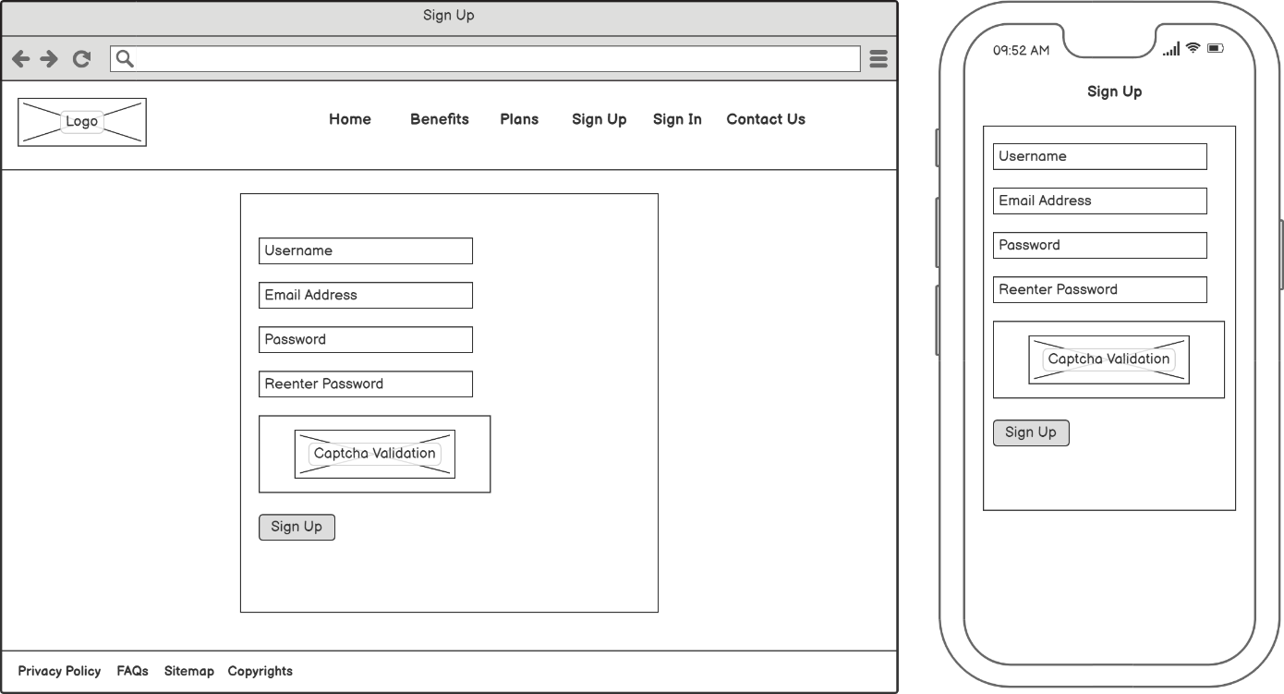

Website: The user should be able to sign up by providing their username, email address and password along with the Captcha validation. Once the email address is entered, the user would need to verify the email address at their email client.

Mobile App (iOS and Android): The Sign-up process will be similar to website and verification of email would be required.

### Plans

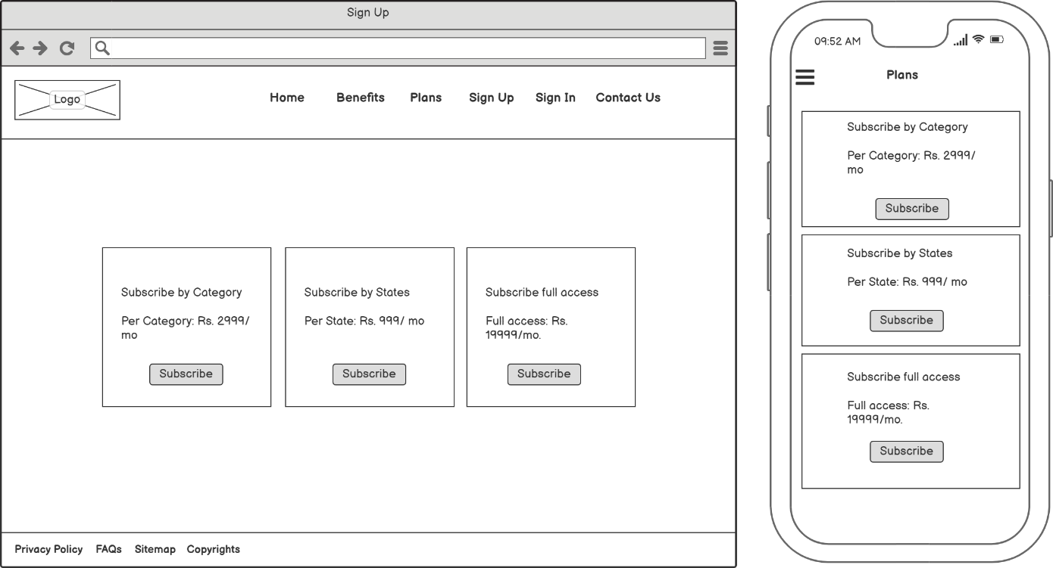

Website: The user should be able view the available plans which they can subscribe for by making the payment for the plan

Mobile App (iOS and Android): Same as website

### Searching Tenders

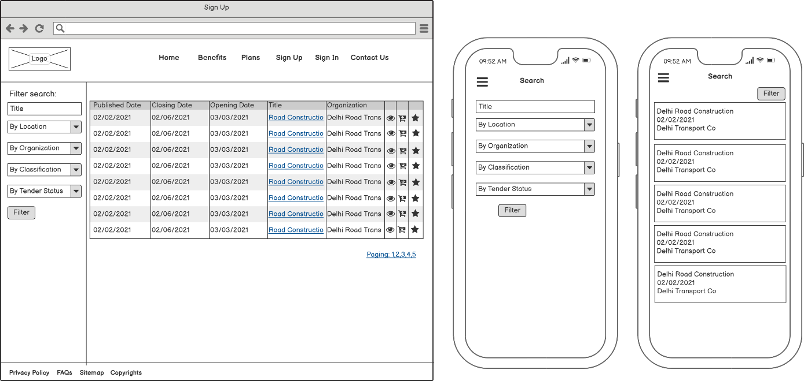

Website: The user should be able to perform the search over the tenders with available filters. User can favorite tenders, view them or apply the bid which will take them to the external website.

Mobile App (iOS and Android): Same as website

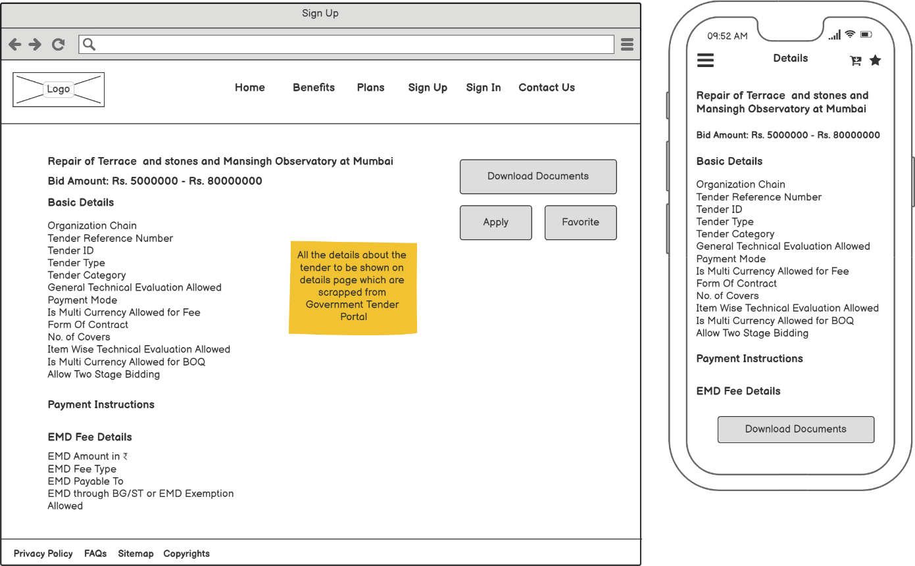

Website: The user should be able to view the entire details of the tender, favorite them, or apply the bid on the external website. User can also download the documents related to the tender by clicking the ‘Download documents’ button.

Mobile App (iOS and Android): Same as website

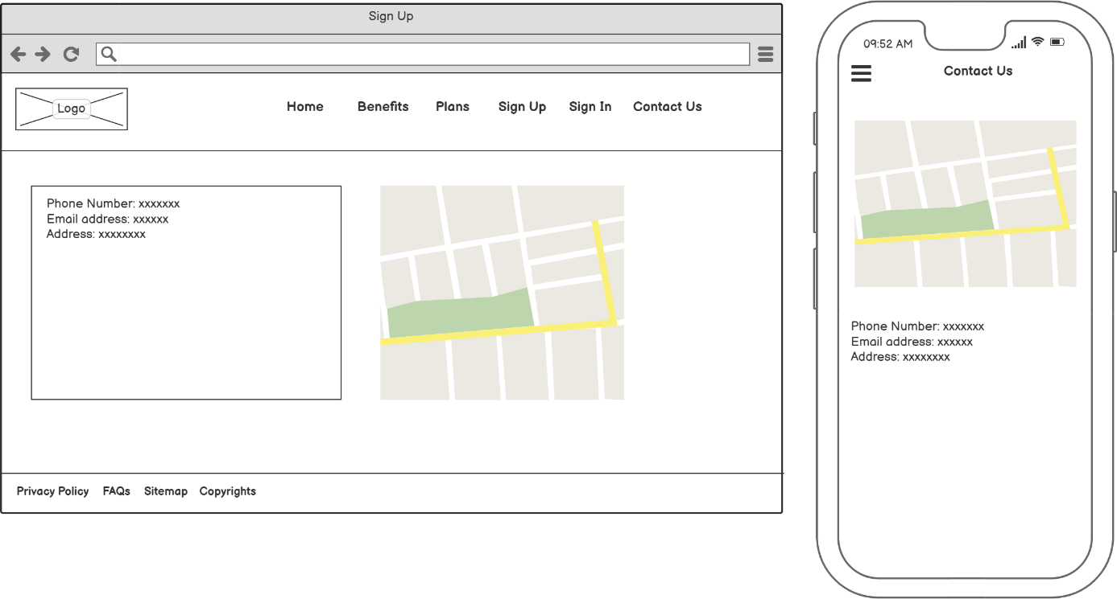

Website: The user should be able to view the contact information.

Mobile App (iOS and Android): Same as website

# Target Deliverable Schedule

We are expecting the Phase 1 features to be completed in 2 months’ time frame by the vendor.

# Budget

We are expecting vendors to share the proposal, cost and efforts in response to this RFP.

# Evaluation Metrics

Our organization will evaluate bidders and proposals based on the following criteria:

● Previous experience/ past performance history.

● Samples and/or case studies from previous projects.

● Projected costs.

● Experience and technical expertise.

● Technology stack for Website Scrapping, Website and mobile apps development.

# Submission Requirements

Bidders must adhere to the following guidelines to be considered:

● Only bidders who meet all 5 metrics in the evaluation section should submit a proposal.

● Proposals must be sent in by [date]. Bidders who are interested in submitting a proposal should inform [name and email] no later than [deadline date].

● Include samples and references with your proposal.

● A proposed schedule must also be included and clearly expressed.

# Contact Information

For questions or concerns connected to this RFP, we can be reached at:

Mayank Mundhra

[email address]

[phone number]