

A Course End Project Report on
Text Analysis System

A9511- Python Programming Laboratory

Submitted by
R. RamyaSree
25881A05B0
V.Spoorthi
25881A05C2

Course Facilitator

P.S.Madhavi
Assistant Professor

Department of Computer Science and Engineering Vardhaman College of Engineering, Hyderabad
Academic Year 2026-27



Autonomous Institute, Affiliated to JNTUH,
Approved by AICTE, Accredited by NAAC with A++ Grade Kacharam, Shamshabad, Hyderabad- 501 218, Telangana, India.

DEPARTMENT OF COMPUTER SCIENCE AND ENGINEERING

This is to certify that the Course End Project titled “Text Analysis System” is carried out by R.RamyaSree and V.Spoorthi with Roll Numbers 25881A05B0 and 25881A05C2 towards A9511- Python Programming Laboratory course in partial fulfilment of the requirements for the award of degree of Bachelor of Technology in Computer Science and Engineering during the Academic year 2026-27.

Signature of the Course Faculty
P.S.Madhavi
Assistant Professor, CSE
Signature of the HOD
Dr. Y.Vijayalata
Professor, Head of the Department & Dean (Student Mentoring)
Department Computer Science and Engineering,
Vardhaman College of Engineering, Hyderabad

Contents
- Introduction 3
- Literature Review 3
- Objectives 4
- Methodology 4
  - Architectural Diagram 5
  - Hardware and Software Requirements 5
  - Working Principle 6
  - Software Implementation..............................................................................................7
- Results and Discussion.............................................................................................................14
- Mapping POs ,PSOs and SDGs............................................................................................. ..18
  - Program Outcomes (POs) Mapping............................................................................18
  - Program Specific Outcomes (PSOs) Mapping............................................................18
  - Sustainable Development Goals (SDGs) Mapping.....................................................18
- Conclusion...............................................................................................................................19
8 Bibliography............................................................................................................................20

Abstract

The Text Analysis System is a menu-driven console application written in Python that examines English text and reports its basic statistics together with its overall sentiment. The user can either type a piece of text directly or supply the name of a plain text file. The program converts the text to lower case, extracts the words with a regular expression, and compares every word with two built-in lexicons: a set of positive words (about 290 entries) and a set of negative words (about 140 entries). It also counts the total words, characters and sentences.
After the analysis, the system prints a formatted report containing the total words, character count, sentence count, the list and count of positive words, the list and count of negative words, and the overall sentiment. The sentiment is Positive when positive words outnumber negative words, Negative when negative words outnumber positive words, and Neutral when both counts are equal. Error handling covers an empty input, a missing file, unreadable files and invalid menu choices. The tool uses only the Python standard library (the re module), so it runs on any computer with Python and demonstrates, in a small and easily understandable program, how lexicon-based text analysis works.
Keywords: Text Analysis, Sentiment Analysis, Lexicon-based Approach, Python, Regular Expressions, Word Count, Console Application.

Introduction

A huge amount of information today is available as unstructured text: reviews, feedback forms, emails, news articles, social media posts and reports. Reading every document manually to judge whether the writer is happy or unhappy is slow and inconsistent. Text analysis, and sentiment analysis in particular, automates this by extracting measurable features from the text, such as the number of words and the number of positive or negative expressions.
One of the simplest and most transparent approaches is the lexicon-based method. A lexicon is a prepared list of words that are known to express a positive or a negative opinion. The text is split into words, each word is looked up in the lexicons, and the counts are compared to decide the overall tone. Unlike machine-learning models, this approach needs no training data and every result can be explained by pointing to the exact words that were matched.
This project implements such a system as a Python console program. The main menu offers three choices: enter text, analyze a text file, or exit. For the chosen text, the function analyze_text() produces the word, character and sentence counts, the matched positive and negative words and the final sentiment, and the function display_results() prints them in a readable report. The program is intentionally simple and keeps all rules in plain sight, which makes it suitable for learning and for a course-end project.
Python is an ideal language for this work because it provides powerful string handling, the re module for pattern matching, sets for very fast word lookup and straightforward file handling. No external library is required, so the program can be run immediately on Windows, Linux or macOS.

Literature Review

Sentiment analysis, also called opinion mining, studies how opinions and emotions are expressed in text. Early surveys described the field as a combination of natural language processing and information retrieval, with applications in product reviews, politics, finance and customer service. Two main families of methods are reported in the literature: machine-learning methods, which learn from labelled examples, and lexicon-based methods, which rely on dictionaries of opinion words.
Lexicon-based work builds on word lists such as the opinion lexicon used for mining customer reviews and later rule-based tools such as VADER, which combines a sentiment lexicon with rules for punctuation, capitalisation and negation. Studies of lexicon-based methods also show that handling negation, intensifiers and context improves accuracy, while a plain word-count approach is quick and easy to interpret but can misjudge sentences in which the meaning depends on the surrounding words.
Toolkits such as NLTK have made tokenisation, stop-word removal and sentiment analysis available to students through Python. However, many ready-made libraries hide their internal rules, and learners often cannot see why a particular sentence was classified in a certain way. A compact program with an open lexicon helps students understand each step: tokenising, matching, counting and deciding.
The present project follows the lexicon-based tradition in its simplest form. It uses large hand-written sets of positive and negative words, a regular expression for tokenisation and a majority rule for the final decision. The source code even documents its main limitation, namely that a negative word is counted even when a word such as "not" precedes it, which makes the behaviour of the system predictable and easy to discuss.

Objectives

To design and develop a menu-driven Python console application that analyses text typed by the user or read from a file.
The first objective is to build a complete, working program using only the Python standard library. The program must show a clear main menu, accept text from the keyboard or from a text file, repeat until the user chooses Exit, and respond to wrong input without crashing.

To implement lexicon-based detection of positive and negative words using regular-expression tokenisation.
Two large sets of words, POSITIVE_WORDS and NEGATIVE_WORDS, are maintained in the program. The text is converted to lower case and split into words with the pattern \b[a-zA-Z]+\b, and every word is checked against both sets so that all occurrences of sentiment words are collected and counted.

To compute text statistics and the overall sentiment, and present them as a formatted report with proper error handling.
The report must show the total words, characters and sentences, the matched positive and negative words with their counts and the overall sentiment (Positive, Negative or Neutral). Errors such as a missing file, an empty text or an invalid menu choice must produce clear messages.

Methodology

Architectural Diagram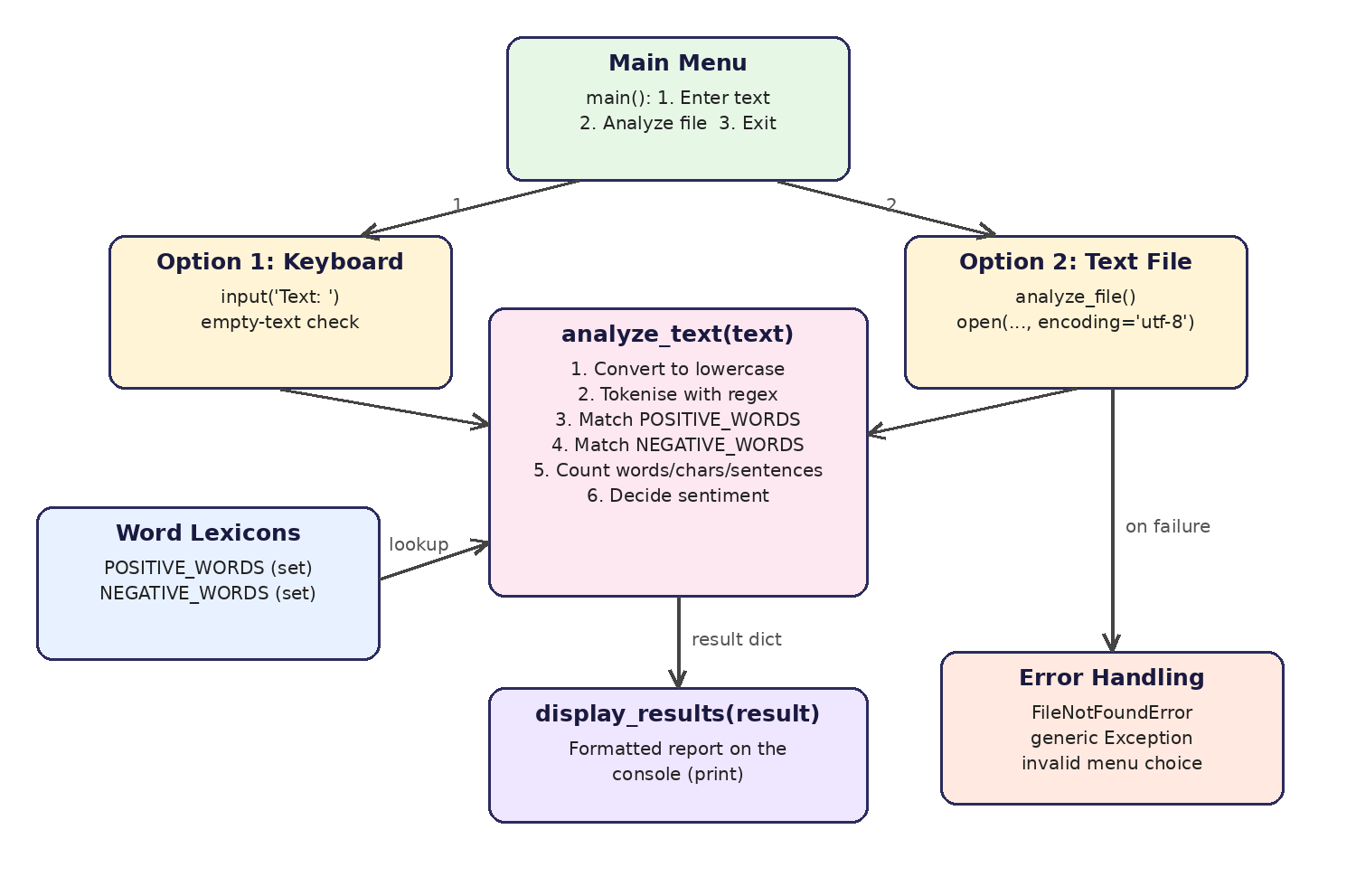

Figure 1: Architectural Diagram
The program is organised into four functions and two lexicons. The Main Menu, implemented in main(), runs inside an infinite loop and shows three options. Option 1 reads one line of text with input() and rejects empty text. Option 2 calls analyze_file(), which asks for a file name, opens the file in UTF-8 mode and reads the complete content.
Both input paths pass the text to analyze_text(), the core of the system. This function converts the text to lower case, extracts the words with re.findall(), builds the list of positive words and the list of negative words by checking membership in the two sets, counts words, characters and sentences, and finally decides the sentiment. The function returns all results in a dictionary.
The dictionary is handed to display_results(), which prints the report on the console. Error handling is built into analyze_file() through the try and except blocks (FileNotFoundError and a general Exception) and into main() through the empty-text check and the invalid-choice message.

Hardware and Software Requirements

Hardware:
    - Intel / AMD processor (Core i3 or equivalent and above)
    - Minimum 2 GB RAM (4 GB recommended)
    - Standard keyboard and display

Software:
    - Python 3.8 or later (only the standard library module re is used)
    - Any code editor or IDE (IDLE, VS Code, PyCharm) or a command prompt / terminal
    - Operating system: Windows, Linux or macOS
    - Optional: a UTF-8 encoded .txt file for the file-analysis option

Working Principle

The working principle of the Text Analysis System is described in the following steps:
- Start and menu: main() displays the menu and reads the choice (1, 2 or 3).
- Get the text: for choice 1 the text is read with input(); for choice 2 the file name is read and the file content is loaded.
- Normalise: the text is converted to lower case so that "Great" and "great" are treated as the same word.
- Tokenise: re.findall(r'\b[a-zA-Z]+\b') extracts the words; digits and punctuation are ignored.
- Match: each word is checked against POSITIVE_WORDS and NEGATIVE_WORDS; every occurrence is stored in a list.
- Count: total words, characters (len(text)) and sentences (split on . ! ?) are calculated.
- Decide: the larger of the two counts decides the sentiment, as shown in Table 2.
- Display: display_results() prints the report and the menu appears again until Exit is chosen.
The two lexicons are grouped by theme inside the source code. Table 1 lists the groups with sample words taken from the program.
Table 1: Organisation of the word lexicons
Lexicon | Group | Example words
Positive | General positive words | good, great, excellent, amazing, wonderful
Positive | Positive emotions | happiness, delight, grateful, proud, peace
Positive | Personality qualities | kind, honest, polite, brave, wise
Positive | Success and achievement | success, victory, progress, growth, champion
Positive | Descriptions / actions / concepts | beautiful, elegant, help, solve, teamwork, innovation
Negative | General and personality | bad, poor, terrible, problem, rude, lazy, selfish
Negative | Insults and descriptions | stupid, useless, awful, ugly, horrible
Negative | Emotions | angry, sad, upset, afraid, lonely, miserable
Negative | Actions, loss and others | cheat, lie, hurt, lose, mistake, disaster, toxic, risk

Table 2: Sentiment decision rule used in analyze_text()
Condition | Overall sentiment
Positive word count > Negative word count | Positive
Negative word count > Positive word count | Negative
Both counts are equal (including 0 and 0) | Neutral

For the sample inputs used during testing, the program produced the following results (all values were taken from actual runs of the program):
Table 3: Sample inputs and results produced by the system
Sample text | Words | Chars | Sent. | Pos. | Neg. | Sentiment
"The new project is excellent and the team was very helpful. The final result is amazing!" | 16 | 88 | 2 | 3 | 0 | Positive
"The service was terrible and the staff was rude. I am upset and disappointed with this awful experience." | 18 | 104 | 2 | 0 | 5 | Negative
"The meeting is at ten. The report is good but the delay is a problem." | 15 | 69 | 2 | 1 | 1 | Neutral
"He is not stupid." | 4 | 17 | 1 | 0 | 1 | Negative
sample.txt (college fest paragraph) | 41 | 246 | 4 | 7 | 2 | Positive

Software Implementation
The complete program is contained in a single file. The two sets POSITIVE_WORDS and NEGATIVE_WORDS hold the lexicons. The function analyze_text(text) performs the analysis and returns a dictionary; display_results(result) prints it; analyze_file() reads a text file and calls the analysis; main() shows the menu and controls the program flow. The listing below shows the complete source code.

1 | import re
2
3 | # ============================================================
4 | # TEXT ANALYSIS SYSTEM
5 | # ============================================================
6
7 | # ============================================================
8 | # POSITIVE WORDS
9 | # ============================================================
10
11 | POSITIVE_WORDS = {
12
13 | # --------------------------------------------------------
14 | # General positive words
15 | # --------------------------------------------------------
16
17 | "good", "great", "excellent", "amazing", "awesome",
18 | "wonderful", "fantastic", "best", "beautiful", "nice",
19 | "happy", "joy", "joyful", "love", "loved", "lovely",
20 | "kind", "helpful", "honest", "brilliant", "smart",
21 | "intelligent", "success", "successful", "win", "winner",
22 | "perfect", "positive", "strong", "friendly", "peaceful",
23 | "useful", "interesting", "exciting", "fun", "pleasant",
24 | "enjoy", "enjoyed", "enjoyable", "impressive", "valuable",
25 | "safe", "healthy", "respectful", "generous", "creative",
26 | "beautifully", "super", "outstanding", "remarkable",
27 | "superb", "magnificent", "delightful", "cheerful",
28 | "achievement", "achieve", "victory", "hope", "hopeful",
29 | "trust", "trusted", "trustworthy", "care", "caring",
30 | "support", "supportive", "fair", "polite", "humble",
31 | "patient", "calm", "confident", "courageous", "brave",
32 | "loyal", "responsible", "reliable", "generous",
33 | "talented", "skillful", "wise", "clever", "genius",
34 | "motivated", "motivating", "inspiring", "inspiration",
35
36 | # --------------------------------------------------------
37 | # Positive emotions
38 | # --------------------------------------------------------
39
40 | "happiness", "happily", "happier", "happiest",
41 | "joyful", "joyous", "joyfully", "delight",
42 | "delighted", "delightful", "pleasure", "pleased",
43 | "excited", "excitement", "exciting",
44 | "cheerful", "cheer", "cheering",
45 | "content", "contentment",
46 | "satisfied", "satisfaction",
47 | "grateful", "gratitude",
48 | "thankful", "thankfulness",
49 | "hopeful", "hopefulness",
50 | "optimistic", "optimism",
51 | "confident", "confidence",
52 | "proud", "pride",
53 | "peace", "peaceful", "peacefully",
54 | "relaxed", "relaxing", "relaxation",
55 | "comfortable", "comforting", "comfort",
56 | "loving", "affection", "affectionate",
57 | "admire", "admired", "admiration",
58
59 | # --------------------------------------------------------
60 | # Positive personality qualities
61 | # --------------------------------------------------------
62
63 | "kind", "kindness", "kindly",
64 | "honest", "honesty", "honestly",
65 | "friendly", "friendliness",
66 | "helpful", "helpfulness",
67 | "generous", "generosity",
68 | "polite", "politeness",
69 | "respectful", "respect",
70 | "responsible", "responsibility",
71 | "reliable", "reliability",
72 | "loyal", "loyalty",
73 | "patient", "patience",
74 | "humble", "humility",
75 | "brave", "bravery",
76 | "courageous", "courage",
77 | "wise", "wisdom",
78 | "clever", "cleverness",
79 | "intelligent", "intelligence",
80 | "smart", "smartness",
81 | "creative", "creativity",
82 | "talented", "talent",
83 | "skillful", "skill",
84 | "determined", "determination",
85 | "disciplined", "discipline",
86 | "hardworking", "hardwork",
87 | "dedicated", "dedication",
88 | "compassionate", "compassion",
89 | "caring", "care",
90 | "thoughtful", "thoughtfulness",
91 | "considerate", "consideration",
92 | "mature", "maturity",
93 | "professional", "professionalism",
94 | "fair", "fairness",
95 | "supportive", "support",
96 | "understanding", "understand",
97
98 | # --------------------------------------------------------
99 | # Success and achievement
100 | # --------------------------------------------------------
101
102 | "success", "successful", "succeed", "succeeded",
103 | "achieve", "achieved", "achievement", "achievements",
104 | "victory", "victorious", "win", "wins", "winning",
105 | "winner", "winners", "champion", "champions",
106 | "triumph", "triumphant",
107 | "progress", "improve", "improved", "improvement",
108 | "growth", "develop", "developed", "development",
109 | "advance", "advanced", "advancement",
110 | "excellent", "excellence",
111 | "outstanding", "superior", "brilliant",
112 | "masterpiece", "masterful",
113
114 | # --------------------------------------------------------
115 | # Positive descriptions
116 | # --------------------------------------------------------
117
118 | "beautiful", "beauty", "beautifully",
119 | "attractive", "attractiveness",
120 | "gorgeous", "pretty", "handsome",
121 | "lovely", "charming", "charm",
122 | "elegant", "elegance",
123 | "wonderful", "fantastic", "amazing",
124 | "awesome", "incredible", "excellent",
125 | "perfect", "perfectly",
126 | "magnificent", "superb", "spectacular",
127 | "fabulous", "marvelous", "brilliant",
128 | "remarkable", "extraordinary",
129 | "impressive", "impressive",
130 | "pleasant", "pleasing",
131 | "enjoyable", "interesting",
132 | "exciting", "excitingly",
133 | "fun", "entertaining", "entertainment",
134
135 | # --------------------------------------------------------
136 | # Positive actions
137 | # --------------------------------------------------------
138
139 | "help", "helped", "helping",
140 | "support", "supported", "supporting",
141 | "protect", "protected", "protecting",
142 | "save", "saved", "saving",
143 | "improve", "improved", "improving",
144 | "solve", "solved", "solving",
145 | "create", "created", "creating",
146 | "build", "built", "building",
147 | "achieve", "achieved", "achieving",
148 | "learn", "learned", "learning",
149 | "teach", "taught", "teaching",
150 | "share", "shared", "sharing",
151 | "respect", "respected", "respecting",
152 | "trust", "trusted", "trusting",
153 | "care", "cared", "caring",
154 | "love", "loved", "loving",
155 | "enjoy", "enjoyed", "enjoying",
156
157 | # --------------------------------------------------------
158 | # Positive concepts
159 | # --------------------------------------------------------
160
161 | "benefit", "beneficial", "advantage", "advantageous",
162 | "opportunity", "opportunities",
163 | "solution", "solutions",
164 | "progress", "growth",
165 | "freedom", "peace", "harmony",
166 | "unity", "cooperation", "teamwork",
167 | "friendship", "community",
168 | "health", "healthy",
169 | "safety", "safe",
170 | "quality", "valuable",
171 | "value", "benefit",
172 | "success", "hope",
173 | "future", "potential",
174 | "possibility", "possibilities",
175 | "innovation", "innovative",
176 | "technology", "efficient", "efficiency",
177 | "effective", "effectiveness",
178 | "productive", "productivity",
179 | "convenient", "convenience"
180 | }
181
182
183 | # -------------------- NEGATIVE WORDS -------------------------
184
185 | # IMPORTANT:
186 | # Every negative word is counted independently.
187 | # Negation such as "not" does NOT remove the negative word.
188
189 | NEGATIVE_WORDS = {
190 | # General negative words
191 | "bad", "poor", "terrible", "worst", "worse",
192 | "negative", "problem", "problems", "danger",
193 | "dangerous", "harmful", "dirty", "pollution",
194 | "failure", "fail", "failing", "difficult", "waste",
195
196 | # Negative personality / qualities
197 | "arrogant", "rude", "selfish", "dishonest", "lazy",
198 | "cruel", "greedy", "jealous", "careless", "ignorant",
199 | "stubborn", "unfriendly", "unfair", "impolite",
200 | "inconsiderate", "irresponsible", "incompetent",
201 | "disrespectful", "unreliable", "cowardly",
202
203 | # Insults / negative descriptions
204 | "stupid", "foolish", "idiot", "useless", "pathetic",
205 | "annoying", "disgusting", "ugly", "horrible", "awful",
206 | "nasty", "evil", "worthless", "ridiculous", "silly",
207 | "dumb", "fool", "loser", "crazy", "weird",
208
209 | # Negative emotions
210 | "angry", "sad", "hate", "hated", "hateful",
211 | "frustrated", "frustration", "upset", "disappointed",
212 | "disappointment", "jealous", "fear", "afraid",
213 | "worried", "worry", "stress", "stressed",
214 | "lonely", "unhappy", "miserable",
215
216 | # Negative actions
217 | "cheat", "cheating", "cheated",
218 | "lie", "lying", "lied",
219 | "insult", "insulted", "insulting",
220 | "abuse", "abused", "abusive",
221 | "betray", "betrayed", "betrayal",
222 | "harm", "harmed", "hurt",
223 | "steal", "stole", "stealing",
224 | "attack", "attacked", "threat", "threaten",
225
226 | # Failure / loss
227 | "loss", "lose", "losing", "lost",
228 | "mistake", "mistakes", "wrong",
229 | "disappointing", "disappoint",
230 | "disaster", "damage", "damaged",
231 | "defeat", "defeated", "reject", "rejected",
232 | "rejection",
233
234 | # Other negative words
235 | "toxic", "risk", "risky", "unpleasant",
236 | "horrendous", "terrible", "disastrous",
237 | "hateful", "hostile", "violence", "violent",
238 | "conflict", "failure", "shortage", "weak",
239 | "weakness", "suffer", "suffering", "pain",
240 | "painful", "negative", "complaint", "complain",
241 | "complaining"
242 | }
243
244
245 | # ============================================================
246 | # TEXT ANALYSIS FUNCTION
247 | # ============================================================
248
249 | def analyze_text(text):
250
251 | # Convert text to lowercase
252 | lower_text = text.lower()
253
254 | # Extract only words
255 | words = re.findall(r'\b[a-zA-Z]+\b', lower_text)
256
257 | # --------------------------------------------------------
258 | # Count positive words
259 | # --------------------------------------------------------
260
261 | positive_words = [
262 | word for word in words
263 | if word in POSITIVE_WORDS
264 | ]
265
266 | # --------------------------------------------------------
267 | # Count negative words
268 | #
269 | # IMPORTANT:
270 | # Negative words are counted regardless of sentence meaning.
271 | #
272 | # Example:
273 | # "He is not stupid."
274 | #
275 | # "stupid" WILL still be counted.
276 | # --------------------------------------------------------
277
278 | negative_words = [
279 | word for word in words
280 | if word in NEGATIVE_WORDS
281 | ]
282
283 | # Count total words
284 | total_words = len(words)
285
286 | # Count characters
287 | character_count = len(text)
288
289 | # Count sentences
290 | sentences = re.split(r'[.!?]+', text)
291 | sentence_count = len([
292 | sentence for sentence in sentences
293 | if sentence.strip()
294 | ])
295
296 | # --------------------------------------------------------
297 | # Determine overall sentiment
298 | # --------------------------------------------------------
299
300 | if len(positive_words) > len(negative_words):
301 | sentiment = "Positive"
302
303 | elif len(negative_words) > len(positive_words):
304 | sentiment = "Negative"
305
306 | else:
307 | sentiment = "Neutral"
308
309 | # Return all results
310 | return {
311 | "total_words": total_words,
312 | "character_count": character_count,
313 | "sentence_count": sentence_count,
314 | "positive_words": positive_words,
315 | "negative_words": negative_words,
316 | "positive_count": len(positive_words),
317 | "negative_count": len(negative_words),
318 | "sentiment": sentiment
319 | }
320
321
322 | # ============================================================
323 | # DISPLAY RESULTS
324 | # ============================================================
325
326 | def display_results(result):
327
328 | print("\n")
329 | print("=" * 55)
330 | print(" TEXT ANALYSIS RESULTS")
331 | print("=" * 55)
332
333 | print("\nTotal Words :", result["total_words"])
334 | print("Character Count :", result["character_count"])
335 | print("Sentence Count :", result["sentence_count"])
336
337 | print("\n---------------- POSITIVE WORDS ----------------")
338
339 | if result["positive_words"]:
340 | print(", ".join(result["positive_words"]))
341 | else:
342 | print("No positive words detected.")
343
344 | print("\nPositive Word Count:", result["positive_count"])
345
346 | print("\n---------------- NEGATIVE WORDS ----------------")
347
348 | if result["negative_words"]:
349 | print(", ".join(result["negative_words"]))
350 | else:
351 | print("No negative words detected.")
352
353 | print("\nNegative Word Count:", result["negative_count"])
354
355 | print("\n---------------- SENTIMENT ----------------")
356
357 | print("Overall Sentiment :", result["sentiment"])
358
359 | print("\n" + "=" * 55)
360
361
362 | # ============================================================
363 | # FILE ANALYSIS
364 | # ============================================================
365
366 | def analyze_file():
367
368 | filename = input("\nEnter the file name: ")
369
370 | try:
371
372 | with open(filename, "r", encoding="utf-8") as file:
373 | text = file.read()
374
375 | print("\nFile successfully loaded.")
376
377 | result = analyze_text(text)
378
379 | display_results(result)
380
381 | except FileNotFoundError:
382
383 | print("\nError: File not found.")
384
385 | except Exception as e:
386
387 | print("\nError:", e)
388
389
390 | # ============================================================
391 | # MAIN PROGRAM
392 | # ============================================================
393
394 | def main():
395
396 | while True:
397
398 | print("\n")
399 | print("=" * 55)
400 | print(" TEXT ANALYSIS SYSTEM")
401 | print("=" * 55)
402
403 | print("\n1. Enter text")
404 | print("2. Analyze text file")
405 | print("3. Exit")
406
407 | choice = input("\nEnter your choice: ")
408
409 | # ----------------------------------------------------
410 | # OPTION 1: ENTER TEXT
411 | # ----------------------------------------------------
412
413 | if choice == "1":
414
415 | print("\nEnter your text below.")
416 | print("Press ENTER when you have finished.\n")
417
418 | text = input("Text: ")
419
420 | if text.strip() == "":
421 | print("\nPlease enter some text.")
422 | continue
423
424 | result = analyze_text(text)
425
426 | display_results(result)
427
428 | # ----------------------------------------------------
429 | # OPTION 2: ANALYZE FILE
430 | # ----------------------------------------------------
431
432 | elif choice == "2":
433
434 | analyze_file()
435
436 | # ----------------------------------------------------
437 | # OPTION 3: EXIT
438 | # ----------------------------------------------------
439
440 | elif choice == "3":
441
442 | print("\nThank you for using Text Analysis System!")
443 | break
444
445 | else:
446
447 | print("\nInvalid choice. Please enter 1, 2, or 3.")
448
449
450 | # ============================================================
451 | # START PROGRAM
452 | # ============================================================
453
454 | if __name__ == "__main__":
455 | main()

The program is started with the command python text_analysis.py (or the name under which the file is saved). For file analysis, the text file should be kept in the same folder or the full path should be typed.

Results and Discussion

The program was executed on a computer with Python and tested with typed text as well as with a text file. The screenshots below were taken from the console. Figure 2 shows Option 1 with a positive sentence. The system finds three positive words (excellent, helpful, amazing) and no negative word, so the overall sentiment is Positive.
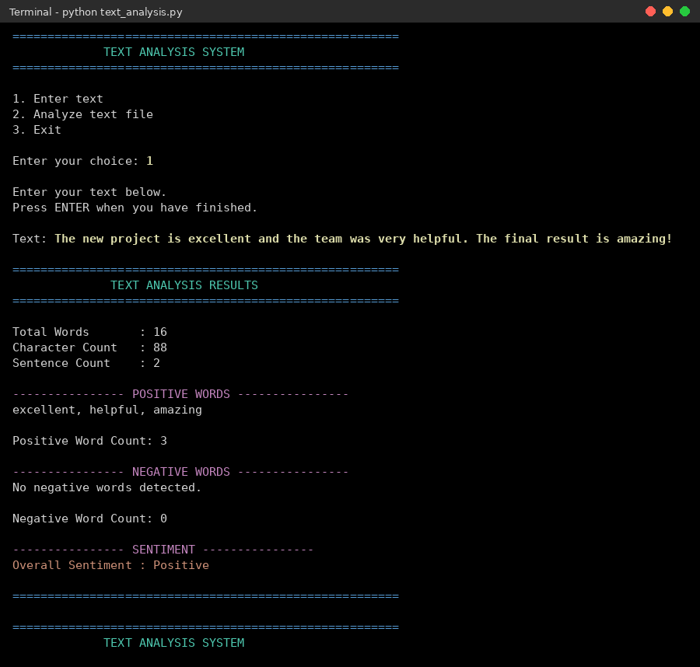
Figure 2: Analysis of a positive text (Overall Sentiment: Positive)
In Figure 3 a negative review is analysed. Five negative words (terrible, rude, upset, disappointed, awful) are detected and no positive word, therefore the sentiment is Negative.
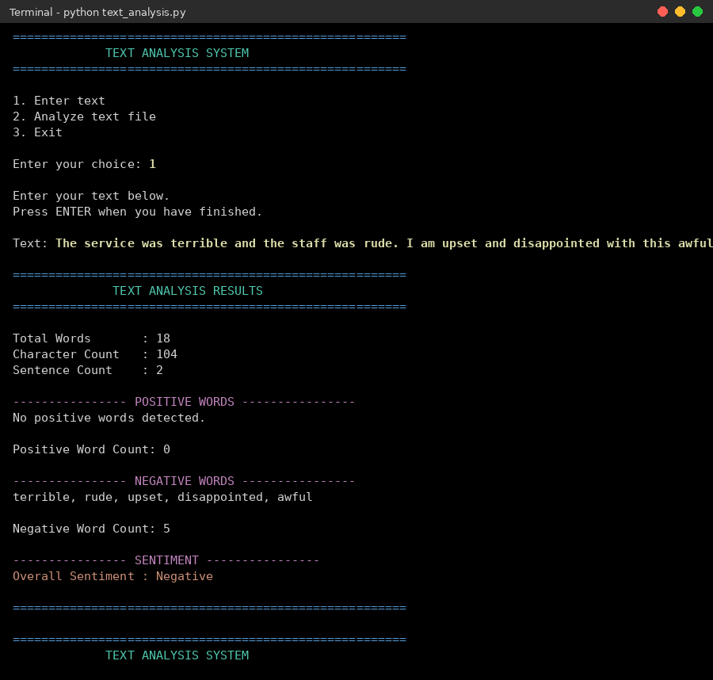
Figure 3: Analysis of a negative text (Overall Sentiment: Negative)
Figure 4 shows Option 2, in which the file sample.txt is loaded. The paragraph contains seven positive words and two negative words (problem, difficult), so the sentiment is Positive.
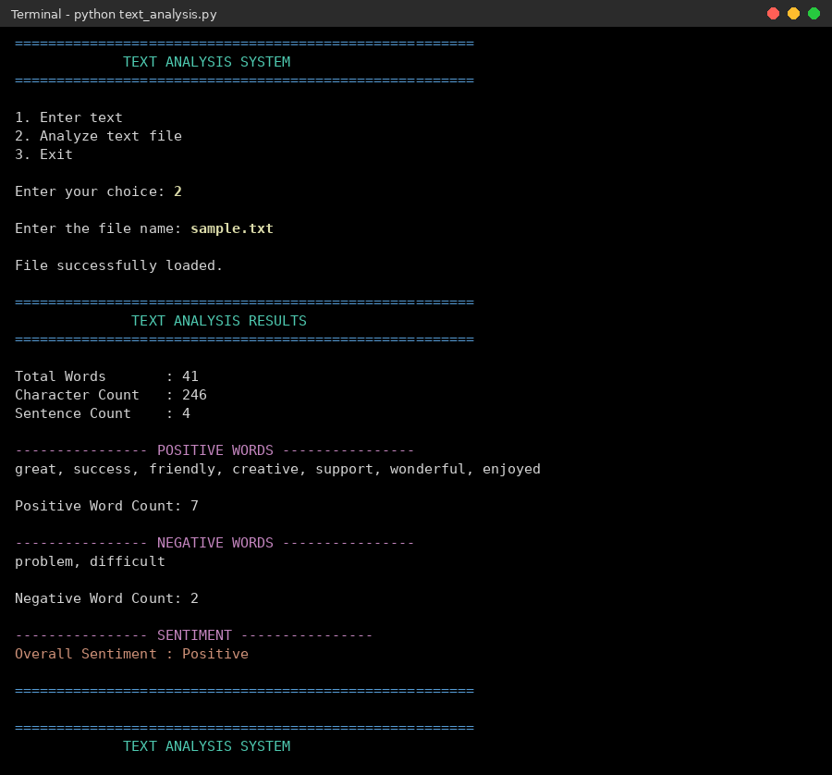
Figure 4: Analysis of a text file (Overall Sentiment: Positive)
Figure 5 demonstrates the error handling: a missing file, an empty text and an invalid menu choice each produce a clear message and the program continues to run.
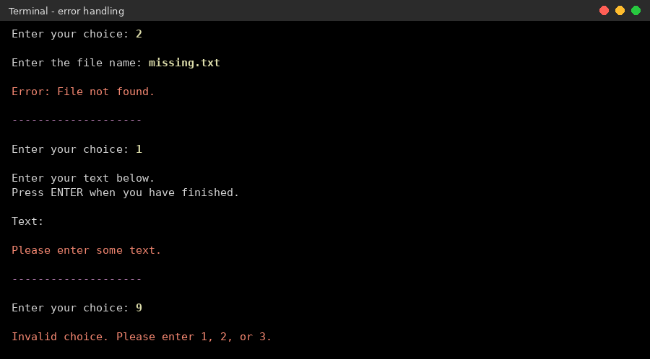
Figure 5: Error handling for a missing file, empty text and invalid choice
The following test cases were executed to verify the behaviour of the system:
Table 4: Test cases and observed results
No. | Test case | Observed output | Result
1 | Option 1: positive sentence | 3 positive, 0 negative; Positive | Pass
2 | Option 1: negative sentence | 0 positive, 5 negative; Negative | Pass
3 | Equal positive and negative count | 1 and 1; Neutral | Pass
4 | Option 2: sample.txt | 7 positive, 2 negative; Positive | Pass
5 | Option 2: file that does not exist | "Error: File not found." | Pass
6 | Option 1: only spaces | "Please enter some text." | Pass
7 | Menu choice 9 | "Invalid choice. Please enter 1, 2, or 3." | Pass
8 | Option 3 | Thank-you message; program ends | Pass
9 | "He is not stupid." | "stupid" counted; Negative (negation is not handled by design) | Limitation
10 | "don't like it" | 4 words (don, t, like, it); Neutral | Limitation

Discussion: the results show that the lexicon-based approach is fast, simple and fully explainable, because the report lists exactly which words influenced the decision. The statistics are always correct for the given definition of a word and a sentence. The limitations are equally clear. Negation is not handled, so "He is not stupid." is classified as Negative, which is the behaviour that the comments in the code describe. A word followed by an apostrophe, such as "don't", is split into two tokens. Sentences are counted by splitting on full stops, question marks and exclamation marks, so abbreviations or decimal numbers can increase the count. Finally, the text typed in Option 1 is limited to one line, and sarcasm or context cannot be understood by a word list.

Mapping Pos, PSOs and SDGs

Program Outcomes (POs) Mapping
Table 5: Mapping of Program Outcomes (POs) to Project Relevance
PO No. | Program Outcome | Relevance
PO1 | Engineering Knowledge | Applied Python programming, sets, regular expressions and file handling to build a text analysis system.
PO2 | Problem Analysis | Analysed how opinion in text can be measured and defined rules for word counting and sentiment decision.
PO3 | Design/Development of Solutions | Designed a modular program with separate functions for analysis, display, file handling and menu control.
PO4 | Conduct Investigations of Complex Problems | Tested positive, negative, neutral, negated and invalid inputs and studied the limitations of the method.
PO5 | Engineering Tool Usage | Used Python, the re module and an IDE / terminal to develop, run and test the program.
PO8 | Individual and Collaborative Team work | Shared design, coding, testing and documentation tasks among team members.
PO9 | Communication | Presented the work through a clear console report and this project documentation.
PO11 | Life-Long Learning | Learned text processing and basic natural language processing concepts through self-study.

Program Specific Outcomes (PSOs) Mapping
Table 6: Mapping of Program Specific Outcomes (PSOs) to Project Relevance
PSO No. | Program Specific Outcome | Relevance
PSO1 | Foundations of Computer Science and Programming | Applied programming, string processing, sets and regular expressions to solve a real text analysis problem with a working program.
PSO2 | Software Development and Problem Solving | Designed, implemented, tested and documented a modular, menu-driven software application using modern tools and good coding practice.
PSO3 | Emerging Areas and Application Development | Introduced natural language processing and sentiment analysis concepts and built a base that can grow into data analytics and AI applications.

Sustainable Development Goals (SDGs) Mapping
Table 7: Mapping of Sustainable Development Goals (SDGs) to Project Relevance
SDG No. | Goal | Relevance
SDG 4 | Quality Education | The tool helps students learn text processing, sets and sentiment analysis through a hands-on example.
SDG 8 | Decent Work and Economic Growth | Builds programming and data analysis skills that improve employability in the IT sector.
SDG 9 | Industry, Innovation and Infrastructure | Promotes innovation by providing a lightweight and extensible text analytics tool.

Conclusion

The Text Analysis System successfully shows how a small Python program can analyse text and judge its overall sentiment. The system accepts typed text or a text file, extracts words with a regular expression, matches them with positive and negative lexicons, counts words, characters and sentences, and prints a clear report that lists the matched words and the final sentiment. Error handling makes the console application robust, and the testing confirmed the correct behaviour for positive, negative, neutral and invalid inputs.
The project also highlights the limits of a pure word-list method. For future work the system can be extended with negation and intensifier handling, a weighted lexicon, stemming or lemmatisation, better tokenisation for contractions, multi-line input, a graphical interface, charts of word frequency and the export of reports to a file. Machine-learning models could also be combined with the lexicon to improve accuracy on complex sentences.

8 Bibliography

Online Resources
- Python Software Foundation – re: Regular expression operations. https://docs.python.org/3/library/re.html
- Python Software Foundation – Regular Expression HOWTO. https://docs.python.org/3/howto/regex.html
- Python Software Foundation – Sets (Data Structures). https://docs.python.org/3/tutorial/datastructures.html#sets
- Python Software Foundation – Reading and Writing Files. https://docs.python.org/3/tutorial/inputoutput.html
- NLTK Project – Natural Language Processing with Python. https://www.nltk.org/book/

Research article references
- Bird, S., Klein, E., & Loper, E. (2009). Natural Language Processing with Python. O'Reilly Media.
- Jurafsky, D., & Martin, J. H. (2023). Speech and Language Processing (3rd ed. draft). Stanford University.
- Pang, B., & Lee, L. (2008). Opinion Mining and Sentiment Analysis. Foundations and Trends in Information Retrieval, 2(1–2), 1–135.
- Liu, B. (2012). Sentiment Analysis and Opinion Mining. Morgan & Claypool Publishers.
- Hu, M., & Liu, B. (2004). Mining and summarizing customer reviews. Proceedings of the 10th ACM SIGKDD International Conference on Knowledge Discovery and Data Mining, 168–177.
- Taboada, M., Brooke, J., Tofiloski, M., Voll, K., & Stede, M. (2011). Lexicon-based methods for sentiment analysis. Computational Linguistics, 37(2), 267–307.
- Hutto, C. J., & Gilbert, E. (2014). VADER: A parsimonious rule-based model for sentiment analysis of social media text. Proceedings of ICWSM-14.

