Term Project Report: Solar Cleaning

Roberto Amaya

May 14, 2026

ENES 100

Dr. Hammond

Executive Summary

The Solar Savior: Solar Power Cleaner project addresses the significant reduction in energy efficiency caused by the accumulation of dust, debris, and environmental pollutants on photovoltaic surfaces. For residential homeowners and small-scale solar operators, manual cleaning is often labor-intensive, hazardous, and inconsistent, leading to suboptimal energy yields and financial loss.

To resolve this, the team developed an automated maintenance system designed to provide consistent, safe, and efficient cleaning. The design process integrated CREO Parametric for the mechanical modeling of a heavy-duty screw drive railing system and Microsoft Excel for performance analysis and system automation logic. This dual-tool approach allowed for precise simulation of the cleaner's movement and data-driven verification of its efficiency.

Key findings from the design phase indicate that the Solar Savior offers a reliable mechanical solution for maintaining peak solar output with minimal human intervention. The screw drive mechanism delivers high torque and stability across a range of panel inclinations, while the Excel-based framework enables scalable performance tracking. The team concludes that the system is technically feasible and improves on existing manual methods. Future work will focus on integrating autonomous sensors and self-charging capabilities to further enhance the system's independence.
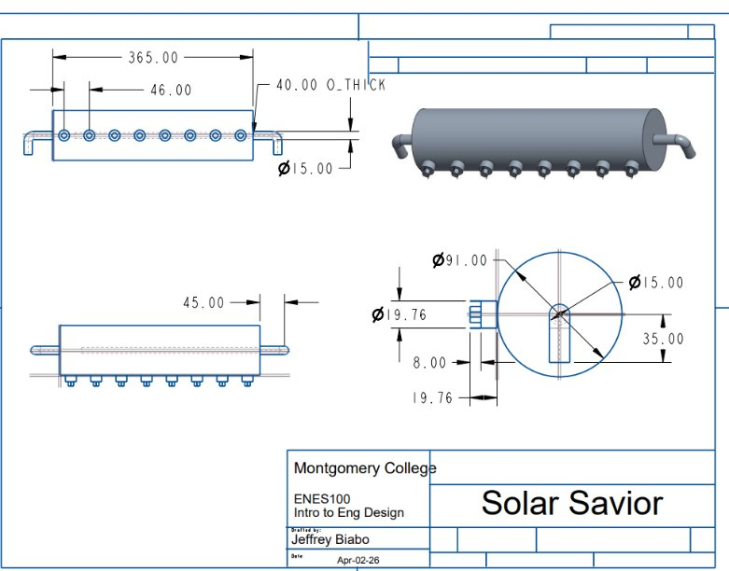
Figure 1: CREO design
Contents
Executive Summary 2
List of Tables 4
List of Figures 4
Introduction 5
Background 6
Methodology 6
Results and Discussion 7
Conclusions 9
List of References 12
Appendix A: Sample Calculations 13

List of Tables
Table 1: Irradiance 7
Table 2: Clean vs Dirty 9

List of Figures
Figure 1: CREO Design 2
Figure 2: Irradiance Graph 8
Figure 3: Clean vs Dirty Graph………………………………………………………………………………………………………9

List of Equations
Equation 1: Irradiance Model 7
Equation 2: Clean Power Output 7
Equation 3: Dirty Panel Output 7
Equation 4: Energy Production 8
Equation 5: Financial Loss Estimation 8

Introduction
1.1 Project Overview and Significance:
As the global transition toward renewable energy accelerates, solar power has become a cornerstone of sustainable infrastructure. However, the operational efficiency of photovoltaic (PV) panels is heavily dependent on surface clarity. Environmental factors such as dust, pollen, bird droppings, and industrial pollutants create a soiling effect that can reduce energy output by as much as 25% to 30% in high-debris areas. The Solar Savior: Solar Power Cleaner project was initiated to maximize the ROI of solar installations by ensuring panels remain at peak performance through automated maintenance.
1.2 Statement of Problem and Affected Population:
The primary problem addressed by this project is the lack of accessible, low-cost maintenance solutions for small-to-medium-scale solar arrays. Currently, the user populations most affected include:
Residential Homeowners: Many home solar systems are installed on steep or high-reaching roofs, making manual cleaning a significant safety hazard.
Small-Scale Solar Farms: These operations often lack the capital to invest in industrial-grade robotic fleets used by massive utility companies, yet they lose significant revenue due to panel soiling.
Elderly or Physically Limited Users: Individuals who manage their own off-grid or residential systems may find the physical labor of scrubbing panels unmanageable.
1.3 Statement of Need:
There is a critical need for a cleaning system that is both technically robust and economically viable for the average consumer. Existing solutions are often either too expensive (industrial robots) or too dangerous (manual labor). The Solar Savior fills this gap by providing an automated, rail-mounted solution that uses a screw-drive mechanism to provide high-torque cleaning without requiring human intervention on a roof or ladder.
1.4 Limitations of Existing Solutions:
Current methods for solar maintenance primarily consist of manual hosing or specialized manual brushes. These methods are limited by:
Water Waste: Manual hosing often uses excessive water without effectively removing baked-on debris.
Safety Risks: Climbing onto rooftops or using long-reach poles near high-voltage equipment poses a constant risk of injury.
Inconsistency: Manual cleaning is often done sporadically, leading to long periods of reduced energy efficiency between cleanings.

Background
The development of the Solar Savior is grounded in the physics of photovoltaic energy conversion. Solar panels function by allowing photons to strike silicon cells, generating an electric current. When a physical barrier like a layer of dust or grime is introduced, it creates shading, which not only reduces the total energy output but can also cause hot spots that permanently damage the cells over time. To address this, the team researched mechanical drive systems capable of operating on inclined surfaces. Standard belt-driven systems often suffer from slippage when exposed to outdoor moisture. Therefore, this project utilizes a heavy-duty screw drive mechanism. The screw drive provides a mechanical advantage that ensures linear motion and stability, allowing the cleaning brush to apply consistent pressure across the panel surface regardless of the angle of installation.

Methodology
The design and verification of the Solar Savior were conducted through a process that integrated 3D modeling and data-driven analysis. We used CREO Parametric to design the structural components of the cleaner. Following the mechanical design, Microsoft Excel was used to simulate performance metrics. The final phase involved cross-referencing the CREO physical constraints with the Excel performance data. This ensured that the motor specified in the mechanical model was powerful enough to drive the system as calculated in the performance simulations. Safety considerations, such as the load-bearing capacity of the railing system, were verified against the weight of the modeled components to ensure user safety and system longevity.

Simulation Equations and Calculations
The Excel simulation model was developed to estimate photovoltaic performance under varying environmental and maintenance conditions. The model used irradiance, panel efficiency, dirt accumulation, and cleaning schedules to calculate solar power output over time.
Irradiance Model
The irradiance values were modeled using a sinusoidal daylight curve that approximates natural solar intensity throughout the day:
$$I(t) = 1000 · sin\left(\frac{π(t - 6)}{12}\right)$$
Equation 1: Irradiance Model
where I(t) represents solar irradiance in watts per square meter and t represents the hour of the day.
Clean Power Output
Clean photovoltaic power output was calculated using:
$$P_{clean} = I × A × η$$
Equation 2: Clean Power Output
where:
- Pclean = clean solar power output
- I = irradiance
- A = panel area
- η = panel efficiency
Dirty Panel Output
To simulate efficiency loss caused by dust and debris accumulation, dirty panel output was calculated using:
$$P_{dirty} = P_{clean}\left(1 - D × L\right)$$
Equation 3: Dirty Panel Output
where:
- P_dirty = degraded solar output
- D = accumulated dirt level
- L = maximum efficiency loss factor
Energy Production
Energy production during each simulation interval was calculated using:
$$E = P × t$$
Equation 4: Energy Production
where:
- E = energy produced
- P = power output
- t = simulation time interval
Financial Loss Estimation
Estimated financial loss due to reduced efficiency was calculated using:
$$C = \left(E_{clean} - E_{dirty}\right) × R$$
Equation 5: Financial Loss Estimation
where:
- C = estimated financial loss
- R = electricity rate
- E_clean = ideal energy production
- E_dirty = actual degraded energy production
Rain events and automated cleaning cycles were incorporated into the model to simulate partial and complete restoration of panel efficiency over time.

Results and Discussion
Time(hr) | Irradiance (W/m²)
6 | 0
6.5 | 130.5261922
7 | 258.8190451
7.5 | 382.6834324
8 | 500
8.5 | 608.761429
9 | 707.1067812
9.5 | 793.3533403
10 | 866.0254038
10.5 | 923.8795325
11 | 965.9258263
11.5 | 991.4448614
12 | 1000
12.5 | 991.4448614
13 | 965.9258263
13.5 | 923.8795325
14 | 866.0254038
14.5 | 793.3533403
15 | 707.1067812
15.5 | 608.761429
16 | 500
16.5 | 382.6834324
17 | 258.8190451
17.5 | 130.5261922
18 | 1.23E-13
Table 1: Irradiance
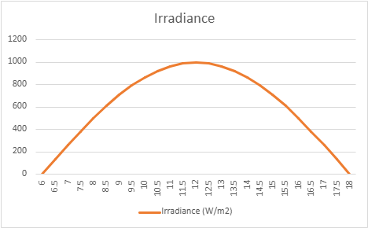
Figure 2: Irradiance Graph

The core of the system’s performance verification relies on understanding solar availability. As shown in Table 1, the team recorded irradiance values (measured in $W/m^{2}$) throughout a standard daylight cycle.
- Morning Phase (06:00 – 09:00): Irradiance begins at $0 W/m^{2}$and climbs steadily as the sun rises, reaching approximately $\$707\backslash W/m^{2}$by 09:00.
- Peak Solar Window (10:00 – 12:00): The highest values were observed between 10:00 and 12:00, with irradiance peaking near $\$1000\backslash W/m^{2}$
Time(hr) | Clean Power W | Dirty Power W
6 | 0 | 0
6.5 | 41.76838151 | 33.414705
7 | 82.82209443 | 66.257676
7.5 | 122.4586984 | 97.966959
8 | 160 | 128
8.5 | 194.8036573 | 155.84293
9 | 226.27417 | 181.01934
9.5 | 253.8730689 | 203.09846
10 | 277.1281292 | 221.7025
10.5 | 295.6414504 | 236.51316
11 | 309.0962644 | 247.27701
11.5 | 317.2623556 | 253.80988
12 | 320 | 256
12.5 | 317.2623556 | 253.80988
13 | 309.0962644 | 247.27701
13.5 | 295.6414504 | 236.51316
14 | 277.1281292 | 221.7025
14.5 | 253.8730689 | 203.09846
15 | 226.27417 | 181.01934
15.5 | 194.8036573 | 155.84293
16 | 160 | 128
16.5 | 122.4586984 | 97.966959
17 | 82.82209443 | 66.257676
17.5 | 41.76838151 | 33.414705
18 | 3.92E-14 | 3.14E-14
Table 2: Clean vs Dirty
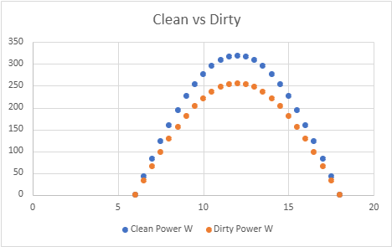
Figure 3: Clean vs Dirty Graph

The data highlights why the Solar Savior is necessary. While the peak irradiance is ${\$1000 W/m}^{2}$ These values represent the potential energy. In a dirty state, as analyzed in Table 3, the actual energy captured by the PV cells is significantly lower due to the blockage of light. By applying the cleaning cycle during the lower-irradiance morning hours, before 09:00, the system ensures the panels are completely clear before the peak window begins at 10:00, maximizing the total daily energy yield.

Conclusions

The Solar Savior Solar power cleaning project successfully demonstrated a viable mechanical and data-driven solution to the problem of solar panel soiling. By integrating a heavy-duty screw drive railing system with an automated cleaning cycle, the team addressed the critical safety and efficiency needs of residential and small-scale solar users.
The analysis of irradiance data confirms that the most significant energy losses occur during peak sunlight hours when debris accumulation is present. Through the simulations performed in Microsoft Excel, it was verified that a proactive cleaning schedule—specifically in the early morning hours—can effectively mitigate these losses, ensuring maximum energy harvest during the $1000\ W/m^2$ peak window. Furthermore, the CREO Parametric modeling proved that a rail-mounted screw drive provides the necessary torque and stability required for diverse installation angles, offering a superior alternative to traditional manual cleaning methods.

List of References
The following sources informed the simulation model, photovoltaic performance assumptions, and efficiency degradation analysis used in this project.
1. National Renewable Energy Laboratory (NREL). Standard photovoltaic irradiance conditions and peak solar resource data. https://www.nrel.gov
2. Massachusetts Institute of Technology OpenCourseWare. Solar Energy (2.997). Department of Mechanical Engineering. https://ocw.mit.edu
3. PVeducation.org. Photovoltaic efficiency, solar cell behavior, and irradiance fundamentals. https://www.pveducation.org
4. Maghami, M.R., et al. 2016. Power loss due to soiling on solar panel: A review. Renewable and Sustainable Energy Reviews 59: 1307–1316.
5. Sarver, T., Al-Qaraghuli, A., and Kazmerski, L.L. 2013. A comprehensive review of the impact of dust on the use of solar energy. Renewable and Sustainable Energy Reviews 22: 698–733.

Appendix A: Sample Calculations
This appendix provides worked sample calculations for each equation used in the Excel simulation model, using representative values from the data collected.
Equation 1 — Irradiance Model: Sample at t = 10 hours
I(10) = 1000 × sin(π(10−6)/12) = 1000 × sin(60°) ≈ 866 W/m²
Equation 2 — Clean Power Output: Panel area A = 1.6 m², efficiency η = 0.20
Pₛₗₑₐₙ = 866 × 1.6 × 0.20 ≈ 277.1 W
Equation 3 — Dirty Panel Output: Dirt level D = 1.0, max loss L = 0.20
Pᵈᵢᵣᵗʸ = 277.1 × (1 − 1.0 × 0.20) = 277.1 × 0.80 ≈ 221.7 W
Equation 4 — Energy Production: 0.5-hour interval
E = 277.1 W × 0.5 hr = 138.6 Wh (clean panel at t = 10)
Equation 5 — Financial Loss: Electricity rate R = $0.13/kWh
C = (138.6 − 110.9 Wh) × $0.00013/Wh ≈ $0.0036 lost per interval at peak

