Practice Environments Installation Guide

CONTENTS
Introduction: Practice Environments for the EPAM Big Data Course
Prerequisites for Running the Practice Environment
Creating a Virtual Docker Network 2
Creating the Kafka Docker Container 3
Starting the Kafka Docker Container 4
Connecting to the Docker Environment 4
Useful Docker Commands 4
Stopping and Starting the Docker Container 4
Remove a Previously Installed Docker Container 5
Check Container Resource Usage (e.g., RAM) 5
Stopping the Docker Environment 5
Creating the MySQL Docker Container 5
Creating the Kafkadrop Docker Container (optional) 5
Troubleshooting the Docker Environment 5

INTRODUCTION: PRACTICE ENVIRONMENTS FOR THE EPAM BIG DATA COURSE
- Practice environments are based on Docker containers, which can be downloaded and invoked on the student machines.
- To minimize resources, most topics will have their own dockers, running only the minimum required components
- For each Docker it will be stated what is the optimal resource allocation and what is the minimum resource requirements for using it.

PREREQUISITES FOR RUNNING THE PRACTICE ENVIRONMENT
- Docker
- Install Docker
    - Mac: https://docs.docker.com/docker-for-mac/install/
    - Windows: https://docs.docker.com/docker-for-windows/install/
    - Linux: https://docs.docker.com/engine/install/ (Choose your Linux distribution)
- Configure Docker
    - Open Docker settings and configure to 8GB RAM
    - For more details see here:
    - Mac: https://docs.docker.com/docker-for-mac/
    - Windows: https://docs.docker.com/docker-for-windows/ ▪ Install Docker Compose (Linux only):
    - Mac & Windows: Docker compose already included along with Docker Desktop.
    - Linux: https://docs.docker.com/compose/install/
- Minimum system requirements
- 8 GB RAM
- 2GHz CPU
- 10GB free space on hard disk

CREATING A VIRTUAL DOCKER NETWORK
- Run command in terminal to create a virtual Docker network:
docker network create bigdata_network
- Inspect the network to find the gateway's IP address and mark the IP address. (You will need this IP address for future commands):
docker network inspect bigdata_network
For example: (Note that you may get a different IP address)
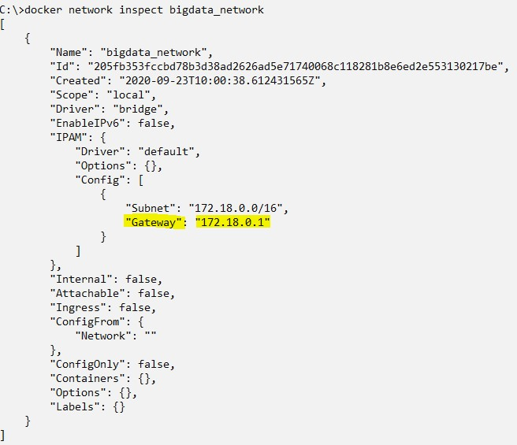

CREATING THE KAFKA DOCKER CONTAINER
To install the Docker container for the Kafka practice, run the following command - `
Be sure to change the IP address to the IP you previously marked
docker create --name kafka --network bigdata_network -p 2181:2181 -p 9092:9092 -p 8083:8083 -e ADVERTISED_HOST=<network gateway ip> -it ofrir119/kafka:2.4.0
This can take anywhere from 2 minutes up to an hour, depending on your internet connection. For example: (Be sure to use the IP of your Docker network gateway)

STARTING THE KAFKA DOCKER CONTAINER
- Start the Docker container using the following command:
docker start kafka
- Make sure the image is up and running:
docker ps -a
Sample output:
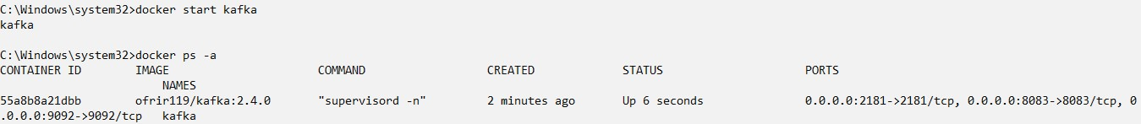

CONNECTING TO THE DOCKER ENVIRONMENT
Open the command prompt and issue the following command:
Be sure to include the “-l” flag to load scripts
docker exec -it kafka /bin/bash

USEFUL DOCKER COMMANDS
Notes:
- All commands below are to be executed in the command prompt.
- Assuming Docker name is “kafka”, as it is in the practice environment for Hive
VIEW DOCKER CONTAINERS AND THEIR STATUS
Run the command:
docker ps -a
STOPPING AND STARTING THE DOCKER CONTAINER
Run the commands:
docker stop kafka
docker start kafka

REMOVE A PREVIOUSLY INSTALLED DOCKER CONTAINER
Run the command:
docker rm kafka
CHECK CONTAINER RESOURCE USAGE (E.G., RAM)
Run the command:
docker stats

STOPPING THE DOCKER ENVIRONMENT
Run the command:
docker stop kafka

CREATING THE MYSQL DOCKER CONTAINER
- Install this only before performing the MySQL related practice.
- To install the MySQL Docker container, run the following command - `
- Be sure to change the IP address to the IP you previously marked
docker run -d --name mysql --network bigdata_network -p 3306:3306 -e MYSQL_ROOT_PASSWORD=root mysql

CREATING THE KAFDROP DOCKER CONTAINER (OPTIONAL)
Install this only before performing the Kafdrop related practice. It is optional but recommended. Still, this docker is provided for students who want to install this GUI tool for Kafka. Install this only if you intend to use it.
- To install the Kafdrop Docker container, run the following command - `
- Be sure to change the IP address to the IP you previously marked
docker create --name kafdrop --network bigdata_network -p 9000:9000 -e KAFKA_BROKERCONNECT=:9092 -it obsidiandynamics/kafdrop

TROUBLESHOOTING THE DOCKER ENVIRONMENT
See the Guidelines document for troubleshooting issues.

