|  |  |  |
| --- | --- | --- |
| CS3343-LA3 2014/15 Sem A December 5, 2014 | B.T.  User Manual | |
| [Type the abstract of the document here. The abstract is typically a short summary of the contents of the document. Type the abstract of the document here. The abstract is typically a short summary of the contents of the document.] | | Prepared by  B.T. |

Contents

Data Preparation 2

Required Files 2

Data File 2

Constraint Files 3

Time Gap Constraint 3

Building Constraint 3

Required Constraint 3

Time Constraint 4

Environment Preparation 5

Launch Application 7

# Data Preparation

## Required Files

There are some files required to launch this program. They are classified into two categories, data file and constraint files. The data file stores all candidate sessions of courses. Constraint files consist of 4 txt files: MaxTimeBetween2Sessions.txt, NoClassInTherseBuildings.txt, TheseCRNsMustBeIncluded.txt and TimeConstraints.txt.

## Data File

The format of the file is “CRN,Course Code,Session,Building,Room,Start Time,Finish Time,Day of week”. Please be reminded that there is no space in any of the items. The data file name can be any.

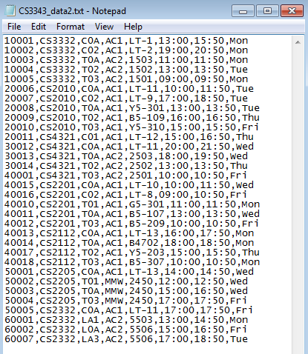

## Constraint Files

The name of four constraint files should not be modified or the program cannot run successfully.

### Time Gap Constraint

In order to indicate the maximum number of hours between any of two sessions, you have to put a valid integer in a file MaxTimeBetween2Sessions.txt with an empty line at the end.

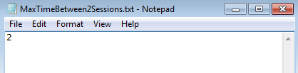

### Building Constraint

You can indicate the buildings that you do NOT want to have lesson in, in NoClassInTheseBuildings.txt. You have to include an empty line at the end of file.

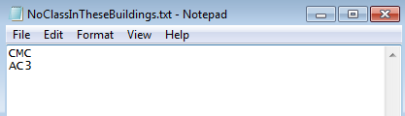

### Required Constraint

If you have some compulsory sessions that you must take, please put their CRNs one on each line in TheseCRNsMustBeIncluded.txt, with an empty line at the end of file.

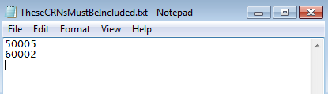

### Time Constraint

Some of you would NOT like to attend classes before or after certain time, or have day-off on a specific day. You can indicate these kinds of constraints into one text file, TimeConstraints.txt. Please be reminded that the time format is 24-hour. You can use a hash (“#”) to comment out a sentence.

The format of the file is: Keyword<Tab>Day<Tab>(Time1)<Tab> (Time2)

|  |  |  |  |
| --- | --- | --- | --- |
| **Keyword** | **Day** | **Time1** | **Time2** |
| Before | Either one in {Everyday, Mon, Tue, Wed, Thu, Fri, Sat, Sun} | Any integer from 8 to 22 | N/A |
| After | Any integer from 8 to 22 | N/A |
| Between | Any integer from 8 to 22 | Any integer from 8 to 22 |
| Dayoff | N/A | |

For example, if you do NOT want to have any classes before 10 am, you can type: Before<Tab>Everyday<10> on a line.

If you want to have a day off on every Friday, you can type: Dayoff<Tab>Fri

If you do NOT want to have classes between 1 to 2pm on Mondays and Wednesdays, you can type: Between<Tab>Mon<Tab>13<Tab>14 and Between<Tab>Wed<Tab>13<Tab>14 on two DIFFERENT lines.

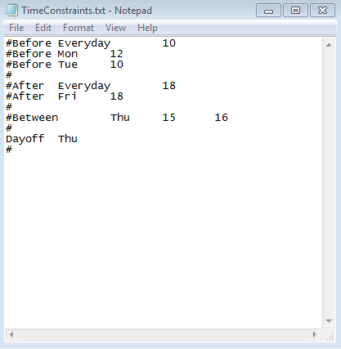

# Environment Preparation

1. Launch command prompt from the directory storing the manifest (TimetableSchedulingSystem.jar).

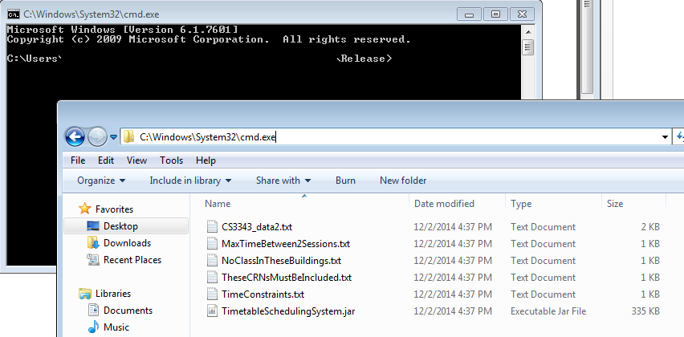

1. Right click the window and select Properties.

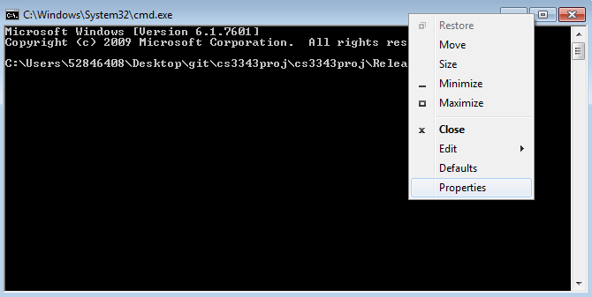

1. In the Layout tab, change both the widths of Screen Buffer Size and Window Size as 140.

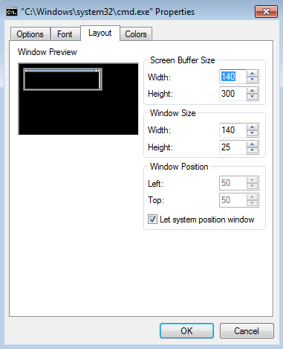

# Launch Application

After preparing the data files and the environment, in the command prompt, you can type:

java –jar TimetableSchedulingSystem.jar *nameOfDataFile.txt*



There are several information printed on the console.

1. Number of possible combinations before applying constraints. (e.g. There are 4248 possible combinations.)
2. Number of possible combinations after applying constraints. (e.g. There are 5 timetables available.)
3. The ID of timetable (e.g. Timetable 2:) In the following example, there could be timetable 1 to 5.

If there are multiple possible combinations, every time you run the program may result in different timetable as the ID is random.

1. The timetable printed for visual inspection.
2. The corresponding list of CRNs.

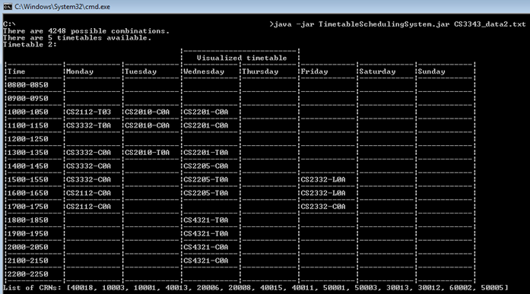

5

4

3

2

1