|  |  |  |
| --- | --- | --- |
| CS3343-LA3 2014/15 Sem A December 5, 2014 | B.T.  Bug Report | |
| [Type the abstract of the document here. The abstract is typically a short summary of the contents of the document. Type the abstract of the document here. The abstract is typically a short summary of the contents of the document.] | | Prepared by  B.T. |

Contents

1. Summary of the project 2

2. Summary Methodology 2

3. Work Breakdown Structure 3

4. Project Schedule 4

5. Deliverables 5

# Summary of the project

* 1. Project Description

In this project we are going to develop a Java program that can output an auto-scheduled school timetable, based on the user’s course data and timetable preference input.

* 1. Stakeholders
     1. Students in CityU and CCCU

This program is designed for CityU and CCCU students that are using AIMS for course add/drop.

* 1. Objectives of this project
     1. Provide an automated way for the user to design their timetable

As if the students want to modify their timetable, they can only check the master class schedule in AIMS, jot down the CRN number of the courses they would like to take and finish the add/drop of courses through AIMS or paper form. We want to let the user design their timetable automatically by just inputting the details of the courses they want to take and also their timetable preferences.

* + 1. Provide an visualized timetable for the user when designing their timetable

When designing the timetable, the user can’t have a visualized timetable for confirmation of their choices in AIMS, which they might actually not feeling satisfy with the timetable later and have to modify again. With this program we would like to provide a visualized provisional output of the generated timetable, allowing the user to have a better way to customize the timetable.

# Summary Methodology

* 1. Software development methodology to be used

We will use basic test-driven process strategy to develop this project, which will involve testing, debugging and code refactoring.

* 1. Project team organization

|  |  |  |
| --- | --- | --- |
| Student Number | Name | Position |
| 53031057 | YAU, Yet Chi | Project Manager |
| 52846408 | KWAN, Tsz Ho | Assistant PM / Configuration Manager |
| 53038741 | HUI, Kwun Tung | Development and Test Lead |
| 53035683 | CHENG, Suk Yin | Developer |
| 53019498 | LO, Weng Kuai | Developer |
| 53028089 | TUNG, Leong Kok | Developer |

* 1. Development tool and platform to be used

Platform: Windows 7 SP1 (64bit), Eclipse 4.3.2, JDK (32 bits) 7u67

Plug-in: Junit 4.11, JAutoDoc 1.11.1, EGit 3.3.1, EclEmma Java Code Coverage 2.3.2

* 1. Configuration management

At the very first time, CM builds the basic version of the project cs3343proj, with only the package Schedule and testSchedule. After he has connect and uploaded the project to Google Code through EGit, other team members then import the project through Package Explorer. Every time before a member make a change on a module, he/she should first ‘Pull’ the content so to have the latest version to edit. After editing, he/she should ‘Commit and Push’ the edited module. Every time there is a change on module, every members should have a look on the change log through Google Code and if there is no other comment on Google Code, members can continue the modification of code.

Google Code link: <http://code.google.com/p/cs3343-201415-timetable/>

# Work Breakdown Structure

1. Timetable Scheduling System
2. Project Management
   1. Project Plan
   2. Project Schedule
   3. Time keeping
   4. Meeting agendas
   5. Meeting minutes
   6. Weekly activity logs
3. Analysis & Design
   1. Design document
      1. Design overview
      2. Design for IO
      3. Design for sample data
      4. Design for utilities
4. Java Program Development
   1. Main program
   2. IO
      1. Read course data (Sample: CS3343_data2.txt)
      2. Read constraint data
         1. Building constraint
         2. Required constraint
         3. Time constraint
         4. Time gap constraint
      3. Visualized timetable output
   3. Supporting utilities
      1. Input validation
      2. Helper functions
      3. Course ArrayList generating functions
   4. Data creation
      1. Sample course data text file
      2. Sample constraint data text file
5. Testing
   1. Unit testing
   2. Integration testing
   3. System testing
   4. Junit test cases
6. Product
   1. Presentation materials
   2. Final release
      1. Source code
      2. User manual
      3. Installation guide
      4. Release note

# Project Schedule

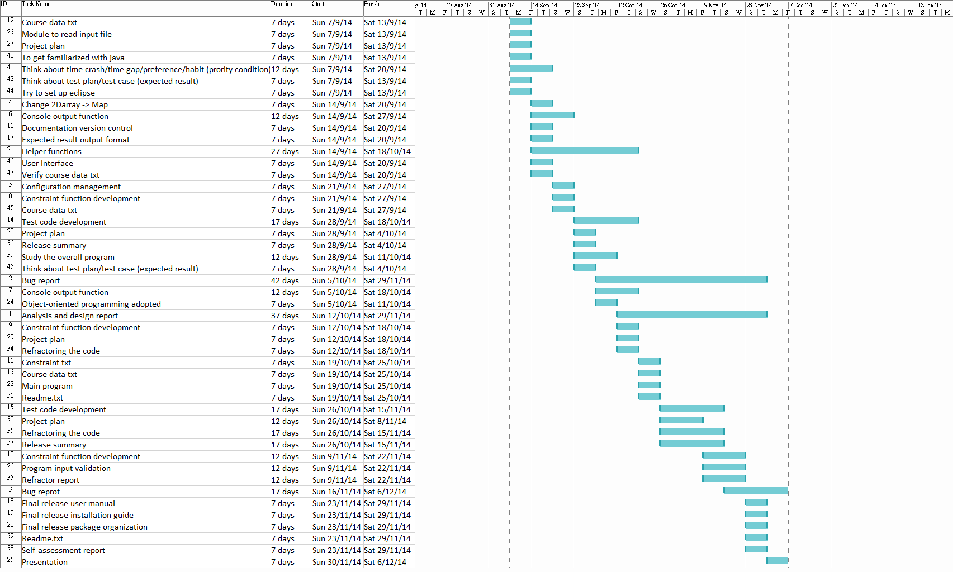

# Deliverables

|  |  |  |  |
| --- | --- | --- | --- |
| Item | Release 1 includes | Release 2 includes | Release 3 includes |
| Project Plan | 0.0.1 | 0.1.0 | 0.1.1 |
| Bug Report | 0.1.0 | 0.3.1 | 0.6.0 |
| Refactor Report | N/A | 0.1.0 | 0.2.0 |
| Test Report | N/A | N/A | 0.2.0 |
| Design and Analysis Report | N/A | N/A | 0.1.0 |
| Program File ‘BuildingConstraint.java’ | 0.1.0 | 0.1.0 | 0.1.0 |
| Program File ‘Constraint.java’ | 0.1.0 | 0.1.0 | 0.1.0 |
| Program File ‘IO.java’ | N/A | 0.1.0 | 0.2.0 |
| Program File ‘RequiredConstraint.java’ | 0.1.0 | 0.1.0 | 0.1.0 |
| Program File ‘Schedule.java’ |  |  |  |
| Program File ‘TimeConstraint.java’ | 0.1.0 | 0.1.1 | 0.2.0 |
| Program File TimeGapConstraint.java’ | 0.1.0 | 0.1.0 | 0.1.0 |
| Program File ‘Timeslot.java’ | 0.1.0 | 0.2.1 | 0.3.1 |
| Program File ‘Timetable.java’ | N/A | N/A | 0.1.0 |
| Program File ‘Utilities.java’ | N/A | N/A | 0.1.0 |
| Program File ‘Weekday.java’ | 0.1.0 | 0.1.0 | 0.1.0 |
| Program File ‘AllTests.java’ | N/A | N/A | 0.1.0 |
| Test script ‘OtherIntegrationTests.java’ | N/A | N/A | 0.1.0 |
| Test script ‘TestConstraints.java’ | N/A | N/A | 0.1.0 |
| Test script ‘TestIO.java’ | N/A | N/A | 0.1.0 |
| Test script ‘TestSchedule.java’ | 0.1.0 | 0.2.0 | 0.3.0 |
| Test script ‘TestTimeslot.java’ | N/A | N/A | 0.1.0 |
| Test script ‘TestTimetable.java’ | N/A | N/A | 0.1.0 |
| Test script ‘TestUtilities.java’ | N/A | N/A | 0.1.0 |
| Test script ‘TestWeekday.java’ | N/A | N/A | 0.1.0 |
| Course data file ‘CS3343_data2.txt’ | 0.1.0 | 0.1.0 | 0.1.0 |
| Constraint file ‘MaxTimeBetween2Sessions.txt’ | N/A | N/A | 0.1.0 |
| Constraint file ‘NoClassInTheseBuildings.txt’ | N/A | N/A | 0.1.0 |
| Constraint file ‘TheseCRNsMustBeIncluded.txt’ | N/A | N/A | 0.1.0 |
| Constraint file ‘TimeConstraints.txt’ | N/A | N/A | 0.1.0 |
| Junit Framework | Ver. 4.0 | Ver. 4.0 | Ver. 4.0 |
| Java compiler | Java 7 | Java 7 | Java 7 |
| User manual | N/A | N/A | 0.1.0 |
| Installation guide | N/A | N/A | 0.1.0 |
| Manifest | N/A | N/A | 0.1.0 |