**THE PROCESS OF WITHDRAW MONEY FROM ATM**

- Card Reader: The card reader gets information of the account which is stored on the magnetic stripe of card. The host processor helps to move on the transaction for cardholder.

- Keypad: This part of device helps the cardholder to choose what kind of transaction is required. Also PIN is needed for verification of cardholder’s identity.

- Sensing Bills**:** ATM has a electric eye that counts each bill.

- Every transaction is recorded in a journal.

- ATM also has a sensor that evaluates the thickness of each bill.

- If two bills are stuck together, then instead of being dispensed to the cardholder they are diverted to a reject bin.

- The ATM forwards this information to the host processor, which routes the transaction request to the cardholder's bank or the institution that issued the card. If the cardholder is requesting cash, the host processor causes an electronic funds transfer to take place from the customer's bank account to the host processor's account.

- After that the funds are transferred to the host processor's bank account, the processor sends an approval code to the ATM authorizing the machine to dispense the cash.

- The processor then the cardholder's funds into the merchant's bank account, usually the next bank business day. In this way, the merchant is reimbursed for all funds dispensed by the ATM.

- ATMs protect our PIN and personal information by using encryption system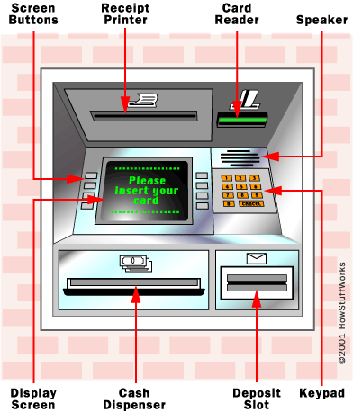

Ramazan Irmak

Gözde Yetimoğlu

Mohammad saber Alam