**Kullanıcılar**

USE [Kargo_Otomasyon]

GO

SET ANSI_NULLS ON

GO

SET QUOTED_IDENTIFIER ON

GO

CREATE TABLE [dbo].[tbl_kullanicilar](

[kullanici_no] [int] IDENTITY(1,1) NOT NULL,

[kullanici_adi] [nchar](20) NOT NULL,

[parola] [nchar](20) NOT NULL,

[adsoyad] [nchar](30) NOT NULL,

[eposta] [nchar](30) NOT NULL,

[adres] [nchar](30) NOT NULL,

[yetki] [int] NOT NULL,

[uyelik_tarihi] [datetime] NOT NULL,

CONSTRAINT [PK_tbl_kullanicilar] PRIMARY KEY CLUSTERED

(

[kullanici_no] ASC

)WITH (PAD_INDEX = OFF, STATISTICS_NORECOMPUTE = OFF, IGNORE_DUP_KEY = OFF, ALLOW_ROW_LOCKS = ON, ALLOW_PAGE_LOCKS = ON) ON [PRIMARY]

) ON [PRIMARY]

GO

ALTER TABLE [dbo].[tbl_kullanicilar] WITH CHECK ADD CONSTRAINT [FK_tbl_kullanicilar_tbl_yetkiler] FOREIGN KEY([yetki])

REFERENCES [dbo].[tbl_yetkiler] ([yetki_no])

GO

ALTER TABLE [dbo].[tbl_kullanicilar] CHECK CONSTRAINT [FK_tbl_kullanicilar_tbl_yetkiler]

GO

**Yetkiler**

USE [Kargo_Otomasyon]

GO

SET ANSI_NULLS ON

GO

SET QUOTED_IDENTIFIER ON

GO

CREATE TABLE [dbo].[tbl_yetkiler](

[yetki_no] [int] IDENTITY(1,1) NOT NULL,

[yetki_adi] [nchar](20) NOT NULL,

[yonetici] [bit] NOT NULL,

[kullanici] [bit] NOT NULL,

CONSTRAINT [PK_tbl_yetkiler] PRIMARY KEY CLUSTERED

(

[yetki_no] ASC

)WITH (PAD_INDEX = OFF, STATISTICS_NORECOMPUTE = OFF, IGNORE_DUP_KEY = OFF, ALLOW_ROW_LOCKS = ON, ALLOW_PAGE_LOCKS = ON) ON [PRIMARY]

) ON [PRIMARY]

GO

**Kargo**

USE [Kargo_Otomasyon]

GO

SET ANSI_NULLS ON

GO

SET QUOTED_IDENTIFIER ON

GO

CREATE TABLE [dbo].[tbl_kargo](

[kargo_no] [int] IDENTITY(1,1) NOT NULL,

[gonderen_adsoyad] [nchar](30) NOT NULL,

[gonderen_adres] [nchar](30) NOT NULL,

[alici_adsoyad] [nchar](30) NOT NULL,

[alici_adres] [nchar](30) NOT NULL,

[kargo_turu] [int] NOT NULL,

[cikis_subesi] [int] NOT NULL,

[varis_subesi] [int] NOT NULL,

[fiyat] [int] NOT NULL,

[ekleyen] [int] NOT NULL,

CONSTRAINT [PK_tbl_kargo] PRIMARY KEY CLUSTERED

(

[kargo_no] ASC

)WITH (PAD_INDEX = OFF, STATISTICS_NORECOMPUTE = OFF, IGNORE_DUP_KEY = OFF, ALLOW_ROW_LOCKS = ON, ALLOW_PAGE_LOCKS = ON) ON [PRIMARY]

) ON [PRIMARY]

GO

ALTER TABLE [dbo].[tbl_kargo] WITH CHECK ADD CONSTRAINT [FK_tbl_kargo_tbl_cikis_merkezi] FOREIGN KEY([cikis_subesi])

REFERENCES [dbo].[tbl_cikis_merkezi] ([sube_no])

GO

ALTER TABLE [dbo].[tbl_kargo] CHECK CONSTRAINT [FK_tbl_kargo_tbl_cikis_merkezi]

GO

ALTER TABLE [dbo].[tbl_kargo] WITH CHECK ADD CONSTRAINT [FK_tbl_kargo_tbl_kargo_turleri] FOREIGN KEY([kargo_turu])

REFERENCES [dbo].[tbl_kargo_turleri] ([kargoturu_no])

GO

ALTER TABLE [dbo].[tbl_kargo] CHECK CONSTRAINT [FK_tbl_kargo_tbl_kargo_turleri]

GO

ALTER TABLE [dbo].[tbl_kargo] WITH CHECK ADD CONSTRAINT [FK_tbl_kargo_tbl_kullanicilar] FOREIGN KEY([ekleyen])

REFERENCES [dbo].[tbl_kullanicilar] ([kullanici_no])

GO

ALTER TABLE [dbo].[tbl_kargo] CHECK CONSTRAINT [FK_tbl_kargo_tbl_kullanicilar]

GO

ALTER TABLE [dbo].[tbl_kargo] WITH CHECK ADD CONSTRAINT [FK_tbl_kargo_tbl_varis_merkezi] FOREIGN KEY([varis_subesi])

REFERENCES [dbo].[tbl_varis_merkezi] ([sube_no])

GO

ALTER TABLE [dbo].[tbl_kargo] CHECK CONSTRAINT [FK_tbl_kargo_tbl_varis_merkezi]

GO

**Kargo Türleri**

USE [Kargo_Otomasyon]

GO

SET ANSI_NULLS ON

GO

SET QUOTED_IDENTIFIER ON

GO

CREATE TABLE [dbo].[tbl_kargo_turleri](

[kargoturu_no] [int] IDENTITY(1,1) NOT NULL,

[kargo_turu] [nchar](20) NOT NULL,

CONSTRAINT [PK_tbl_kargo_turleri] PRIMARY KEY CLUSTERED

(

[kargoturu_no] ASC

)WITH (PAD_INDEX = OFF, STATISTICS_NORECOMPUTE = OFF, IGNORE_DUP_KEY = OFF, ALLOW_ROW_LOCKS = ON, ALLOW_PAGE_LOCKS = ON) ON [PRIMARY]

) ON [PRIMARY]

GO

**Çıkış Merkezi MMerkezi**

USE [Kargo_Otomasyon]

GO

SET ANSI_NULLS ON

GO

SET QUOTED_IDENTIFIER ON

GO

CREATE TABLE [dbo].[tbl_cikis_merkezi](

[sube_no] [int] IDENTITY(1,1) NOT NULL,

[sube_adi] [nchar](30) NOT NULL,

[sube_adres] [nchar](30) NOT NULL,

CONSTRAINT [PK_tbl_cikis_merkezi] PRIMARY KEY CLUSTERED

(

[sube_no] ASC

)WITH (PAD_INDEX = OFF, STATISTICS_NORECOMPUTE = OFF, IGNORE_DUP_KEY = OFF, ALLOW_ROW_LOCKS = ON, ALLOW_PAGE_LOCKS = ON) ON [PRIMARY]

) ON [PRIMARY]

GO

**Varış Merkezi**

USE [Kargo_Otomasyon]

GO

SET ANSI_NULLS ON

GO

SET QUOTED_IDENTIFIER ON

GO

CREATE TABLE [dbo].[tbl_varis_merkezi](

[sube_no] [int] IDENTITY(1,1) NOT NULL,

[sube_adi] [nchar](30) NOT NULL,

[sube_adres] [nchar](30) NOT NULL,

CONSTRAINT [PK_tbl_varis_merkezi] PRIMARY KEY CLUSTERED

(

[sube_no] ASC

)WITH (PAD_INDEX = OFF, STATISTICS_NORECOMPUTE = OFF, IGNORE_DUP_KEY = OFF, ALLOW_ROW_LOCKS = ON, ALLOW_PAGE_LOCKS = ON) ON [PRIMARY]

) ON [PRIMARY]

GO

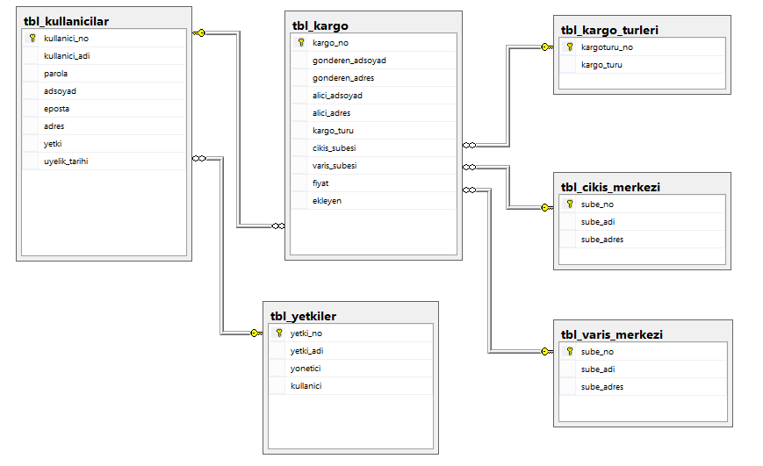

1

n

1

n

n

n

n

1

1

1

**Kargo Türleri**

**Varış Merkezi**

**Çıkış Merkezi MMerkezi**

Kargo Türü

Varış

**Kargo**

Çıkış

Yetkisi

**Yetkiler**

**Kullanıcılar**

Ekleyen