Introduction to Algorithm Design
Ramazan Sakin
111044069
HW3 – Report

Resulsts

Graphic
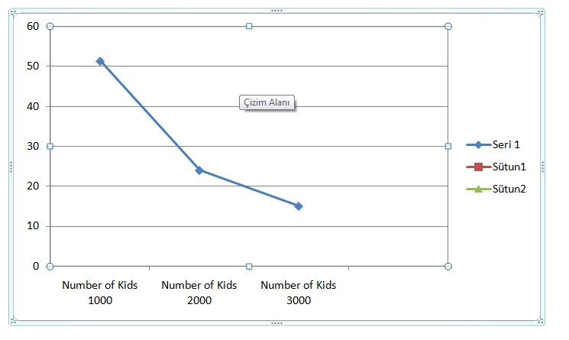
* Pseude Code , Complexity analsys and real-life examples are hand-written.

