Home Theater Facade
  - Assignment 4 | Software Design Patterns | Java 17

1 Introduction
This project implements the Facade structural design pattern using the assignment's suggested Home Theater topic. Starting a movie requires several devices to work together: preparing popcorn, adjusting lighting, lowering the screen, configuring the projector and amplifier, and starting the player. Repeating these steps in every client would duplicate coordination rules and make changes harder to maintain.
HomeTheaterFacade gives the client a small movie-session API and performs the device calls in the correct order. The six subsystem classes keep their own responsibilities and can also be used directly. The program simulates equipment by changing Java object state and printing English messages; it does not play media or control physical hardware.

1.1 Simplified facade operations
Operation | Client-level purpose
watchMovie(title) | Prepare the room and start the selected movie.
pauseMovie() | Pause playback and brighten the room for a break.
resumeMovie() | Restore movie lighting and continue playback.
endMovie() | Stop playback, switch off equipment, and restore the room.
getStatus() | Read Ready, Playing, or Paused without accessing devices.

1.2 Focused subsystem responsibilities
Class | Responsibility
Amplifier | Sound power, bounded volume, and surround mode.
StreamingPlayer | Movie playback and valid playback transitions.
Projector | Projector power and widescreen mode.
Screen | Lowering and raising the projection screen.
TheaterLights | Room brightness and full-light restoration.
PopcornMaker | Preparing popcorn while the maker is powered on.

2 UML Class Diagram
Diagram correction 20 October 2026. Java source baseline 1ea6a10 is unchanged.
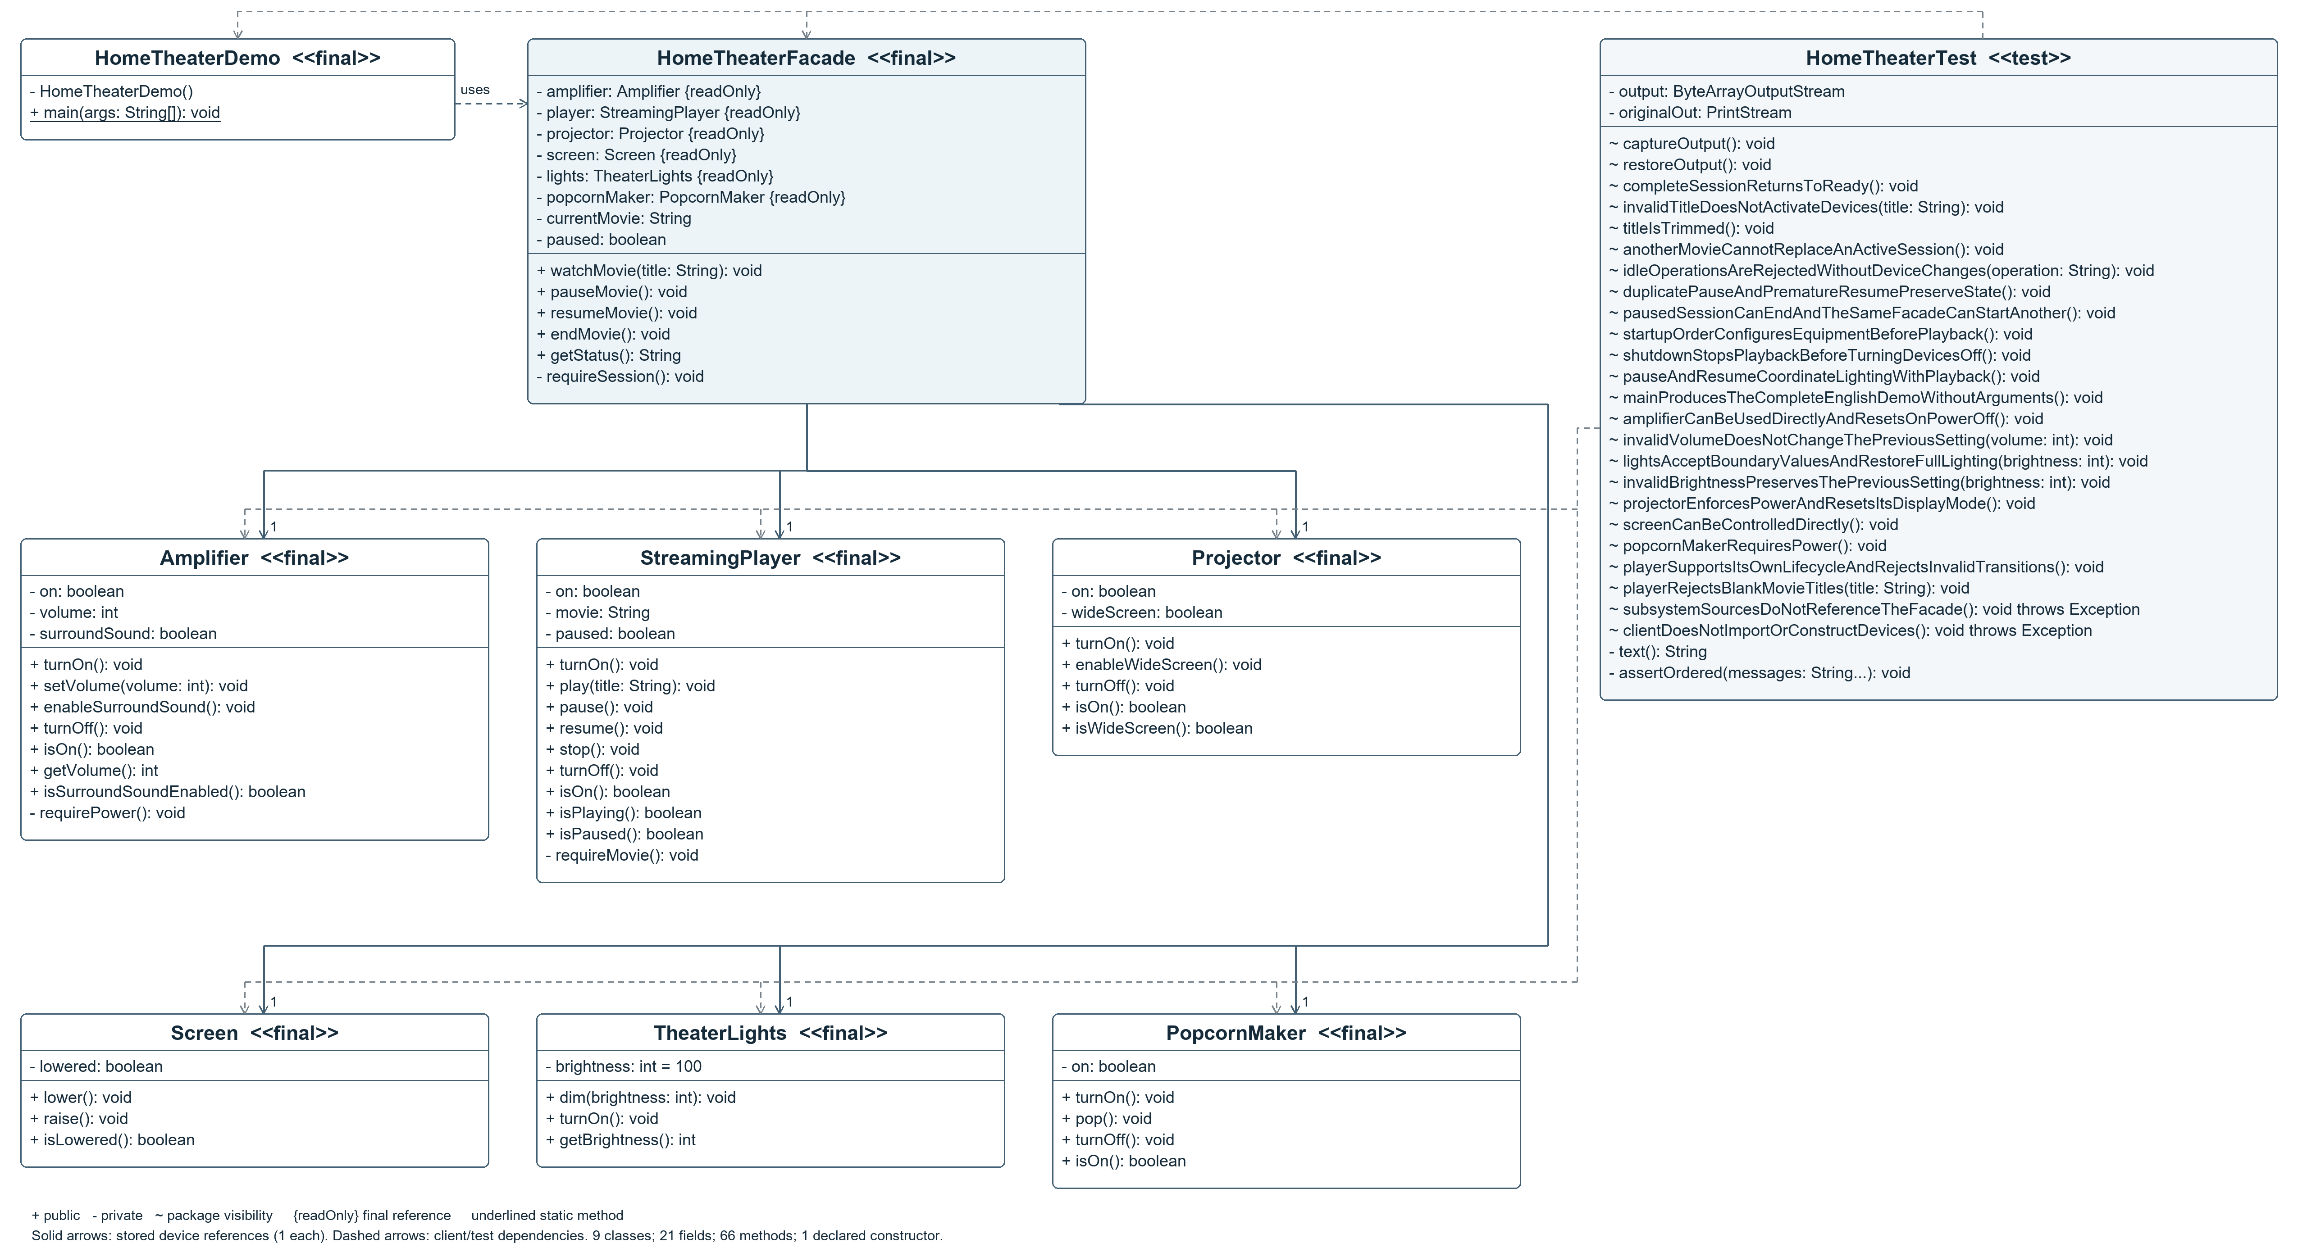
Figure 1. Complete source declarations: 8 application classes and 1 test class, 21 fields, 66 methods, and 1 explicit constructor. A3 landscape preserves legibility. Public (+), private (-), package (~), final references ({readOnly}), static main (underlined), and one device of each type per facade are shown.
The dashed arrows show client and test dependencies; solid arrows show stored device references. HomeTheaterTest has package visibility. Method parameters appear in signatures. All local declarations are listed in Appendix A. External Java/JUnit types and implicit constructors are outside the authored-class count.

3 Clean Code Principles
The following five principles are illustrated with annotated excerpts from the submitted implementation. The simplified API stays readable while the device classes remain independent.

3.1 Meaningful names
Names describe the user's intention. watchMovie and endMovie communicate the desired result, while title identifies the required input. A caller can understand the API without reading the device sequence.
// Movie-session intentions are visible in the API.
public void watchMovie(String title)
public void pauseMovie()
public void resumeMovie()
public void endMovie()

3.2 Single responsibility
The facade coordinates the workflow. Each device implements its own state changes and validation. For example, watchMovie delegates projector and sound configuration instead of implementing those behaviors itself.
// Excerpt from watchMovie: delegate to devices.
projector.turnOn();
projector.enableWideScreen();
amplifier.turnOn();
amplifier.setVolume(35);

3.3 Hide subsystem details from the client
The client constructs one facade and uses movie operations. It imports no devices and does not choose settings or startup order. The six device fields are private; getStatus returns a high-level description. The following client requests need no subsystem objects.
HomeTheaterFacade theater = new HomeTheaterFacade();
theater.watchMovie("Interstellar");
theater.endMovie();

3.4 Small focused subsystem classes
Each subsystem models one device. Screen changes screen position, while TheaterLights validates and changes brightness. Focused classes can be understood and tested directly without constructing the complete theater.
public void lower() {
lowered = true;
System.out.println("[Screen] Lowered for the movie.");
}

3.5 Explicit error handling
watchMovie rejects blank titles and active sessions before changing any device. Pause and resume enforce session state. Devices validate their power prerequisites and numeric limits independently. Descriptive exceptions reach the caller, so a failed request is never reported as success.
if (title == null || title.isBlank()) {
throw new IllegalArgumentException("Movie title must not be blank.");
}
if (currentMovie != null) {
throw new IllegalStateException(
"End the current movie session before starting another.");
}

4 Live Demonstration
Run HomeTheaterDemo.main() without arguments. The demo starts Interstellar, pauses it, resumes it, and ends the session. It then starts and ends The Martian using the same facade. Client-request headings, facade messages, and device messages make the delegation visible. The complete output is saved in docs/demo-output.txt.
1. CLIENT REQUEST: watchMovie("Interstellar")
[Facade] Preparing the theater for Interstellar.
[Popcorn] Maker ON.
[Popcorn] Fresh popcorn is ready.
[Lights] Brightness set to 10%.
[Screen] Lowered for the movie.
...
FINAL STATUS: Ready
DEMONSTRATION COMPLETED SUCCESSFULLY

5 Validation
Validation was performed on 18 October 2026 using JDK 17. Maven clean verify passed all 34 JUnit test cases with zero failures, errors, or skipped tests. The packaged JAR was launched twice with identical output. The Windows launcher also compiled the sources and completed the demonstration successfully.
Coverage | What was checked
Session lifecycle | Ready, Playing, Paused, resume, shutdown, and another session.
Coordination and output | Startup/shutdown order, lighting during pause/resume, and the complete demo transcript.
Invalid requests | Blank titles, inactive-session commands, duplicate pause, and replacing an active movie.
Device behavior | Power prerequisites, volume and brightness boundaries, and reset behavior.
Pattern structure | The client does not construct devices; subsystem sources do not reference the facade.

A clean project copy was imported and run in IntelliJ IDEA 2025.3.3 on this computer. HomeTheaterDemo completed with exit code 0. No program arguments or input paths were needed. The shared run configuration and run-demo.cmd launcher are also included.

6 Conclusion
HomeTheaterFacade hides device creation, device settings, startup order, pause and resume lighting, and shutdown order behind four intention-revealing operations. The client handles a movie session through one object instead of managing six devices. The detailed console output demonstrates that each facade request triggers several coordinated actions.
The subsystem classes remain public, focused, and unaware of the facade. Advanced clients may construct them directly, as the device tests do. The facade therefore simplifies the common workflow while leaving direct component access available. The design uses concrete classes, private fields, straightforward validation, and the Java standard library for production code.

Repository
https://github.com/ramazanutegen583-pixel/facade-pattern-vault-backup

Appendix A Source declarations and local variables
The counts below were extracted from all Java files under src using the JDK compiler tree API. The application has 8 classes; its separate JUnit test adds one class. The main pattern creates one facade and six device objects. HomeTheaterDemo has a static entry point and is not instantiated. Local variables have method scope and are not UML class attributes.
Class | Fields | Methods | Declared constructors
HomeTheaterDemo | 0 | 1 | 1
HomeTheaterFacade | 8 | 6 | 0
Amplifier | 3 | 8 | 0
PopcornMaker | 1 | 4 | 0
Projector | 2 | 5 | 0
Screen | 1 | 3 | 0
StreamingPlayer | 3 | 10 | 0
TheaterLights | 1 | 3 | 0
HomeTheaterTest | 2 | 26 | 0

Local variable register
All 31 local and lambda parameter declarations are listed below. Method parameters are already included in UML signatures. Explicit var declarations and inferred lambda parameters are identified; line numbers refer to the unchanged Java sources.
Class and method | Local declarations
HomeTheaterDemo.main | theater: HomeTheaterFacade (L10)
HomeTheaterFacade.watchMovie | movie: String (L28)
HomeTheaterTest.completeSessionReturnsToReady | theater: HomeTheaterFacade (L38)
HomeTheaterTest.invalidTitleDoesNotActivateDevices | theater: HomeTheaterFacade (L54)
HomeTheaterTest.titleIsTrimmed | theater: HomeTheaterFacade (L62)
HomeTheaterTest.anotherMovieCannotReplaceAnActiveSession | theater: HomeTheaterFacade (L69); before: String (L71)
HomeTheaterTest.idleOperationsAreRejectedWithoutDeviceChanges | theater: HomeTheaterFacade (L80)
HomeTheaterTest.duplicatePauseAndPrematureResumePreserveState | theater: HomeTheaterFacade (L94); before: String (L99)
HomeTheaterTest.pausedSessionCanEndAndTheSameFacadeCanStartAnother | theater: HomeTheaterFacade (L107)
HomeTheaterTest.shutdownStopsPlaybackBeforeTurningDevicesOff | theater: HomeTheaterFacade (L131)
HomeTheaterTest.pauseAndResumeCoordinateLightingWithPlayback | theater: HomeTheaterFacade (L143)
HomeTheaterTest.amplifierCanBeUsedDirectlyAndResetsOnPowerOff | amplifier: Amplifier (L165)
HomeTheaterTest.invalidVolumeDoesNotChangeThePreviousSetting | amplifier: Amplifier (L183)
HomeTheaterTest.lightsAcceptBoundaryValuesAndRestoreFullLighting | lights: TheaterLights (L193)
HomeTheaterTest.invalidBrightnessPreservesThePreviousSetting | lights: TheaterLights (L203)
HomeTheaterTest.projectorEnforcesPowerAndResetsItsDisplayMode | projector: Projector (L210)
HomeTheaterTest.screenCanBeControlledDirectly | screen: Screen (L223)
HomeTheaterTest.popcornMakerRequiresPower | maker: PopcornMaker (L233)
HomeTheaterTest.playerSupportsItsOwnLifecycleAndRejectsInvalidTransitions | player: StreamingPlayer (L245)
HomeTheaterTest.playerRejectsBlankMovieTitles | player: StreamingPlayer (L272)
HomeTheaterTest.subsystemSourcesDoNotReferenceTheFacade | files: var (L280); source: Path (L281); path: inferred (L281); code: String (L282)
HomeTheaterTest.clientDoesNotImportOrConstructDevices | client: String (L291); type: String (L295)
HomeTheaterTest.assertOrdered | previous: int (L303); message: String (L304); position: int (L305)

Full field initializers, annotations, parameter names, local scopes, source paths, and SHA-256 hashes are included in docs/code-inventory.json. The editable UML is docs/class-diagram.puml. docs/uml-inventory.md provides the complete textual member register.

