Facade Pattern Assignment Report
Vault Backup System | Assignment 4 | Software Design Patterns

1. Introduction
This project applies the Facade pattern to a verified file backup workflow. Creating a reliable archive involves locating files, calculating checksums, encoding a manifest, writing ZIP entries, and verifying stored content. A client that coordinates these operations directly must understand their order and low-level formats. VaultBackupFacade provides a small API for creating, verifying, and restoring backups while the subsystem classes keep their own focused responsibilities.
The implementation uses Java 17 and the standard library. Each archive stores source files at their relative paths and includes a versioned UTF-8 manifest with file sizes and SHA-256 checksums. The restore operation verifies the archive before writing and requires a new or empty destination directory.

2. UML Class Diagram
The client depends on the facade alone. The facade coordinates five subsystem classes; ArchiveAssembler and ArchiveInspector use ManifestCodec to share the archive manifest format. None of the subsystem classes holds a reference to VaultBackupFacade.
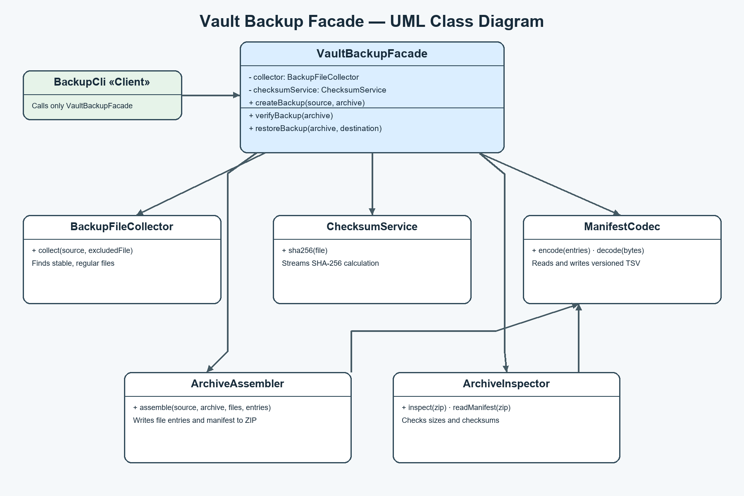
Figure 1. Main Facade and subsystem relationships.

3. Clean Code Principles
The excerpts below show how the implementation makes the simplified API readable, keeps responsibilities focused, hides coordination details, and handles failures explicitly.

3.1 Meaningful names
Operation names describe the user-visible result and their parameters communicate the input and output roles.
Before / after
// Before
void run(Path a, Path b)
// After
void createBackup(Path sourceDirectory, Path archive)

3.2 Single Responsibility
The facade coordinates the workflow. It delegates collection, hashing, and archive writing instead of implementing those algorithms itself.
Before / after
// Before: one class owns every operation
byte[] hash = digest(file);
zip.putNextEntry(entry); copy(file, zip);
// After: facade delegates each responsibility
List<Path> files = collector.collect(source, target);
String hash = checksumService.sha256(file);
assembler.assemble(source, target, files, entries);

3.3 Hide subsystem details
Clients call a small, stable facade API and do not construct or sequence the subsystem objects.
Before / after
// Before: client coordinates internals
collector.collect(source, archive);
checksums.sha256(file);
assembler.assemble(source, archive, files, entries);
// After: client asks for the operation
new VaultBackupFacade().createBackup(source, archive);

3.4 Small, focused classes
Subsystem classes expose one cohesive job. BackupFileCollector finds eligible files; ChecksumService computes SHA-256. The facade reuses these independent classes rather than merging their work into one large method.
Before / after
// Before: a mixed-purpose helper
List<Path> handle(Path root) { /* walk, hash, zip */ }
// After: focused APIs
List<Path> collect(Path source, Path excludedFile);
String sha256(Path file);

3.5 Explicit error handling
Invalid input, missing manifests, malformed rows, and failed verification remain visible to the caller. Verification also returns a structured result that identifies each mismatch.
Before / after
// Before: hides failure
try { verify(archive); } catch (Exception ignored) { return true; }
// After: preserve failure and report details
VerificationReport report = backup.verifyBackup(archive);
if (!report.valid()) throw new IOException(String.join("; ", report.problems()));

4. Conclusion
VaultBackupFacade hides the sequence of file collection, checksum calculation, manifest serialization, ZIP creation, and verification. It also keeps archive-format decisions away from the client. The public subsystem classes remain available for advanced clients that need direct control, and they do not know that the facade exists. The command-line client demonstrates the intended simple path by calling only VaultBackupFacade.
GitHub repository: https://github.com/ramazanutegen583-pixel/facade-pattern-vault-backup

