Strategy Calculator Assignment Report
  - Assignment 5 Software Design Patterns Java 17
24 October 2026

1 Introduction
This project uses the assignment's suggested Calculator topic. Addition, subtraction, multiplication, and division form a family of interchangeable algorithms. Calculator stores a CalculationStrategy and delegates calculation through that contract. CalculatorDemo selects strategies and replaces them on one context at runtime.
BigDecimal operands preserve exact decimal addition, subtraction, and multiplication. Division uses DECIMAL64: 16 significant digits with HALF_EVEN rounding. A zero divisor raises ArithmeticException. The console client catches the expected error and continues; it needs no arguments or interactive input.

Pattern participants
Role | Types and responsibility
Client | CalculatorDemo creates and selects concrete strategies and presents results.
Context | Calculator stores one CalculationStrategy and delegates each calculation.
Strategy interface | CalculationStrategy declares one common calculate operation.
Concrete strategies | AdditionStrategy, SubtractionStrategy, MultiplicationStrategy, DivisionStrategy.
Tests | CalculatorTest checks the context contract; StrategyTest checks arithmetic variants.

Visible runtime switching
One no-argument run prints the client's strategy choice, operands, delegation action, and result. With the same operands 20 and 4, changing the strategy produces 24, 16, 80, and 5. The run also demonstrates exact decimals, a recurring quotient, a rejected zero divisor, recovery, and switching back.
The Markdown reflection is included as reports/strategy-pattern-report.md. This Word version includes a larger UML page and a source declaration appendix.

2 Complete UML Class Diagram
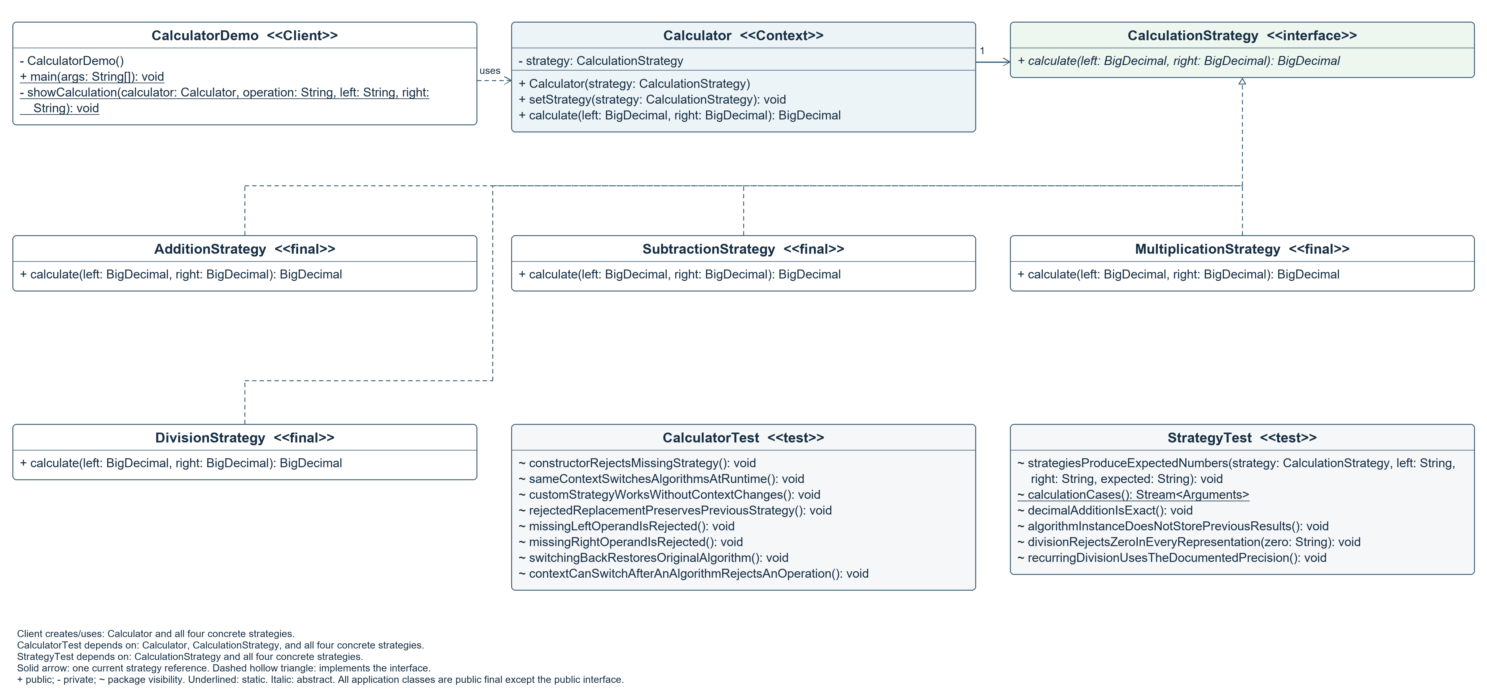
Figure 1. All authored Java types: 6 application classes, 1 interface, and 2 test classes. Static methods are underlined; the abstract interface operation is italic. The mutable strategy field supports replacing the one current strategy. Dashed hollow triangles show realization; other client/test dependencies are listed as notes to avoid crossing member text. They are also explicit in the editable PlantUML source.
Source inventory: 8 classes, 1 interface, 1 field, 23 methods, and 2 explicit constructors. Parameters appear in signatures; local declarations are listed in Appendix A. Library types and implicit constructors are outside the authored-type count.

3 Clean Code Chapters 9 10 and 11
The following seven applications use the requested chapters. Excerpts are annotated versions of the submitted implementation. Names also reveal each algorithm, while the counted principles focus on tests, classes, and system construction.

Readable tests
Chapter 9 Unit Tests. Tests make the setup, action, and expected result visible. customStrategyWorksWithoutContextChanges uses one small scenario to prove delegation. This follows the Build Operate Check structure.
// Build: inject a predictable algorithm.
Calculator calculator = new Calculator((left, right) -> new BigDecimal("42"));
// Operate.
BigDecimal result = calculator.calculate(BigDecimal.ONE, BigDecimal.TEN);
// Check.
assertEquals(new BigDecimal("42"), result);

Independent and repeatable tests
Chapter 9 Unit Tests. Each test creates its own context or stateless strategy. Tests use fixed numbers and no network, files, clock, or random input. JUnit makes success automatic. This applies the fast, independent, repeatable, and self validating parts of FIRST; no claim of a complete TDD process is made.
// A fresh object prevents dependence on an earlier test.
Calculator calculator = new Calculator(new AdditionStrategy());
assertThrows(NullPointerException.class,
() -> calculator.calculate(null, BigDecimal.ONE));

Small classes with one responsibility
Chapter 10 Classes. Each concrete strategy implements one arithmetic algorithm. Calculator coordinates delegation and null checks; CalculatorDemo selects strategies and presents results. Algorithm names reveal their purpose, and arithmetic classes contain no console presentation.
// AdditionStrategy owns only the addition algorithm.
public BigDecimal calculate(BigDecimal left, BigDecimal right) {
return left.add(right);
}

Clean Code continued

Organizing for change
Chapter 10 Classes. DivisionStrategy was added after the original three strategies. Git history shows that Calculator, CalculationStrategy, and the three existing algorithm classes stayed unchanged. The client composition and tests were updated to select and exercise the new strategy.
// New implementation; the context does not change.
public BigDecimal calculate(BigDecimal left, BigDecimal right) {
return left.divide(right, MathContext.DECIMAL64);
}

Isolating the context from concrete algorithms
Chapter 10 Classes. Calculator depends on CalculationStrategy. Its calculation method performs the same delegation for every operation. There is no if, switch, instanceof, or strategy type name in the context. Polymorphism replaces conditional algorithm selection.
// Calculator knows the contract, not a concrete algorithm.
private CalculationStrategy strategy;
// After shared operand checks:
return strategy.calculate(left, right);

Separate construction from use
Chapter 11 Systems. CalculatorDemo is the composition root: it constructs concrete strategies and injects them. Calculator receives a ready strategy through its constructor or setter and never creates concrete algorithms. Runtime switching replaces the reference on the same context.
Calculator calculator = new Calculator(new AdditionStrategy());
calculator.setStrategy(new SubtractionStrategy());
calculator.setStrategy(new MultiplicationStrategy());

Testable system boundaries through injection
Chapter 11 Systems. A small strategy contract lets a test replace arithmetic with a deterministic lambda. The context can therefore be tested independently from actual arithmetic. Manual injection is enough for this small application; a dependency injection framework would add unnecessary setup.
// Any implementation of the contract can be injected.
Calculator calculator = new Calculator((left, right) -> new BigDecimal("42"));

4 Live Demonstration
Run CalculatorDemo.main() without arguments. The same context produces 24, 16, 80, and 5 for operands 20 and 4 as the client selects addition, subtraction, multiplication, and division. Additional examples cover decimals, negatives, repeating division, division by zero, recovery, and switching back to addition.
Same operands 20 and 4 on one context
Addition Result: 24
Subtraction Result: 16
Multiplication Result: 80
Division Result: 5
Rejected as expected: Division by zero
Division after rejection: 9 and 3 -> 3
Switch back to addition: 20 and 4 -> 24
DEMONSTRATION COMPLETED SUCCESSFULLY

Validation
On 24 October 2026, Maven verify with JDK 17 passed all 30 JUnit cases with zero failures, errors, or skipped cases. Two packaged JAR runs produced identical 62-line output. The Windows launcher also compiled the production classes and completed the same demonstration. A source audit confirmed that the context contains no strategy-selection branches or concrete strategy references.
Coverage | Evidence
Algorithms | Positive, negative, decimal, and zero operands for all four strategies.
Context | Runtime switching, custom injected algorithm, null rejection, previous strategy preserved.
Division | Three representations of zero rejected; 1/3 rounded to the documented precision.
Execution | Two matching JAR runs and the JDK-only Windows launcher.
Structure | No algorithm selection branches or concrete strategy references inside Calculator.

5 Conclusion
Strategy moves each arithmetic algorithm into an interchangeable object. Runtime switching changes behavior without replacing the Calculator or editing its delegation logic. The cost is more small classes and explicit client configuration. For a tiny calculator a direct expression would be shorter; the separate classes make the variation point and extension behavior visible for this assignment. The context is mutable and intended for sequential use.

Repository
https://github.com/ramazanutegen583-pixel/strategy-pattern-calculator

References
Robert C. Martin. Clean Code. 2008. Chapters 9, 10, and 11. Publisher contents: https://www.informit.com/store/clean-code-a-handbook-of-agile-software-craftsmanship-9780132350884
Assignment 5 Strategy Pattern Instructions and the supplied chapter requirement.

Appendix A Complete source register
The JDK compiler tree API extracted the declarations from all Java files under src. The table includes the strategy interface and both test classes. Interface calculate is implicitly public abstract; default constructors generated by Java are not explicit source declarations.
Type | Kind | Fields | Methods | Constructors
AdditionStrategy | class | 0 | 1 | 0
CalculationStrategy | interface | 0 | 1 | 0
DivisionStrategy | class | 0 | 1 | 0
MultiplicationStrategy | class | 0 | 1 | 0
SubtractionStrategy | class | 0 | 1 | 0
CalculatorDemo | class | 0 | 2 | 1
Calculator | class | 1 | 2 | 1
CalculatorTest | class | 0 | 8 | 0
StrategyTest | class | 0 | 6 | 0

Local variable register
These are all 25 method-local and lambda parameter declarations. Regular method parameters already appear in UML signatures. Inferred lambda types are identified. The source inventory also records method annotations, paths, line numbers, and SHA-256 hashes.
Class and method | Local declarations
CalculatorDemo.main | calculator: Calculator (L20); exception: ArithmeticException (L45)
CalculatorDemo.showCalculation | result: BigDecimal (L59)
CalculatorTest.sameContextSwitchesAlgorithmsAtRuntime | calculator: Calculator (L21); left: BigDecimal (L22); right: BigDecimal (L23)
CalculatorTest.customStrategyWorksWithoutContextChanges | calculator: Calculator (L34); left: inferred (L34); right: inferred (L34); result: BigDecimal (L36)
CalculatorTest.rejectedReplacementPreservesPreviousStrategy | calculator: Calculator (L43)
CalculatorTest.missingLeftOperandIsRejected | calculator: Calculator (L52)
CalculatorTest.missingRightOperandIsRejected | calculator: Calculator (L58)
CalculatorTest.switchingBackRestoresOriginalAlgorithm | calculator: Calculator (L64); result: BigDecimal (L68)
CalculatorTest.contextCanSwitchAfterAnAlgorithmRejectsAnOperation | calculator: Calculator (L75); result: BigDecimal (L80)
StrategyTest.strategiesProduceExpectedNumbers | result: BigDecimal (L22)
StrategyTest.decimalAdditionIsExact | strategy: CalculationStrategy (L50); result: BigDecimal (L52)
StrategyTest.algorithmInstanceDoesNotStorePreviousResults | strategy: CalculationStrategy (L59); result: BigDecimal (L62)
StrategyTest.divisionRejectsZeroInEveryRepresentation | strategy: CalculationStrategy (L70)
StrategyTest.recurringDivisionUsesTheDocumentedPrecision | strategy: CalculationStrategy (L77); result: BigDecimal (L79)

Editable UML: docs/class-diagram.puml. Full text: docs/uml-inventory.md. Machine-readable declarations: docs/code-inventory.json.

