ShopSmart: Your Digital Grocery Store Experience

our basic grocery-web app! Our app is designed to provide a seamless online shopping experience for customers, making it convenient for them to explore and purchase a wide range of products. Whether you are a tech enthusiast, a fashionista, or a homemaker looking for everyday essentials, our app has something for everyone.

With user-friendly navigation and intuitive design, our grocery-webapp app allows customers to browse through various categories, view product details, add items to their cart, and securely complete the checkout process. We prioritize user satisfaction and aim to provide a smooth and hassle-free shopping experience.

Architecture

Technical Architecture:

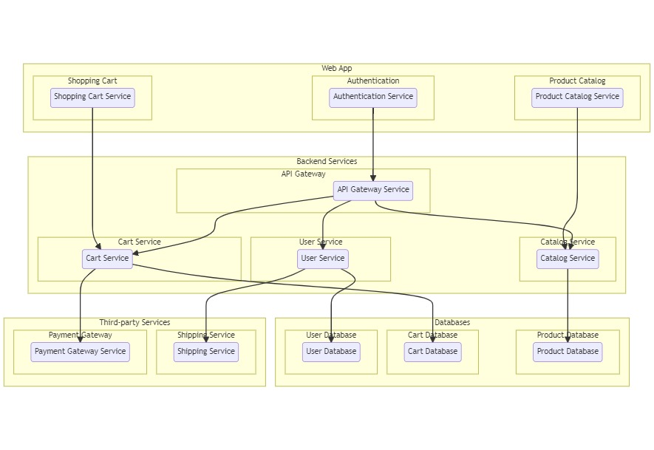

The technical architecture of an flower and gift delivery app typically involves a client-server model, where the frontend represents the client and the backend serves as the server. The frontend is responsible for user interface, interaction, and presentation, while the backend handles data storage, business logic, and integration with external services like payment gateways and databases. Communication between the frontend and backend is typically facilitated through APIs, enabling seamless data exchange and functionality.

ER Diagram:

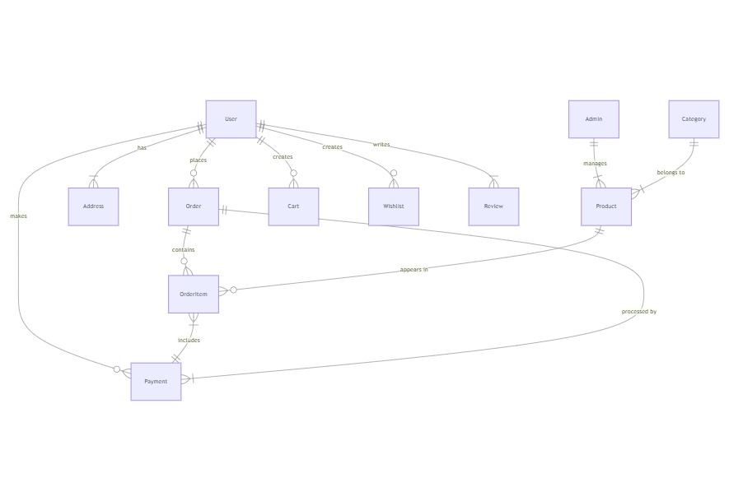

The Entity-Relationship (ER) diagram for an flower and gift delivery app visually represents the relationships between different entities involved in the system, such as users, products, orders, and reviews. It illustrates how these entities are related to each other and helps in understanding the overall database structure and data flow within the application.

Project Structure

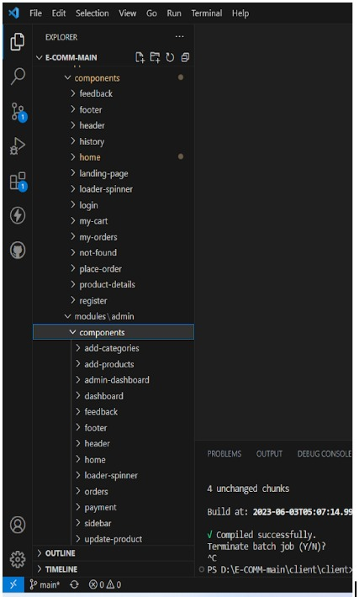

This structure assumes an Angular app and follows a modular approach. Here's a brief explanation of the main directories and files:

src/app/components: Contains components related to the customer app, such as register, login, home, products, my-cart, my-orders, placeorder, history, feedback, product-details, and more.

src/app/modules: Contains modules for different sections of the app. In this case, the admin module is included with its own set of components like add-category, add-product, dashboard, feedback, home, orders, payment, update-product, users, and more.

src/app/app-routing.module.ts: Defines the routing configuration for the app, specifying which components should be loaded for each route.

src/app/app.component.ts, src/app/app.component.html, `src.

Pre-requisites

To develop a full-stack Grocery web app using AngularJS, Node.js, and MongoDB, there are several prerequisites you should consider. Here are the key prerequisites for developing such an application:

Node.js and npm: Install Node.js, which includes npm (Node Package Manager), on your development machine. Node.js is required to run JavaScript on the server side.

Download: https://nodejs.org/en/download/

Installation instructions: https://nodejs.org/en/download/package-manager/

MongoDB: Set up a MongoDB database to store hotel and booking information. Install MongoDB locally or use a cloud-based MongoDB service.

Download: https://www.mongodb.com/try/download/community

Installation instructions: https://docs.mongodb.com/manual/installation/

Express.js: Express.js is a web application framework for Node.js. Install Express.js to handle server-side routing, middleware, and API development.

Installation: Open your command prompt or terminal and run the following command: npm install express

Angular: Angular is a JavaScript framework for building client-side applications. Install Angular CLI (Command Line Interface) globally to create and manage your Angular project.

Install Angular CLI:

Angular provides a command-line interface (CLI) tool that helps with project setup and development.

Install the Angular CLI globally by running the following command:

npm install -g @angular/cli

Verify the Angular CLI installation:

Run the following command to verify that the Angular CLI is installed correctly: ng version

You should see the version of the Angular CLI printed in the terminal if the installation was successful.

Create a new Angular project:

Choose or create a directory where you want to set up your Angular project.

Open your terminal or command prompt.

Navigate to the selected directory using the cd command.

Create a new Angular project by running the following command: ng new client Wait for the project to be created:

The Angular CLI will generate the basic project structure and install the necessary dependencies

Navigate into the project directory:

After the project creation is complete, navigate into the project directory by running the following command: cd client

Start the development server:

To launch the development server and see your Angular app in the browser, run the following command: ng serve / npm start

The Angular CLI will compile your app and start the development server.

Open your web browser and navigate to http://localhost:4200 to see your Angular app running.

You have successfully set up Angular on your machine and created a new An- gular project. You can now start building your app by modifying the generated project files in the src directory.

Please note that these instructions provide a basic setup for Angular. You can explore more ad- vanced configurations and features by referring to the official Angular documentation: https://angular.io

HTML, CSS, and JavaScript: Basic knowledge of HTML for creating the structure of your app, CSS for styling, and JavaScript for client-side interactivity is essential.

Database Connectivity: Use a MongoDB driver or an Object-Document Mapping (ODM) library like Mongoose to connect your Node.js server with the MongoDB database and perform CRUD (Create, Read, Update, Delete) operations.

Front-end Framework: Utilize Angular to build the user-facing part of the application, including products listings, booking forms, and user interfaces for the admin dashboard.

Version Control: Use Git for version control, enabling collaboration and tracking changes throughout the development process. Platforms like GitHub or Bitbucket can host your repository.

Git: Download and installation instructions can be found at: https://git-scm.com/downloads

Development Environment: Choose a code editor or Integrated Development Environment (IDE) that suits your preferences, such as Visual Studio Code, Sublime Text, or WebStorm.

Visual Studio Code: Download from https://code.visualstudio.com/download

Sublime Text: Download from https://www.sublimetext.com/download

WebStorm: Download from https://www.jetbrains.com/webstorm/download

To Connect the Database with Node JS go through the below provided link:

• Link: [https://www.section.io/engineering-education/nodejs- mongoosejs-mongodb/](https://www.section.io/engineering-education/nodejs-%20mongoosejs-mongodb/)

Git Repository Cloning

To run the existing grocery-web app project downloaded from github:

Follow below steps:

1. Clone the Repository:

Open your terminal or command prompt.

Navigate to the directory where you want to store the grocery-webapp app.

Execute the following command to clone the repository:

git clone https://github.com/Bharath136/grocery-webapp

2. Install Dependencies:

Navigate into the cloned repository directory:

cd grocery-webapp

Install the required dependencies by running the following command:

npm install

3. Start the Development Server:

To start the development server, execute the following command:

npm run dev or npm run start

The e-commerce app will be accessible at http://localhost:5100 by default. You can change the port configuration in the .env file if needed.

4. Access the App:

Open your web browser and navigate to http://localhost:5100.

You should see the grocery-webapp app's homepage, indicating that the installation and setup were successful.

Video Tutorial Link to clone the project: - https://drive.google.com/file/d/1KTGK0XZj0XWOiDeNKJVRKQHXLyVWZYLM/view?usp=sharing

Project Repository Link: https://github.com/Bharath136/grocery-webapp

Congratulations! You have successfully installed and set up the grocery-webapp app on your local machine. You can now proceed with further customization, development, and testing as needed.

Role Based Access

Roles of Admin and User can be defined for an online grocery web application

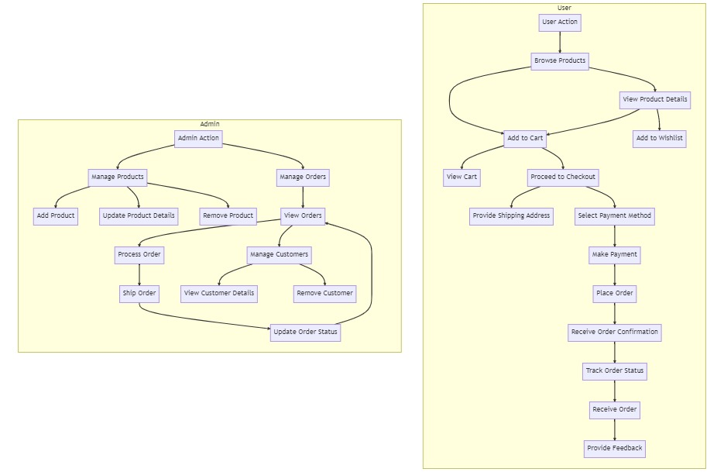

Admin Role

1-Admin Role:

Responsibilities: The admin role has full control and administrative privileges over the system.

Permissions:

Manage: Admins can add, edit, and delete shop information along with products.

Manage product bookings: Admins can view and manage all product bookings made by users and agents, including canceling or modifying product bookings.

Manage users: Admins can create, edit, and delete user accounts, as well as manage their roles and permissions.

Generate reports: Admins have access to generate reports and analytics on product booking details, booking counts, and sales reports.

User Role

2-User Role:

Responsibilities: Users are the customers of the online shopping web application who can search for products, and make product bookings.

Permissions:

View products: Users can search for products, based on interest.

Product bookings: Users can select products that are available and complete the order process.

Manage product booking: Users can view their own product order bookings, modify booking details, track booking details, and cancel their bookings

Manage cart: Users can view their cart details and modify them if needed.

Project Flow

Frontend Development

Backend Development

Integration

Demo link:-

https://drive.google.com/file/d/1HLowcIqs2d8lxTprS2jqPmR4AOnUW8xD/view?usp=drive_link

Use the code in:-

<https://drive.google.com/drive/folders/1RP-29p9mf-bbLAK5r7S4HSF_Itai0i1G?usp=drive_link>

Frontend Development

Frontend development involves building the user interface (UI) and implementing the visual elements of the online shopping web application. It focuses on creating an intuitive and engaging user experience that allows users to interact with the application seamlessly.

To Setup the frontend development and to connect node.js with MongoDB Database Go through this video link: -

<https://drive.google.com/file/d/1b5bMvnqmASXLnSZ74B2t3EzNjuWHj63g/view?usp=drive_link>

User Interface (UI) Design

Create a visually appealing and consistent design using modern design principles.

Use a UI design tool like Adobe XD, Sketch, Figma, or InVision to create wireframes and mockups.

Pay attention to typography, color schemes, spacing, and visual hierarchy.

Use responsive design techniques to ensure the app looks great on different devices.

Responsive Design

Utilize CSS media queries and responsive design frameworks like Bootstrap or Tailwind CSS to create a responsive layout.

Test your app on various devices and screen sizes to ensure a seamless user experience.

Product Catalog

Design and implement a product listing page that displays product images, titles, descriptions, prices, and other relevant details.

Implement search functionality to allow users to find products easily.

Include filters and sorting options to enhance the browsing experience.

Shopping Cart and Checkout Process

Design and develop a shopping cart component to allow users to add products, view cart contents, update quantities, and remove items.

Create a checkout process with multiple steps, including shipping information, payment selection, and order review.

Shopping Cart and Checkout Process

Design and develop a shopping cart component to allow users to add products, view cart contents, update quantities, and remove items.

Create a checkout process with multiple steps, including shipping information, payment selection, and order review.

User Authentication and Account Management

Design and implement a user registration and login system.

Create user profile pages where users can view and edit their personal information, addresses, payment methods, and order history.

Implement authentication guards to restrict access to certain pages or features.

Payment Integration

Integrate with a payment gateway service like Stripe, PayPal, or Braintree.

Implement a secure and seamless payment flow that allows users to enter payment details and complete transactions.

Handle transaction success and failure scenarios and provide appropriate feedback to the user.

Backend Development

Backend development involves building the server-side components and logic of the online shopping web application. It focuses on handling the business logic, processing requests from the front end, and interacting with the database. The following activities are part of the backend development process:

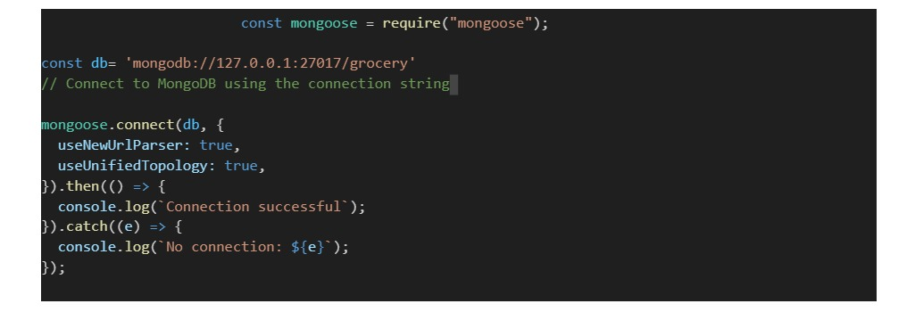

Set Up Backend

Set Up Project Structure:

Create a new directory for your project and set up a package.json file using npminit command.

Install necessary dependencies such as Express.js, Mongoose, and other required packages.

Database Configuration:

Set up a MongoDB database either locally or using a cloud-based MongoDB service like MongoDB Atlas.

Create a database and define the necessary collections for hotels, users, bookings, and other relevant data.

Create Express.js Server:

Set up an Express.js server to handle HTTP requests and serve API endpoints.

Configure middleware such as body-parser for parsing request bodies and cors for handling cross-origin requests.

Define API Routes:

Create separate route files for different API functionalities such as hotels, users, bookings, and authentication.

Define the necessary routes for listing hotels, handling user registration and login, managing bookings, etc.

Implement route handlers using Express.js to handle requests and interact with the database.

Implement Data Models:

Define Mongoose schemas for the different data entities like hotels, users, and bookings.

Create corresponding Mongoose models to interact with the MongoDB database.

Implement CRUD operations (Create, Read, Update, Delete) for each model to perform database operations.

API Design and Development:

Identify the necessary functionality and data required by the frontend.

Design a set of RESTful APIs using a framework like Express.js or Django REST Framework.

Define API endpoints for user management, product catalog, shopping cart, order management, payment gateway integration, shipping integration, etc.

Implement the API routes, controllers, and data models to handle the corresponding operations.

Ensure that the APIs follow best practices, are secure, and provide appropriate responses.

User Management and Authentication:

Implement user registration and login functionality.

Choose an authentication mechanism like session-based authentication or token-based authentication (e.g., JWT).

Store and hash user credentials securely.

Implement middleware to authenticate API requests and authorize access to protected routes.

Product Catalog and Inventory Management:

Design the database schema to store product details, pricing, availability, and inventory levels.

Create APIs to retrieve product information, update inventory quantities, and handle search and filtering.

Implement validations to ensure data integrity and consistency.

Shopping Cart and Order Management:

Design the database schema to store shopping cart details and order information.

Create APIs to handle cart operations like adding items, modifying quantities, and placing orders.

Implement logic to calculate totals, apply discounts, and manage the order lifecycle.

Payment Gateway Integration:

Choose a suitable payment gateway provider (e.g., Stripe, COD).

Integrate the payment gateway SDK or API to handle secure payment processing.

Implement APIs or callback endpoints to initiate transactions, handle payment callbacks, and receive payment confirmation.

Shipping and Logistics Integration:

Identify shipping and logistics providers that align with your application's requirements.

Utilize the APIs provided by these providers to calculate shipping costs, generate shipping labels, and track shipments.

Implement APIs or services to fetch rates, generate labels, and obtain tracking information.

Database Integration:

Choose a suitable database technology (e.g., MySQL, PostgreSQL, MongoDB) based on your application's requirements.

Design the database schema to efficiently store and retrieve flower and gift delivery data.

Establish a connection to the database and handle data persistence and retrieval.

External Service Integration:

Identify third-party services like email service providers, analytics services, or CRM systems that are required for your application.

Utilize the APIs or SDKs provided by these services to exchange data and perform necessary operations.

Implement the integration logic to send order confirmations, track user behavior, or manage customer relationships.

Security and Data Protection:

Apply appropriate security measures like encryption techniques for secure data transmission and storage.

Implement input validation and sanitization to prevent common security vulnerabilities.

Implement access control to ensure authorized access to sensitive data.

Error Handling and Logging:

Implement error handling mechanisms to handle exceptions and provide meaningful error messages to the frontend.

Use logging frameworks to record application logs for monitoring and troubleshooting purposes.

Connect database to backend:



Integration

Integration is the process of combining and connecting the frontend and backend components of the online flower shop web application to create a unified and fully functional system. It involves establishing communication channels, exchanging data, and ensuring seamless interaction between the frontend UI and backend APIs. The following activities are part of the integration process:

Landing page:-

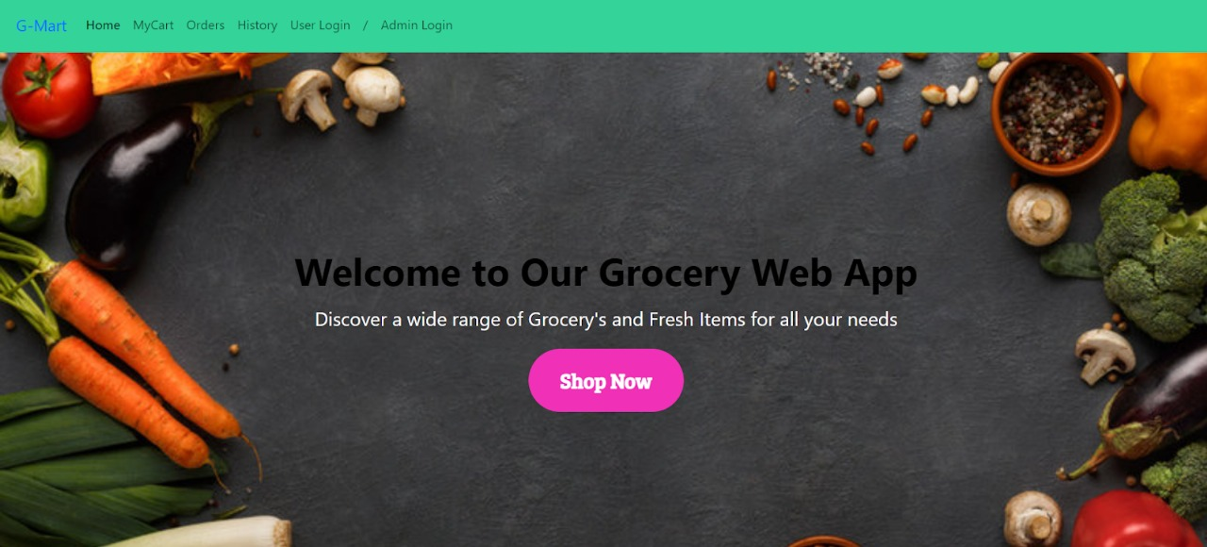

Login Page:-

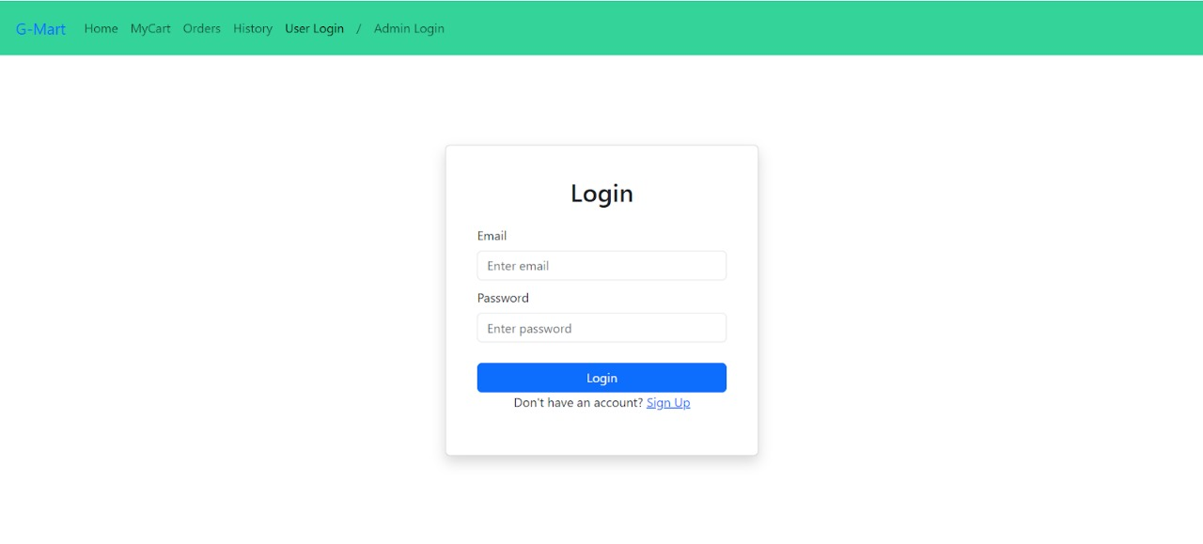

Items Page:-

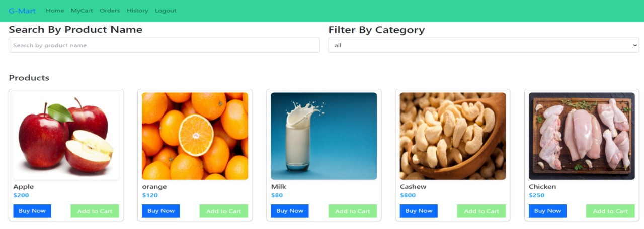

My Cart:-

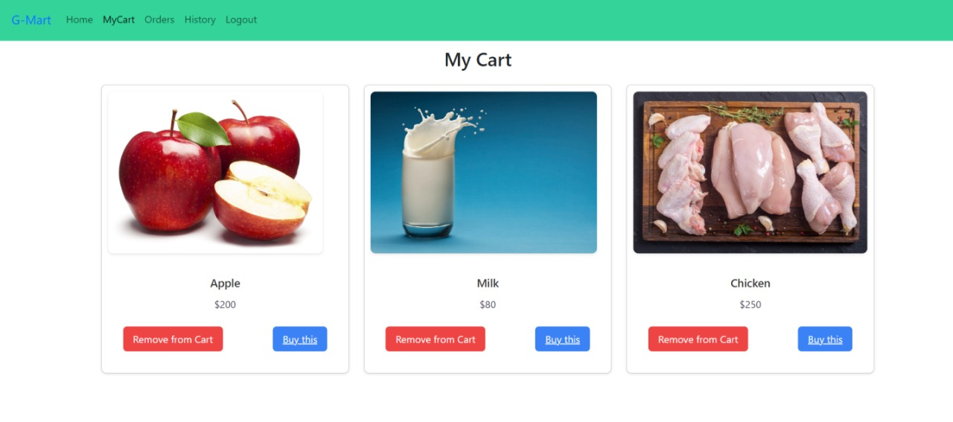

My Orders Page:-

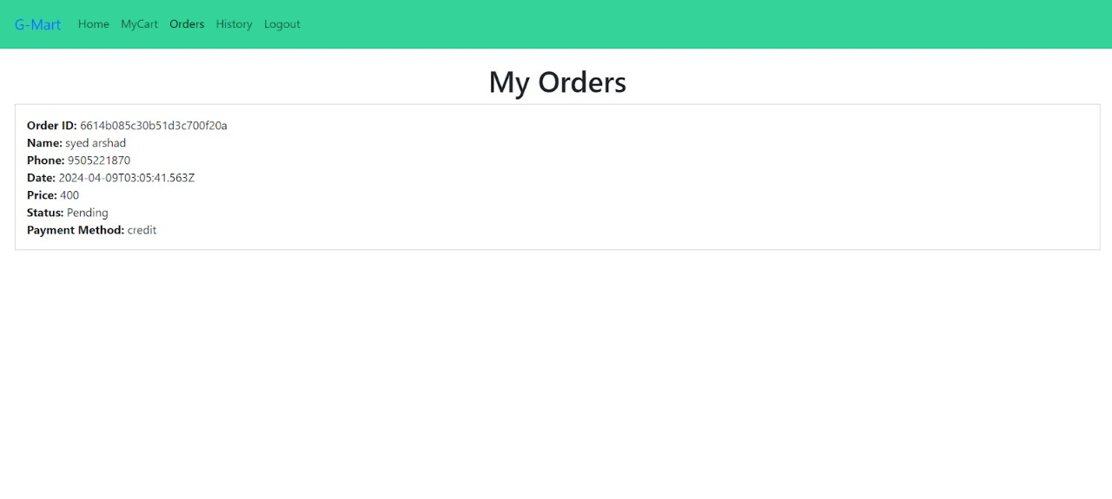

My History Page:-

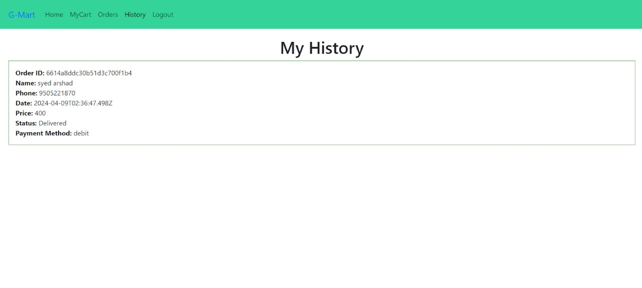

Place Order Page:-

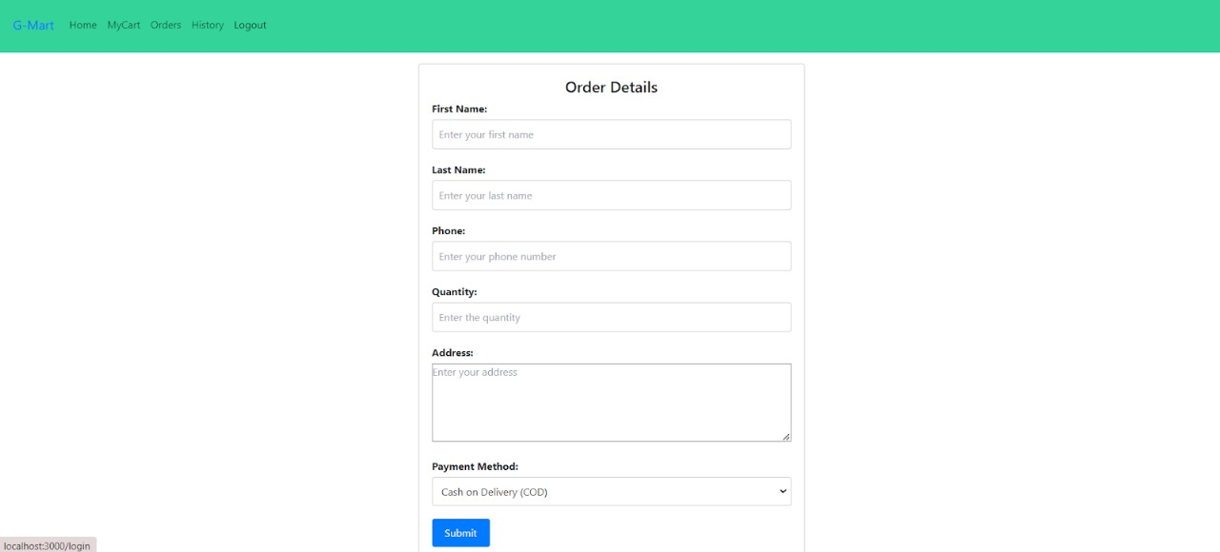

Users Page:-

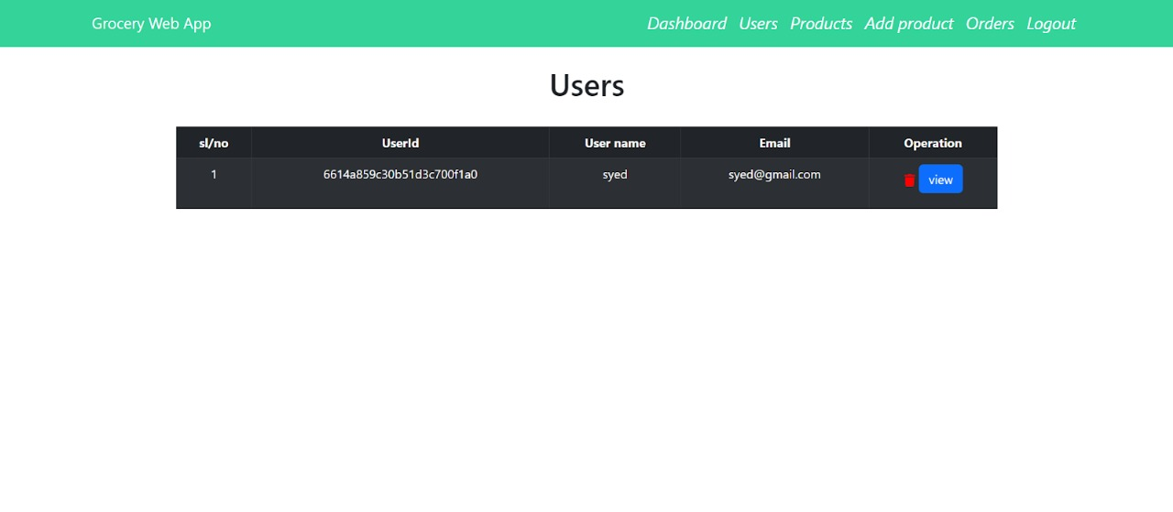

Add Product page:-

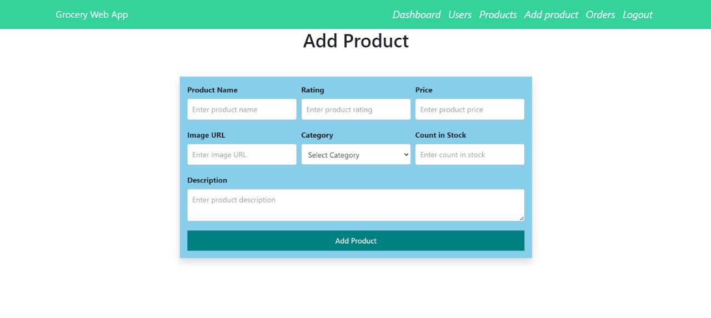

Admin Orders Page:-

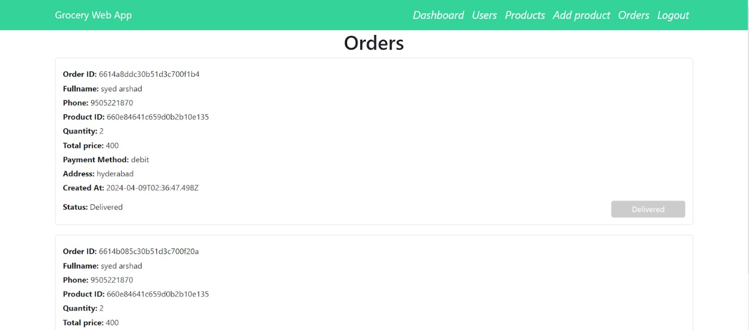

Frontend-Backend Integration

Integrate the frontend UI components with the backend APIs, ensuring proper communication and data exchange.

Implement API calls from the front end to retrieve the data.

Handle data validation and error responses between the frontend and backend components.

Conduct thorough testing to ensure seamless integration and compatibility between frontend and backend.