Corridor XI: JBS (New) - Shamirpet

# Traffic

Section Length: **22.0** km

Train Average Speed: **36.0** km/h

Train Composition: **['DMC', 'TC', 'DMC']**

Train Carrying Capacity (AW3 Load): **900**

|  |  |  |  |  |
| --- | --- | --- | --- | --- |
| **Item** | **2030** | **2035** | **2045** | **2055** |
| **Ridership** | 192000 | 240134 | 316800 | 373700 |
| **PHPDT** | 6790 | 8490 | 12000 | 14430 |
| **Headways in min** | 8.0 | 6.4 | 4.5 | 3.7 |
| **Nos. of train** | 10 | 13 | 18 | 22 |

# Transit Data Plot

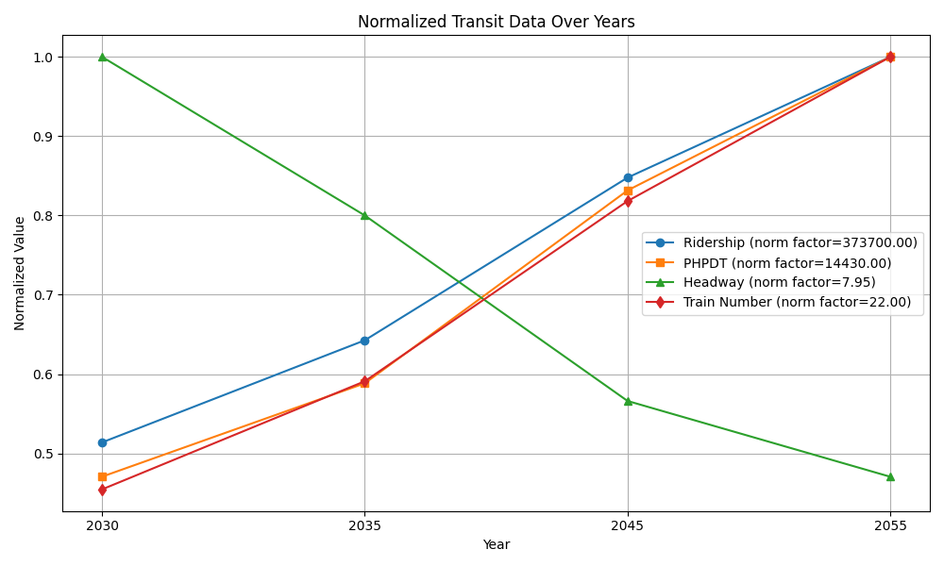

The above plot shows the normalized transit data over the specified years.

# Power

Specific Energy Consumption: **50.0** KWH/GTKM

Regeneration Percentage: **30.0** %

Losses in Traction Power: **5.0** %

Traction Power Factor: **0.95**

Number of Elevated Station: **14.0**

Number of Under Ground Station: **0.0**

Number of Depots: **0.0**

Losses in Auxiliary Power: **5.0** %

Auxiliary Power Factor: **0.95**

|  |  |  |  |  |
| --- | --- | --- | --- | --- |
| **Item** | **2030** | **2035** | **2045** | **2055** |
| **Traction Energy, MW** | 3.31 | 4.14 | 5.85 | 7.04 |
| **Traction Energy with loss & PF, MVA** | 3.68 | 4.32 | 5.65 | 6.57 |
| **Auxiliary Energy, MW** | 4.2 | 4.2 | 4.2 | 4.2 |
| **Auxiliary Energy with loss & PF, MVA** | 4.65 | 4.65 | 4.65 | 4.65 |
| **Total Power Requirement, MU** | 43.84 | 48.51 | 58.22 | 64.93 |
| **Maximum Demand** | 9 | 9 | 11 | 12 |