RAMBA PUN MAGAR  Curriculum Vitae  Email: ramapunmagar28@gmail.com  Phone: +977 982-9691414  Temporary Address: Nepalgunj, Banke  Permanent Address: Rukum (West) | 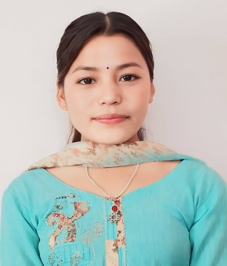

PERSONAL INFORMATION
Father's Name | Aaitaram Pun Magar
Mother's Name | Jhuma Pun Magar
Date of Birth | 11 June 2006 (28 Jestha, 2063 B.S.)
Gender | Female
Marital Status | Unmarried
Nationality | Nepali
Religion | Hindu
Languages Known | Nepali, English, Hindi
EDUCATIONAL QUALIFICATION
Level | Year | University / Institute | Percentage
10th (SEE) | 2077 (2021) | Shree Tribhuwan Secondary School | 87%
12th | 2080 (2023) | Shree Tribhuwan Secondary School | 80.75%
WORK EXPERIENCE
- 9-month On-the-Job Training (OJT) at Bardiya Institution and Sana Kisan Sahakari Sanstha, Bardiya.
HOBBIES & INTERESTS
- Coding
- Writing
DECLARATION
I hereby declare that the above-mentioned information is true and correct to the best of my knowledge and belief.
Ramba Pun Magar

