RAMBELENERGY.COM

Simple System Architecture
Professional Energy Analysis & Sustainability Intelligence Platform
Document Item | Details
Project | RamBelEnergy.com - Phase 1 Lean MVP
Architecture Purpose | Define the simple technical structure required to deliver the public website, lightweight CMS and basic AI prototype.
Solution Boundary | A professional starter platform; not a full RAG, SaaS or real-time energy intelligence system.
Technology Basis | Next.js, Supabase, Vercel and OpenAI/OpenRouter through a secured backend layer.
Timeline Basis | 4 weeks, subject to timely content, access and review feedback.
Status | Architecture baseline for implementation and client review.

Architecture principle: keep Phase 1 simple, secure and credible while preserving a clean path for future expansion.

Document Control
Item | Details
Document Name | Simple System Architecture - Phase 1
Related Documents | Phase 1 MVP Scope Document and Simple Requirement Document
Reference Basis | Phase 1 MVP Structure final - RamBelEnergy.com
Primary Audience | Client / project owner and delivery team
Architecture Scope | Public web application, admin CMS, content storage, basic AI prototype and deployment structure
Future Scope Note | RAG, vector database, document indexing and advanced SaaS components are excluded.

Contents
1. Architecture Objective and Scope
2. Architecture Principles
3. High-Level System Architecture
4. Component Responsibilities
5. Core Data and Storage Model
6. Main System Flows
7. Deployment and Environment Architecture
8. Security and Operational Controls
9. Architecture Exclusions and Future Expansion
10. Implementation Handover Checklist
Architecture Boundary
Phase 1 supports a credible content platform, a lightweight CMS and a basic AI demonstration. It deliberately avoids full knowledge-base ingestion, vector retrieval, automated data monitoring and complex user/account capabilities.

1. Architecture Objective and Scope
The Phase 1 system architecture establishes the minimum production-ready structure for RamBelEnergy.com: a clean public-facing website, a protected administration area for core content, and a limited AI summarization/assistant prototype routed securely through backend services.

1.1 Architecture Objectives
- Provide a stable technical foundation for the approved homepage, profile, news/analysis, article detail and research/publication pages.
- Enable authorized administration of articles, publications and agreed essential site content.
- Integrate basic AI summarization without exposing API credentials in the browser.
- Use managed cloud services suitable for a lean MVP and a four-week delivery period.
- Keep future AI/RAG and SaaS expansion feasible without building those capabilities in Phase 1.

2. Architecture Principles
Principle | Phase 1 Application
Lean by design | Only agreed features and services required for MVP delivery are implemented.
Content-first credibility | The public UI prioritizes research-style presentation and professional publishing structure.
Security by default | Admin features require authentication and AI/API secrets are processed server-side.
Managed infrastructure | Vercel and Supabase reduce operational complexity for the first release.
Growth-ready foundation | Database and API boundaries support later enhancement without prematurely implementing future scope.

3. High-Level System Architecture
The following diagram shows the Phase 1 application boundary and the relationship between visitors/admin users, the Next.js application, backend processing, Supabase services and the external AI provider.
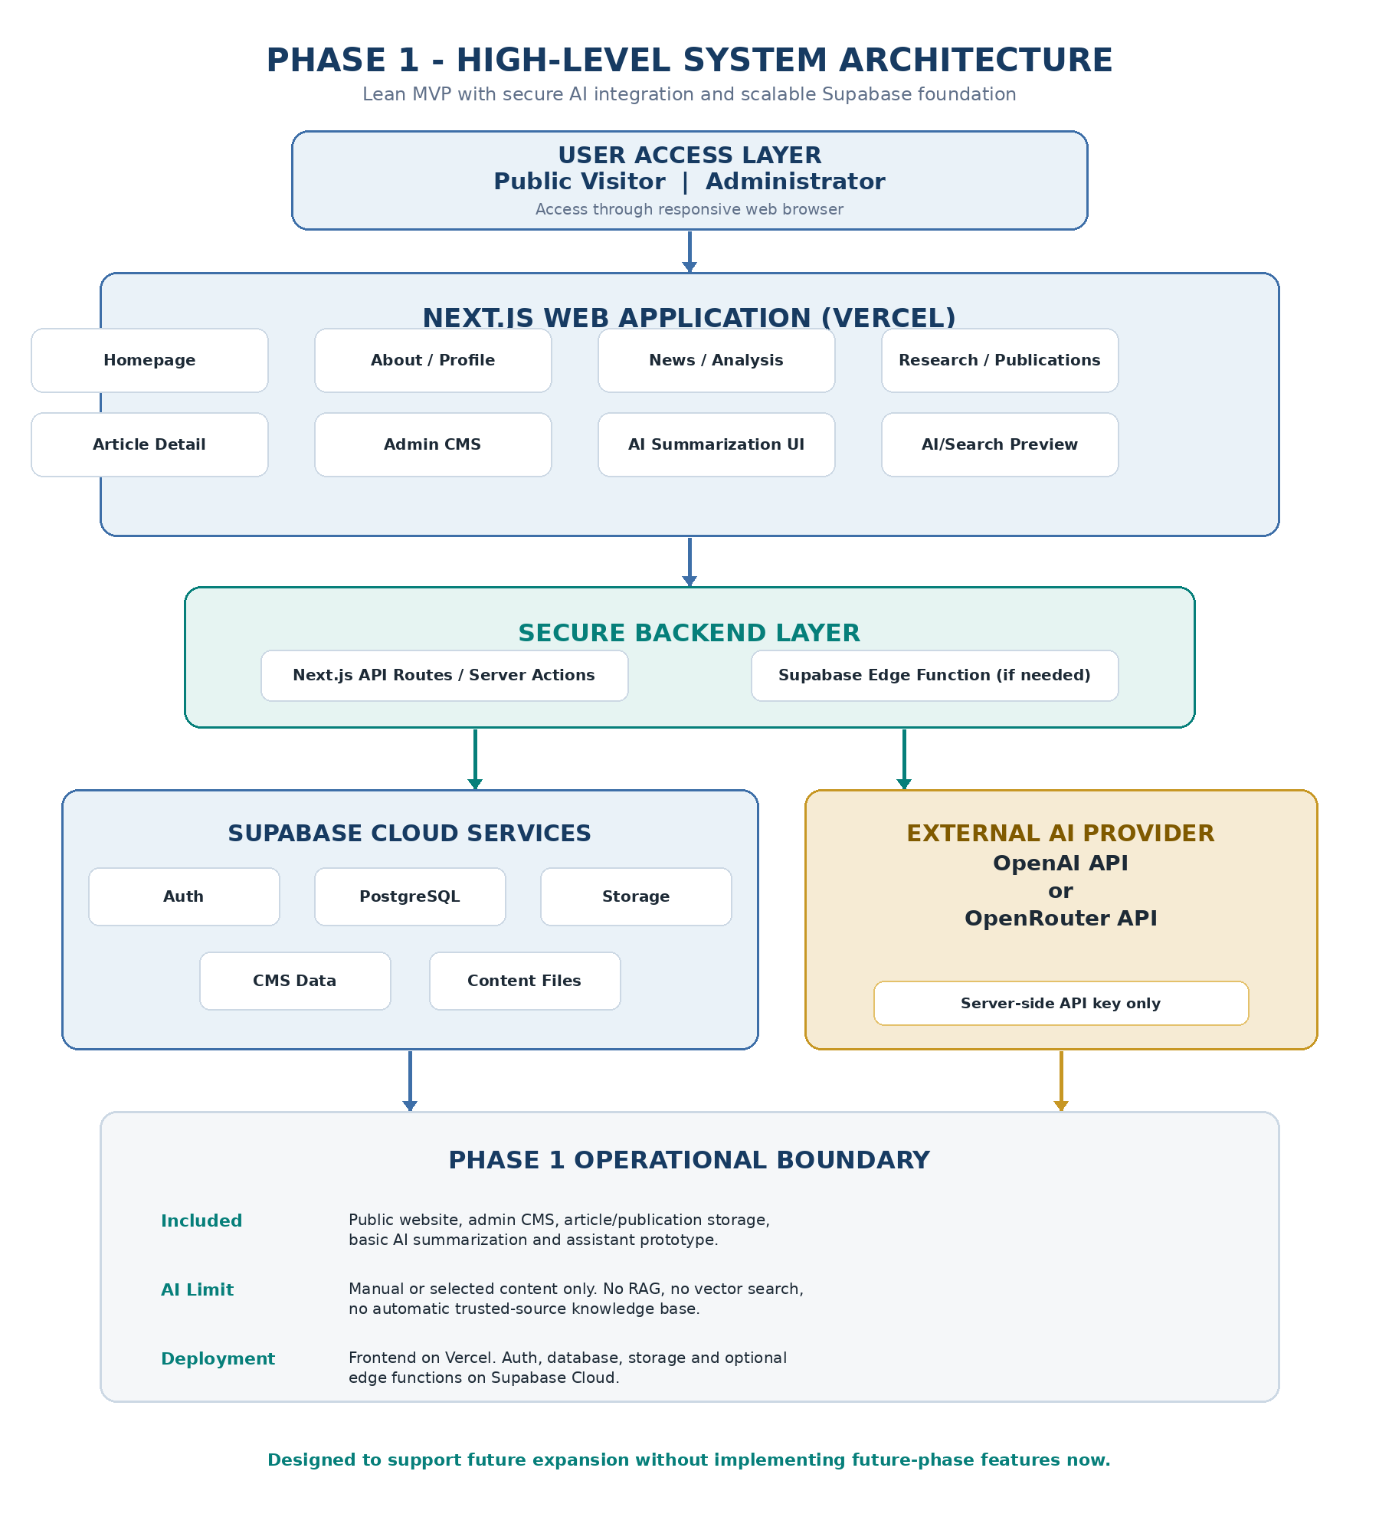
Figure 1. Phase 1 high-level architecture for the lean MVP.
Reading the Diagram
Visitors and administrators use the web application delivered through Vercel. Content and authentication are supported by Supabase. Basic AI requests pass through a secured backend layer before reaching OpenAI or OpenRouter. No vector retrieval or automated source ingestion is used in Phase 1.

4. Component Responsibilities
Component | Technology / Service | Responsibility
Web Frontend | Next.js / React / Tailwind CSS | Public pages; responsive UI; article and publication presentation; admin interface; AI prototype UI and future AI/Search preview.
Backend Layer | Next.js API Routes / Server Actions; Supabase Edge Functions if needed | Validates requests; applies access control; performs server-side data operations; securely calls AI provider APIs.
Authentication | Supabase Auth | Provides administrator login and protects content management actions.
Application Database | Supabase PostgreSQL | Stores article, publication and basic editable site content data.
File Storage | Supabase Storage | Stores supported uploaded publication/files or media assets when included in agreed content setup.
AI Provider | OpenAI API or OpenRouter API | Generates summaries and simple assistant responses from supplied/selected content.
Hosting / Runtime | Vercel and Supabase Cloud | Hosts the frontend and provides managed backend/database/auth/storage services.

5. Core Data and Storage Model
The database model remains deliberately small for the MVP. Exact field names may be refined during implementation, while retaining the following functional entities.
Entity | Primary Store | Minimum Data | Purpose
Admin User | Supabase Auth | Identifier, login identity, authentication state | Controls authorized CMS access.
Article / Analysis | PostgreSQL | Title, slug, author, date, category, content, optional source link, publishing status | Feeds News/Analysis listing and Article Detail pages.
Publication / Research | PostgreSQL + optional Storage | Title, summary/metadata, date, external URL or file reference | Feeds Research/Publications page.
Basic Site Content | PostgreSQL | Approved editable featured content or presentation blocks where included | Supports limited content updates without code modification.
AI Request Context | Server request; optional logging only if agreed | Selected article/manual text, prompt intent, response | Supports basic summarization/assistant prototype.

6. Main System Flows

6.1 Public Content Viewing Flow
- Visitor opens RamBelEnergy.com through a web browser.
- Next.js renders the requested public page and requests relevant published content.
- Published article/publication information is retrieved from Supabase PostgreSQL; files or supported assets are resolved from storage where applicable.
- Visitor views the institutional-style content experience on desktop or mobile.

6.2 Admin Content Management Flow
- Administrator signs in through Supabase Auth.
- Protected admin interface grants access only after successful authentication.
- Administrator creates, edits or deletes article/publication records through the backend/data access layer.
- Updated published content is reflected on the public pages.

6.3 Basic AI Request Flow
Phase 1 AI is intentionally limited to text selected or supplied within the platform workflow. It does not search a complete corpus of government, news or research sources.
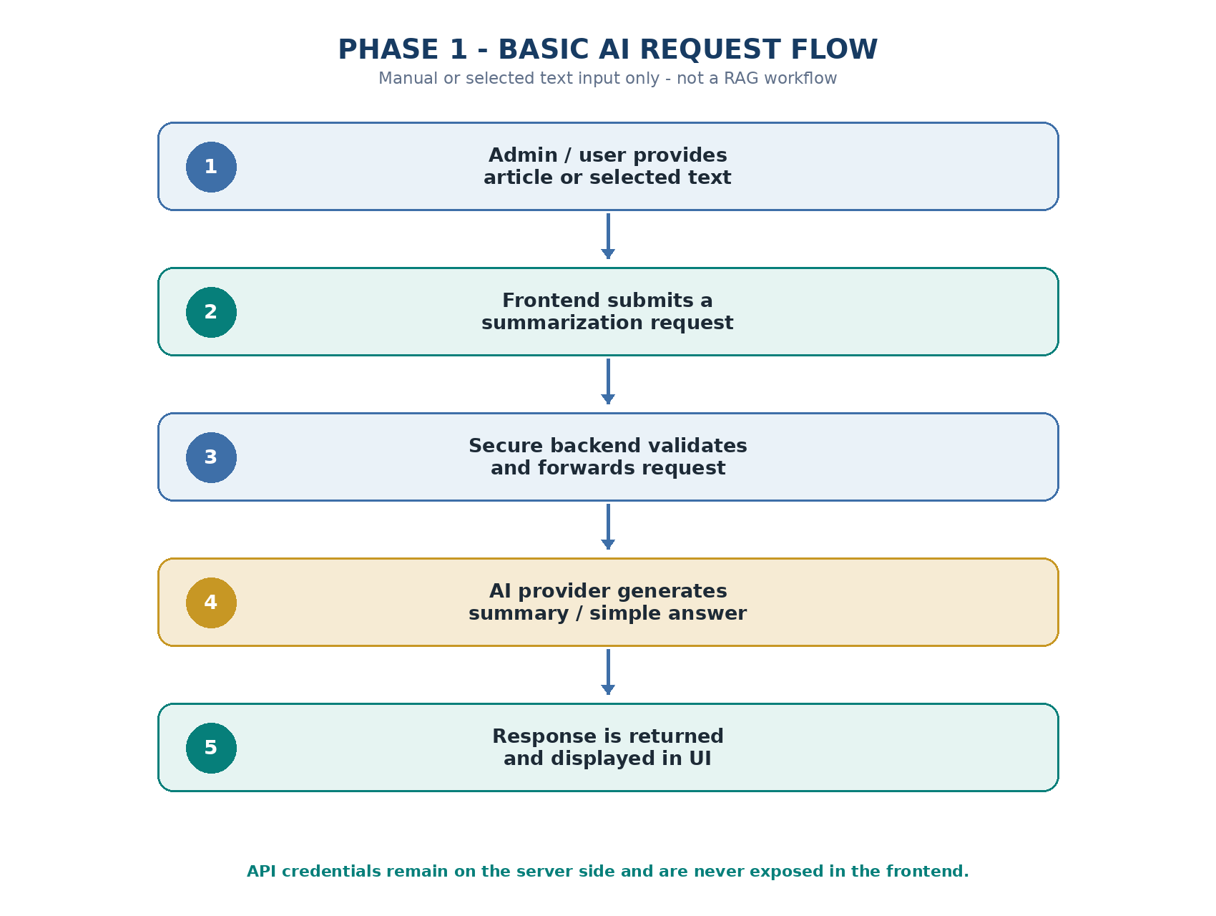
Figure 2. Basic AI summarization / simple assistant request flow.
Flow Step | System Responsibility | Phase 1 Control
Input | Accept article text or manually supplied/selected content for a supported AI action. | No bulk ingestion or automatic crawling.
Request Handling | Send request from UI to a secured backend/API endpoint. | AI provider key is not exposed to frontend.
Processing | Forward supported content and prompt direction to AI provider. | Basic summarization/simple answer only.
Response | Display generated result within the application prototype. | Output remains subject to editorial judgement.

7. Deployment and Environment Architecture
Environment | Components | Purpose / Notes
Local Development | Next.js local application; local Supabase via Docker; local PostgreSQL/Auth/Storage; optional local edge functions. | Developer implementation and testing. AI provider access still requires internet/API credentials.
Preview / Review | Vercel preview deployment with configured Supabase environment as agreed. | Client review of key milestones before production release.
Production | Vercel frontend; Supabase Cloud database/auth/storage/optional edge functions; configured external AI provider. | Final operational MVP deployment after review and approval.

7.1 Environment Configuration Requirements
- Separate environment variables must be used for public configuration values and secret server-side API keys.
- Required deployment/project access shall be provided or approved by the client before production setup.
- Third-party charges, including AI usage and paid hosting/tool subscriptions, are external to the Phase 1 build budget.

8. Security and Operational Controls
Control Area | Architecture Requirement
Authentication | Admin CMS routes and management actions require Supabase Auth session validation.
Authorization | Create/update/delete operations are restricted to authenticated administrative users.
Secret management | AI provider key and other secrets are stored in backend environment configuration, not exposed in client code.
Input handling | Backend endpoints validate supported inputs before database updates or AI provider requests.
Storage access | Publication/media storage access is configured according to the agreed public/private usage model.
Editorial responsibility | AI-generated output is treated as assisted/prototype content and reviewed before publication when used publicly.

9. Architecture Exclusions and Future Expansion
Excluded from Phase 1 | Future Architecture Direction
Full RAG workflow and vector database | Trusted-source ingestion, embedding pipeline, vector retrieval and cited answer generation may be developed in a later phase.
Large PDF/document indexing and PDF Q&A | A future document processing pipeline may ingest and extract research files.
Automated news crawling / real-time energy APIs | Future monitoring and data integration services may provide refreshed intelligence feeds.
Advanced dashboard, map and analytics | Future application modules may build on the existing data/application foundation.
Subscription, premium and enterprise access | Future identity/authorization and billing modules would be designed separately.
Multilingual and advanced translation workflow | Future internationalization and multilingual AI processing would require a separate requirement/design review.

Controlled Change Note
Additional sections such as tourism content, institutional/company logo showcases, or expanded editorial/curation workflows are not part of this architecture baseline unless separately reviewed and approved.

10. Implementation Handover Checklist
Deliverable / Item | Architecture Coverage | Handover Evidence
Source Code | Next.js frontend, backend/API handling and agreed CMS implementation. | Repository access and branch/release notes.
Supabase Configuration | Auth, database and storage structure required for Phase 1. | Project access and basic setup notes.
AI Integration Configuration | Secure server-side environment configuration for chosen AI provider. | Environment variable notes without exposing secret values.
Deployment | Vercel frontend and Supabase production services. | Deployed URL/access confirmation.
Admin Operation | Content management workflow for articles/publications. | Basic admin usage notes.
Scope Confirmation | Phase 1 implementation matches approved boundary. | Final review against MVP Scope and Requirements documents.

10.1 Architecture Approval Record
This approval page confirms that the architecture baseline is understood as a controlled Phase 1 MVP foundation. The delivered system is intended to support professional publishing, lightweight administration and a limited AI prototype within the agreed scope boundary.
Approval Basis
Approval of this document confirms the system boundary, core technology choices and Phase 1 exclusions. It does not authorize future-phase capabilities such as RAG, vector search, automated data ingestion or advanced analytics.

Items Confirmed for Phase 1
- Next.js public application with institutional content presentation and responsive layout.
- Supabase-backed authentication, article/publication data and agreed supporting storage.
- Secure server-side AI integration for basic summarization and simple assistant demonstration only.
- Vercel and Supabase Cloud deployment architecture with basic handover documentation.

Sign-off
Client / Project Owner | Development Provider
Name: Ramdane Belamri | Name: Moh Puji Junaedi
Signature: ___________________________ | Signature: ___________________________
Date: 25/05/2026 | Date: 25/05/2026

End of document - Phase 1 Simple System Architecture for RamBelEnergy.com.

