Installation

**Pre Requirements**

1. JDK 7 or latest should be installed on your pc.

**Installation commands:**

1. wget -q -O - https://pkg.jenkins.io/debian/jenkins-ci.org.key | sudo apt-key add -
2. sudo sh -c 'echo deb http://pkg.jenkins.io/debian-stable binary/ > /etc/apt/sources.list.d/jenkins.list'
3. sudo apt-get update
4. sudo apt-get install Jenkins

**Commands to operate server:**

1)  /etc/init.d/Jenkins start

2)/etc/init.d/Jenkins stop

3)/etc/init.d/Jenkins restart

**For more details on Jenkins installation follow url :**

<https://wiki.jenkins-ci.org/display/JENKINS/Installing+Jenkins+on+Ubuntu>

Jekins Maven Integration.

1. Download plugin **maven Integration**.
2. Create new job using maven.
3. For configuration follow snapshots.
4. Global Tool Configuration 1.1

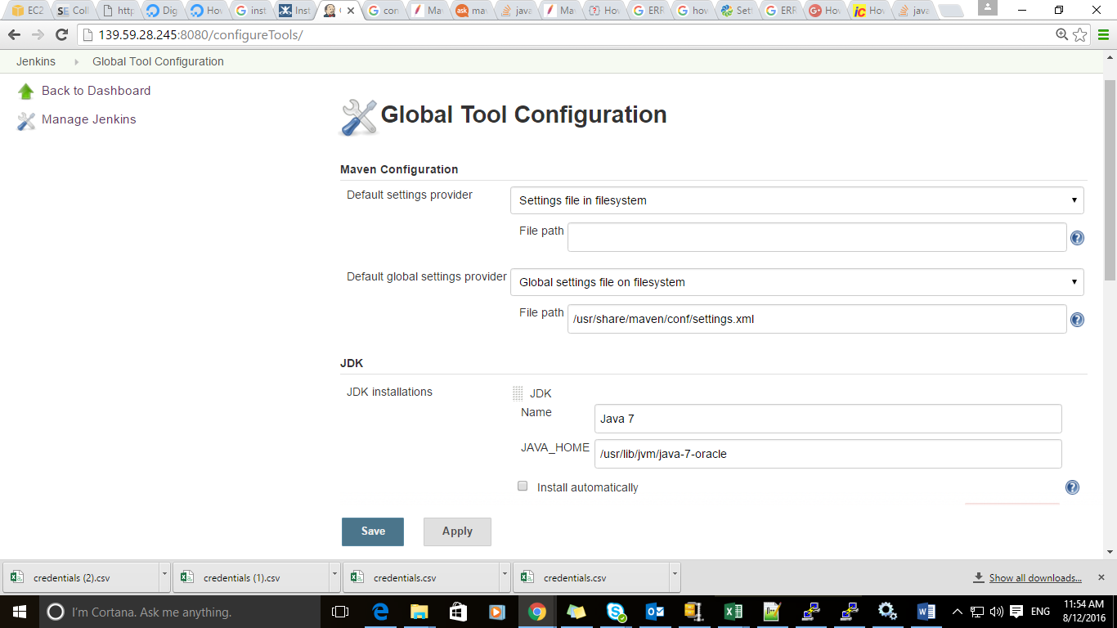

1. Global Tool Configuration 1.2 scoll down in Jenkins you will see another maven configuration

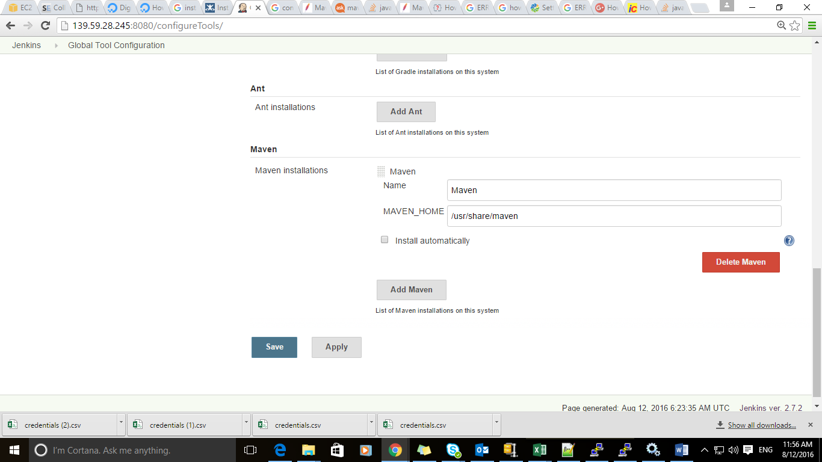

1. Job Configuration 1.1

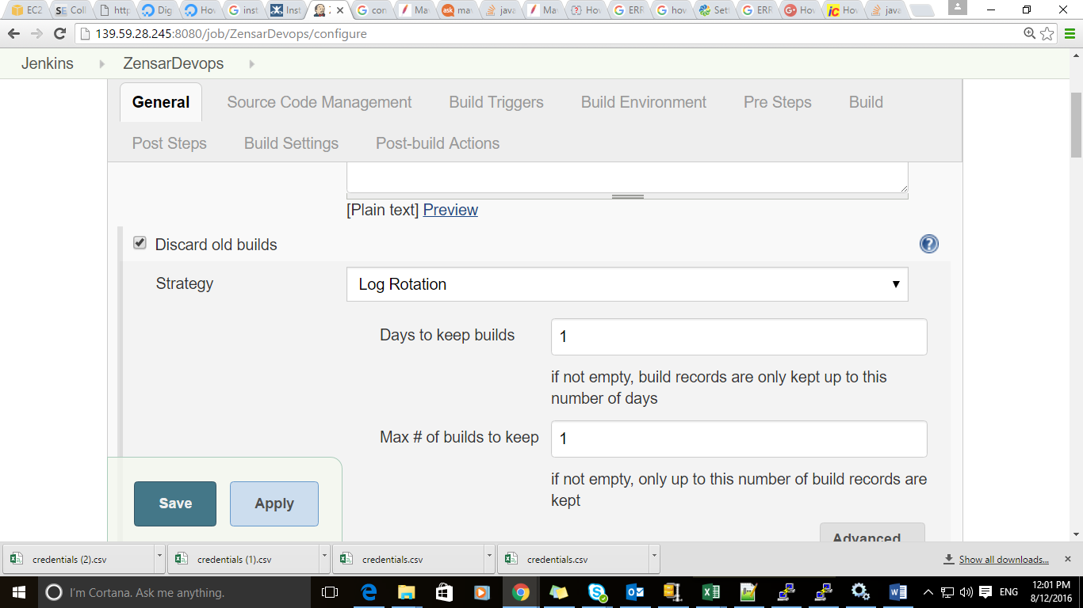

1. Job Configuration 1.2

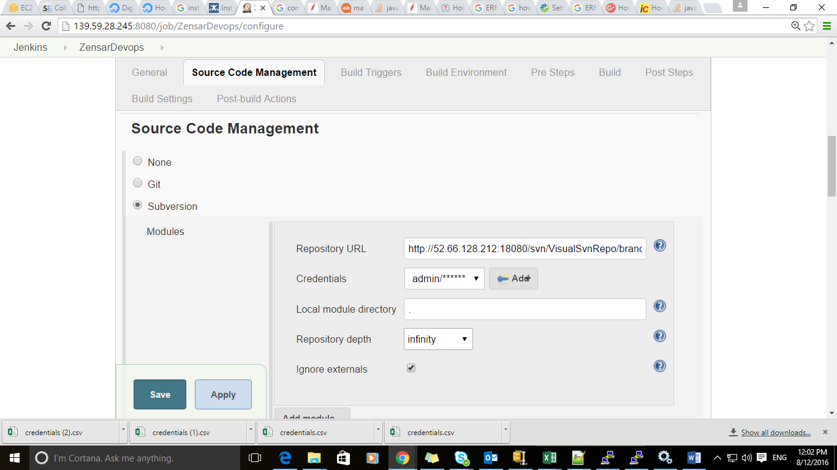

1. Job Configuration 1.3

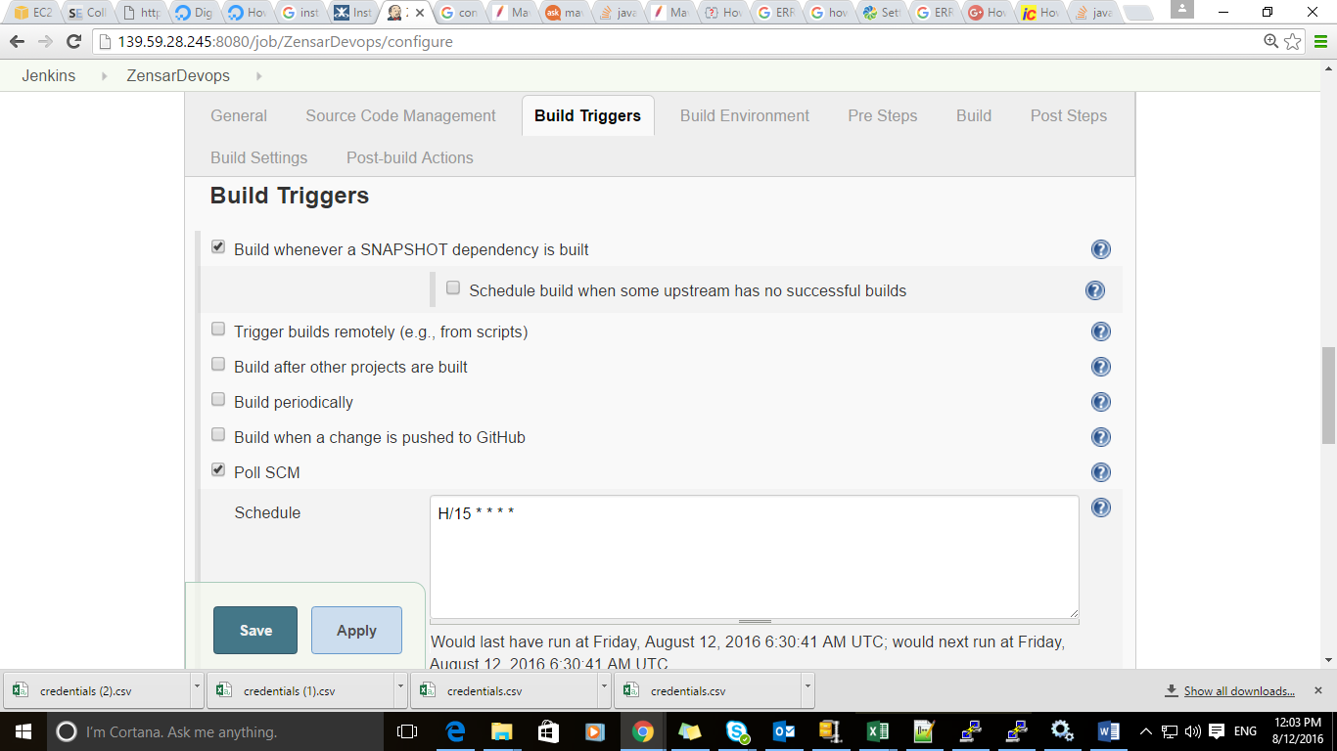

1. Job Configuration 1.4

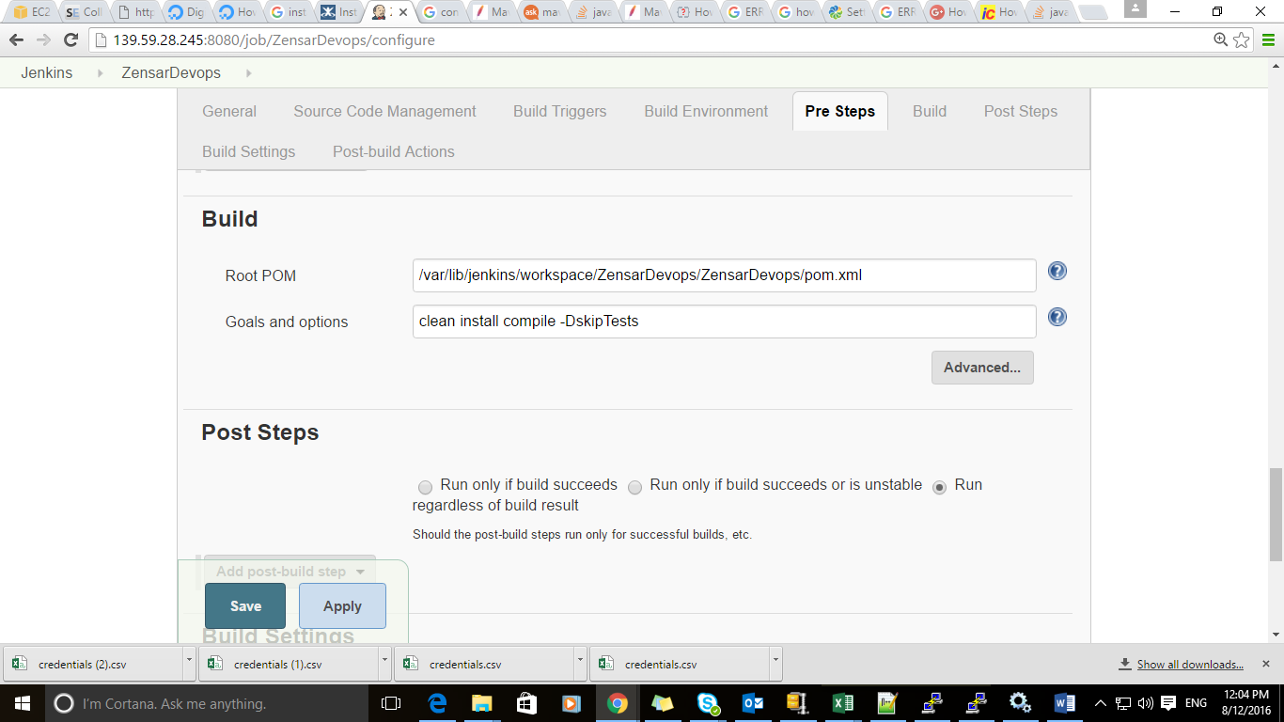

# Continous Deployment using Jenkins of maven project with tomcat server

1. Open /var/lib/tomcat7/conf/ tomcat-users.xml file
2. Add annotation 🡺

<user username="admin"

password="admin"

roles="manager-gui,admin-gui,manager-script"

/>

Save the changes.

1. Restart tomcat server.
2. Open tomcat server on browser. Ex 🡺localhost:8080
3. Open manager gui .

5.1) If tomcat gives error🡺 Resources not available.

5.2) Then type command 🡺sudo apt-get install tomcat7-admin

5.3) Restart tomcat 🡺 sudo service tomcat7 restart.

5.4) Open Manager-gui . (Now it should work. Other wise search google to trouble shoot ;)

6) Follow snapshots inside Job configuration.

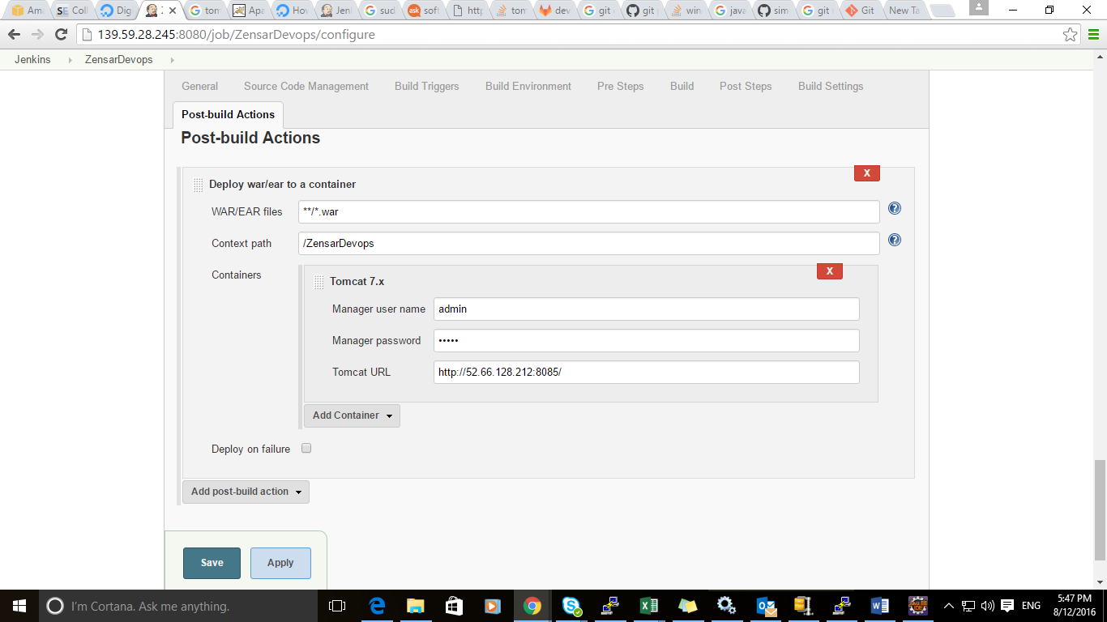

#Jenkins Pipeline Configuration Upstream and downstream

Download plugin **Copy Artifact , Pipeline .**

Upstream project configuration

1)

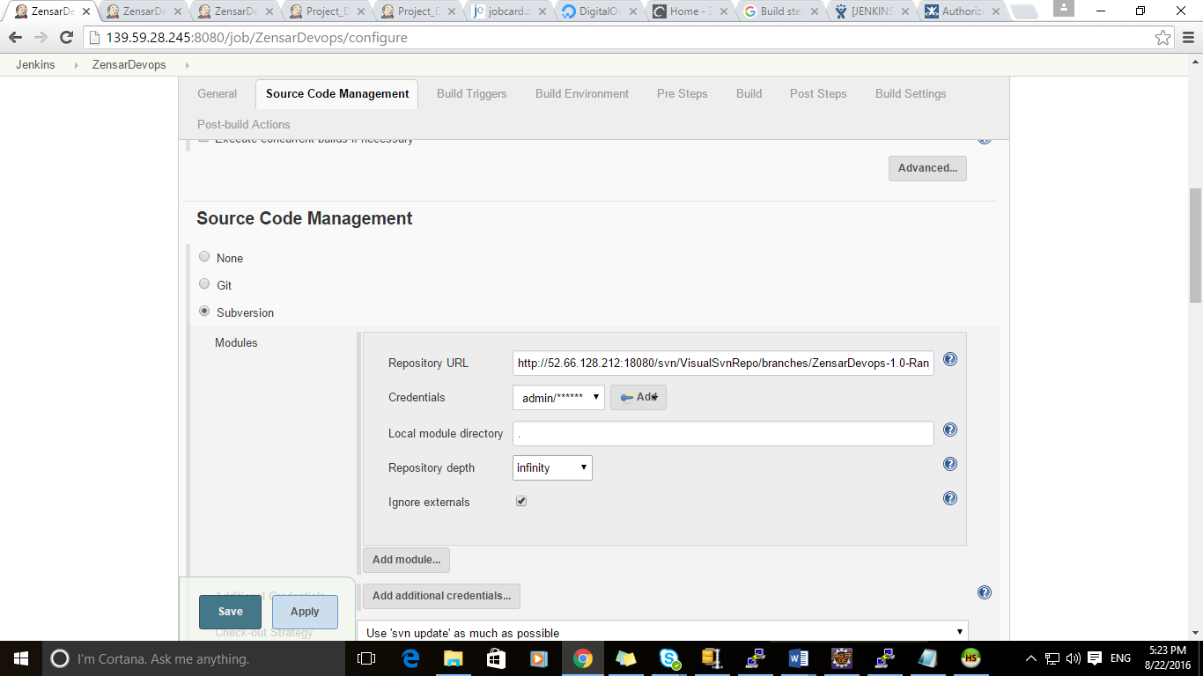

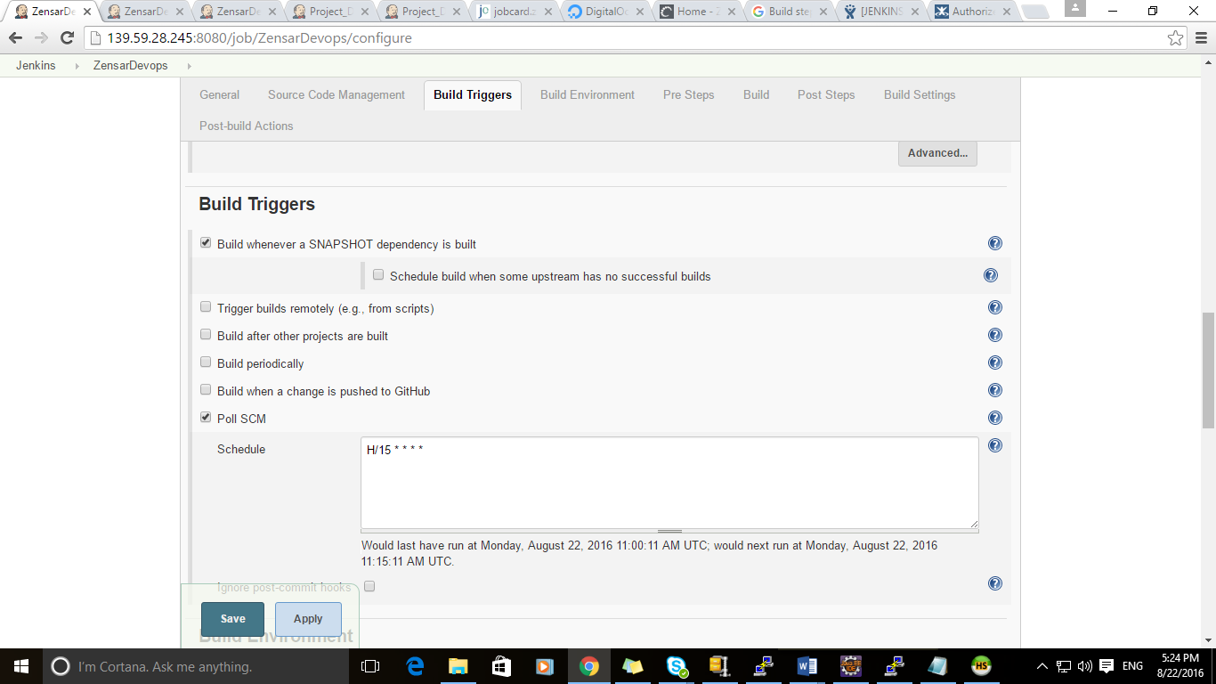

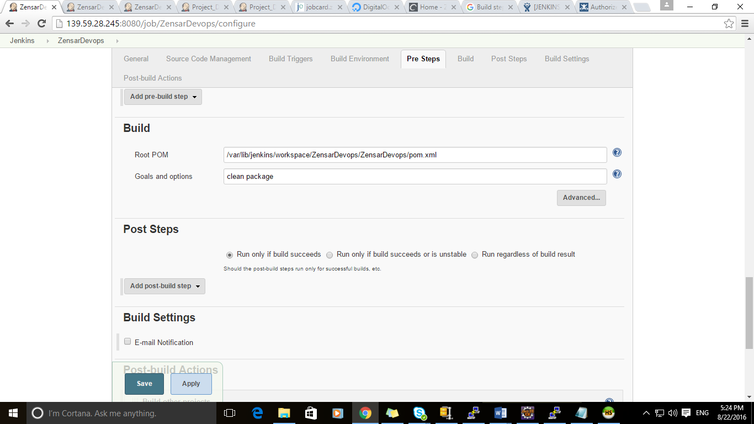

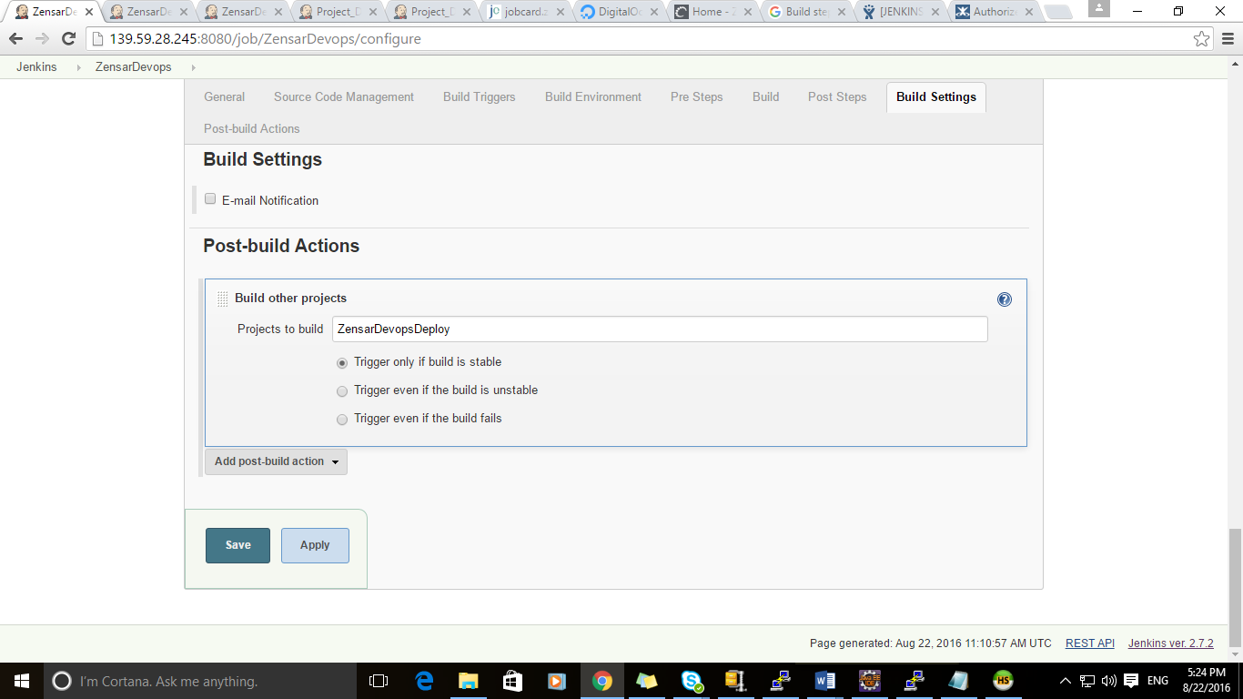

Down stream project configuration

