**Artificial Intelligence – *Project 3 Report***

Qinyang Li G33129490

**Algorithm Choice**

In this project, I used Python implemented value iteration, and policy iteration algorithms to solve a n*n grid world. Treat first 3 entry of the file as the size, gamma, noise of the world and following with the detail of the grid world. Using pseudocode available on PPT, value iteration was straight forward. For policy iteration, I first implemented a policy evaluation algorithm. By store each evaluation, the iteration will be achieved at the end of final evaluation.

**Problem**

We are given a file which contains information about the grid world. We need to read those files and add them to our graph. Then, we apply our Algorithms and print desired outputs and performance measures.

**How to run script**

The program first asks to input the file name to determine which files are used. After storing info into workable data structure, the program first asks to input the number of iterations. It will time value iteration, and policy iteration algorithm separately.

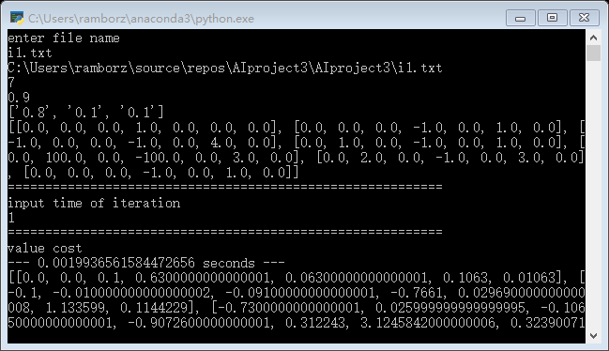Finally, it will show the cost of each search.

**Performance Measure**

The policy and value algorithm performed similar with small iterations. However, with larger iterations, value algorithm will be noticeably faster than the policy.