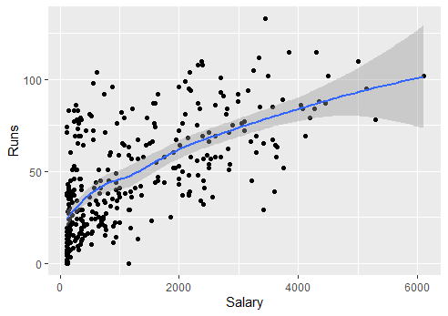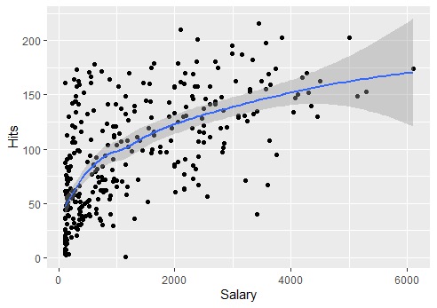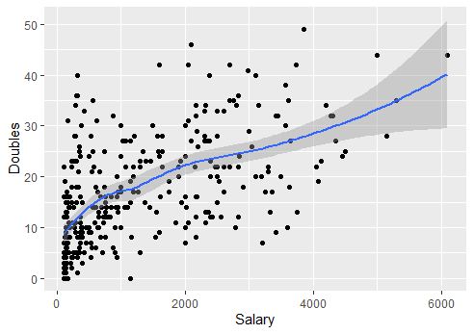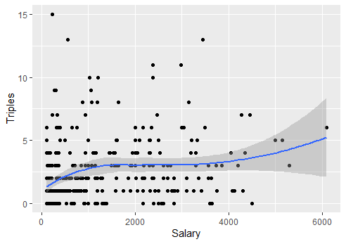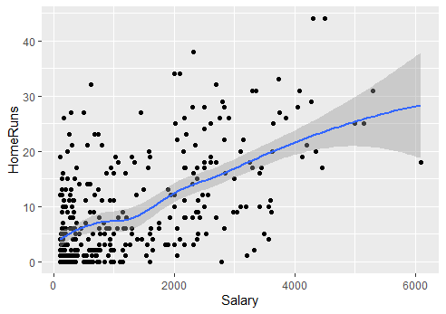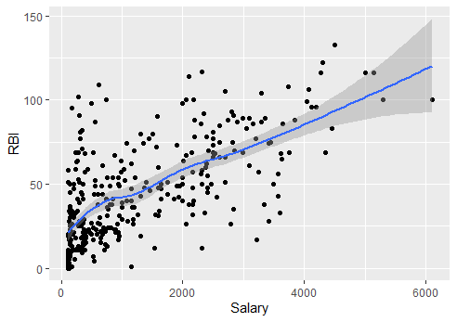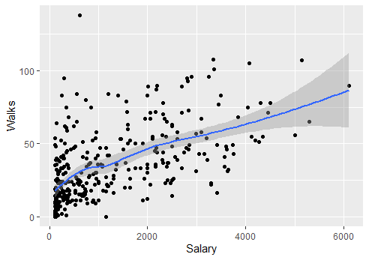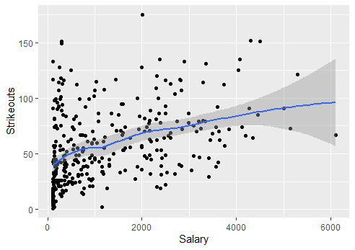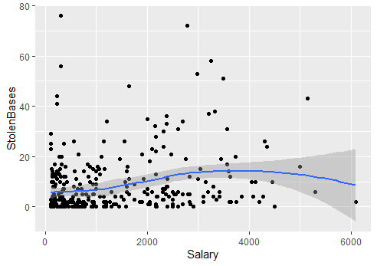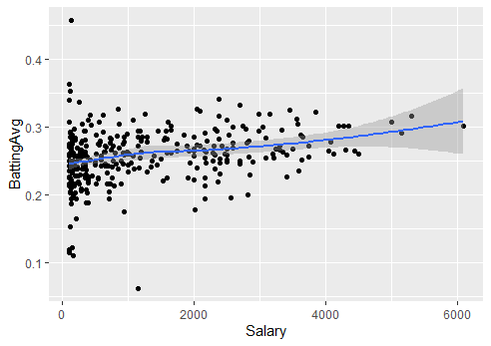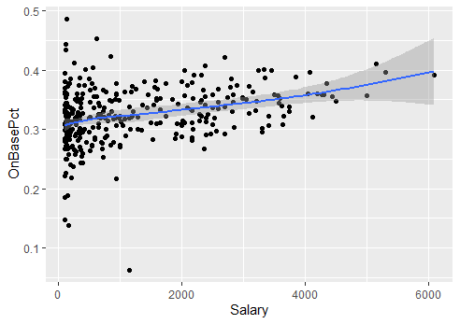

Call:

lm(formula = Salary ~ BattingAvg + OnBasePct + Runs + Hits +

Doubles + Triples + HomeRuns + RBI + Walks + Strikeouts +

StolenBases, data = myfile)

Residuals:

Min 1Q Median 3Q Max

-2952.27 -463.99 -72.93 479.76 3088.48

Coefficients:

Estimate Std. Error t value Pr(>|t|)

(Intercept) 909.597 406.740 2.236 0.02601 \*

BattingAvg -2068.742 3342.597 -0.619 0.53641

OnBasePct -937.774 2949.277 -0.318 0.75071

Runs 3.903 6.996 0.558 0.57727

Hits 6.174 3.936 1.568 0.11776

Doubles -5.492 10.620 -0.517 0.60541

Triples -18.292 26.725 -0.684 0.49417

HomeRuns 44.114 15.321 2.879 0.00425 \*\*

RBI 13.719 6.282 2.184 0.02969 \*

Walks 8.781 5.588 1.571 0.11704

Strikeouts -15.027 2.599 -5.782 1.74e-08 \*\*\*

StolenBases 11.446 5.841 1.959 0.05092 .

---

Signif. codes: 0 ‘\*\*\*’ 0.001 ‘\*\*’ 0.01 ‘\*’ 0.05 ‘.’ 0.1 ‘ ’ 1

Residual standard error: 865.9 on 325 degrees of freedom

Multiple R-squared: 0.5283, Adjusted R-squared: 0.5124

F-statistic: 33.1 on 11 and 325 DF, p-value: < 2.2e-16

The linear fit of all factors is shown in graph above. The standard error of all factors is shown above, the least one of standard error is strikeout and hits, which could be the best indicator for salary.